WEEK:8
- Develop a program using malloc(), calloc(), realloc(), and free(). Monitor memory allocation behavior and identify memory leaks using Valgrind.
Code:
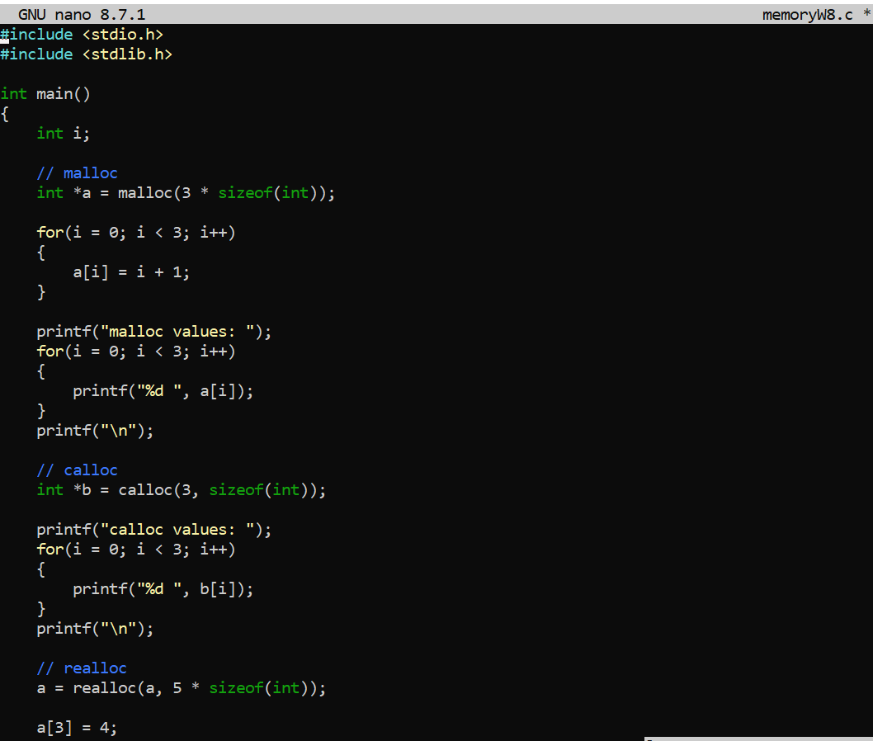
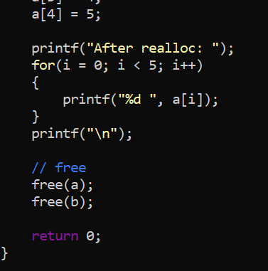
Output:
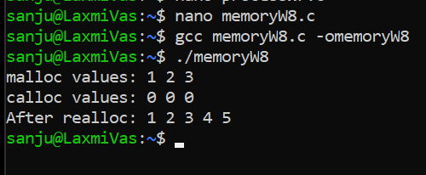

- Develop a program that demonstrates Copy-on-Write behavior after a fork(). Analyze memory usage before and after modifying data in the child process.
Code:
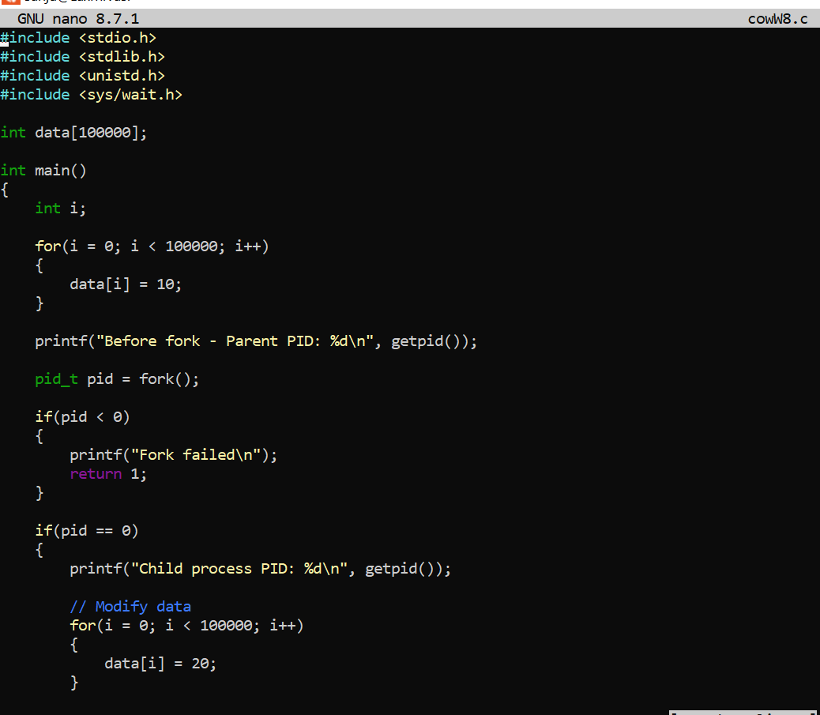
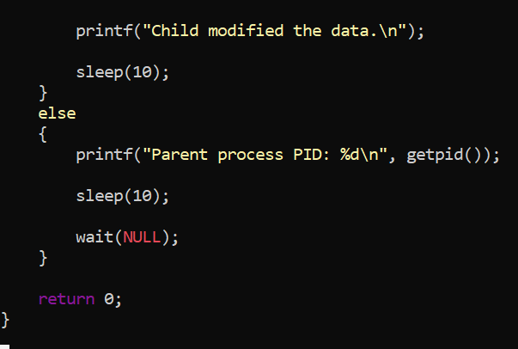
Output:
