OSSP – EXPERIMENT 1
Linux Command Execution using fork(), exec() and wait()
Name: Manne Thanishka
Roll Number: 2520030583

Aim
To develop a C program that accepts a Linux command from the user, creates a child process using fork(), executes the command in the child using an exec() system call, allows the parent to wait for the child using wait(), and displays the parent and child process IDs.

Program Code
#include <stdio.h>
#include <stdlib.h>
#include <unistd.h>
#include <sys/wait.h>

int main() {
char command[100];

printf("Enter Linux command: ");
scanf("%s", command);

pid_t pid = fork();

if (pid < 0) {
printf("Fork failed\n");
return 1;
}

if (pid == 0) {
// Child process
printf("Child PID: %d\n", getpid());

execlp(command, command, NULL);

printf("Execution failed\n");
exit(1);
}
else {
// Parent process
printf("Parent PID: %d\n", getpid());
printf("Parent waiting for child...\n");

wait(NULL);

printf("Child completed.\n");
}

return 0;
}

Compilation and Execution
Commands executed:
gcc exp1.c -o exp1
./exp1

Output
The program was executed with the Linux command: ls

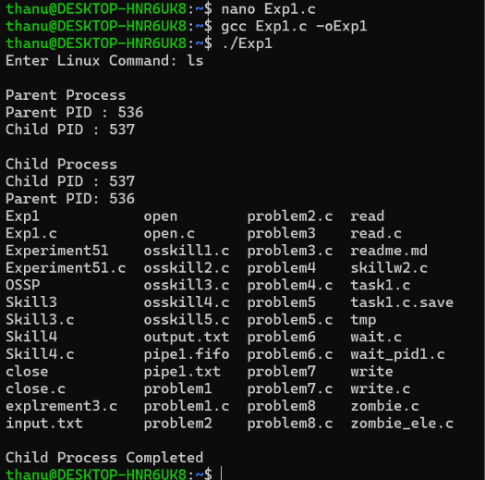

Observation / Analysis
The program successfully created a child process using fork(). The child process displayed its PID and executed the ls command using execlp(). The parent process displayed its own PID and waited for the child using wait(). After the child completed execution, the parent displayed 'Child completed.'

Result
The Linux command was successfully executed by the child process, and the parent process successfully synchronized with the child using wait().

