OSSP – EXPERIMENT 4
Process Creation and Process States
Name:Manne Thanishka
Roll Number: 2520030583

Aim
To develop a C program using fork() to create a parent and child process, display their Process ID (PID) and Parent Process ID (PPID), and observe the process execution and synchronization.

Program Code
#include <stdio.h>
#include <unistd.h>
#include <sys/wait.h>

int main() {
pid_t pid;

printf("Parent process started\n");
printf("Parent PID: %d\n", getpid());

pid = fork();

if (pid < 0) {
printf("Fork failed\n");
return 1;
}

if (pid == 0) {
// Child process
printf("\nChild process created\n");
printf("Child PID: %d\n", getpid());
printf("Child PPID: %d\n", getppid());

printf("Child is running...\n");
sleep(5);

printf("Child completed\n");
}
else {
// Parent process
printf("\nParent process\n");
printf("Parent PID: %d\n", getpid());
printf("Child PID: %d\n", pid);

printf("Parent waiting for child...\n");
wait(NULL);

printf("Parent completed\n");
}

return 0;
}

Compilation and Execution
gcc exp3.c -o exp3
./exp3

File Copy Output
Parent process started
Parent PID: 1187

Parent process
Parent PID: 1187
Child PID: 1188
Parent waiting for child...

Child process created
Child PID: 1188
Child PPID: 1187
Child is running...
Child completed
Parent completed

Process Monitoring
ps -ef | grep exp3
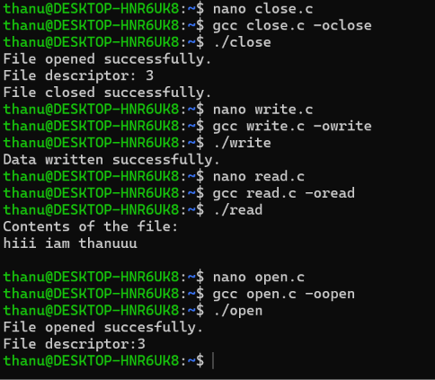

Observation / Analysis
The program successfully created a child process using fork().
The parent process had PID 1187, while the child process had PID 1188. The child process displayed its PPID as 1187, confirming that the child was created by the parent process.
The parent process used wait() and waited for the child process to complete. After the child completed its execution, the parent process also completed.
The ps command was used to observe the process. The /proc command with PID 601 did not provide information because PID 601 was not the PID of the child process in this execution.

Result
The parent and child processes were successfully created using fork(). Their PID and PPID were displayed, and process synchronization was successfully demonstrated using wait().

