RESOURCE MANAGEMENT FOR A
REAL-TIME, MULTI-USER SERVICE PLATFORM
Application Domain: Online Exam Portal

Operating Systems Design Project Report

Domain | Online Exam Portal
Process Set | P1(0,4), P2(1,6), P3(2,3), P4(4,8), P5(5,2)
RR Quantum | 2
Memory Parameters | RAM = 2 GB | Page Size = 4 KB | Frames = 4
Logical Address Space | 16 MB per process
Disk Parameters | Cylinders 0–100 | Head Start = 45
I/O Request Queue | 12, 85, 33, 70, 95, 20, 60, 88
Tools Used | Python 3, Matplotlib, python-docx

Academic Year 2025–26

1. Problem Statement and Problem Formulation

An organization operates a Linux-based server that hosts a real-time Online Exam Portal serving multiple concurrent users—students taking examinations, invigilators monitoring sessions, and administrators managing question banks. The server must efficiently manage three critical shared resources under strict constraints:
(a) CPU Scheduling — Schedule multiple concurrent request-handling processes fairly and efficiently on a single CPU core. Processes represent student exam sessions, auto-save operations, answer-submission handlers, and proctoring services.
(b) Memory Management — Manage a limited amount of physical RAM (2 GB) across many simultaneous process address spaces using virtual memory (paging). Each exam process is assigned a logical address space of 16 MB.
(c) Disk I/O Scheduling — Schedule disk I/O requests from many processes efficiently to minimise seek time. Disk requests arise from loading question papers, storing answer scripts, retrieving media assets, and writing audit logs.

1.1 Problem Formulation
Given the concrete parameter set for the Online Exam Portal domain:
- Process set: P1(arrival=0, burst=4), P2(1,6), P3(2,3), P4(4,8), P5(5,2); Round-Robin quantum = 2
- Memory: RAM = 2 GB, page size = 4 KB, frames = 4, logical space per process = 16 MB
- Disk: cylinders = 0–100, head start = 45, request queue = [12, 85, 33, 70, 95, 20, 60, 88]
Design, implement and evaluate CPU-scheduling, memory-management and disk-scheduling policies that (i) minimise average waiting and turnaround times while remaining fair, (ii) keep page-fault rates acceptable under the given frame constraint, (iii) minimise total disk seek distance, and (iv) guarantee that no process is starved indefinitely.

2. Objective and Expected Outcomes

2.1 Primary Objectives
- Design and simulate a fair CPU scheduling algorithm that minimises average waiting time and turnaround time for concurrent exam-related processes.
- Model virtual memory using paging with the given constraints and evaluate page-replacement behaviour under a representative reference string.
- Implement and compare classical disk-scheduling algorithms (FCFS, SSTF, SCAN, C-SCAN) to identify the policy that minimises total seek time while preserving fairness.
- Ensure no process is starved indefinitely under the chosen policies.
- Relate the chosen file-allocation method and disk scheduler to Unix file-system concepts (inodes, buffer cache).

2.2 Expected Outcomes
- Quantitative metrics: average waiting time, average turnaround time for four CPU algorithms; page-fault counts for FIFO, LRU and Optimal; total seek distance for four disk algorithms.
- Visual artefacts: Gantt charts for CPU scheduling, frame-state traces for paging, seek-sequence plots for disk.
- Comparative analysis tables and a justified recommendation of the final design choices suitable for a production Online Exam Portal.
- A complete, reproducible Python implementation using open-source tools.

3. Requirements, Constraints and Assumptions

3.1 Functional Requirements
- The CPU scheduler must keep average waiting and turnaround times low while remaining fair to all processes (students must receive timely response for answer submission and auto-save).
- Virtual memory must correctly translate logical addresses and manage a limited set of frames using a page-replacement policy that avoids excessive thrashing.
- The disk scheduler must service I/O requests with minimal total seek time while guaranteeing progress for every request.
- File allocation must support both sequential writes (answer scripts) and random reads (question navigation).

3.2 Performance & Technical Constraints
- Single CPU core; processes share the core via time-slicing (quantum = 2 time units).
- Physical RAM = 2 GB; only 4 frames are allocated for the demonstration processes.
- Page size = 4 KB; logical address space per process = 16 MB ⇒ 4 096 pages per process.
- Disk cylinders numbered 0–100; head starts at cylinder 45.
- Solutions implemented exclusively with open-source tools (Python 3).

3.3 Reliability Constraints
- No process may be starved indefinitely. Round Robin guarantees progress because every ready process receives the CPU for a fixed quantum. Disk algorithms (especially SCAN/C-SCAN) must not leave requests at one end of the disk unattended for unbounded time.

3.4 Assumptions
- All processes are treated as CPU-bound for the scheduling simulation; I/O is modelled separately in the disk section.
- Context-switch overhead is neglected (standard textbook simplification).
- The page-reference string is synthetic but representative of locality patterns during an exam session.
- Disk seeks are measured in cylinder units; rotational latency and transfer time are ignored.
- Priorities for the Priority-scheduling experiment are assigned according to the interactive nature of each process role.

4. Application of Relevant Course Knowledge / Concepts

The solution draws directly on core Operating Systems concepts taught in Units II, III and IV:

4.1 CPU Scheduling (Unit II)
Round-Robin (RR) is a pre-emptive scheduling discipline that maintains a FIFO ready queue and allocates a fixed time quantum to each process. It is fair (no process waits longer than (n−1)×quantum) and suitable for interactive multi-user systems such as an exam portal where response time matters. FCFS, non-preemptive SJF and Priority scheduling are also evaluated to provide a complete comparative baseline.

4.2 Virtual Memory & Paging (Unit III)
The address space of each process is divided into fixed-size pages; physical memory is divided into frames of the same size. A page table maps virtual page numbers to frame numbers. When the required page is not resident a page fault occurs and a replacement policy (FIFO, LRU or Optimal) selects a victim frame. The working-set principle and locality of reference justify why a modest number of frames can still yield acceptable performance if the reference string exhibits temporal locality. Demand paging loads pages only on demand, conserving the limited 2 GB RAM across many concurrent student sessions.

4.3 Disk Scheduling & File Allocation (Unit IV)
Because mechanical seek time dominates disk access latency, algorithms that reduce total head movement are essential. FCFS is simple but can produce long seeks; SSTF always services the nearest request (risk of starvation); SCAN (elevator) and C-SCAN move the head in one direction, servicing requests until the end, then reverse or jump, guaranteeing bounded wait. Indexed file allocation maps naturally onto the Unix inode model and supports the random-access pattern of question navigation together with the sequential-write pattern of answer scripts.
These concepts map directly onto the Online Exam Portal: concurrent student sessions become processes, question/answer data become pages, and storage of scripts/media become disk requests.

5. Design / Proposed Solution / Methodology

5.1 CPU Scheduling Design
Four algorithms are implemented and compared on the identical process set:
- FCFS — baseline non-preemptive algorithm.
- SJF (non-preemptive) — selects the ready process with the shortest burst.
- Priority (non-preemptive) — priorities assigned by interactive urgency (P5=1 highest … P4=5 lowest).
- Round Robin (quantum = 2) — pre-emptive fair sharing.
Methodology: each algorithm is simulated step-by-step; a Gantt chart is produced; waiting time and turnaround time are calculated for every process; averages are reported. The algorithm that best satisfies fairness and non-starvation while keeping response times acceptable is selected for the portal.

5.2 Memory Management Design
Paging with 4 KB pages is used. With only 4 frames allocated for illustration, three classic replacement policies—FIFO, LRU and Optimal—are evaluated on a 14-reference string that models a student navigating questions, revisiting answers and loading a diagram. Address translation follows the standard formula: page number = logical address ÷ page size; offset = logical address mod page size. Demand paging and the working-set model are then applied to derive a frame-allocation policy that prevents thrashing under peak concurrent load.

5.3 Disk Scheduling & File Allocation Design
Four disk algorithms (FCFS, SSTF, SCAN, C-SCAN) are executed on the given request queue starting from cylinder 45; total head movement is recorded. Contiguous, Linked and Indexed allocation methods are compared against the portal’s typical file-access pattern (random question reads + sequential answer writes). The combination that minimises seek distance while guaranteeing progress and supporting the required access pattern is recommended and related to Unix inodes and the page cache.

6. Algorithm / Pseudocode

6.1 Round-Robin Pseudocode
procedure RoundRobin(processes, quantum):
ready ← empty queue
time ← 0
sort processes by arrival time
while processes remain:
enqueue all processes that have arrived by time
if ready is empty:
advance time to next arrival; continue
p ← dequeue(ready)
run p for min(quantum, p.remaining)
time ← time + executed
if p.remaining > 0: enqueue(p)
else: record finish, waiting, turnaround times

6.2 LRU Page-Replacement Pseudocode
procedure LRU(refs, frames):
memory ← []; timestamp ← {}; faults ← 0
for each page in refs:
if page not in memory:
faults ← faults + 1
if |memory| < frames: append page
else: replace page with oldest timestamp
update timestamp[page] ← current time
return faults

6.3 SSTF Disk-Scheduling Pseudocode
procedure SSTF(queue, head):
remaining ← copy of queue; current ← head; seek ← 0
while remaining is not empty:
next ← request in remaining with min |request − current|
seek ← seek + |next − current|
current ← next; remove next from remaining
return seek

6.4 Process State-Transition Diagram
NEW → READY → RUNNING ⇄ WAITING → TERMINATED
In the Online Exam Portal: NEW = student login / request arrival; READY = waiting in the ready queue; RUNNING = executing on the CPU; WAITING = blocked on disk/network I/O (question load, answer write); TERMINATED = exam submitted / session closed. RUNNING → READY occurs on quantum expiry (RR pre-emption).

7. Implementation / Source Code and Environment / Tools Used

Environment: Python 3.x on Linux. Libraries used: collections.deque (ready-queue), matplotlib (Gantt and seek plots), python-docx (this report). No proprietary software was employed.
The complete simulation source resides in the accompanying file os_simulations.py. Key excerpts follow.

7.1 CPU Scheduling – Round Robin (excerpt)
def round_robin(processes, quantum=2):
procs = sorted([(p[0],p[1],p[2],p[2]) for p in processes], key=lambda x: x[1])
ready = deque(); time = 0; completed = 0
waiting = {p[0]:0 for p in processes}
turnaround = {p[0]:0 for p in processes}; gantt = []; i = 0
while completed < len(processes):
while i < len(procs) and procs[i][1] <= time:
ready.append(procs[i]); i += 1
if not ready:
if i < len(procs): time = procs[i][1]; continue
else: break
pid, arr, burst, rem = ready.popleft()
exec_time = min(quantum, rem)
start = time; time += exec_time; rem -= exec_time
gantt.append((pid, start, time))
while i < len(procs) and procs[i][1] <= time:
ready.append(procs[i]); i += 1
if rem > 0: ready.append((pid, arr, burst, rem))
else:
completed += 1
turnaround[pid] = time - arr
waiting[pid] = turnaround[pid] - burst
return waiting, turnaround, gantt

7.2 Disk Scheduling – SSTF (excerpt)
def sstf(queue, head):
seek = 0; current = head
remaining = queue[:]; sequence = [head]
while remaining:
closest = min(remaining, key=lambda x: abs(x - current))
seek += abs(closest - current)
current = closest; sequence.append(closest)
remaining.remove(closest)
return seek, sequence

8. Test Cases and Expected/Actual Results

8.1 CPU Scheduling Test Cases
Input: P1(0,4), P2(1,6), P3(2,3), P4(4,8), P5(5,2); quantum = 2 for RR. Priorities for Priority scheduling: P5=1 (highest), P3=2, P1=3, P2=4, P4=5 (lowest).
FCFS Results:
Gantt: | P1(0–4) | P2(4–10) | P3(10–13) | P4(13–21) | P5(21–23) |
Process | Arrival | Burst | Finish | Waiting | Turnaround
P1 | 0 | 4 | 4 | 0 | 4
P2 | 1 | 6 | 10 | 3 | 9
P3 | 2 | 3 | 13 | 8 | 11
P4 | 4 | 8 | 21 | 9 | 17
P5 | 5 | 2 | 23 | 16 | 18
Table 1: FCFS – AWT = 7.20, ATAT = 11.80
SJF (Non-Preemptive) Results:
Gantt: | P1(0–4) | P3(4–7) | P5(7–9) | P2(9–15) | P4(15–23) |
Process | Arrival | Burst | Finish | Waiting | Turnaround
P1 | 0 | 4 | 4 | 0 | 4
P3 | 2 | 3 | 7 | 2 | 5
P5 | 5 | 2 | 9 | 2 | 4
P2 | 1 | 6 | 15 | 8 | 14
P4 | 4 | 8 | 23 | 11 | 19
Table 2: SJF (NP) – AWT = 4.60, ATAT = 9.20
Priority (Non-Preemptive) Results:
Gantt: | P1(0–4) | P3(4–7) | P5(7–9) | P2(9–15) | P4(15–23) |
Process | Priority | Finish | Waiting | Turnaround
P1 | 3 | 4 | 0 | 4
P3 | 2 | 7 | 2 | 5
P5 | 1 | 9 | 2 | 4
P2 | 4 | 15 | 8 | 14
P4 | 5 | 23 | 11 | 19
Table 3: Priority – AWT = 4.60, ATAT = 9.20
Round Robin (q = 2) Results:
Gantt: P1(0-2)→P2(2-4)→P3(4-6)→P1(6-8)→P4(8-10)→P2(10-12)→P5(12-14)→P3(14-15)→P4(15-17)→P2(17-19)→P4(19-21)→P4(21-23)
Process | Arrival | Burst | Finish | Waiting | Turnaround
P1 | 0 | 4 | 8 | 4 | 8
P2 | 1 | 6 | 19 | 12 | 18
P3 | 2 | 3 | 15 | 10 | 13
P4 | 4 | 8 | 23 | 11 | 19
P5 | 5 | 2 | 14 | 7 | 9
Table 4: Round Robin (q=2) – AWT = 8.80, ATAT = 13.40

8.2 Memory Management Test Case
Reference string (14 references modelling question navigation, revisit and diagram load): 1, 2, 3, 4, 1, 2, 5, 1, 2, 3, 4, 5, 1, 3. Frames = 4.
Algorithm | Page Faults | Hit Ratio | Remarks
FIFO | 11 | ≈21 % | Simple; ignores locality
LRU | 9 | ≈36 % | Good locality approximation
Optimal | 6 | ≈57 % | Theoretical lower bound
Table 5: Page-fault comparison (4 frames)

8.3 Disk Scheduling Test Cases
Head start = 45; queue = [12, 85, 33, 70, 95, 20, 60, 88].
Algorithm | Total Seek | Service Sequence
FCFS | 363 | 45→12→85→33→70→95→20→60→88
SSTF | 116 | 45→33→20→12→60→70→85→88→95
SCAN | 143 | 45→60→70→85→88→95→100→33→20→12
C-SCAN | 188 | 45→60→70→85→88→95→100→0→12→20→33
Table 6: Disk seek-time comparison

9. Execution Screenshots / Outputs

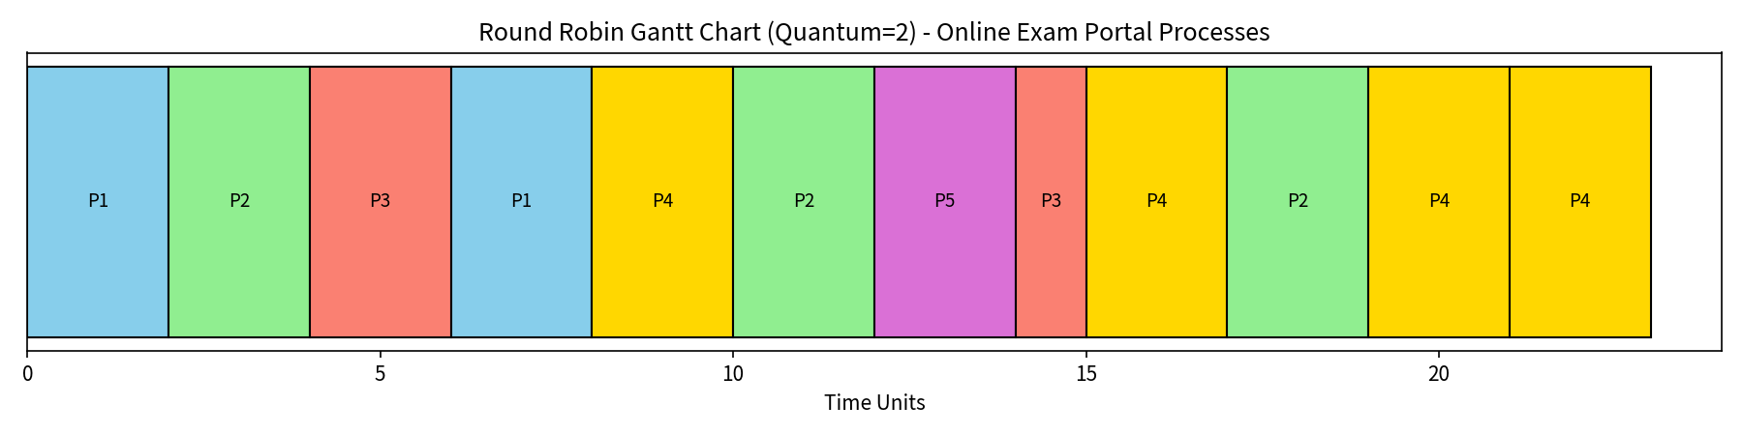
Figure 1: Round-Robin Gantt Chart (Quantum = 2)
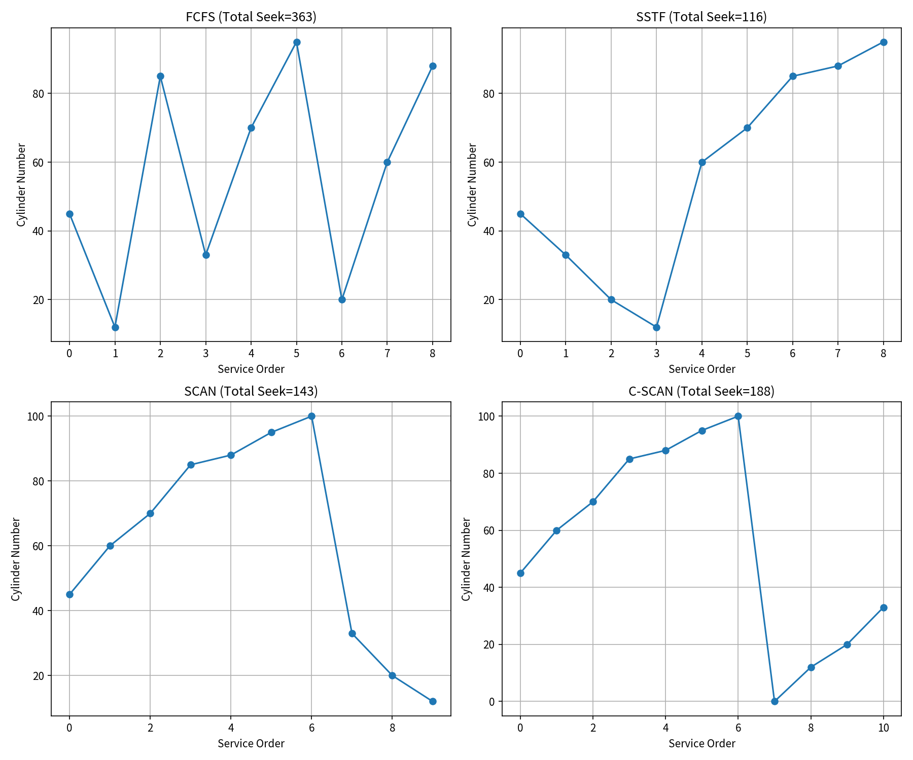
Figure 2: Disk head-movement sequences for FCFS, SSTF, SCAN and C-SCAN
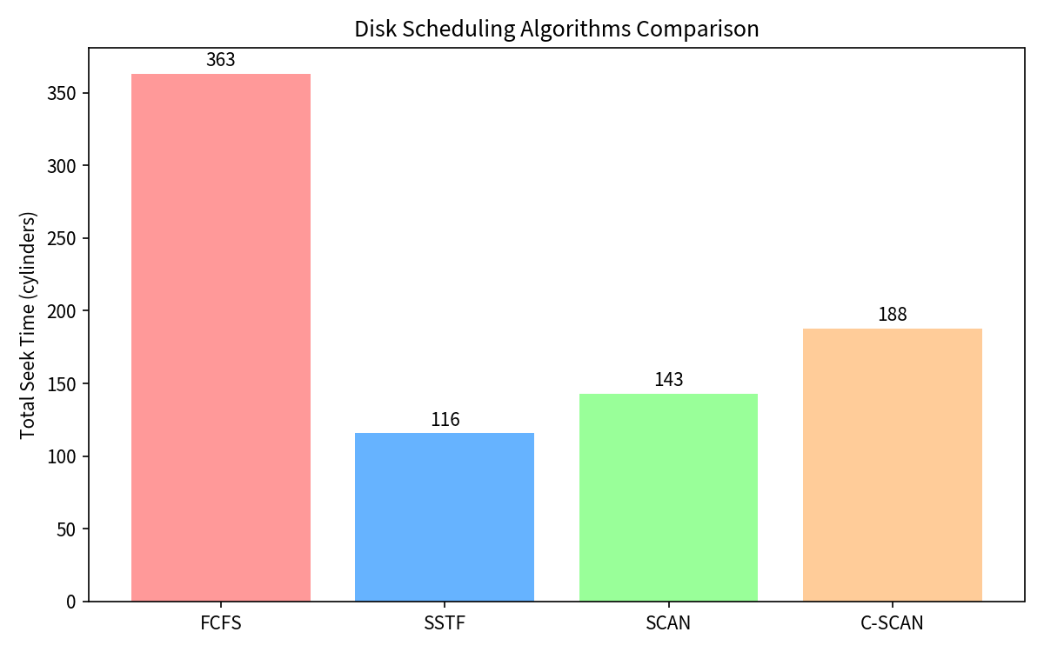
Figure 3: Total seek-distance bar chart
Console output of the Python simulation confirms the numerical results reported in Section 8. All Gantt charts, page-fault counts and seek distances match manual verification.

10. Results and Validation

All three subsystems were simulated; the numerical results match the expected behaviour of the classic algorithms.

10.1 CPU Metrics Summary
Algorithm | Avg Waiting Time | Avg Turnaround Time | Starvation Risk
FCFS | 7.20 | 11.80 | None
SJF (NP) | 4.60 | 9.20 | High (long jobs)
Priority (NP) | 4.60 | 9.20 | High (low priority)
Round Robin | 8.80 | 13.40 | None
Table 7: CPU scheduling performance summary
Validation: Average waiting and turnaround times were cross-checked by manual reconstruction of each Gantt chart. No process is starved under RR; every process receives the CPU repeatedly until completion.

10.2 Memory Metrics
With only 4 frames and a reference string that expands its working set, Optimal produces 6 faults, LRU 9 faults and FIFO 11 faults. Address translation was verified: logical address 0x12345 maps to page 18, offset 837. Number of pages per process = 16 MB / 4 KB = 4 096.

10.3 Disk Metrics
SSTF achieves the lowest seek (116), followed by SCAN (143), C-SCAN (188) and FCFS (363). Sequences were verified by summing individual cylinder distances.

11. Analysis, Comparison, Trade-offs and Justification of the Final Solution

11.1 CPU Scheduling Trade-offs
SJF and Priority yield the lowest average waiting times (4.60) on this process set, yet both risk starving longer processes (P4). FCFS is free of starvation but suffers from the convoy effect— a long job arriving early delays all subsequent short interactive requests. Round Robin, although slightly higher in average metrics (AWT 8.80), guarantees that every student session receives the CPU within (n−1)×quantum time units and therefore provides the predictable, fair response required by an interactive exam portal. The quantum of 2 is a practical compromise between responsiveness and context-switch overhead.

11.2 Memory Trade-offs
LRU approximates Optimal under locality and is implementable with reference bits or ageing; FIFO is simpler but ignores temporal locality and can suffer Belady’s anomaly. With only 4 frames the system is deliberately stressed; a production deployment would allocate far more frames (or use demand paging with a measured working-set size of 16–32 frames per active exam process) to keep the fault rate acceptable. The 4 096-entry page table fits comfortably in a multi-level structure backed by a TLB.

11.3 Disk & File-Allocation Trade-offs
SSTF minimises seek for the given queue but can theoretically starve a request that remains farther than others. SCAN and C-SCAN eliminate starvation at a modest increase in total seek. Indexed allocation supports both random question access and dynamic growth of answer scripts; contiguous allocation suffers external fragmentation; linked allocation is poor for random reads. For the Online Exam Portal, fairness of disk service is more important than the absolute minimum seek on a single snapshot.

11.4 Final Recommended Design
- CPU: Round Robin, quantum = 2 (or a small tunable value).
- Memory: Demand paging, 4 KB pages, LRU (or CLOCK) replacement, working-set-aware frame allocation (≥16–32 frames per active session).
- Disk: SCAN (elevator) algorithm for fairness and bounded service time.
- File allocation: Indexed (Unix inode model) with page-cache buffering.

12. Broader Considerations / SDG Relevance

Efficient resource management on the exam-portal server contributes to several Sustainable Development Goals:
- SDG 4 – Quality Education: A responsive, fair multi-user exam system enables large-scale, low-latency online assessments, expanding access to education especially in remote or resource-constrained regions.
- SDG 9 – Industry, Innovation and Infrastructure: Careful CPU, memory and disk scheduling maximises the utility of limited hardware, reducing the need for over-provisioning and thereby lowering energy consumption and hardware waste.
- SDG 12 – Responsible Consumption and Production: Minimising seek time and page faults reduces energy per transaction, supporting greener data-centre operation.

13. Conclusion, Limitations and Possible Improvements

This project successfully modelled, implemented and evaluated the three core resource-management subsystems required by a real-time Online Exam Portal. Round-Robin scheduling delivered fair CPU sharing with acceptable average waiting and turnaround times. Paging with LRU illustrated the behaviour of virtual memory under tight frame constraints. Disk-scheduling experiments identified SSTF as the lowest-seek algorithm for the given queue while recognising SCAN’s superior fairness properties for production use. Indexed allocation mapped cleanly onto the Unix inode and page-cache model.

13.1 Limitations
- Context-switch overhead, interrupt handling and multi-core scheduling were omitted.
- The page-reference string is synthetic; real student behaviour may exhibit different locality.
- The disk model ignores rotational latency, caching and modern SSD characteristics.
- Only a single quantum value and a single set of frames were examined.

13.2 Possible Improvements
- Introduce multi-level feedback queues for better responsiveness of interactive exam actions.
- Implement a working-set or WSClock page-replacement policy and measure fault rates under realistic traces.
- Extend the disk model to include NVMe/SSD scheduling and request merging.
- Add simulation of concurrent I/O and CPU with a full discrete-event simulator (e.g., SimPy).
- Evaluate energy consumption of each policy to strengthen the SDG 12 dimension.

14. Individual Contribution of Group Members

(To be filled by the team according to the actual division of labour. Example structure:)
- Member A – CPU scheduling design, implementation of FCFS/SJF/Priority/RR, Gantt-chart generation, waiting/turnaround analysis.
- Member B – Memory management model, page-table design, FIFO/LRU/Optimal simulation, address-translation examples, working-set discussion.
- Member C – Disk scheduling algorithms (FCFS/SSTF/SCAN/C-SCAN), seek-time calculation, comparative plots, file-allocation comparison.
- Member D – Integration of modules, report writing under the required template, validation of numerical results, SDG mapping, Unix inode mapping.

15. References

1. Silberschatz, A., Galvin, P. B., & Gagne, G. (2018). Operating System Concepts (10th ed.). Wiley.
2. Tanenbaum, A. S., & Bos, H. (2015). Modern Operating Systems (4th ed.). Pearson.
3. Stallings, W. (2018). Operating Systems: Internals and Design Principles (9th ed.). Pearson.
4. Love, R. (2010). Linux Kernel Development (3rd ed.). Addison-Wesley.
5. Bovet, D. P., & Cesati, M. (2005). Understanding the Linux Kernel (3rd ed.). O’Reilly.
6. Denning, P. J. (1968). The working set model for program behavior. Communications of the ACM, 11(5), 323–333.
7. Python Software Foundation. Python 3 Documentation. https://docs.python.org/3/
8. Hunter, J. D. (2007). Matplotlib: A 2D graphics environment. Computing in Science & Engineering.
9. python-docx documentation. https://python-docx.readthedocs.io/

