You are given an undirected graph G(V, E) with N vertices and M edges. We need to
find the minimum number of edges between a given pair of vertices (u, v).
Examples:

Input: For given graph G. Find minimum number of edges between (1, 5).

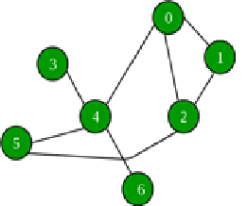

Output: 2
Explanation: (1, 2) and (2, 5) are the only edges resulting into shortest path between 1 and 5.


