Given the root of a binary search tree and K as input, find Kth smallest element in BST.
For example, in the following BST,
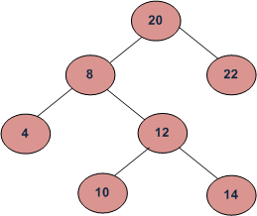
if k = 3, then the output should be 10, and
if k = 5, then the output should be 14.
Sample:
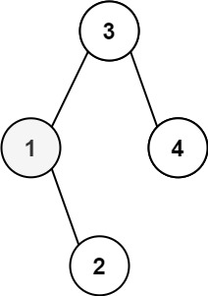
Input: root = [3,1,4,null,2], k = 1
Output: 1
Input: root = [5,3,6,2,4,null,null,1], k = 3
Output: 3

Sort Ascendingminimum edgessingly linked listFibonacci Sumbinary searchTree traversalSort AscendingPalindrome or notbinary searchFrequencyMissing NumbersBinary TreeLinked Listbubble sortMissing Numbersodd nuberInsert-deleteValid StringFibonacci Sumindex of first stringFIFOdescending orderFactorialAscending orderMin stackFactorialLinked Listsingly linked listLinked Listsum of array
