SE LAB5

Screenshot 1: Original program output (before any changes)
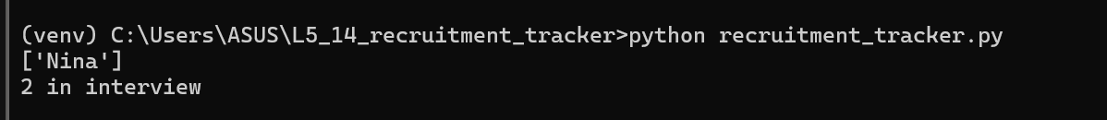

Screenshot 2: Pylint report before fixes (4.47/10)
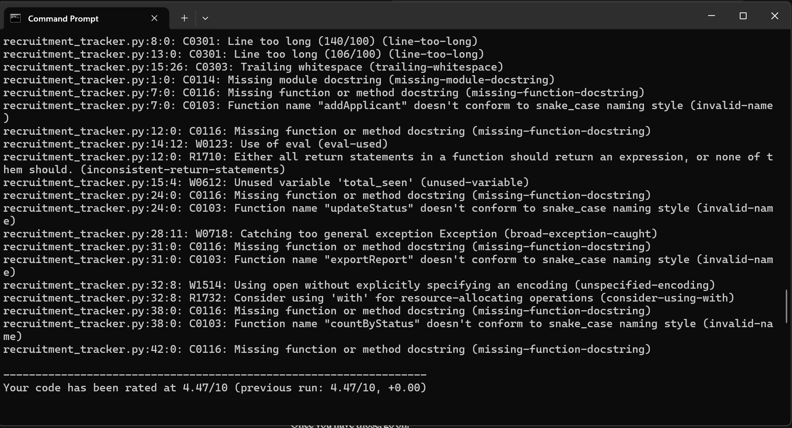

Screenshot 3: Bandit after fixes (no issues identified)
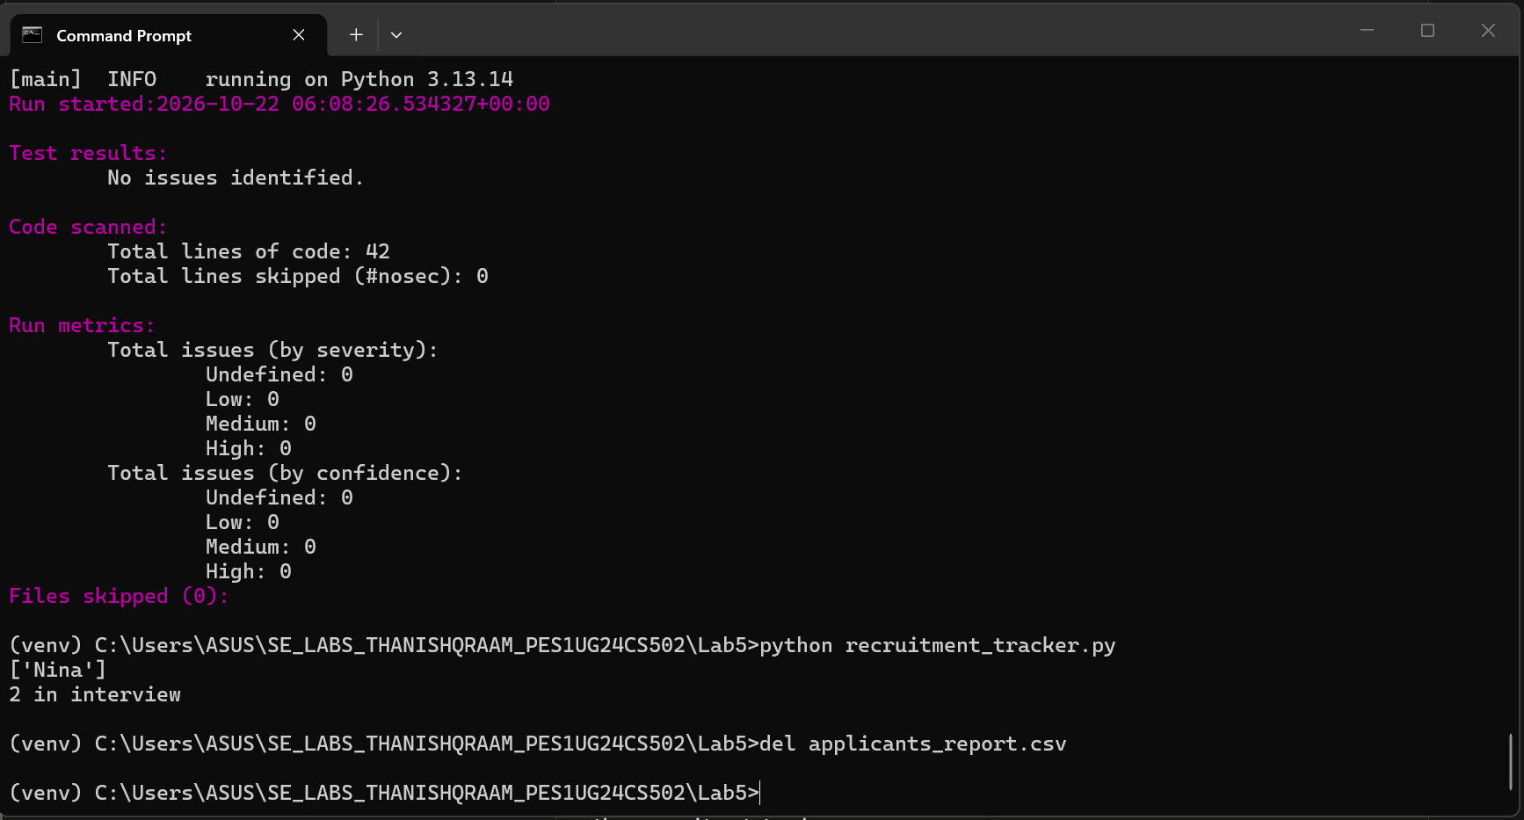

Screenshot 4: Pylint after fixes (9.72 to 10.00/10 after adding the final newline)
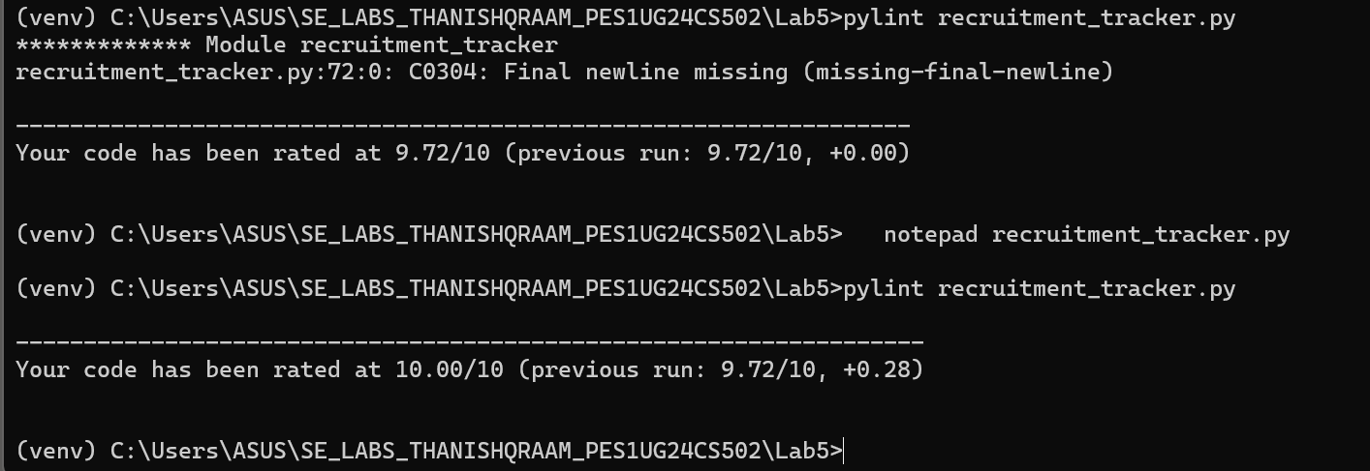

Screenshot 5: Flake8, Pylint and Bandit all clean after final fixes
