Lab 1 – Requirements Engineering & UML Use-Case Modelling

NAME: THANISHQ RAAM PAATIL
SRN: PES1UG24CS502
Problem Statement 14 — Corporate Mental Wellness & Counseling Platform
Domain: Healthcare & Telemedicine

1. Problem Context
Many employees put off seeking help for stress because they worry their employer, or even the therapist, will connect the visit to their name. Existing options like company EAP lines or open booking forms usually ask for a corporate email or employee ID, which puts people off.
This portal lets employees check their stress levels, book confidential sessions with licensed therapists, and track their own wellness indicators under an anonymous pseudo-ID, so the therapist and the employer never see who they are.
Actors: Corporate Employee, Licensed Therapist

2. Functional Requirements
Five requirements (FR-001–FR-005), built by following the employee journey: get an anonymous identity, assess stress, book a session, have the therapist manage the session, and track wellness over time. FR-001 was the given sample; FR-002–FR-005 were written for this submission.
ID | Type | Description | Priority | Acceptance Criteria | Rationale
FR-001 | Functional | Generate an anonymized pseudo-ID for each employee account, so sessions can be booked without revealing the corporate email or employee ID to the therapist. | High | Pass: therapist dashboard displays the pseudo-ID only. Fail: employee PII is exposed in booking metadata. | Core privacy mechanism; employees will not use the portal if they can be identified.
FR-002 | Functional | Let an employee complete a stress self-assessment and see a stress score with a severity level (Low / Moderate / High); show crisis support resources when the level is High. | High | Pass: score and level appear within 3 seconds of submission, and a High score shows crisis resources. Fail: no result is shown, or a High score shows no resources. | Entry point of the workflow; helps employees recognise stress and gets high-risk users help fast.
FR-003 | Functional | Let an employee view a therapist's open slots in their own timezone, book a slot, and reschedule or cancel it, with confirmations that carry the pseudo-ID only. | High | Pass: booked slot appears on both dashboards and the confirmation contains only the pseudo-ID. Fail: a slot is double-booked or the confirmation contains PII. | Booking is the main link between employee and therapist; rescheduling cuts no-shows.
FR-004 | Functional | Let a licensed therapist publish availability slots, view upcoming sessions (pseudo-ID only), and record session notes against the pseudo-ID. | Medium | Pass: a new slot is visible to employees within 5 seconds and notes are stored against the pseudo-ID. Fail: session lists or notes show employee identity. | Therapists need control of their schedule and a care record without learning who the employee is.
FR-005 | Functional | Let an employee log and view personal wellness indicators (mood, sleep, stress score) over time, visible only to that employee. | Medium | Pass: the trend view shows only the employee's own entries and no other role can open them. Fail: the data is visible to any other user or the employer. | Self-tracking builds awareness, and it only works if the data stays private.

3. Non-Functional Requirements
NFR-001 was the given sample. NFR-002 was added to cover security and privacy, since anonymity is the whole point of the platform.
ID | Type | Description | Priority | Acceptance Criteria | Rationale
NFR-001 | Performance & Security | The appointment scheduler must handle timezone conversions accurately across global office locations, and return slot searches in under 2 seconds at peak load. | High | Pass: test bookings across at least 5 timezones (including DST changes) show the correct local time to both parties, and benchmarks meet 2 seconds under simulated peak load. Fail: any timezone mismatch or latency over 2 seconds. | Given sample requirement; a wrong time means a missed session, and slow searches discourage use.
NFR-002 | Security & Privacy | All personal and session data must be encrypted in transit (TLS 1.2+) and at rest (AES-256), employer admins must have no access to individual records, and every access to session data must be logged. | High | Pass: security scan finds no unencrypted channel or store, an employer-admin access attempt is denied, and the audit log records each access. Fail: any plaintext data or employer access to individual records. | Mental-health data is highly sensitive; this protects employees and supports data-protection compliance.

4. UML Use-Case Diagram
The diagram covers both actors and the main use cases. «include» connects Book Confidential Counseling Session to Generate Anonymous Pseudo-ID and to Check Availability & Convert Timezone, since both happen on every booking. «extend» connects Provide Crisis Support Resources to Take Stress Self-Assessment, since resources appear only when the score is High, and connects Reschedule / Cancel Session to Book Confidential Counseling Session, since it applies only when an employee changes an existing booking.
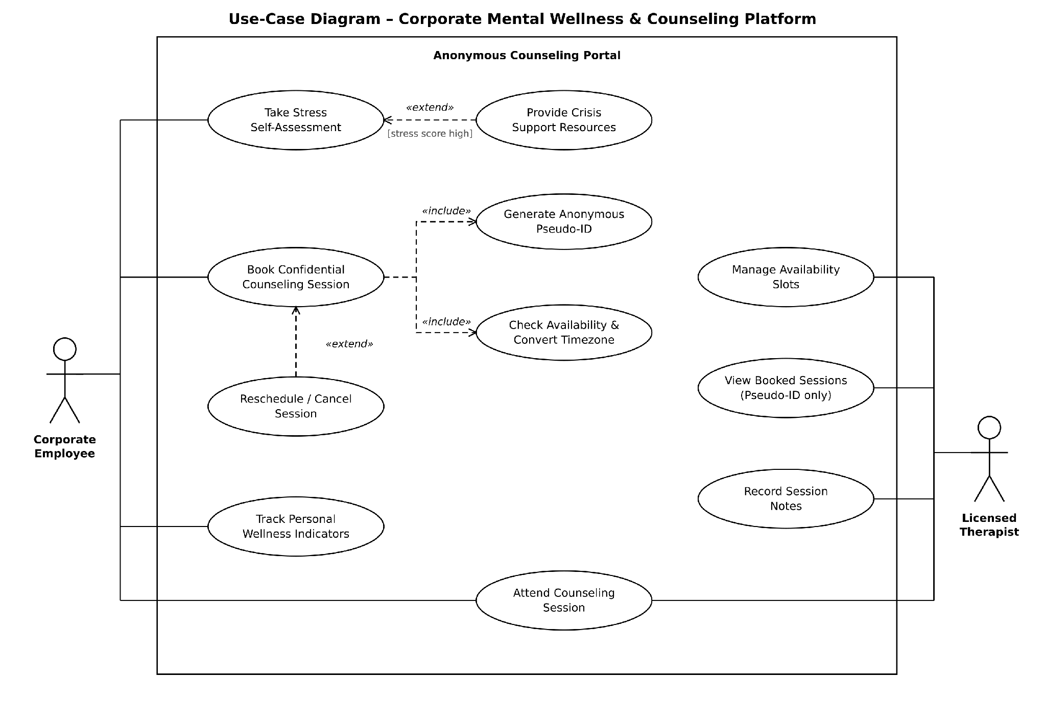

5. Use-Case Flow Specification
Book Confidential Counseling Session
Actor: Corporate Employee (primary), with Licensed Therapist as secondary actor who sees the pseudo-ID only. Generate Anonymous Pseudo-ID and Check Availability & Convert Timezone are included as part of the flow.
Preconditions
• The employee is logged in through corporate single sign-on and has an account with a generated pseudo-ID.
• At least one therapist has published availability.
Postconditions
• A session is booked under the pseudo-ID, the slot is marked as taken, and both dashboards show the session (therapist sees the pseudo-ID only).
• The employee has received a confirmation containing the pseudo-ID only.
Main Success Scenario
1. Employee opens the portal, selects "Book Confidential Counseling Session", and picks a therapist.
2. System retrieves the employee's pseudo-ID by running Generate Anonymous Pseudo-ID («include»).
3. System runs Check Availability & Convert Timezone («include») and lists the therapist's open slots in the employee's local time.
4. Employee selects a preferred slot.
5. System confirms the slot is still available.
6. System reserves the slot, creates the booking under the pseudo-ID, and marks the slot as taken.
7. System shows the confirmation and sends a notification carrying the pseudo-ID only.
8. Therapist's dashboard shows the new session under the pseudo-ID.
Alternate Flow — No Suitable Slot Available
5a. At step 5, the chosen slot has been taken or no suitable slot is available.
5a.1. System shows "No Slot Available" and offers to add the employee to a waitlist.
5a.2. Employee accepts, and the system adds them to the waitlist under the pseudo-ID only.
5a.3. When the therapist opens or releases a slot, the system notifies the employee through the pseudo-ID; the employee confirms and the booking is made as in steps 6–8.
5a.4. If the employee declines the waitlist, the use case ends without a booking.

