WEEK 3 REPORT
Advanced Data Analysis and Visualization in Logistics

1. Introduction and Objectives
1.1 Introduction to Logistics Data Analysis
- Logistics plays an important role in the transportation and delivery of goods from one location to another. Efficient logistics operations help organizations deliver packages on time, control transportation costs, reduce delivery failures, and improve customer satisfaction.
- Data analysis helps logistics organizations understand delivery performance by examining factors such as delivery time, distance, transportation cost, vehicle type, weather conditions, delivery mode, region, and delivery partner. Python-based exploratory data analysis and visualization make it easier to identify patterns, compare performance, and discover areas that require improvement.
- This project, titled Delivery Performance Analysis, uses the Delivery Logistics Dataset (India – Multi-Partner) to examine delivery outcomes, delivery durations, transportation costs, and relationships between logistics variables. Statistical summaries, comparative analysis, and visualizations are used to identify meaningful patterns and support data-driven operational decisions.
1.2 Problem Statement
- Logistics operations may experience delayed deliveries, unsuccessful deliveries, variations in transportation costs, and differences in performance across weather conditions, regions, delivery modes, vehicle types, and delivery partners.
- Without systematic analysis, it can be difficult to identify which areas require further investigation. Therefore, this project analyses delivery records to understand delivery performance, examine factors associated with delays and failures, and identify relationships between delivery time, distance, cost, and customer ratings.
1.3 Objectives of the Analysis
The main objectives of this project are:
- To explore the logistics dataset and understand its structure and important variables.
- To calculate descriptive statistics, including mean, median, standard deviation, minimum, and maximum values.
- To analyze delivery outcomes, including delivered, delayed, and failed shipments.
- To create visualizations that explain delivery status, delivery time distribution, distance and delivery time relationships, transportation costs, and weather-related delays.
- To examine correlations among numerical logistics variables.
- To compare delivery performance across weather conditions, regions, vehicle types, delivery modes, and delivery partners.
- To identify important patterns and provide practical recommendations for improving logistics operations.
1.4 Scope of the Analysis
- The analysis uses 25,000 delivery records from the selected logistics dataset. The cleaned dataset contains 16 columns, including the added unique record identifier.
- The study focuses on exploratory data analysis, descriptive statistics, delivery performance metrics, comparative analysis, correlation analysis, and six visualizations created using Python. The findings are based on the available dataset and are intended to identify patterns for further investigation. They do not independently establish that a particular factor causes delivery delays, failures, or increased costs.

2. Dataset Description
2.1 Dataset Overview
- The dataset used for this project is the Delivery Logistics Dataset (India – Multi-Partner). It contains delivery-related information that can be used to study delivery performance, transportation costs, delivery durations, and factors associated with delays and failed deliveries.
- The dataset includes information about delivery partners, package types, vehicle types, delivery modes, regions, weather conditions, delivery distances, package weights, expected delivery times, actual delivery times, delivery status, customer ratings, and delivery costs.
- This dataset provides a basis for exploratory data analysis, statistical calculations, comparative analysis, and visualization of logistics performance.
2.2 Dataset Source
The dataset was obtained from Kaggle.
Dataset Name: Delivery Logistics Dataset (India – Multi-Partner)
Source: Kaggle
Dataset Link: https://www.kaggle.com/datasets/kundanbedmutha/delivery-logistics-dataset-india-multi-partner
The dataset is used for educational and analytical purposes in this project.
2.3 Dataset Structure and Dimensions
- The original dataset contains 25,000 records and 15 columns. During data preparation, a unique record_id column was added to distinguish individual records because the original delivery_id column contains repeated values.
- Therefore, the cleaned dataset used for analysis contains 25,000 records and 16 columns.
- The dataset includes categorical variables, such as weather condition and delivery status, as well as numerical variables, such as distance, delivery time, package weight, and delivery cost. These variables support the analysis of delivery performance and operational patterns.

2.4 Description of Important Variables
The following table describes the main variables used in the analysis.
Variable | Description
record_id | Unique identifier added during data preparation for counting individual records.
delivery_id | Original delivery identifier; repeated values were observed.
delivery_partner | Name of the delivery service provider.
package_type | Category of the package being delivered.
vehicle_type | Type of vehicle used for delivery.
delivery_mode | Delivery service category, such as standard, express, same day, or two day.
region | Geographical region associated with the delivery.
weather_condition | Weather condition recorded for the delivery.
distance_km | Delivery distance in kilometres.
package_weight_kg | Package weight in kilograms.
delivery_time_hours | Recorded delivery duration in hours after data preparation.
expected_time_hours | Expected delivery duration in hours after data preparation.
delayed | Indicator specifying whether a delivery was marked as delayed.
delivery_status | Recorded outcome: Delivered, Delayed, or Failed.
delivery_rating | Rating associated with the delivery.
delivery_cost | Recorded cost associated with the delivery.
2.5 Key Logistics Performance Indicators (KPIs)
Key Performance Indicators (KPIs) are measurable values used to assess logistics performance. The following indicators were calculated or examined in this project:
- Successful Delivery Rate: Percentage of records marked as Delivered.
- Delayed Status Rate: Percentage of records marked as Delayed.
- Failed Delivery Rate: Percentage of records marked as Failed.
- On-Time Delivery Rate: Percentage of records where recorded delivery time was less than or equal to expected delivery time.
- Time-Based Late Delivery Rate: Percentage of records where recorded delivery time exceeded expected delivery time.
- Average Delivery Time: Mean recorded delivery duration in hours.
- Average Delivery Cost: Mean recorded delivery cost.
- Delivery Rating: Used to examine the relationship between delivery performance and recorded ratings.
The status-based delay rate and the time-based late delivery rate measure different things. A delivery marked as Delayed is classified using its recorded status, whereas a time-based late delivery is identified by comparing actual and expected delivery durations. Both measures are included to provide a more complete understanding of delivery performance.

3. Methodology and Tools Used
3.1 Analysis Workflow
The project followed a structured data analysis workflow to examine logistics delivery performance. The workflow consisted of dataset inspection, data preparation, exploratory data analysis, statistical calculations, visualization, comparative analysis, interpretation, and recommendation development.
The main stages were:
- Dataset Inspection: Examining the dataset dimensions, column names, data types, and initial records.
- Data Preparation: Checking for missing values and duplicate rows, correcting data types, handling repeated delivery identifiers, and examining potential outliers.
- Exploratory Data Analysis: Calculating descriptive statistics and examining important logistics performance indicators.
- Visualization: Creating six charts to understand delivery outcomes, delivery time distributions, relationships, transportation costs, weather-related delays, and correlations.
- Comparative Analysis: Comparing delivery performance across weather conditions, regions, vehicle types, delivery modes, and delivery partners.
- Interpretation and Recommendations: Summarizing findings and identifying areas for further operational investigation.
3.2 Tools and Technologies Used
The following tools were used to conduct the analysis:
- Python: Used to perform data processing, statistical calculations, and analysis.
- Jupyter Notebook: Used to organize and execute Python code, display analytical outputs, and generate visualizations.
- Pandas: Used to load, inspect, clean, group, and summarize the dataset.
- NumPy: Used for numerical operations and data analysis.
- Matplotlib: Used to create charts, including bar charts, histograms, scatter plots, and the correlation heatmap.
- Seaborn: Used to create the delivery status count plot and support statistical visualization.

3.3 Python Libraries Used
The required libraries were imported into the notebook as follows:

import pandas as pd
import numpy as np
import matplotlib.pyplot as plt
import seaborn as sns

- Pandas was used for data manipulation and descriptive statistics. NumPy supported numerical operations. Matplotlib was used to customize and display the charts, while Seaborn was used for the delivery status distribution chart.
3.4 Data Preparation for Analysis
- Before conducting the analysis, the dataset was inspected to understand its structure and quality. The original dataset contained 25,000 records and 15 columns. A unique record_id column was added because the original delivery_id column contained repeated values.
- The data preparation process also included checking missing values and complete duplicate rows, correcting the delivery time and expected time columns to numerical values, and examining numerical variables for potential outliers.
- No missing values or complete duplicate rows were found in the dataset during the earlier cleaning process. A small number of high delivery-time observations were identified during outlier analysis. These values were retained because they could represent plausible delivery durations.
- The cleaned dataset was used for the subsequent statistical analysis and visualizations. The original units were retained for interpreting delivery times, distances, weights, ratings, and costs.
3.5 Analytical Approach
- The project used exploratory and descriptive analytical methods rather than relying solely on predictive modelling.
- Descriptive statistics were calculated to summarize numerical variables. Delivery performance indicators were calculated using delivery status and comparisons between actual and expected delivery times. Group-based analysis was used to compare results across different logistics categories.
- Six visualizations were created to explore distributions, compare categories, examine relationships between variables, and summarize correlation coefficients. The results were interpreted using actual numerical outputs from the notebook.
- This approach helped identify patterns in the dataset and develop practical recommendations. Since the analysis is based on observed data, the findings describe associations and patterns rather than proving that a particular factor directly causes a delivery outcome.

4. Exploratory Data Analysis (EDA)
4.1 Dataset Inspection
- Exploratory Data Analysis (EDA) was performed to understand the structure, characteristics, and performance patterns in the logistics dataset. The dataset was examined using Pandas to inspect its dimensions, column names, data types, sample records, and missing values.
- The cleaned dataset contained 25,000 records and 16 columns, including the additional record_id column. The variables included delivery status, delivery time, expected delivery time, distance, package weight, weather condition, vehicle type, delivery mode, delivery partner, customer rating, and delivery cost.
- This initial inspection helped confirm that the dataset was ready for statistical analysis and visualization.
4.2 Data Quality Verification
- Data quality was checked before calculating the analytical metrics. The following results were obtained during the data preparation stage:
Data Quality Check | Result
Total records | 25,000
Total columns in the cleaned dataset | 16
Missing values | 0
Complete duplicate rows | 0
Unique values in record_id | 25,000
- The original delivery_id column contained repeated values. Therefore, a separate record_id column was added to uniquely identify each record and support accurate record counting.
- The delivery_time_hours and expected_time_hours columns were converted to numerical values during data preparation. Outlier analysis identified 203 delivery-time observations between 15 and 19 hours. These observations were retained because they could represent plausible delivery durations.
- These checks helped establish a consistent dataset for the subsequent analysis.
4.3 Descriptive Statistics
- Descriptive statistics were calculated to summarize the numerical variables. The mean, median, minimum, and maximum values were examined to understand the distribution and range of delivery measurements.
The following table presents selected results obtained from the notebook:
Variable | Mean | Median | Minimum | Maximum
Delivery Time (hours) | 6.25 | 6.00 | 0 | 19
Expected Time (hours) | 13.11 | 8.00 | 2 | 24
Distance (km) | 150.39 | 151.00 | 3.60 | 297.10
Delivery Cost | 864.94 | 867.54 | 95.67 | 1,632.72
- The results show that the average recorded delivery time was 6.25 hours, while the median was 6 hours. The average delivery distance was 150.39 km, with distances ranging from 3.6 km to 297.1 km. The average delivery cost was 864.94 in the dataset's recorded cost units.
- The expected delivery time had a mean of 13.11 hours and a median of 8 hours. The difference between these values indicates that the distribution of expected delivery times may be influenced by higher values.
- These statistics provide an overview of delivery durations, distances, and costs before examining relationships between variables.
4.4 Measures of Central Tendency
- Measures of central tendency help describe the typical value of a numerical variable. The mean and median were used to summarize important logistics measurements.
Mean: The mean is calculated by dividing the sum of all observations by the number of observations.
Mean = Sum of all observations / Number of observations
- For delivery time, the mean was 6.25 hours. This represents the average recorded delivery duration across the 25,000 records.
Median: The median is the middle value when observations are arranged in ascending order. The median delivery time was 6 hours, meaning that the middle observation in the ordered dataset was 6 hours.
- The mean and median delivery times were relatively close. However, both measures should be considered alongside the full distribution because averages alone do not describe every delivery.
- For distance, the mean was 150.39 km and the median was 151 km. For delivery cost, the mean was 864.94 and the median was 867.54. These values help summarize typical distances and costs within the dataset.
4.5 Delivery Performance KPI Calculations
- Key Performance Indicators (KPIs) were calculated to understand delivery outcomes and timeliness. Each percentage was calculated by dividing the relevant record count by the total number of records and multiplying by 100.
Formula:
Percentage = (Relevant record count / Total records) × 100
The following results were obtained:

KPI | Count | Percentage
Successful Delivery Rate | 18,331 | 73.32%
Delayed Status Rate | 5,341 | 21.36%
Failed Delivery Rate | 1,328 | 5.31%
On-Time Delivery Rate | 19,534 | 78.14%
Time-Based Late Delivery Rate | 5,466 | 21.86%
- The successful delivery rate was calculated using records marked as Delivered. The delayed status rate and failed delivery rate were calculated using records marked as Delayed and Failed, respectively.
- The on-time delivery rate was calculated by comparing recorded delivery time with expected delivery time. A record was classified as on time when its delivery time was less than or equal to its expected time. The time-based late delivery rate represents records where delivery time exceeded expected time.
4.6 Numerical Examples and Metric Interpretation
- The KPI calculations can be demonstrated using the actual dataset results.
Example 1: Successful Delivery Rate
Number of records marked as Delivered = 18,331
Total records = 25,000
Successful Delivery Rate = (18,331 / 25,000) × 100
Successful Delivery Rate = 73.324%, or approximately 73.32%.
This means that 73.32% of the records were marked as successfully delivered.
Example 2: Failed Delivery Rate
Number of records marked as Failed = 1,328
Failed Delivery Rate = (1,328 / 25,000) × 100
Failed Delivery Rate = 5.312%, or approximately 5.31%.
This indicates that 5.31% of the records were marked as failed deliveries.
Example 3: On-Time Delivery Rate
Number of records where delivery time was less than or equal to expected time = 19,534
On-Time Delivery Rate = (19,534 / 25,000) × 100
On-Time Delivery Rate = 78.136%, or approximately 78.14%.
- This shows that 78.14% of the records met the expected delivery duration according to the time-based comparison.
- The status-based delayed delivery rate was 21.36%, while the time-based late delivery rate was 21.86%. These percentages differ because delivery status and the comparison of actual and expected delivery times are separate measures.
- Overall, the EDA results provide a quantitative foundation for the visualizations and comparative analysis in the following sections. They highlight delivery outcomes, typical delivery durations, transportation distances, costs, and timeliness patterns that can be investigated further.

5. Data Visualization and Interpretation
- Data visualization was used to understand delivery performance, identify patterns, compare logistics categories, and examine relationships between numerical variables. Six visualizations were created using Matplotlib and Seaborn. Each chart provides a different perspective on the delivery dataset and supports the interpretation of the analytical results.
5.1 Delivery Status Distribution
Figure 1: Delivery Status Distribution
Objective: To compare the number of records marked as Delivered, Delayed, and Failed.
Python Code:
plt.figure(figsize=(8, 5))
sns.countplot(data=data, x="delivery_status")
plt.title("Delivery Status Distribution")
plt.xlabel("Delivery Status")
plt.ylabel("Number of Deliveries")
plt.tight_layout()
plt.show()
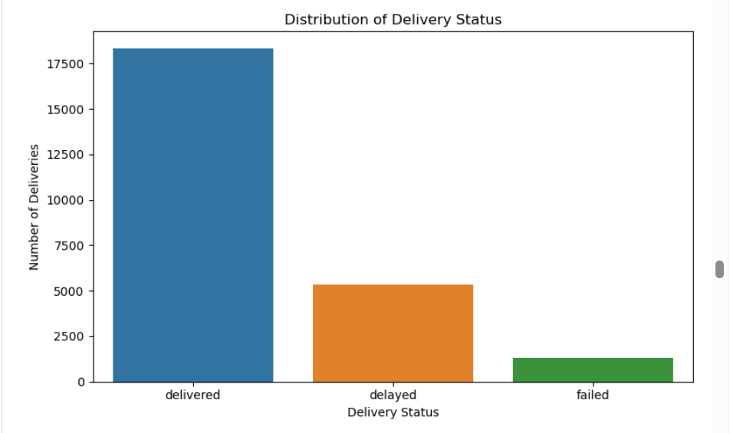
Figure 5.1: Delivery Status Distribution
Results and Interpretation:
- The dataset contains 18,331 records marked as Delivered, 5,341 marked as Delayed, and 1,328 marked as Failed. These represent approximately 73.32%, 21.36%, and 5.31% of the total records, respectively.
- The bar chart shows that the Delivered category has the highest count, while the Failed category has the lowest count. However, 5,341 records were marked as Delayed, indicating that delays are an important area for further investigation.
Logistics Insight: The chart helps compare delivery outcomes and identify the proportion of records that did not achieve the Delivered status. Investigating delayed and failed deliveries may help identify opportunities to improve operational performance.
5.2 Distribution of Delivery Times
Figure 2: Distribution of Delivery Times
Objective: To examine the frequency distribution of recorded delivery durations and identify common delivery times.
Python Code:
delivery_times = pd.to_numeric(
data["delivery_time_hours"],
errors="coerce"
).dropna()

plt.figure(figsize=(8, 5))
plt.hist(
delivery_times,
bins=20,
edgecolor="black"
)
plt.title("Distribution of Delivery Times")
plt.xlabel("Delivery Time (Hours)")
plt.ylabel("Frequency")
plt.tight_layout()
plt.show()

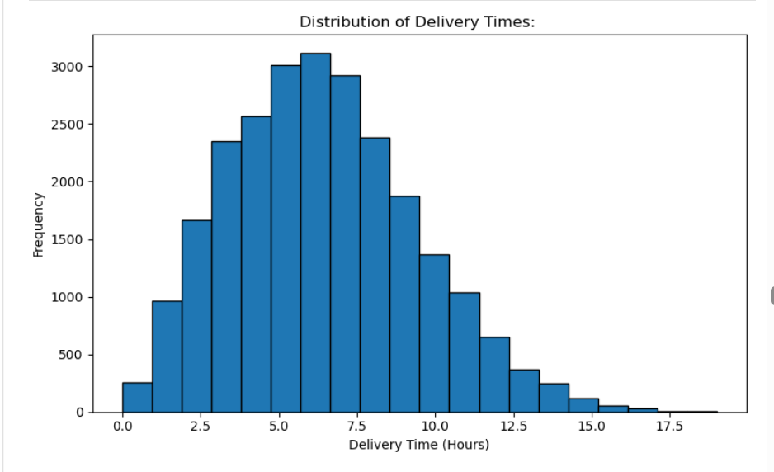
Figure 5.2: Distribution of Delivery Times
Results and Interpretation:
- The average recorded delivery time was 6.25 hours, while the median was 6 hours. The observed values ranged from 0 to 19 hours. The histogram shows that delivery durations are concentrated around the middle of the observed range, with many deliveries taking approximately 4–8 hours. A smaller number of observations extend towards longer delivery durations.
- The histogram helps show the spread of delivery times and makes it easier to identify common durations and less frequent longer deliveries.
Logistics Insight: Understanding the distribution of delivery durations can support delivery scheduling and help identify longer-duration deliveries for further examination. The observed pattern should be considered alongside expected delivery times and delivery status.
5.3 Distance vs Delivery Time
Figure 3: Distance vs Delivery Time Scatter Plot
Objective: To examine the relationship between delivery distance and recorded delivery time.
Python Code:
plt.figure(figsize=(8, 5))
plt.scatter(
data["distance_km"],
data["delivery_time_hours"],
alpha=0.4
)
plt.title("Distance vs Delivery Time")
plt.xlabel("Distance (km)")
plt.ylabel("Delivery Time (Hours)")
plt.tight_layout()
plt.show()

correlation = data[
["distance_km", "delivery_time_hours"]
].corr().iloc[0, 1]

print("Correlation coefficient:", round(correlation, 3))
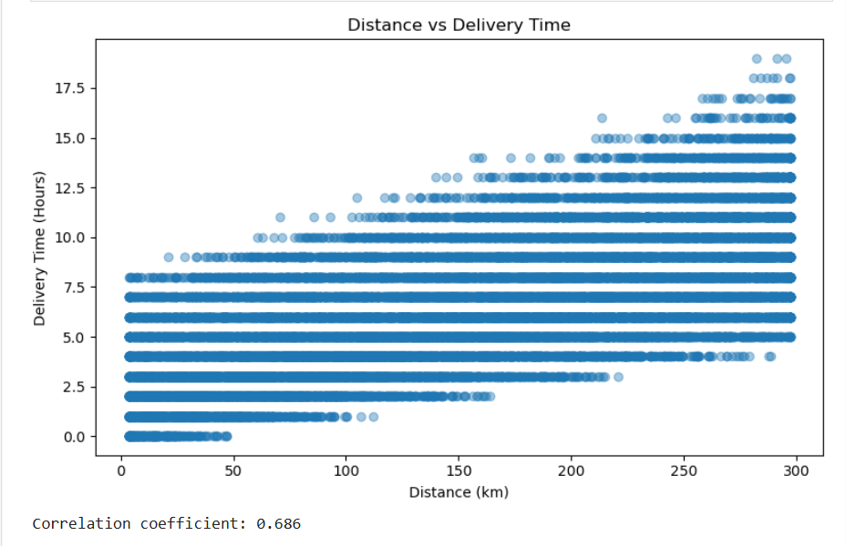
Figure 5.3: Distance vs Delivery Time
Results and Interpretation:
- The correlation coefficient between distance and delivery time was approximately 0.69. This indicates a positive relationship between the two variables: longer delivery distances tend to be associated with longer delivery durations in the dataset.
- The scatter plot displays individual records and allows the overall relationship and variation in delivery times at different distances to be examined.
Logistics Insight: Distance is an important variable to investigate when reviewing delivery schedules and route planning. However, the correlation does not establish that distance alone causes longer delivery times. Other factors, such as traffic, weather, delivery mode, and operational processes, may also be relevant.
5.4 Average Delivery Cost by Vehicle Type
Figure 4: Average Delivery Cost by Vehicle Type
Objective: To compare the average recorded delivery cost across vehicle categories.
Python Code:
vehicle_cost = (
data.groupby("vehicle_type")["delivery_cost"]
.mean()
.sort_values(ascending=False)
)

plt.figure(figsize=(9, 5))
plt.bar(
vehicle_cost.index,
vehicle_cost.values,
edgecolor="black"
)
plt.title("Average Delivery Cost by Vehicle Type")
plt.xlabel("Vehicle Type")
plt.ylabel("Average Delivery Cost")
plt.xticks(rotation=30)
plt.tight_layout()
plt.show()
print (vehicle_cost.round(2))

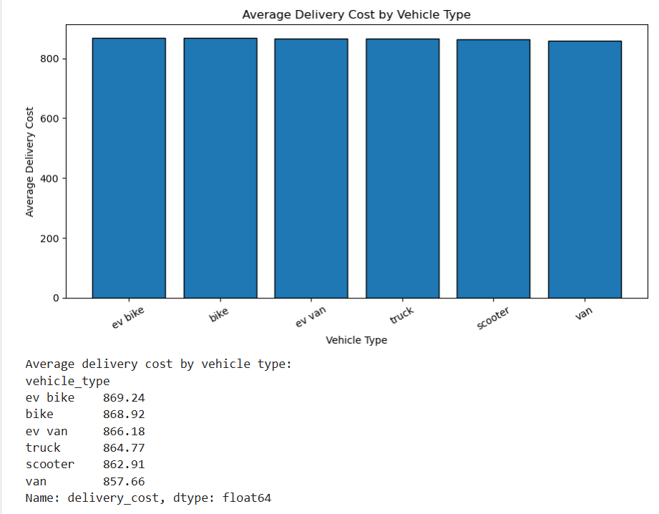
Figure 5.4: Average Delivery Cost by Vehicle Type
Results and Interpretation:
- The comparison showed that EV bikes had the highest average recorded delivery cost at 869.24, while vans had the lowest average recorded delivery cost at 857.66.
- The bar chart makes differences in average costs across vehicle categories easier to compare. The difference between the highest and lowest averages was 11.58 cost units.
Logistics Insight: Comparing average costs by vehicle type can help identify categories for further cost investigation. However, these averages alone do not establish which vehicle type is the most economical overall. Delivery distance, package characteristics, delivery volume, and other operating conditions should also be considered.
5.5 Delay Rate by Weather Condition
Figure 5: Time-Based Delay Rate by Weather Condition
Objective: To compare the percentage of deliveries whose recorded delivery times exceeded their expected delivery times under different weather conditions.
Python Code:
weather_delay = (
data.groupby("weather_condition")["late_by_time"]
.mean()
.mul(100)
.sort_values(ascending=False)
)

plt.figure(figsize=(9, 5))
plt.bar(
weather_delay.index,
weather_delay.values,
edgecolor="black"
)
plt.title("Time-Based Delay Rate by Weather Condition")
plt.xlabel("Weather Condition")
plt.ylabel("Delay Rate (%)")
plt.xticks(rotation=30)
plt.tight_layout()
plt.show()

print (weather_delay.round(2))
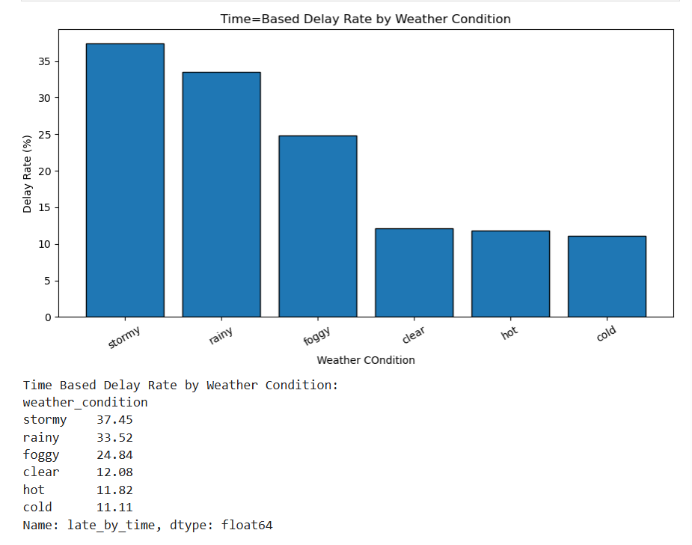
Figure 5.5: Time-Based Delay Rate by Weather Condition
Results and Interpretation:
The time-based delay rates were as follows:
Weather Condition | Delay Rate
Stormy | 37.45%
Rainy | 33.52%
Foggy | 24.84%
Clear | 12.08%
Hot | 11.82%
Cold | 11.11%
- Stormy weather had the highest observed time-based delay rate at 37.45%, followed by rainy weather at 33.52%. Cold weather had the lowest observed rate at 11.11%.
- The bar chart highlights differences in delay rates across weather categories. These results suggest that deliveries recorded under stormy and rainy conditions deserve closer investigation.
Logistics Insight: Logistics teams could investigate weather-related delays and review whether delivery schedules, route planning, and contingency arrangements need improvement during adverse conditions. The observed differences do not, by themselves, prove that weather caused the delays.
5.6 Correlation Heatmap of Logistics Variables
Figure 6: Correlation Heatmap of Logistics Variables
Objective: To summarize the relationships between selected numerical logistics variables using correlation coefficients.
Python Code:
corr_cols = [
"distance_km",
"package_weight_kg",
"delivery_time_hours",
"expected_time_hours",
"delivery_rating",
"delivery_cost"
]

correlation_matrix = data[corr_cols].corr()

plt.figure(figsize=(9, 7))
plt.imshow(
correlation_matrix,
cmap="coolwarm",
vmin=-1,
vmax=1
)
plt.colorbar(label="Correlation Coefficient")

plt.xticks(
range(len(corr_cols)),
corr_cols,
rotation=45,
ha="right"
)
plt.yticks(range(len(corr_cols)), corr_cols)

for i in range(len(corr_cols)):
for j in range(len(corr_cols)):
plt.text(
j, i,
f"{correlation_matrix.iloc[i, j]:.2f}",
ha="center",
va="center"
)

plt.title("Correlation Heatmap of Logistics Variables")
plt.tight_layout()
plt.show()

display(correlation_matrix.round(2))
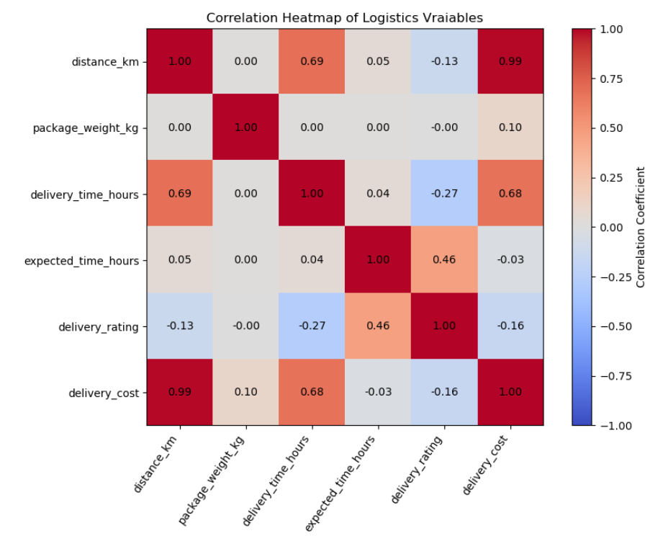

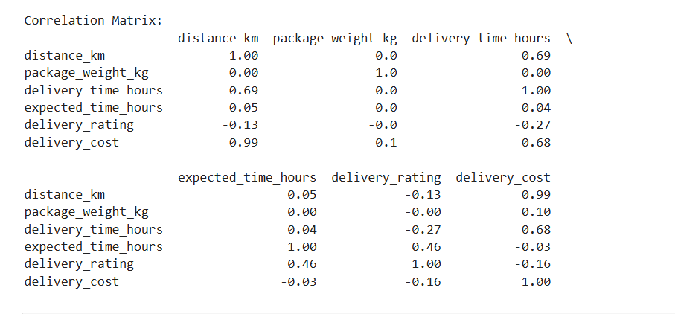
Figure 5.6: Correlation Heatmap
Results and Interpretation:
- The heatmap summarizes the relationships between six numerical variables. The main observed relationships include:
Variable Pair | Correlation | Interpretation
Distance and delivery cost | 0.99 | Very strong positive relationship
Distance and delivery time | 0.69 | Positive relationship
Delivery time and delivery cost | 0.68 | Positive relationship
Expected time and delivery rating | 0.46 | Moderate positive relationship
Delivery time and delivery rating | -0.27 | Negative relationship
- Distance and delivery cost showed a very strong positive correlation of approximately 0.99. This indicates that the two variables move together very closely in this dataset. The relationship is unusually strong, so the underlying cost calculation or data-generation process should be examined before drawing operational conclusions.
- Distance and delivery time had a positive correlation of 0.69, while delivery time and delivery cost had a positive correlation of 0.68. Delivery time and delivery rating had a negative correlation of -0.27, indicating a tendency for longer delivery durations to be associated with lower ratings.
Logistics Insight: The heatmap helps identify relationships that may deserve further investigation, including the relationship between distance and cost and the association between delivery duration and ratings. Correlation measures association, not causation, and the results should be interpreted in the context of the dataset.
5.7 Overall Interpretation of the Visualizations
- The six visualizations provide complementary views of logistics delivery performance. The delivery status chart summarizes delivery outcomes, while the histogram explains the distribution of delivery durations. The scatter plot examines the relationship between distance and delivery time, and the vehicle cost chart compares average costs across vehicle categories.
- The weather delay chart identifies differences in time-based delay rates across weather conditions. Finally, the correlation heatmap summarizes relationships between numerical variables and highlights areas for further investigation.
- Together, these visualizations help convert the dataset into interpretable findings. They support the identification of possible operational improvement areas, while further analysis is needed to determine the causes of the observed patterns.
6. Comparative Analysis
- Comparative analysis was performed to examine differences in delivery performance across weather conditions, regions, vehicle types, delivery modes, and delivery partners. The analysis considered delivery counts, average delivery time, average delivery cost, time-based delay rates, and failed delivery counts.
- These comparisons help identify categories that may require further investigation and support data-driven logistics decisions.

6.1 Delivery Performance by Weather Condition
- Weather conditions were compared using the time-based delay rate. This metric represents the percentage of records for which the recorded delivery time exceeded the expected delivery time.
- The results showed that stormy weather had the highest time-based delay rate at 37.45%, followed by rainy weather at 33.52% and foggy weather at 24.84%. Clear, hot, and cold conditions had lower observed delay rates of 12.08%, 11.82%, and 11.11%, respectively.
- Interpretation: Deliveries recorded under stormy and rainy conditions had higher observed delay rates than deliveries under other weather conditions. Logistics teams could investigate these records to determine whether weather-related operating conditions, route choices, or scheduling practices require improvement.
6.2 Delivery Performance by Region
- Delivery performance was compared across the geographical regions represented in the dataset. The analysis examined the total number of deliveries, average delivery time, average delivery cost, time-based delay rate, and failed delivery count.
- The central region had the highest time-based delay rate among the regions, at 22.75%.
- Interpretation: The central region may be a useful starting point for a more detailed investigation of delivery delays. Additional analysis of delivery distances, weather conditions, delivery modes, and partner performance would help determine whether particular operational patterns are associated with the higher delay rate.
6.3 Delivery Performance by Vehicle Type
- Vehicle categories were compared using average delivery cost, average delivery time, time-based delay rate, and failed delivery counts.
- The average recorded delivery cost was highest for EV bikes at 869.24 and lowest for vans at 857.66. The difference between these averages was 11.58 cost units.
- Interpretation: The comparison highlights differences in average recorded costs between vehicle categories. These results can guide further cost analysis, but they do not establish that one vehicle type is more efficient overall. A fair comparison should also consider delivery distance, package weight, delivery volume, and operating conditions.
6.4 Delivery Performance by Delivery Mode
- Delivery modes were compared using the time-based delay rate and other delivery performance measures.
- The observed time-based delay rates were:
Delivery Mode | Time-Based Delay Rate
Express | 64.67%
Same day | 22.68%
Two day | 0.17%
Standard | 0.00%
- Express delivery had the highest observed time-based delay rate at 64.67%, followed by same-day delivery at 22.68%.
- Interpretation: The high observed delay rate for express deliveries is an important finding for further investigation. The delivery records should be examined to understand whether the express category includes different distances, stricter expected delivery durations, or other operating conditions that could explain the observed pattern. The results alone do not prove the cause of the delays.
6.5 Delivery Performance by Delivery Partner
- Delivery partners were compared using average delivery cost, delivery time, time-based delay rate, and failed delivery counts.
- DHL had the highest average recorded delivery cost among the delivery partners, at 872.83. Xpressbees had the highest number of failed deliveries, with 167 records.
- Interpretation: These findings identify two different areas for investigation. DHL's average cost could be examined alongside distance and package characteristics, while Xpressbees' failed deliveries could be reviewed to understand the recorded reasons for unsuccessful deliveries. The figures alone do not establish that either partner performs poorly overall because total delivery volumes and other operating conditions also matter.
6.6 Comparison of Delay Rates, Delivery Costs, and Failed Deliveries
- The comparative analysis identified several notable patterns:
- Weather: Stormy weather had the highest time-based delay rate at 37.45%.
- Region: The central region had the highest regional time-based delay rate at 22.75%.
- Vehicle type: EV bikes had the highest average delivery cost at 869.24, while vans had the lowest at 857.66.
- Delivery mode: Express deliveries had the highest time-based delay rate at 64.67%.
- Delivery partner: DHL had the highest average delivery cost at 872.83, while Xpressbees recorded 167 failed deliveries, the highest failure count among the partners.
- These results highlight areas for more detailed analysis of delivery scheduling, operational conditions, transportation costs, and unsuccessful deliveries. Delay rates, average costs, and failure counts measure different aspects of performance and should not be treated as interchangeable indicators.
- Overall, comparative analysis provides a clearer understanding of how delivery performance varies across logistics categories. Further investigation is required to establish the reasons behind the observed differences and determine which operational changes would be most effective.

7. Key Findings
- The exploratory data analysis, visualizations, and comparative analysis revealed several important patterns in the logistics dataset. The key findings are summarized below.
7.1 Delivery Outcome Findings
- Out of 25,000 delivery records, 18,331 were marked as Delivered (73.32%), 5,341 as Delayed (21.36%), and 1,328 as Failed (5.31%).
- Finding: Most records were marked as delivered, but delayed and failed delivery records represent important areas for further investigation.
7.2 Delivery Time Findings
- The average recorded delivery time was 6.25 hours, while the median was 6 hours. Recorded delivery times ranged from 0 to 19 hours.
- Finding: The distribution of delivery durations provides a baseline for understanding typical delivery times and identifying longer-duration observations for further review.
7.3 Distance and Delivery Time Relationship
- Distance and delivery time had a positive correlation of approximately 0.69.
Finding: Longer delivery distances tended to be associated with longer recorded delivery durations. This relationship may help guide further investigation into route planning and delivery scheduling.
7.4 Transportation Cost Findings
- EV bikes had the highest average recorded delivery cost at 869.24, while vans had the lowest at 857.66. Distance and delivery cost had a very strong positive correlation of approximately 0.99.

Finding: Average costs varied across vehicle categories, and distance was strongly associated with recorded delivery cost. The unusually strong correlation should be investigated to understand how the cost values were generated or calculated.
7.5 Weather-Related Delay Findings
- Stormy weather had the highest time-based delay rate at 37.45%, followed by rainy weather at 33.52% and foggy weather at 24.84%.
Finding: Weather categories showed noticeable differences in observed delay rates. Stormy and rainy conditions are useful starting points for further investigation of delivery delays.
7.6 Regional and Delivery Mode Findings
- The central region had the highest time-based delay rate among regions at 22.75%. Express deliveries had the highest time-based delay rate among delivery modes at 64.67%.
Finding: The central region and express delivery category merit closer examination to identify operational patterns that may be associated with late deliveries.

7.7 Delivery Partner Findings
- DHL had the highest average recorded delivery cost among the delivery partners at 872.83. Xpressbees recorded 167 failed deliveries, the highest failure count among the partners.
- Finding: These results identify areas for further cost and failure analysis. Total delivery volumes, delivery distances, and other operating conditions should be considered before comparing overall partner performance.
7.8 Summary of Important Numerical Results
Metric | Observed Result
Total delivery records | 25,000
Successful delivery rate | 73.32%
Delayed status rate | 21.36%
Failed delivery rate | 5.31%
On-time delivery rate by time comparison | 78.14%
Average delivery time | 6.25 hours
Distance–delivery time correlation | 0.69
Distance–delivery cost correlation | 0.99
Highest weather-related delay rate | 37.45% (Stormy)
Highest regional delay rate | 22.75% (Central)
Highest delivery-mode delay rate | 64.67% (Express)
- These findings summarize the main numerical results of the project. They identify patterns that may help prioritize further investigation into delivery timeliness, transportation costs, regional performance, and unsuccessful deliveries.
- The findings describe relationships observed in the dataset and do not independently establish the causes of delays, failures, or cost differences.

8. Role and Justification of Visualizations
8.1 Role of Visualizations in Logistics Analysis
- Data visualization plays an important role in exploratory data analysis because it presents numerical results and relationships in an easy-to-understand visual format. Tables provide exact values, while charts help identify differences, distributions, patterns, and relationships among variables.
- In this project, six visualizations were created to examine delivery outcomes, delivery durations, transportation costs, weather-related delays, and correlations between numerical variables.
- The visualizations support logistics analysis in the following ways:
- Delivery Status Distribution: Helps compare the number of delivered, delayed, and failed records.
- Delivery Time Histogram: Shows the frequency distribution of delivery durations and helps identify common delivery times.
- Distance vs Delivery Time Scatter Plot: Helps examine the relationship between delivery distance and recorded delivery time.
- Average Delivery Cost by Vehicle Type: Helps compare average recorded costs across vehicle categories.
- Delay Rate by Weather Condition: Highlights differences in time-based delay rates across weather categories.
- Correlation Heatmap: Summarizes relationships among numerical logistics variables in a single visualization.
- Together, these visualizations make the analysis easier to interpret and help identify areas that deserve further investigation.
8.2 Justification for Each Visualization Method
8.2.1 Delivery Status Bar Chart
- A bar chart was selected because delivery status is a categorical variable. It allows the counts of Delivered, Delayed, and Failed records to be compared clearly.
- The chart shows that 18,331 records were marked as Delivered, 5,341 as Delayed, and 1,328 as Failed. This makes differences in delivery outcomes easy to identify.
8.2.2 Delivery Time Histogram
- A histogram was selected because delivery time is a numerical variable. It groups delivery durations into intervals and displays the frequency of observations in each interval.
- This visualization helps reveal common delivery durations, the spread of delivery times, and the presence of less frequent longer-duration observations.
8.2.3 Distance vs Delivery Time Scatter Plot
- A scatter plot was selected because both distance and delivery time are numerical variables. Each point represents a record, allowing the relationship between the two variables to be examined.
- The observed correlation of approximately 0.69 indicates a positive relationship between distance and delivery time. The scatter plot helps visualize this relationship and the variation among individual observations.
8.2.4 Average Delivery Cost by Vehicle Type Bar Chart
- A bar chart was selected because vehicle type is categorical and average delivery cost is numerical. Each bar represents the mean recorded cost for a vehicle category.
- The visualization makes it easier to compare average costs and identify vehicle categories for further cost investigation.

8.2.5 Delay Rate by Weather Condition Bar Chart
- A bar chart was selected to compare calculated delay percentages across weather categories. Displaying the values as percentages makes differences in observed delay rates easier to interpret.
- The chart shows that stormy weather had the highest time-based delay rate at 37.45%, followed by rainy weather at 33.52%.
8.2.6 Correlation Heatmap
- A correlation heatmap was selected because it can display the correlation coefficients between several numerical variables in a single figure. The colors and numerical annotations help distinguish stronger positive and negative relationships.
- The heatmap highlights the strong positive relationship between distance and delivery cost (approximately 0.99), the positive relationship between distance and delivery time (approximately 0.69), and the negative relationship between delivery time and delivery rating (-0.27).
8.3 How Visualizations Support Data-Driven Decisions
- The visualizations support data-driven decision-making by highlighting patterns that can guide further investigation.
- Delivery outcome charts help prioritize the analysis of delayed and failed records.
- Delivery time distributions help organizations understand typical delivery durations and examine longer-duration observations.
- Distance and delivery time comparisons help investigate route planning and delivery scheduling.
- Vehicle cost comparisons help identify differences in recorded costs across vehicle categories.
- Weather-related delay comparisons help identify conditions associated with higher observed delay rates.
- Correlation analysis helps identify relationships that may require additional investigation, such as the relationship between distance and delivery cost.
- The visualizations provide evidence about patterns in the available dataset, but they do not independently establish causation. Additional analysis and operational context are needed before making major changes to logistics processes.

9. Analytical Recommendations
- Based on the exploratory data analysis, visualizations, and comparative analysis, several recommendations can be proposed to improve logistics operations. These recommendations are based on patterns observed in the dataset and should be validated through further investigation before operational implementation.
9.1 Weather-Based Delivery Planning
- Stormy weather had the highest time-based delay rate at 37.45%, followed by rainy weather at 33.52% and foggy weather at 24.84%.
Recommendation: Investigate deliveries recorded under stormy and rainy conditions. Review route choices, delivery schedules, and contingency arrangements to determine whether adjustments could help reduce delays during adverse weather.
9.2 Review of Express Delivery Operations
- Express deliveries had the highest time-based delay rate among delivery modes, at 64.67%.
Recommendation: Examine express delivery records to understand the reasons for the high observed delay rate. Review expected delivery durations, delivery distances, operational processes, and other relevant conditions before deciding on corrective measures.
9.3 Reduction of Failed Deliveries
- Xpressbees recorded 167 failed deliveries, the highest failure count among the delivery partners.
Recommendation: Review the failed delivery records to identify any available patterns in delivery region, package type, delivery mode, or other relevant variables. Compare failure rates as well as failure counts, taking each partner's total delivery volume into account.
9.4 Transportation Cost Analysis
- Distance and delivery cost showed a very strong positive correlation of approximately 0.99. Average recorded delivery costs also differed across vehicle categories.
Recommendation: Investigate how delivery costs relate to distance, vehicle type, package weight, and delivery mode. Because the correlation between distance and cost is unusually strong, verify the underlying cost calculation or data-generation process before drawing conclusions about real-world cost drivers.
9.5 Improving Customer Experience
- Delivery time and delivery rating had a negative correlation of approximately -0.27, indicating a tendency for longer delivery durations to be associated with lower ratings.
Recommendation: Examine records with longer delivery times alongside their delivery ratings and status. Further analysis could help determine whether late deliveries are associated with lower customer ratings and identify opportunities to improve delivery experience.

9.6 Regional Performance Investigation
- The central region had the highest time-based delay rate among the regions, at 22.75%.
Recommendation: Examine deliveries in the central region by distance, weather condition, delivery mode, and delivery partner. This may help identify specific patterns associated with the observed delay rate and determine where further operational attention is needed.
9.7 Limitations and Further Investigation
- The analysis identifies associations and patterns in the available dataset, but it does not establish the causes of delays, failures, or cost differences. Some observed relationships, particularly the correlation between distance and delivery cost, require additional validation.
- Further investigation should include:
- Comparing delivery delay and failure rates while accounting for the total number of records in each category.
- Examining whether delivery distance, weather, and delivery mode are associated with delays independently or in combination.
- Verifying the meaning and calculation of delivery cost values.
- Investigating the relationship between delivery time and customer ratings.
- Validating the findings with additional operational data before implementing changes.
- These recommendations provide a basis for further analysis and help translate the observed results into potential areas for logistics improvement.

10. Conclusion and References
10.1 Conclusion
- This project analyzed delivery performance using the Delivery Logistics Dataset (India – Multi-Partner), containing 25,000 delivery records. Exploratory data analysis, descriptive statistics, comparative analysis, and six visualizations were used to examine delivery outcomes, delivery durations, transportation costs, weather-related delays, and relationships between numerical variables.
- The analysis showed that 73.32% of records were marked as Delivered, while 21.36% were marked as Delayed and 5.31% as Failed. The time-based analysis indicated an on-time delivery rate of 78.14%. Distance and delivery time had a positive correlation of approximately 0.69, while stormy weather had the highest observed time-based delay rate at 37.45%. Express deliveries also showed a high time-based delay rate of 64.67%.
- The findings identified areas for further investigation, including weather-related delays, express delivery performance, transportation costs, regional differences, and failed deliveries. The visualizations helped present these patterns clearly and supported the development of analytical recommendations.
- Overall, this project demonstrated how Python-based data analysis and visualization can help interpret logistics performance and identify potential areas for operational improvement. Further investigation and validation would be required to determine the causes of the observed patterns and assess the effectiveness of any proposed changes.
10.2 Dataset Reference
Kaggle. Delivery Logistics Dataset (India – Multi-Partner). Available at:
https://www.kaggle.com/datasets/kundanbedmutha/delivery-logistics-dataset-india-multi-partner
10.3 Python Library References
- Pandas documentation: https://pandas.pydata.org/docs/
- NumPy documentation: https://numpy.org/doc/
- Matplotlib documentation: https://matplotlib.org/stable/
- Seaborn documentation: https://seaborn.pydata.org/
s

