SIMATS ENGINEERING
ASSESSMENT TOOL1
Name: Thanmai Reddy Regno: 192425372
COURSE CODE: MLA 0202 COURSE NAME: Fundamentals of Machine Learning

Q1.A real estate company collected the following training data:(15Marks -20 Mins)
House No Area (sq.ft) Bedrooms Price (₹ Lakhs)
1 1000 2 50
2 1500 3 75
3 800 2 40
4 1200 3 60
5 2000 4 90
(i) Construct a linear regression model of the form
(ii) Estimate the regression coefficients.
(iii) Interpret the meaning of each coefficient.
Code:
from sklearn.linear_model import LinearRegression
x=[[1000,2],[1500,3],[800,2],[1200,3],[2000,4]]
y=[50,75,40,60,90]
model=LinearRegression()
model.fit(x,y)
print(model.intercept_)
print(model.coef_)

output:
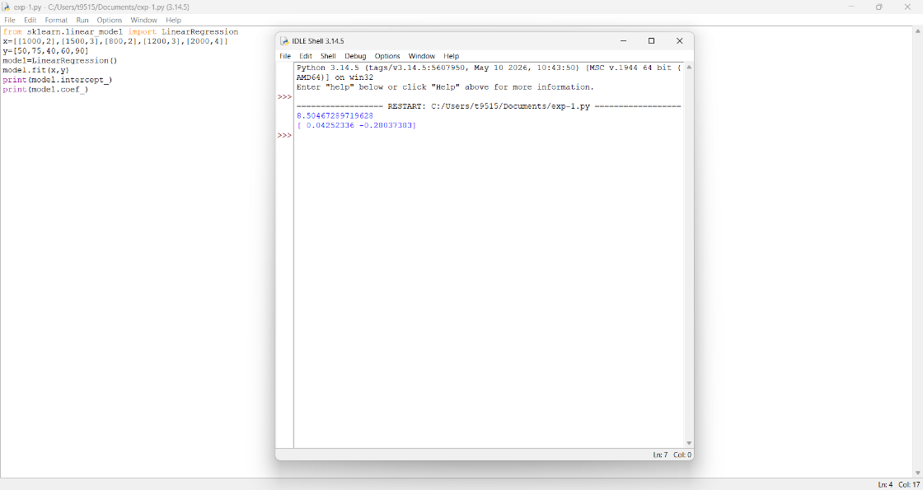

Q2.An email system uses the following feature values:(15Marks -20 Mins)
Email Word Frequency (Offer) Word Frequency (Win) Spam (1/0)
1 3 2 1
2 2 1 1
3 1 0 0
4 3 3 1
5 0 1 0
(i) Construct a linear classification model.
(ii) Determine the decision boundary.
(iii) Classify a new email with: Offer = 2, Win = 1.
Code:
from sklearn.linear_model import LogisticRegression
x=[[3,3],[2,1],[1,0],[3,3],[0,1]]
y=[1,1,0,1,0]
model=LogisticRegression()
model.fit(x,y)
print(model.intercept_)
print(model.coef_)
print(model.predict([[2,1]]))
output:
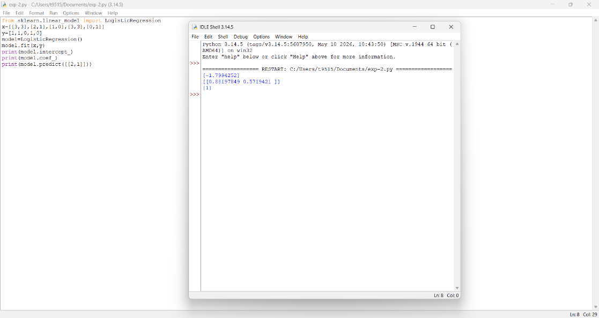

Q3.A medical dataset is given:(15Marks -20 Mins)
Patient Fever (1/0) Headache (1/0) Disease (Yes/No)
1 1 1 Yes
2 1 0 Yes
3 0 1 No
4 1 1 Yes
5 0 0 No
(i) Compute prior probabilities.
(ii) Compute conditional probabilities.
(iii) Estimate the probability that a patient with Fever = 1 and Headache = 0 has the disease.
Code:
from sklearn.naive_bayes import BernoulliNB
X=[[1,1],[1,0],[0,1],[1,1],[0,0]]
y=["Yes","Yes","No","Yes","No"]
model=BernoulliNB()
model.fit(X,y)
print(model.class_log_prior_)
print(model.feature_log_prob_)
print(model.predict([[1,0]]))
output:

