**Global Food Production Trends and Analysis: A Comprehensive Study from 1961 to 2023 Using Power BI**

**Introduction:**

ABC Company undertook a comprehensive study of global food production trends from 1961 to 2023, leveraging Power BI for insightful visualizations. The analysis encompassed key agricultural commodities, revealing that total rice production amounted to 269 billion tonnes, while wheat production reached 282 billion tonnes. The study highlighted that tea production stood at 2 billion tonnes, with Africa emerging as the leading producer of green coffee. Additionally, the research underscored a steady rise in wheat, maize, and rice production over the years, with wheat showing the most significant increase.

The project also explored the production volumes of apples, avocados, bananas, and oranges by different regions, identifying Europe and Asia as significant contributors. Maize production demonstrated consistent growth, particularly from the late 1980s onward. The study further indicated that grapes had the highest total production among fruits at 43 billion tonnes, followed by apples, bananas, and oranges. This comprehensive analysis equips ABC Company with valuable insights to better understand global food production trends, aiding strategic decision-making in the agricultural sector.

**Scenario 1** - Sum of Rice Production (tonnes): The analysis of global rice production from 1961 to 2023 provides valuable insight into the immense scale of rice cultivation worldwide. The total production of 269 billion tonnes over this period underscores rice’s role as a critical staple food, feeding billions of people, especially in Asia, Africa, and Latin America. By visualizing this data in Power BI, you can highlight key trends, such as production growth, regional contributions, and significant fluctuations due to factors like climate change, technological advancements, and policy shifts.

**Scenario 2** -Sum of Wheat Production (tonnes): The total global wheat production of 282billion tonnes from 1961 to 2023 emphasizes its pivotal role in global food security. As one of the most widely cultivated cereal crops, wheat serves as a dietary staple for billions of people, particularly in Europe, North America, and Asia. The steady growth in wheat production over the decades reflects advancements in agricultural technology, improved farming practices, and increased demand due to population growth.

**Scenario 3** - Sum of Tea Production (tonnes): The total global tea production of 2 billiontonne**s** from 1961 to 2023 highlights the significance of tea as one of the world’s most consumed beverages. Despite being much smaller in volume compared to staple crops like wheat and rice, tea remains a key agricultural commodity. By using a gauge chart in Power BI, you can effectively illustrate the scale of tea production relative to other major crops. This visualization helps contextualize tea's contribution to global agriculture and its economic importance in many regions.

**Technical Architecture:**

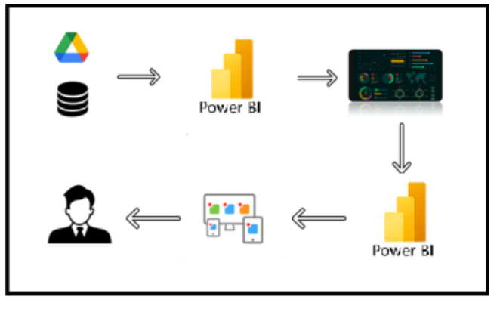

**Project Flow :**

To accomplish this, we have to complete all the activities listed below,

* Data Collection
* Collect the dataset,
* Connect Data with Power BI
* Data Preparation
* Prepare the Data for Visualization
* Data Visualizations
* Visualizations
* Dashboard
  + Responsive and Design of Dashboard
* Report
* Report Creation
* Performance Testing
* Utilization of Data Filters
* No. of Calculation fields
* No. of Visualizations/Graphs
* Project Demonstration & Documentation
* Record explanation Video for project end to end solution
* Project Documentation-Step by step project development procedure

**Milestone 1: Data Collection & Extraction from Database**

Data collection is the process of gathering and measuring information on variables of interest, in an established systematic fashion that enables one to answer stated research questions, test hypotheses, evaluate outcomes and generate insights from the data.

**Activity 1: Collect the dataset**

Please use the link to download the dataset: [Link](https://www.kaggle.com/datasets/rafsunahmad/world-food-production)

**Activity 1.1: Understand the data**

Data contains all the meta information regarding the columns described in the CSV

files.

**Column Description of the Dataset:**

1. Entity: Represents the country or region where the food production data is recorded.
2. Code: A unique identifier or code for each entity (country or region).
3. Year: The specific year for which the data is recorded, ranging from 1961 to 2023.
4. Apples_Production (tonnes): The total annual production of apples measured in tonnes.
5. Avocados_Production (tonnes): The total annual production of avocados measured in tonnes.
6. Bananas_Production (tonnes): The total annual production of bananas measured in tonnes.
7. Coffee_green_Production (tonnes): The total annual production of green coffee measured in tonnes.
8. Grapes_Production (tonnes): The total annual production of grapes measured in tonnes.
9. Maize_Production (tonnes): The total annual production of maize measured in tonnes.
10. Oranges_Production (tonnes): The total annual production of oranges measured in tonnes.
11. Rice_Production (tonnes): The total annual production of rice measured in tonnes.
12. Tea_Production (tonnes): The total annual production of tea measured in tonnes.
13. Wheat_Production (tonnes): The total annual production of wheat measured in tonnes.

**Activity 1.2: Connect Data with Power BI**

With Power BI, users can seamlessly connect to a wide range of data sources, including databases, cloud services, spreadsheets, and streaming data. This capability allows organizations to consolidate disparate data sources into a single, unified platform, breaking down data silos and enabling holistic analysis.

Explanation video link:

<https://drive.google.com/drive/folders/1ObZpCJR12DAY-nCLD2_Aw2K3nG12HlOD?usp=sharing>

**Milestone 2: Data Preparation**

Data preparation is a critical phase in the data lifecycle, encompassing activities that transform raw data into a format suitable for analysis. This multifaceted process involves several steps including data cleaning, integration, transformation, and enrichment. Data cleaning involves identifying and rectifying errors, inconsistencies, and missing values within datasets to ensure accuracy and reliability.

**Activity 1: Prepare the Data for Visualization**

Preparing the data for visualization involves cleaning the data to remove irrelevant or missing data, transforming the data into a format that can be easily visualized, exploring the data to identify patterns and trends, filtering the data to focus on specific subsets of data, preparing the data for visualization software, and ensuring the data is accurate and complete. This process helps to make the data easily understandable and ready for creating visualizations to gain insights into the performance and efficiency. Since the data is already cleaned, we can move to visualization.

Explanation video link 1:

<https://drive.google.com/file/d/1wpcUUgBTTg1_P6_RCGxHz5Y5G5manbDH/view?usp=drive_link>

Explanation video link 2:

<https://drive.google.com/file/d/1vWBs6sQxoIIs1VV7uvF-7EtZs92xwPZS/view?usp=drive_link>

**Milestone 3: Data Visualization**

Data visualization is the process of creating graphical representations of data in order to help people understand and explore the information. The goal of data visualization is to make complex data sets more accessible, intuitive, and easier to interpret. By using visual elements such as charts, graphs, and maps, data visualizations can help people quickly identify patterns, trends, and outliers in the data.

**Activity 1: No of Unique Visualizations**

In Global Food Production Trends and Analysis: A Comprehensive Study from 1961 to 2023 utilizing a variety of unique visualizations enhances data interpretation and storytelling. Line charts can illustrate long-term production trends from 1961 to 2023, while bar and column charts can compare production volumes of major crops. Tree maps and stacked bar charts highlight the relative contribution of different crops to total production. Geographical maps help visualize country-wise production, whereas gauge charts effectively display total production figures for specific crops. Heat maps can show variations in production across different regions, and forecasting charts can provide insights into future trends based on historical data.

**Activity 1.1: Sum of Rice Production (tonnes)**

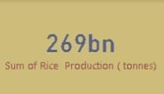

**Activity 1.2: Sum of Wheat Production (tonnes)**

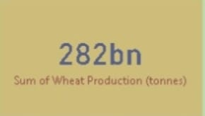

**Activity 1.3: Sum of Tea Production (tonnes)**

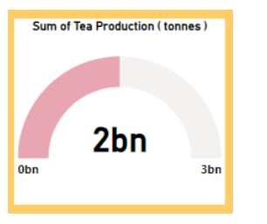

**Activity 1.4: Sum of Coffee, Green Production (tonnes) by Entity**

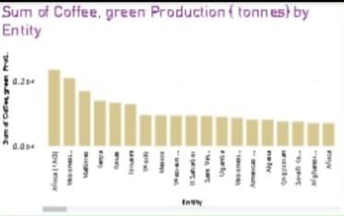

**Activity 1.5:  Sum of Wheat, Maize, and Rice Production (tonnes) by Year**

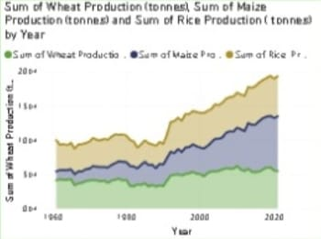

**Activity 1.6: Sum of Apples, Avocados, Bananas, and Oranges**

**Production (tonnes) by Entity**

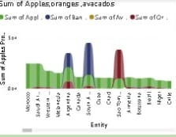

**Activity 1.7: Sum of Maize Production (tonnes) by Year**

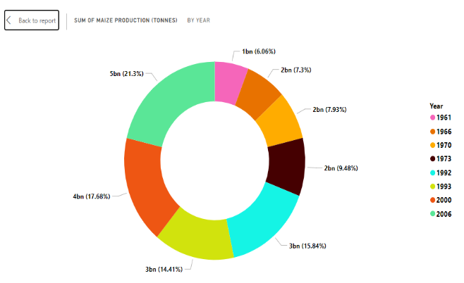

**Activity 1.8: Sum of Grapes, Apples, Bananas, and Oranges Production**

**(tonnes)**

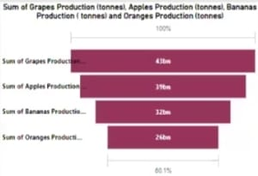

**Milestone 4: Dashboard**

A dashboard is a graphical user interface (GUI) that displays information and data in an organized, easy-to-read format. Dashboards are often used to provide real-time monitoring and analysis of data and are typically designed for a specific purpose or use case. Dashboards can be used in a variety of settings, such as business, finance, manufacturing, healthcare, and many other industries. They can be used to track key performance indicators (KPIs), monitor performance metrics, and display data in the form of charts, graphs, and tables.

**Activity 1: Responsive and Design of Dashboard**

A well-designed and responsive Power BI dashboard for "Global Food Production Trends and Analysis: A Comprehensive Study from 1961 to 2023" ensures seamless data visualization and user interaction across devices. The dashboard should present key metrics such as total production trends, crop comparisons, and regional insights using interactive charts, maps, and KPI cards. A clean and intuitive layout with responsive design enables users to filter data by year, crop type, and country, enhancing analytical depth. Utilizing visuals like line charts for trends, bar charts for comparisons, and heat maps for geographical distribution ensures clarity and engagement. Performance optimization and mobile compatibility further enhance usability, while features like forecasting and export options provide additional analytical capabilities. This approach ensures that users can explore and interpret global food production trends efficiently and effectively.

Once you have created views on different sheets in Power Bi you can pull them into a dashboard.

Dashboard 1:

Explanation video link:

<https://drive.google.com/file/d/1VOMhiTpMsEBGuFCjNoQbCe023MCOl7cp/view?usp=drive_link>

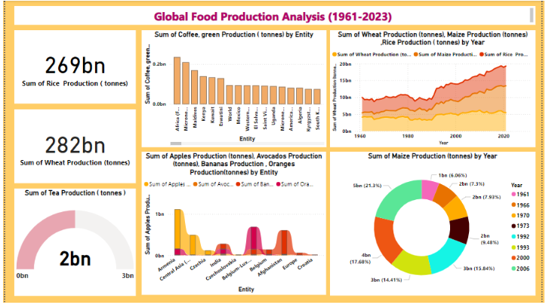

**Milestone 5: Report**

A report is a comprehensive document that provides a detailed and structured account of data analysis, findings, and insights. It is typically used for in-depth analysis, documentation, and communication of results. Reports are suitable for a diverse audience, including decision-makers, analysts, and stakeholders who need a comprehensive understanding of the data.

**Report:**

Explanation video link:

<https://drive.google.com/file/d/1Zd8ZhUdkUkpuOD-Lohu2WvLA0UCLrVCu/view?usp=drive_link>

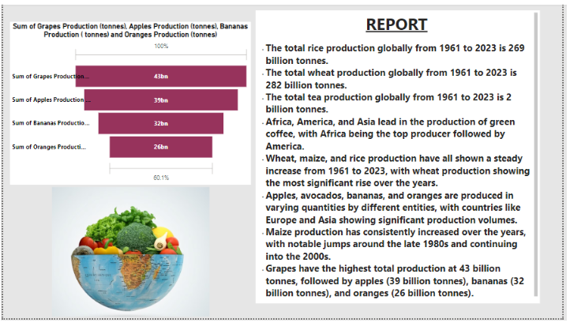

**Milestone 6: Performance Testing**

Performance testing is a crucial aspect of software development aimed at evaluating the speed, responsiveness, stability, and scalability of an application under various workload conditions. It involves simulating real-world usage scenarios to assess how the system behaves and performs under stress, peak loads, or normal conditions.

**Activity 1:** **Amount of Data Loaded**

Amount of Data Loaded refers to the quantity or volume of data that has been imported, retrieved, or loaded into a system, software application, database, or any other data storage or processing environment. It's a measure of how much data has been successfully processed and made available for analysis, manipulation, or use within the system.

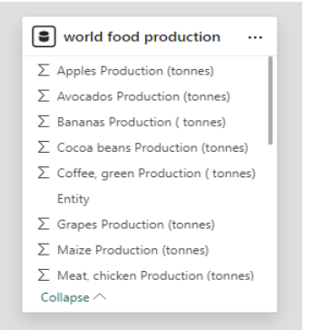

**Activity 2:** **Utilization of Filters**

Utilization of Filters refers to the application or use of filters within a system, software application, or data processing pipeline to selectively extract, manipulate, or analyze data based on specified criteria or conditions.

**Activity 2.1: Selected “Country” as a Filter**

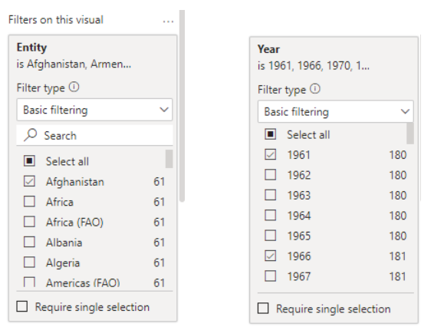

**Activity 2.2: No of Visualizations/ Graphs**

1. Sum of Rice Production (tonnes)
2. Sum of Wheat Production (tonnes)
3. Sum of Tea Production (tonnes)
4. Sum of Coffee, Green Production (tonnes) by Entity
5. Sum of Wheat Production (tonnes), Maize Production (tonnes), Rice Production (tonnes) by Year
6. Sum of Apples, Avocados, Bananas, Oranges Production (tonnes) by Entity
7. Sum of Maize Production (tonnes) by Year
8. Sum of Grapes, Apples, Bananas, Oranges Production (tonnes)

**Milestone 7: Project Demonstration & Documentation**

Below mentioned deliverables to be submitted along with other deliverables

**Activity 1: - Record explanation Video for the project's end-to-end solution**

Creating a record explanation video for a project's end-to-end solution is crucial for ensuring clarity and transparency in its implementation. This video serves as a comprehensive guide, detailing every aspect of the project from inception to completion.

**Activity 2: - Project Documentation-Step by step project development procedure**

Create document as per the template provided