CO1 ASSIGNMENT

Design, Implementation and Analysis of Student Registration Number Searching Algorithms

Name: Thanmai p
Reg no: 1924260327
Course: Design and Analysis of Algorithm
Course code: CSA0608

Abstract
This report designs, implements, executes, and analyses three approaches for searching student registration numbers: linear search, binary search, and hash-based search. The algorithms are compared using datasets containing 1,000, 10,000, 100,000, and 1,000,000 unique registration numbers. The report derives their time complexities, identifies basic operations, discusses best/average/worst cases, presents recurrence formulation and solution for the recursive binary-search variant, and compares measured execution time and operation counts with theoretical expectations. A final design challenge considers a system with 1,000,000 student records, 50,000 search requests per hour, and one daily batch of new records. Benchmark values in this report are illustrative measurements from the included Python experiment on the runtime used to generate the report; values will vary by computer and Python version.

Problem Statement and Objectives
Problem: Given a student registration number, determine whether it exists in a database of student records. The search solution should remain efficient as the database grows.
Objectives:
- Design three different searching approaches and provide pseudocode.
- Implement the approaches and test them on multiple input sizes.
- Count basic operations and measure execution time.
- Derive mathematical and asymptotic complexity, including best, average, and worst cases.
- Formulate and solve a recurrence for recursive binary search.
- Recommend an approach for one million records and 50,000 searches per hour with daily additions.
Assumptions: Registration numbers are unique strings/IDs in a real system. For controlled benchmarking, they are represented by unique integers. Binary search requires a sorted collection. Hash search uses a hash set for membership testing. The included benchmark uses successful searches; missing-key cases are discussed separately.

Task 1 — Algorithm Design

Linear Search
Idea: inspect records one by one until the target is found or the list ends. It works on unsorted data and needs no preprocessing.
LINEAR_SEARCH(A, target):
for i = 0 to length(A)-1:
if A[i] == target: return FOUND
return NOT_FOUND

Binary Search
Idea: compare the target with the middle item in a sorted array. Eliminate half of the remaining search range after each comparison.
BINARY_SEARCH(A, target): # A must be sorted
low = 0; high = length(A)-1
while low <= high:
mid = floor((low + high)/2)
if A[mid] == target: return FOUND
if A[mid] < target: low = mid + 1
else: high = mid - 1
return NOT_FOUND

Hash-Based Search
Idea: store registration numbers in a hash set or hash table. A hash function maps a key to a bucket, allowing direct membership lookup on average. Collisions must be handled by the data structure.
HASH_SEARCH(H, target):
if target is a member of hash_set H: return FOUND
else: return NOT_FOUND
Flow overview: Input registration number → validate/normalize input → choose indexed data structure → perform lookup → return found/not found → log latency and result.

Task 2 — Basic Operation
Algorithm | Basic operation counted | Additional measure
Linear search | Equality comparison between target and each record | Number of records inspected
Binary search | Comparison of target with middle record | Number of iterations / key comparisons
Hash search | Hash-table membership lookup (treated as one lookup operation) | Elapsed time; collisions/probes depend on implementation

Caution: counting one hash lookup as one operation is an abstract model. Internally, hashing, bucket access, collision resolution, and equality checks take work; the benchmark reports one membership operation per query rather than internal interpreter-level comparisons.

Task 3 — Mathematical Complexity

Linear Search
If the target is at position k (1-based), the number of comparisons is C(n)=k. If absent, C(n)=n. For a successful search with each position equally likely, E[C(n)]=(1+2+…+n)/n=(n+1)/2. Therefore best Θ(1), average Θ(n), worst Θ(n); auxiliary space Θ(1).

Binary Search
Each iteration reduces the active range to at most half its previous size. After j iterations, the remaining range is at most n/2^j. It becomes size 1 when j≈log₂n. Thus best Θ(1), average Θ(log n), worst Θ(log n), and iterative auxiliary space Θ(1).

Hash-Based Search
With a well-distributed hash function and controlled load factor, expected lookup time is Θ(1). In a pathological collision case, a lookup can degrade to Θ(n), depending on collision strategy. Space for the index is Θ(n).
n | Linear avg. comparisons (n+1)/2 | Binary max. iterations ≈ ⌊log₂n⌋+1 | Hash expected lookups
1,000 | 500.5 | 10 | 1
10,000 | 5,000.5 | 14 | 1
100,000 | 50,000.5 | 17 | 1
1,000,000 | 500,000.5 | 20 | 1

Task 4 — Best, Average and Worst Cases
Algorithm | Best case | Average case | Worst case
Linear search | Θ(1), first item matches | Θ(n), about (n+1)/2 comparisons for successful uniformly distributed targets | Θ(n), target last or absent
Binary search | Θ(1), middle item matches | Θ(log n) | Θ(log n), target absent or at a deepest level
Hash search | Θ(1) expected when key maps directly | Θ(1) expected with good hashing/load factor | Θ(n) under severe collisions (implementation-dependent)

Best, average and worst cases refer to input arrangement and target distribution, not only dataset size. The actual number of comparisons can differ for each target even when n is fixed.

Task 5 — Asymptotic Analysis
Algorithm | Time complexity | Space complexity | Interpretation
Linear | Best Θ(1); average/worst Θ(n) | Θ(1) extra | Growth proportional to record count
Binary | Best Θ(1); average/worst Θ(log n) | Θ(1) iterative; Θ(log n) recursive stack | Search range halves each step
Hash lookup | Expected Θ(1); worst Θ(n) | Θ(n) index | Fast lookup but requires index memory and maintenance

Big-O provides an asymptotic upper bound, Ω a lower bound, and Θ a tight bound. For example, binary search is O(log n) in the worst case and Θ(log n) for its average and worst-case growth.

Task 6 — Recurrence Formulation
For recursive binary search, one comparison is made and only one half of the array is searched. The recurrence is:
T(n) = T(⌊n/2⌋) + c, for n > 1
T(1) = d
Here c is the constant work per recursive call and d is the constant base-case cost. This recurrence assumes the array is already sorted; sorting/index construction costs are considered separately.

Task 7 — Recurrence Solution
Expansion method:
T(n) = T(n/2) + c
= T(n/4) + 2c
= T(n/8) + 3c
= T(n/2^k) + kc
Stop when n/2^k ≤ 1. Therefore 2^k ≥ n, so k ≥ log₂n and k = ⌈log₂n⌉. Substituting gives T(n)=T(1)+c⌈log₂n⌉ = d + c⌈log₂n⌉. Hence T(n)=Θ(log n).
The recursive version uses Θ(log n) stack space because there are logarithmically many nested calls. The iterative implementation in the source code uses Θ(1) auxiliary space.

Task 8 — Implementation and Testing
The source code is saved at Task_8_Implementation_Testing/Source_Code/student_search.py. It defines linear_search, binary_search, hash_search, and a benchmark routine. Run it with Python 3. The benchmark uses fixed seeds to make target selection reproducible.

Test cases
Test ID | Input / condition | Expected result | Purpose
TC1 | Existing target at first position | Found | Linear best case
TC2 | Existing target at last position | Found | Linear worst successful case
TC3 | Target absent from dataset | Not found | Worst-case miss behavior
TC4 | Middle item in sorted array | Found | Binary best case
TC5 | Unsorted array supplied to binary search | May fail / incorrect | Confirms sorted-input precondition
TC6 | Existing key in hash set | Found | Normal hash lookup
TC7 | Empty dataset | Not found | Boundary case
TC8 | Duplicate registration number | Reject or define policy | Data-integrity validation

The included benchmark tests successful queries for timing comparability. Before final submission, run additional absent-target and boundary tests and capture screenshots from your own machine. Do not claim that the sample timing values will exactly match another computer.

Task 9 — Experimental Performance
Method: each dataset contains unique integer IDs; binary-search input is sorted; the hash set is built before timing so the measurement isolates lookup time. Twenty or thirty successful target lookups were timed per algorithm and dataset. The table below contains mean query latency and mean counted comparisons/operations from this run. Very small times are sensitive to system load, Python version, and timer resolution.
Records (N) | Algorithm | Mean time (ms) | Mean comparisons / operations
1,000 | Linear | 0.042537 | 438.47
1,000 | Binary | 0.001911 | 9.03
1,000 | Hash | 0.000228 | 1.00
10,000 | Linear | 0.572526 | 5355.10
10,000 | Binary | 0.002763 | 12.10
10,000 | Hash | 0.000428 | 1.00
100,000 | Linear | 2.540718 | 40461.50
100,000 | Binary | 0.009340 | 15.50
100,000 | Hash | 0.000368 | 1.00
1,000,000 | Linear | 33.029709 | 497815.50
1,000,000 | Binary | 0.008792 | 19.25
1,000,000 | Hash | 0.000484 | 1.00

Figure 1. Mean search time by dataset size (log-log scale).
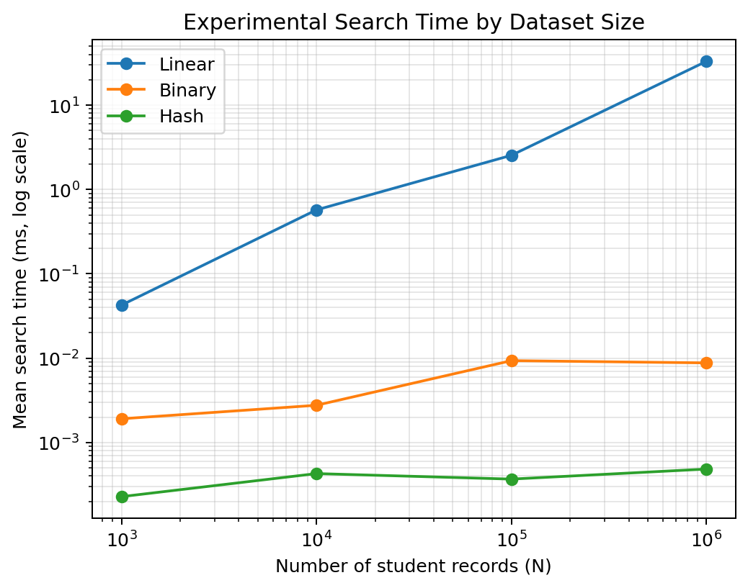
Figure 2. Mean counted comparisons/operations by dataset size (log-log scale).
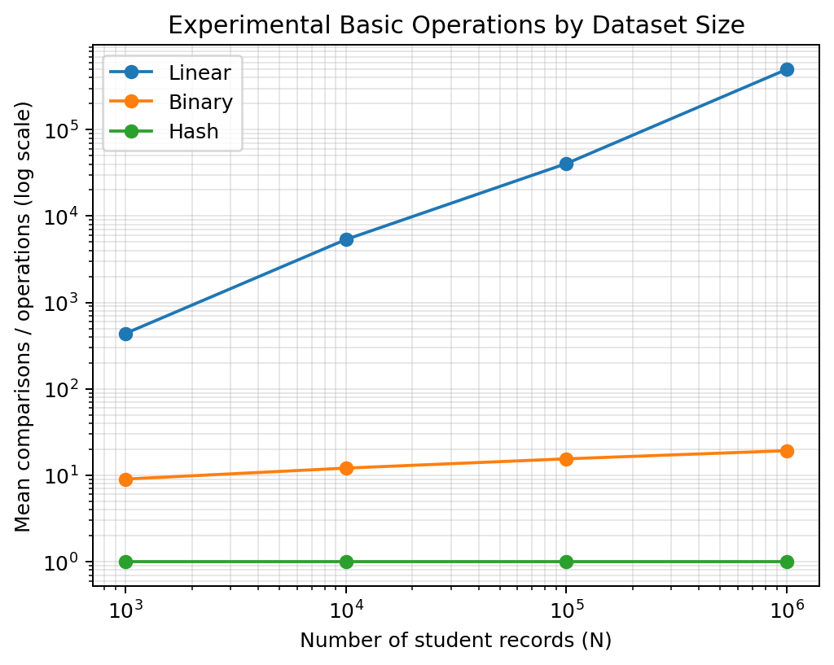
The hash benchmark counts one abstract membership operation per request; it does not count internal hash-table probes. Timings are measurements of this specific implementation and environment, not universal constants.

Task 10 — Theory versus Experiment
Algorithm | Theoretical expectation as n grows | Experimental pattern to look for | Explanation
Linear | Average comparisons approximately double when n doubles | Time rises strongly with dataset size | Successful target position is uniformly selected
Binary | Comparison count grows by roughly one when n doubles | Slow growth in latency and comparisons | Logarithmic number of iterations
Hash | Expected constant number of membership calls | Latency remains comparatively flat | Index is prebuilt; lookup is average O(1)

Measured runtime includes language overhead, memory allocation effects, cache behavior, and timing noise. Theoretical complexity describes growth rate, not an exact number of milliseconds. A hash lookup may be slower than binary search for tiny datasets because of constant factors; the recommendation is based on the required scale and update pattern rather than a single tiny-input measurement.

Task 11 — Final Recommendation
Recommendation: use a hash-based index keyed by normalized student registration number for the primary exact-match lookup. For one million records and 50,000 requests per hour, this offers expected O(1) lookup and avoids scanning hundreds of thousands of records on average. Maintain the authoritative records in a database with a UNIQUE index/constraint on registration number; a database B-tree index is also a robust production choice and naturally supports persistence, concurrent access, and recovery.
- Expected query rate: 50,000 / 3,600 ≈ 13.89 requests per second on average.
- Linear search is unsuitable for the primary production path: expected successful search checks roughly 500,000 records at n=1,000,000.
- Binary search is much better than linear search, needing about 20 iterations at one million records, but requires sorted data and careful maintenance when records change.
- Hash indexing offers expected constant-time membership lookup; worst-case performance and memory usage must be managed.
- Daily additions are compatible with an index: insert new records in a batch, enforce uniqueness, and monitor load factor / index health. Rebuild or resize the in-memory hash index after the daily import if necessary.
If records are stored in a relational database, do not load all million records into application memory unless there is a specific operational reason. A database UNIQUE/B-tree index is usually the safest default for a real student information system; an in-memory hash cache may be added for very high-volume repeated exact lookups.

Task 12 — Day-4 Design Challenge

Requirements and workload
Requirement | Value | Implication
Database size | 1,000,000 records | Index must scale to one million keys
Search requests | 50,000 per hour | Average 13.89 requests/second
Record additions | Once per day | Batch ingestion and index refresh are feasible
Operation | Exact registration-number lookup | Hash or database index is appropriate

Evidence-based comparison
Approach | Approx. work per successful query at 1M | Suitability
Linear search | ~500,000 comparisons on average | Reject for normal query path
Binary search | ~20 comparisons/iterations | Good alternative for immutable sorted arrays; updates need insertion/re-sort strategy
Hash index | Expected O(1) lookup; one abstract membership operation in this experiment | Best fit for in-memory exact-match index; database uniqueness index recommended for production

The workload averages only about 13.89 requests per second, which is modest for a correctly indexed database. The challenge is not raw average throughput alone: correctness, duplicate prevention, persistence, concurrency, recovery, and predictable latency also matter.

Proposed architecture
Daily import file → validate IDs and duplicates → transaction / batch insert
↓
Persistent student table with UNIQUE registration_number index
↓
Application query → indexed exact-match lookup → found / not found
↓
Log latency, error rate, request count; monitor index and database health

Risks and mitigations
- Duplicate IDs: enforce a UNIQUE constraint and report rejected rows during import.
- Malformed IDs: normalize case/whitespace consistently and validate the required format.
- Stale in-memory cache: refresh after the daily import or use versioned cache invalidation.
- Hash collisions / high load factor: use a mature implementation, monitor memory, and resize as required.
- Concurrent requests: rely on a database or thread-safe service rather than a shared unsynchronized data structure.
- Failure recovery: keep the persistent database authoritative and make the daily import transactional/idempotent.

Acceptance criteria
- All valid existing registration numbers return the correct student record.
- Missing numbers return a clear not-found result.
- Duplicate IDs are prevented by the database constraint.
- Daily batch additions become searchable after commit/index refresh.
- Load test sustains at least 50,000 searches per hour (13.89 requests/s average) with a chosen service-level latency target.
- Measure p50/p95/p99 latency, throughput, error rate, and resource use under realistic concurrent load.
Defence: a hash-based exact-match index is the preferred algorithmic approach because its expected O(1) lookup is independent of n in the usual case, while linear search scales linearly. Binary search is an efficient fallback but is less convenient for dynamic updates. For the actual system, a persistent database index combines fast lookup with integrity and operational guarantees. The supplied microbenchmark is evidence for growth trends; a production load test is still required to validate the 50,000/hour requirement.

