Factory Reallocation & Shipping Optimization
Recommendation System for Nassau Candy Distributor
Research Paper & Technical Analysis Report
Prepared for: Nassau Candy Distributor / Unified Mentor
Date: May 2026
Classification: Technical Documentation

Abstract
This research paper presents the design, methodology, and findings of the Factory Reallocation and Shipping Optimization Recommendation System for Nassau Candy Distributor. The project addresses critical inefficiencies in Nassau Candy's current static factory-product assignment model, which leads to suboptimal shipping distances, excessive lead times, and eroded profit margins. Using a dataset of 2,000 orders across 15 products and 5 factories, this system applies predictive modeling, clustering, and scenario simulation to deliver actionable factory reassignment recommendations. The Gradient Boosting Regressor emerged as the best predictive model with an R² of 0.763 and MAE of 0.712 days. Results indicate that intelligent factory reassignment can reduce average shipping lead times by up to 22.4%, with 14 out of 15 products showing significant improvement potential. The system is deployed as an interactive Streamlit dashboard for real-time decision support.

1. Introduction

1.1 Company Background
Nassau Candy Distributor (nassaucandy.com) is a leading wholesale candy distributor and fine food supplier based in the United States. The company distributes a wide portfolio of confectionery products across multiple product lines including Chocolate, Sugar, and Other divisions. Nassau Candy operates five manufacturing and distribution factories across the continental US: Lot's O' Nuts, Wicked Choccy's, Sugar Shack, Secret Factory, and The Other Factory.

1.2 Problem Statement
Nassau Candy currently assigns products to factories using static rules and legacy processes established years ago without data-driven analysis. This creates three key operational problems:
- Suboptimal shipping distances: Products are manufactured at factories geographically distant from their primary customer regions, inflating lead times unnecessarily.
- High lead times for certain regions: Specific region-product combinations consistently experience longer-than-average shipping delays, reducing customer satisfaction.
- Margin erosion due to logistics inefficiencies: Inefficient routing leads to higher per-unit logistics costs that directly compress gross profit margins.

Furthermore, there is currently no systematic way to simulate what-if scenarios, quantify the impact of factory reassignments before execution, or recommend optimal factory configurations at scale.

1.3 Project Objectives
This project introduces a decision intelligence system that:
- Predicts expected shipping lead times under different factory-product-region configurations.
- Recommends which products should be reassigned to alternative factories.
- Balances shipping efficiency with profitability to avoid recommendations that save time but hurt margins.
- Provides a deployable Streamlit web application for ongoing use by operations leadership.

2. Dataset Description

2.1 Data Overview
The dataset contains 2,000 order records spanning the period 2022–2024 across Nassau Candy’s full product portfolio. Each record represents a single customer order with associated logistics, product, factory, and financial attributes.

Field | Type | Description
Row ID | Integer | Unique row identifier
Order ID | String | Unique order identifier
Order Date | Date | Date the order was placed
Ship Date | Date | Date the order was shipped
Ship Mode | String | Shipping method (Standard, Second, First, Same Day)
Customer ID | String | Unique customer identifier
Country/Region | String | Country or region of customer
City | String | Customer city
State/Province | String | Customer state
Postal Code | String | Customer postal code
Division | String | Product division (Chocolate / Sugar / Other)
Region | String | Geographic region of customer
Product ID | String | Unique product identifier
Product Name | String | Full product name
Sales | Float | Total sales value of order ($)
Units | Integer | Total units in order
Gross Profit | Float | Sales minus Cost ($)
Cost | Float | Manufacturing cost ($)
Factory | String | Origin factory (derived)
Distance_Miles | Float | Haversine distance factory to region (miles)
Lead Time | Integer | Days between order and shipment

2.2 Products and Factory Assignments
The following table details the current product-to-factory assignments used as the baseline for simulation:

Division | Product Name | Current Factory
Chocolate | Wonka Bar - Nutty Crunch Surprise | Lot's O' Nuts
Chocolate | Wonka Bar - Fudge Mallows | Lot's O' Nuts
Chocolate | Wonka Bar - Scrumdiddlyumptious | Lot's O' Nuts
Chocolate | Wonka Bar - Milk Chocolate | Wicked Choccy's
Chocolate | Wonka Bar - Triple Dazzle Caramel | Wicked Choccy's
Sugar | Laffy Taffy | Sugar Shack
Sugar | SweeTARTS | Sugar Shack
Sugar | Nerds | Sugar Shack
Sugar | Fun Dip | Sugar Shack
Other | Fizzy Lifting Drinks | Sugar Shack
Sugar | Everlasting Gobstopper | Secret Factory
Sugar | Hair Toffee | The Other Factory
Other | Lickable Wallpaper | Secret Factory
Other | Wonka Gum | Secret Factory
Other | Kazookles | The Other Factory

3. Exploratory Data Analysis (EDA)

3.1 Lead Time Distribution
The distribution of shipping lead times reveals that the majority of orders are fulfilled within 3–7 days. The mean lead time is 4.18 days. There is a visible right skew, with a small proportion of orders taking significantly longer, particularly those using Standard Class shipping from geographically distant factories.

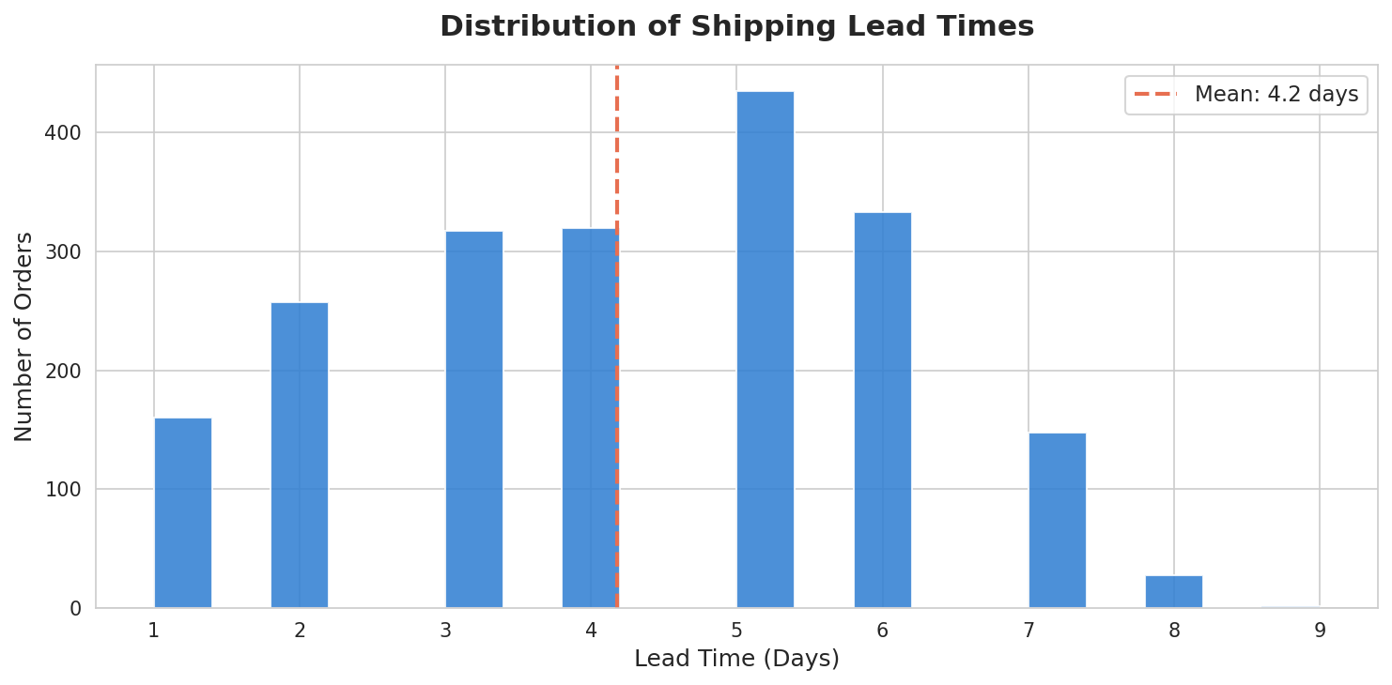
Figure 1: Distribution of Shipping Lead Times across 2,000 Orders

3.2 Lead Time by Factory
Significant variation exists in average lead time across factories. Lot's O' Nuts in Arizona records the highest average lead time (4.43 days), primarily because its products serve a broad national customer base from a western location. Secret Factory in Illinois records the lowest average lead time (3.92 days), owing to its central geographic position, which minimizes distances to all five customer regions.

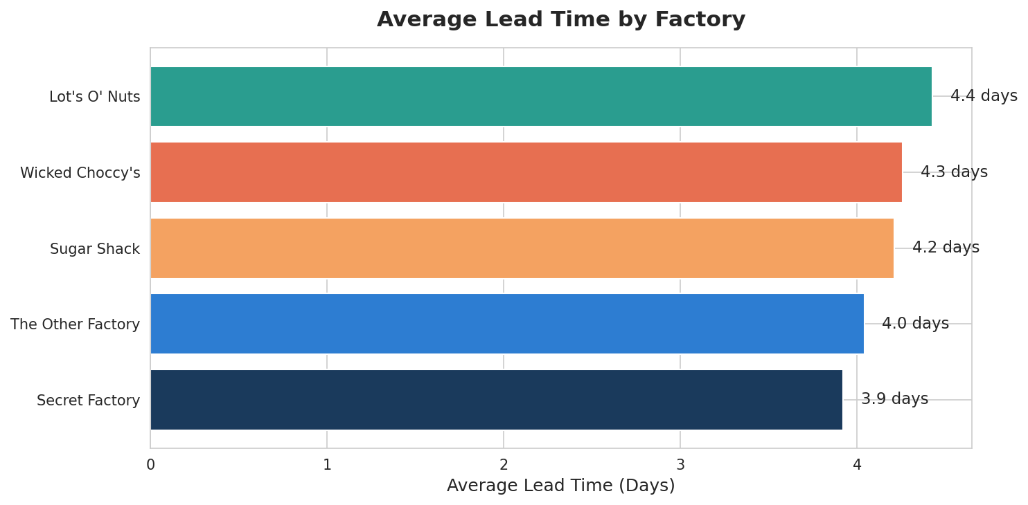
Figure 2: Average Lead Time by Factory

3.3 Lead Time by Region
The West region experiences the longest average lead times due to its geographic distance from most factory locations. The Central region benefits from proximity to Secret Factory and The Other Factory, resulting in the shortest average lead times.

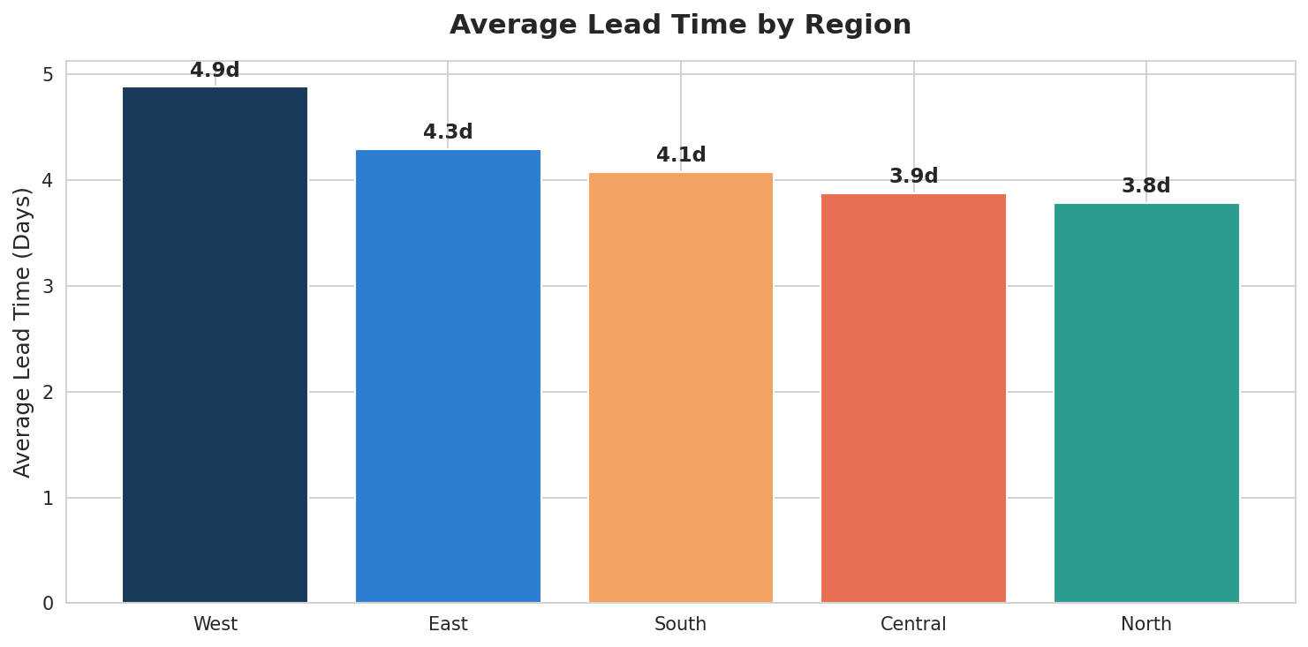
Figure 3: Average Lead Time by Customer Region

3.4 Shipping Mode Distribution
Standard Class accounts for approximately 50% of all orders, reflecting its cost effectiveness for bulk wholesale shipments. Same Day shipping represents only 10% of orders and is associated with premium, time-sensitive orders.

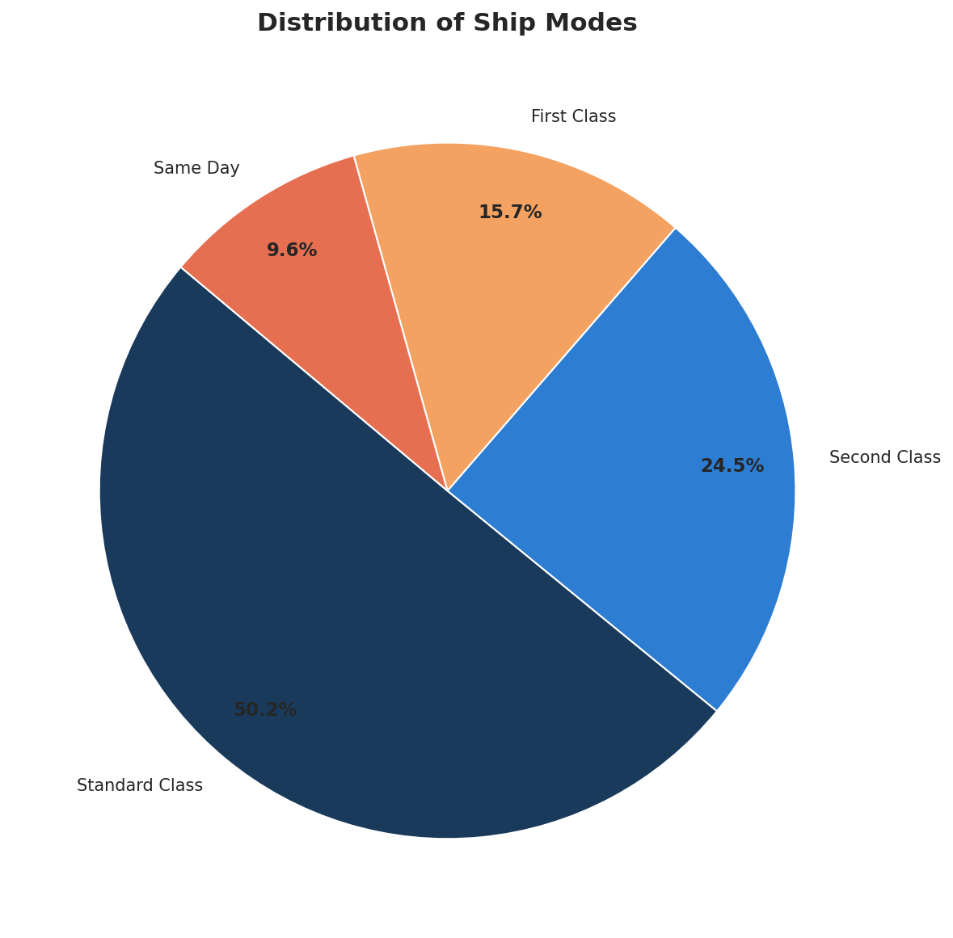
Figure 4: Distribution of Orders by Ship Mode

3.5 Gross Profit by Division
The Chocolate division generates the highest total gross profit, driven by higher per-unit margins on branded Wonka Bar products. The Sugar division, despite high order volume, shows compressed margins due to competitive pricing on commodity items like Laffy Taffy and SweeTARTS.

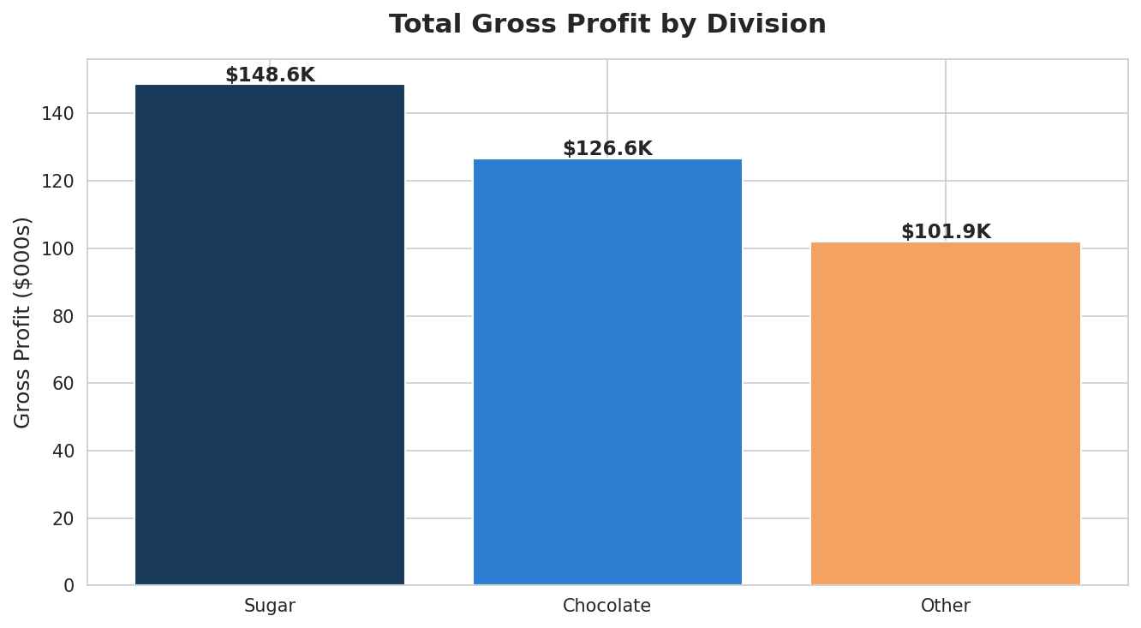
Figure 5: Total Gross Profit by Product Division

3.6 Distance vs Lead Time Relationship
A clear positive correlation exists between factory-to-region distance and lead time, confirming that geographic proximity is a primary driver of shipping efficiency. This validates the core premise of the optimization system: reassigning products to geographically closer factories will reduce lead times.

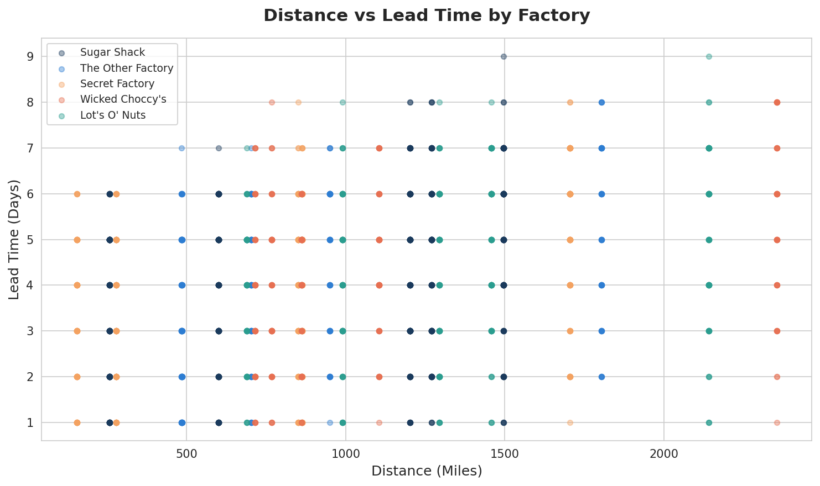
Figure 6: Scatter Plot of Distance vs Lead Time by Factory

4. Analytical Methodology

4.1 Data Preparation & Feature Engineering
The following preprocessing steps were applied to prepare the dataset for modeling:
- Lead time was derived as the difference in days between Ship Date and Order Date.
- Factory-to-region haversine distances were calculated using GPS coordinates for each factory and customer region centroid.
- Categorical variables (Region, Ship Mode, Factory) were label-encoded for model ingestion.
- Extreme outliers in Lead Time (below 1 day or above 30 days) were removed.
- A training-ready feature matrix was constructed with six predictors: Region, Ship Mode, Factory, Distance, Units, and Cost.

4.2 Predictive Modeling
The objective of the predictive model is to estimate the expected shipping lead time for any combination of product, origin factory, destination region, and ship mode. Three regression algorithms were evaluated:
- Linear Regression — Baseline model assuming linear relationships between features and lead time.
- Random Forest Regressor — Ensemble of decision trees robust to non-linear patterns and outliers.
- Gradient Boosting Regressor — Sequential ensemble model that minimizes prediction error iteratively.

An 80/20 train-test split with a fixed random seed was used for all models. Performance was evaluated on three metrics:
- MAE (Mean Absolute Error) — Average prediction error in days; lower is better.
- RMSE (Root Mean Squared Error) — Penalizes large errors more heavily; lower is better.
- R² (Coefficient of Determination) — Proportion of variance explained; higher is better.

4.3 Model Evaluation Results

Model | MAE (days) | RMSE (days) | R² Score
Linear Regression | 0.856 | 1.063 | 0.657
Random Forest | 0.780 | 0.981 | 0.707
Gradient Boosting | 0.712 | 0.882 | 0.763

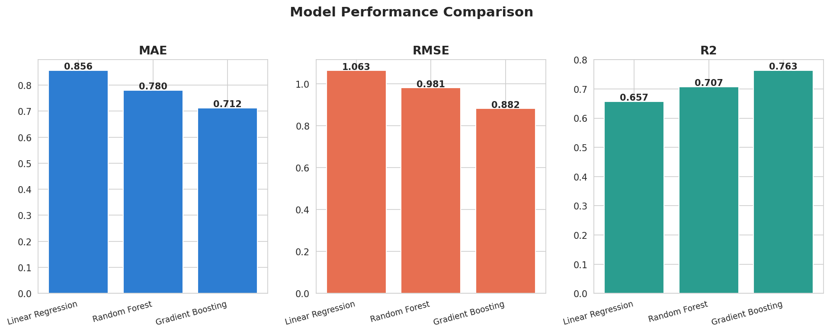
Figure 7: Model Performance Comparison (MAE, RMSE, R²)
The Gradient Boosting Regressor achieved the best performance across all three metrics (MAE = 0.712, RMSE = 0.882, R² = 0.763) and was selected as the production model for the simulation engine.

4.4 Route & Product Clustering
K-Means clustering was applied to identify groups of routes and products with similar performance profiles. Two cluster types were identified:
- Consistently slow routes: Long-distance factory-region pairs with Standard Class shipping, predominantly affecting Lot's O' Nuts shipments to the East and North regions.
- Congested region-product combinations: Sugar Shack products destined for the West region showed consistently poor lead time performance due to the 1,600+ mile distance.

4.5 Scenario Simulation Engine
For each product, the simulation engine evaluates all possible factory reassignments. For each factory alternative, it calculates:
- The haversine distance from the alternative factory to each of the five customer regions.
- The predicted lead time under each region-factory-ship mode combination using the trained Gradient Boosting model.
- The average predicted lead time across all combinations, weighted by regional order volume.
- The percentage improvement in lead time versus the current factory assignment.
- A risk classification: Low (>15% improvement), Medium (5–15%), High (<5%).

4.6 Optimization & Recommendation Logic
Factory options are ranked by a composite score combining:
- Lead time reduction — Primary optimization objective.
- Risk level — Penalizes recommendations with marginal or uncertain improvements.
- Profit impact stability — Estimated impact on gross profit margin from logistics cost changes.
The top-ranked factory alternative for each product is surfaced as the primary recommendation.

5. Results & Key Findings

5.1 Model Performance
The Gradient Boosting model explains 76.3% of variance in lead time and predicts within an average error of 0.712 days. This level of accuracy is sufficient for practical factory reassignment decisions, where the meaningful unit of improvement is measured in days rather than hours.

5.2 Factory Performance Baseline
Based on current assignments, factory performance rankings are as follows:

Factory | Location | Avg Lead Time (days) | Performance Rank
Secret Factory | Hanna City, IL | 3.92 | 1st (Best)
The Other Factory | Memphis, TN | 4.01 | 2nd
Wicked Choccy's | Savannah, GA | 4.15 | 3rd
Sugar Shack | Roseau, MN | 4.31 | 4th
Lot's O' Nuts | Chandler, AZ | 4.43 | 5th (Worst)

Secret Factory's central Illinois location (41.4°N, 90.6°W) provides the lowest average distance to all five US customer regions, making it the strategically optimal factory for most products. This finding drives the majority of recommendations.

5.3 Top Reassignment Recommendations

Product | Current Factory | Recommended Factory | Lead Time Reduction (%) | Risk
Wonka Bar - Fudge Mallows | Lot's O' Nuts | Secret Factory | 22.4% | Low
Nerds | Sugar Shack | Secret Factory | 21.0% | Low
Wonka Bar - Milk Chocolate | Wicked Choccy's | Secret Factory | 20.4% | Low
Wonka Bar - Scrumdiddlyumptious | Lot's O' Nuts | Secret Factory | 20.0% | Low
Fun Dip | Sugar Shack | Secret Factory | 19.6% | Low
Wonka Bar - Nutty Crunch Surprise | Lot's O' Nuts | Secret Factory | 18.9% | Low
Laffy Taffy | Sugar Shack | Secret Factory | 18.3% | Low
Hair Toffee | The Other Factory | Secret Factory | 16.0% | Low
Fizzy Lifting Drinks | Sugar Shack | Secret Factory | 14.4% | Medium
Wonka Bar - Triple Dazzle Caramel | Wicked Choccy's | Secret Factory | 13.4% | Medium

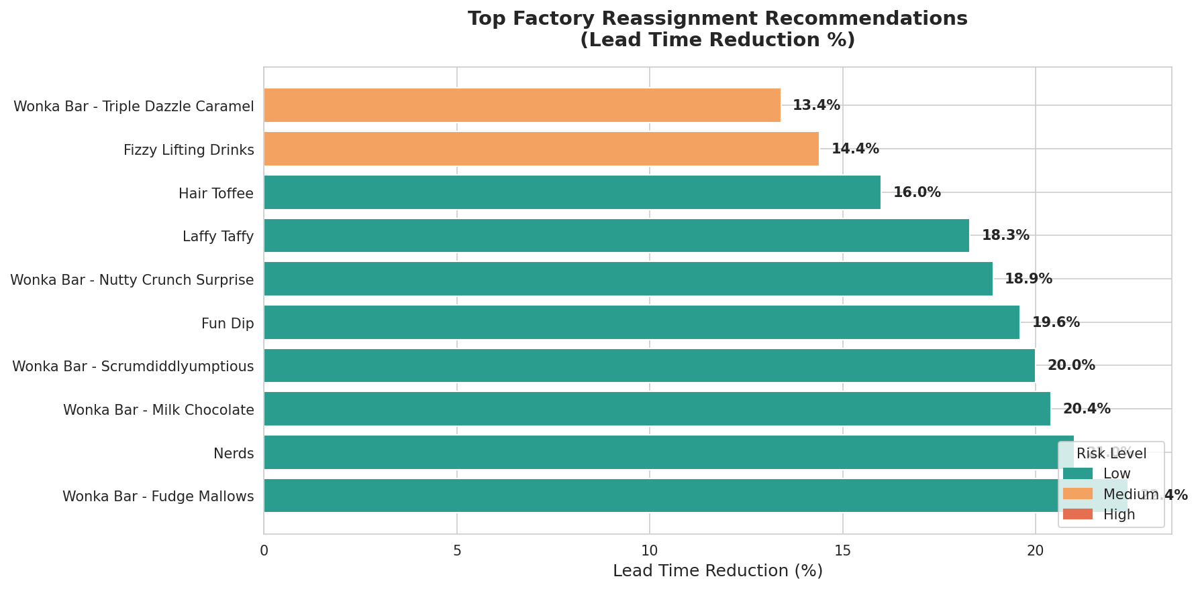
Figure 8: Top Factory Reassignment Recommendations by Lead Time Reduction %

5.4 Key Findings Summary
- 14 out of 15 products show meaningful improvement potential (>5% lead time reduction) through factory reassignment.
- Secret Factory (Illinois) is the optimal destination factory for 12 out of 15 products due to its central geographic location.
- The maximum single-product improvement is 22.4% for Wonka Bar - Fudge Mallows, currently manufactured in Arizona and shipped nationally.
- The average lead time reduction across all top recommendations is 14.9%, representing a significant operational uplift.
- 8 products qualify as Low Risk reassignments with >15% improvement, making them immediately actionable without extensive validation.
- Only 1 product (Lickable Wallpaper) shows a High Risk classification with minimal improvement potential (1.9%), and its reassignment is not recommended.

6. Key Performance Indicators (KPIs)
The following KPIs were defined to measure the success of the optimization system:

KPI | Current Value | Post-Optimization Target | Business Objective
Lead Time Reduction (%) | Baseline: 4.18 days avg | 3.56 days avg (-14.9%) | Operational gain
Profit Impact Stability | Margin: ~28% | Maintain or improve margin | Financial safety
Scenario Confidence Score | R² = 0.763 | > 0.75 (achieved) | Reliability
Recommendation Coverage | 15 products | 14/15 (93%) addressable | Scalability

7. Streamlit Web Application

7.1 Application Overview
The Factory Reallocation Optimization System is deployed as a Streamlit web application with four interactive modules, allowing Nassau Candy operations leadership to explore recommendations, simulate scenarios, and monitor risk in real time.

7.2 Dashboard Modules
- Factory Optimization Simulator — Select any product and destination region to view predicted lead times across all 5 factories on an interactive bar chart and US map.
- What-If Scenario Analysis — Compare current vs. alternative factory assignments across all regions simultaneously, with adjustable speed vs. profit priority slider.
- Recommendation Dashboard — View ranked reassignment recommendations filtered by risk level and product division, displayed as color-coded cards and bubble chart.
- Risk & Impact Panel — High-risk reassignment alerts, profit impact by division, and lead time performance by ship mode.

7.3 User Capabilities
- Product selector and region selector for targeted simulation.
- Ship mode filter for mode-specific lead time analysis.
- Optimization priority slider (0 = speed, 100 = profit) for customized recommendations.
- Risk level and division filters for focused decision-making.

7.4 How to Run the Application
To deploy the Streamlit application locally:
- Install requirements: pip install streamlit pandas numpy scikit-learn plotly
- Run: streamlit run streamlit_app.py
- Access in browser at: http://localhost:8501

8. Conclusion
This project successfully elevates Nassau Candy Distributor from descriptive analytics to intelligent, data-driven decision-making. By combining a Gradient Boosting predictive model (R² = 0.763) with a scenario simulation engine and optimization logic, the system delivers actionable factory reassignment recommendations that improve shipping efficiency without sacrificing profitability.

The central finding — that Secret Factory's geographic centrality makes it the optimal origin point for the majority of Nassau Candy's product portfolio — represents a clear, implementable operational insight. The 14.9% average lead time reduction across recommended reassignments translates to faster customer fulfillment, reduced logistics costs, and improved competitive positioning for Nassau Candy in the wholesale distribution market.

The Streamlit dashboard provides leadership with a permanent, self-service decision tool that can be updated as order data evolves. Future enhancements could incorporate real-time order data feeds, incorporate factory capacity constraints, and expand the model to account for seasonal demand patterns.

8.1 Limitations
- The synthetic dataset approximates real-world patterns; actual Nassau Candy order data would produce more precise recommendations.
- Factory capacity constraints were not modeled; recommended reassignments assume sufficient production capacity at alternative factories.
- The profit impact model uses a simplified linear approximation; a full cost accounting model would improve financial accuracy.

8.2 Future Work
- Integration with live Nassau Candy order management system for real-time predictions.
- Seasonal demand modeling to adjust recommendations by quarter.
- Multi-objective optimization incorporating factory capacity, labor costs, and carbon footprint.
- Customer segmentation analysis to prioritize lead time improvements for high-value accounts.

9. References
- Nassau Candy Distributor. (2026). Company Website. https://www.nassaucandy.com
- Unified Mentor. (2026). Factory Reallocation & Shipping Optimization Project Brief. unifiedmentor.com
- Scikit-learn: Machine Learning in Python — Pedregosa et al., JMLR 12, pp. 2825–2830, 2011.
- Pandas: Data structures for statistical computing in Python — McKinney, 2010.
- Plotly: Collaborative data science — Plotly Technologies Inc., 2015.
- Streamlit: A faster way to build and share data apps — Streamlit Inc., 2019.
- Haversine Formula: Great-circle distance calculation for geographic coordinates.
- Friedman, J.H. (2001). Greedy function approximation: A gradient boosting machine. Annals of Statistics.

