Suicide-Risk Detection Using NLP-Based Text and Speech Analysis
A Project Report
Submitted in partial fulfilment of requirements for the award of the degree of
BACHELOR OF TECHNOLOGY
IN
INFORMATION TECHNOLOGY
Submitted by
S. Thanmayi (23761A1251)
Ch. Venu Madhav (24765A1201)
M. Samuel Babu (23761A1235)

Under the Esteemed Guidance of
Dr. G. Rajendra
Associate Professor
Dept. of IT, LBRCE

DEPARTMENT OF INFORMATION TECHNOLOGY
LAKIREDDY BALI REDDY COLLEGE OF ENGINEERING
(AUTONOMOUS)
An ISO 21001:2018, 14001:2015, 50001:2018 Certified Institution
Approved by AICTE, New Delhi and Affiliated to JNTUK, Kakinada
L.B. REDDY NAGAR, MYLAVARAM, NTR DIST., A.P.-521 230
2026-2027

LAKIREDDY BALI REDDY COLLEGE OF ENGINEERING
(AUTONOMOUS)
Accredited by NAAC & NBA (Under Tier - I)
An ISO 21001:2018, 14001:2015, 50001:2018 Certified Institution
Approved by AICTE, New Delhi and Affiliated to JNTUK, Kakinada
L.B. REDDY NAGAR, MYLAVARAM, NTR DIST., A.P.-521 230

DEPARTMENT OF INFORMATION TECHNOLOGY

CERTIFICATE
This is to certify that S. Thanmayi (23761A1251), Ch. Venu Madhav (24765A1201) and M. Samuel Babu (23761A1235), students of IV B. Tech (Information Technology), have successfully completed the project titled “Suicide-Risk Detection Using NLP-Based Text and Speech Analysis” at Lakireddy Bali Reddy College of Engineering during the Academic Year 2026-2027. This project report is submitted as partial fulfilment for the award of the degree of Bachelor of Technology (Information Technology).

Project Guide | Head of the Department
Dr. G. Rajendra  Associate Professor | Dr. D. Ratna Kishore  Professor & HOD, IT

Project Co Ordinator name | External Examiner
Mr. M. Vijay Kumar
Sr Assistant Professor

ACKNOWLEDGEMENT
Behind every achievement lies the support and encouragement of many people. We express our sincere gratitude to all those who contributed directly or indirectly to the successful completion of this project.
We express our special gratitude to Dr. K. Appa Rao, Principal, Lakireddy Bali Reddy College of Engineering, for providing the academic environment and facilities required to carry out this work. We also thank all teaching and non-teaching staff members of the Department of Information Technology for their cooperation.
We are highly obliged to Dr. D. Ratna Kishore, Head of the Department of Information Technology, for his encouragement and support throughout the project.
It is our privilege to express heartfelt gratitude to our guide, Dr. G. Rajendra, Associate Professor, Department of Information Technology, for valuable guidance, technical suggestions, careful review and continuous support during all phases of the project.
We are also thankful to the project coordinator, Mr. M. Vijay Kumar, Sr Assistant Professor, Department of IT, for coordinating the project reviews and providing systematic guidance.
Finally, we express our gratitude to our parents and friends for their constant encouragement and support.

CANDIDATE’S DECLARATION
We hereby declare that the project report entitled “Suicide-Risk Detection Using NLP-Based Text and Speech Analysis” is a record of our work carried out during the academic year 2026-2027 under the guidance of Dr. G. Rajendra, Associate Professor, Department of Information Technology, and submitted in partial fulfilment of the requirements for the award of the degree of Bachelor of Technology (B. Tech) in Information Technology.
The matter embodied in this project is genuine work carried out by us and has not been submitted earlier to this university or any other university for the award of any degree, diploma or prize.

PROJECT ASSOCIATES
S. Thanmayi (23761A1251)
Ch. Venu Madhav (24765A1201)
M. Samuel Babu (23761A1235)

INDEX
Contents | Page No
LIST OF FIGURES | I
ACRONYMS AND ABBREVIATIONS | II
ABSTRACT | III
1. INTRODUCTION | 1-3
1.1 Introduction | 1-2
1.2 Existing System | 2
1.3 Proposed System | 3
2. LITERATURE SURVEY | 4-5
3. SYSTEM SPECIFICATIONS | 6-9
3.1 Software Requirements | 6-7
3.2 Hardware Requirements | 7
3.3 Functional Requirements | 8
3.4 Non-Functional Requirements | 9
4. METHODOLOGY | 10-13
5. DESIGN VIEW | 14-18
6. IMPLEMENTATION | 19-29
7. TESTING | 30-31
8. RESULTS AND EVALUATION | 32-35
9. CONCLUSION | 36
10. FUTURE ENHANCEMENT | 37
REFERENCES | 38-39
APPENDIX

LIST OF FIGURES
Figure No | Description | Page No
4.1 | System Architecture Diagram | 10
5.1 | System Flow Chart | 14
5.2 | Logical Diagram | 15
5.3 | Activity Diagram | 16
5.4 | Conceptual ER Diagram | 17
5.5 | DFD Level 1 | 18
8.1 | Text Model Performance Comparison | 32
8.2 | Text SVM Confusion Matrix | 33
8.3 | Speech Model Confusion Matrix | 33
8.4 | Text-only Output | 34
8.5 | Speech-only Output | 34
8.6 | Text + Speech Output | 35
8.7 | Automated Test Summary | 35

ACRONYMS AND ABBREVIATIONS
AI | Artificial Intelligence
NLP | Natural Language Processing
SDCNL | Suicide and Depression Classification with Noisy Labels
EATD | Emotional Audio-Textual Depression Corpus
TF-IDF | Term Frequency-Inverse Document Frequency
SVM | Support Vector Machine
BERT | Bidirectional Encoder Representations from Transformers
BiLSTM | Bidirectional Long Short-Term Memory
LR | Logistic Regression
MFCC | Mel-Frequency Cepstral Coefficients
RMS | Root Mean Square Energy
ZCR | Zero-Crossing Rate
ROC-AUC | Receiver Operating Characteristic - Area Under Curve
CV | Cross-Validation
UI | User Interface

ABSTRACT
Suicide-risk identification is a challenging research problem because warning signals can appear in written language, speech characteristics, or both. This project presents a multimodal research screening framework that combines Natural Language Processing based text analysis with acoustic speech analysis. The text branch uses the SDCNL dataset and evaluates a BiLSTM, frozen BERT mean-pooled embeddings with Logistic Regression, and TF-IDF bigram features with a calibrated Linear SVM. After leakage-free preprocessing, the final SDCNL training set contains 1,513 records and the held-out test set contains 379 records, with zero normalized train-test text overlap. The calibrated Linear SVM is the best verified text model with 72.56% accuracy, 71.92% precision, 75.65% recall, 73.74% F1-score and 78.22% ROC-AUC. The speech branch uses the EATD-Corpus as a complementary depression/distress source. Speech is processed at mono 16 kHz with peak normalization, and acoustic features including MFCC, pitch, RMS energy, zero-crossing rate, spectral centroid and duration are extracted. A participant-grouped Logistic Regression speech model achieved 63.29% participant-level validation accuracy, 63.44% balanced accuracy and 59.22% ROC-AUC. Since SDCNL and EATD contain different participants and different targets, they are not merged row-by-row. The final application keeps P_text and P_speech separate and applies a transparent prototype late-fusion decision layer for Low, Moderate and High research-screening levels. The Streamlit implementation supports text-only, speech-only and combined input modes, and the final automated verification suite passed 37 out of 37 checks. The system is intended for academic research screening and not for clinical diagnosis.

CHAPTER - 1

1.1. INTRODUCTION:
Suicide and self-harm related risk is a major mental-health concern, and early identification of warning signals can support timely human intervention. Conventional assessment depends on professional interviews and validated clinical instruments. These remain essential for diagnosis, but they are difficult to scale continuously across large online populations and may not capture every individual who is reluctant to disclose distress directly.
Digital platforms have created new sources of behavioural and linguistic information. Social-media posts, forum messages and other online text can contain patterns associated with hopelessness, distress, self-harm references and changes in emotional expression. Natural Language Processing makes it possible to represent and classify such text automatically, while speech processing can capture complementary acoustic characteristics such as pitch variation, energy, timing and spectral patterns.
This project therefore studies a multimodal research-screening architecture with independent text and speech branches. The text branch is trained on SDCNL suicide/depression text, while the speech branch uses EATD depression/distress speech. Because the two datasets do not contain the same people and do not share an identical target label, the project does not perform invalid row-wise multimodal training. Instead, each branch is evaluated separately and the resulting evidence scores are combined only at the final prototype decision layer.

1.2. EXISTING SYSTEM:
- Traditional screening relies on interviews and questionnaires conducted by trained mental-health professionals. These methods are clinically meaningful but require time and expert availability.
- Many automated text systems use only one representation or one classifier. Their results can be affected by noisy labels, duplicate records, train-test leakage and poor probability calibration.
- Speech-based mental-health systems often require specialized corpora. Public speech datasets with direct suicide-risk labels are scarce, which makes it unsafe to assume that a depression corpus is equivalent to a suicide-risk corpus.
- Some multimodal studies combine paired text and audio from the same participants. Such approaches cannot be reproduced by simply concatenating unrelated SDCNL and EATD rows because the participants and labels do not correspond.

1.3. PROPOSED SYSTEM:
- Leakage-aware text pipeline using the cleaned SDCNL training and fixed held-out test split.
- Comparison of BiLSTM, frozen BERT embeddings with Logistic Regression, and TF-IDF + calibrated Linear SVM.
- Independent speech pipeline using EATD acoustic features with participant-grouped cross-validation.
- Single-audio speech inference with MFCC, pitch, RMS energy, ZCR, spectral centroid and duration features.
- Late decision-level fusion of P_text and P_speech only, rather than invalid feature-level merging of unmatched datasets.
- Streamlit interface supporting Text Only, Speech Only and Text + Speech modes.
- Low / Moderate / High research-screening display with clear non-diagnostic disclaimer.
- Automated verification covering files, syntax, dataset integrity, model metrics, diagrams and end-to-end inference.

CHAPTER - 2

2. LITERATURE SURVEY
Haque, Reddi and Giallanza (ICANN 2021): proposed SDCNL for suicide-versus-depression text classification and addressed noisy web labels using unsupervised label correction. Their work is directly relevant to the text dataset used in this project and motivates careful treatment of noisy labels and evaluation leakage.
Shen, Yang and Lin (ICASSP 2022): introduced the EATD-Corpus and a GRU/BiLSTM-based depression detection framework using emotional audio and textual responses. EATD contains audio and transcripts from 162 volunteers and provides the speech/distress source used in this project.
Pokrywka, Kaczmarek and Gorzelańczyk (IEEE BigData 2024): evaluated modern transformer configurations for suicide-risk classification on social-media text and demonstrated the strong potential of contextual language models in risk classification.
Jin, Liu and Dai (2025): studied multimodal speech and text models for adolescent suicide-risk detection using paired recordings and transcripts. Their findings support multimodal analysis, but their paired-data setting differs from this project because SDCNL and EATD are unmatched.
Devlin et al. (2019): introduced BERT, a bidirectional transformer architecture that enables contextual representation of language. In this project BERT is used as a frozen mean-pooled embedding baseline rather than as a fully fine-tuned final model.
Classical calibrated machine learning: remains competitive on limited text datasets. The project therefore compares deep-learning representations against a calibrated linear SVM with TF-IDF features instead of assuming a transformer will automatically provide the best held-out performance.

Research Gap
Publicly available suicide-related text datasets and public depression-related speech datasets usually do not describe the same participants. A system that directly merges such datasets can create an artificial multimodal relationship that does not exist in the original data.
Another recurring concern is data leakage. Duplicate or near-duplicate text across training and testing can inflate reported performance. This project explicitly checks normalized overlap and retains a leakage-free held-out test set.
The project therefore focuses on scientifically supportable modular evaluation: direct suicide-related text classification on SDCNL, complementary depression/distress speech modelling on EATD, and transparent late fusion only at the decision layer.

CHAPTER - 3

3. SYSTEM SPECIFICATIONS
3.1 SOFTWARE REQUIREMENTS:
Python 3.11: Primary programming environment used for preprocessing, model training, evaluation, inference and testing.
NumPy: Numerical operations and feature arrays.
Pandas: CSV loading, cleaning, participant-level feature tables and evaluation data.
Scikit-learn: TF-IDF, LinearSVC, probability calibration, Logistic Regression, feature selection, cross-validation and metrics.
PyTorch: BiLSTM text baseline implementation.
Hugging Face Transformers: Frozen BERT embedding baseline.
Librosa: Audio loading and acoustic feature extraction.
SoundFile: Audio support.
Joblib: Saving and loading vectorizers and trained models.
Streamlit: Local browser-based user interface.
Matplotlib: Charts and evaluation figures.

3.2 HARDWARE REQUIREMENTS:
- 64-bit Windows 10/11 system.
- Intel Core i5/i7 or equivalent processor recommended.
- Minimum 8 GB RAM; 16 GB preferred for development and model experimentation.
- At least 10-20 GB free storage for datasets, model artifacts, reports and temporary files.
- GPU is optional for the final app because the verified production inference pipeline can run on CPU; GPU is useful only for heavier deep-learning experiments.

3.3 FUNCTIONAL REQUIREMENTS:
- Accept text-only, speech-only or combined input.
- Validate that required inputs are present for the selected mode.
- Transform text using the saved TF-IDF vectorizer and return calibrated P_text.
- Load audio, normalize it and extract the same acoustic features used during speech training.
- Return P_speech using the saved speech model and selected threshold.
- Combine available branch scores according to the documented prototype fusion configuration.
- Display screening level, branch scores, combined score, technical details and research disclaimer.
- Provide reusable saved models so retraining is not required for every demonstration.

3.4 NON-FUNCTIONAL REQUIREMENTS:
- Usability: a non-technical user should be able to run the application using helper batch files.
- Reliability: model artifacts, file paths and dependencies are verified by an automated test suite.
- Maintainability: training, inference, configuration and UI code are kept in separate files.
- Transparency: text and speech branch scores are shown separately instead of hiding the fusion process.
- Reproducibility: package versions are recorded in requirements.txt and final metrics are stored in JSON reports.
- Safety of interpretation: the application clearly states that it is a research screening prototype, not a clinical diagnostic system.

CHAPTER - 4

4. METHODOLOGY
4.1. Overview of the Project:
The methodology consists of two independently trained branches and a transparent decision layer. The text branch estimates suicide-related evidence from SDCNL text. The speech branch estimates depression/distress evidence from EATD speech. The two datasets are never treated as if they describe the same people.
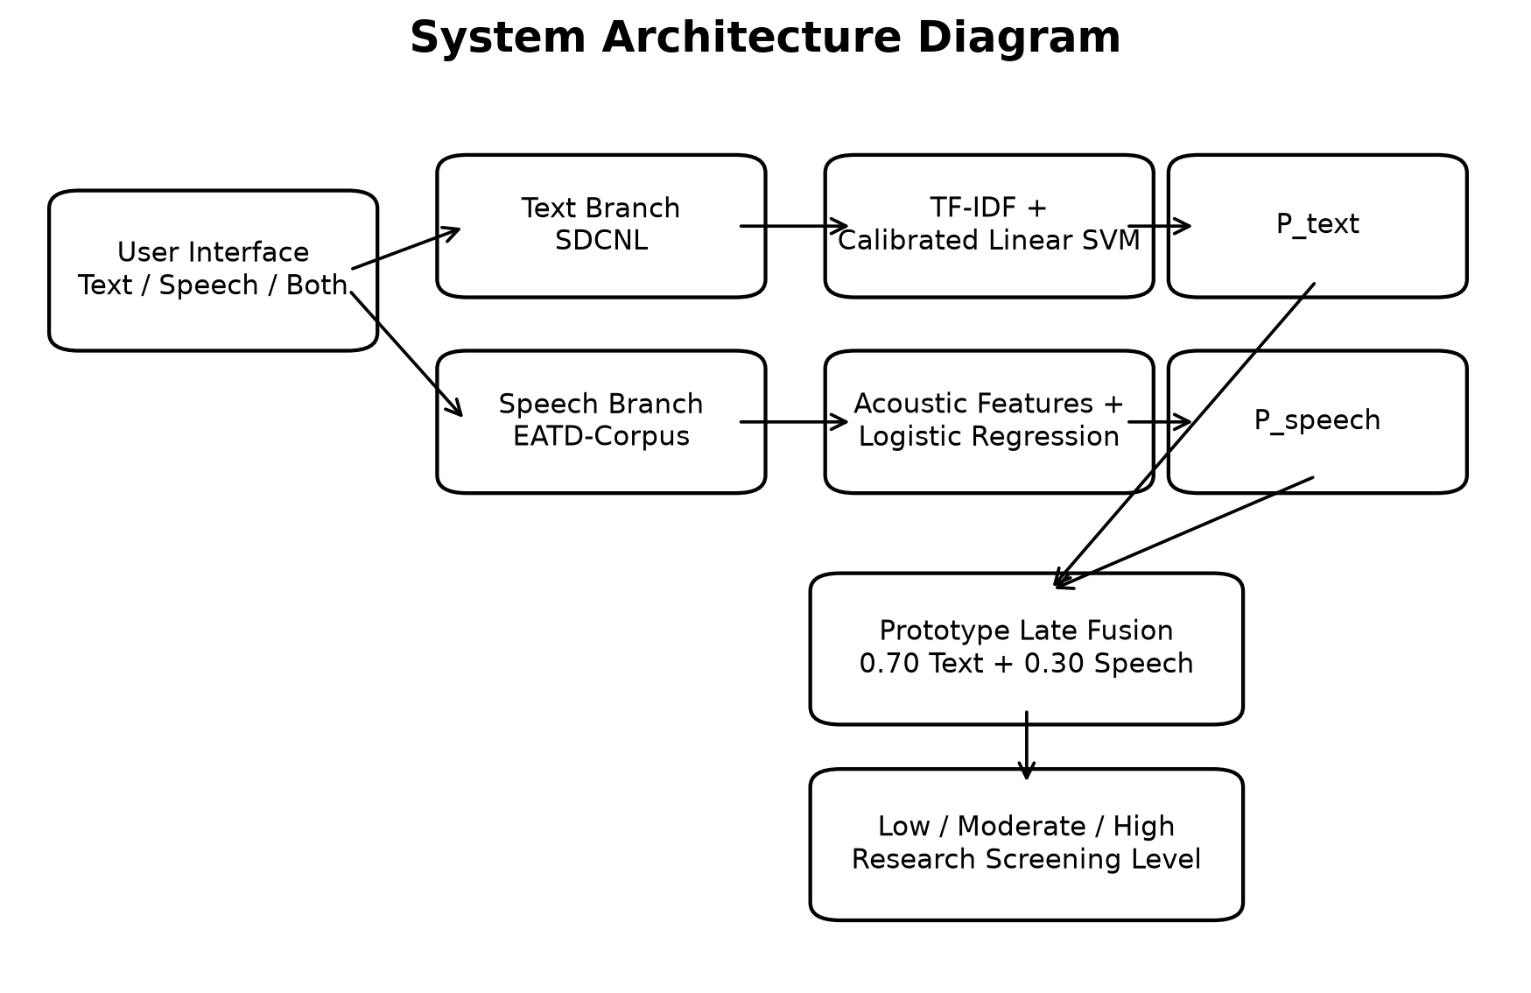
Figure 4.1: System Architecture Diagram

4.2 Text Data Pre-processing
- Remove unwanted index columns and create a model_text field from the cleaned source text.
- Remove records that become empty after model-input cleaning.
- Remove exact duplicate model_text + label records within each split.
- Preserve the original binary labels.
- Normalize case and whitespace for explicit train-test overlap checking.
- Keep the final held-out test split isolated; do not train on combined-set-clean.csv because it contains test records.
The final cleaned training set contains 1,513 rows and the fixed held-out test set contains 379 rows. The final normalized text overlap between training and testing is zero.
4.3 Text Model Development
- BiLSTM baseline with train/validation split inside the training data.
- TF-IDF unigrams/bigrams with calibrated Linear SVM.
- Frozen bert-base-uncased mean-pooled embeddings followed by Logistic Regression.
- All final comparisons are reported on the same 379-row leakage-free held-out test set.

4.4 Speech Pre-processing and Feature Extraction
- Prefer *_out.wav files when available and usable.
- Fallback to raw WAV only when the processed audio is unusable.
- Load audio as mono at 16 kHz.
- Apply peak normalization.
- Extract 13 MFCC means and 13 MFCC standard deviations.
- Extract pitch mean/std, RMS mean/std, ZCR mean/std, spectral centroid mean/std and duration.
The EATD audit found 80 usable training participants and all 79 validation participants. The final audio-level feature tables contain 240 training rows and 237 validation rows.
4.5 Speech Model Selection
The operational speech model is a single-audio Logistic Regression pipeline with feature selection. Candidate configurations were selected using participant-grouped cross-validation so that recordings from one participant never appear in both the training and validation folds. The official EATD validation split was used only after model and threshold selection.

4.6 Prototype Late Fusion and Decision Making
- Text-only mode uses P_text directly.
- Speech-only mode uses P_speech directly.
- Combined mode computes 0.70 × P_text + 0.30 × P_speech.
- Low: score < 0.40.
- Moderate: 0.40 ≤ score < 0.70.
- High: score ≥ 0.70.
The fusion values are transparent research-prototype settings, not clinically calibrated thresholds. A valid learned multimodal fusion model would require paired text and speech with the same participants and the same target label.
4.7 Evaluation Metrics
Accuracy, precision, recall, F1-score, ROC-AUC and confusion matrix are used for model evaluation. Balanced accuracy is additionally emphasized for the imbalanced EATD participant validation set.

CHAPTER - 5

5. DESIGN VIEW
5.1 System Flow Chart
The flow chart describes how the user selects an input mode, provides the required data, triggers branch inference, and receives the final research-screening result.
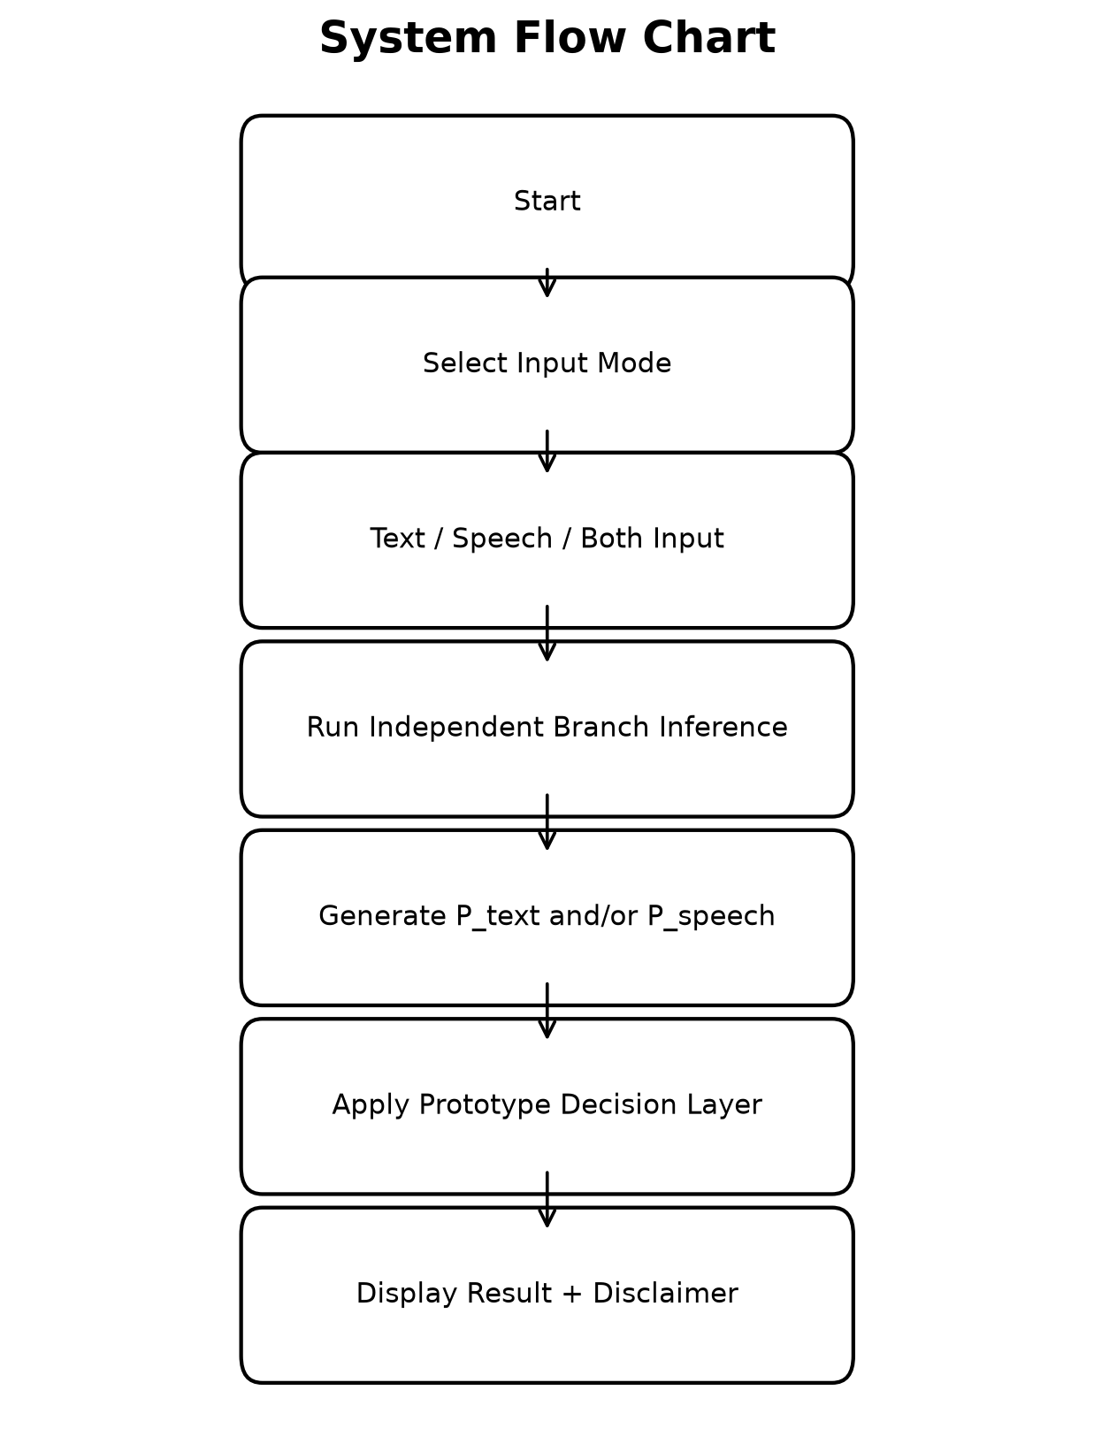
Figure 5.1: System Flow Chart

5.2 Logical Diagram
The logical view separates the input, processing, model and decision layers so that text and speech processing remain independent until the final decision stage.
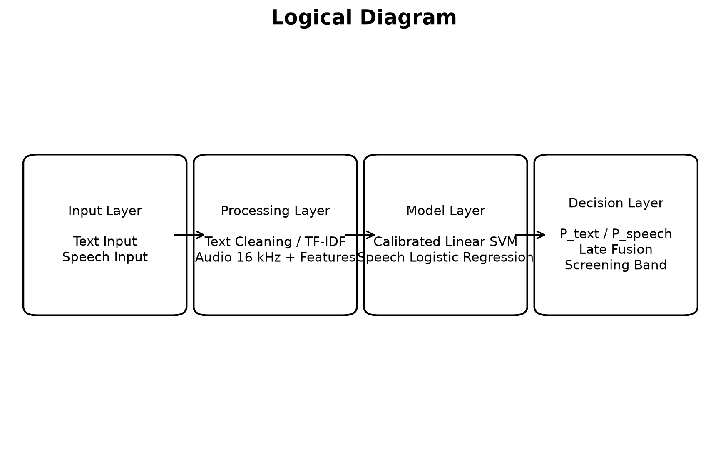
Figure 5.2: Logical Diagram

5.3 Behavioural / Activity Diagram
The activity diagram represents the application workflow from input selection through validation, model execution, score combination and output display.
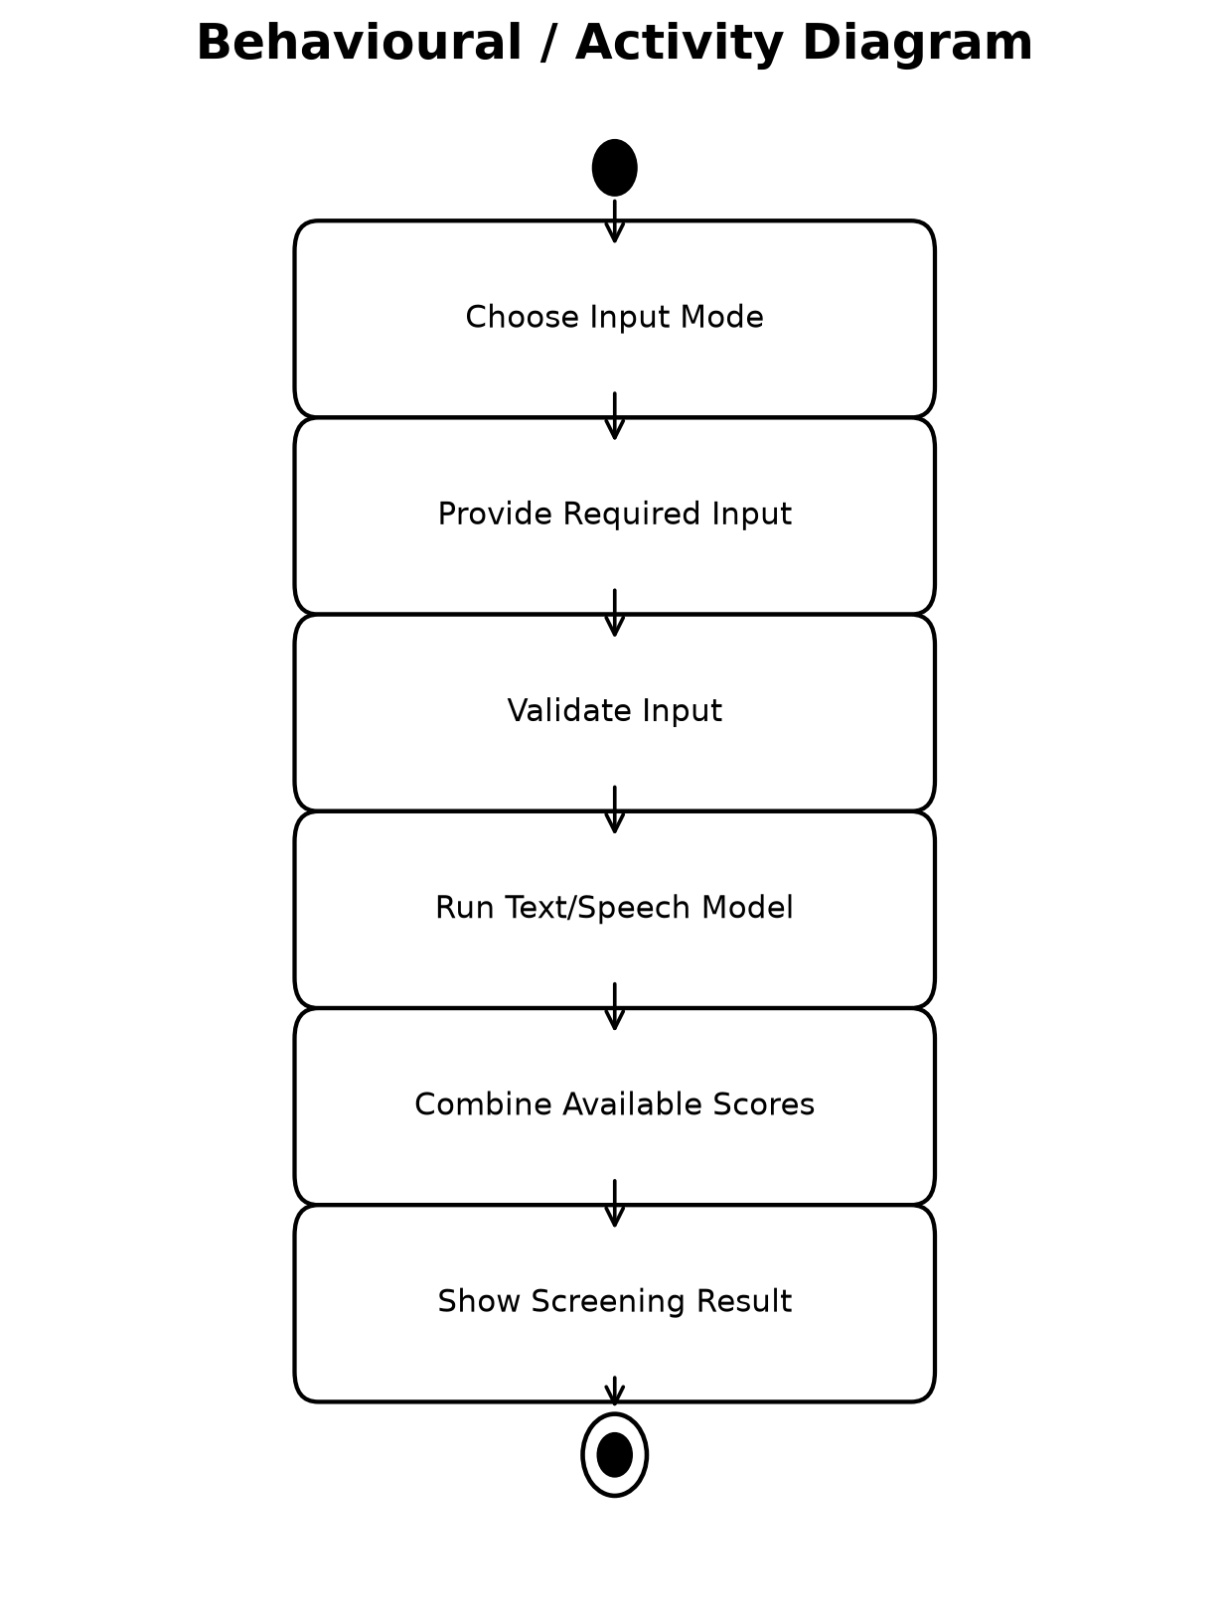
Figure 5.3: Activity Diagram

5.4 Conceptual ER Diagram
The ER view is conceptual because the current prototype uses files and saved model artifacts rather than a relational database. It shows the logical relationship among input, branch results and screening result.
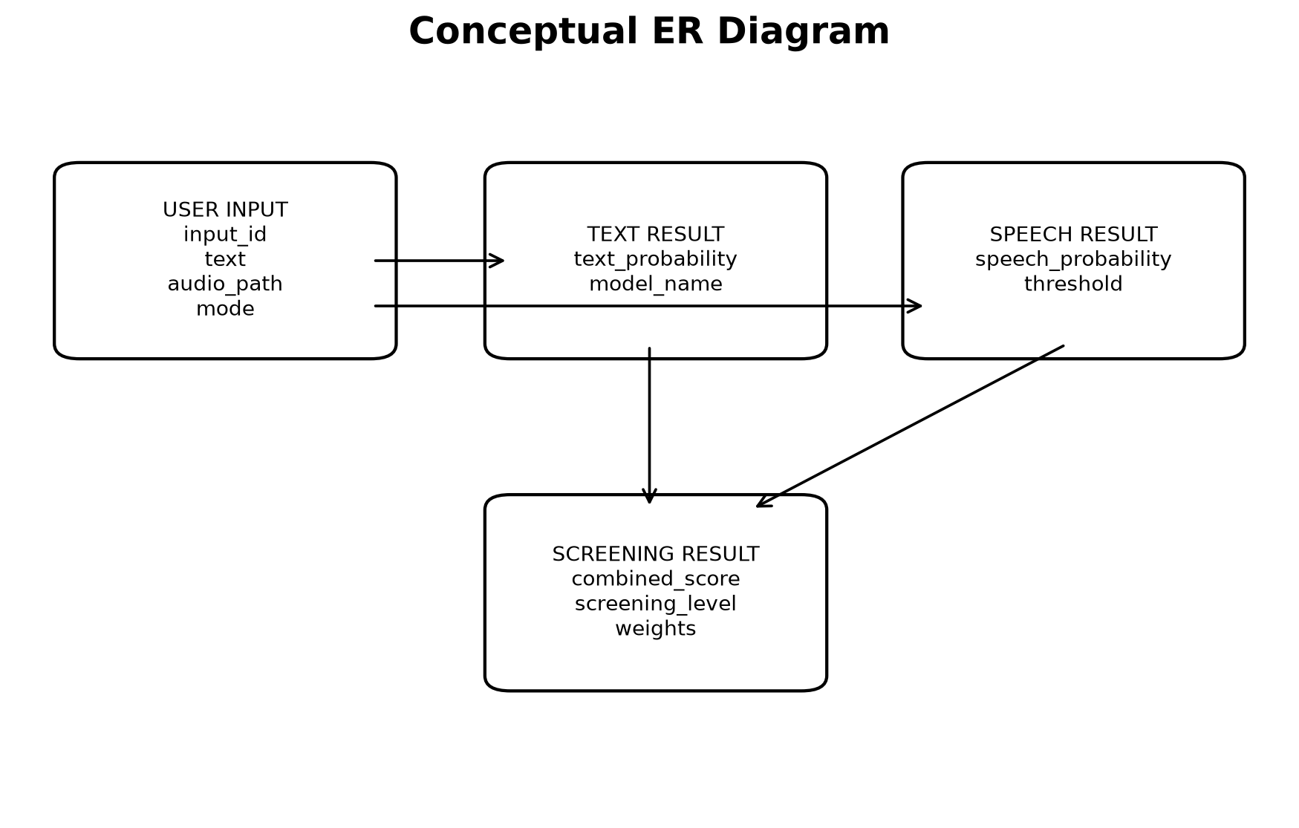
Figure 5.4: Conceptual ER Diagram

5.5 Data Flow Diagram
The DFD shows user input entering the text and speech analysis processes, branch scores flowing into the decision process and the final result returning to the user.
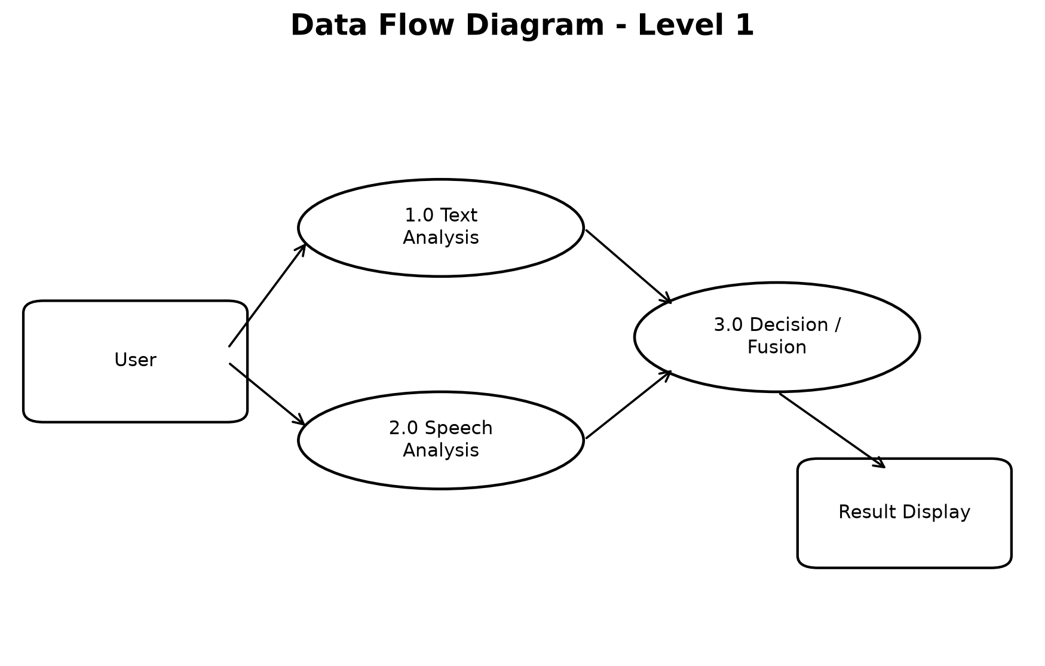
Figure 5.5: DFD Level 1

CHAPTER - 6

6. IMPLEMENTATION
The implementation is organized into dataset preprocessing, independent model training, saved model artifacts, a unified inference pipeline, a Streamlit user interface and automated verification. The following pages show the principal source-code components from the verified project. The complete executable source is stored in the project folder.
6.1 Text SVM Training
import json
from pathlib import Path
import pandas as pd
from sklearn.feature_extraction.text import TfidfVectorizer
from sklearn.svm import LinearSVC
from sklearn.metrics import accuracy_score, precision_recall_fscore_support, confusion_matrix, roc_auc_score, classification_report
from sklearn.calibration import CalibratedClassifierCV
import joblib
BASE=Path(r"C:\Users\RAMESH\Desktop\Projects\Thanmayi 8000")
DATA=BASE/"Datasets"
MODEL_DIR=BASE/"models"/"text_model"
REPORT_DIR=BASE/"reports"/"text_model"
train=pd.read_csv(DATA/"training-set-clean.csv").dropna(subset=["model_text","is_suicide"])
test=pd.read_csv(DATA/"testing-set-clean-leakage-free.csv").dropna(subset=["model_text","is_suicide"])
vec=TfidfVectorizer(ngram_range=(1,2),min_df=2,max_df=0.98,max_features=50000,sublinear_tf=True)
Xtr=vec.fit_transform(train["model_text"].astype(str))
Xte=vec.transform(test["model_text"].astype(str))
base=LinearSVC(C=1.0,class_weight=None,random_state=42)
clf=CalibratedClassifierCV(base,cv=5,method="sigmoid")
clf.fit(Xtr,train["is_suicide"].astype(int))
pred=clf.predict(Xte)
probs=clf.predict_proba(Xte)[:,1]
y=test["is_suicide"].astype(int).values
acc=accuracy_score(y,pred)
p,r,f,_=precision_recall_fscore_support(y,pred,average="binary",zero_division=0)
auc=roc_auc_score(y,probs)
cm=confusion_matrix(y,pred)
metrics={"model":"TF-IDF bigram + calibrated LinearSVC","accuracy":float(acc),"precision":float(p),"recall":float(r),"f1_score":float(f),"roc_auc":float(auc),"confusion_matrix":cm.tolist(),"train_rows":len(train),"test_rows":len(test)}
joblib.dump(vec,MODEL_DIR/"tfidf_vectorizer.joblib")
joblib.dump(clf,MODEL_DIR/"text_svm_calibrated.joblib")
with open(REPORT_DIR/"text_svm_metrics.json","w",encoding="utf-8") as fp: json.dump(metrics,fp,indent=2)
with open(REPORT_DIR/"text_svm_classification_report.txt","w",encoding="utf-8") as fp: fp.write(classification_report(y,pred,digits=4,zero_division=0))
print(json.dumps(metrics,indent=2))

6.2 BiLSTM Text Baseline
import os, json, random, re
from pathlib import Path
from collections import Counter
import numpy as np
import pandas as pd
import torch
import torch.nn as nn
from torch.utils.data import TensorDataset, DataLoader
from sklearn.model_selection import train_test_split
from sklearn.metrics import accuracy_score, precision_recall_fscore_support, confusion_matrix, roc_auc_score, classification_report
import matplotlib.pyplot as plt
SEED = 42
random.seed(SEED)
np.random.seed(SEED)
torch.manual_seed(SEED)
BASE = Path(r"C:\Users\RAMESH\Desktop\Projects\Thanmayi 8000")
DATA = BASE / "Datasets"
MODEL_DIR = BASE / "models" / "text_model"
REPORT_DIR = BASE / "reports" / "text_model"
MODEL_DIR.mkdir(parents=True, exist_ok=True)
REPORT_DIR.mkdir(parents=True, exist_ok=True)
TRAIN_CSV = DATA / "training-set-clean.csv"
TEST_CSV = DATA / "testing-set-clean-leakage-free.csv"
VOCAB_SIZE = 20000
EMBED_DIM = 128
LSTM_UNITS = 64
BATCH_SIZE = 32
EPOCHS = 20
VAL_SIZE = 0.15
PATIENCE = 3
DEVICE = torch.device("cuda" if torch.cuda.is_available() else "cpu")
def tokenize(text):
return str(text).strip().split()
def load_data():
train_df = pd.read_csv(TRAIN_CSV)
test_df = pd.read_csv(TEST_CSV)
required = {"model_text", "is_suicide"}
if not required.issubset(train_df.columns) or not required.issubset(test_df.columns):
raise ValueError("Required columns model_text and is_suicide are missing.")
train_df = train_df.dropna(subset=["model_text", "is_suicide"]).copy()
test_df = test_df.dropna(subset=["model_text", "is_suicide"]).copy()
train_df["model_text"] = train_df["model_text"].astype(str)
test_df["model_text"] = test_df["model_text"].astype(str)
train_df["is_suicide"] = train_df["is_suicide"].astype(int)
test_df["is_suicide"] = test_df["is_suicide"].astype(int)
return train_df, test_df
def build_vocab(texts):
counter = Counter()
for t in texts:
counter.update(tokenize(t))
vocab = {"<PAD>":0, "<OOV>":1}
for word, _ in counter.most_common(VOCAB_SIZE - 2):
vocab[word] = len(vocab)
return vocab
def encode(text, vocab, max_len):
ids = [vocab.get(tok, 1) for tok in tokenize(text)]
ids = ids[:max_len]
length = max(1, len(ids))
if len(ids) < max_len:
ids += [0] * (max_len - len(ids))
return ids, length
class TextBiLSTM(nn.Module):
def __init__(self, vocab_size, embed_dim, hidden_dim):
super().__init__()
self.embedding = nn.Embedding(vocab_size, embed_dim, padding_idx=0)
self.lstm = nn.LSTM(embed_dim, hidden_dim, batch_first=True, bidirectional=True)
self.dropout = nn.Dropout(0.35)
self.fc1 = nn.Linear(hidden_dim * 2, 64)
self.relu = nn.ReLU()
self.fc2 = nn.Linear(64, 1)
def forward(self, x, lengths):
emb = self.embedding(x)
packed = nn.utils.rnn.pack_padded_sequence(
emb, lengths.cpu(), batch_first=True, enforce_sorted=False
)
_, (h, _) = self.lstm(packed)
hcat = torch.cat((h[-2], h[-1]), dim=1)
z = self.dropout(self.relu(self.fc1(hcat)))

6.3 Frozen BERT Embedding Baseline
import json, joblib
from pathlib import Path
import numpy as np
import pandas as pd
import torch
from transformers import AutoTokenizer, AutoModel
from sklearn.linear_model import LogisticRegression
from sklearn.metrics import accuracy_score, precision_recall_fscore_support, confusion_matrix, roc_auc_score, classification_report
BASE=Path(r"C:\Users\RAMESH\Desktop\Projects\Thanmayi 8000")
DATA=BASE/"Datasets"
MODEL_DIR=BASE/"models"/"text_model"
REPORT_DIR=BASE/"reports"/"text_model"
CACHE=Path(r"C:\Users\RAMESH\.cache\huggingface\hub\models--bert-base-uncased\snapshots\86b5e0934494bd15c9632b12f734a8a67f723594")
MODEL_DIR.mkdir(parents=True,exist_ok=True)
REPORT_DIR.mkdir(parents=True,exist_ok=True)
train=pd.read_csv(DATA/"training-set-clean.csv").dropna(subset=["model_text","is_suicide"]).copy()
test=pd.read_csv(DATA/"testing-set-clean-leakage-free.csv").dropna(subset=["model_text","is_suicide"]).copy()
device=torch.device("cpu")
tokenizer=AutoTokenizer.from_pretrained(str(CACHE),local_files_only=True)
encoder=AutoModel.from_pretrained(str(CACHE),local_files_only=True).to(device)
encoder.eval()
def embed_texts(texts,batch_size=16,max_len=128):
out=[]
texts=list(map(str,texts))
for i in range(0,len(texts),batch_size):
batch=texts[i:i+batch_size]
enc=tokenizer(batch,padding=True,truncation=True,max_length=max_len,return_tensors="pt")
enc={k:v.to(device) for k,v in enc.items()}
with torch.no_grad():
res=encoder(**enc).last_hidden_state
mask=enc["attention_mask"].unsqueeze(-1).float()
pooled=(res*mask).sum(1)/mask.sum(1).clamp(min=1e-9)
out.append(pooled.cpu().numpy())
print(f"embedded {min(i+batch_size,len(texts))}/{len(texts)}",flush=True)
return np.vstack(out)
Xtr=embed_texts(train["model_text"].values)
Xte=embed_texts(test["model_text"].values)
np.save(MODEL_DIR/"bert_train_embeddings.npy",Xtr)
np.save(MODEL_DIR/"bert_test_embeddings.npy",Xte)
clf=LogisticRegression(max_iter=3000,C=1.0,random_state=42)
clf.fit(Xtr,train["is_suicide"].astype(int).values)
y=test["is_suicide"].astype(int).values
pred=clf.predict(Xte)
probs=clf.predict_proba(Xte)[:,1]
acc=accuracy_score(y,pred)
p,r,f,_=precision_recall_fscore_support(y,pred,average="binary",zero_division=0)
auc=roc_auc_score(y,probs)
cm=confusion_matrix(y,pred)
metrics={
"model":"bert-base-uncased mean-pooled frozen embeddings + LogisticRegression",
"embedding_model":"bert-base-uncased",
"max_length":128,
"train_rows":int(len(train)),
"test_rows":int(len(test)),
"accuracy":float(acc),"precision":float(p),"recall":float(r),"f1_score":float(f),"roc_auc":float(auc),
"confusion_matrix":cm.tolist()
}
joblib.dump(clf,MODEL_DIR/"bert_embedding_logreg.joblib")
with open(MODEL_DIR/"bert_embedding_config.json","w",encoding="utf-8") as fp:
json.dump({"local_model_path":str(CACHE),"pooling":"attention-mask mean pooling","classifier":"LogisticRegression","test_policy":"held-out leakage-free test only"},fp,indent=2)
with open(REPORT_DIR/"bert_embedding_metrics.json","w",encoding="utf-8") as fp: json.dump(metrics,fp,indent=2)
with open(REPORT_DIR/"bert_embedding_classification_report.txt","w",encoding="utf-8") as fp: fp.write(classification_report(y,pred,digits=4,zero_division=0))
print(json.dumps(metrics,indent=2),flush=True)

6.4 Speech Single-Audio Model
import json, joblib
from pathlib import Path
import numpy as np
import pandas as pd
from sklearn.pipeline import Pipeline
from sklearn.impute import SimpleImputer
from sklearn.preprocessing import StandardScaler
from sklearn.feature_selection import SelectKBest, f_classif
from sklearn.linear_model import LogisticRegression
from sklearn.svm import SVC
from sklearn.model_selection import StratifiedGroupKFold, cross_val_predict
from sklearn.metrics import accuracy_score, precision_recall_fscore_support, confusion_matrix, roc_auc_score, balanced_accuracy_score, classification_report
BASE=Path(r"C:\Users\RAMESH\Desktop\Projects\Thanmayi 8000")
DATA=BASE/"Datasets"/"Processed_EATD"
MODEL_DIR=BASE/"models"/"speech_model"
REPORT_DIR=BASE/"reports"/"speech_model"
MODEL_DIR.mkdir(parents=True,exist_ok=True)
REPORT_DIR.mkdir(parents=True,exist_ok=True)
train=pd.read_csv(DATA/"EATD-train-features.csv",encoding="utf-8-sig")
val=pd.read_csv(DATA/"EATD-validation-features.csv",encoding="utf-8-sig")
TARGET="depression_label"
GROUP="participant_id"
EXCLUDE={GROUP,"raw_sds_score","standard_sds_score",TARGET,"emotion","transcript","audio_file","audio_source_type",
"original_duration_sec","original_sample_rate","original_channels","sample_rate_model"}
features=[c for c in train.columns if c not in EXCLUDE and pd.api.types.is_numeric_dtype(train[c]) and train[c].nunique(dropna=True)>1]
X=train[features].copy(); y=train[TARGET].astype(int).values; groups=train[GROUP].astype(str).values
Xv=val[features].copy(); yv=val[TARGET].astype(int).values; gv=val[GROUP].astype(str).values
def binary_metrics(y_true,probs,thr):
pred=(probs>=thr).astype(int)
p,r,f,_=precision_recall_fscore_support(y_true,pred,average="binary",zero_division=0)
return {
"threshold":float(thr),
"accuracy":float(accuracy_score(y_true,pred)),
"balanced_accuracy":float(balanced_accuracy_score(y_true,pred)),
"precision":float(p),"recall":float(r),"f1_score":float(f),
"roc_auc":float(roc_auc_score(y_true,probs)),
"confusion_matrix":confusion_matrix(y_true,pred).tolist()
}
def participant_aggregate(df, probs):
tmp=pd.DataFrame({
"participant_id":df[GROUP].astype(str).values,
"true_label":df[TARGET].astype(int).values,
"probability":probs
})
return tmp.groupby("participant_id",as_index=False).agg(
true_label=("true_label","first"), probability=("probability","mean")
)
cv=StratifiedGroupKFold(n_splits=5,shuffle=True,random_state=42)
specs=[]
for k in [8,12,16,20,25,30,35]:
if k>len(features): continue
for C in [0.2,0.5,1.0]:
specs.append((f"lr_k{k}_c{C}",Pipeline([
("imputer",SimpleImputer(strategy="median")),
("scaler",StandardScaler()),
("select",SelectKBest(f_classif,k=k)),
("model",LogisticRegression(max_iter=5000,class_weight="balanced",C=C,random_state=42))
])))
for C in [0.5,1.0,2.0]:
specs.append((f"rbf_k{k}_c{C}",Pipeline([
("imputer",SimpleImputer(strategy="median")),
("scaler",StandardScaler()),
("select",SelectKBest(f_classif,k=k)),
("model",SVC(C=C,gamma="scale",class_weight="balanced",probability=True,random_state=42))
])))
candidate_results={}
best=None
for name,pipe in specs:
oof=cross_val_predict(pipe,X,y,cv=cv,groups=groups,method="predict_proba",n_jobs=1)[:,1]
agg=participant_aggregate(train,oof)
yy=agg["true_label"].values; pp=agg["probability"].values
best_m=None
for thr in np.linspace(0.15,0.75,121):
m=binary_metrics(yy,pp,thr)
score=(m["f1_score"],m["balanced_accuracy"],m["roc_auc"],m["recall"])
if best_m is None or score>(best_m["f1_score"],best_m["balanced_accuracy"],best_m["roc_auc"],best_m["recall"]):
best_m=m
candidate_results[name]=best_m
rank=(best_m["f1_score"],best_m["balanced_accuracy"],best_m["roc_auc"])
if best is None or rank>best[0]:
best=(rank,name,pipe,best_m["threshold"],best_m)
_,best_name,best_pipe,best_thr,best_oof=best
best_pipe.fit(X,y)
val_sample_probs=best_pipe.predict_proba(Xv)[:,1]
val_sample_metrics=binary_metrics(yv,val_sample_probs,best_thr)
val_part=participant_aggregate(val,val_sample_probs)
val_part_metrics=binary_metrics(val_part["true_label"].values,val_part["probability"].values,best_thr)
val_part_default=binary_metrics(val_part["true_label"].values,val_part["probability"].values,0.5)
joblib.dump(best_pipe,MODEL_DIR/"best_speech_single_audio_model.joblib")
selected=[features[i] for i in best_pipe.named_steps["select"].get_support(indices=True)]
config={
"model_scope":"single audio acoustic depression/distress estimator",
"best_model":best_name,"threshold":best_thr,
"all_input_features":features,"selected_features":selected,
"train_audio_rows":len(train),"validation_audio_rows":len(val),
"train_participants":int(train[GROUP].nunique()),"validation_participants":int(val[GROUP].nunique()),
"cv":"5-fold StratifiedGroupKFold by participant; no participant crosses train CV folds",
"selection":"participant-aggregated OOF F1, then balanced accuracy, then ROC-AUC",
"final_validation":"official EATD validation split only after selection",
"important_limit":"EATD outcome is SDS-derived depression/distress; not direct suicide risk."
}
summary={
"config":config,
"training_grouped_oof_participant_metrics":best_oof,
"official_validation_sample_level_metrics":val_sample_metrics,
"official_validation_participant_aggregated_metrics":val_part_metrics,

6.5 Unified Inference Pipeline
import json
from pathlib import Path
import numpy as np
import pandas as pd
import joblib
import librosa
BASE = Path(__file__).resolve().parents[1]
TEXT_MODEL_DIR = BASE / "models" / "text_model"
SPEECH_MODEL_DIR = BASE / "models" / "speech_model"
CONFIG_DIR = BASE / "config"
_TEXT_VEC = None
_TEXT_MODEL = None
_SPEECH_MODEL = None
_SPEECH_CFG = None
_FUSION_CFG = None
def _load_artifacts():
global _TEXT_VEC, _TEXT_MODEL, _SPEECH_MODEL, _SPEECH_CFG, _FUSION_CFG
if _TEXT_VEC is None:
_TEXT_VEC = joblib.load(TEXT_MODEL_DIR / "tfidf_vectorizer.joblib")
if _TEXT_MODEL is None:
_TEXT_MODEL = joblib.load(TEXT_MODEL_DIR / "text_svm_calibrated.joblib")
if _SPEECH_MODEL is None:
_SPEECH_MODEL = joblib.load(SPEECH_MODEL_DIR / "best_speech_single_audio_model.joblib")
if _SPEECH_CFG is None:
_SPEECH_CFG = json.loads((SPEECH_MODEL_DIR / "speech_single_audio_config.json").read_text(encoding="utf-8"))
if _FUSION_CFG is None:
_FUSION_CFG = json.loads((CONFIG_DIR / "fusion_config.json").read_text(encoding="utf-8"))
def predict_text(text: str):
_load_artifacts()
text = str(text or "").strip()
if not text:
raise ValueError("Text input is empty.")
x = _TEXT_VEC.transform([text])
p = float(_TEXT_MODEL.predict_proba(x)[0, 1])
return {
"text_probability": p,
"text_binary_prediction": int(p >= 0.5),
"model": _FUSION_CFG["text_model"],
}
def extract_audio_features(audio_path):
audio_path = str(audio_path)
y, sr = librosa.load(audio_path, sr=16000, mono=True)
if y.size == 0:
raise ValueError("Audio contains no samples.")
mx = float(np.max(np.abs(y)))
if mx > 0:
y = y / mx
mfcc = librosa.feature.mfcc(y=y, sr=sr, n_mfcc=13)
rms = librosa.feature.rms(y=y)[0]
zcr = librosa.feature.zero_crossing_rate(y)[0]
centroid = librosa.feature.spectral_centroid(y=y, sr=sr)[0]
pitch = librosa.yin(y, fmin=50, fmax=500, sr=sr)
pitch = pitch[np.isfinite(pitch)]
f = {
"duration_sec": float(len(y) / sr),
"rms_mean": float(np.mean(rms)),
"rms_std": float(np.std(rms)),
"zcr_mean": float(np.mean(zcr)),
"zcr_std": float(np.std(zcr)),
"spectral_centroid_mean": float(np.mean(centroid)),
"spectral_centroid_std": float(np.std(centroid)),
"pitch_mean": float(np.mean(pitch)) if pitch.size else np.nan,
"pitch_std": float(np.std(pitch)) if pitch.size else np.nan,
}
for i in range(13):
f[f"mfcc{i+1}_mean"] = float(np.mean(mfcc[i]))
f[f"mfcc{i+1}_std"] = float(np.std(mfcc[i]))
return f
def predict_speech(audio_path):
_load_artifacts()
feats = extract_audio_features(audio_path)
cols = _SPEECH_CFG["all_input_features"]
row = pd.DataFrame([[feats.get(c, np.nan) for c in cols]], columns=cols)
p = float(_SPEECH_MODEL.predict_proba(row)[0, 1])
thr = float(_SPEECH_CFG["threshold"])
return {
"speech_distress_probability": p,
"speech_binary_prediction": int(p >= thr),
"speech_threshold": thr,
"model": _FUSION_CFG["speech_model"],
"features": feats,
}
def screening_band(score: float):
_load_artifacts()
low = float(_FUSION_CFG["low_upper_exclusive"])
mod = float(_FUSION_CFG["moderate_upper_exclusive"])
if score < low:
return "Low"
if score < mod:
return "Moderate"
return "High"
def combine_scores(text_probability=None, speech_probability=None):
_load_artifacts()
if text_probability is None and speech_probability is None:
raise ValueError("At least one modality score is required.")
if text_probability is not None and speech_probability is not None:
tw = float(_FUSION_CFG["text_weight"])
sw = float(_FUSION_CFG["speech_weight"])
score = tw * float(text_probability) + sw * float(speech_probability)
mode = "text+speech"
weights = {"text": tw, "speech": sw}
elif text_probability is not None:
score = float(text_probability)
mode = "text-only"
weights = {"text": 1.0, "speech": 0.0}
else:
score = float(speech_probability)
mode = "speech-only"
weights = {"text": 0.0, "speech": 1.0}
return {
"mode": mode,
"combined_evidence_score": score,
"screening_level": screening_band(score),
"weights": weights,
"status": _FUSION_CFG["status"],
"rationale": _FUSION_CFG["rationale"],
}
def analyze(text=None, audio_path=None):
t = predict_text(text) if text and str(text).strip() else None
s = predict_speech(audio_path) if audio_path else None
f = combine_scores(
text_probability=t["text_probability"] if t else None,
speech_probability=s["speech_distress_probability"] if s else None,
)
return {
"text": t,
"speech": s,
"decision": f,
"disclaimer": (
"Research screening prototype only. The text model was trained on SDCNL suicide/depression Reddit text. "
"The speech model was trained on EATD SDS-derived depression/distress audio, not direct suicide labels. "
"The modalities are not participant-matched, so the combined score is a documented prototype late-fusion signal, "
"not a clinically validated suicide-risk probability or diagnosis."
),
}
if __name__ == "__main__":
import argparse
parser = argparse.ArgumentParser(description="Suicide-risk NLP + speech research screening inference")
parser.add_argument("--text", default=None)
parser.add_argument("--audio", default=None)

6.6 Streamlit User Interface
from pathlib import Path
import sys, tempfile
import streamlit as st
BASE = Path(__file__).resolve().parent
sys.path.insert(0, str(BASE / "src"))
from inference_pipeline import analyze
st.set_page_config(
page_title="Suicide-Risk Detection Using NLP-Based Text and Speech Analysis",
page_icon="🧠",
layout="centered",
)
st.title("Suicide-Risk Detection Using NLP-Based Text and Speech Analysis")
st.caption("Research screening prototype — NLP text signal + speech distress signal + documented late fusion")
mode = st.radio("Input mode", ["Text only", "Speech only", "Text + Speech"], horizontal=True)
text_value = None
audio_file = None
if mode in ("Text only", "Text + Speech"):
text_value = st.text_area(
"Text input",
height=160,
placeholder="Enter the text to analyze...",
)
if mode in ("Speech only", "Text + Speech"):
audio_file = st.file_uploader(
"Speech input",
type=["wav", "mp3", "m4a", "ogg", "flac"],
help="For closest consistency with EATD training data, WAV speech is preferred.",
)
if audio_file is not None:
st.audio(audio_file)
if st.button("Analyze", type="primary", use_container_width=True):
if mode == "Text only" and not (text_value or "").strip():
st.error("Please enter text.")
st.stop()
if mode == "Speech only" and audio_file is None:
st.error("Please upload speech audio.")
st.stop()
if mode == "Text + Speech" and (not (text_value or "").strip() or audio_file is None):
st.error("Please provide both text and speech audio.")
st.stop()
tmp_path = None
try:
if audio_file is not None:
suffix = Path(audio_file.name).suffix or ".wav"
with tempfile.NamedTemporaryFile(delete=False, suffix=suffix) as tmp:
tmp.write(audio_file.getbuffer())
tmp_path = tmp.name
result = analyze(
text=text_value if mode != "Speech only" else None,
audio_path=tmp_path if mode != "Text only" else None,
)
st.subheader("Screening result")
d = result["decision"]
c1, c2 = st.columns(2)
c1.metric("Research screening level", d["screening_level"])
c2.metric("Combined evidence score", f"{d['combined_evidence_score']:.3f}")
if result["text"] is not None:
st.metric("Text suicide-related score (P_text)", f"{result['text']['text_probability']:.3f}")
if result["speech"] is not None:
st.metric("Speech depression/distress score (P_speech)", f"{result['speech']['speech_distress_probability']:.3f}")
with st.expander("Technical details"):
st.write("Mode:", d["mode"])
st.write("Fusion weights:", d["weights"])
if result["speech"] is not None:
st.write("Speech binary threshold:", result["speech"]["speech_threshold"])
st.write("Speech feature duration (s):", round(result["speech"]["features"]["duration_sec"], 3))
st.write("Decision-layer status:", d["status"])
st.write("Fusion rationale:", d["rationale"])
if d["screening_level"] == "High":
st.warning(
"This result is not a diagnosis. If a person may be in immediate danger or at risk of self-harm, "
"contact local emergency services or a qualified mental-health professional."
)
st.info(result["disclaimer"])
except Exception as e:
st.exception(e)
finally:
if tmp_path:
try:
Path(tmp_path).unlink(missing_ok=True)
except Exception:
pass
st.divider()
st.caption(
"Current verified text model: TF-IDF + calibrated Linear SVM. "
"Speech branch: EATD acoustic Logistic Regression selected using participant-grouped cross-validation. "
"The combined decision layer is a research prototype and is not clinically calibrated."
)

6.7 Automated Verification
import json, sys, py_compile
from pathlib import Path
import pandas as pd
BASE=Path(__file__).resolve().parents[1]
sys.path.insert(0,str(BASE/"src"))
results={"checks":[]}
def check(name,cond,detail=""):
results["checks"].append({"name":name,"pass":bool(cond),"detail":str(detail)})
if not cond:
print("FAIL",name,detail)
else:
print("PASS",name,detail)
required=[
BASE/"app.py",
BASE/"requirements.txt",
BASE/"README.md",
BASE/"config"/"fusion_config.json",
BASE/"src"/"inference_pipeline.py",
BASE/"models"/"text_model"/"tfidf_vectorizer.joblib",
BASE/"models"/"text_model"/"text_svm_calibrated.joblib",
BASE/"models"/"speech_model"/"best_speech_single_audio_model.joblib",
BASE/"models"/"speech_model"/"speech_single_audio_config.json",
BASE/"reports"/"text_model"/"text_svm_metrics.json",
BASE/"reports"/"speech_model"/"speech_single_audio_summary.json",
BASE/"diagrams"/"Thanmayi_Final_System_Design_Diagrams.drawio",
BASE/"diagrams"/"DIAGRAM_VERIFICATION_REPORT.json",
]
for p in required:
check(f"required file: {p.relative_to(BASE)}",p.exists(),p)
# Python syntax
for p in list((BASE/"src").glob("*.py"))+[BASE/"app.py"]:
try:
py_compile.compile(str(p),doraise=True)
check(f"python syntax: {p.name}",True)
except Exception as e:
check(f"python syntax: {p.name}",False,e)
# Dataset integrity
tr=pd.read_csv(BASE/"Datasets"/"training-set-clean.csv")
te=pd.read_csv(BASE/"Datasets"/"testing-set-clean-leakage-free.csv")
check("text train rows",len(tr)==1513,len(tr))
check("text test rows",len(te)==379,len(te))
check("train labels binary",set(tr["is_suicide"].astype(int).unique())<= {0,1},sorted(tr["is_suicide"].unique()))
check("test labels binary",set(te["is_suicide"].astype(int).unique())<= {0,1},sorted(te["is_suicide"].unique()))
norm=lambda s:" ".join(str(s).casefold().split())
overlap=set(map(norm,tr["model_text"])) & set(map(norm,te["model_text"]))
check("train-test normalized text overlap = 0",len(overlap)==0,len(overlap))
# Model metrics integrity
tm=json.loads((BASE/"reports"/"text_model"/"text_svm_metrics.json").read_text())
check("text metric accuracy exact",abs(tm["accuracy"]-0.7255936675461742)<1e-12,tm["accuracy"])
sm=json.loads((BASE/"reports"/"speech_model"/"speech_single_audio_summary.json").read_text())
vm=sm["official_validation_participant_aggregated_metrics"]
check("speech validation participant count",sm["config"]["validation_participants"]==79,sm["config"]["validation_participants"])
check("speech validation metrics present",all(k in vm for k in ["accuracy","balanced_accuracy","precision","recall","f1_score","roc_auc"]),vm)
# Diagrams
dr=json.loads((BASE/"diagrams"/"DIAGRAM_VERIFICATION_REPORT.json").read_text(encoding="utf-8"))
check("six diagrams present",dr["page_count"]==6,dr["page_count"])
check("diagram structural verification pass",dr["pass"] is True,dr["pass"])
# Inference smoke tests
from inference_pipeline import analyze, predict_text, predict_speech, combine_scores
neutral=predict_text("I had a normal day and spent time with my friends.")
check("text inference probability range",0<=neutral["text_probability"]<=1,neutral["text_probability"])
# pick a valid EATD validation wav
audio=None
for p in sorted((BASE/"Datasets"/"validation").glob("*/*_out.wav")):
if p.stat().st_size>100:
audio=p; break
check("validation audio found",audio is not None,audio)
if audio:
sp=predict_speech(audio)
check("speech inference probability range",0<=sp["speech_distress_probability"]<=1,sp["speech_distress_probability"])
fused=combine_scores(neutral["text_probability"],sp["speech_distress_probability"])
check("fusion score range",0<=fused["combined_evidence_score"]<=1,fused)
check("fusion screening level",fused["screening_level"] in {"Low","Moderate","High"},fused["screening_level"])
results["passed"]=sum(c["pass"] for c in results["checks"])
results["failed"]=sum(not c["pass"] for c in results["checks"])
results["overall_pass"]=results["failed"]==0
out=BASE/"reports"/"FINAL_AUTOMATED_TEST_REPORT.json"
out.write_text(json.dumps(results,indent=2,ensure_ascii=False),encoding="utf-8")
print(json.dumps({"passed":results["passed"],"failed":results["failed"],"overall_pass":results["overall_pass"]},indent=2))
sys.exit(0 if results["overall_pass"] else 1)

CHAPTER - 7

7. TESTING
Testing verifies the correct functioning and integrity of the complete research prototype. The project contains an automated verification suite that checks the required files, Python syntax, dataset counts, labels, text leakage, stored model metrics, diagrams and end-to-end branch inference.
7.1 Types of Testing Implemented
Unit Testing: Individual preprocessing, text inference, speech feature extraction, model loading and score functions were checked.
Integration Testing: Interaction between saved models, the inference pipeline, fusion configuration and Streamlit application was verified.
Dataset Integrity Testing: SDCNL row counts, binary labels and normalized train-test overlap were checked.
Model Artifact Testing: Saved vectorizer, text model, speech model and metric files were verified.
System Testing: The complete application was started locally and text, speech and combined outputs were generated.
Diagram Verification: All six required diagrams were checked for required pages, broken connections, overlaps and obsolete architecture labels.

7.2 Test Cases and Results
ID | Test Description | Expected Output | Result
TC1 | Required project files | Files/models/configs available | Pass
TC2 | Python source syntax | All source files compile | Pass
TC3 | Text train rows | 1,513 rows | Pass
TC4 | Text test rows | 379 rows | Pass
TC5 | Train-test overlap | 0 normalized overlaps | Pass
TC6 | Text inference | Probability in [0,1] | Pass
TC7 | Speech inference | Real EATD WAV returns probability | Pass
TC8 | Fusion output | Score in [0,1] + valid band | Pass
TC9 | Diagram verification | 6 pages, no structural errors | Pass
TC10 | Complete automated suite | 37 passed, 0 failed | Pass

CHAPTER - 8

8. RESULTS AND EVALUATION
All three text models were evaluated on the same leakage-free 379-row held-out SDCNL test set. The calibrated Linear SVM with TF-IDF features achieved the best verified text performance. The speech model was evaluated on the official EATD validation split with participant-level aggregation.
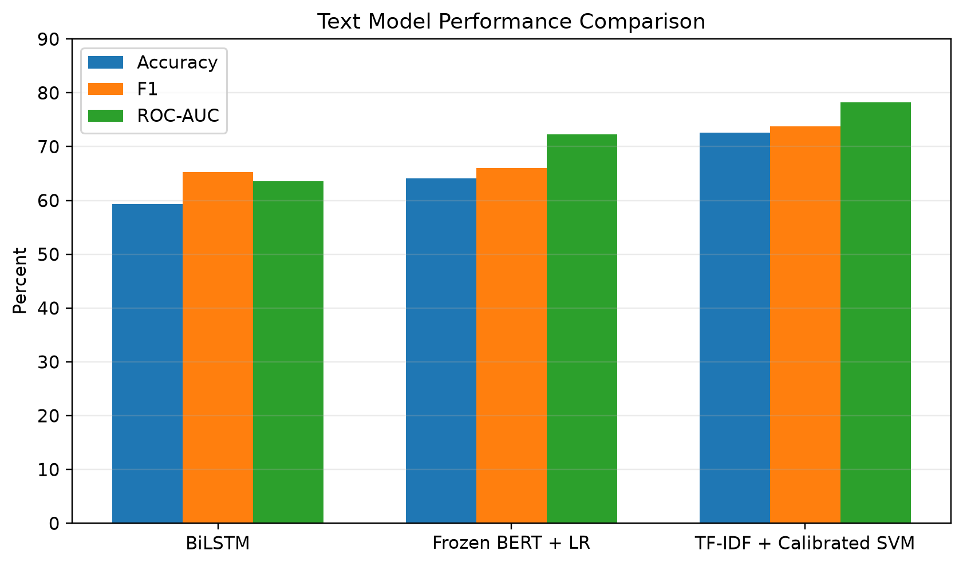
Figure 8.1: Text Model Performance Comparison

8.1 Text Model Results
Model | Accuracy | Precision | Recall | F1 | ROC-AUC
BiLSTM | 59.37% | 57.77% | 75.13% | 65.32% | 63.58%
Frozen BERT + LR | 64.12% | 63.77% | 68.39% | 66.00% | 72.27%
TF-IDF + Calibrated SVM | 72.56% | 71.92% | 75.65% | 73.74% | 78.22%
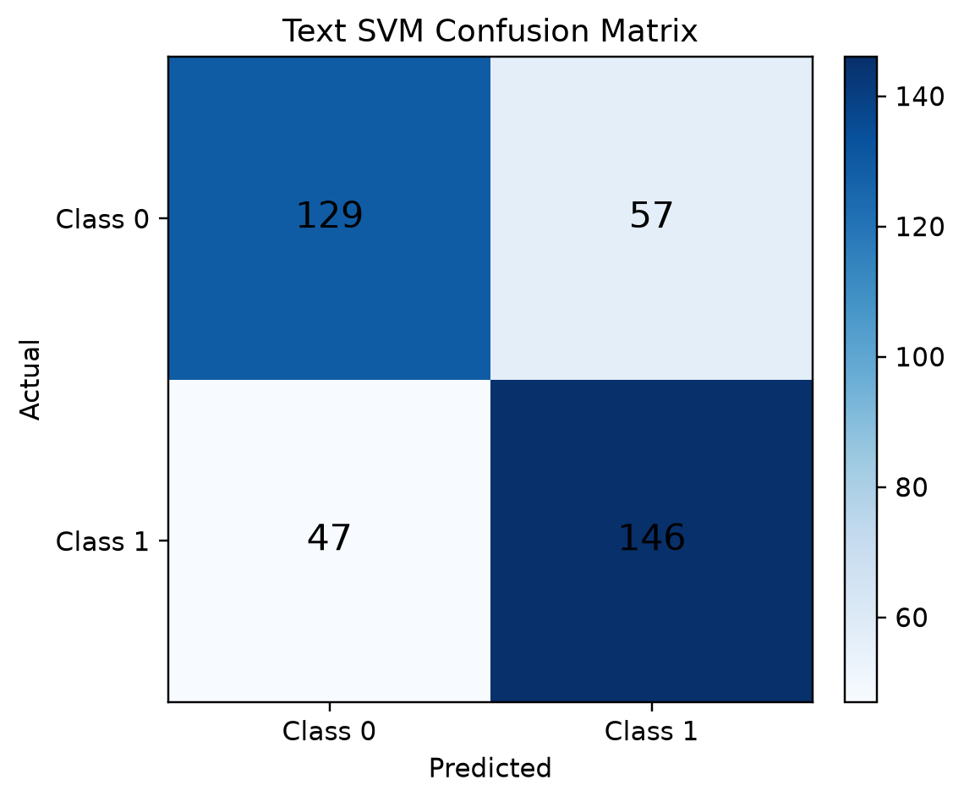
Figure 8.2: Text SVM Confusion Matrix

8.2 Speech Model Results
The participant-aggregated EATD validation result at the train-selected threshold of 0.38 is reported below. Accuracy alone is not sufficient because the validation set is imbalanced; therefore balanced accuracy, recall, F1 and ROC-AUC are also reported.
Accuracy | 63.29%
Balanced Accuracy | 63.44%
Precision | 21.88%
Recall | 63.64%
F1-score | 32.56%
ROC-AUC | 59.22%
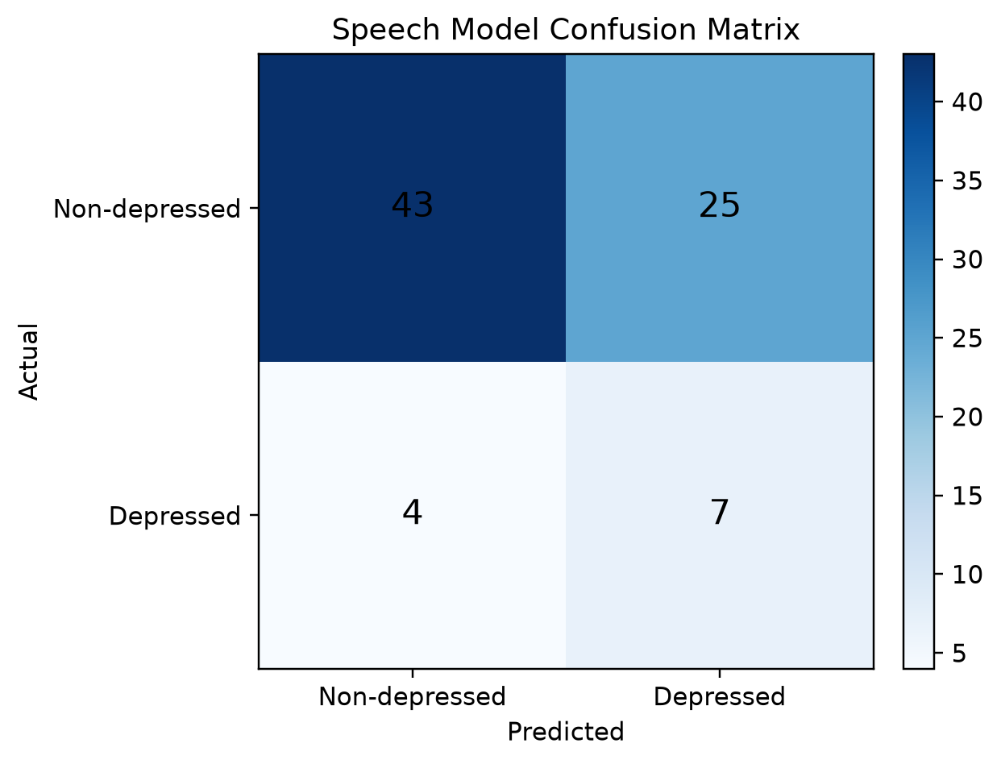
Figure 8.3: Speech Model Confusion Matrix

8.3 Application Output
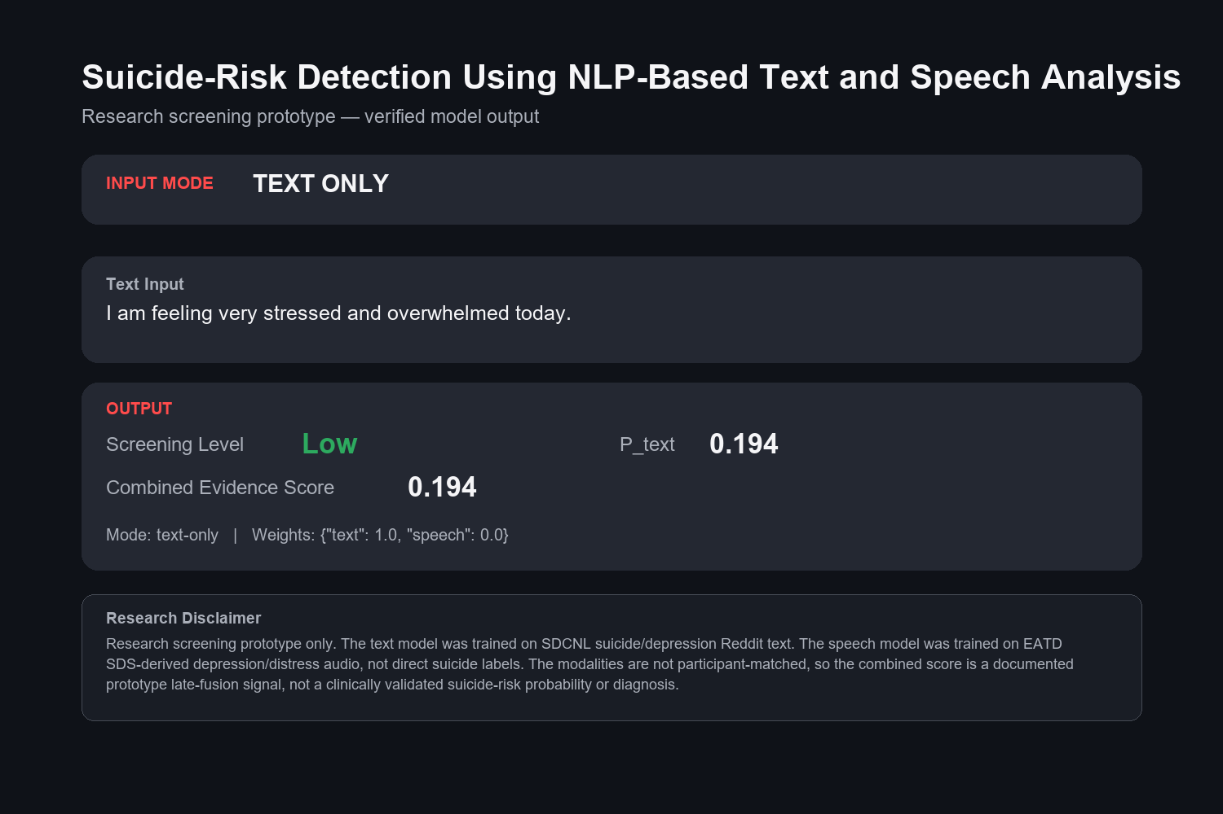
Figure 8.4: Text-only Output
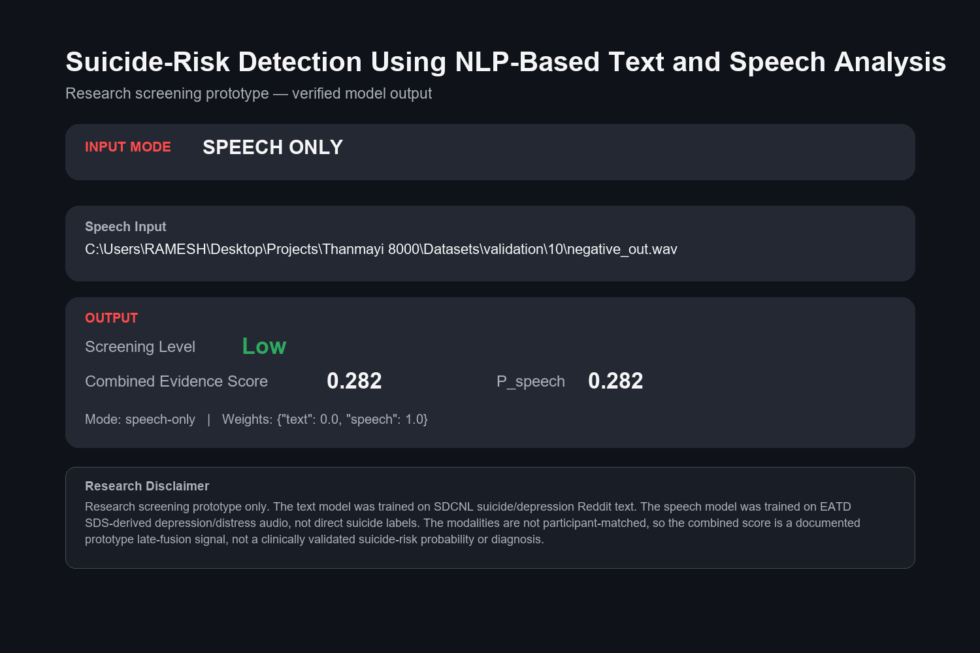
Figure 8.5: Speech-only Output
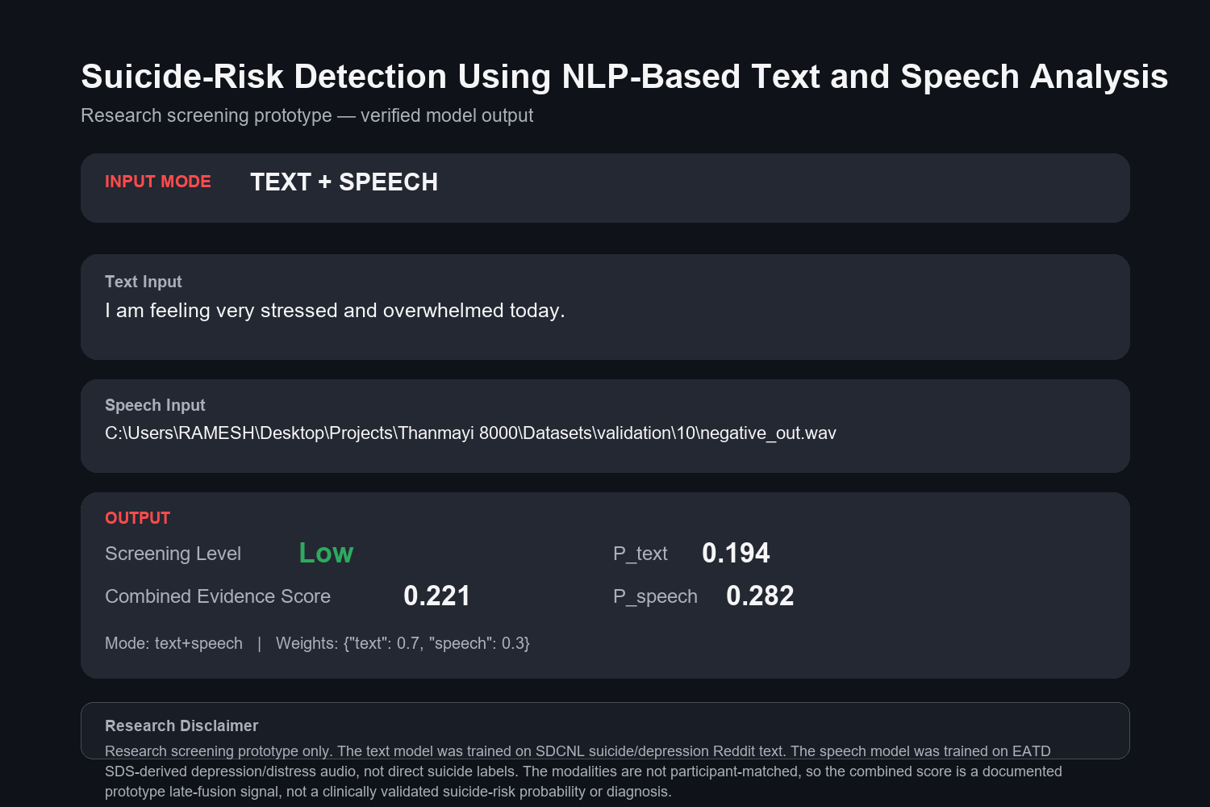
Figure 8.6: Text + Speech Output
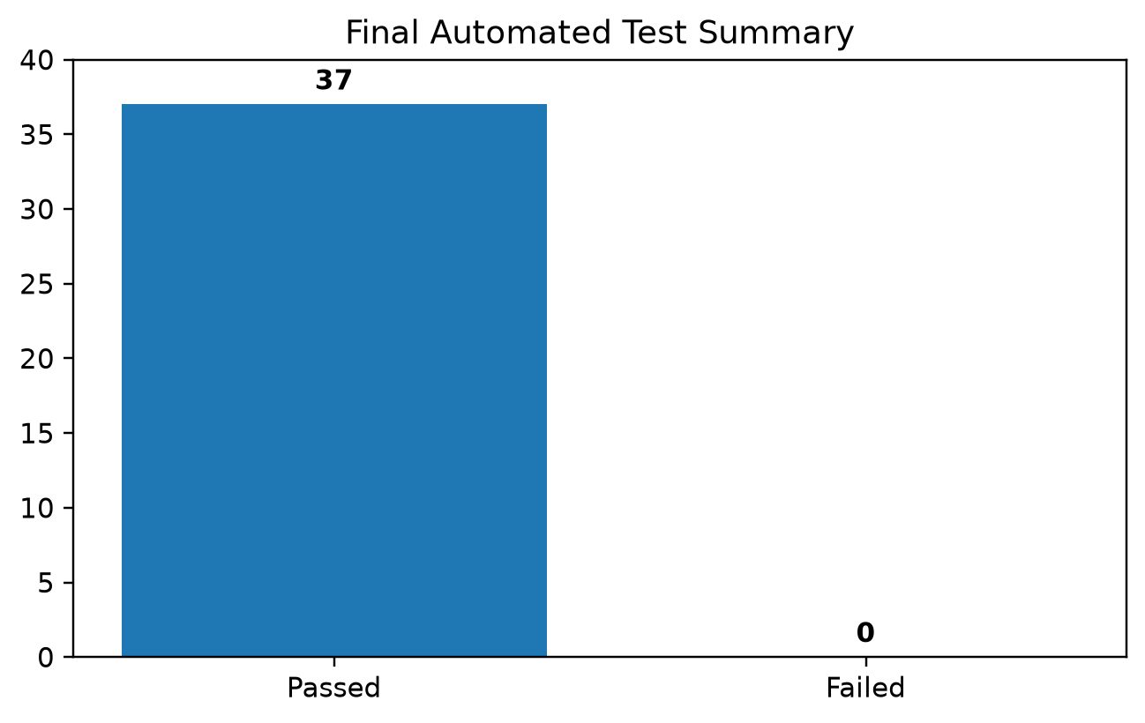
Figure 8.7: Final Automated Test Summary
The final automated suite passed 37 checks with zero failures. The generated UI outputs confirm that text-only, speech-only and combined modes execute using the saved model artifacts.

CHAPTER - 9

9. CONCLUSION
This project implemented and verified a modular suicide-risk research-screening prototype using NLP-based text analysis and complementary speech distress analysis. The SDCNL text data were cleaned with explicit duplicate handling and leakage verification, producing a final 1,513-row training set and a fixed 379-row held-out test set with zero normalized text overlap.
Three text-model approaches were compared under the same test conditions. TF-IDF with calibrated Linear SVM produced the best verified text performance with 72.56% accuracy, 73.74% F1-score and 78.22% ROC-AUC. The speech branch was implemented using EATD acoustic features and participant-grouped model selection. Its official participant-level validation performance is modest and is therefore reported transparently rather than overstated.
The final Streamlit application supports text-only, speech-only and combined modes. Since SDCNL and EATD describe different participants and different targets, the project intentionally avoids invalid row-wise multimodal training. The combined decision is a transparent prototype late-fusion evidence score rather than a clinically calibrated suicide-risk probability.
The final implementation, models, diagrams, documentation and automated verification are complete for the available datasets and the scientifically supportable project architecture. The system is suitable for academic demonstration and research experimentation, but it is not a substitute for professional mental-health assessment or clinical diagnosis.

CHAPTER - 10

10. FUTURE ENHANCEMENT
Future work should prioritize collection or access to a genuinely paired multimodal dataset in which speech, text and suicide-risk labels come from the same participants. Such data would enable supervised multimodal fusion and statistically valid estimation of final multimodal performance.
The speech branch can be strengthened using larger multilingual datasets, self-supervised speech representations and external validation across languages and demographic groups. Because EATD is primarily Chinese and uses depression/distress labels, future suicide-specific acoustic datasets would improve target validity.
The text branch can be extended with fully fine-tuned transformer models, stronger calibration, explainability methods and robust evaluation under domain shift. Any increase in model complexity should continue to use leakage-free evaluation and fixed held-out testing.
Finally, a future production research platform could add consent-aware data collection, secure storage, audit logging and clinician-reviewed escalation pathways. Such deployment would require ethical review, privacy controls and independent clinical validation before use in real-world healthcare.

REFERENCES
[1] A. Haque, V. Reddi, and T. Giallanza, “Deep Learning for Suicide and Depression Identification with Unsupervised Label Correction,” in Proc. 30th International Conference on Artificial Neural Networks (ICANN), 2021, pp. 436–447, doi: 10.1007/978-3-030-86383-8_35.
[2] Y. Shen, H. Yang, and L. Lin, “Automatic Depression Detection: an Emotional Audio-Textual Corpus and A GRU/BiLSTM-Based Model,” in Proc. IEEE ICASSP, 2022, doi: 10.1109/ICASSP43922.2022.9746569.
[3] J. Pokrywka, J. I. Kaczmarek, and E. J. Gorzelańczyk, “Evaluating Transformer Models for Suicide Risk Detection on Social Media,” in 2024 IEEE International Conference on Big Data, 2024, doi: 10.1109/BigData62323.2024.10826094.
[4] J. Jin, Y. Liu, and Y. Dai, “Multimodal Speech and Text Models to Detect Suicidal Risks in Adolescents,” medRxiv, 2025, doi: 10.1101/2025.07.31.25332367.
[5] J. Devlin, M.-W. Chang, K. Lee, and K. Toutanova, “BERT: Pre-training of Deep Bidirectional Transformers for Language Understanding,” in NAACL-HLT, 2019.
[6] F. Pedregosa et al., “Scikit-learn: Machine Learning in Python,” Journal of Machine Learning Research, vol. 12, pp. 2825–2830, 2011.
[7] B. McFee et al., “librosa: Audio and Music Signal Analysis in Python,” in Proc. 14th Python in Science Conference, 2015.
[8] SDCNL project repository and dataset, A. Haque et al., https://github.com/ayaanzhaque/SDCNL.
[9] EATD-Corpus project repository, https://github.com/speechandlanguageprocessing/ICASSP2022-Depression.
[10] Streamlit documentation, https://docs.streamlit.io/.

Note: Reference metadata for the core SDCNL and EATD studies is based on their published proceedings and official project pages. Project-specific experimental results in this report are taken from the verified local model metric files.

APPENDIX

Suicide-Risk Detection Using NLP-Based Text and Speech Analysis
Dr. G. Rajendra | S. Thanmayi | Ch. Venu Madhav | M. Samuel Babu
Department of Information Technology, Lakireddy Bali Reddy College of Engineering, Mylavaram, India
Abstract— This article presents the current implementation of a multimodal suicide-risk research-screening framework using independent NLP text analysis and acoustic speech analysis. The SDCNL text branch compares BiLSTM, frozen BERT embeddings with Logistic Regression, and TF-IDF with calibrated Linear SVM. On the fixed leakage-free test set, the calibrated SVM achieved 72.56% accuracy, 73.74% F1 and 78.22% ROC-AUC. The EATD speech branch uses participant-safe acoustic modelling and provides a complementary depression/distress score. Because the datasets are unmatched, only transparent late decision fusion is used.
I. INTRODUCTION Automated analysis of digital language and speech can support research into early mental-health screening. This project focuses on a scientifically cautious architecture that keeps text suicide-related evidence separate from speech depression/distress evidence until the final decision stage.
II. METHODOLOGY The text branch uses leakage-free SDCNL splits and three model families. The speech branch uses EATD audio processed at 16 kHz with MFCC, pitch, RMS, ZCR, spectral centroid and duration features. Participant-grouped cross-validation is used for speech model selection. Combined mode applies a transparent 0.70/0.30 text/speech weighting.
III. RESULTS The calibrated text SVM achieved 72.56% accuracy, 71.92% precision, 75.65% recall, 73.74% F1 and 78.22% ROC-AUC. Participant-aggregated EATD validation for the operational speech model achieved 63.29% accuracy, 63.44% balanced accuracy and 59.22% ROC-AUC. The final automated verification suite passed 37/37 checks.
IV. CONCLUSION The project demonstrates a complete academic prototype with independent branch evaluation, transparent fusion, Streamlit UI and automated verification. The system is not clinically validated and does not claim a final multimodal accuracy because the underlying datasets are not paired.
REFERENCES
[1] A. Haque, V. Reddi, and T. Giallanza, “Deep Learning for Suicide and Depression Identification with Unsupervised Label Correction,” in Proc. 30th International Conference on Artificial Neural Networks (ICANN), 2021, pp. 436–447, doi: 10.1007/978-3-030-86383-8_35.
[2] Y. Shen, H. Yang, and L. Lin, “Automatic Depression Detection: an Emotional Audio-Textual Corpus and A GRU/BiLSTM-Based Model,” in Proc. IEEE ICASSP, 2022, doi: 10.1109/ICASSP43922.2022.9746569.
[3] J. Pokrywka, J. I. Kaczmarek, and E. J. Gorzelańczyk, “Evaluating Transformer Models for Suicide Risk Detection on Social Media,” in 2024 IEEE International Conference on Big Data, 2024, doi: 10.1109/BigData62323.2024.10826094.
[4] J. Jin, Y. Liu, and Y. Dai, “Multimodal Speech and Text Models to Detect Suicidal Risks in Adolescents,” medRxiv, 2025, doi: 10.1101/2025.07.31.25332367.

