

**KESHAV MEMORIAL INSTITUTE OF TECHNOLOGY**

PROJECT SCHOOL CERTIFICATE

**PROJECT TITLE:** Indoor navigation for museum (mobile app)

**FACULTY INCHARGE:** Dr. S. Rajasekaran

**DURATION OF PROJECT:** 19/11/2022 - 4/2/2023

**NAME**: Banda Aakash

**CLASS**: II CSM-A

**ROLL-NO**: 21BD1A660E

Signature of Faculty Signature of Student

# TECHNOLOGIES USED:

* **React native** is used for Front-End development of mobile application.
* **Firebase** is used as database for storing user credentials and for authentication of user details.
* **SVG** is used for creating maps.
* **Figma** is used to design maps.

# ALGORITHMS USED:

* **Dijkstra's Algorithm** is used to find shortest distance between the source and the destination.

# OBJECTIVES:

* To create a mobile application consisting of a homepage

which receives users' credentials using React Native and allows them to access the map.

* Firebase is used to store the user credentials.
* The user can click on the source and the destination on the map so that it displays the shortest distance between the source and the destination for the user.

# PROJECT DESCRIPTION:

* Firstly, a Login/ Signup page is displayed. If the user is new to the app, he/she must register to the app with email id, password and name. Otherwise, the user can directly Login.
* After login, the user is directed to the MUSEUM MAP
* After choosing the source and destination, the user clicks on **Get Path** button which display’s the shortest path between the source and the destination.
* The user can reset the source and destination by clicking the **Reset Path** button and can once again choose a different destination and/or source, to get the shortest path.
* Current source and destination are displayed at the bottom of the page.

# IMPLEMENTATION:

## 1.Creating login/signup page:

React Native is a Java-script framework for building Native mobile apps using react.

By using React Native, a login and a signup page is created. If the user is new to the app he/she needs register with their mail-id , name and password which is stored in the firebase database.

If the user has already used the app previously he/she can login to the app with their registered mail-id and password.

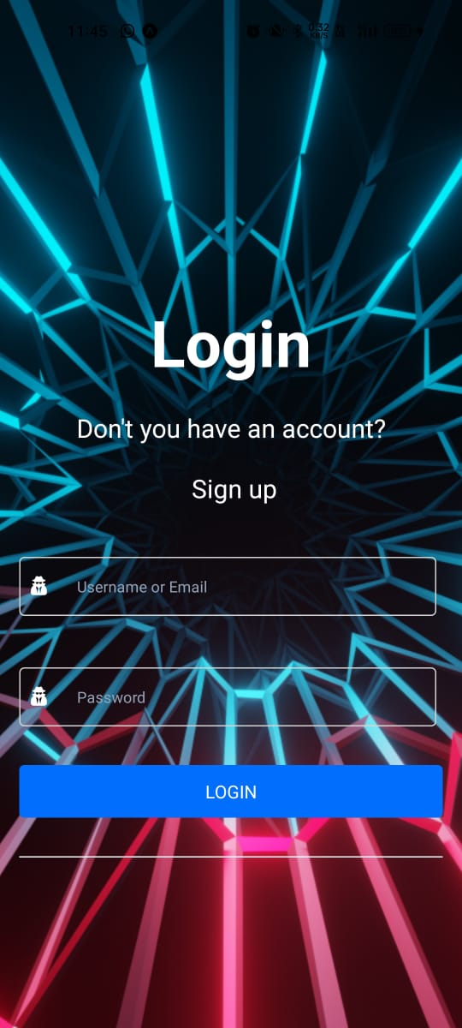 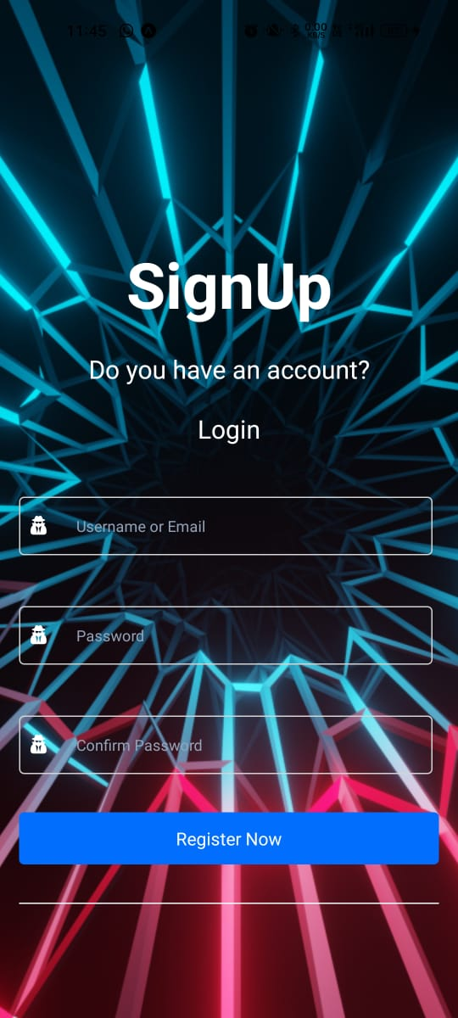

Fig1: Login/Register page

## 2. Storing user credentials in Firebase

Firebase Real-time Database is a cloud-hosted database. If the user is new to the app, the user can register to the app with his respective mail-id and password. Firebase Authentication is used to add a complete sign-in system to the app. When the user registers with a mail id and password, the registered mail id is stored in firebase authentication page. When the user visits the app again he needs to just login with the registered mail id and password and he will be directed to the map.

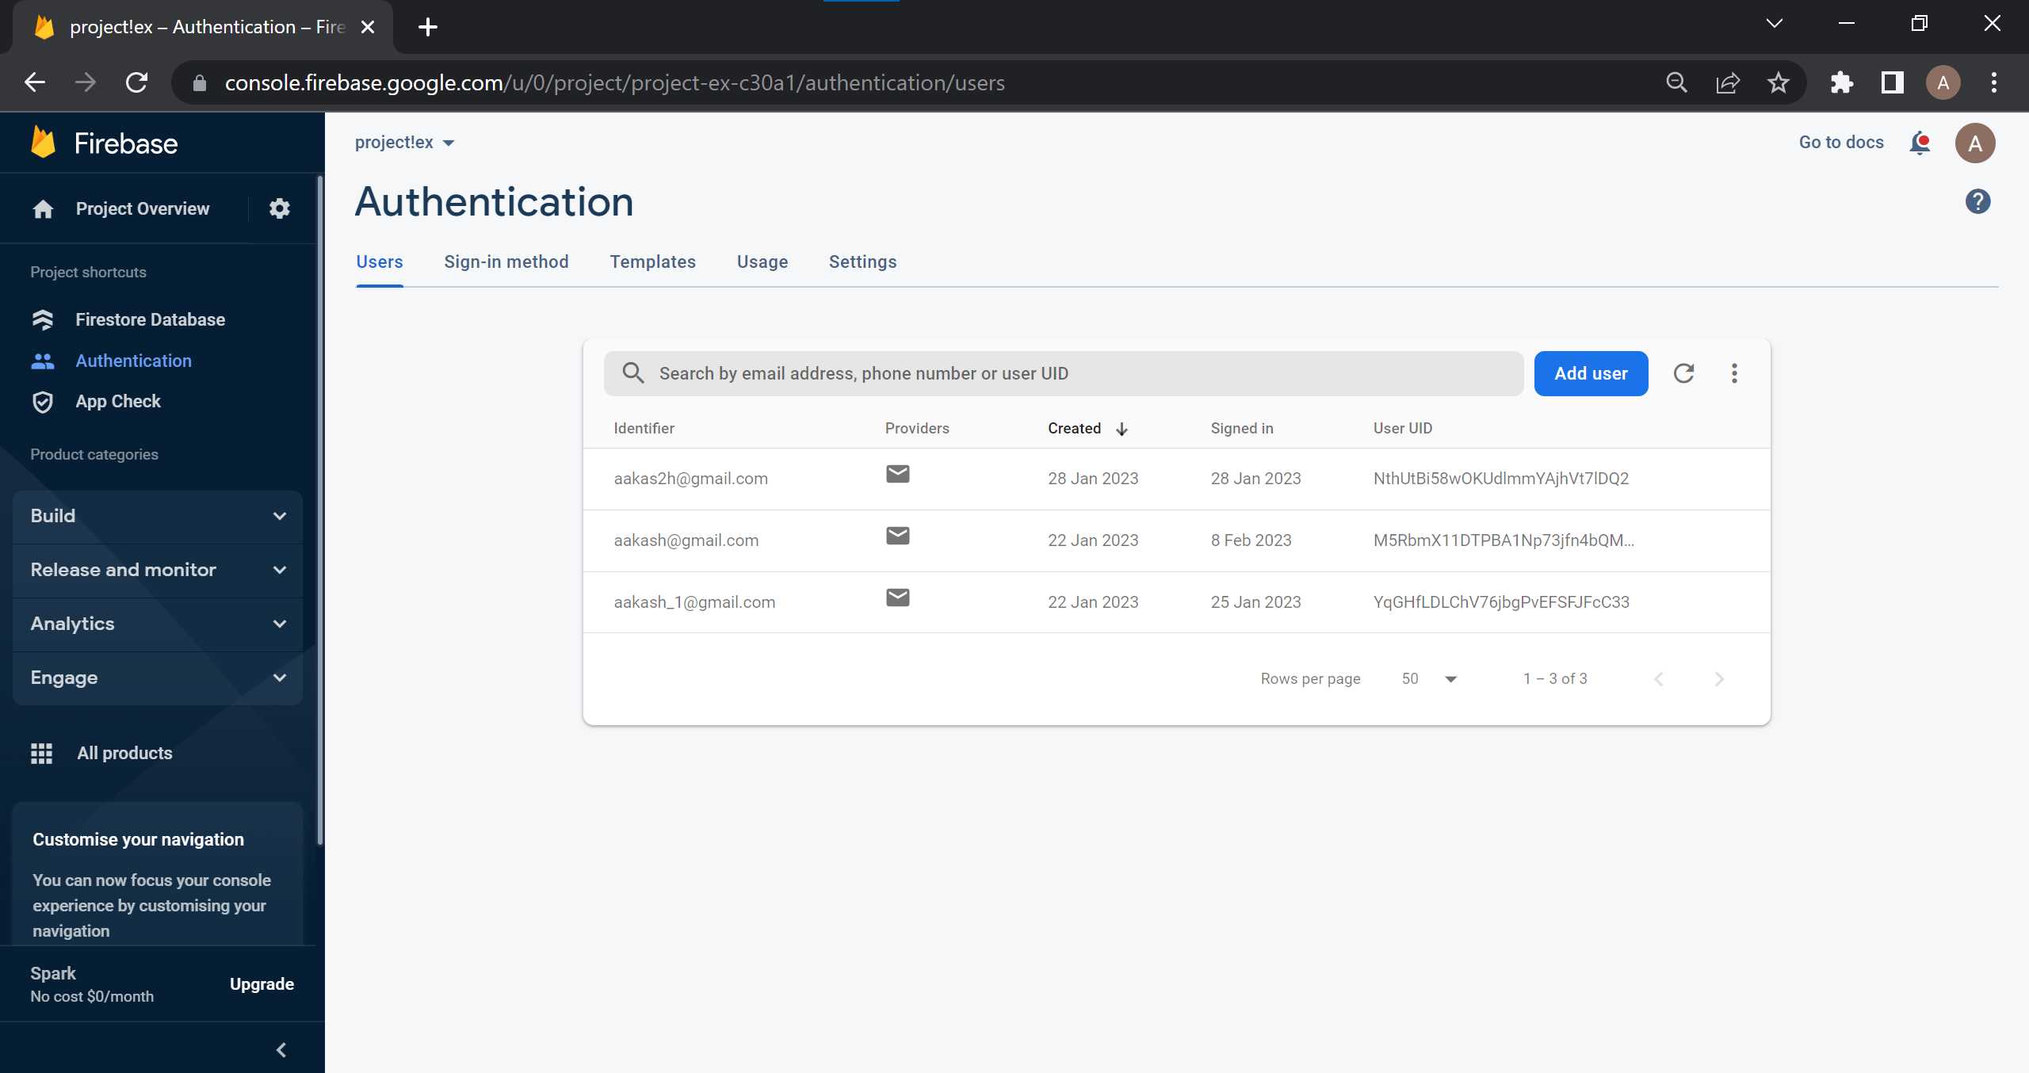

Fig2: User credentials in Firebase authentication page

3.Creating a map using Figma:

Figma is a design tool that helps us to design logs, web applications, maps etc. Here Figma is used to design a map so that the user can easily understand the map. After creating and designing the map in Figma, the map is exported as SVG.

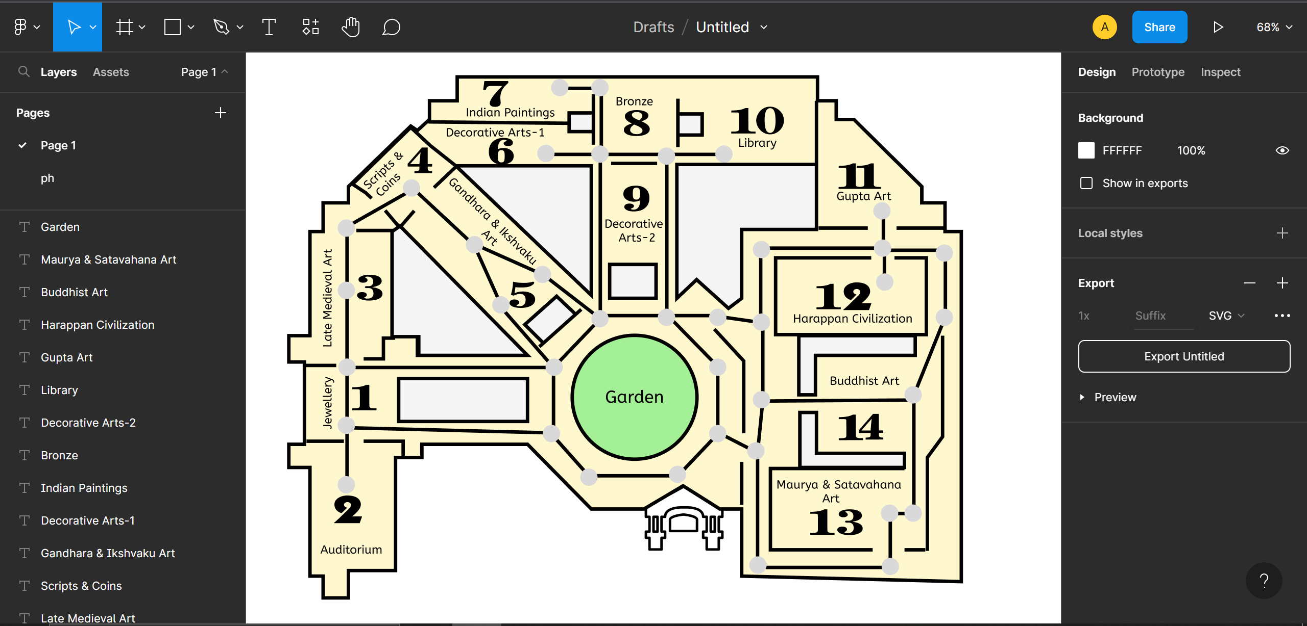

Fig3: Creating a map using Figma

4. Connecting Dijkstra’s algorithm to map:

Dijkstra’s algorithm is used to find the shortest distance between two nodes in a graph. In this mobile application Dijkstra’s algorithm is used to find the shortest path between the source and destination.

Dijkstra’s algorithm using priority queues has been used in this

mobile application. When the user is directed to map page he has to choose the destination by clicking on the desired destination. When the user clicks on GET PATH button Dijkstra’s algorithm runs in the backend and the shortest path between the source and destination is highlighted so that the user can see the shortest route between source and destination.

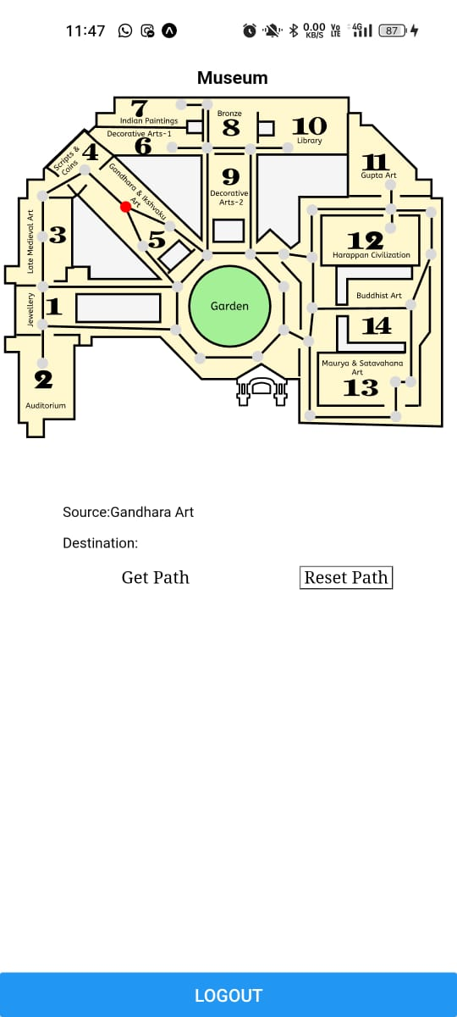 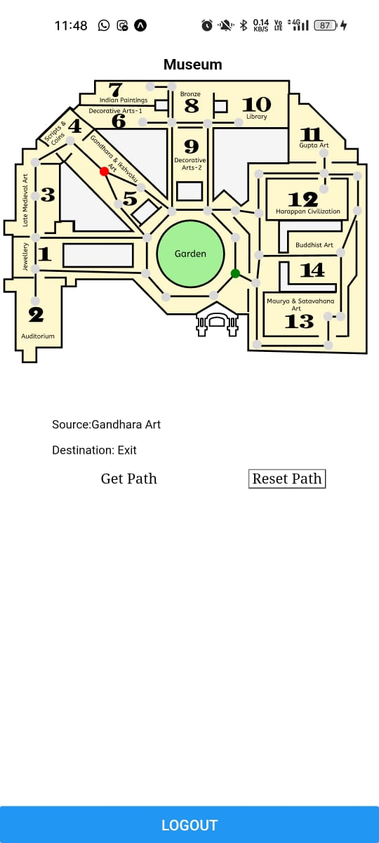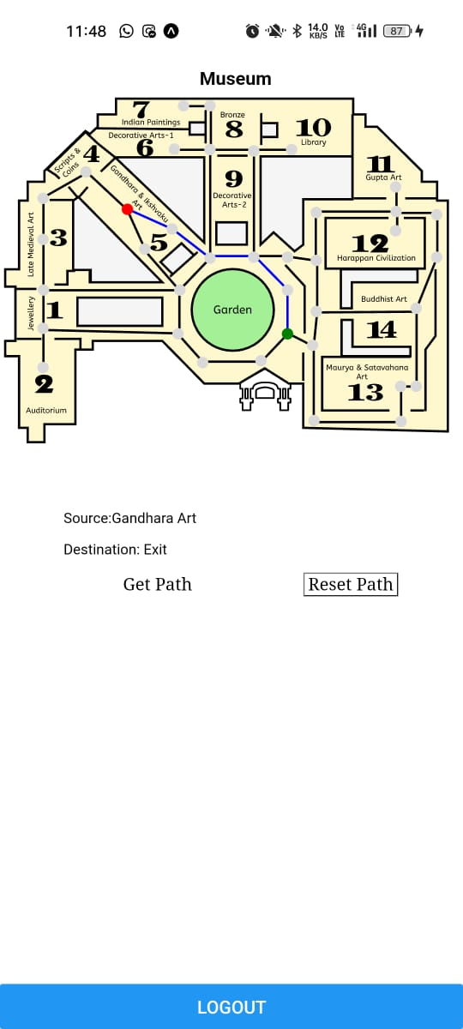 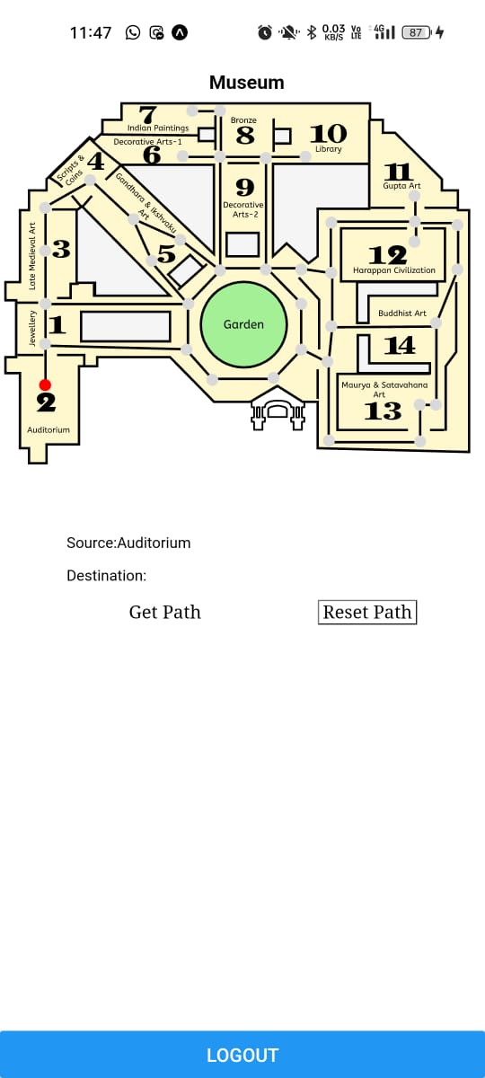 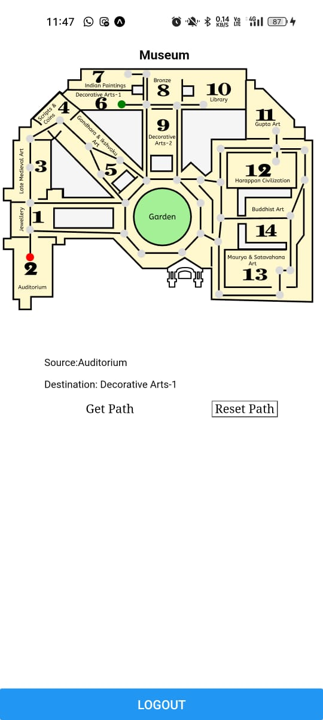 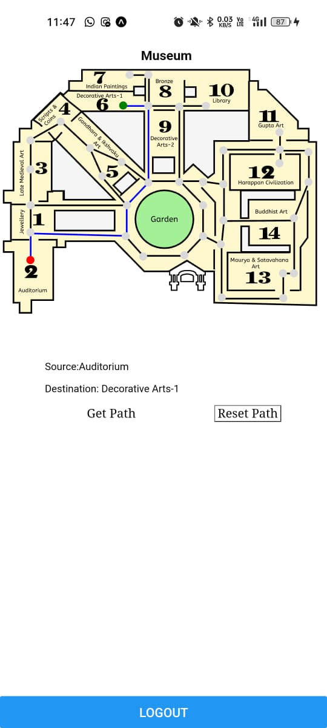

Selecting Destination

Selecting Source

Selecting other Source

Getting the Shortest Path

Getting the Shortest Path

Selecting other Destination

SUMMARY:

This mobile application consists of a map. The user can find the shortest path on the map between the desired source and the

desired destination.