File name: Day1 – 109347652 – Thanmy  
  
**What is SDLC:**

The Software Development Life Cycle (SDLC) is a structured step-by-step process used by software engineering teams to design, develop, test, deploy, and maintain high-quality software efficiently and cost-effectively. SDLC breaks down software development into distinct. SDLC provides a clear roadmap for managing software projects, improving visibility, planning, and risk management throughout the software's lifecycle.

**Why we need SDLC:**

1. ***Provides Structure:*** SDLC offers a clear step- by-step process, making complex projects easier to manage.
2. ***Improves Planning***: It helps teams estimate time, resources, and costs more accurately.
3. ***Ensures Quality:*** Systematic testing at each stage ensures the software works as intended.
4. ***Facilitates Maintenance:*** Makes it easier to update and fix the software after release.
5. ***Increases Efficiency:*** Streamlines tasks and avoids unnecessary work.
6. ***Ensures Customer Satisfaction:*** Helps ensure the final product meets user needs and requirements.

**Steps of SDLC:**

1. ***Planning:*** Define project goals, scope, timelines, and resources.
2. ***Requirements Analysis***: Gathering and analyzing what the software needs to do, based on user input. **Divided in to sprints**
3. ***Design:*** Create the architecture and detailed design of the software, including user interfaces and system components.
4. ***Implementation (Coding):*** write the actual code based on the design specifications.
5. ***Testing:*** Test the software to find and fix bugs, and ensure it meets requirements and works as intended.
6. ***Deployment:*** Release the software to users.
7. ***Maintenance:*** Provide ongoing support, fix issues, and update the software as needed.

**SDLC models:**

* Waterfall
* V-model
* Iterative
* Spiral
* Incremental
* Agile
* Big Bang

***Waterfall:*** A linear and sequential model where each phase must be completed before the next begins (cascading). It is useful for simple projects.

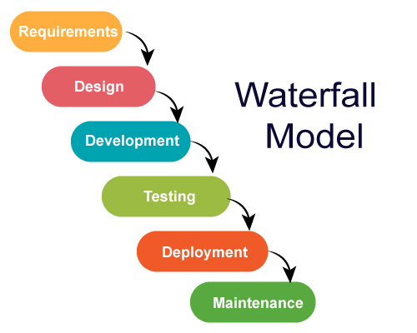

***V-Shaped (Validation and Verification):*** An extension of Waterfall here for each development stage has a testing phase. In this early testing will done.

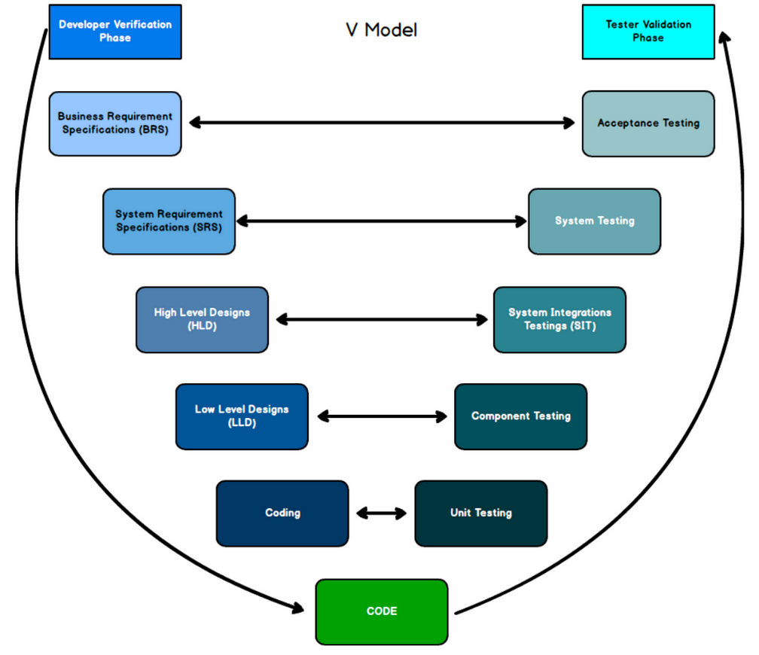

***Iterative:*** Develops the software in repeated cycles, based on the feedback from each cycle improvement will be done respectively.

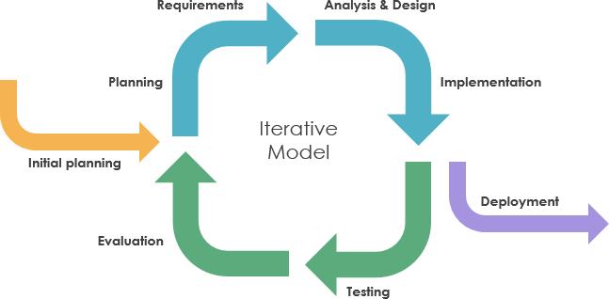

***Spiral:*** Combines iterative development with risk analysis, focuses on identifying and resolving risks at each loop it is used for large and high-risk projects.

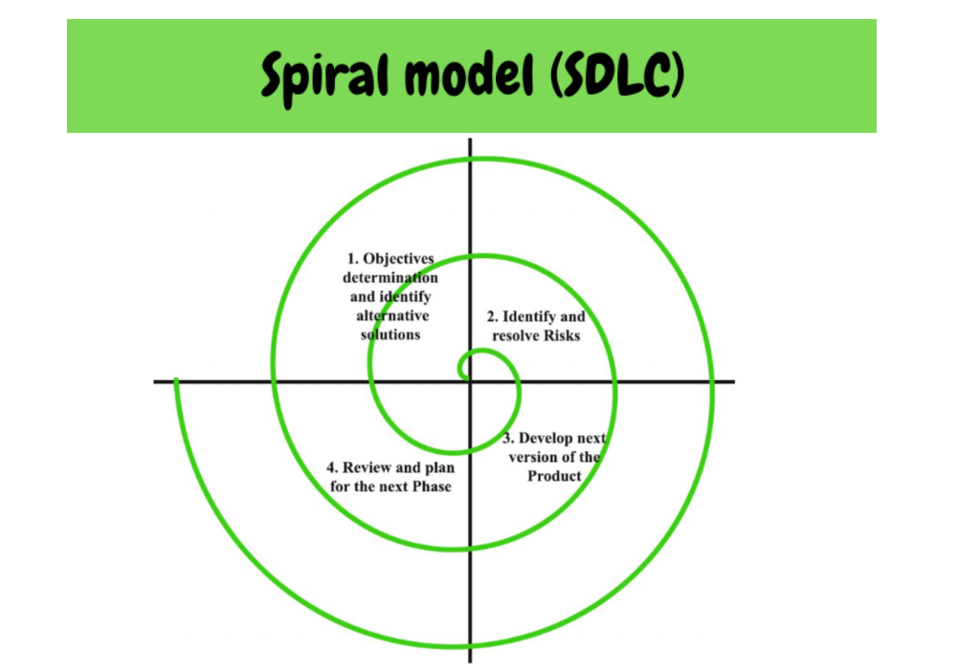

***Incremental Model:*** In this model the product is developed in small parts, for each increment adds functionality to the previous part. It Is used for the projects that need early releases

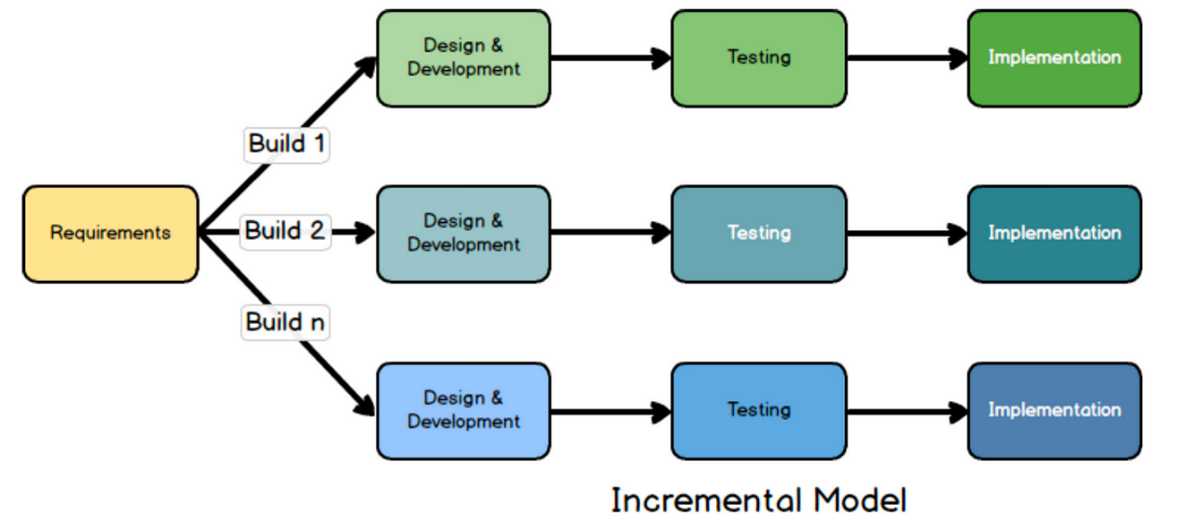

***Big Bang:*** It don’t have any structured planning it starts with Minimal planning; coding starts immediately based on initial ideas. It is used for very small or experimental projects.

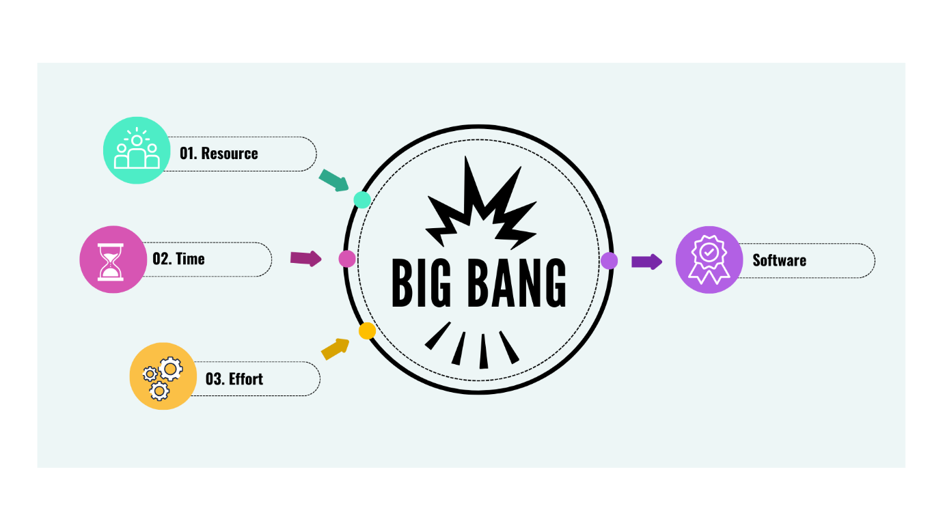

***Agile:*** It is an iterative and incremental approach it focuses on customer collaboration and flexibility. It is used for dynamic projects with frequent changes. (It uses Scrum frameworks)

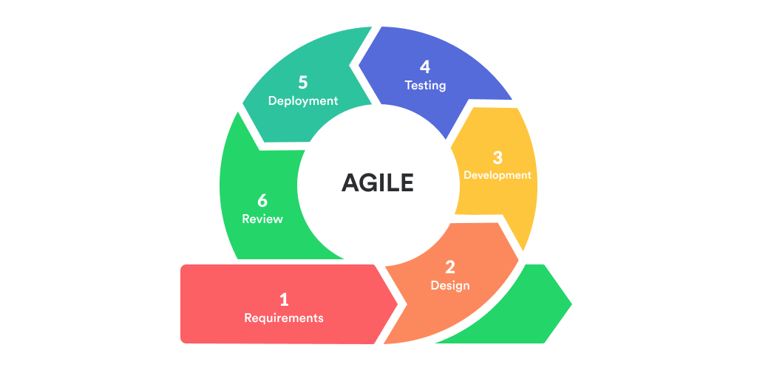

**Different network Types:**

* Personal Area Network (PAN)
* Local Area Network (LAN)
* Wireless Local Area Network (WLAN)
* Metropolitan Area Network (MAN)
* Wide Area Network (WAN)
* Virtual Private Network (VPN)
* Campus Area Network (CAN)
* Cloud-Based Network (CBN)

**Type of servers:**

***Web Server:*** Hosts websites and delivers web pages to users over the internet using **HTTP/HTTPS** protocols. It stores website data and responds to browser requests.

***File Server:*** Stores and manages files, allowing users to upload, download, and share documents or data across a network. Common in organizations for centralized file access.

***Database Server:*** Manages and provides access to databases, handling data storage, retrieval, and management for applications and users.

***Application Server:*** Runs specific applications and delivers their functions to client computers over a network, enabling centralized management and access to business software.

***Mail Server:*** Handles the sending, receiving, and storage of email messages for users within a network.

***Proxy Server:*** Acts as an intermediary between client devices and other servers, improving security, filtering content, and managing requests.

***FTP Server:*** Facilitates the transfer of files between computers using the File Transfer Protocol, often used for uploading or downloading large files.

***Virtual Server:*** Runs multiple virtual machines on a single physical server, allowing for efficient resource use and flexible deployment.

**what is TCP and UDP? What is the difference?**

TCP (Transmission Control Protocol) is a connection-oriented protocol that ensures reliable, ordered delivery of data with error checking and retransmission if packets are lost. UDP (User Datagram Protocol) is connectionless, faster, and lightweight, but does not guarantee delivery, order, or error correction.

***Difference:***

TCP is reliable and slower, used for tasks like web browsing and email.

***V/S***

UDP is faster but less reliable, suitable for real-time applications like video streaming and online gaming.

**What do you know about mac address? What is the difference between Mac address and IP address?**

A MAC address is a unique hardware identifier assigned to a device's network card, used for communication within a local network. An IP address is a logical address assigned to a device for identifying it on a network or the internet.

***Difference:***

MAC address works at the local (hardware) level and doesn't change.

***V/S***

IP address works at the network (software) level and can change depending on the network.

**What is OSI model?**

The OSI (*Open system interconnection*) model is a framework that explains how computers communicate over a network by dividing the process into seven layers. Each layer has a specific role, from sending raw data (Physical Layer) up to providing services for applications like web browsers and email (Application Layer). This model helps people understand, design, and troubleshoot networks more easily.

**1. Physical Layer (Layer 1)**

***Function:*** Transfers raw bits (0s and 1s) over physical media.

Examples: Cables, switches, connectors.

**2. Data Link Layer (Layer 2)**

***Function:*** Ensures data transfer between two devices on the same network.

Examples: MAC address, Ethernet.

**3. Network Layer (Layer 3)**

***Function:*** Handles data routing and forwarding across networks.

Examples: IP address, routers.

**4. Transport Layer (Layer 4)**

***Function:*** Provides data transfer, flow control, and error checking.

Examples: TCP, UDP.

**5. Session Layer (Layer 5)**

***Function:*** Manages sessions or connections between applications.

Examples: Logins.

**6. Presentation Layer (Layer 6)**

***Function:*** Translates, encrypts, and compresses data for the application layer.

Examples: Data formatting (JPEG, MP4), encryption (SSL/TLS).

**7. Application Layer (Layer 7)**

***Function:*** Provides services and interfaces for end-user applications.

Examples: Web browsers, email clients, HTTP, DNS.

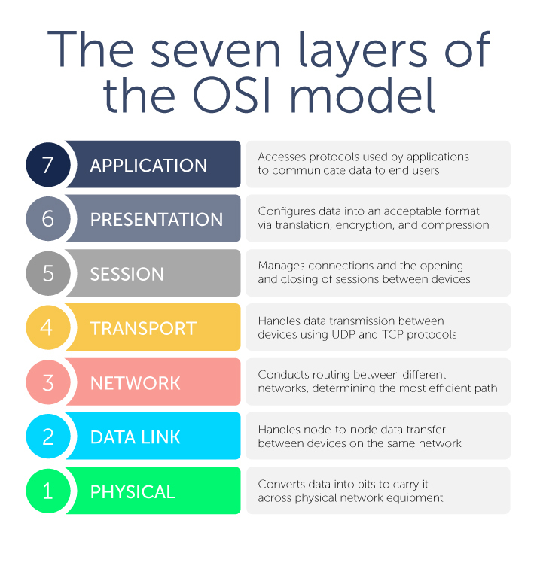

**What is an IPv4 address? What are the different classes of IPv4?**

***IPv4 address:*** A 32-bit number used to identify devices on a network, written as four decimal numbers separated by dots (e.g., 192.168.1.1).

IPv4 Classes:

* Class A: 1-126 (large networks)
* Class B: 128-191 (medium networks)
* Class C: 192-223 (small networks)
* Class D: 224-239 (multicast)
* Class E: 240-255 (experimental)

Classes A, B, and C are for regular hosts; D is for multicast; E is reserved.

**What are the advantages of using VPN?**

***Enhanced Privacy and Security:*** VPNs encrypt our internet traffic, hiding our IP address and protecting sensitive data from hackers, ISPs, and trackers, especially on public Wi-Fi

***Safe Public Wi-Fi Use:*** VPNs secure our connection on unsecured public networks, preventing data theft or spying.

***Access to Geo-Restricted Content:*** VPNs let us connect through servers in other countries to access content or services blocked in our location.

***Bypass Censorship and Throttling:*** VPNs help bypass government or ISP restrictions and prevent bandwidth throttling by hiding our activity type.

**Types of VPN**

* ***Access VPN (Remote Access VPN):*** Allows individual remote users to securely connect to a private network from any location over the internet.
* ***Site-to-Site VPN:*** Connects entire networks at different locations, enabling secure communication between offices or branches.
* ***Intranet VPN:*** Connects multiple sites of the same organization, providing secure internal connectivity across company locations.
* ***Extranet VPN:*** Extends a company's network to external partners, suppliers, or customers for secure shared access to specific resources.

**What is Network topology?**

Network topology is the pattern or structure in which devices and connections are arranged in a network, showing how they communicate with each other.

**Different types of network topology**

* ***Bus Topology:*** All devices share a single communication line or cable.
* ***Star Topology:*** All devices connect to a central hub or switch.
* ***Ring Topology:*** Each device connects to two others, forming a circular path.
* ***Mesh Topology:*** Every device connects directly to every other device.
* ***Tree Topology:*** A hierarchical combination of star and bus topologies.
* ***Hybrid Topology:*** A mix of two or more different topology types.
* ***Point-to-Point Topology:*** Direct connection between two devices.

**What is extended bus topology? its Tree Topology.**

Extended Bus Topology is a network topology where a central bus (main cable) has branches with additional nodes or segments attached. It is an expansion of the basic Bus Topology, which has a single main cable with all nodes connected directly to it.

**What is the use of a router and how is it different from a gateway?**

* ***Router*** connects two similar networks (like our home Wi-Fi to the internet) and sends data to the right device using IP addresses.
* ***Gateway*** connects two different types of networks (like our network and a different protocol network) and translates between them.

Router = Same type networks

Gateway = Different type networks