Task 1:
What is a Process?
In computing, a process is an instance of a computer program that is currently being executed. It's more than just the program code; it's an active entity that includes the program counter, process stack, registers, and other information necessary for execution. Think of it as a program "in action".

import java.io.IOException;

public class ProcessExample {
public static void main(String[] args) {
try {
// Start a new process to open Notepad (Windows example)
Process process = Runtime.getRuntime().exec("notepad.exe");
System.out.println("Notepad process started.");

// Wait for the process to complete (optional)
process.waitFor();
System.out.println("Notepad process finished.");

// Check the exit value of the process
int exitCode = process.exitValue();
System.out.println("Exit code: " + exitCode);

} catch (IOException | InterruptedException e) {
e.printStackTrace();
}
}
}

Task2:
What is a Thread?
A thread is a lightweight unit of execution within a process. Think of it as a single sequence of instructions or tasks that can run concurrently within a program.

Task 3:
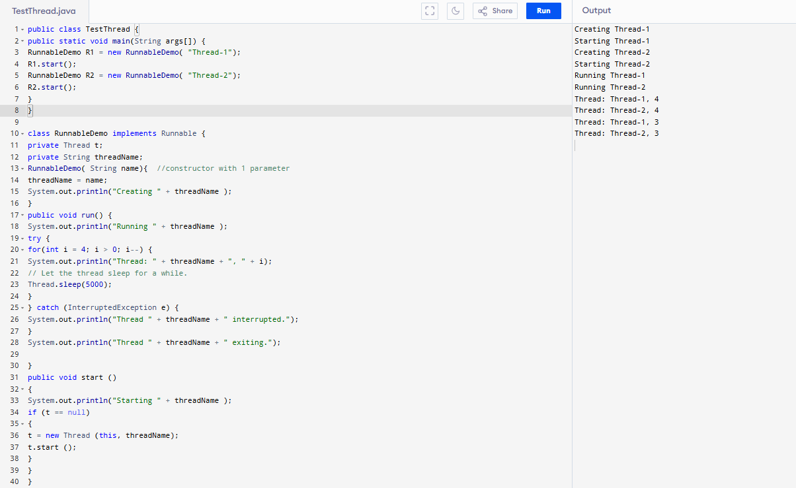

Task5:
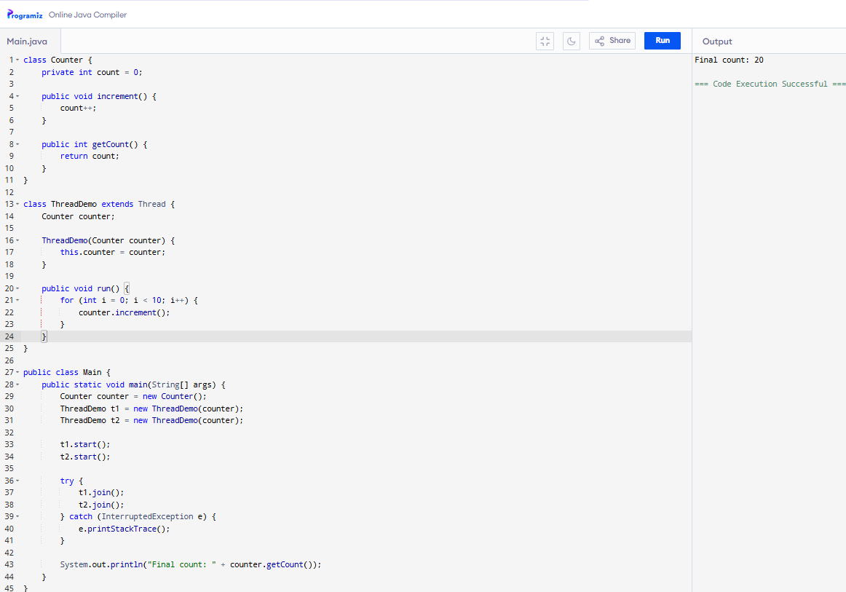

Task 12:
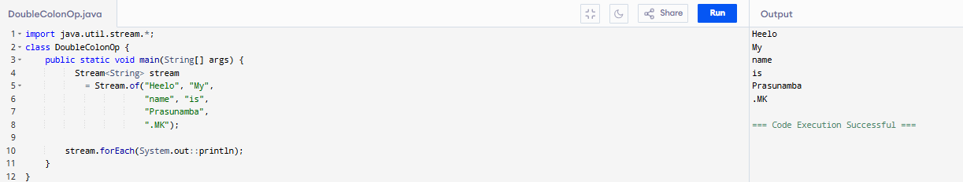

Task 16:

What are the debugging tools in Java.. list down a few.
Java Debugger (jdb), Eclipse, IntelliJ IDEA, NetBeans, and Visual Studio Code.

Task 16:

Type of Error Messages in Java

- Compile time and run time

- Compile time grammatical mistakes … ;, {} , missing the code

- Run time error or exceptions

- Stack overflow error

- Array index out of bounds
- IO exception

- Null pointer exception

Task 18:
