Task 1:
data structure is a way of organizing and storing data in a computer so that it can be accessed and used efficiently. Thinking of it as a blueprint for how data is arranged and manipulated within a program.

Task 2:
- Linear
- non-linear
Linear data structures store data in a sequential manner, while non-linear structures organize data in a hierarchical or interconnected way.

Task 3:
Data structures enable a variety of operations including insertion, deletion, traversal, searching, sorting, and merging.

Task 4:
Feature | Static Array | Dynamic Array
Size | Fixed and determined at compile time. | Variable and can change during runtime.
Performance | Faster element access (O(1)) and generally efficient execution time due to fixed size and contiguous memory allocation. | Faster access (O(1)) similar to static arrays. However, operations that require resizing, like adding elements beyond capacity or insertions/deletions in the middle, can be time-consuming (O(n)) due to memory allocation and copying.
Memory | Memory is allocated on the stack. Predictable memory usage but can lead to wasted space if size is overestimated. | Memory is allocated on the heap. More efficient memory utilization as it adjusts its size to the number of elements. Requires careful memory management to prevent leaks, especially in C++.
Flexibility | Limited flexibility as the size cannot be changed after declaration. | More flexible, allowing for adding or removing elements at runtime.
Limitations | Fixed size can be a drawback if the data set size varies significantly. Underestimating size can lead to data overflow, and overestimating can result in wasted memory. | Resizing can be expensive due to the need to allocate new memory and copy existing elements. Heap allocation can also be slower compared to stack allocation.

Task 5:
What is the binary value of a?
01100001

Task 6:
Types of Computer memory with examples. Explain ..
Computer memory can be broadly classified into primary (volatile and non-volatile) and secondary (non-volatile) storage. Primary memory, including RAM and ROM, provides fast access to actively used data and instructions, while secondary memory, like HDDs and SSDs, offers larger storage capacity with slower access speeds.

Task 7:
public class ReverseArray {
public static void main(String[] args) {
int[] arr = {10, 20, 30, 40, 50};
System.out.println("Original Array:");
for (int num : arr) {
System.out.print(num + " ");
}
int n = arr.length;
for (int i = 0; i < n / 2; i++) {
int temp = arr[i];
arr[i] = arr[n - 1 - i];
arr[n - 1 - i] = temp;
}
System.out.println("\nReversed Array:");
for (int num : arr) {
System.out.print(num + " ");
}
}
}

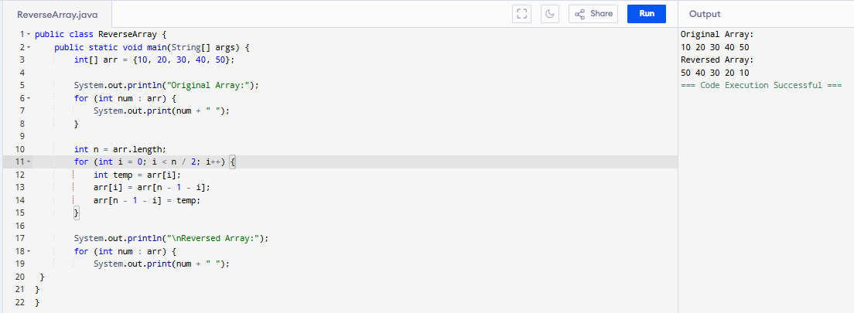

Task 8:
import java.util.Scanner;
public class ReverseName {
public static void main(String[] args) {
Scanner scanner = new Scanner(System.in);
System.out.print("Enter your name: ");
String name = scanner.nextLine();
String reversed = "";
for (int i = name.length() - 1; i >= 0; i--) {
reversed += name.charAt(i);
}
System.out.println("Reversed name: " + reversed);
}
}
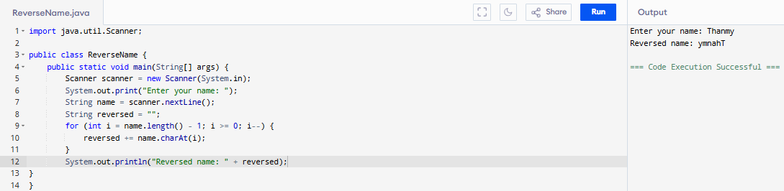

Task 9:
public class Example {
public static void main (String[] args) {
int[] arr1 = {11, 34, 66, 75};
int n1 = arr1.length;
int[] arr2 = {1, 5, 19, 50, 89, 100};
int n2 = arr2.length;
int[] merge = new int[n1 + n2];
int i = 0, j = 0, k = 0, x;
System.out.print("Array 1: ");
for (x = 0; x < n1; x++)
System.out.print(arr1[x] + " ");
System.out.print("\nArray 2: ");
for (x = 0; x < n2; x++)
System.out.print(arr2[x] + " ");
while (i < n1 && j < n2) {
if (arr1[i] < arr2[j])
merge[k++] = arr1[i++];
else
merge[k++] = arr2[j++];
}
while (i < n1)
merge[k++] = arr1[i++];
while (j < n2)
merge[k++] = arr2[j++];
System.out.print("\nArray after merging: ");
for (x = 0; x < n1 + n2; x++)
System.out.print(merge[x] + " ");
}
}

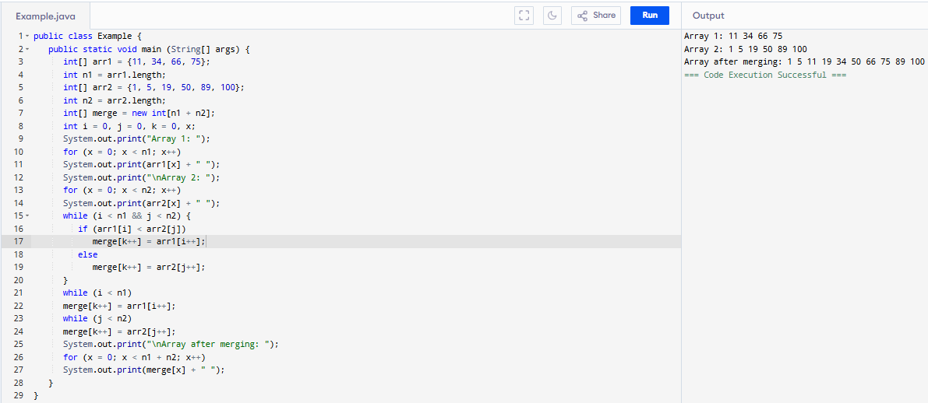

Task 10 :
Need to do how work
rewrite the code in such a way that it has to take unsorted list and then, merge in an array the sorted list

Task 11 :
Hashtable is a legacy class within the java.util package that implements a hash table data structure. It operates on the principle of hashing to store and retrieve data in the form of key-value pairs efficiently.
- Hashing:
- Key-Value Pairs:
- Buckets:
- Collision Resolution:
- Synchronization:
- Null Handling:
A Hashtable uses a hash function (specifically, the hashCode() method of the key object) to compute an integer hash code. This hash code is then used to determine the index, or "bucket," within an internal array where the corresponding key-value pair should be stored.

import java.util.Hashtable;
import java.util.Map;

public class HashTable {
public static void main(String[] args) {
Hashtable<String, Integer> ht = new Hashtable<>();
ht.put("Anitha", 101);
ht.put("Kavitha", 102);
ht.put("Meera", 103);
// use get method of Ht
for (Map.Entry<String, Integer> e : ht.entrySet())
System.out.println(e.getKey() + " " + e.getValue());
}
}

Task 14:
In Java, both HashMap and Hashtable are used to store key-value pairs, but they differ primarily in their synchronization and handling of null values. HashMap is not synchronized, allowing for faster performance in single-threaded or non-concurrent environments, while Hashtable is synchronized, making it thread-safe but potentially slower.

//set -- array List, replace the values, updates the previous value
//put -- hash table, insert the value, puts a new value

