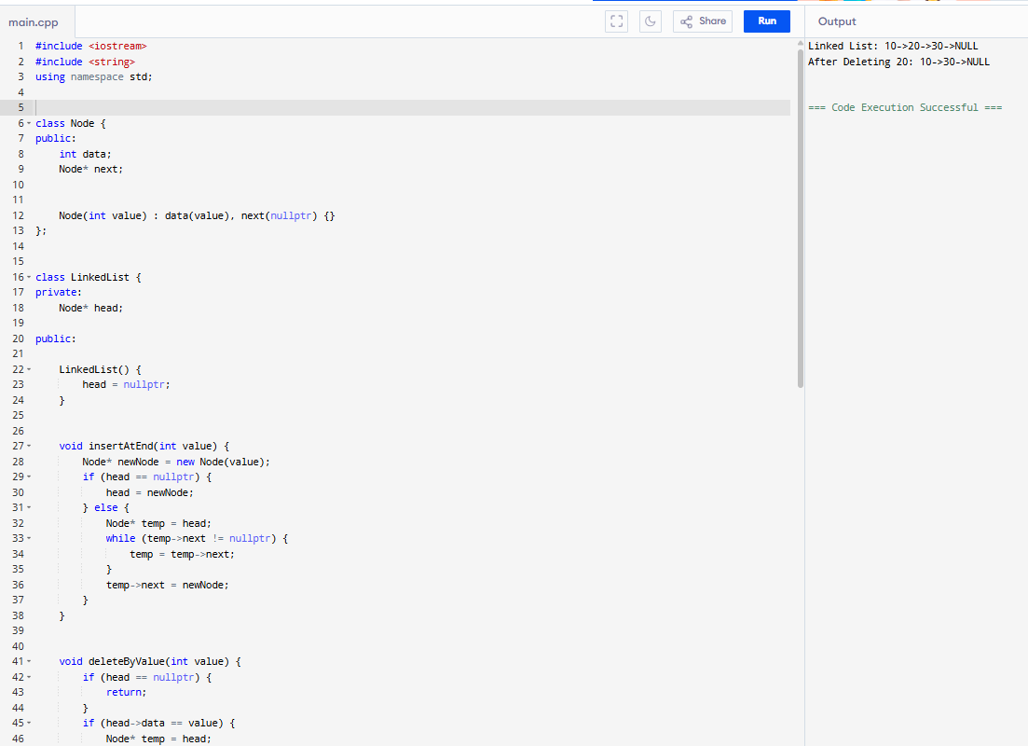

Task 04:
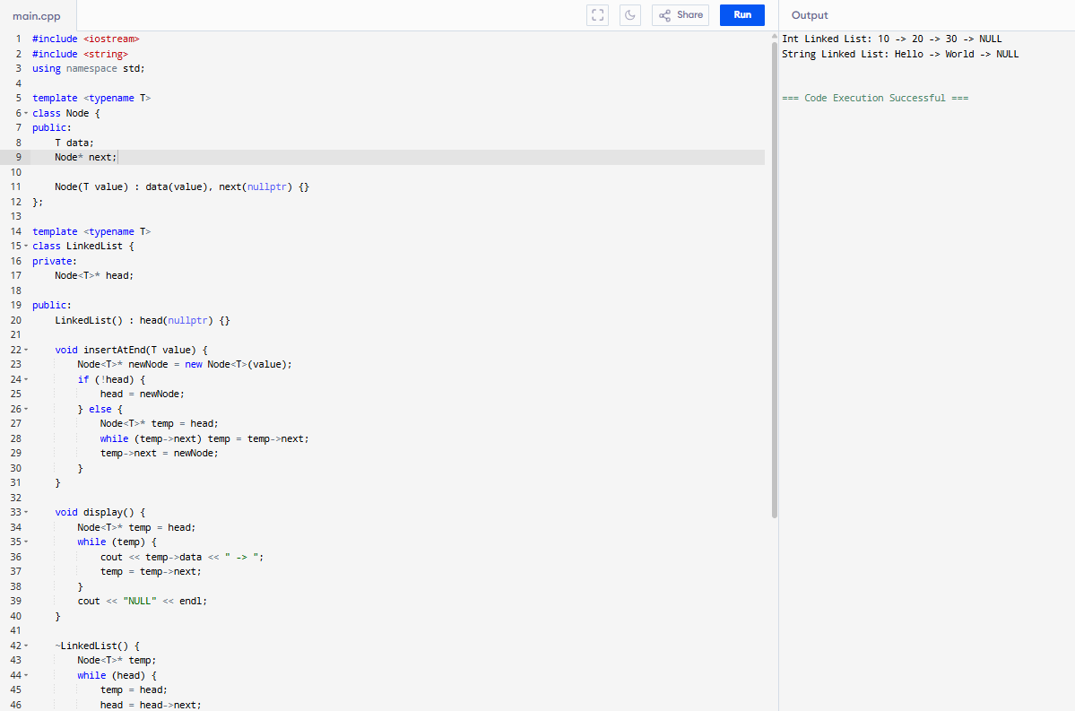

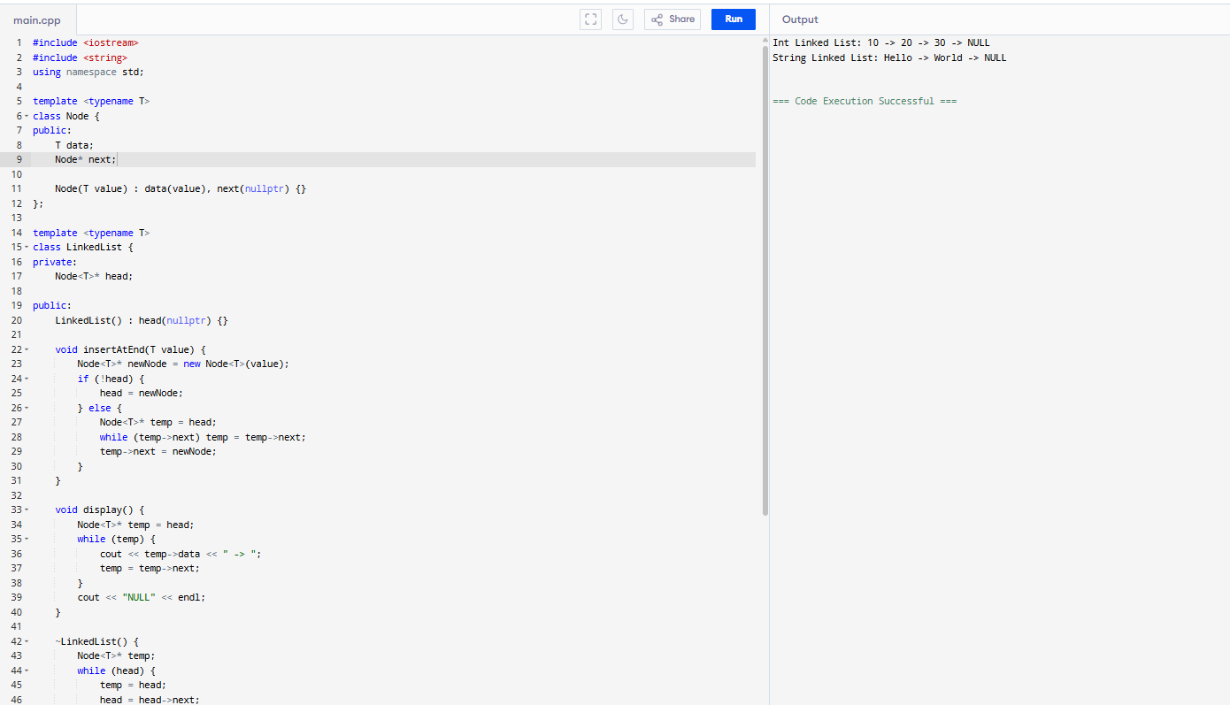

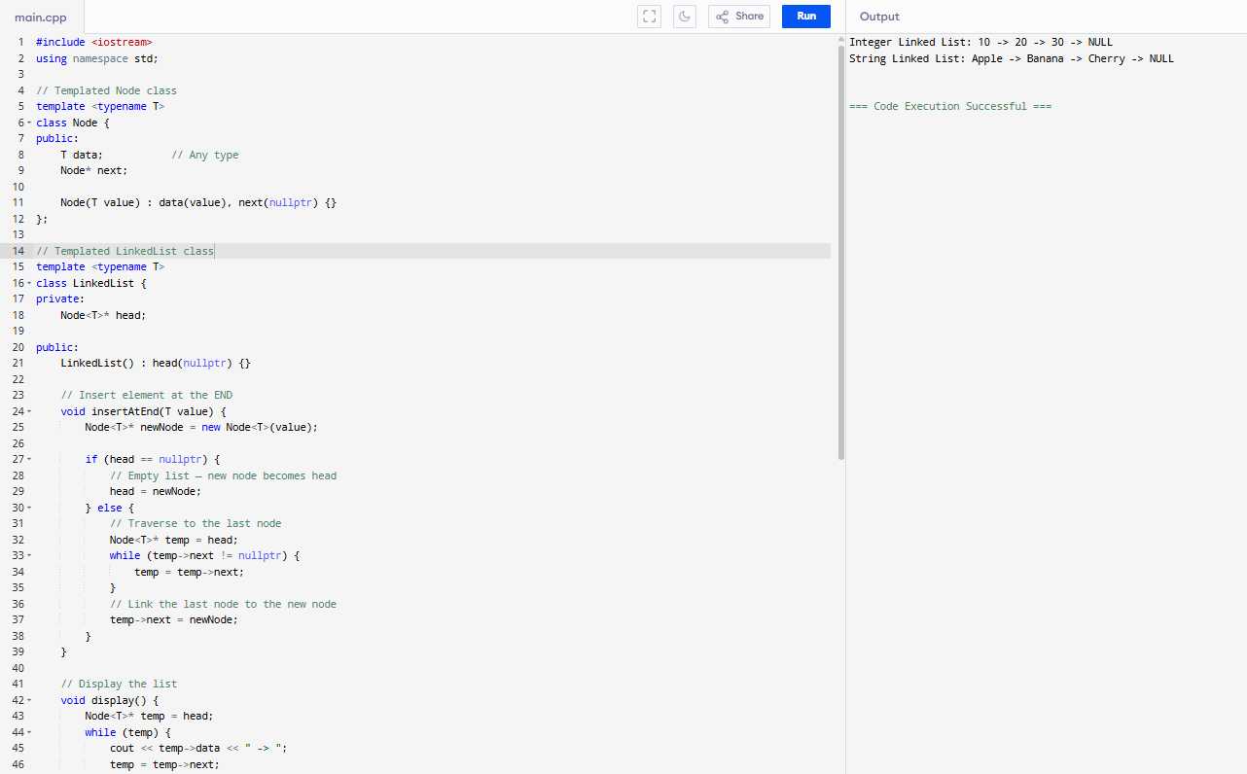

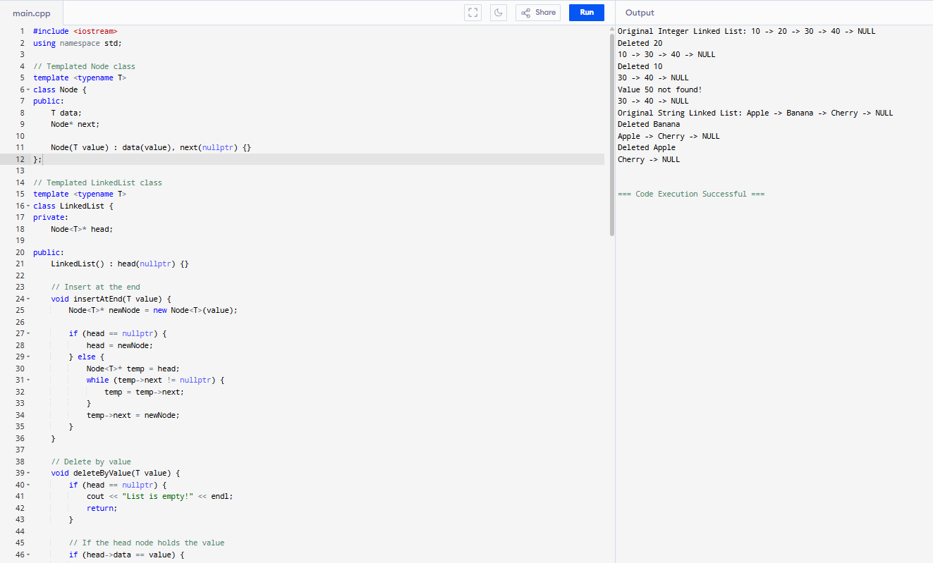

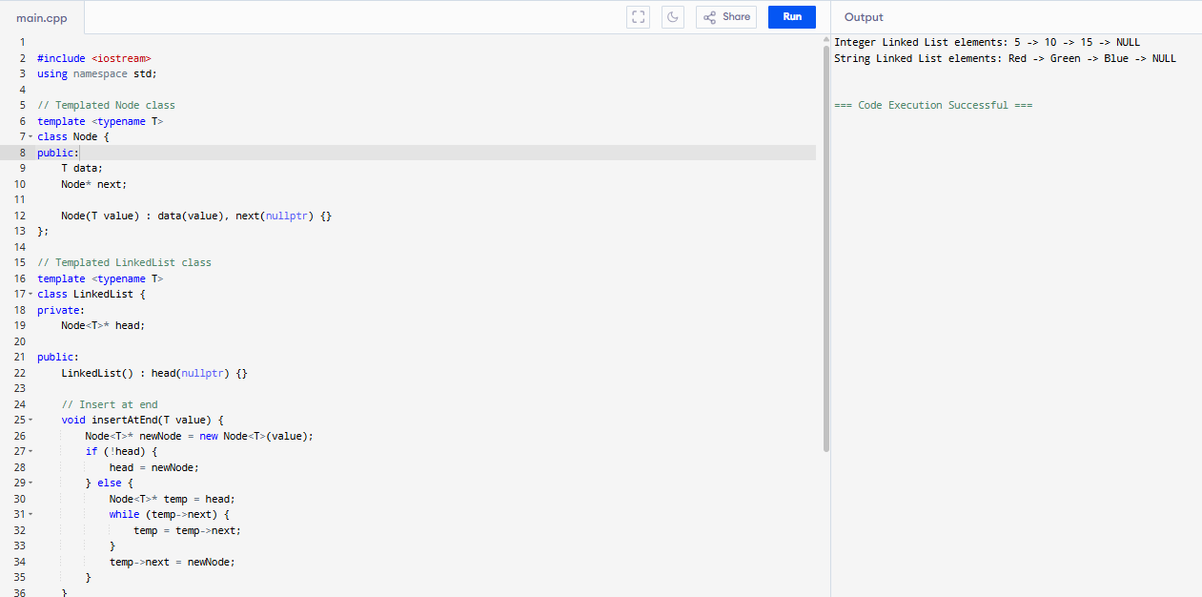

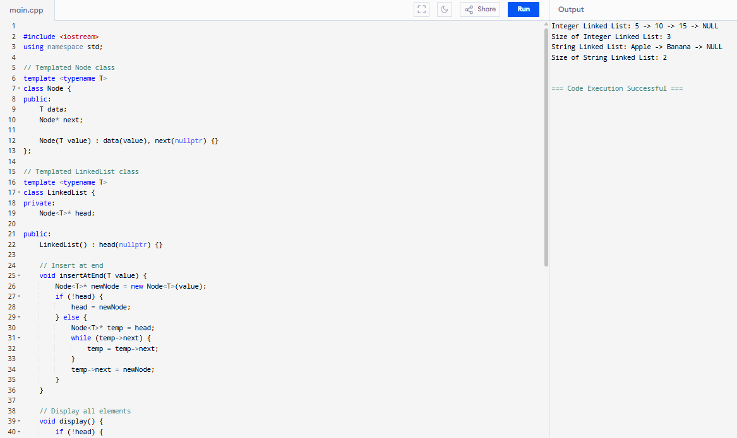

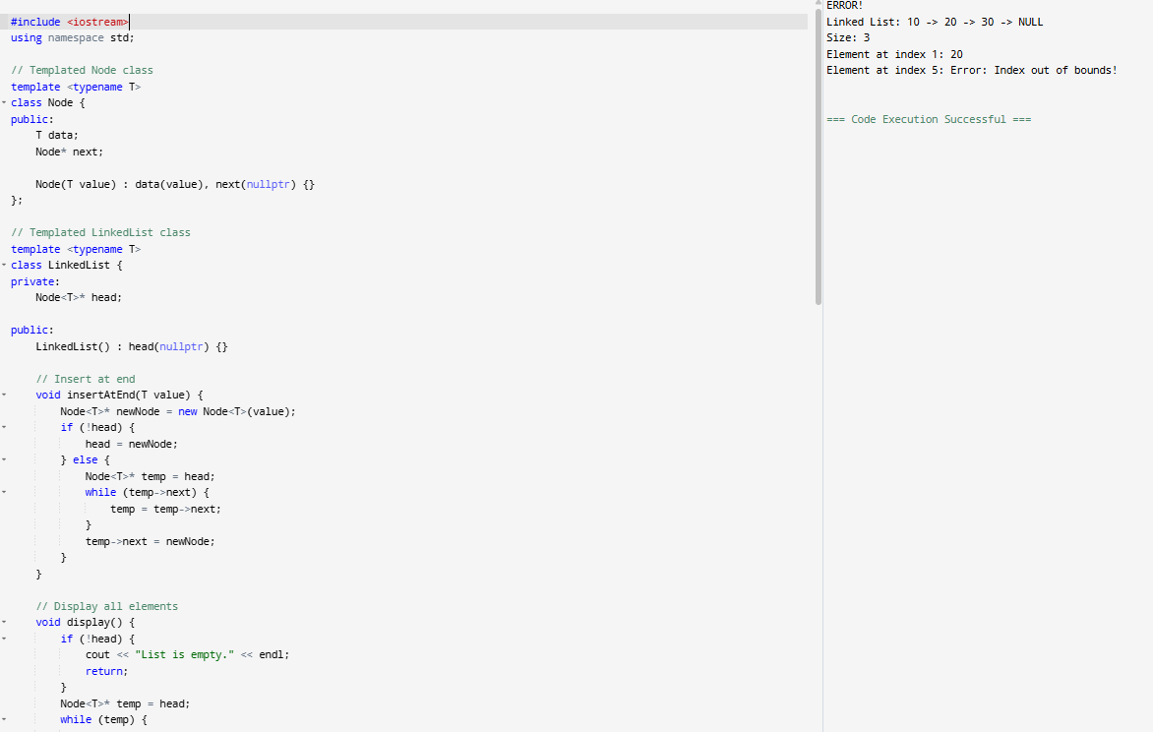

Task 05:
Linked List Methods:
1. insertAtBeginning(value)
2. insertAtEnd(value)
3. insertAtPosition(index, value)
4. deleteByValue(value)
5. deleteAtPosition(index)
6. clear()
7. display()
8. getSize()
9. isEmpty()
10. getAtIndex(index)
11. search(value)
12. reverse()
13. sort()
14. merge(otherList)
15. removeDuplica

Task 6:
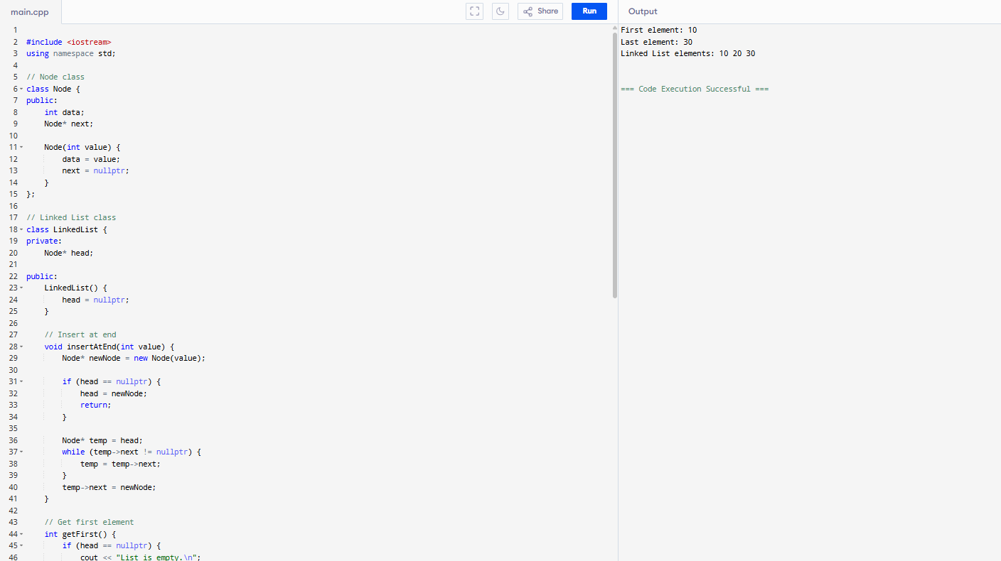
Task 7:

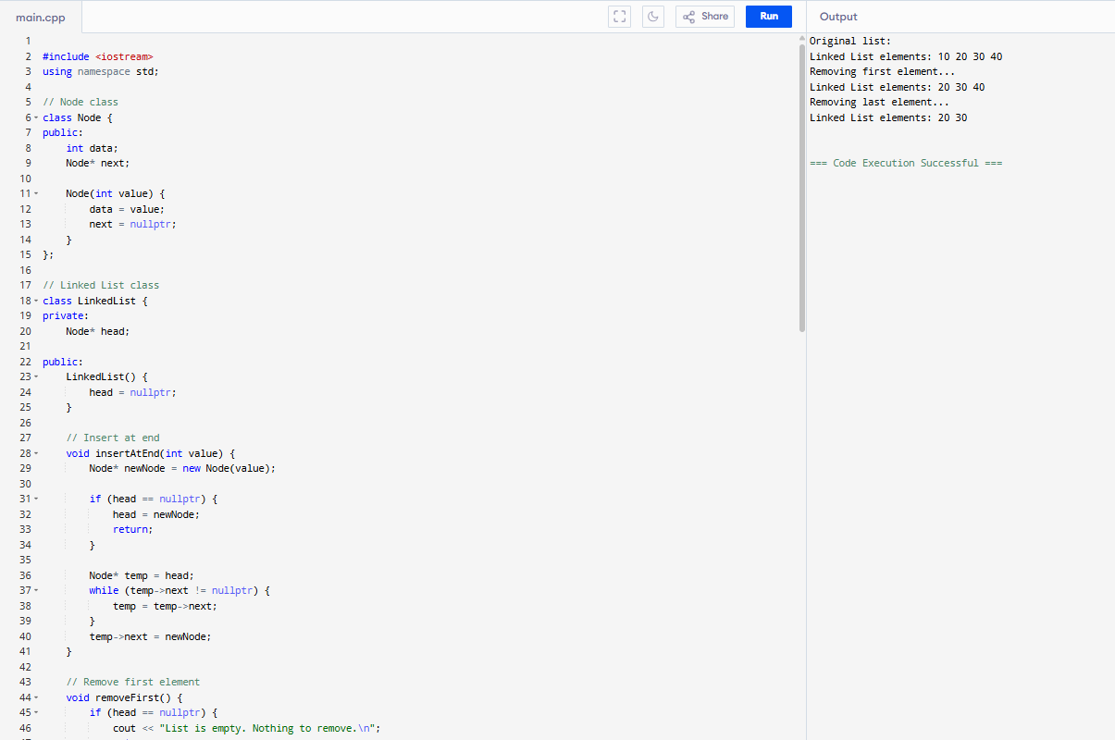

Task 8:
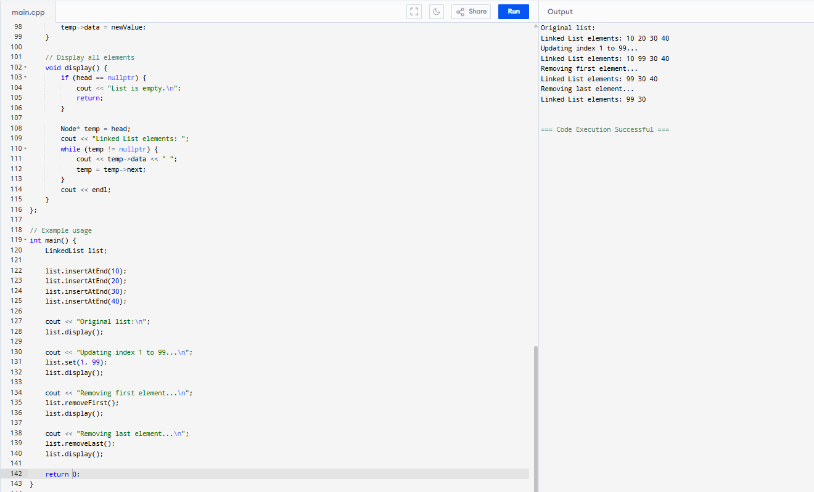

Task 9:
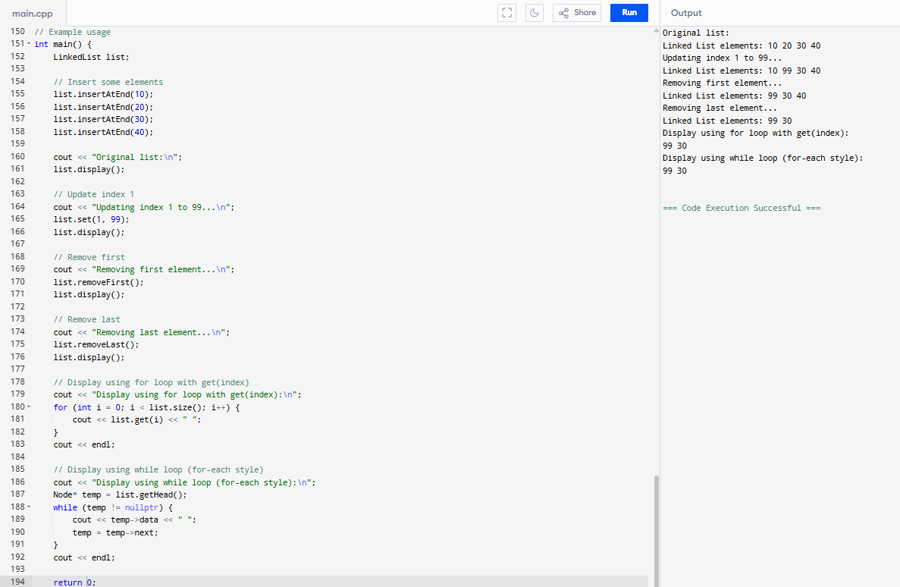

Task 10:
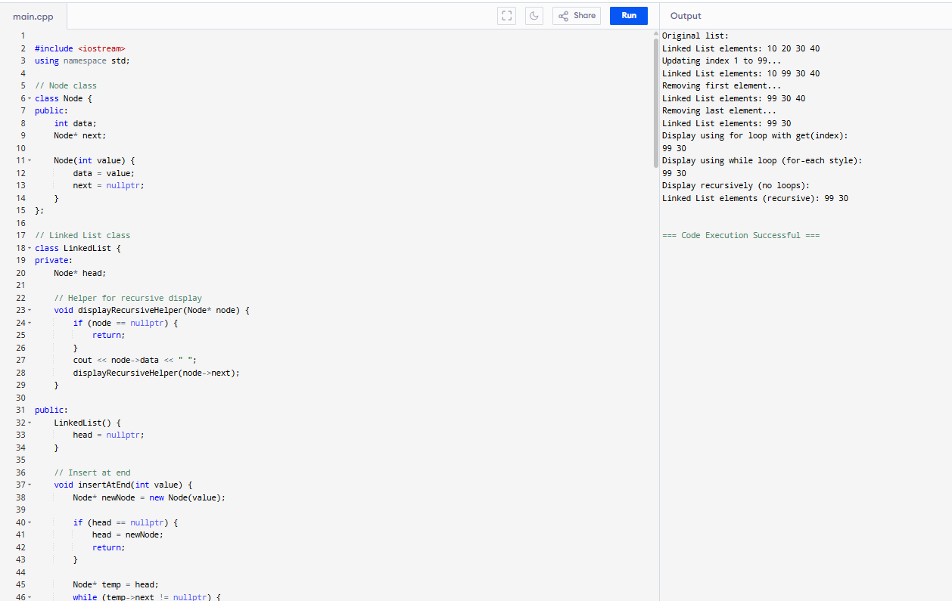

Task 11:
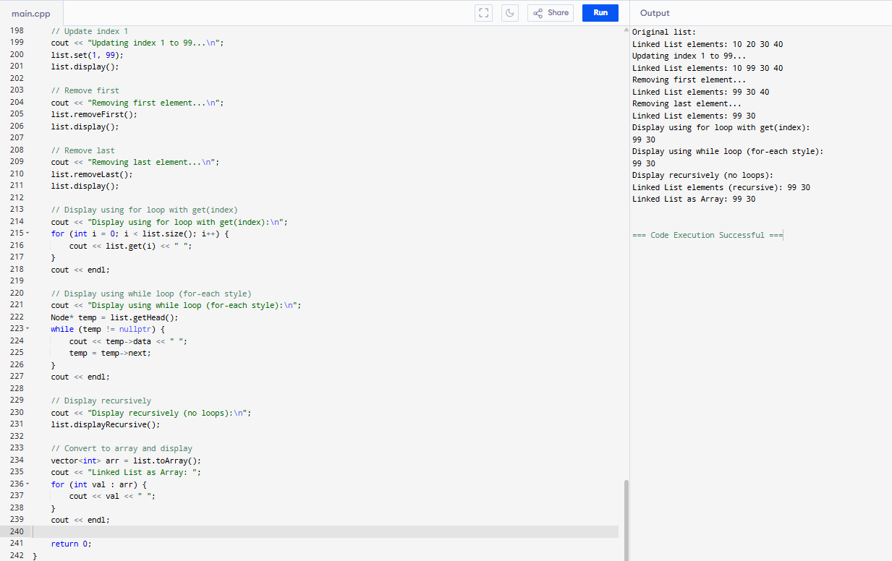

Task 12:
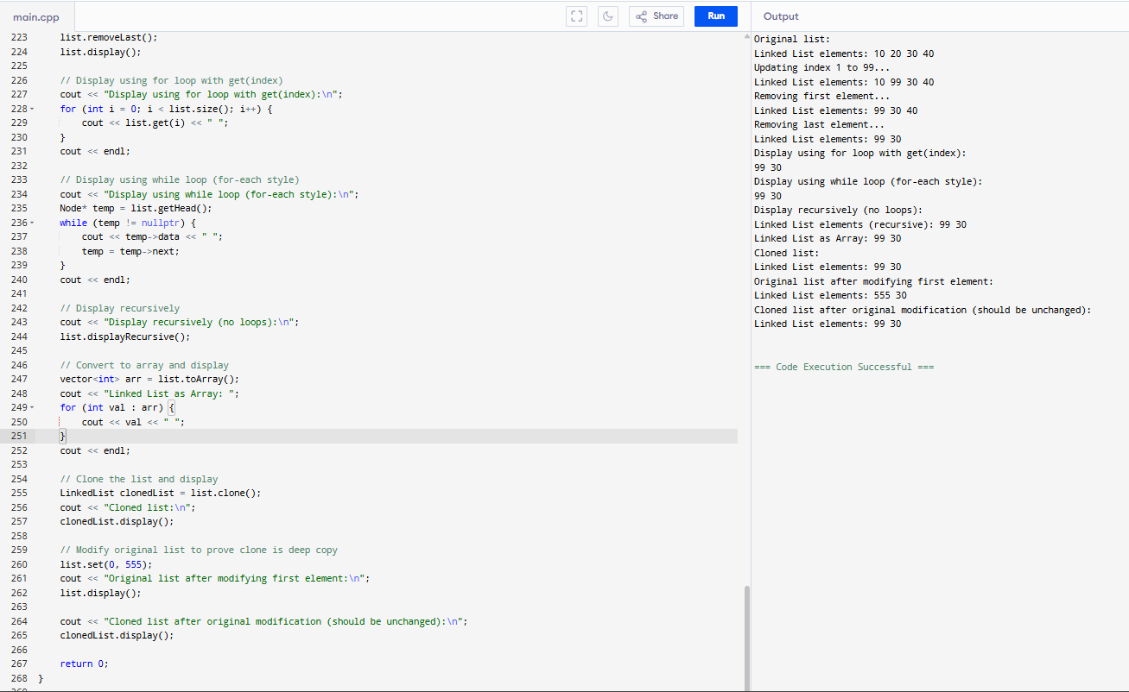

Task 17:
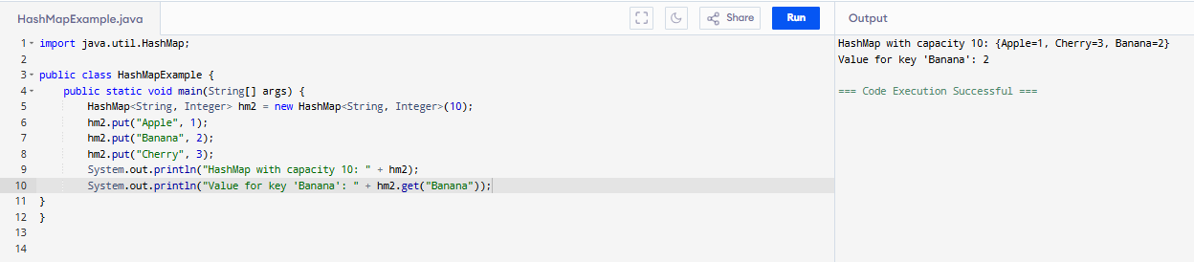

Task 18:
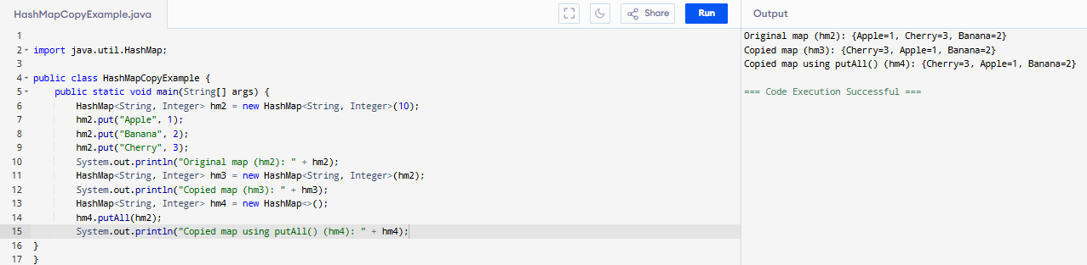

Task 19:

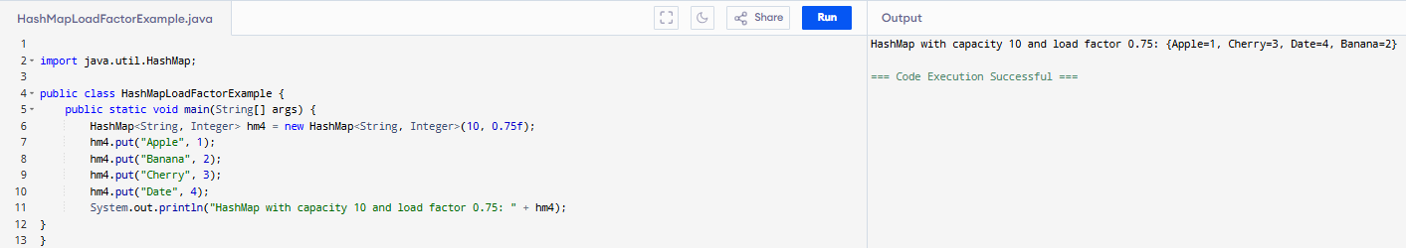

Task 20 :
Summarize of the HashMapCreateMethods

Task 21:
