Task033
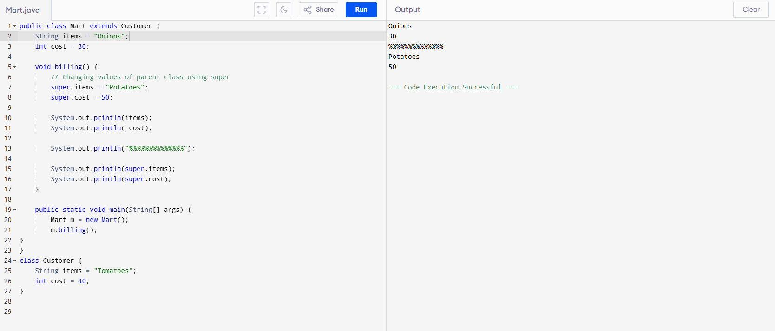

https://www.programiz.com/online-compiler/4oVSTImWcEd5x

Task034
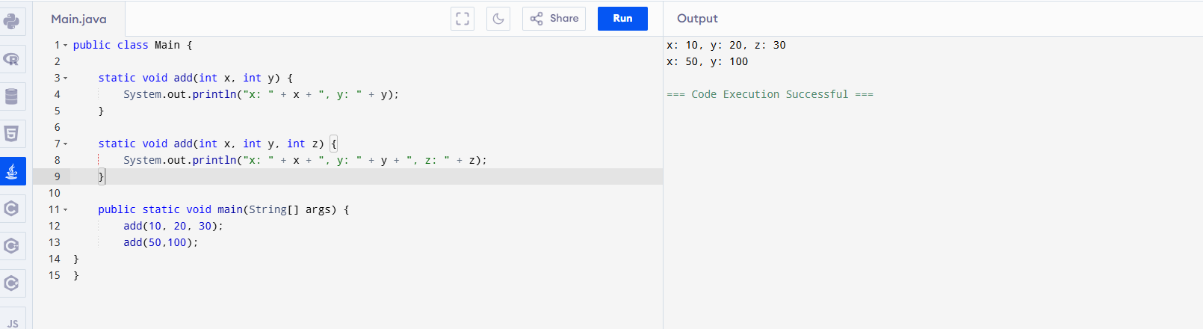
https://www.programiz.com/online-compiler/9gfZI7qwNuFY2

Task035
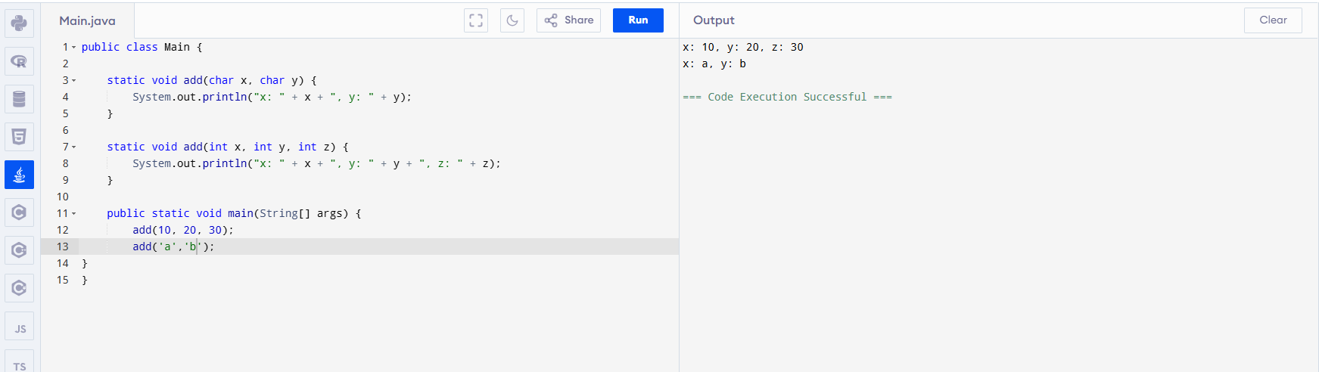

Task036
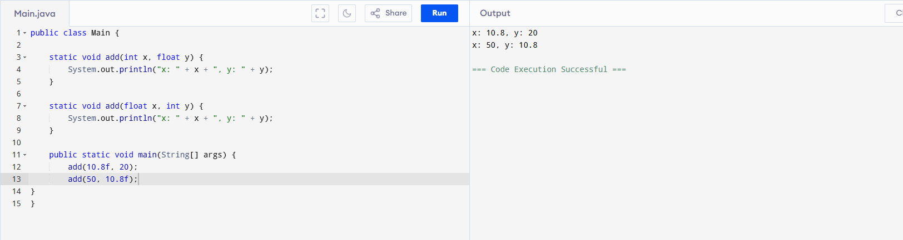

Task037

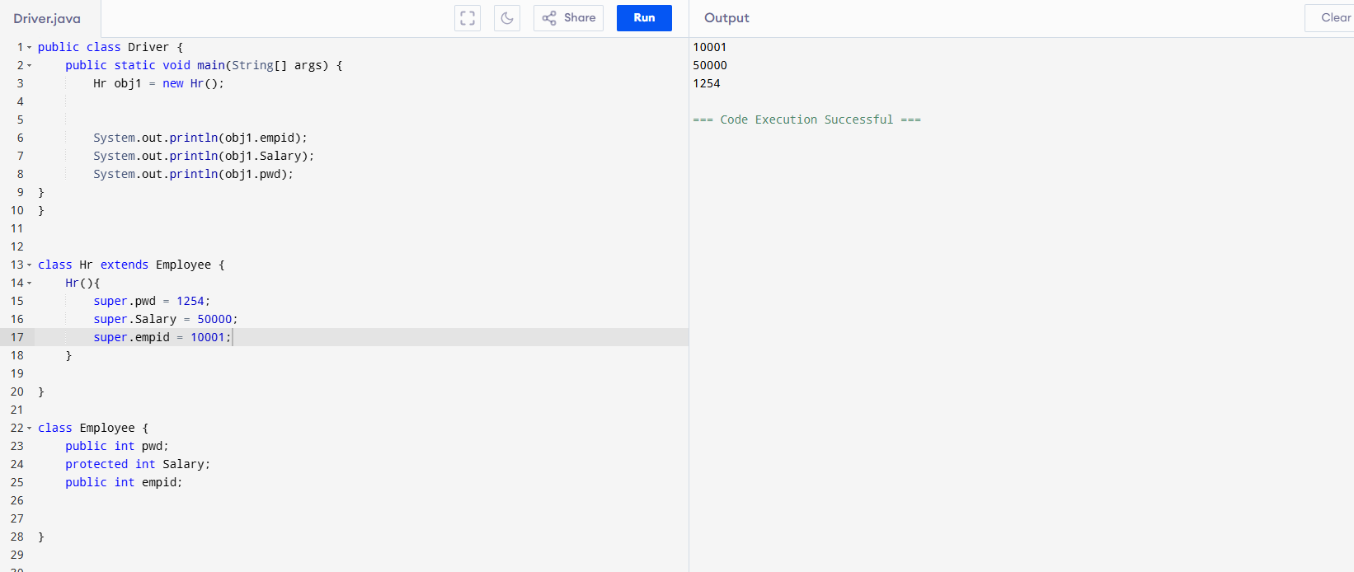

Task040:
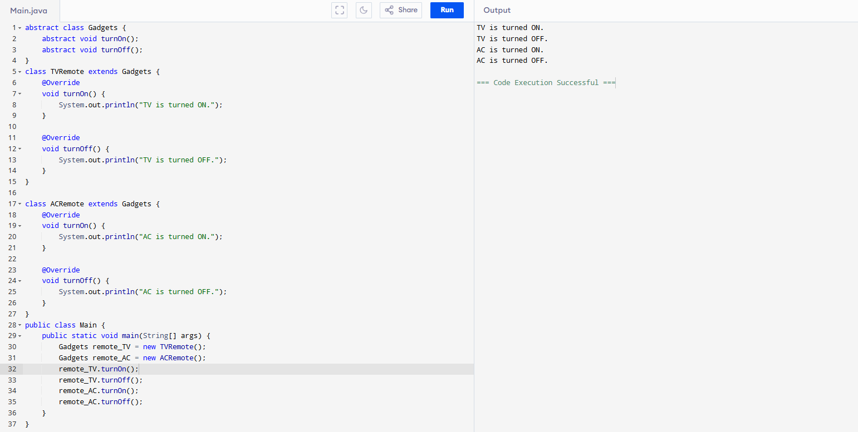

Tas039:
