Task 1
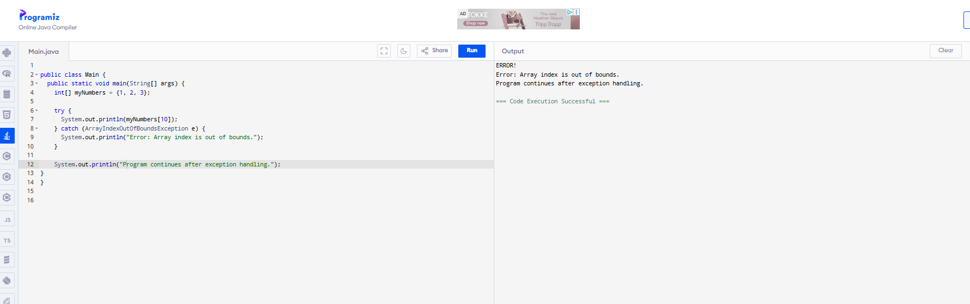

Task 2
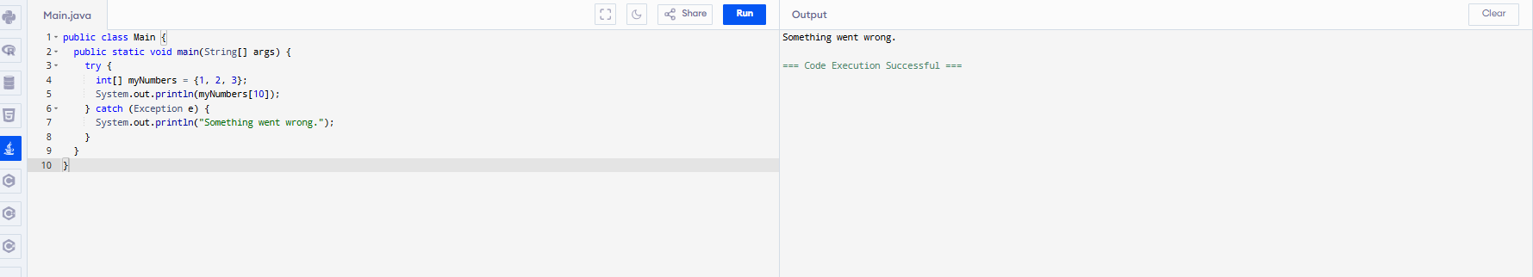

Task 4
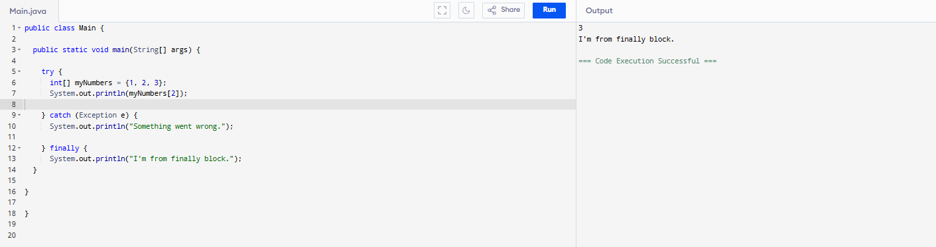

Task 5
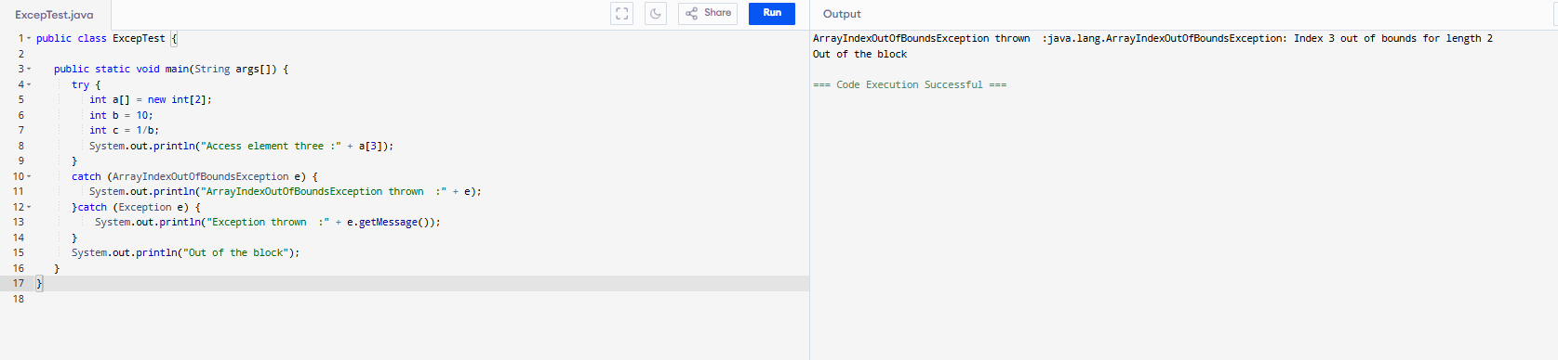

Task 6:
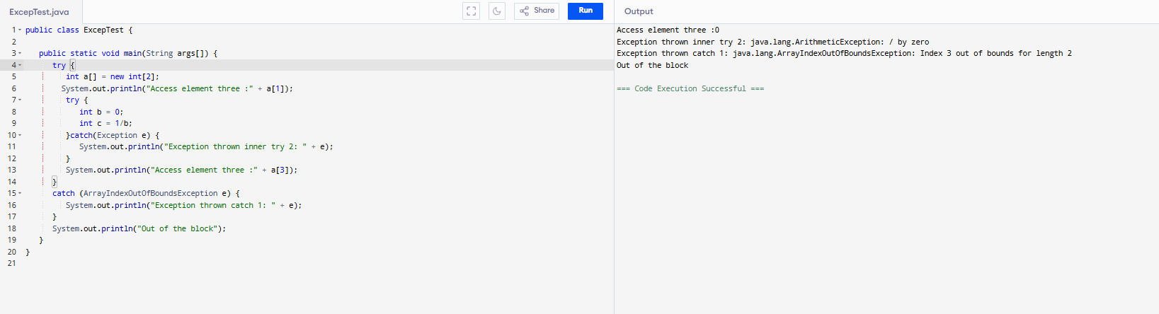

Task 7:
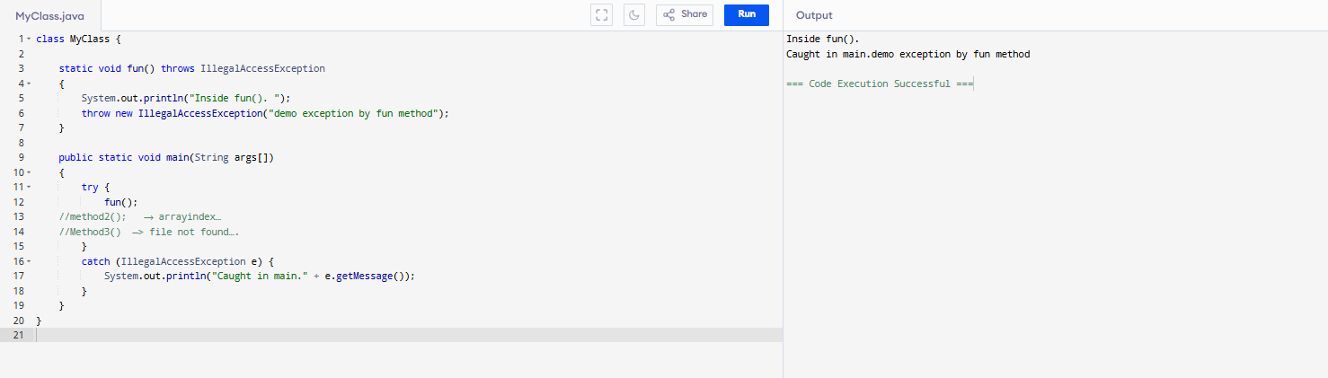

Task 8:
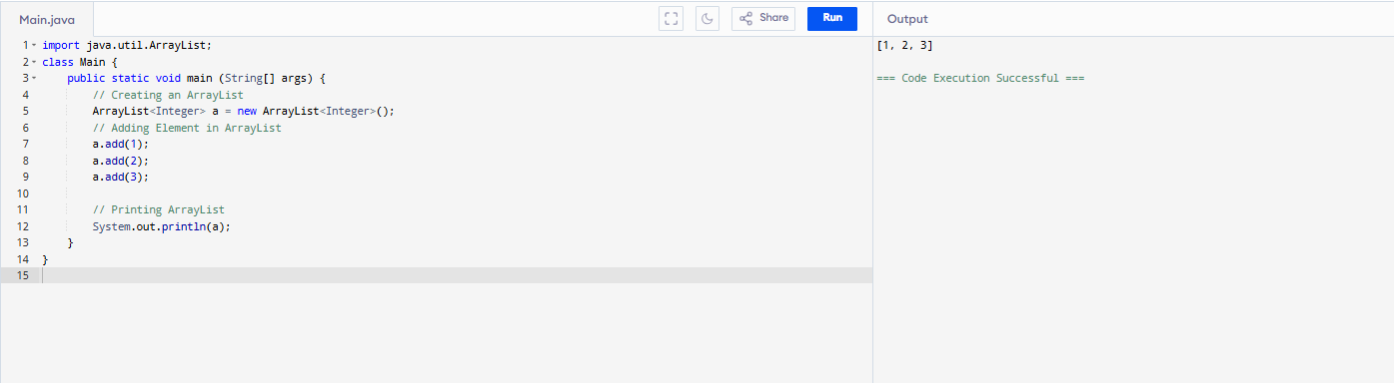

Task 9 :
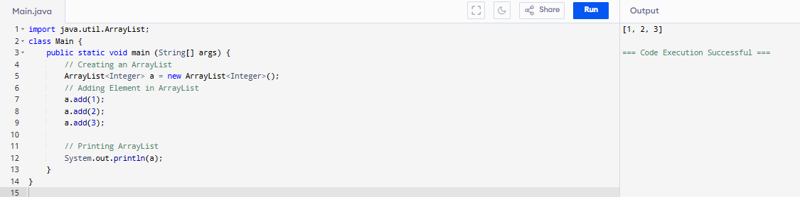

Task 10:
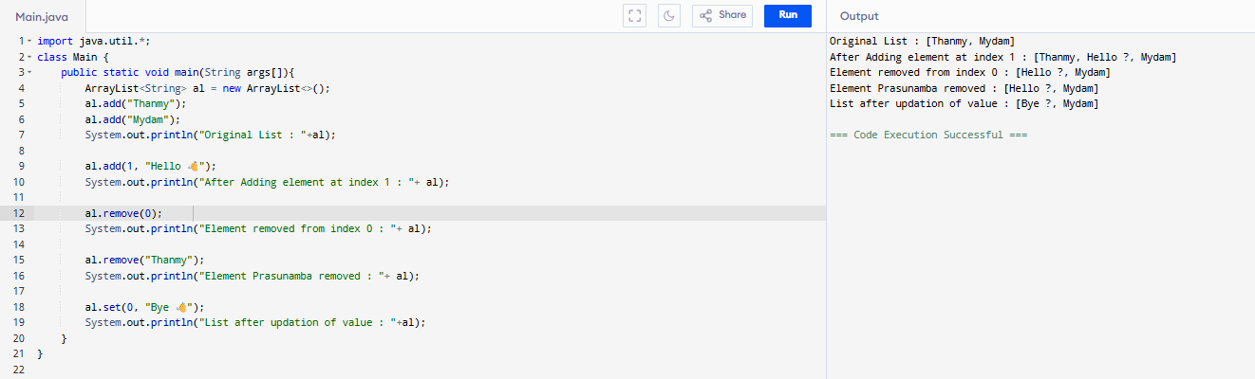

Task 11:
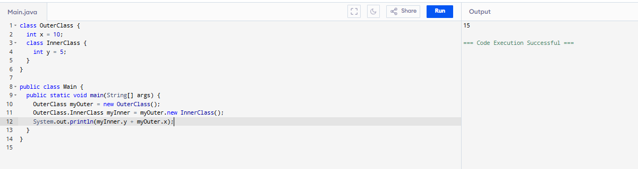

Task 12:
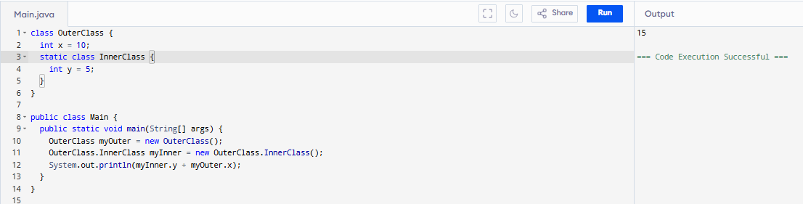

Task 17:
Features of Java 8
Lambda Expressions: Concise functional code using ->.
Functional Interfaces: Single-method interfaces.
Introduced and Improved APIs:
Stream API: Efficient Data Manipulation.
Date/Time API: Robust Date and Time Handling.
Collection API Improvements: Enhanced Methods for Collections (e.g., removeIf, replaceAll).
Concurrency API Improvements: New classes for parallel processing (e.g., CompletableFuture).
Optional Class: Handle null values safely.
forEach() Method in Iterable Interface: Executes an action for each element in a Collection.
Default Methods: Evolve interfaces without breaking compatibility.
Static Methods: Allows adding methods with default implementations to interfaces.
Method References: Refer to methods easily.

Task 18:
