File name: Day3 – 109347652 – Thanmy Recap & DATABASE
Task 1:

Recap of Last session:

Create a file names 21st May.txt and push it to your git hub.

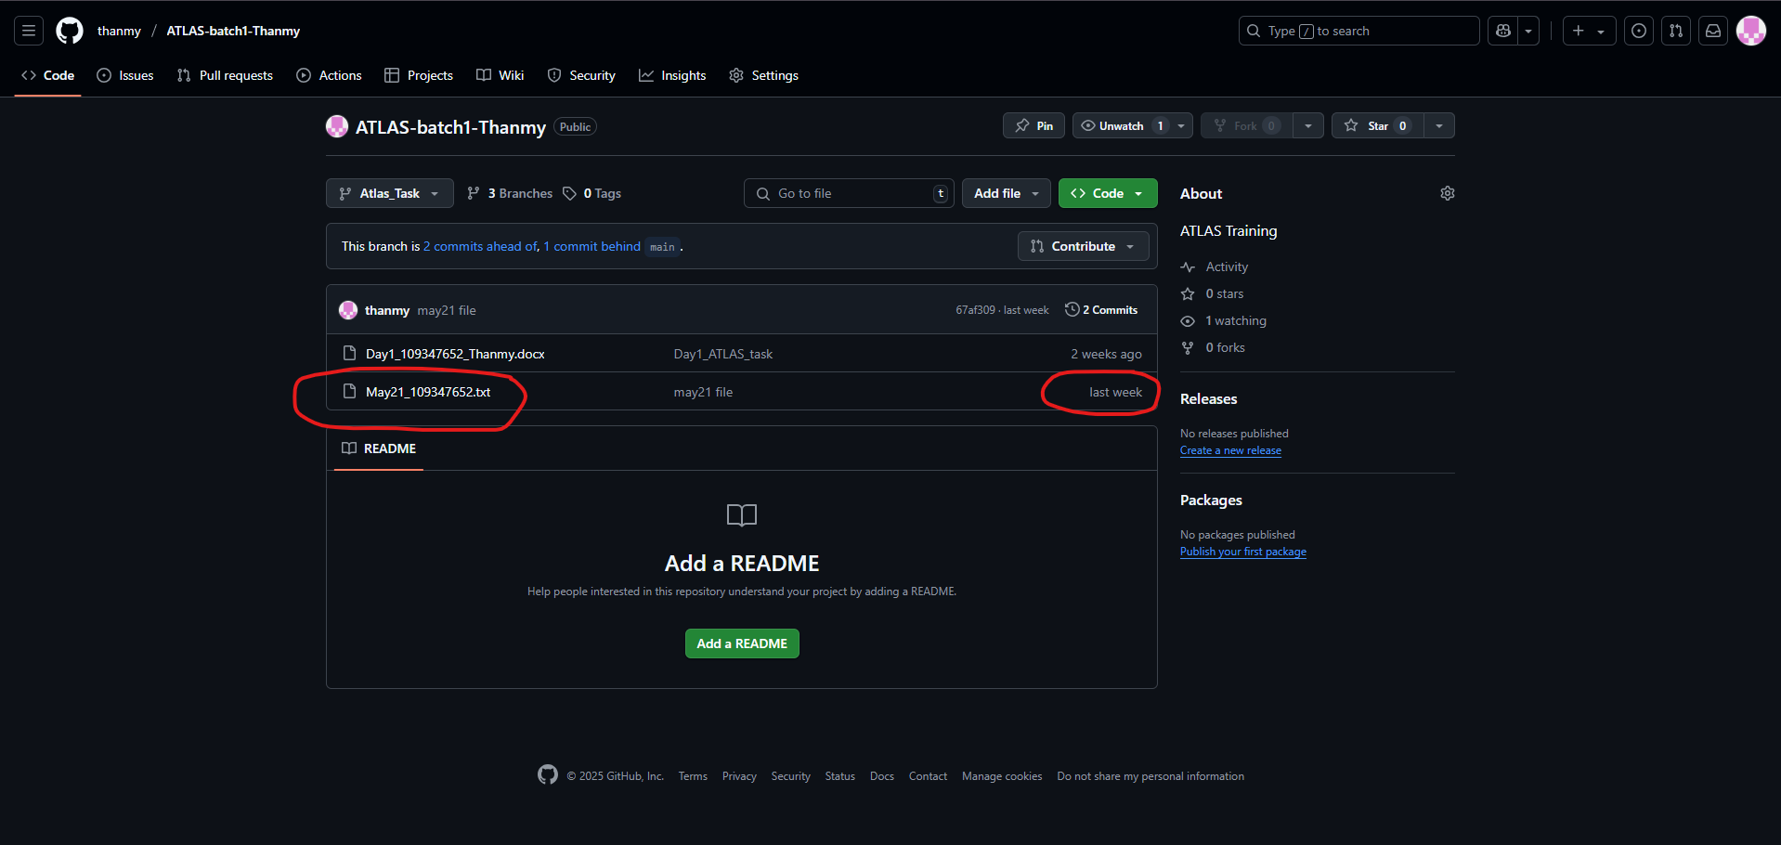

Created a new branch Atlas_Task

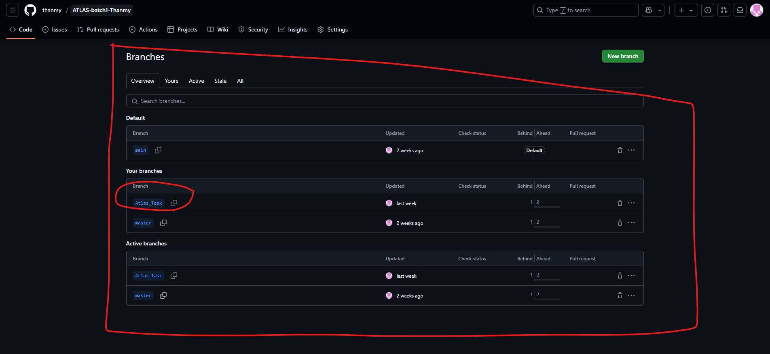

Task 2:
ACID stands for Atomicity, Consistency, Isolation, and Durability. These are properties of database transactions that guarantee data integrity and reliability, even in the face of failures.
Here's a breakdown of each property:

Atomicity:
A transaction is either fully completed (all changes are saved) or rolled back to its original state if any part of the transaction fails. This ensures that a transaction is treated as a single, indivisible unit.

Consistency:
A transaction preserves the database's integrity by ensuring that all changes adhere to the database's rules and constraints. If a transaction violates these rules, it's rolled back to maintain data integrity.

Isolation:
One transaction's changes are not visible to other concurrent transactions until the first transaction is fully committed. This prevents interference between concurrent transactions and ensures that each transaction sees a consistent view of the data.

Durability:
Once a transaction is committed, the changes are permanently stored and survive system failures (like power outages or crashes). This ensures that data is preserved and recoverable even in unexpected situations.

RDBMS Doc 4.pdf
https://drive.google.com/file/d/1cgSZ6wmPmFbx-tC78lt6zC9UBYiDJlyP/view?usp=sharing

NOSQL Doc 5 pdf

https://drive.google.com/file/d/1PDqGKE766Z-rG4GVh3ycwJyrraiJV-my/view?usp=sharing

MongoDb Installation link

https://www.mongodb.com/try/download/community

MongoDb installation steps link

https://www.mongodb.com/docs/manual/tutorial/install-mongodb-on-windows/

this is also MongoDb link any one you can follow..

https://www.geeksforgeeks.org/how-to-install-mongodb-on-windows/

+++++++++++++++++++++++++ Installed mongodb +++++++++++++++++++++++++++++++++++++++

