File name: Day5 – 109347652 – Thanmy Linux
Task1:

Task2:

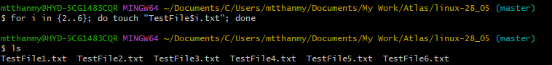

1. touch – Create an empty file
Command: touch file.txt
- Creates an empty file if it doesn’t exist.
- If the file already exists, it updates the last modified time.
- Does not add any content to the file.
Used when: just want to create a file quickly.

2. echo – Write a single line of text to a file
Command: echo "Hello World" > file.txt
- Writes "Hello World" into file.txt.
- If file.txt exists, this overwrites the content.
Use >> to append instead of overwrite:
Command: echo "Another line" >> file.txt

Used when: want to write or append one line of text.

3. cat – Create a file with multi-line input or display file content
To create and type multi-line content:
Command: cat > file.txt
You can also use it to view file content:
Command: cat file.txt
Used when: want to manually type multiple lines or view files.

Task 21:

Task23:
Display disk space in Human Understanding lang

Display disk space in machine

Task25:
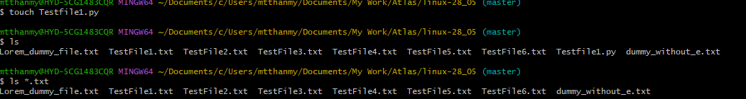

Task26:

Task27:
. Refer the current directory
.. Refer to the parent directory

Task28:
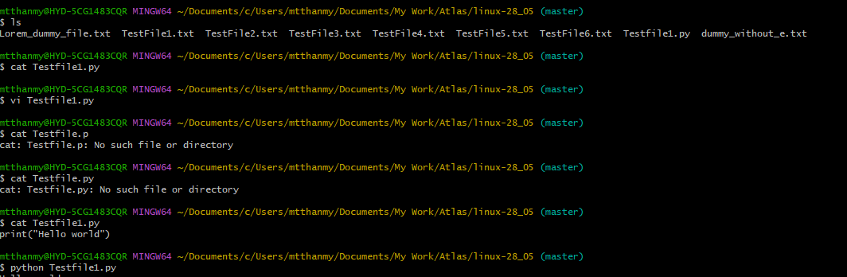

Task31:
Yes, we can use WC cmd for 2 or more files
Even the file is different also works

Task32:
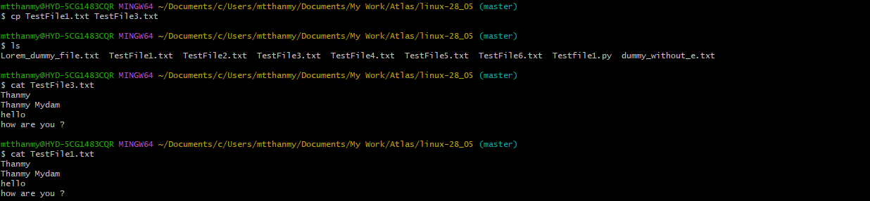

Task33:
Task34:
Yes, we can remove multiple Files at once

Task35:
It moves to root
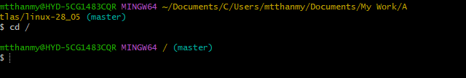
Task36:
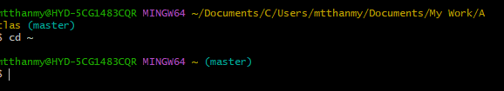

Task38:
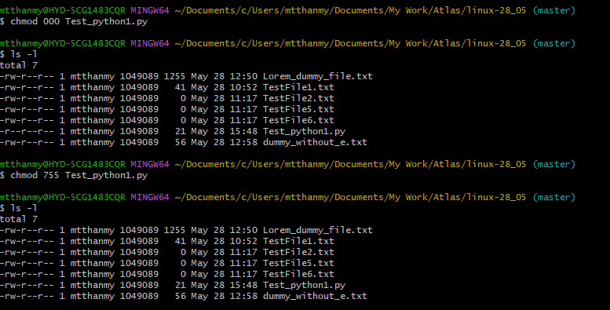

Calendar
