File name: Day6 – 109347652 – Thanmy Regex
- BASIC REGULAR EXPRESSIONS (BRE)
Used by default in: grep, sed
Special Characters (escape required for some):
. - Match any single character except newline
^ - Match start of line
$ - Match end of line
* - Match 0 or more of previous character
[abc] - Match any one character in set (a, b, or c)
[^abc] - Match any character NOT in set
\{n\} - Exactly n repetitions
\{n,\} - At least n repetitions
\{n,m\} - Between n and m repetitions
\? - Match 0 or 1 of previous (escaped)
\+ - Match 1 or more of previous (escaped)
\| - OR (escaped)
2. EXTENDED REGULAR EXPRESSIONS (ERE)
Used in: grep -E, egrep, awk
Special Characters (no escape needed):
. - Any character
^ - Start of line
$ - End of line
* - 0 or more
+ - 1 or more
? - 0 or 1
| - OR
() - Grouping
[] - Character class
{n} - Exactly n
{n,} - At least n
{n,m} - Between n and m

3. CHARACTER CLASSES
[abc] - Match a, b, or c
[^abc] - Match NOT a, b, or c
[a-z] - Match any lowercase letter
[A-Z] - Match any uppercase letter
[0-9] - Match any digit
[:digit:] - Match digit (POSIX)
[:alpha:] - Match alphabetic character
[:space:] - Match whitespace (space, tab, newline)
[:alnum:] - Match alphanumeric (A–Z, a–z, 0–9)
[:punct:] - Match punctuation
[:lower:] - Match lowercase
[:upper:] - Match uppercase
4. COMMON SHORTHANDS (Perl-compatible / grep -P)
\d - Digit (0-9)
\D - Non-digit
\w - Word character (a-zA-Z0-9_)
\W - Non-word character
\s - Whitespace
\S - Non-whitespace
\b - Word boundary
\B - Non-word boundary

5. COMMON EXAMPLES
grep '^hello' file.txt
- Match lines starting with "hello"
grep 'world$' file.txt
- Match lines ending with "world"
grep '[0-9]' file.txt
- Match any line with a digit
grep -E 'colou?r' file.txt
- Match "color" or "colour"
grep -E '(dog|cat)' file.txt
- Match "dog" or "cat"
grep -E '[0-9]{3}-[0-9]{2}-[0-9]{4}' file.txt
- Match SSN pattern like 123-45-6789
sed -n '/^Error/p' file.txt
- Print lines starting with "Error"
sed 's/[0-9]\+/[number]/g' file.txt
- Replace all numbers with "[number]"

We can use Our expression workable using regex101.com

Task2:
1. Open-Source Nature:
Linux's open-source nature means its source code is freely available for anyone to use, modify, and distribute.
This allows for community contributions, leading to continuous improvements and updates.
2. Security:
Linux offers robust security features, including user privilege separation, mandatory access controls, and secure package management.
It's known for its resistance to viruses and malware, reducing the need for antivirus software.
3. Multiuser and Multitasking:
Linux supports multiple users simultaneously accessing the system and running different programs.
Its multitasking capabilities allow for smooth execution of multiple processes without affecting system speed.
4. Customization and Flexibility:
Linux allows for extensive customization, with various desktop environments and configurations available.
Its modular architecture allows for adapting to different hardware and software needs.
5. Portability:
Linux is highly portable, running on a wide range of hardware architectures.
This makes it suitable for use in various devices, from servers and desktops to embedded systems.
6. Strong Community Support:
Linux has a large and active community providing support, documentation, and development resources.
This community-driven approach contributes to the ongoing development and improvement of the operating system.
7. Stability and Reliability:
Linux is known for its stability and reliability, allowing it to run for extended periods without needing reboots.
This makes it a popular choice for servers and other critical systems.
8. Performance:
Linux offers excellent performance, especially in resource-intensive tasks like server environments.
Its lightweight kernel and efficient resource management contribute to its overall performance.
9. Interoperability:
Linux is designed for interoperability with other operating systems and established computing standards.
This allows for seamless integration with existing infrastructure and applications.

Task 3:
A kernel is the core of an operating system (OS), acting as a bridge between the software and the hardware. It manages system resources, like the CPU and memory, ensuring everything runs smoothly and efficiently. Essentially, it handles low-level tasks that other parts of the OS rely on.

Key Features of a Kernel:
Resource Management:
Allocates and manages system resources like CPU time, memory, and disk I/O, ensuring fair allocation to various applications.
Process Management:
Handles the creation, execution, and termination of processes (running programs), allowing multiple applications to run concurrently.
Memory Management:
Manages how memory is used by applications, allocating space and preventing conflicts.
File System Management:
Handles file access, storage, and retrieval.
Device Management:
Provides interfaces (drivers) for communicating with hardware devices like printers and keyboards.
Security:
Enforces access control, protecting the system from unauthorized access and preventing applications from interfering with each other.
Network Management:
Handles network communication, allowing the system to connect to other networks and devices.
Inter-Process Communication (IPC):
Facilitates communication between different processes.

Task 4:
BASH stands for (Bourne-Again Shell). It's a command-line interpreter and scripting language used on Unix-like operating systems, including Linux and macOS. Bash is widely used for automating tasks, managing files, and interacting with the operating system through a text-based interface.

Task 5:
Linux is an open-source operating system, meaning its source code is freely available for anyone to view, modify, and distribute. It is widely known for its stability, security, and flexibility, making it a popular choice among developers, system administrators, and tech enthusiasts. Linux is highly customizable and can run on a wide range of devices, from servers to smartphones. It is typically free to use and gives users full control over the system. With strong community support and a powerful command-line interface, Linux excels in tasks like programming, networking, and automation. It is also considered more secure due to its strict permission model and lower exposure to malware.

Windows, developed by Microsoft, is a proprietary operating system that is widely used in homes, businesses, and schools. It features a user-friendly graphical interface, making it accessible to users with little or no technical knowledge. Windows supports a vast array of commercial software and hardware out of the box, which makes it a popular choice for gaming, productivity, and general computing. However, it is a paid operating system and generally offers less customization than Linux. While Windows is easier to use for many people, it is more prone to viruses and malware due to its widespread use and open access for third-party applications. It’s ideal for everyday users, gamers, and business environments that rely on Microsoft products.

Task 6:
The core components of a Linux operating system include the kernel, system libraries, and system utilities
Task 7:
Yes, it is legal to modify the Linux Kernel, assuming you're not making it proprietary or distributing it under a license that conflicts with the GPL (GNU General Public License).
Task 8:
LILO (LInux LOader) is an older bootloader program used in Linux operating systems. It's responsible for loading the operating system into memory when a computer is turned on or restarted.

Task 9:
In Linux, a shell is a command interpreter that allows users to interact with the operating system through a text-based interface. It's essentially the program that takes your typed commands and translates them into instructions for the system to execute. There are many different shells available in Linux
- Bourne Shell (sh): The original Unix shell, known for its simplicity and speed.
- Bash (Bourne Again Shell): A widely used and powerful shell that's often the default shell on many Linux distributions.
- C Shell (csh): A shell that emphasizes C-like syntax, often used on high-performance computing machines.

Taks10:
In Linux, swap space acts as an extension of physical RAM, providing temporary storage for infrequently used data on disk. When RAM is full, the operating system moves inactive data to swap space, effectively increasing the virtual memory available to the system. This allows the system to continue running even with limited physical RAM.

Taks11:
What is mount in Linux?
In Linux, mounting means attaching a file system (like a USB drive, hard disk partition, or ISO image) to a directory in the existing file system tree. Once mounted, you can access its contents like any other folder.

Think of it like plugging in a USB drive and assigning it a place (like /mnt/usb) so the system knows where to find its files.
"sudo" stands for "super user do"

How to Mount a File System
sudo mount /dev/sdX1 /mnt/myfolder

Explanation:
/dev/sdX1 → the device name (like /dev/sdb1 for a USB)
/mnt/myfolder → the folder where you want to access it (mount point)

Example:
sudo mount /dev/sdb1 /mnt/usb
How to Unmount a File System
sudo umount /mnt/myfolder
sudo umount /mnt/usb

df -h is to list the mounted device
h – human readable

Task12:
The chmod command in Linux (and other Unix-like systems) is used to change the permissions of files and directories.
Use letters and symbols to represent permissions and users.
u: User (owner), g: Group, o: Others, a: All.
+: Add permissions, -: Remove permissions, =: Set specific permissions.
r: Read, w: Write, x: Execute.
For example, chmod u+w filename grants write permission to the file owner.

Task 15:
A process is a program in execution, while a thread is a unit of execution within a process. Processes are isolated and have their own memory space, while threads within a process share the same memory space. Processes are more heavyweight than threads, requiring more resources and time for creation and destruction.

AWK
in this NR – Current line number*

Task19 :
For the new file the permissions will be
-rw-r--r—

Task20:

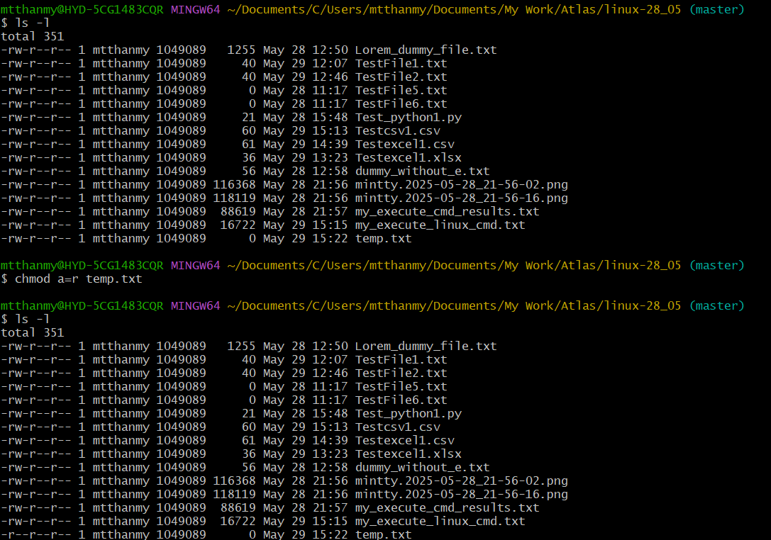

Task 21:
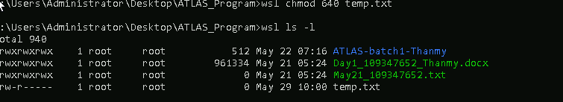

Task22:

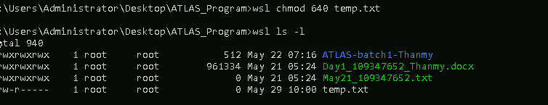

Task23:

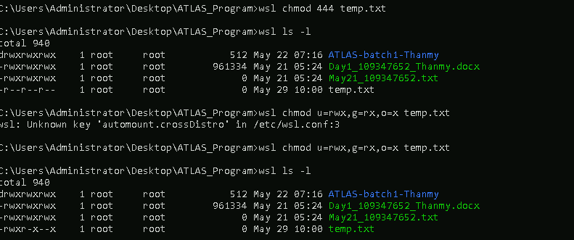

Task24
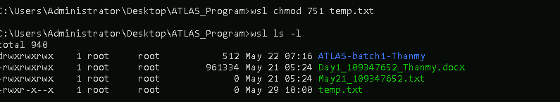

Task25:
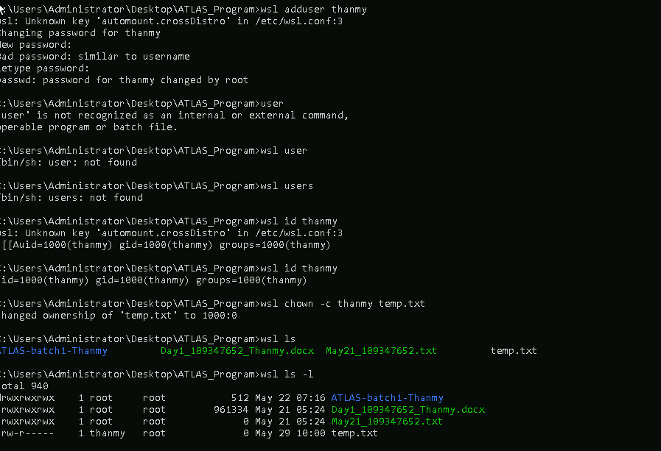

Task 27:
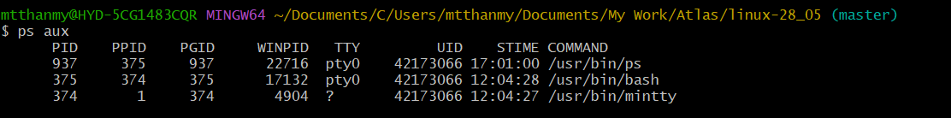

Task 28:
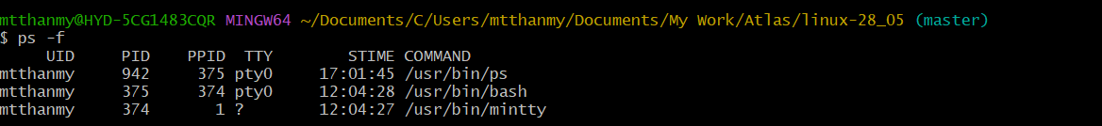

How Top work :
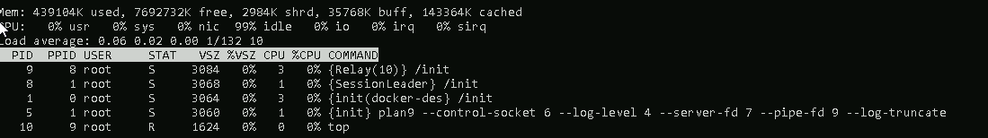

Task30:
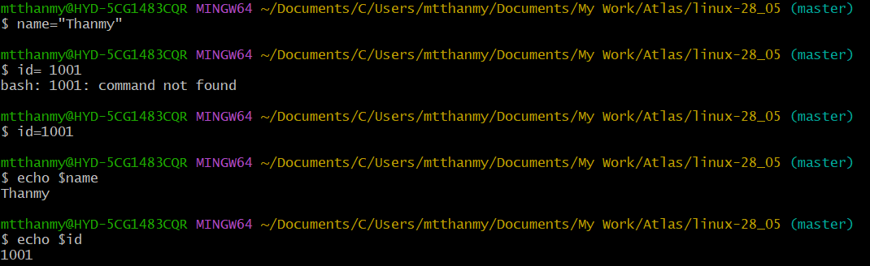

Task31:
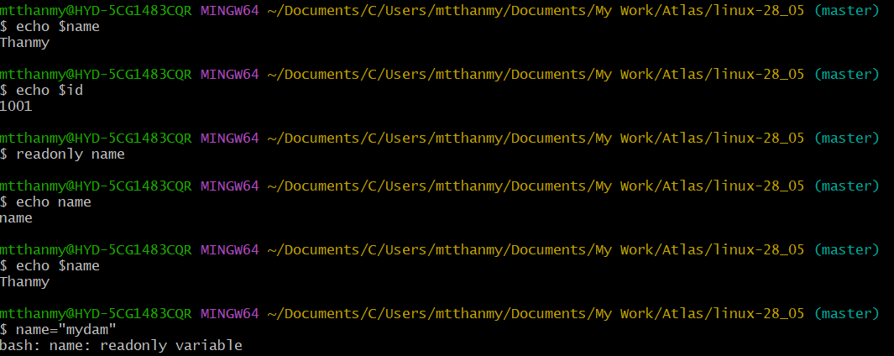

Task32:

Task32:
Unset or deleting and checking*
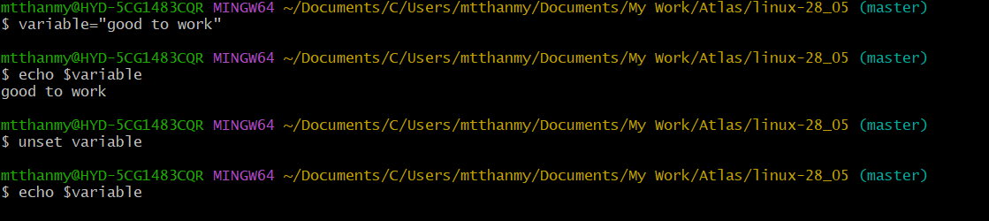

Task33:
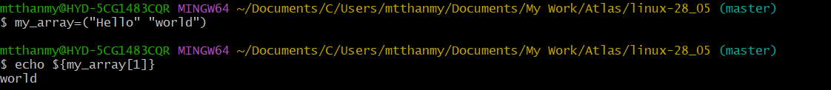

Task34:
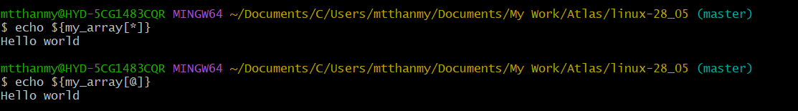

Task35:
