BACKEND ANALYSIS DOCUMENT

Chat Application - "ConnectPro"

Version: 1.0
Date: 2026-07-28
Status: Draft / Review
Document Owner: Tech Lead / Backend Architect

MỤC LỤC
- Backend Overview
- System Architecture
- Technology Stack
- Service Design
- API Design
- Database Design
- Realtime Communication
- Caching Strategy
- Message Queue & Async Processing
- File & Media Handling
- Authentication & Authorization
- Security & Privacy
- Monitoring & Logging
- Performance & Scalability
- Error Handling
- Deployment Strategy
- 1. BACKEND OVERVIEW
- 1.1. Mục tiêu Backend
- Xây dựng hệ thống backend cho ứng dụng chat ConnectPro với các mục tiêu:
Mục tiêu | Mô tả
High Performance | Xử lý 2.000 CCU với độ trễ < 300ms
High Availability | 99% uptime (MVP), 99.95% (Production)
Scalability | Horizontal scaling khi tăng user
Security | Bảo mật dữ liệu người dùng, mã hóa, authentication
Reliability | Zero message loss, ACID transactions
Maintainability | Clean architecture, microservices, clear boundaries
- 1.2. Backend Responsibilities
Domain | Responsibilities
User Management | Authentication, authorization, profile management
Social Graph | Friend management, blocking, friend requests
Conversation | 1-1 and group chat management
Messaging | Message CRUD, realtime delivery, reactions
Notification | In-app and push notifications
Media | File upload, storage, transformation
Admin | System configuration, moderation, analytics
- 1.3. System Scale
Metric | Current (MVP) | Future (Production)
Total Users | 10,000 | 100,000+
Peak CCU | 2,000 | 10,000+
Daily Messages | 200,000 | 2,000,000+
Daily Media Uploads | 20,000 | 200,000+
Storage | 100GB/year | 1TB+/year
Requests/sec | ~500 | ~5,000

2. SYSTEM ARCHITECTURE

2.1. High-Level Architecture
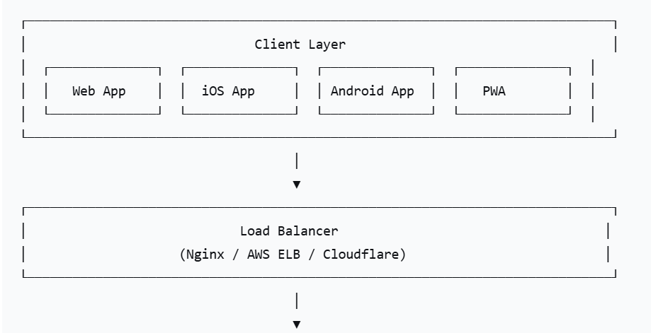
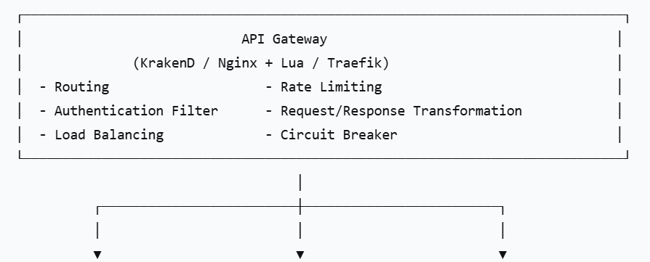
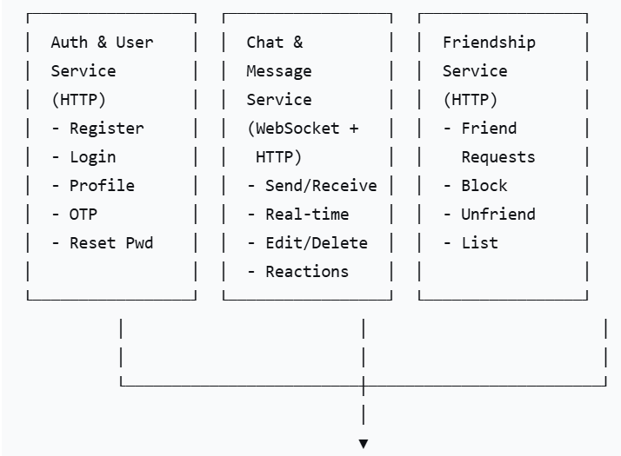
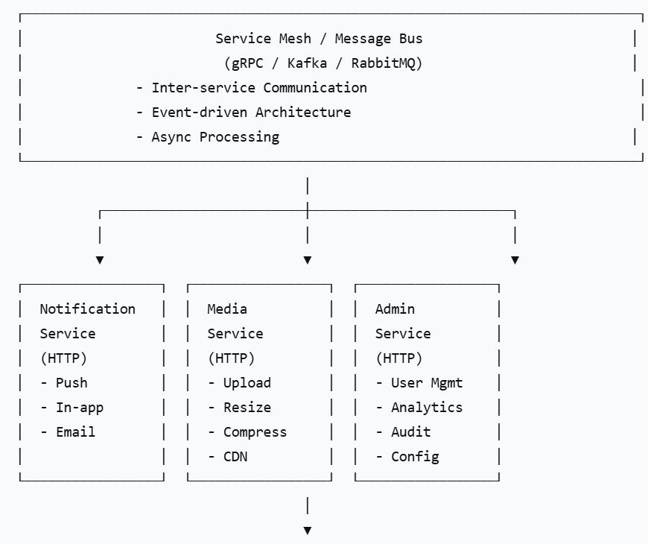
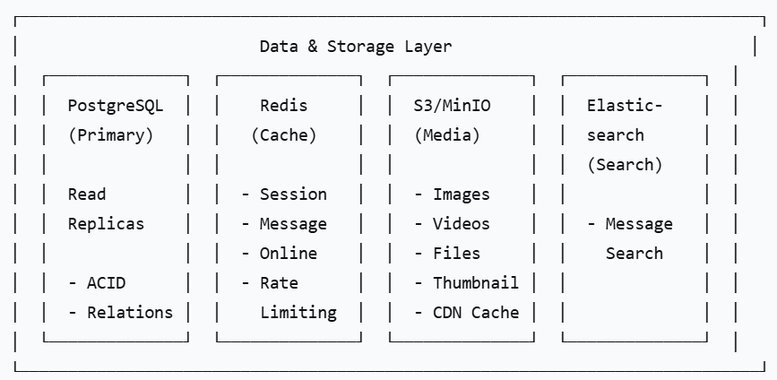

2.2. Service Communication Patterns
Pattern | Usage | Protocol | Example
Synchronous | Request-response | REST/gRPC | API calls
Asynchronous | Event-driven | Message Queue (Kafka/RabbitMQ) | Push notifications
Realtime | Bi-directional | WebSocket | Chat messages
Cron/Background | Scheduled tasks | Cron jobs | Data cleanup

2.3. Data Flow Diagram
┌────────────────────────────────────────────────┐
│ Message Flow (Synchronous) │
│ │
│ [Client] ──(1) Send Message──► [API Gateway] │
│ │ │
│ (2) Validate JWT │
│ ▼ │
│ [Chat Service] │
│ │ │
│ (3) Check Friendship ──► [Friendship Service] │
│ │ │
│ (4) Save Message ──► [PostgreSQL] │
│ │ │
│ (5) Check Online ──► [Redis] │
│ │ │ │
│ (6) Online (7) Offline │
│ ▼ ▼ │
│ [WebSocket] [Queue] │
│ │ │ │
│ (8) Push (9) Notify │
│ │ ▼ │
│ ▼ [Notification] │
│ [Client B] │ │
│ ▼ │
│ [FCM/APNS] │
│ │
└────────────────────────────────────────────────┘

3. TECHNOLOGY STACK

3.1. Backend Technologies
Component | Technology | Version | Purpose
Programming Language | Go (Golang) | 1.21+ | High performance, concurrency
Web Framework | Gin / Fiber | v1.9+ | HTTP routing, middleware
Database | PostgreSQL | 15+ | ACID, relational data
Cache | Redis | 7+ | Session, caching, realtime state
Message Queue | RabbitMQ / Redis Streams | 3.12+ | Async processing
Object Storage | MinIO / AWS S3 | - | Media files
Search Engine | Elasticsearch | 8+ | Message search (Future)
API Gateway | KrakenD / Nginx | - | Routing, rate limiting
Service Mesh | Istio / Consul | - | Service discovery (Future)
WebSocket Library | Gorilla WebSocket | v1.5+ | Realtime communication
gRPC | gRPC-Go | v1.57+ | Inter-service communication
Logging | Logrus / Zap | v1.9+ | Structured logging
Metrics | Prometheus | - | Monitoring
Tracing | Jaeger | - | Distributed tracing

3.2. Development Tools
Tool | Purpose
Docker | Containerization
Docker Compose | Local development
Kubernetes | Production orchestration
Helm | Package management
Make | Build automation
Swagger/OpenAPI | API documentation
GoReleaser | Build and release
GolangCI-Lint | Code linting
Testify | Testing framework

3.3. Technology Justification
go:
pros:
- Excellent concurrency (goroutines)
- High performance (compiled language)
- Low memory footprint
- Great standard library
- Easy to deploy (single binary)
- Strong ecosystem for microservices
cons:
- Limited generics (improving in Go 1.18+)
- Verbose error handling
- Smaller community than Node.js/Java

postgresql:
pros:
- ACID compliance
- Strong community
- JSONB support (flexible schema)
- Full-text search
- Partitioning support
- Open source
cons:
- Harder to scale horizontally than NoSQL
- Requires careful indexing
- Connection pooling needed

redis:
pros:
- In-memory performance
- Data structures (strings, hashes, sets, sorted sets)
- Pub/Sub support
- Persistence options
- Cluster support
cons:
- In-memory (cost)
- Eventual consistency in cluster mode

rabbitmq:
pros:
- Reliable message delivery
- Complex routing capabilities
- Mature and stable
- Great for microservices
cons:
- Heavy compared to Redis Streams
- More complex to manage

4. SERVICE DESIGN

4.1. Service 1: Auth & User Service

Responsibilities
Responsibility | Description
Authentication | Login, register, OTP, refresh token, logout
User Management | CRUD operations for users, profile management
Password Management | Change password, reset password via email
Session Management | JWT generation, validation, revocation
Device Management | Track user devices, push tokens

API Endpoints
Method | Endpoint | Description
POST | /auth/register | User registration
POST | /auth/login | User login
POST | /auth/refresh | Refresh access token
POST | /auth/verify-otp | Verify OTP
POST | /auth/resend-otp | Resend OTP
POST | /auth/forgot-password | Request password reset
POST | /auth/reset-password | Reset password
POST | /auth/logout | Logout
GET | /users/me | Get current user profile
PATCH | /users/me | Update profile
POST | /users/me/avatar | Update avatar
PUT | /users/me/password | Change password
DELETE | /users/me | Delete account
GET | /users/{user_id} | Get user profile by ID

Internal Methods (for other services)
Method | Description
ValidateToken(token string) | Validate JWT token
GetUserByID(userID string) | Get user by ID
GetUserByPhone(phone string) | Get user by phone
BatchGetUsers(ids []string) | Get multiple users
CheckUserStatus(userID string) | Get user online status

Data Models
type User struct {
ID string `json:"id" db:"id"`
Phone string `json:"phone" db:"phone"`
Email string `json:"email" db:"email"`
PasswordHash string `json:"-" db:"password_hash"`
Salt string `json:"-" db:"salt"`
FullName string `json:"full_name" db:"full_name"`
DisplayName string `json:"display_name" db:"display_name"`
Bio string `json:"bio" db:"bio"`
AvatarURL string `json:"avatar_url" db:"avatar_url"`
AvatarThumb string `json:"avatar_thumbnail_url" db:"avatar_thumbnail_url"`
Status string `json:"status" db:"status"` // online, offline, away
LastSeenAt time.Time `json:"last_seen_at" db:"last_seen_at"`
IsVerified bool `json:"is_verified" db:"is_verified"`
IsActive bool `json:"is_active" db:"is_active"`
Language string `json:"language" db:"language"`
CreatedAt time.Time `json:"created_at" db:"created_at"`
UpdatedAt time.Time `json:"updated_at" db:"updated_at"`
}

type UserDevice struct {
ID string `json:"id" db:"id"`
UserID string `json:"user_id" db:"user_id"`
DeviceID string `json:"device_id" db:"device_id"`
DeviceName string `json:"device_name" db:"device_name"`
DeviceType string `json:"device_type" db:"device_type"` // web, ios, android
FCMToken string `json:"fcm_token" db:"fcm_token"`
APNSToken string `json:"apns_token" db:"apns_token"`
RefreshToken string `json:"-" db:"refresh_token_hash"`
LastActivityAt time.Time `json:"last_activity_at" db:"last_activity_at"`
IsActive bool `json:"is_active" db:"is_active"`
CreatedAt time.Time `json:"created_at" db:"created_at"`
}

4.2. Service 2: Friendship Service

Responsibilities
Responsibility | Description
Friend Management | Send, accept, reject friend requests
Block Management | Block/unblock users
Friend List | Get friends list, mutual friends
Permission Check | Check if two users are friends
Relationship Status | Check if user is blocked by another

API Endpoints
Method | Endpoint | Description
POST | /friends/requests | Send friend request
GET | /friends/requests | Get friend requests
PUT | /friends/requests/{id} | Accept/reject request
DELETE | /friends/requests/{id} | Cancel request
GET | /friends | Get friends list
DELETE | /friends/{user_id} | Unfriend
POST | /friends/block | Block user
DELETE | /friends/block/{user_id} | Unblock user
GET | /friends/blocked | Get blocked list
GET | /friends/status | Get relationship status

Internal Methods (for other services)
Method | Description
AreFriends(userA, userB string) bool | Check if two users are friends
IsBlocked(userA, userB string) bool | Check if A blocked B
GetFriendIDs(userID string) []string | Get all friend IDs
GetMutualFriends(userA, userB string) []string | Get mutual friends
CheckPermissions(userA, userB string) bool | Can A send message to B

Data Models
type Friendship struct {
ID int64 `json:"id" db:"id"`
UserID string `json:"user_id" db:"user_id"`
FriendID string `json:"friend_id" db:"friend_id"`
Status string `json:"status" db:"status"` // pending, accepted, blocked
RequestedAt time.Time `json:"requested_at" db:"requested_at"`
AcceptedAt *time.Time `json:"accepted_at" db:"accepted_at"`
BlockedAt *time.Time `json:"blocked_at" db:"blocked_at"`
CreatedAt time.Time `json:"created_at" db:"created_at"`
UpdatedAt time.Time `json:"updated_at" db:"updated_at"`
}

type FriendRequest struct {
ID int64 `json:"id" db:"id"`
SenderID string `json:"sender_id" db:"sender_id"`
ReceiverID string `json:"receiver_id" db:"receiver_id"`
Message string `json:"message" db:"message"`
Status string `json:"status" db:"status"` // pending, accepted, rejected
SentAt time.Time `json:"sent_at" db:"sent_at"`
RespondedAt *time.Time `json:"responded_at" db:"responded_at"`
}

type Block struct {
ID int64 `json:"id" db:"id"`
BlockerID string `json:"blocker_id" db:"blocker_id"`
BlockedID string `json:"blocked_id" db:"blocked_id"`
Reason string `json:"reason" db:"reason"`
CreatedAt time.Time `json:"created_at" db:"created_at"`
UnblockedAt *time.Time `json:"unblocked_at" db:"unblocked_at"`
}

4.3. Service 3: Chat & Message Service (Most Critical)

Responsibilities
Responsibility | Description
WebSocket Management | Connection management, realtime messaging
Message CRUD | Send, edit, delete, reply messages
Conversation Management | Create 1-1 and group conversations
Reactions | Add/remove emoji reactions
Message Status | Track sent, delivered, read status
Group Management | Add/remove members, manage roles

API Endpoints
Method | Endpoint | Description
GET | /ws | WebSocket connection
POST | /conversations | Create conversation
GET | /conversations | Get conversations list
GET | /conversations/{id} | Get conversation detail
PUT | /conversations/{id} | Update conversation
DELETE | /conversations/{id} | Delete conversation
POST | /conversations/{id}/members | Add members
DELETE | /conversations/{id}/members/{user_id} | Remove member
PUT | /conversations/{id}/members/{user_id} | Update member role
POST | /conversations/{id}/leave | Leave group
GET | /conversations/{id}/messages | Get messages
POST | /conversations/{id}/messages | Send message
PUT | /messages/{id} | Edit message
DELETE | /messages/{id} | Delete message
POST | /messages/{id}/reactions | Add reaction
DELETE | /messages/{id}/reactions/{emoji} | Remove reaction
POST | /messages/{id}/read | Mark as read

WebSocket Events
Event (Client → Server) | Event (Server → Client)
connect | connected
send_message | new_message
typing | typing_indicator
edit_message | message_edited
delete_message | message_deleted
add_reaction | reaction_updated
mark_read | message_read
ping | pong
- | message_delivered
- | user_status_update
- | group_member_update

Data Models
type Conversation struct {
ID string `json:"id" db:"id"`
Type string `json:"type" db:"type"` // direct, group
Name string `json:"name" db:"name"`
Description string `json:"description" db:"description"`
AvatarURL string `json:"avatar_url" db:"avatar_url"`
CreatedBy string `json:"created_by" db:"created_by"`
IsActive bool `json:"is_active" db:"is_active"`
LastMessage *Message `json:"last_message" db:"-"`
LastMessageAt time.Time `json:"last_message_at" db:"last_message_at"`
CreatedAt time.Time `json:"created_at" db:"created_at"`
UpdatedAt time.Time `json:"updated_at" db:"updated_at"`
}

type Message struct {
ID string `json:"id" db:"id"`
ConversationID string `json:"conversation_id" db:"conversation_id"`
SenderID string `json:"sender_id" db:"sender_id"`
Type string `json:"type" db:"type"` // text, image, file, video
Content string `json:"content" db:"content"`
MediaURL string `json:"media_url" db:"media_url"`
MediaThumbnail string `json:"media_thumbnail" db:"media_thumbnail_url"`
MediaMetadata JSON `json:"media_metadata" db:"media_metadata"`
Status string `json:"status" db:"status"` // sent, delivered, read
RepliedToID string `json:"replied_to_id" db:"replied_to_id"`
Reactions JSON `json:"reactions" db:"reactions"` // {"👍": ["user1"]}
IsEdited bool `json:"is_edited" db:"is_edited"`
EditedAt *time.Time `json:"edited_at" db:"edited_at"`
IsDeleted bool `json:"is_deleted" db:"is_deleted"`
DeletedAt *time.Time `json:"deleted_at" db:"deleted_at"`
SentAt time.Time `json:"sent_at" db:"sent_at"`
DeliveredAt *time.Time `json:"delivered_at" db:"delivered_at"`
ReadAt *time.Time `json:"read_at" db:"read_at"`
CreatedAt time.Time `json:"created_at" db:"created_at"`
}

type ConversationMember struct {
ConversationID string `json:"conversation_id" db:"conversation_id"`
UserID string `json:"user_id" db:"user_id"`
Role string `json:"role" db:"role"` // owner, admin, member
JoinedAt time.Time `json:"joined_at" db:"joined_at"`
LastReadMessageID string `json:"last_read_message_id" db:"last_read_message_id"`
LastReadAt *time.Time `json:"last_read_at" db:"last_read_at"`
MutedUntil *time.Time `json:"muted_until" db:"muted_until"`
NotificationEnabled bool `json:"notification_enabled" db:"notification_enabled"`
IsActive bool `json:"is_active" db:"is_active"`
}

4.4. Service 4: Notification Service

Responsibilities
Responsibility | Description
In-app Notification | Store and deliver in-app notifications
Push Notification | Send push via FCM/APNS
Email Notification | Send emails (OTP, password reset, etc.)
Notification Preferences | Manage user notification settings
Scheduling | Batch and schedule notifications

API Endpoints
Method | Endpoint | Description
GET | /notifications | Get user notifications
PUT | /notifications/{id}/read | Mark as read
PUT | /notifications/read-all | Mark all as read
DELETE | /notifications/{id} | Delete notification
GET | /notifications/unread-count | Get unread count
PUT | /notifications/settings | Update preferences

Internal Methods (called by other services)
Method | Description
SendPushNotification(userID, title, body, data) | Send push notification
SendEmailNotification(email, subject, body) | Send email
CreateInAppNotification(userID, title, body, data) | Create in-app notification

Data Models
type Notification struct {
ID int64 `json:"id" db:"id"`
UserID string `json:"user_id" db:"user_id"`
Type string `json:"type" db:"type"` // new_message, friend_request, system
Title string `json:"title" db:"title"`
Body string `json:"body" db:"body"`
Data JSON `json:"data" db:"data"`
SourceUserID string `json:"source_user_id" db:"source_user_id"`
SourceConvID string `json:"source_conversation_id" db:"source_conversation_id"`
IsRead bool `json:"is_read" db:"is_read"`
ReadAt *time.Time `json:"read_at" db:"read_at"`
IsDelivered bool `json:"is_delivered" db:"is_delivered"`
DeliveredAt *time.Time `json:"delivered_at" db:"delivered_at"`
PushStatus string `json:"push_status" db:"push_status"` // pending, sent, failed
CreatedAt time.Time `json:"created_at" db:"created_at"`
}

type PushDevice struct {
ID int64 `json:"id" db:"id"`
UserID string `json:"user_id" db:"user_id"`
DeviceToken string `json:"device_token" db:"device_token"`
Platform string `json:"platform" db:"platform"` // fcm, apns, web_push
DeviceName string `json:"device_name" db:"device_name"`
IsActive bool `json:"is_active" db:"is_active"`
LastActiveAt time.Time `json:"last_active_at" db:"last_active_at"`
CreatedAt time.Time `json:"created_at" db:"created_at"`
}

type NotificationSettings struct {
UserID string `json:"user_id" db:"user_id"`
MessageEnabled bool `json:"message_enabled" db:"message_enabled"`
FriendEnabled bool `json:"friend_enabled" db:"friend_enabled"`
GroupEnabled bool `json:"group_enabled" db:"group_enabled"`
SystemEnabled bool `json:"system_enabled" db:"system_enabled"`
SoundEnabled bool `json:"sound_enabled" db:"sound_enabled"`
VibrationEnabled bool `json:"vibration_enabled" db:"vibration_enabled"`
}

4.5. Service 5: Media Service

Responsibilities
Responsibility | Description
Upload | Handle file uploads
Storage | Store files in S3/MinIO
Transformation | Resize, compress, convert
Thumbnail | Generate thumbnails
CDN Integration | Serve files via CDN
Validation | Validate file type, size

API Endpoints
Method | Endpoint | Description
POST | /media/upload | Upload file
GET | /media/{file_id} | Get file info
DELETE | /media/{file_id} | Delete file
GET | /media/{file_id}/download | Download file

Internal Methods
Method | Description
UploadFile(file, metadata) | Upload to S3
GenerateThumbnail(fileID) | Generate thumbnail
GetFileURL(fileID) | Get CDN URL
DeleteFile(fileID) | Delete from S3

Data Models
type MediaFile struct {
ID string `json:"id" db:"id"`
UserID string `json:"user_id" db:"user_id"`
FileName string `json:"file_name" db:"file_name"`
FilePath string `json:"file_path" db:"file_path"`
FileSize int64 `json:"file_size" db:"file_size"`
MimeType string `json:"mime_type" db:"mime_type"`
FileType string `json:"file_type" db:"file_type"` // image, video, document
ThumbnailPath string `json:"thumbnail_path" db:"thumbnail_path"`
Width int `json:"width" db:"width"`
Height int `json:"height" db:"height"`
Duration int `json:"duration" db:"duration"` // for video
Metadata JSON `json:"metadata" db:"metadata"`
IsPublic bool `json:"is_public" db:"is_public"`
UsedInMsgID string `json:"used_in_message_id" db:"used_in_message_id"`
UploadStatus string `json:"upload_status" db:"upload_status"` // uploading, completed, failed
CreatedAt time.Time `json:"created_at" db:"created_at"`
}

4.6. Service 6: Admin Service

Responsibilities
Responsibility | Description
User Management | List, ban, unban users
System Config | Manage system configuration
Audit Logs | Track admin actions
Analytics | Generate reports
Moderator Management | Add/remove moderators

API Endpoints
Method | Endpoint | Description
GET | /admin/users | List users
POST | /admin/users | Create user
PUT | /admin/users/{id}/ban | Ban user
PUT | /admin/users/{id}/unban | Unban user
DELETE | /admin/users/{id} | Delete user
GET | /admin/stats | System statistics
GET | /admin/audit-logs | Get audit logs
PUT | /admin/config | Update system config
GET | /admin/config | Get system config

Data Models
type SystemConfig struct {
ID int64 `json:"id" db:"id"`
ConfigKey string `json:"config_key" db:"config_key"`
ConfigValue JSON `json:"config_value" db:"config_value"`
Description string `json:"description" db:"description"`
IsSecret bool `json:"is_secret" db:"is_secret"`
CreatedAt time.Time `json:"created_at" db:"created_at"`
UpdatedAt time.Time `json:"updated_at" db:"updated_at"`
}

type AuditLog struct {
ID int64 `json:"id" db:"id"`
UserID string `json:"user_id" db:"user_id"`
Action string `json:"action" db:"action"`
ResourceType string `json:"resource_type" db:"resource_type"`
ResourceID string `json:"resource_id" db:"resource_id"`
OldValue JSON `json:"old_value" db:"old_value"`
NewValue JSON `json:"new_value" db:"new_value"`
IPAddress string `json:"ip_address" db:"ip_address"`
UserAgent string `json:"user_agent" db:"user_agent"`
IsSuccess bool `json:"is_success" db:"is_success"`
ErrorMsg string `json:"error_message" db:"error_message"`
CreatedAt time.Time `json:"created_at" db:"created_at"`
}

5. API DESIGN

5.1. API Conventions

Base URL
Development: http://localhost:8080/v1
Staging: https://api-staging.connectpro.com/v1
Production: https://api.connectpro.com/v1

HTTP Headers
Header | Value | Purpose
Content-Type | application/json | Request/Response format
Authorization | Bearer {access_token} | Authentication
X-Request-ID | {uuid} | Request tracing
X-Device-ID | {device_id} | Device identification
X-API-Version | 1 | API versioning

HTTP Status Codes
Code | Name | Usage
200 | OK | Successful request
201 | Created | Resource created
204 | No Content | Successful but no response body
400 | Bad Request | Invalid request parameters
401 | Unauthorized | Missing/invalid token
403 | Forbidden | Insufficient permissions
404 | Not Found | Resource not found
409 | Conflict | Resource already exists
422 | Unprocessable Entity | Validation failed
429 | Too Many Requests | Rate limit exceeded
500 | Internal Server Error | Server error

Response Format
{
"success": true,
"code": 200,
"message": "Success",
"data": {
// Response data
},
"pagination": {
"page": 1,
"limit": 20,
"total": 100,
"next_cursor": "cursor_xyz"
},
"timestamp": "2026-07-28T10:30:00Z",
"request_id": "req_abc123"
}

Error Response Format
{
"success": false,
"code": 400,
"message": "Validation failed",
"errors": [
{
"field": "phone",
"message": "Phone number is required"
}
],
"timestamp": "2026-07-28T10:30:00Z",
"request_id": "req_abc123"
}

5.2. API Endpoint Summary

Auth & User Service
Method | Endpoint | Description
POST | /auth/register | User registration
POST | /auth/login | User login
POST | /auth/refresh | Refresh token
POST | /auth/verify-otp | Verify OTP
POST | /auth/resend-otp | Resend OTP
POST | /auth/forgot-password | Request password reset
POST | /auth/reset-password | Reset password
POST | /auth/logout | Logout
GET | /users/me | Get current user
PATCH | /users/me | Update profile
POST | /users/me/avatar | Upload avatar
PUT | /users/me/password | Change password
DELETE | /users/me | Delete account
GET | /users/{id} | Get user by ID

Friendship Service
Method | Endpoint | Description
POST | /friends/requests | Send friend request
GET | /friends/requests | List requests
PUT | /friends/requests/{id} | Accept/reject
DELETE | /friends/requests/{id} | Cancel request
GET | /friends | Get friends list
DELETE | /friends/{id} | Unfriend
POST | /friends/block | Block user
DELETE | /friends/block/{id} | Unblock
GET | /friends/blocked | Get blocked list

Chat Service
Method | Endpoint | Description
GET | /ws | WebSocket connection
POST | /conversations | Create conversation
GET | /conversations | List conversations
GET | /conversations/{id} | Get conversation
PUT | /conversations/{id} | Update conversation
DELETE | /conversations/{id} | Delete conversation
POST | /conversations/{id}/members | Add members
DELETE | /conversations/{id}/members/{uid} | Remove member
PUT | /conversations/{id}/members/{uid} | Update role
POST | /conversations/{id}/leave | Leave group
GET | /conversations/{id}/messages | Get messages
POST | /conversations/{id}/messages | Send message
PUT | /messages/{id} | Edit message
DELETE | /messages/{id} | Delete message
POST | /messages/{id}/reactions | Add reaction
DELETE | /messages/{id}/reactions/{e} | Remove reaction
POST | /messages/{id}/read | Mark read

Notification Service
Method | Endpoint | Description
GET | /notifications | Get notifications
PUT | /notifications/{id}/read | Mark read
PUT | /notifications/read-all | Mark all read
DELETE | /notifications/{id} | Delete notification
GET | /notifications/unread-count | Get unread count
PUT | /notifications/settings | Update settings

Media Service
Method | Endpoint | Description
POST | /media/upload | Upload file
GET | /media/{id} | Get file info
DELETE | /media/{id} | Delete file

Admin Service
Method | Endpoint | Description
GET | /admin/users | List users
PUT | /admin/users/{id}/ban | Ban user
PUT | /admin/users/{id}/unban | Unban user
DELETE | /admin/users/{id} | Delete user
GET | /admin/stats | System stats
GET | /admin/audit-logs | Audit logs
GET | /admin/config | Get config
PUT | /admin/config | Update config

6. DATABASE DESIGN

6.1. Database Strategy

Database Selection
Data Type | Database | Reason
User Data | PostgreSQL | ACID compliance, relationships
Messages | PostgreSQL (Partitioned) | Durability, query performance
Conversations | PostgreSQL | Relationships with users
Media Metadata | PostgreSQL | References to S3 files
Session/Cache | Redis | In-memory performance
Online Status | Redis | Real-time updates
Rate Limiting | Redis | Atomic operations
Message Queue | RabbitMQ/Redis Streams | Async processing

Database Schema Overview
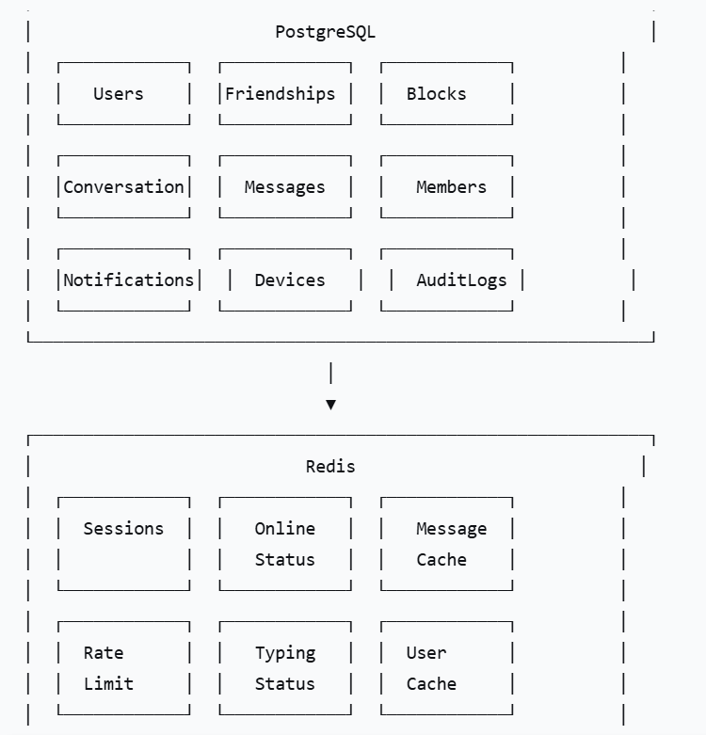

6.2. PostgreSQL Schema (Detailed)

Users Table
CREATE TABLE users (
id UUID PRIMARY KEY DEFAULT gen_random_uuid(),
phone VARCHAR(15) UNIQUE NOT NULL,
email VARCHAR(255) UNIQUE,
password_hash VARCHAR(255) NOT NULL,
salt VARCHAR(64) NOT NULL,
full_name VARCHAR(100) NOT NULL,
display_name VARCHAR(100),
bio TEXT DEFAULT '',
avatar_url TEXT,
avatar_thumbnail_url TEXT,
status VARCHAR(20) DEFAULT 'offline',
last_seen_at TIMESTAMP,
is_verified BOOLEAN DEFAULT FALSE,
is_active BOOLEAN DEFAULT TRUE,
is_banned BOOLEAN DEFAULT FALSE,
banned_reason TEXT,
banned_at TIMESTAMP,
preferred_language VARCHAR(10) DEFAULT 'vi',
notification_enabled BOOLEAN DEFAULT TRUE,
failed_login_attempts INT DEFAULT 0,
locked_until TIMESTAMP,
created_at TIMESTAMP DEFAULT NOW(),
updated_at TIMESTAMP DEFAULT NOW(),
last_login_at TIMESTAMP,
last_password_change_at TIMESTAMP
);

-- Indexes
CREATE INDEX idx_users_phone ON users(phone);
CREATE INDEX idx_users_email ON users(email);
CREATE INDEX idx_users_status ON users(status);
CREATE INDEX idx_users_active ON users(is_active) WHERE is_active = true;
CREATE INDEX idx_users_last_seen ON users(last_seen_at);

User Devices Table
CREATE TABLE user_devices (
id BIGSERIAL PRIMARY KEY,
user_id UUID NOT NULL REFERENCES users(id) ON DELETE CASCADE,
device_id VARCHAR(255) UNIQUE NOT NULL,
device_name VARCHAR(100),
device_type VARCHAR(20), -- web, ios, android
device_os VARCHAR(50),
fcm_token VARCHAR(255),
apns_token VARCHAR(255),
refresh_token_hash VARCHAR(255),
last_activity_at TIMESTAMP,
is_active BOOLEAN DEFAULT TRUE,
created_at TIMESTAMP DEFAULT NOW(),
updated_at TIMESTAMP DEFAULT NOW()
);

CREATE INDEX idx_user_devices_user ON user_devices(user_id);
CREATE INDEX idx_user_devices_refresh ON user_devices(refresh_token_hash);
CREATE INDEX idx_user_devices_fcm ON user_devices(fcm_token) WHERE fcm_token IS NOT NULL;

Friendships Table
CREATE TABLE friendships (
id BIGSERIAL PRIMARY KEY,
user_id UUID NOT NULL REFERENCES users(id) ON DELETE CASCADE,
friend_id UUID NOT NULL REFERENCES users(id) ON DELETE CASCADE,
status VARCHAR(20) DEFAULT 'pending', -- pending, accepted, blocked
requested_at TIMESTAMP DEFAULT NOW(),
accepted_at TIMESTAMP,
blocked_at TIMESTAMP,
created_at TIMESTAMP DEFAULT NOW(),
updated_at TIMESTAMP DEFAULT NOW(),
UNIQUE(user_id, friend_id),
CHECK (user_id != friend_id)
);

CREATE INDEX idx_friendships_user_status ON friendships(user_id, status);
CREATE INDEX idx_friendships_friend_status ON friendships(friend_id, status);
CREATE INDEX idx_friendships_accepted ON friendships(user_id, friend_id) WHERE status = 'accepted';

Blocks Table
CREATE TABLE blocks (
id BIGSERIAL PRIMARY KEY,
blocker_id UUID NOT NULL REFERENCES users(id) ON DELETE CASCADE,
blocked_id UUID NOT NULL REFERENCES users(id) ON DELETE CASCADE,
reason TEXT,
created_at TIMESTAMP DEFAULT NOW(),
unblocked_at TIMESTAMP,
UNIQUE(blocker_id, blocked_id)
);

CREATE INDEX idx_blocks_blocker ON blocks(blocker_id);
CREATE INDEX idx_blocks_blocked ON blocks(blocked_id);
CREATE INDEX idx_blocks_active ON blocks(blocker_id) WHERE unblocked_at IS NULL;

Conversations Table
CREATE TABLE conversations (
id UUID PRIMARY KEY DEFAULT gen_random_uuid(),
type VARCHAR(20) NOT NULL, -- direct, group
name VARCHAR(100),
description TEXT,
avatar_url TEXT,
avatar_thumbnail_url TEXT,
created_by UUID NOT NULL REFERENCES users(id),
is_public BOOLEAN DEFAULT FALSE,
is_active BOOLEAN DEFAULT TRUE,
last_message_id UUID,
last_message_preview VARCHAR(255),
last_message_at TIMESTAMP,
created_at TIMESTAMP DEFAULT NOW(),
updated_at TIMESTAMP DEFAULT NOW(),
deleted_at TIMESTAMP
);

CREATE INDEX idx_conversations_type ON conversations(type);
CREATE INDEX idx_conversations_last_message ON conversations(last_message_at DESC);
CREATE INDEX idx_conversations_active ON conversations(is_active) WHERE is_active = true;

Conversation Members Table
CREATE TABLE conversation_members (
id BIGSERIAL PRIMARY KEY,
conversation_id UUID NOT NULL REFERENCES conversations(id) ON DELETE CASCADE,
user_id UUID NOT NULL REFERENCES users(id) ON DELETE CASCADE,
role VARCHAR(20) DEFAULT 'member', -- owner, admin, member
joined_at TIMESTAMP DEFAULT NOW(),
invited_by UUID REFERENCES users(id),
last_read_message_id UUID,
last_read_at TIMESTAMP,
muted_until TIMESTAMP,
notification_enabled BOOLEAN DEFAULT TRUE,
is_active BOOLEAN DEFAULT TRUE,
left_at TIMESTAMP,
created_at TIMESTAMP DEFAULT NOW(),
updated_at TIMESTAMP DEFAULT NOW(),
UNIQUE(conversation_id, user_id)
);

CREATE INDEX idx_conv_members_conversation ON conversation_members(conversation_id);
CREATE INDEX idx_conv_members_user ON conversation_members(user_id);
CREATE INDEX idx_conv_members_active ON conversation_members(conversation_id, user_id) WHERE is_active = true;

Messages Table (Partitioned)
-- Main partitioned table
CREATE TABLE messages (
id UUID PRIMARY KEY DEFAULT gen_random_uuid(),
conversation_id UUID NOT NULL REFERENCES conversations(id) ON DELETE CASCADE,
sender_id UUID NOT NULL REFERENCES users(id),
type VARCHAR(20) DEFAULT 'text', -- text, image, file, video
content TEXT,
media_url TEXT,
media_thumbnail_url TEXT,
media_metadata JSONB,
file_name VARCHAR(255),
file_size BIGINT,
mime_type VARCHAR(100),
status VARCHAR(20) DEFAULT 'sent', -- sent, delivered, read
replied_to_id UUID REFERENCES messages(id),
reply_preview VARCHAR(255),
reactions JSONB DEFAULT '{}',
is_edited BOOLEAN DEFAULT FALSE,
edited_at TIMESTAMP,
edit_history JSONB,
is_deleted BOOLEAN DEFAULT FALSE,
deleted_at TIMESTAMP,
deleted_by UUID REFERENCES users(id),
sent_at TIMESTAMP DEFAULT NOW(),
delivered_at TIMESTAMP,
read_at TIMESTAMP,
created_at TIMESTAMP DEFAULT NOW(),
updated_at TIMESTAMP DEFAULT NOW()
) PARTITION BY RANGE (created_at);

-- Monthly partitions (example)
CREATE TABLE messages_2026_07 PARTITION OF messages
FOR VALUES FROM ('2026-07-01') TO ('2026-08-01');
CREATE TABLE messages_2026_08 PARTITION OF messages
FOR VALUES FROM ('2026-08-01') TO ('2026-09-01');
-- ... Auto-create partitions via function

-- Indexes (applied per partition)
CREATE INDEX idx_messages_conversation_time ON messages(conversation_id, sent_at DESC);
CREATE INDEX idx_messages_sender ON messages(sender_id);
CREATE INDEX idx_messages_status ON messages(status);
CREATE INDEX idx_messages_type ON messages(type);
CREATE INDEX idx_messages_created_at ON messages(created_at);

Message Reads Table
CREATE TABLE message_reads (
id BIGSERIAL PRIMARY KEY,
message_id UUID NOT NULL REFERENCES messages(id) ON DELETE CASCADE,
user_id UUID NOT NULL REFERENCES users(id) ON DELETE CASCADE,
read_at TIMESTAMP DEFAULT NOW(),
device_id VARCHAR(255),
UNIQUE(message_id, user_id)
);

CREATE INDEX idx_message_reads_message ON message_reads(message_id);
CREATE INDEX idx_message_reads_user ON message_reads(user_id);

Notifications Table
CREATE TABLE notifications (
id BIGSERIAL PRIMARY KEY,
user_id UUID NOT NULL REFERENCES users(id) ON DELETE CASCADE,
type VARCHAR(50) NOT NULL,
title VARCHAR(255),
body TEXT,
data JSONB,
source_user_id UUID REFERENCES users(id),
source_conversation_id UUID REFERENCES conversations(id),
is_read BOOLEAN DEFAULT FALSE,
read_at TIMESTAMP,
is_delivered BOOLEAN DEFAULT FALSE,
delivered_at TIMESTAMP,
push_status VARCHAR(20) DEFAULT 'pending', -- pending, sent, failed
created_at TIMESTAMP DEFAULT NOW(),
updated_at TIMESTAMP DEFAULT NOW()
);

CREATE INDEX idx_notifications_user_read ON notifications(user_id, is_read, created_at DESC);
CREATE INDEX idx_notifications_push_status ON notifications(push_status) WHERE push_status = 'pending';

Audit Logs Table
CREATE TABLE audit_logs (
id BIGSERIAL PRIMARY KEY,
user_id UUID REFERENCES users(id),
action VARCHAR(100) NOT NULL,
resource_type VARCHAR(50),
resource_id UUID,
old_value JSONB,
new_value JSONB,
ip_address INET,
user_agent TEXT,
is_success BOOLEAN DEFAULT TRUE,
error_message TEXT,
created_at TIMESTAMP DEFAULT NOW()
);

CREATE INDEX idx_audit_user ON audit_logs(user_id);
CREATE INDEX idx_audit_action ON audit_logs(action);
CREATE INDEX idx_audit_created ON audit_logs(created_at DESC);

6.3. Redis Schema
Key Pattern | Type | TTL | Purpose
session:{user_id} | String (JSON) | 24h | User session data
online:{user_id} | String | 60s | Online status
ws:{user_id} | String | 60s | WebSocket connection ID
typing:{conv_id}:{user_id} | String | 10s | Typing status
messages:{conv_id}:recent | Sorted Set | 10m | Recent message IDs
message:{message_id} | String (JSON) | 24h | Message details
friend:{user_id} | Set | 10m | Friend IDs
block:{user_id} | Set | 10m | Blocked IDs
conv:{user_id} | Set | 5m | Conversation IDs
rate:{endpoint}:{user_id} | String | 1s | Rate limiting
spam:{user_id} | String | 5s | Spam detection

6.4. Partitioning Strategy
-- Auto-create monthly partitions for messages
CREATE OR REPLACE FUNCTION create_message_partition()
RETURNS TRIGGER AS $$
DECLARE
partition_name TEXT;
start_date TEXT;
end_date TEXT;
BEGIN
partition_name := 'messages_' || TO_CHAR(NOW() + INTERVAL '1 month', 'YYYY_MM');
start_date := TO_CHAR(NOW() + INTERVAL '1 month', 'YYYY-MM-01');
end_date := TO_CHAR(NOW() + INTERVAL '2 months', 'YYYY-MM-01');

EXECUTE format(
'CREATE TABLE IF NOT EXISTS %I PARTITION OF messages
FOR VALUES FROM (%L) TO (%L)',
partition_name, start_date, end_date
);

RETURN NEW;
END;
$$ LANGUAGE plpgsql;

CREATE TRIGGER create_message_partition_trigger
BEFORE INSERT ON messages
FOR EACH ROW
EXECUTE FUNCTION create_message_partition();

7. REALTIME COMMUNICATION

7.1. WebSocket Architecture
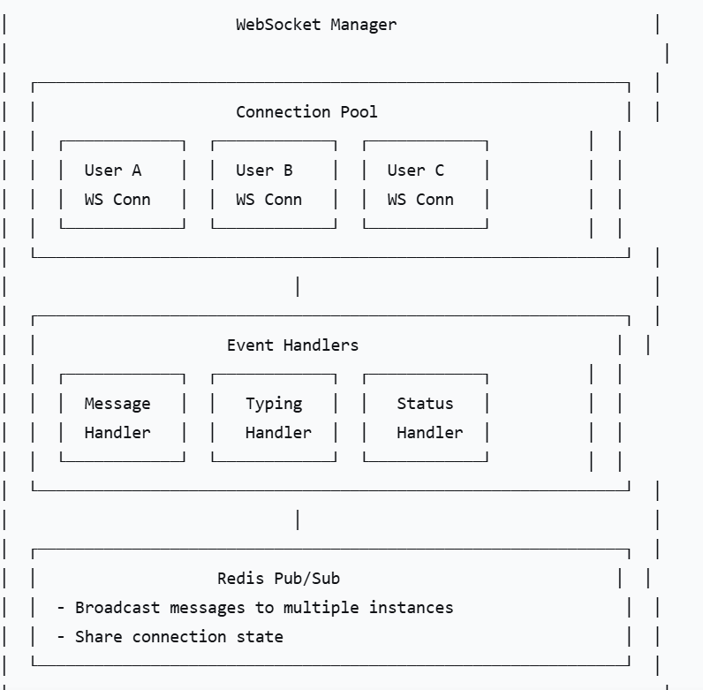

7.2. Connection Lifecycle
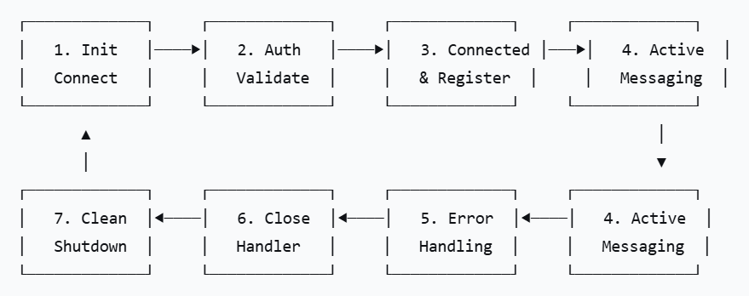

7.3. Message Delivery Guarantee
Guarantee | Implementation
At-least-once | Client sends ACK, retry on failure
Ordering | Sequence numbers, reorder on client side
Deduplication | Client message ID, server deduplication
Status Tracking | Sent → Delivered → Read

7.4. Heartbeat Mechanism
heartbeat:
client_ping_interval: 30s
server_pong_timeout: 60s
max_inactivity: 90s
cleanup_on_disconnect: immediate
reconnection:
max_attempts: 5
backoff_strategy: exponential
initial_delay: 1s
max_delay: 30s

8. CACHING STRATEGY

8.1. Caching Layers
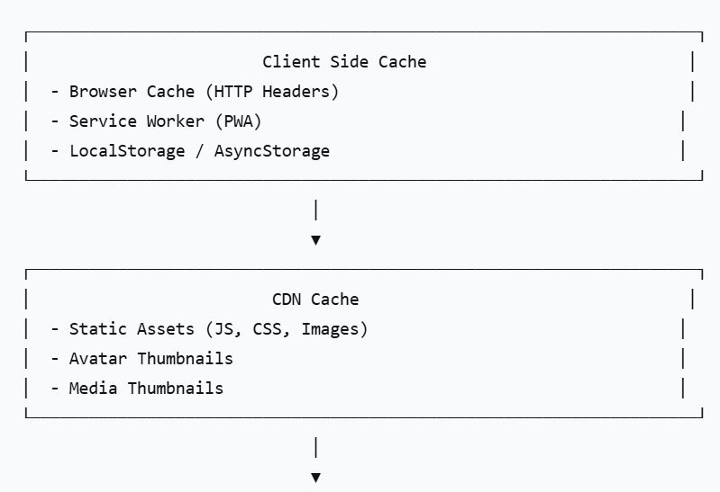
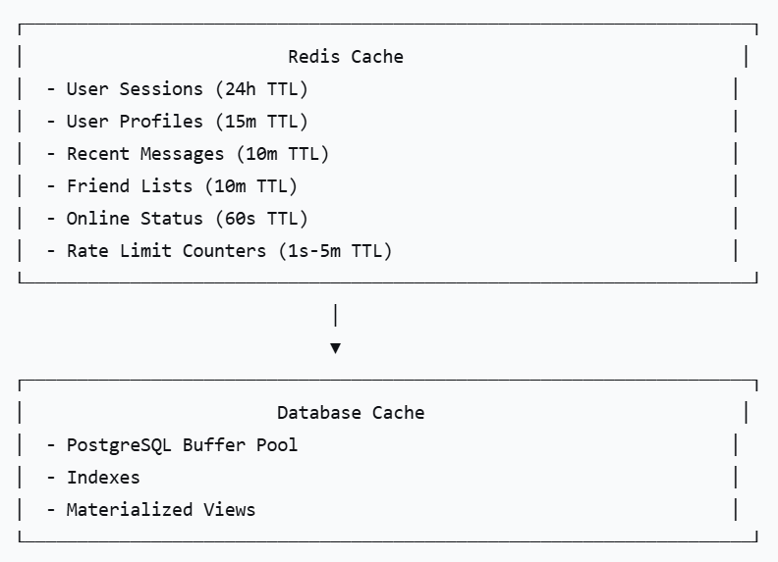

8.2. Cache Invalidation Strategy
Event | Cache Invalidation
New Message | Invalidate recent messages cache
Message Read | Invalidate unread count cache
User Update | Invalidate user profile cache
Friend Added | Invalidate friend list cache
New Conversation | Invalidate conversation list cache
User Online | Invalidate last seen cache

8.3. Cache Policies
cache_policies:
user_profile:
strategy: cache-aside
ttl: 15m
invalidation: on_update

friend_list:
strategy: cache-aside
ttl: 10m
invalidation: on_friend_change

recent_messages:
strategy: write-through
ttl: 10m
invalidation: on_new_message

online_status:
strategy: write-behind
ttl: 60s
invalidation: on_status_change

rate_limit:
strategy: write-through
ttl: window_size
invalidation: automatic_expiry

9. MESSAGE QUEUE & ASYNC PROCESSING

9.1. Queue Architecture
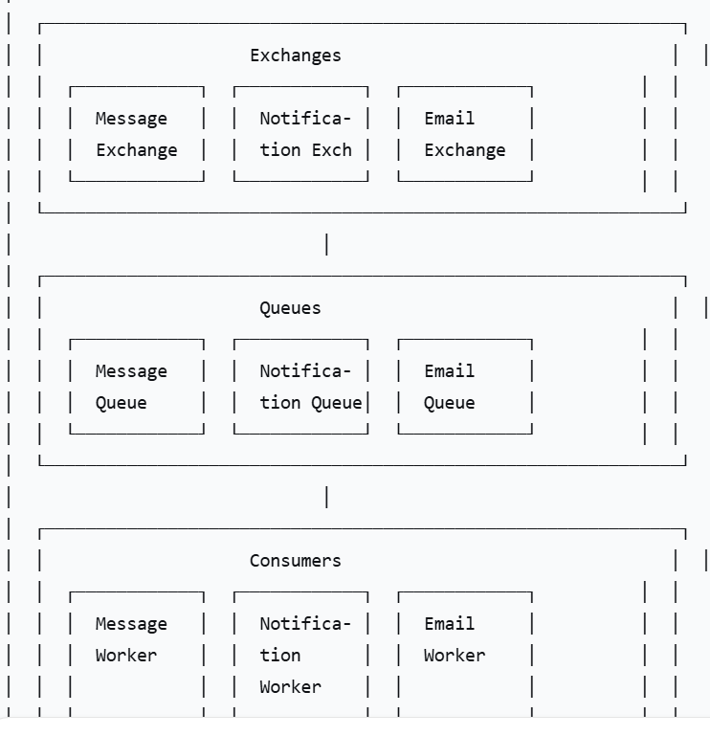

9.2. Event Types
Event | Producer | Consumer | Purpose
message.created | Chat Service | Notification Service | Send push notification
message.created | Chat Service | Email Service | Email digest (future)
user.registered | Auth Service | Email Service | Send welcome email
user.registered | Auth Service | Analytics Service | Track user signup
friend.requested | Friendship Service | Notification Service | Send friend request notification
friend.accepted | Friendship Service | Notification Service | Send acceptance notification
user.offline | Chat Service | Notification Service | Batch notifications
message.read | Chat Service | Analytics Service | Read receipts
media.uploaded | Media Service | Media Service | Generate thumbnail

9.3. Queue Configuration
rabbitmq_config:
exchanges:
message_exchange:
type: topic
durable: true
dead_letter_exchange: dead_letter_exchange

notification_exchange:
type: direct
durable: true

queues:
message_queue:
durable: true
arguments:
x-dead-letter-exchange: dead_letter_exchange
x-max-priority: 10

notification_queue:
durable: true
arguments:
x-max-priority: 5

retry_policy:
max_retries: 3
initial_delay: 1s
backoff_multiplier: 2
max_delay: 60s

10. FILE & MEDIA HANDLING

10.1. Media Upload Flow
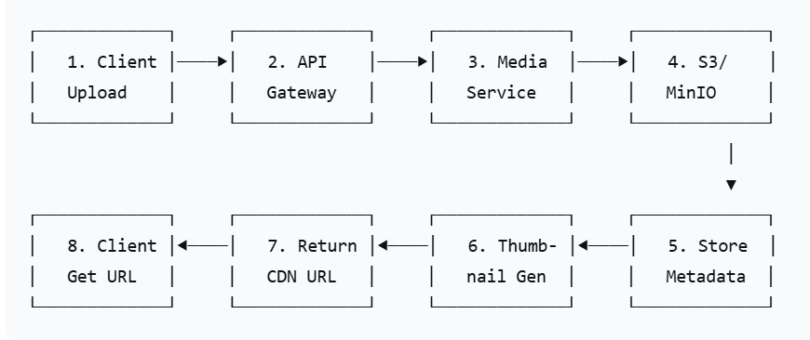

10.2. File Validation
File Type | Allowed Extensions | Max Size | Min Resolution | Max Resolution
Image | JPG, PNG, GIF, WEBP | 25MB | 200x200 | 8192x8192
Video | MP4, MOV | 100MB | 480p | 4K
Document | PDF, DOC, DOCX, XLS, XLSX | 25MB | - | -
Audio | MP3, WAV, M4A | 25MB | - | -

10.3. CDN Integration
cdn_config:
provider: CloudFront / Cloudflare
domain: cdn.connectpro.com
cache_control: public, max-age=31536000, immutable
thumbnail_presets:
small: 100x100
medium: 300x300
large: 600x600
original: original
image_formats:
webp: true
avif: true (future)

11. AUTHENTICATION & AUTHORIZATION

11.1. Authentication Flow
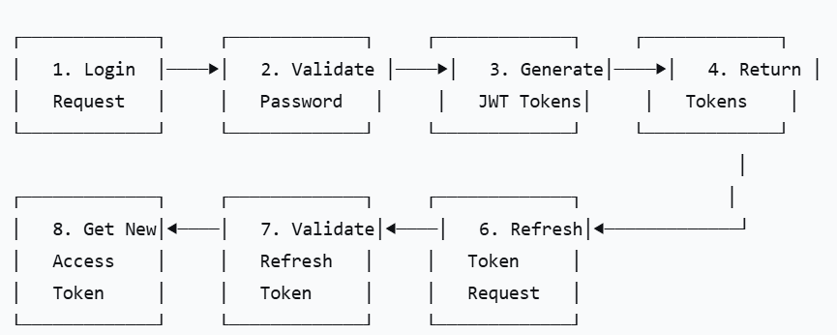

11.2. Token Strategy
Token Type | TTL | Storage | Purpose
Access Token | 15 minutes | Memory (Client) | API authorization
Refresh Token | 7 days | HTTP-only Cookie / Secure Storage | Get new access token
OTP | 5 minutes | Redis | Two-factor authentication
Password Reset | 30 minutes | Database | Password reset flow

11.3. Authorization Matrix
Resource | Owner | Admin | Moderator | Other Users
User Profile | Full access | Full access | Read-only | Partial (public info)
Messages (1-1) | Full access | No access | No access | No access
Messages (Group) | Full access | No access | Delete spam | Read/Write if member
Conversation | Read/Write | Delete | No access | Read/Write if member
Group Members | Manage | No access | No access | Read if member
User List | No access | Full access | Read-only | No access
System Config | No access | Full access | No access | No access

11.4. Rate Limiting
Endpoint | Limit | Window | Purpose
/auth/login | 5 | 1 minute | Prevent brute force
/auth/register | 5 | 1 hour | Prevent spam registration
/auth/resend-otp | 3 | 10 minutes | Prevent OTP abuse
General API | 100 | 1 minute | General rate limiting
/messages (WebSocket) | 10 | 5 seconds | Prevent spam
/media/upload | 20 | 1 hour | Prevent storage abuse

12. SECURITY & PRIVACY

12.1. Security Measures
Measure | Implementation
Transport Security | TLS 1.3 for all traffic
Password Hashing | BCrypt (cost 12+)
Token Security | JWT with RS256 or HS256
SQL Injection | Prepared statements, ORM
XSS Protection | Input sanitization, CORS
Rate Limiting | Redis token bucket
Data Encryption | AES-256 for sensitive data
Audit Logging | All admin actions logged
Security Headers | CSP, HSTS, X-Frame-Options

12.2. Data Privacy
data_privacy:
encryption:
- Messages encrypted at rest (future: E2EE)
- Passwords hashed (not reversible)
- Personal data encrypted in DB

retention:
- Messages: Indefinite (user can delete)
- Audit logs: 1 year
- User data: Until account deletion

deletion:
- Account deletion: Hard delete after 30 days
- Message deletion: Soft delete (can be recovered)
- Media deletion: Immediate from S3

compliance:
- PDPA (Vietnam)
- GDPR (EU) - Future
- CCPA (California) - Future

12.3. Audit Logging
Event | Log Level | Stored | Retention
User Login | Info | Yes | 1 year
User Logout | Info | Yes | 1 year
Password Change | Info | Yes | 1 year
Account Deletion | Warning | Yes | Permanent
Admin Action | Warning | Yes | Permanent
Ban/Unban User | Warning | Yes | Permanent
System Config Change | Error | Yes | Permanent
Failed Login | Error | Yes | 30 days

13. MONITORING & LOGGING

13.1. Key Metrics
Category | Metric | Target
Performance | API Response Time (P95) | < 200ms
Performance | Message Latency (P95) | < 300ms
Performance | Database Query Time | < 50ms
Availability | Service Uptime | > 99%
Usage | Active Users | 2,000 CCU
Usage | Messages/sec | 500 msg/sec
Usage | WebSocket Connections | 2,000
Cache | Hit Rate | > 70%
Cache | Memory Usage | < 80%
Database | Connection Pool | < 80%
Database | Disk Usage | < 70%

13.2. Alerting Rules
Alert | Condition | Severity | Action
High CPU | CPU > 80% for 5 min | Warning | Scale up/out
High Memory | Memory > 85% for 5 min | Warning | Scale up/out
High Error Rate | Error Rate > 5% in 5 min | Critical | Investigate
Slow API | P95 > 500ms for 5 min | Warning | Optimize
Service Down | Service unavailable | Critical | Alert on-call
Low Cache Hit | Hit Rate < 50% for 10 min | Warning | Review cache strategy
DB Connections | Connections > 150 for 5 min | Warning | Increase pool
Storage Full | Disk > 85% | Critical | Clean up

14. PERFORMANCE & SCALABILITY

14.1. Performance Optimization
Area | Optimization | Expected Improvement
Database | Indexes, partitioning, connection pooling | 50-70% faster
Cache | Redis, cache-aside, write-through | 80% fewer DB calls
API | Compression, HTTP/2, gRPC | 30-40% lower latency
WebSocket | Connection pooling, binary messages | 40% less memory
Media | CDN, thumbnails, lazy loading | 60% less bandwidth
Code | Goroutines, sync.Pool, profiling | 30-50% faster

14.2. Scalability Strategy
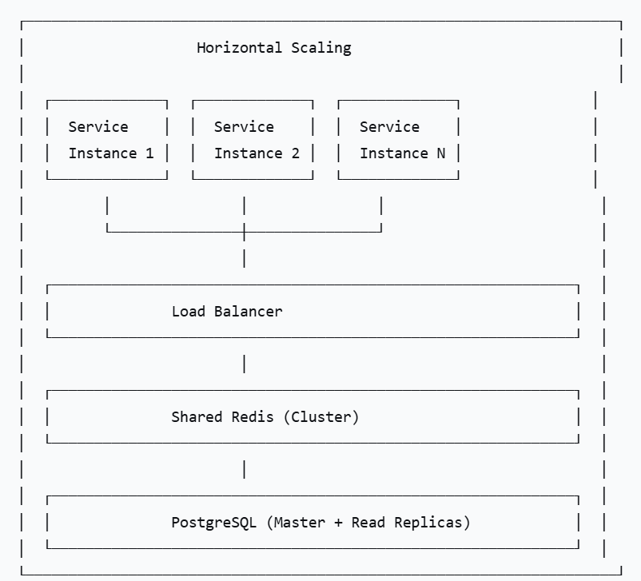

14.3. Scaling Triggers
Trigger | Action | Target
CPU > 70% | Scale up (more CPU) or scale out (more instances) | 1-2 replicas per service
Memory > 80% | Scale up (more RAM) | 1-2 replicas per service
DB Connections > 80% | Increase connection pool / read replicas | 2-3 read replicas
Redis Memory > 80% | Increase memory / cluster mode | Redis cluster
WebSocket > 80% of max | Scale out chat service | 2-3 replicas
Response Time > 500ms | Investigate and optimize | -

15. ERROR HANDLING

15.1. Error Categories
Category | Error Codes | Handling
Client Errors | 400-499 | Return error details to client
Server Errors | 500-599 | Log error, alert team, retry if possible
Business Errors | 1000-1999 | Application-specific errors
System Errors | 2000-2999 | Infrastructure errors

15.2. Error Response Structure
{
"code": 1001,
"message": "Cannot send message to blocked user",
"details": {
"user_id": "user_123",
"blocked_by": "user_456"
},
"timestamp": "2026-07-28T10:30:00Z",
"request_id": "req_abc123"
}

15.3. Error Codes
Code | Name | Description | HTTP Status
1000 | BLOCKED | User is blocked | 403
1001 | NOT_FRIENDS | Users are not friends | 403
1002 | MESSAGE_TOO_LARGE | Message exceeds limit | 400
1003 | INVALID_FILE_TYPE | File type not allowed | 400
1004 | FILE_SIZE_EXCEEDED | File size exceeds limit | 400
1005 | GROUP_FULL | Group has reached max members | 409
1006 | ALREADY_MEMBER | User is already in group | 409
1007 | NOT_OWNER | Only owner can perform action | 403
1008 | SELF_ACTION | Cannot perform action on self | 400
2000 | RATE_LIMIT | Rate limit exceeded | 429
2001 | REDIS_DOWN | Redis service unavailable | 503
2002 | DB_ERROR | Database error | 500
2003 | S3_ERROR | Object storage error | 500
2004 | QUEUE_ERROR | Message queue error | 500

16. DEPLOYMENT STRATEGY

16.1. Environment Strategy
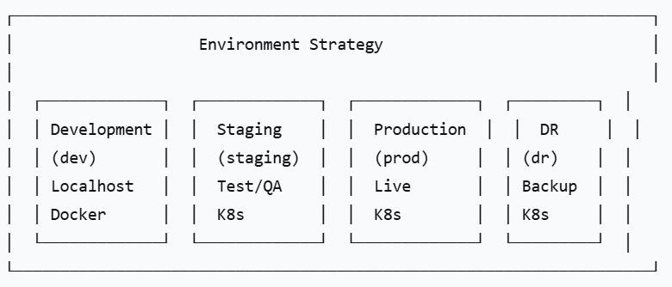

16.2. CI/CD Pipeline
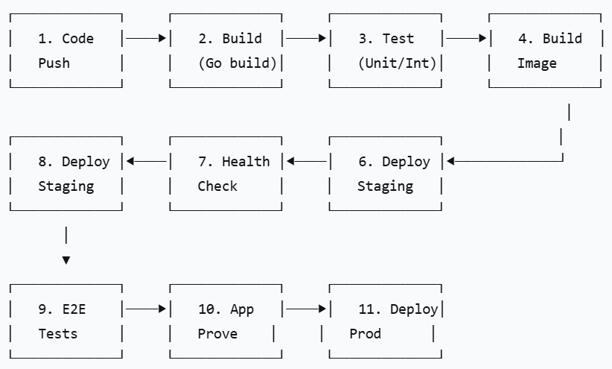

16.3. Deployment Configuration
kubernetes:
namespace: connectpro

deployments:
auth-service:
replicas: 2
resources:
limits:
cpu: 500m
memory: 1Gi

chat-service:
replicas: 2
resources:
limits:
cpu: 1000m
memory: 2Gi

friendship-service:
replicas: 2
resources:
limits:
cpu: 500m
memory: 1Gi

notification-service:
replicas: 2
resources:
limits:
cpu: 500m
memory: 1Gi

media-service:
replicas: 2
resources:
limits:
cpu: 500m
memory: 1Gi

admin-service:
replicas: 1
resources:
limits:
cpu: 500m
memory: 1Gi

statefulsets:
postgres:
replicas: 1 (master) + 2 (read replicas)
storage: 100Gi

redis:
replicas: 3 (cluster)
memory: 4Gi

rabbitmq:
replicas: 3 (cluster)
memory: 2Gi

ingresses:
api:
host: api.connectpro.com
tls: true

ws:
host: ws.connectpro.com
tls: true

cdn:
host: cdn.connectpro.com
tls: true

SUMMARY: BACKEND ANALYSIS
Component | Strategy | Status
Architecture | Microservices, REST + WebSocket | ✅ Designed
Language | Go (Golang) 1.21+ | ✅ Selected
Database | PostgreSQL 15+ (Partitioned) | ✅ Designed
Cache | Redis 7+ | ✅ Designed
Message Queue | RabbitMQ / Redis Streams | ✅ Designed
Storage | MinIO / S3 + CDN | ✅ Designed
Authentication | JWT (Access + Refresh) | ✅ Designed
Realtime | WebSocket (Gorilla) | ✅ Designed
API | RESTful + WebSocket Events | ✅ Designed
Security | TLS, BCrypt, Rate Limiting | ✅ Designed
Monitoring | Prometheus + Grafana | ✅ Planned
Deployment | Docker + Kubernetes | ✅ Planned

