FRONTEND ANALYSIS DOCUMENT

Chat Application - "ConnectPro"

Version: 1.0
Date: 2026-07-27
Status: Draft / Review
Document Owner: Product Owner / Frontend Architect

MỤC LỤC
- Frontend Overview
- Platform Strategy
- User Personas & Journeys
- Screen Flow & Navigation
- UI Components Inventory
- User Interface Design
- Frontend Architecture
- State Management
- Realtime Communication
- Offline Support
- Performance Requirements
- Accessibility Requirements
- Security Requirements
- Third-Party Integrations
- Development Workflow
- 1. FRONTEND OVERVIEW
- 1.1. Mục tiêu Frontend
- Xây dựng giao diện người dùng (UI/UX) cho ứng dụng chat ConnectPro trên các nền tảng Web và Mobile, với mục tiêu:
Mục tiêu | Mô tả
Trải nghiệm realtime | Tin nhắn xuất hiện ngay lập tức, không cần refresh
Giao diện quen thuộc | Thiết kế tương tự WhatsApp/Zalo để giảm chi phí đào tạo
Cross-platform | Hoạt động mượt mà trên Web và Mobile
Offline-first | Người dùng có thể xem tin nhắn cũ và soạn tin nhắn khi không có mạng
Performance | Tối ưu để load nhanh, thao tác mượt mà
- 1.2. Platform Support
Platform | Technology | Version | Priority
Web | React / Next.js | v18+ | P0 - Bắt buộc
Mobile (iOS) | React Native | v0.72+ | P0 - Bắt buộc
Mobile (Android) | React Native | v0.72+ | P0 - Bắt buộc
PWA | Progressive Web App | - | P1 - Nên có
- 1.3. Browser & Device Support
Browser | Min Version | Notes
Chrome | 90+ | Desktop + Mobile
Firefox | 88+ | Desktop + Mobile
Safari | 14+ | Desktop + Mobile
Edge | 90+ | Desktop + Mobile
Mobile OS | Min Version | Notes
iOS | 14+ | iPhone 6s trở lên
Android | 8.0+ | API Level 26+

2. PLATFORM STRATEGY

2.1. Technology Selection
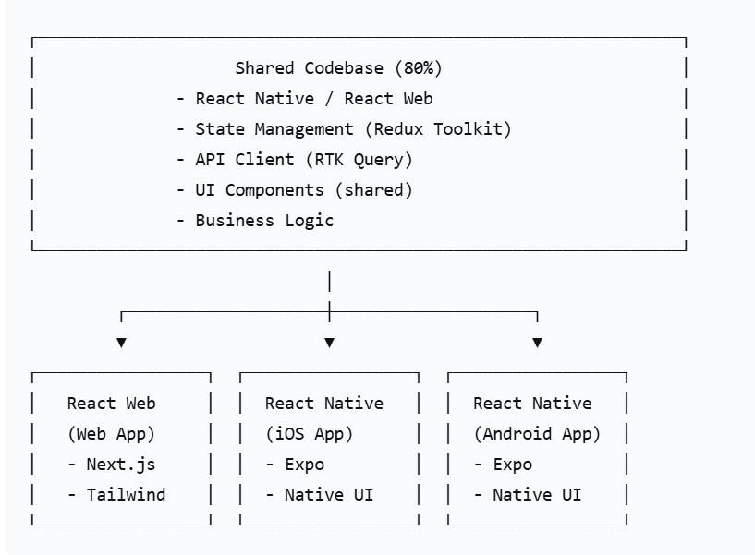

2.2. Code Sharing Strategy
Layer | Share Strategy | Coverage
Business Logic | 100% Shared | API calls, state management, validation
UI Components | 80% Shared | Common components (buttons, inputs, cards)
Navigation | Platform-specific | Web: React Router / Mobile: React Navigation
Native Features | Platform-specific | Camera, Push Notifications, File System

2.3. Development Approach
development_approach:
web_first:
- Build Web app first (faster iteration)
- Validate features on Web
- Port to Mobile when stable

mobile_first:
- Build Mobile app with Expo
- Use platform-specific features (camera, push)
- Share components with Web via React Native Web

hybrid:
- Monorepo with shared packages
- One codebase, multiple targets
- Use React Native for all platforms

3. USER PERSONAS & JOURNEYS

3.1. User Personas

Persona 1: Nguyễn Văn A - "User Power"
Attribute | Detail
Vai trò | Nhân viên văn phòng
Tuổi | 25-35
Tech Savviness | Cao
Thiết bị | Laptop + iPhone
Hành vi | Gửi 50-100 tin nhắn/ngày, 10-15 groups
Nỗi đau | Muốn tìm tin nhắn cũ nhanh, group chat quá nhiều
Mong đợi | Giao diện nhanh, tìm kiếm tốt, sync giữa các thiết bị

Persona 2: Trần Thị B - "User Casual"
Attribute | Detail
Vai trò | Nhân viên bán hàng
Tuổi | 35-50
Tech Savviness | Trung bình
Thiết bị | Android Phone
Hành vi | Gửi 20-30 tin nhắn/ngày, 3-5 groups
Nỗi đau | Khó tìm bạn bè, gửi file chậm
Mong đợi | Giao diện đơn giản, dễ tìm bạn, gửi file ảnh dễ dàng

Persona 3: Lê Văn C - "Admin"
Attribute | Detail
Vai trò | IT Admin / Moderator
Tuổi | 28-40
Tech Savviness | Rất cao
Thiết bị | Laptop + Tablet
Hành vi | Quản lý user, xem thống kê, kiểm duyệt
Nỗi đau | Phải xử lý spam, user vi phạm
Mong đợi | Dashboard đẹp, analytics realtime, audit logs

3.2. User Journeys

Journey 1: First Time User
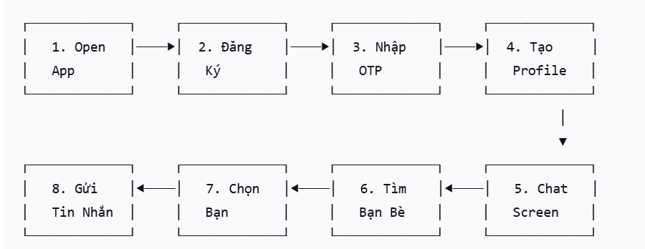

Journey 2: Daily Messaging
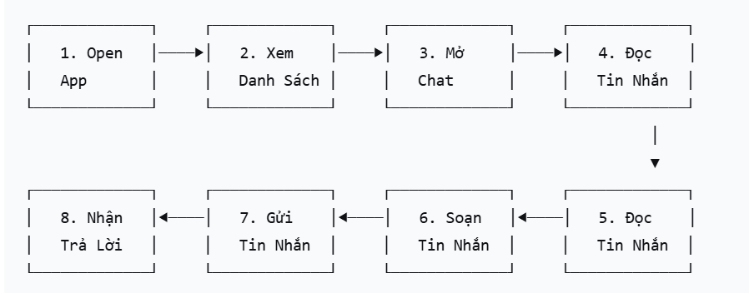

Journey 3: Group Chat
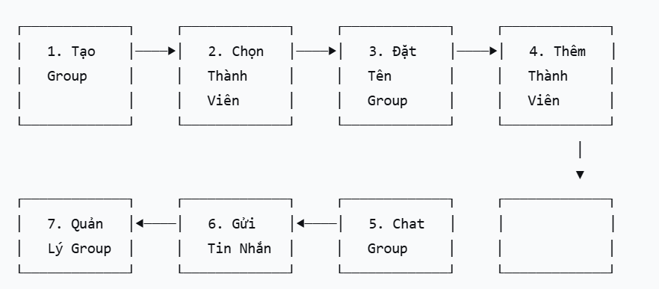

4. SCREEN FLOW & NAVIGATION

4.1. App Structure
Chat App
├── Auth Stack (Chưa đăng nhập)
│ ├── Login Screen
│ ├── Register Screen
│ ├── OTP Verification Screen
│ ├── Forgot Password Screen
│ └── Reset Password Screen
│
├── Main Stack (Đã đăng nhập)
│ ├── Bottom Tab Navigation
│ │ ├── Chat Tab
│ │ │ ├── Chat List Screen
│ │ │ └── Chat Detail Screen
│ │ │ └── Message List
│ │ │ └── Message Input
│ │ │ └── Attachment Picker
│ │ │ └── Message Actions (Edit, Delete, Reply)
│ │ │
│ │ ├── Friends Tab
│ │ │ ├── Friend List Screen
│ │ │ ├── Add Friend Screen
│ │ │ ├── Friend Request Screen
│ │ │ └── Friend Profile Screen
│ │ │
│ │ ├── Group Tab
│ │ │ ├── Group List Screen
│ │ │ ├── Create Group Screen
│ │ │ ├── Group Detail Screen
│ │ │ └── Group Member Management
│ │ │
│ │ └── Profile Tab
│ │ ├── Profile Screen
│ │ ├── Edit Profile Screen
│ │ ├── Change Password Screen
│ │ ├── Settings Screen
│ │ └── Notification Settings Screen
│ │
│ └── Modals & Overlays
│ ├── Image Viewer (Full screen)
│ ├── Emoji Picker
│ ├── Attachment Picker
│ ├── Message Reaction Picker
│ └── Confirmation Dialogs

4.2. Screen Flow Diagram
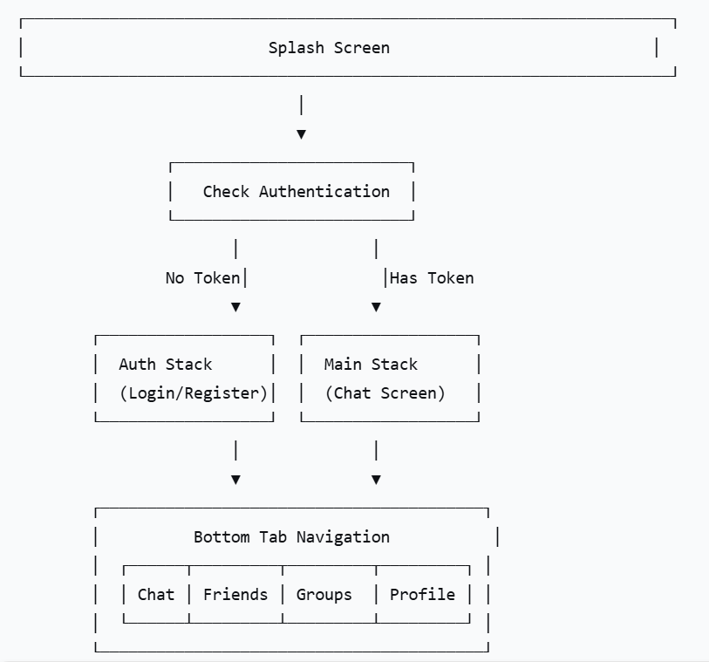

5. UI COMPONENTS INVENTORY

5.1. Atomic Design Structure
┌───────────────────────────────┐
│ ATOMS (Base Components) │
│ - Button (Primary, Secondary, Outline, Danger) │
│ - Input (Text, Password, Search, OTP) │
│ - Avatar (User, Group) │
│ - Badge (Unread count, Online status) │
│ - Icon (Material Icons, Custom SVG) │
│ - Typography (H1-H6, Body, Caption) │
│ - Divider, Spacer │
│ - Checkbox, Radio, Switch │
│ - Loading Spinner, Skeleton │
└──────────────────────────┘
│
▼
┌────────────────────────┐
│ MOLECULES (Composite Components) │
│ - Search Bar │
│ - Chat Bubble (Sent/Received) │
│ - Message Input Bar │
│ - User Card (Friend list item) │
│ - Conversation Card (Chat list item) │
│ - Group Card (Group list item) │
│ - Tab Bar Item │
│ - Notification Item │
│ - Profile Card │
│ - Emoji Picker (Reaction) │
└──────────────────────────────┘
│
▼
┌──────────────────────────────────┐
│ ORGANISMS (Page Sections) │
│ - Chat List Section │
│ - Message List Section │
│ - Friend List Section │
│ - Group List Section │
│ - Profile Section │
│ - Navigation Drawer │
│ - Bottom Tab Navigation │
│ - Header (Title, Actions) │
│ - Empty State (No messages, No friends) │
└─────────────────────────────────┘
│
▼
┌─────────────────────────────────┐
│ TEMPLATES (Page Layouts) │
│ - Chat Detail Layout │
│ - Chat List Layout │
│ - Friend List Layout │
│ - Group Detail Layout │
│ - Profile Layout │
│ - Settings Layout │
└─────────────────────────────────┘
│
▼
┌───────────────────────────────┐
│ PAGES (Screens) │
│ - Login Page │
│ - Register Page │
│ - Chat List Page │
│ - Chat Detail Page │
│ - Friend List Page │
│ - Group List Page │
│ - Profile Page │
│ - Settings Page │
└──────────────────────────────────┘

5.2. Key UI Components Specification

Component 1: Chat Bubble
chat_bubble:
sent:
background_color: "#0084FF" # Blue
text_color: "#FFFFFF"
alignment: right
max_width: 75%
border_radius: 18px
padding: 12px 16px
margin_bottom: 4px
timestamp: "#E0E0E0"
status_icon: true # Checkmark (sent, delivered, read)

received:
background_color: "#F0F0F0" # Light Gray
text_color: "#000000"
alignment: left
max_width: 75%
border_radius: 18px
padding: 12px 16px
margin_bottom: 4px
timestamp: "#888888"
avatar: true # Show sender avatar

media:
image:
max_width: 300px
max_height: 300px
border_radius: 12px
load_spinner: true
tap_to_view: true
video:
max_width: 300px
max_height: 300px
play_button_overlay: true
tap_to_play: true
file:
file_icon: true
file_name: true
file_size: true
download_button: true

reactions:
position: "below_bubble"
max_emoji_count: 5
popup: true
animation: "scale"

Component 2: Message Input Bar
message_input_bar:
layout:
- Attachment Button (Left)
- Text Input (Center)
- Emoji Button (Right)
- Send Button (Right - conditional)

text_input:
placeholder: "Type a message..."
max_lines: 5
auto_expand: true
character_limit: 5000

attachment_button:
icon: "paperclip"
options:
- Gallery (Images/Videos)
- Camera (Take Photo)
- Document (PDF/Word)
- Location (Share Location - Future)

emoji_button:
icon: "smile"
popup_emoji_picker: true
recent_emojis: true

send_button:
icon: "send" # Arrow/Paper plane
disabled: when text_input is empty
action: Send message

Component 3: Conversation Card
conversation_card:
layout:
- Avatar (Left)
- Content (Center)
- Timestamp + Unread Badge (Right)

avatar:
size: 48px
circular: true
fallback: Initial letters
online_indicator: true
group_indicator: true

content:
name: "Nguyễn Văn A"
last_message_preview: "Hello, how are you?"
last_message_short: true # Truncate to 2 lines
message_type_icon: true # Image, Video, File

right_section:
timestamp: "10:30 AM" # or "Yesterday", "Monday"
unread_badge:
background_color: "#0084FF"
text_color: "#FFFFFF"
min_count: 1
max_display: "99+"
pinned_indicator: true
muted_indicator: true

6. USER INTERFACE DESIGN

6.1. Design System

Color Palette
color_palette:
primary:
main: "#0084FF" # Blue - Main brand color
light: "#E3F2FD" # Light blue
dark: "#0055B3" # Dark blue

secondary:
main: "#34B7F1" # Sky blue - Accent color
light: "#D0F0FD" # Light sky blue
dark: "#1A8CC8" # Dark sky blue

neutral:
white: "#FFFFFF"
black: "#000000"
gray_50: "#FAFAFA"
gray_100: "#F5F5F5"
gray_200: "#E0E0E0"
gray_300: "#BDBDBD"
gray_400: "#9E9E9E"
gray_500: "#757575"
gray_600: "#616161"
gray_700: "#424242"
gray_800: "#212121"
gray_900: "#1A1A1A"

semantic:
success: "#4CAF50" # Green
warning: "#FFC107" # Amber
error: "#F44336" # Red
info: "#2196F3" # Blue

chat:
sent_bubble: "#0084FF"
sent_text: "#FFFFFF"
received_bubble: "#E8E8E8"
received_text: "#000000"
unread_badge: "#0084FF"

status:
online: "#4CAF50" # Green
offline: "#9E9E9E" # Gray
away: "#FFC107" # Amber
busy: "#F44336" # Red

Typography
typography:
font_family:
- "Inter" # Primary font (Web)
- "SF Pro" # iOS font
- "Roboto" # Android font

scale:
h1:
size: 32px
weight: 700
line_height: 1.2
h2:
size: 28px
weight: 600
line_height: 1.3
h3:
size: 24px
weight: 600
line_height: 1.4
h4:
size: 20px
weight: 600
line_height: 1.4
h5:
size: 18px
weight: 500
line_height: 1.5
h6:
size: 16px
weight: 500
line_height: 1.5
body_large:
size: 16px
weight: 400
line_height: 1.6
body:
size: 14px
weight: 400
line_height: 1.6
body_small:
size: 12px
weight: 400
line_height: 1.5
caption:
size: 11px
weight: 400
line_height: 1.4
overline:
size: 10px
weight: 500
letter_spacing: 0.5px
uppercase: true

Spacing
spacing:
xs: 4px
sm: 8px
md: 16px
lg: 24px
xl: 32px
xxl: 48px

grid:
columns: 12
gutter: 16px
margin: 16px

breakpoints:
xs: 0px
sm: 600px
md: 960px
lg: 1280px
xl: 1920px

Elevation (Shadows)
elevation:
none: "none"
low: "0px 2px 4px rgba(0,0,0,0.05)" # Cards
medium: "0px 4px 8px rgba(0,0,0,0.10)" # Dropdowns
high: "0px 8px 16px rgba(0,0,0,0.15)" # Modals
extra_high: "0px 16px 32px rgba(0,0,0,0.20)" # Dialogs

6.2. Screen Wireframes (Key Screens)

Screen 1: Chat List

┌──────────────────────────────────────────┐

│ [≡] Messages [🔍] [✏️] [👤] │ Header

├──────────────────────────────────────────┤

│ │

│┌────────────────────────────────────────┐│

│ │ 📱 Trần Thị B 10:30 AM ┌────┐ ││

│ │ "Let's discuss the project" │ 3 │ ◀─ Chat Card ││

│└────────────────────────────────────────┘│

│ │

│┌────────────────────────────────────────┐│

│ │ 👥 Development Team 09:45 AM ┌────┐ ││

│ │ "Hello everyone!" │ 12 │ ││

│└────────────────────────────────────────┘│

│ │

│┌────────────────────────────────────────┐│

│ │ 📱 Lê Văn C Yesterday ┌────┐ ││

│ │ "Thanks for your help" │ │ ││

│└────────────────────────────────────────┘│

│ │

│┌────────────────────────────────────────┐│

│ │ 👥 Marketing Team Yesterday ┌────┐ ││

│ │ "Check the new design" │ │ ││

│└────────────────────────────────────────┘│

│ │

│┌────────────────────────────────────────┐│

│ │ 📱 User D 2 days ago ┌────┐ ││

│ │ "See you tomorrow" │ │ ││

│└────────────────────────────────────────┘│

│ │

└──────────────────────────────────────────┘

Screen 2: Chat Detail
┌───────────────────────────────────────────────┐
│ [←] Nguyễn Văn A [📞] [📹] [⋮] │ Header
├────────────────────────────────────────────────┤
│ │
│┌─────────────────────────────────────────────┐│
│ │ 10:00 AM ││
│ │ ┌────────────────────────────────────┐ ││
│ │ │ Hello, how are you? │ ││ ◀─ Sent
│ │ └────────────────────────────────────┘ ││
│ │ 10:01 AM ✓✓✓ ││ ◀─ Status
│ │ ┌────────────────────────────────────┐ ││
│ │ │ I'm good, thanks! How about you? │ ││ ◀─ Received
│ │ └────────────────────────────────────┘ ││
│ │ 10:02 AM ││
│ │ ┌────────────────────────────────────┐ ││
│ │ │ Can we meet at 3 PM? │ ││
│ │ └────────────────────────────────────┘ ││
│ │ 10:03 AM ✓✓✓ ││
│ │ ┌──────────────────────────────────────────────┐││
│ │ │ 📷 [Image attached] │││ ◀─ Media
│ │ └──────────────────────────────────────────────┘││
│ │ 10:05 AM ││
│ │ ┌─────────────────┐ ││
│ │ │ Sure! See you │ ││
│ │ └─────────────────┘ ││
│ │ 10:06 AM ✓✓ ││
│└──────────────────────────────────────────────┘│
│ │
├────────────────────────────────────────────────┤
│ [📎] [😊] [Type a message...] [📤] │ Input
└────────────────────────────────────────────────┘

Screen 3: Profile
┌────────────────────────────────────────────────┐
│ [←] Profile [⚙️] │ Header
├────────────────────────────────────────────────┤
│ │
│ ┌────────────┐ │
│ │ [Avatar] │ │
│ └────────────┘ │
│ 🟢 Online │
│ Nguyễn Văn A │
│ @annguyen │
│ "Software Engineer | Coffee Lover" │
│ │
│ ┌──────────────────────────────────────────┐│
│ │ 📱 Phone: +84 901 234 567 ││
│ │ ✉️ Email: an.nguyen@example.com ││
│ │ 📅 Joined: January 15, 2026 ││
│ └───────────────────────────────────────────────┘│
│ │
│┌──────────────────────────────────────────────┐│
│ │ 👥 Friends 45 ▶ ││
│├──────────────────────────────────────────────┤│
│ │ 📊 Groups 12 ▶ ││
│├──────────────────────────────────────────────┤│
│ │ 🔒 Change Password ▶ ││
│├──────────────────────────────────────────────┤│
│ │ 🔔 Notifications ▶ ││
│├──────────────────────────────────────────────┤│
│ │ 🌐 Language ▶ ││
│├──────────────────────────────────────────────┤│
│ │ 🎨 Theme ▶ ││
│└──────────────────────────────────────────────┘│
│ │
│┌──────────────────────────────────────────────┐│
│ │ 🚪 Logout ││
│└──────────────────────────────────────────────┘│
│ │
│┌──────────────────────────────────────────────┐│
│ │ ❌ Delete Account ││
│└─────────────────────────────────────────────┘│
│ │
└───────────────────────────────────────────────┘

Screen 4: Group Detail
┌───────────────────────────────────────────────┐
│ [←] Development Team (5) [⋮] │ Header
├────────────────────────────────────────────────┤
│ │
│ ┌────────────┐ │
│ │ [Avatar] │ │
│ └────────────┘ │
│ 5 members │
│ "Team for project development" │
│ │
│ ┌───────────────────────────────────────────────┐│
│ │ Members (5) ▶ ││
│ ├──────────────────────────────────────────────┤│
│ │ 🟢 Nguyễn Văn A Owner ││
│ │ 🟢 Trần Thị B Admin ││
│ │ 🟢 Lê Văn C Member ││
│ │ ⚪ User D Member ││
│ │ ⚪ User E Member ││
│ └───────────────────────────────────────────────┘│
│ │
│ ┌──────────────────────────────────────────────┐│
│ │ Media, Links, Files (12) ▶ ││
│ └───────────────────────────────────────────────┘│
│ │
│ ┌───────────────────────────────────────────────┐│
│ │ Mute Notifications ││
│ │ [Toggle] ││
│ ├───────────────────────────────────────────────┤│
│ │ Pin Conversation ││
│ │ [Toggle] ││
│ ├───────────────────────────────────────────────┤│
│ │ Clear Chat History ││
│ │ ▶ ││
│ └───────────────────────────────────────────────┘│
│ │
│ ┌───────────────────────────────────────────────┐│
│ │ 🚪 Leave Group ││
│ └───────────────────────────────────────────────┘│
│ │
└────────────────────────────────────────────────┘

7. FRONTEND ARCHITECTURE

7.1. High-Level Architecture
┌───────────────────────────────────────────────┐
│ Presentation Layer │
│ ┌──────────────┐ ┌──────────────┐ ┌──────────────┐ │
│ │ Pages │ │ Components │ │ Screens │ │
│ │ (Views) │ │ (UI) │ │ (Routes) │ │
│ └──────────────┘ └──────────────┘ └──────────────┘ │
└────────────────────────────────────────────────┘
│
▼
┌────────────────────────────────────────────────┐
│ State Management │
│ ┌──────────────┐ ┌──────────────┐ ┌──────────────┐ │
│ │ Redux │ │ Context │ │ React │ │
│ │ Store │ │ API │ │ Query │ │
│ │ (Global) │ │ (Theme) │ │ (Cache) │ │
│ └──────────────┘ └──────────────┘ └──────────────┘ │
└────────────────────────────────────────────────┘
│
▼
┌──────────────────────────────────────────────┐
│ Data Layer │
│ ┌──────────────┐ ┌──────────────┐ ┌──────────────┐ │
│ │ RTK Query │ │ WebSocket │ │ Local │ │
│ │ (API) │ │ (Realtime) │ │ Storage │ │
│ └──────────────┘ └──────────────┘ └──────────────┘ │
└────────────────────────────────────────────────┘
│
▼
┌────────────────────────────────────────────────┐
│ Network Layer │
│ ┌──────────────┐ ┌──────────────┐ ┌──────────────┐ │
│ │ HTTP │ │ WebSocket │ │ Image │ │
│ │ Client │ │ Client │ │ Loader │ │
│ └──────────────┘ └──────────────┘ └──────────────┘ │
└────────────────────────────────────────────────┘

7.2. Folder Structure
src/
├── app/
│ ├── store/ # Redux store configuration
│ │ ├── slices/
│ │ │ ├── auth.slice.ts
│ │ │ ├── user.slice.ts
│ │ │ ├── chat.slice.ts
│ │ │ ├── friend.slice.ts
│ │ │ └── notification.slice.ts
│ │ └── store.ts
│ │
│ └── hooks/ # Custom React hooks
│ ├── useAuth.ts
│ ├── useChat.ts
│ ├── useWebSocket.ts
│ └── useMediaUpload.ts
│
├── components/
│ ├── atoms/ # Basic components
│ │ ├── Button/
│ │ ├── Input/
│ │ ├── Avatar/
│ │ └── Badge/
│ │
│ ├── molecules/ # Composite components
│ │ ├── ChatBubble/
│ │ ├── MessageInput/
│ │ ├── UserCard/
│ │ └── ConversationCard/
│ │
│ ├── organisms/ # Page sections
│ │ ├── ChatList/
│ │ ├── MessageList/
│ │ ├── FriendList/
│ │ └── Navigation/
│ │
│ └── templates/ # Page templates
│ ├── ChatTemplate/
│ ├── ProfileTemplate/
│ └── SettingsTemplate/
│
├── pages/ # Screen pages
│ ├── auth/
│ │ ├── LoginPage/
│ │ ├── RegisterPage/
│ │ └── OTPPage/
│ │
│ ├── main/
│ │ ├── ChatListPage/
│ │ ├── ChatDetailPage/
│ │ ├── FriendListPage/
│ │ ├── GroupListPage/
│ │ └── ProfilePage/
│ │
│ └── settings/
│ ├── SettingsPage/
│ ├── NotificationSettingsPage/
│ └── ChangePasswordPage/
│
├── services/ # API services
│ ├── api/
│ │ ├── auth.api.ts
│ │ ├── user.api.ts
│ │ ├── chat.api.ts
│ │ ├── friend.api.ts
│ │ └── notification.api.ts
│ │
│ ├── websocket/
│ │ ├── websocket.service.ts
│ │ └── handlers/
│ │ ├── message.handler.ts
│ │ └── presence.handler.ts
│ │
│ └── storage/
│ ├── secure.storage.ts # JWT tokens
│ └── local.storage.ts # User preferences
│
├── types/ # TypeScript types
│ ├── user.types.ts
│ ├── message.types.ts
│ ├── conversation.types.ts
│ └── api.types.ts
│
├── utils/ # Utilities
│ ├── validators/
│ ├── formatters/
│ ├── constants/
│ └── helpers/
│
├── assets/ # Static assets
│ ├── images/
│ ├── icons/
│ └── fonts/
│
├── styles/ # Global styles
│ ├── theme.ts
│ └── global.css
│
└── config/ # Configuration
├── env.config.ts
└── app.config.ts

8. STATE MANAGEMENT

8.1. State Management Strategy
State Type | Management | Example
Server State | RTK Query / React Query | User data, messages, friends list
UI State | Local state / Context | Modal open, input value, theme
Global State | Redux Toolkit | Auth token, online status, unread count
Cache State | RTK Query Cache | Message list, conversation list
Persistent State | Async Storage / LocalStorage | Theme, language preference

8.2. Redux Store Structure
// store structure
{
auth: {
user: User | null,
token: string | null,
isAuthenticated: boolean,
isLoading: boolean
},
user: {
profile: UserProfile,
status: 'online' | 'offline' | 'away',
friends: User[],
blockedUsers: string[]
},
chat: {
conversations: Conversation[],
currentConversation: Conversation | null,
messages: Record<string, Message[]>, // conversationId -> messages
unreadCounts: Record<string, number>, // conversationId -> count
isTyping: Record<string, string[]> // conversationId -> userId[]
},
notification: {
notifications: Notification[],
unreadCount: number
},
ui: {
theme: 'light' | 'dark',
language: 'vi' | 'en',
isLoading: Record<string, boolean>,
modals: Record<string, boolean>
}
}

8.3. API Client with RTK Query
// API base configuration
const baseQuery = fetchBaseQuery({
baseUrl: API_BASE_URL,
prepareHeaders: (headers, { getState }) => {
const token = (getState() as RootState).auth.token;
if (token) {
headers.set('Authorization', `Bearer ${token}`);
}
return headers;
},
});

export const api = createApi({
reducerPath: 'api',
baseQuery,
tagTypes: ['User', 'Message', 'Conversation', 'Friend'],
endpoints: (builder) => ({
// Auth endpoints
login: builder.mutation<AuthResponse, LoginRequest>({
query: (credentials) => ({
url: '/auth/login',
method: 'POST',
body: credentials,
}),
}),

// User endpoints
getProfile: builder.query<User, void>({
query: () => '/users/me',
providesTags: ['User'],
}),

// Conversation endpoints
getConversations: builder.query<Conversation[], void>({
query: () => '/conversations',
providesTags: ['Conversation'],
}),

// Message endpoints
getMessages: builder.query<Message[], { conversationId: string; cursor?: string }>({
query: ({ conversationId, cursor }) => ({
url: `/conversations/${conversationId}/messages`,
params: { cursor },
}),
providesTags: (result, error, { conversationId }) =>
result ? [{ type: 'Message', id: conversationId }] : ['Message'],
}),

sendMessage: builder.mutation<Message, SendMessageRequest>({
query: (message) => ({
url: `/conversations/${message.conversationId}/messages`,
method: 'POST',
body: message,
}),
invalidatesTags: (result, error, { conversationId }) =>
[{ type: 'Message', id: conversationId }],
}),
}),
});

9. REALTIME COMMUNICATION

9.1. WebSocket Integration

WebSocket Events Flow
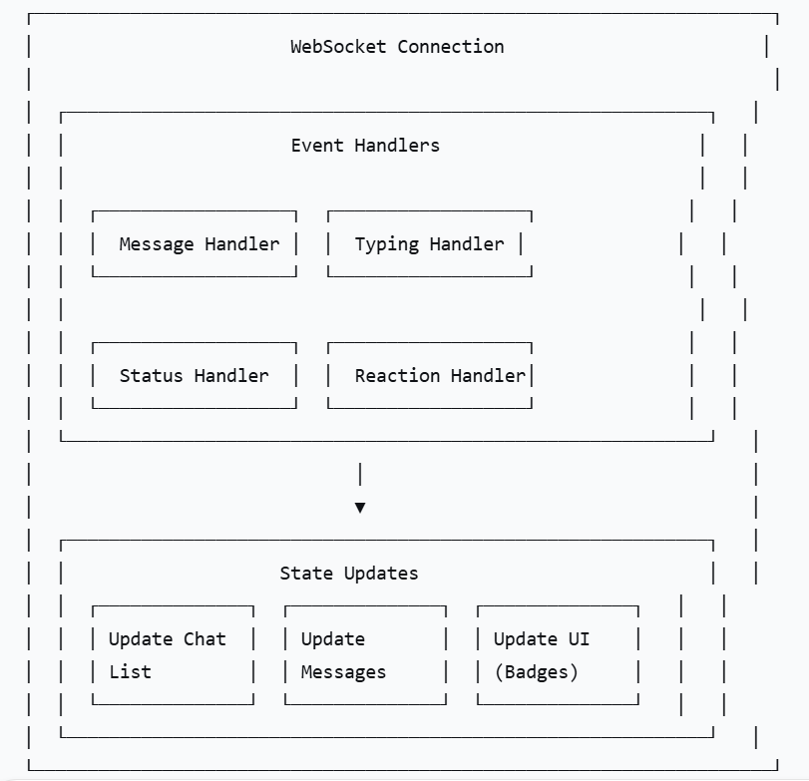

9.2. WebSocket Implementation

class WebSocketService {
private ws: WebSocket | null = null;
private reconnectAttempts = 0;
private reconnectTimeout: NodeJS.Timeout | null = null;

connect(token: string): void {
const wsUrl = `${WS_BASE_URL}/ws?token=${token}`;
this.ws = new WebSocket(wsUrl);

this.ws.onopen = () => {
console.log('WebSocket connected');
this.reconnectAttempts = 0;
this.subscribe();
};

this.ws.onmessage = (event) => {
const data = JSON.parse(event.data);
this.handleMessage(data);
};

this.ws.onclose = () => {
console.log('WebSocket disconnected');
this.reconnect();
};

this.ws.onerror = (error) => {
console.error('WebSocket error:', error);
};
}

private handleMessage(data: WebSocketMessage): void {
switch (data.type) {
case 'new_message':
this.handleNewMessage(data.message);
break;
case 'message_delivered':
this.handleMessageDelivered(data.messageId);
break;
case 'message_read':
this.handleMessageRead(data.messageId);
break;
case 'typing_indicator':
this.handleTypingIndicator(data);
break;
case 'user_status_update':
this.handleUserStatusUpdate(data);
break;
case 'reaction_updated':
this.handleReactionUpdate(data);
break;
}
}

private reconnect(): void {
if (this.reconnectAttempts < 5) {
this.reconnectAttempts++;
const delay = Math.min(1000 * this.reconnectAttempts, 30000);

this.reconnectTimeout = setTimeout(() => {
console.log(`Reconnecting... Attempt ${this.reconnectAttempts}`);
this.connect(this.token);
}, delay);
}
}
}

10. OFFLINE SUPPORT

10.1. Offline Strategy
offline_support:
message_caching:
- Store recent messages in AsyncStorage (Web: IndexedDB)
- Cache limit: 100 messages per conversation
- Auto-cleanup: Remove messages older than 30 days

pending_messages:
- Store outgoing messages in queue when offline
- Auto-send when connection restored
- Conflict resolution: Last-write-wins for edits

optimistic_updates:
- Show "sending" indicator immediately
- Rollback if send fails
- Show "failed" with retry option

sync_strategy:
- Priority: Latest messages first
- Throttle: Sync every 5 seconds when online
- Conflict resolution: Server is always source of truth

10.2. Data Persistence
// AsyncStorage structure
{
// User data
'user:profile': UserProfile,
'user:settings': UserSettings,

// Conversations
'conversations:list': Conversation[],
'conversations:unread': Record<string, number>,

// Messages
'messages:cached': {
[conversationId]: {
messages: Message[],
lastSync: timestamp
}
},

// Pending operations
'queue:pending': PendingMessage[],
'queue:failed': FailedMessage[],

// Auth
'auth:token': string,
'auth:refresh_token': string,
}

11. PERFORMANCE REQUIREMENTS

11.1. Performance Targets
Metric | Web Target | Mobile Target
First Contentful Paint | < 1.5s | < 2s
Time to Interactive | < 3s | < 4s
First Input Delay | < 100ms | < 150ms
Largest Contentful Paint | < 2.5s | < 3s
Cumulative Layout Shift | < 0.1 | < 0.1
App Startup Time | < 1s | < 2s
Navigation Transition | < 300ms | < 400ms
Typing Feedback | < 50ms | < 100ms
Message Send Delay | < 300ms | < 500ms
Image Load Time | < 500ms | < 1s

11.2. Optimization Strategies
optimization_strategies:
code_splitting:
- Route-based splitting (React.lazy)
- Component-level lazy loading
- Dynamic imports for heavy components

bundle_optimization:
- Tree shaking (dead code elimination)
- Bundle size monitoring (< 200KB gzipped)
- Modular import (React Native)

image_optimization:
- Lazy loading images
- Use CDN for images
- Responsive images (srcset)
- Thumbnail for list items

rendering_optimization:
- Virtualized lists (react-window)
- Memoization (React.memo, useMemo)
- Debounce typing indicator
- Throttle scroll events

network_optimization:
- HTTP/2 for Web
- Connection pooling
- Request batching
- Cache with ETag
- Prefetch next messages

12. ACCESSIBILITY REQUIREMENTS

12.1. WCAG Compliance
Standard | Level | Notes
WCAG 2.1 | Level AA | Bắt buộc
Keyboard Navigation | Level A | Full keyboard support
Screen Reader | Level A | aria-label, role attributes
Color Contrast | Level AA | 4.5:1 minimum
Focus Indicators | Level AA | Visible focus states
Reduced Motion | Level A | Respect prefers-reduced-motion
Text Resize | Level AA | Support 200% zoom

12.2. Accessibility Features
accessibility_features:
screen_reader:
- aria-label for all interactive elements
- Role attributes for custom components
- Live regions for dynamic content
- Focus management for modals

keyboard:
- Tab navigation in logical order
- Enter/Space for primary actions
- Escape to close modals
- Arrow keys for navigation

color_contrast:
- Check all text against background
- Pass WCAG 2.1 AA (4.5:1)
- High contrast mode support

reduced_motion:
- Disable animations when prefers-reduced-motion
- Smooth but not essential

text_resize:
- Rem/Em units
- No text cut-off at 200% zoom
- Responsive layout

13. SECURITY REQUIREMENTS

13.1. Frontend Security
Security Aspect | Implementation
Token Storage | HTTP-only cookies (Web) / Secure Keychain (Mobile)
CORS | Configured for allowed origins
XSS Protection | React escaping, CSP headers
CSRF Protection | CSRF tokens for forms
Input Validation | Client-side validation + Server-side validation
Sensitive Data | No logs containing passwords/tokens
Deep Links | Validate scheme before opening

13.2. Data Privacy
data_privacy:
- No storage of passwords in memory
- Auto-clear clipboard after 30 seconds (for sensitive data)
- Biometric authentication for sensitive actions (Mobile)
- Session timeout after inactivity
- Option to enable 2FA (Future)
- Data minimization (collect only necessary data)

14. THIRD-PARTY INTEGRATIONS

14.1. Required Libraries
Library | Purpose | Platform
Axios / RTK Query | API client | All
Socket.io / WebSocket | Realtime communication | All
React Router / React Navigation | Navigation | Web / Mobile
Redux Toolkit | State management | All
React Hook Form | Form handling | All
Zod / Yup | Validation | All
Emoji Mart | Emoji picker | All
React Native Image Picker | Camera/Gallery | Mobile
File Picker | File upload | Web
react-native-push-notification | Push notifications | Mobile
react-native-keychain | Secure storage | Mobile

14.2. Push Notification Integration
push_notification:
web:
- Service Worker
- Web Push API
- VAPID keys

ios:
- APNS (Apple Push Notification Service)
- react-native-push-notification
- Notification permission handling

android:
- FCM (Firebase Cloud Messaging)
- react-native-push-notification
- Notification channels

15. DEVELOPMENT WORKFLOW

15.1. Development Environment
development_environment:
web:
- Node.js v18+
- npm / yarn
- Create React App / Next.js
- React DevTools

mobile:
- React Native CLI / Expo
- iOS Simulator / Android Emulator
- React Native Debugger
- Flipper

code_quality:
- TypeScript
- ESLint
- Prettier
- Husky (Git hooks)
- Jest / React Testing Library

ci_cd:
- GitHub Actions / GitLab CI
- Test automation
- Build automation
- Deploy automation

15.2. Testing Strategy
testing_strategy:
unit_tests:
- Jest
- Component testing (React Testing Library)
- Utility function testing
- Coverage target: > 80%

integration_tests:
- API integration testing
- Redux store testing
- Navigation testing

e2e_tests:
- Cypress (Web)
- Detox (Mobile)
- Critical user flows

performance_tests:
- Lighthouse (Web)
- Performance monitoring
- Bundle size monitoring

16. SUMMARY: FRONTEND ANALYSIS
Component | Strategy | Priority
Platform | React + React Native | P0
State Management | Redux Toolkit + RTK Query | P0
Realtime | WebSocket with auto-reconnect | P0
Offline | AsyncStorage + queue | P1
Performance | Code splitting + virtualization | P1
Accessibility | WCAG 2.1 AA | P2
Security | JWT + Secure storage | P0
Testing | Jest + Cypress/Detox | P1

