PHASE 2: SYSTEM ANALYSIS (SYSTEM DESIGN)

Chuyển đổi Business Analysis thành Mô hình Hệ thống

Version: 1.0
Date: 2026-07-28
Status: Draft / Review
Document Owner: System Architect

MỤC LỤC
- Use Case Diagram
- Use Case Specifications
- Sequence Diagrams
- State Diagrams
- Entity Relationship Diagram (ERD)
- API Specification
- System Flow Diagrams
- Component Architecture

01. System Overview
|
v
02. System Architecture Diagram
|
v
03. Service Dependencies
|
v
04. Component Architecture
|
v
05. Infrastructure Components
|
v
06. Communication Protocols
|
v
07. Database ERD
|
v
08. Sequence Flows

1. USE CASE DIAGRAM

1.1. Tổng thể Use Case Diagram
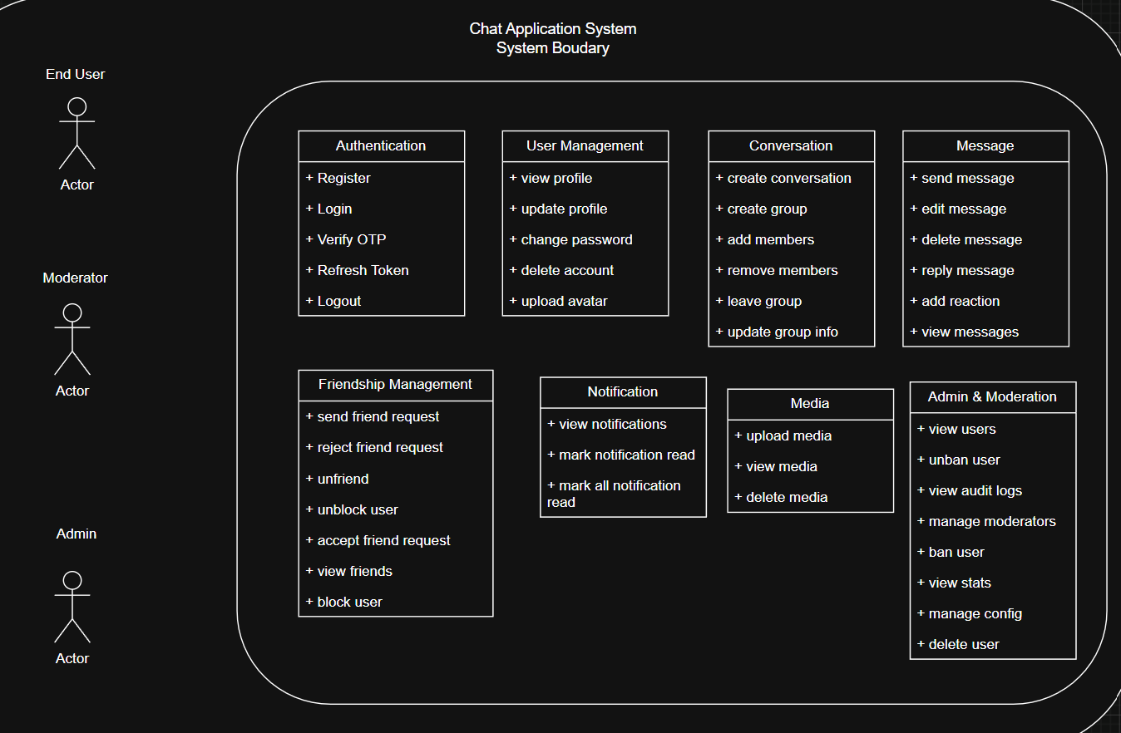
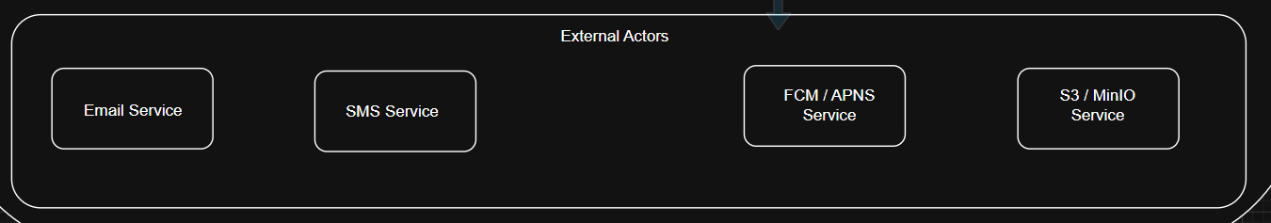

1.2. Use Case Categories
Category | Use Cases | Primary Actor
Authentication | Register, Login, Verify OTP, Refresh Token, Logout | End User
User Management | View Profile, Update Profile, Change Password, Delete Account, Upload Avatar | End User
Friendship | Send Friend Request, Accept/Reject Request, View Friends, Unfriend, Block/Unblock | End User
Conversation | Create Conversation, Create Group, Add/Remove Members, Leave Group, Update Group Info | End User
Messaging | Send Message, Edit Message, Delete Message, Reply Message, Add Reaction, View Messages | End User
Notification | View Notifications, Mark Read, Mark All Read | End User
Media | Upload Media, View Media, Delete Media | End User
Admin | View Users, Ban/Unban User, View Stats, View Audit Logs, Manage Config, Manage Moderators | Super Admin, Moderator

2. USE CASE SPECIFICATIONS

UC-001: Đăng ký tài khoản
Field | Detail
Use Case ID | UC-001
Name | Đăng ký tài khoản
Description | Người dùng tạo tài khoản mới trên hệ thống
Actor | End User
Preconditions | Người dùng có số điện thoại hợp lệ, chưa có tài khoản
Postconditions | Tài khoản được tạo, người dùng đã đăng nhập

Main Flow
Step | Actor Action | System Response
1 | Nhập số điện thoại và mật khẩu | -
2 | - | Validate số điện thoại và mật khẩu
3 | - | Gửi OTP đến số điện thoại
4 | Nhập OTP | -
5 | - | Xác thực OTP
6 | - | Tạo tài khoản mới
7 | - | Tự động đăng nhập
8 | - | Trả về JWT tokens

Alternative Flows
Flow | Description
A1 | User đăng ký bằng email thay vì số điện thoại
A2 | User đăng ký với số điện thoại đã tồn tại

Exception Flows
Flow | Description
E1 | Số điện thoại đã tồn tại → trả về lỗi 409
E2 | OTP sai hoặc hết hạn → trả về lỗi 400
E3 | Mật khẩu không đáp ứng yêu cầu → trả về lỗi 422

UC-002: Đăng nhập
Field | Detail
Use Case ID | UC-002
Name | Đăng nhập
Description | Người dùng đăng nhập vào hệ thống
Actor | End User
Preconditions | Người dùng đã có tài khoản
Postconditions | Người dùng đã đăng nhập, Access Token và Refresh Token được cấp

Main Flow
Step | Actor Action | System Response
1 | Nhập số điện thoại và mật khẩu | -
2 | - | Validate thông tin đăng nhập
3 | - | Tăng failed_login_attempts nếu sai
4 | - | Reset failed_login_attempts nếu đúng
5 | - | Tạo JWT Access Token và Refresh Token
6 | - | Lưu Refresh Token vào database
7 | - | Trả về tokens cho client

Exception Flows
Flow | Description
E1 | Sai mật khẩu 5 lần → khóa tài khoản 15 phút
E2 | Tài khoản bị banned → trả về lỗi 403
E3 | Tài khoản không tồn tại → trả về lỗi 404

UC-003: Gửi tin nhắn
Field | Detail
Use Case ID | UC-003
Name | Gửi tin nhắn
Description | Người dùng gửi tin nhắn trong một conversation
Actor | End User
Preconditions | Người dùng đã đăng nhập, là thành viên của conversation
Postconditions | Tin nhắn được lưu và gửi đến người nhận

Main Flow
Step | Actor Action | System Response
1 | Soạn tin nhắn và nhấn gửi | -
2 | - | Validate tin nhắn (nội dung, kích thước)
3 | - | Kiểm tra quyền gửi (không bị chặn, là bạn bè nếu 1-1)
4 | - | Lưu tin nhắn vào database (status = sent)
5 | - | Kiểm tra người nhận online (Redis)
6 | - | Nếu online: gửi qua WebSocket (status = delivered)
7 | - | Nếu offline: đẩy vào queue để gửi push notification
8 | - | Cập nhật cache (recent messages, unread count)
9 | - | Trả về message ID cho client

Alternative Flows
Flow | Description
A1 | Gửi tin nhắn có đính kèm file → upload file trước
A2 | Reply tin nhắn → thêm replied_to_id
A3 | Gửi tin nhắn group → broadcast đến tất cả members

Exception Flows
Flow | Description
E1 | Người nhận bị chặn → trả về lỗi 1000
E2 | Chưa kết bạn (1-1) → trả về lỗi 1001
E3 | Rate limit vượt ngưỡng → trả về lỗi 2000
E4 | Upload file thất bại → trả về lỗi 1004

UC-004: Tạo nhóm chat
Field | Detail
Use Case ID | UC-004
Name | Tạo nhóm chat
Description | Người dùng tạo một group chat mới
Actor | End User
Preconditions | Người dùng đã đăng nhập, có ít nhất 1 bạn bè
Postconditions | Group được tạo, tất cả thành viên được thêm

Main Flow
Step | Actor Action | System Response
1 | Chọn "Tạo nhóm mới" | -
2 | Chọn thành viên (tối thiểu 2) | -
3 | Nhập tên nhóm (tùy chọn) | -
4 | Nhấn Tạo | -
5 | - | Validate số lượng thành viên (≤ 100)
6 | - | Tạo conversation với type = group
7 | - | Thêm tất cả thành viên vào conversation_members
8 | - | Người tạo được set role = owner
9 | - | Gửi thông báo cho tất cả thành viên
10 | - | Trả về conversation ID cho client

Exception Flows
Flow | Description
E1 | Số thành viên > 100 → trả về lỗi 1005
E2 | User không có bạn bè → trả về lỗi

3. SEQUENCE DIAGRAMS

3.1. Sequence Diagram: Đăng ký tài khoản
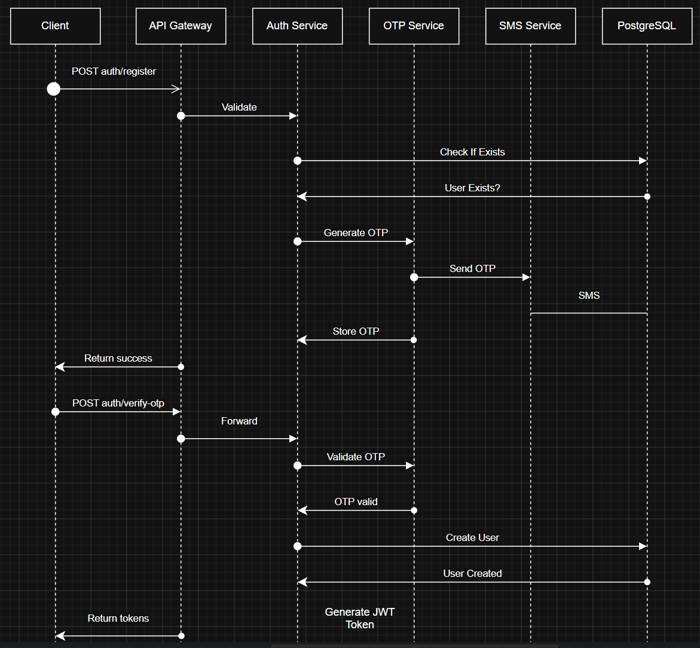

3.2. Sequence Diagram: Gửi tin nhắn
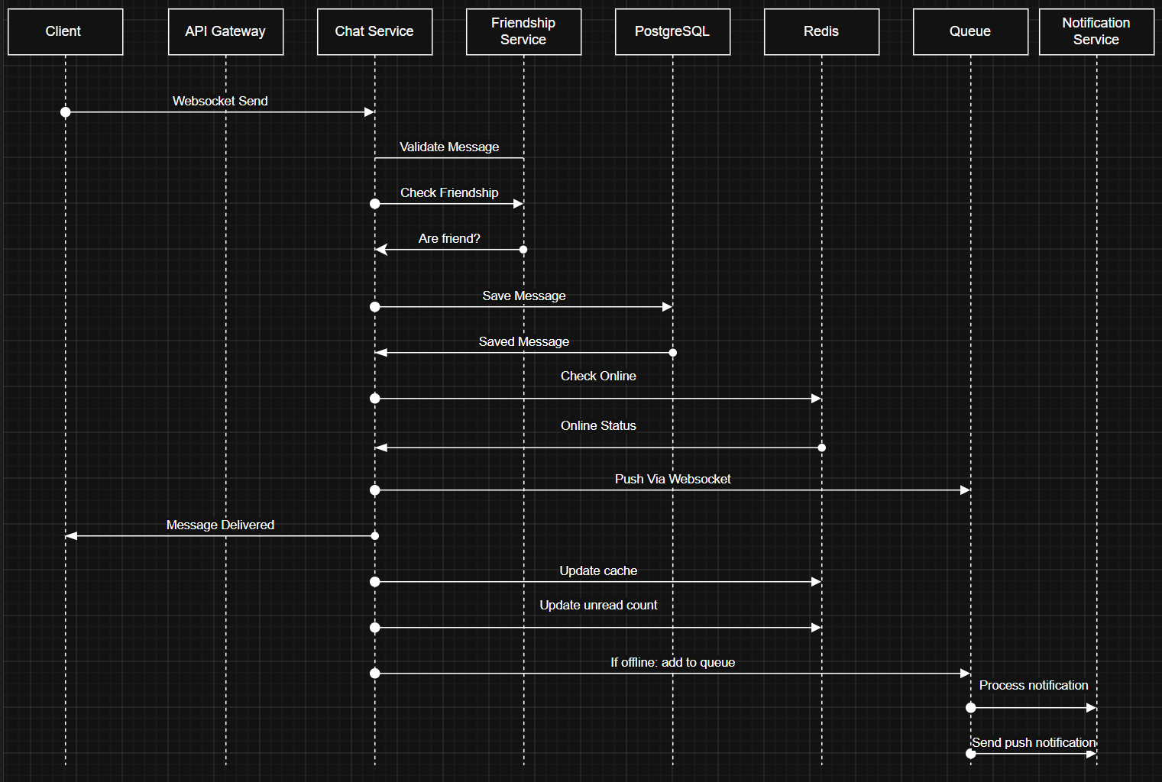

3.3. Sequence Diagram: Đọc tin nhắn (Mark as Read)
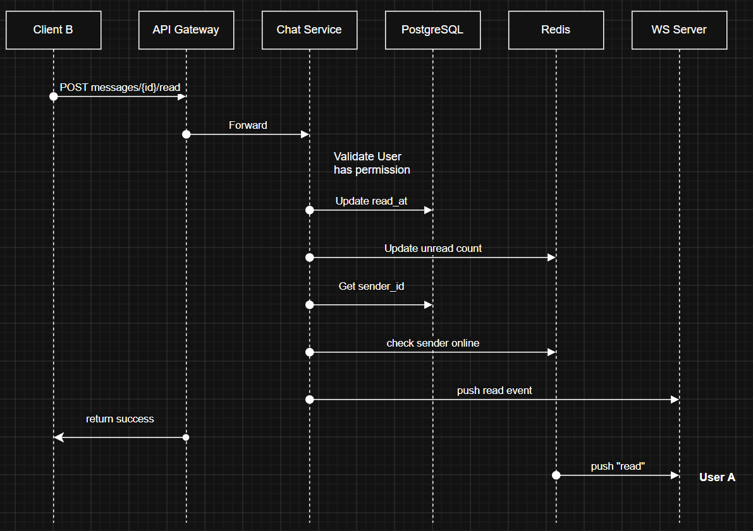

3.4. Sequence Diagram: Verify OTP
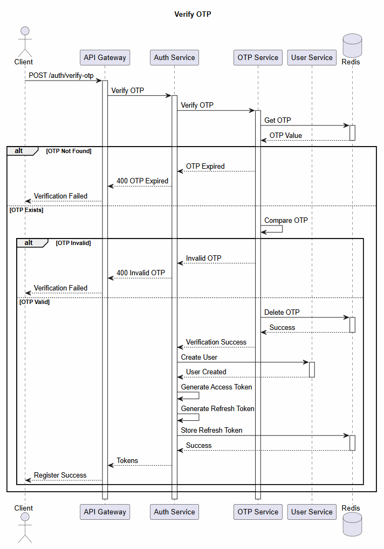

3.5. Sequence Diagram: Login
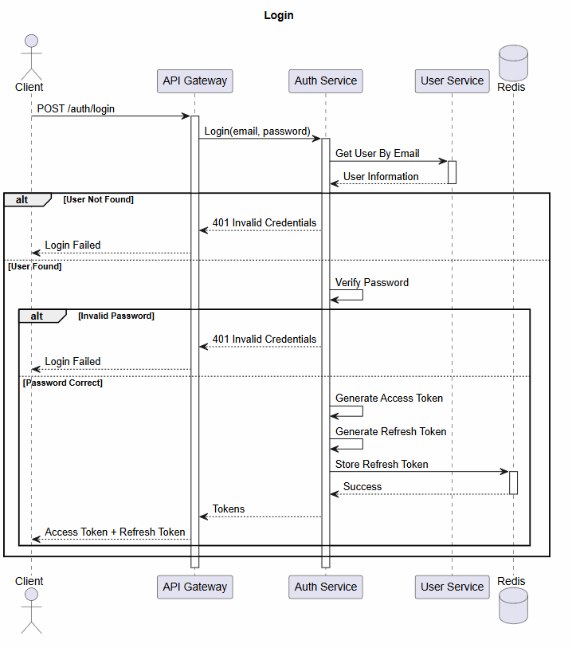

3.6. Sequence Diagram: Refresh Token
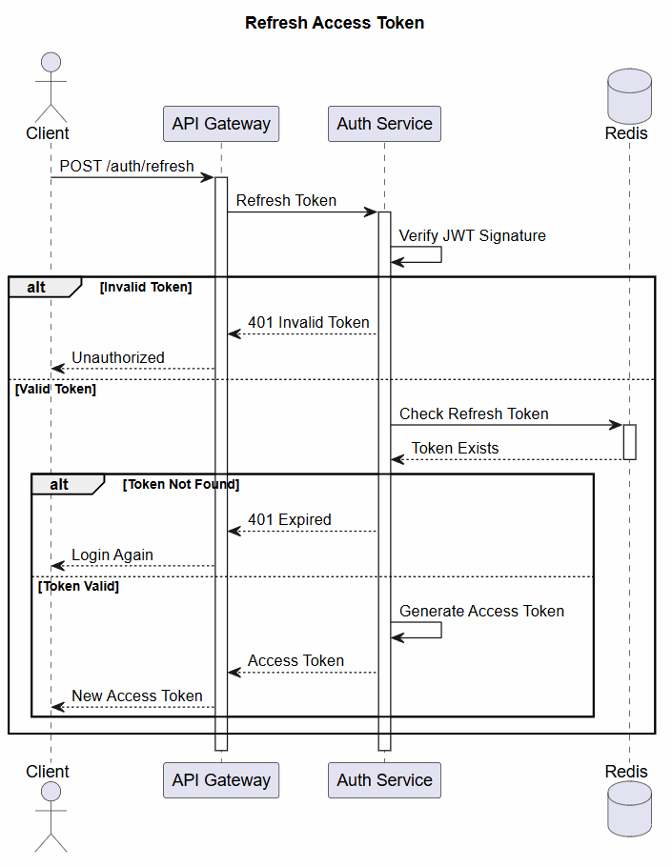
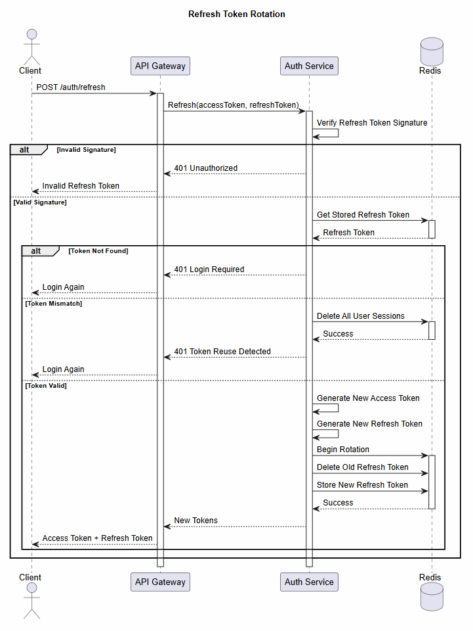

3.7. Sequence Diagram: Logout
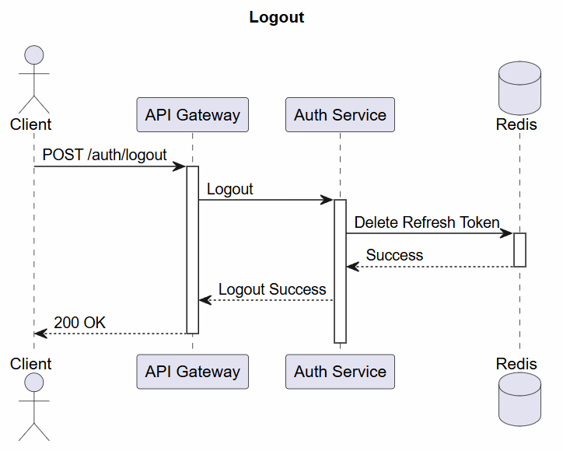
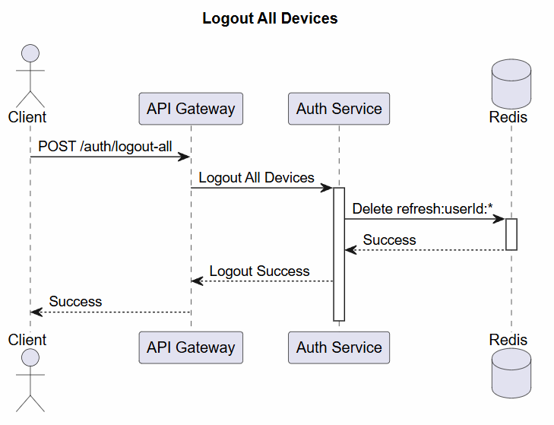

3.8. Sequence Diagram: Create Conversation

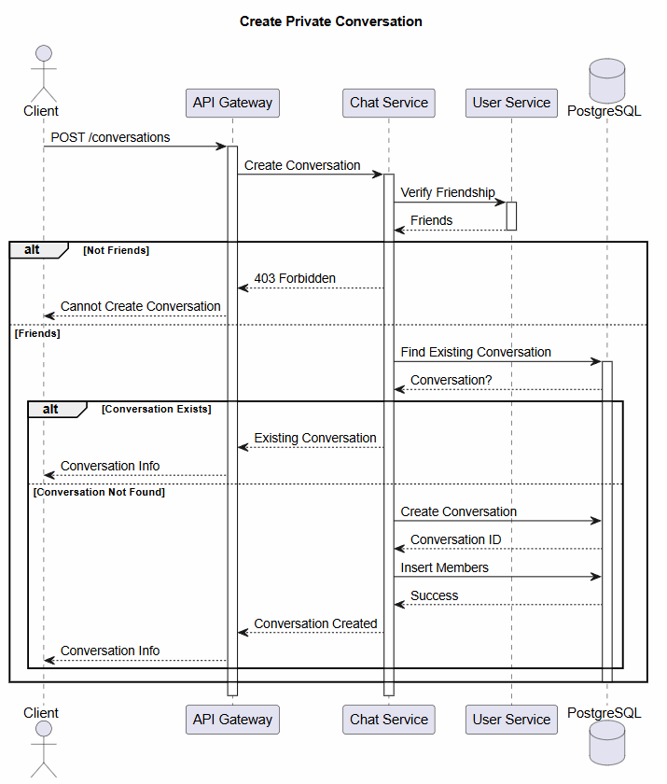

3.9. Sequence Diagram: Receive Message
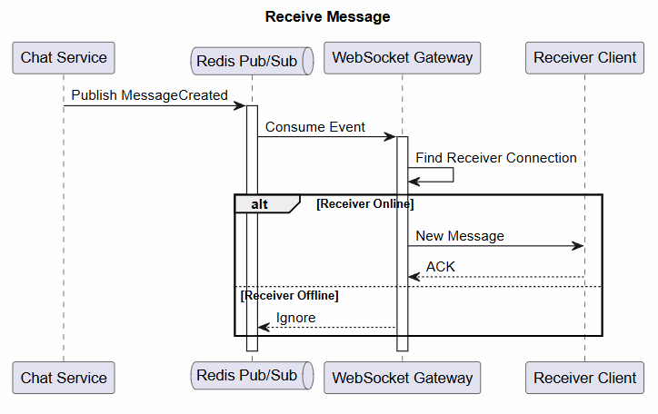

3.10. Sequence Diagram: Load Message History
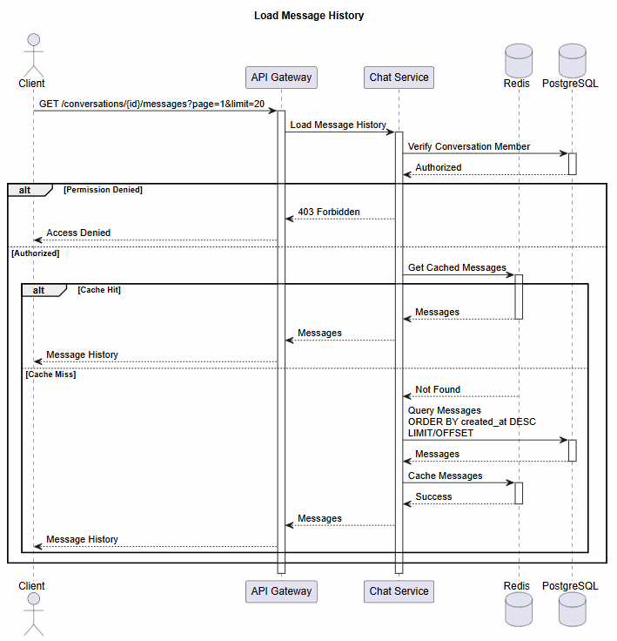

3.11. Sequence Diagram: Recall / Delete message
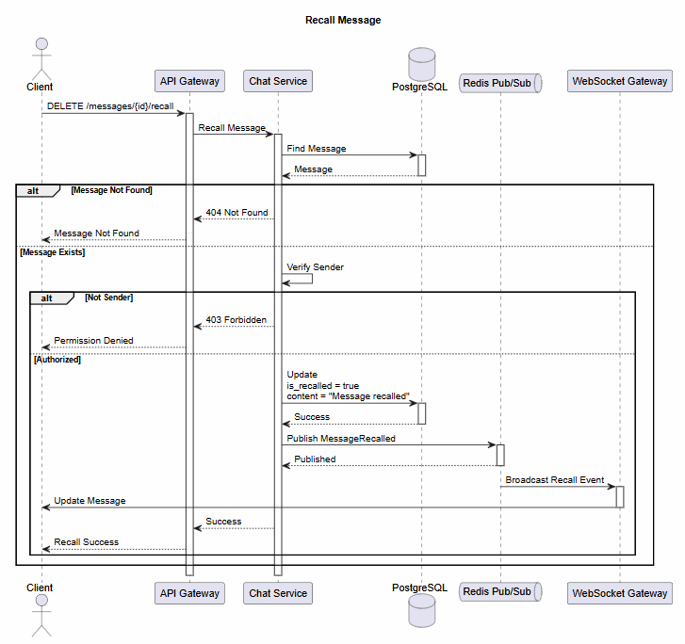
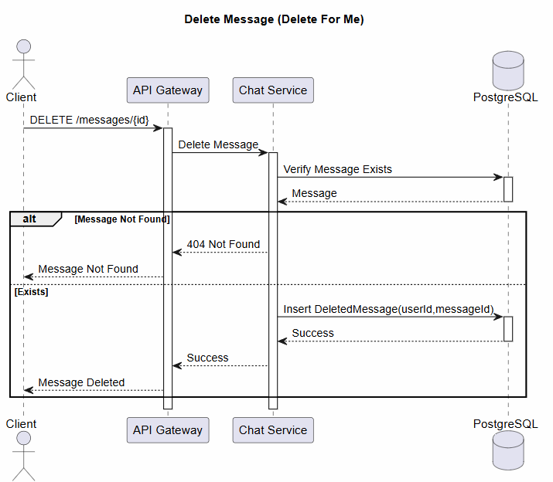

3.12. Sequence Diagram: Upload Image / file
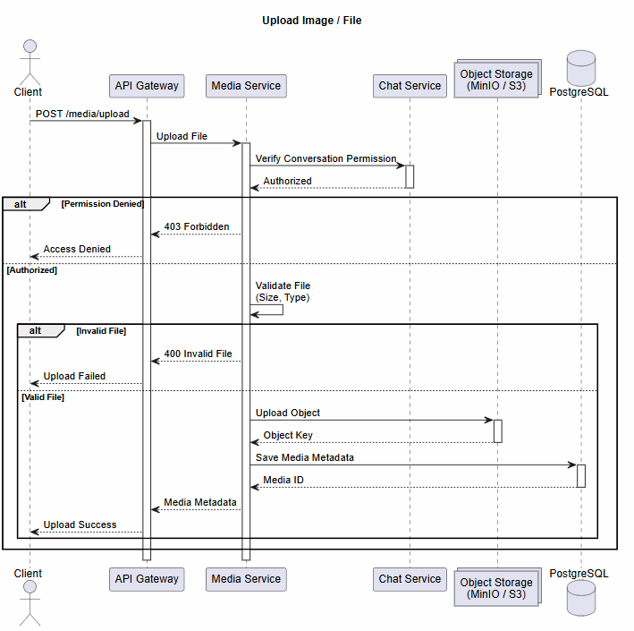

3.13. Sequence Diagram: Download Media
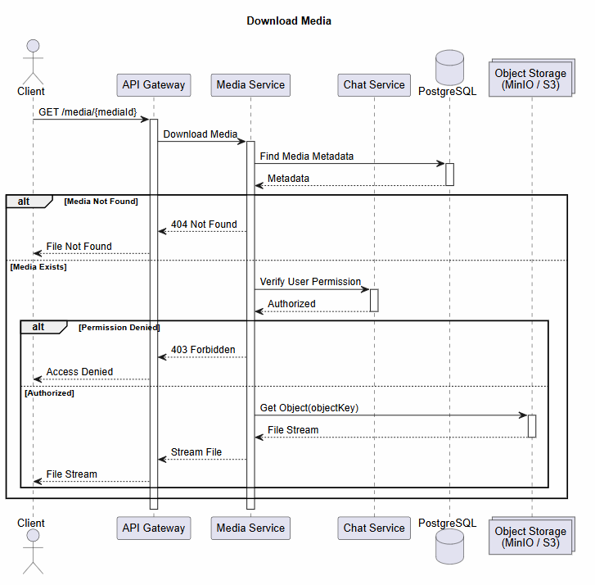
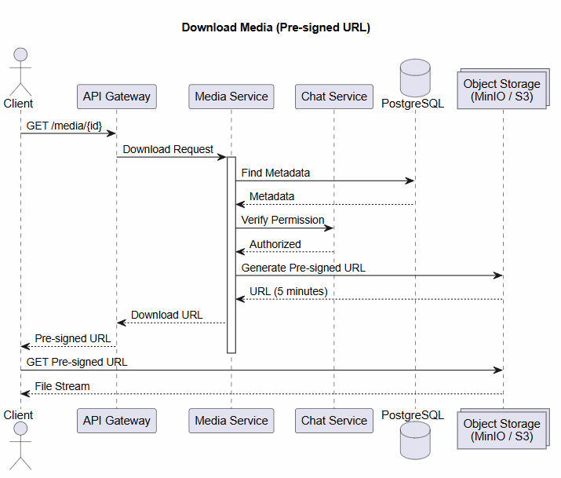

3.14. Sequence Diagram: Send Friend Request
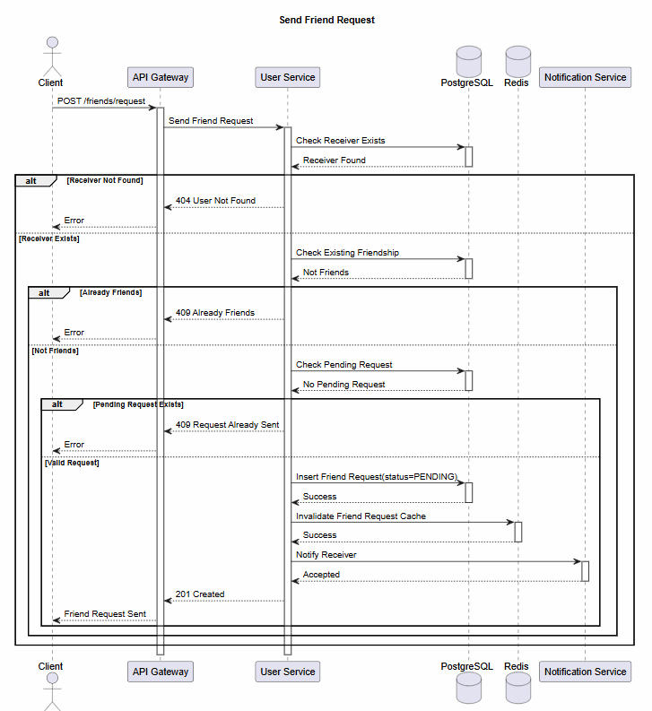

3.15. Sequence Diagram: Accept Friend
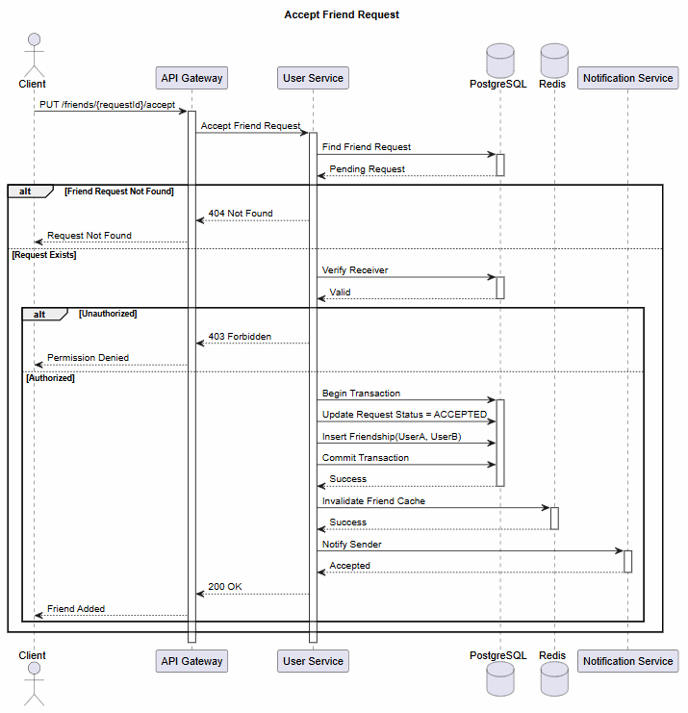

3.16. Sequence Diagram: User online / offline
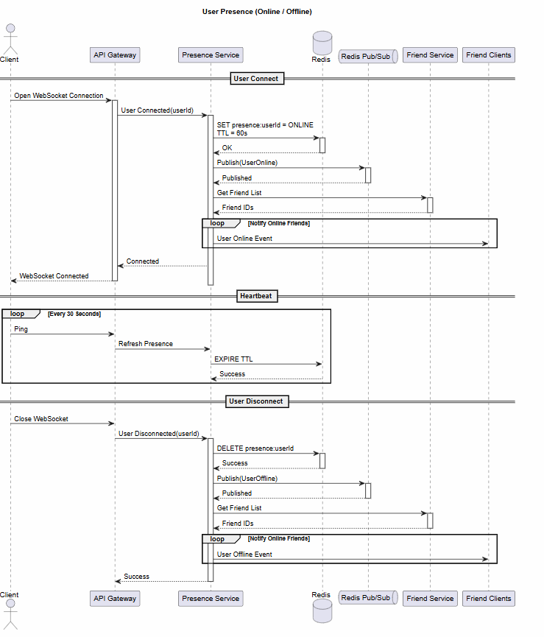

3.17. Sequence Diagram: Push notification
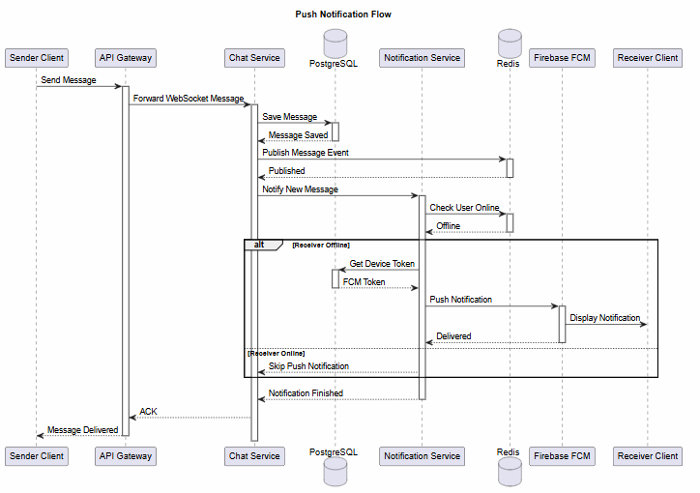

3.18. Sequence Diagram: Create Group Chat
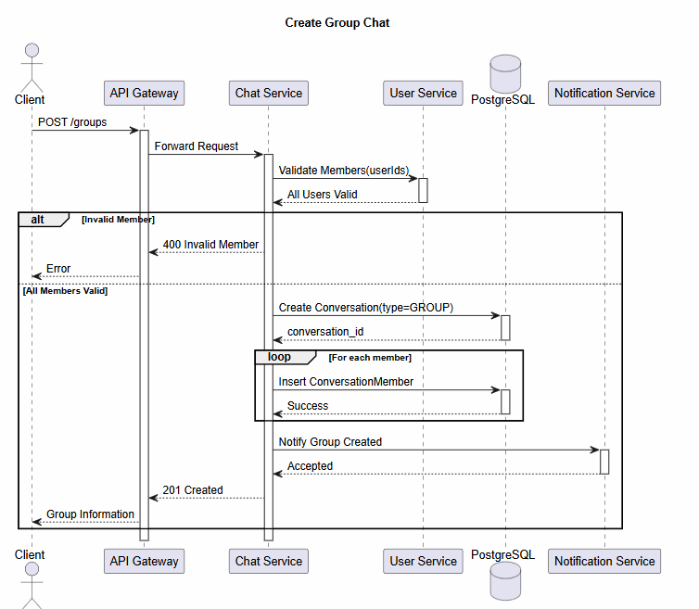

3.19. Sequence Diagram: Add Member
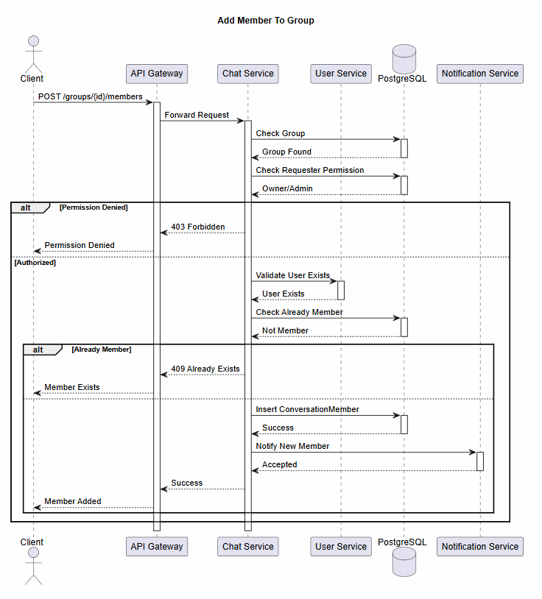

4. STATE DIAGRAMS

4.1. User State Diagram
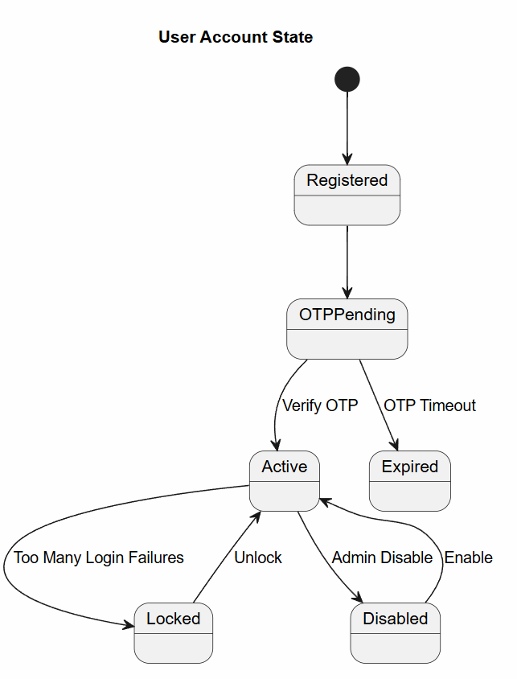

User State Transitions
From | To | Trigger | Condition
Not Registered | Verifying OTP | Register | Phone number valid
Verifying OTP | Active | Verify OTP | OTP correct
Active | Banned | Admin bans | Violation detected
Banned | Active | Admin unbans | Appeal approved
Active | Pending Ban | Moderator flags | Under review
Pending Ban | Banned | Admin confirms | Violation confirmed
Pending Ban | Active | Admin dismisses | No violation
Active | Suspended | Rate limit exceeded | Spam detection
Suspended | Active | Time passes | 15 min cooldown
Active | Inactive | No login | 30 days inactivity
Inactive | Active | Login | User logs in
Active | Deleted | User deletes | Account deletion

4.2. Message State Diagram
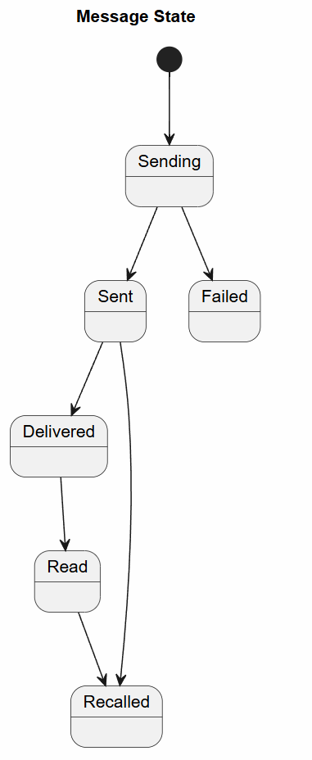

Message State Transitions
From | To | Trigger | Condition
Draft | Sent | User sends | Message validated
Sent | Delivered | Server confirms | Receiver online
Sent | Failed | Delivery fails | Network error
Delivered | Read | Receiver opens | Message viewed
Sent/Delivered | Edited | User edits | Within 5 min
Sent/Delivered/Read | Deleted | User deletes | Soft delete
Sent/Delivered/Read | Deleted (Everyone) | User deletes | Within 5 min

4.3. Conversation State Diagram

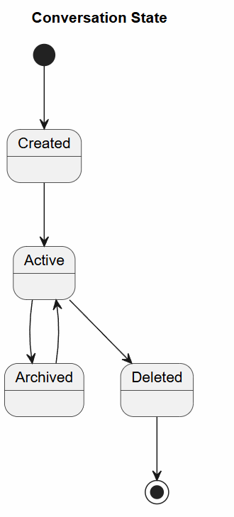

Conversation State Transitions
From | To | Trigger | Condition
Created | Active | Add members | Min 2 members
Active | Archived | User archives | -
Archived | Active | User unarchives | -
Active | Muted | User mutes | -
Muted | Active | User unmutes | -
Active | Deleted | User deletes | -
Deleted | - | Hard delete | After 30 days

4.4. Friendship State Diagram
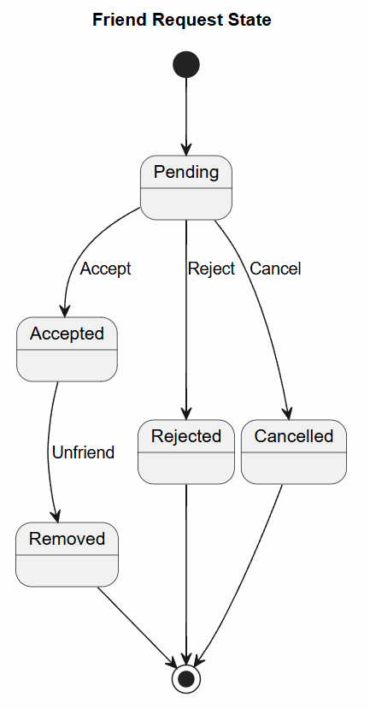

Friendship State Transitions
From | To | Trigger | Condition
None | Pending | Send request | Valid user
Pending | Rejected | Receiver rejects | -
Pending | Accepted | Receiver accepts | -
Rejected | None | Time passes | 7 days
Accepted | Unfriended | User unfriends | -
Accepted | Blocked | User blocks | -
Unfriended | None | - | Can request again
Blocked | None | User unblocks | -
None/Rejected | Blocked | User blocks directly | -

4.5. Group Member State Diagram
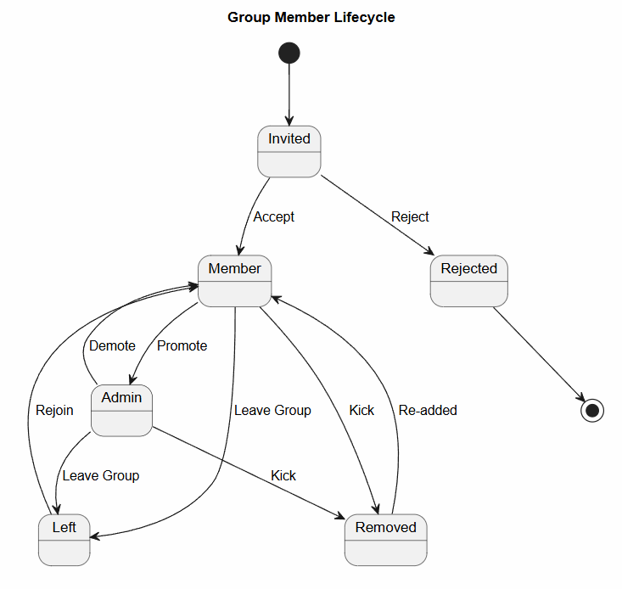

Group Member State Transitions
From | To | Trigger | Condition
Invited | Member | Accept | User joins
Invited | Rejected | Reject | User declines
Member | Admin | Promote | Owner action
Admin | Member | Demote | Owner action
Member | Owner | Promote | Only if no owner
Member | Left | Leave | User voluntary
Member/Admin | Kicked | Kick | Admin/Owner action
Member/Admin | Removed | Remove | Owner action

4.6. OTP
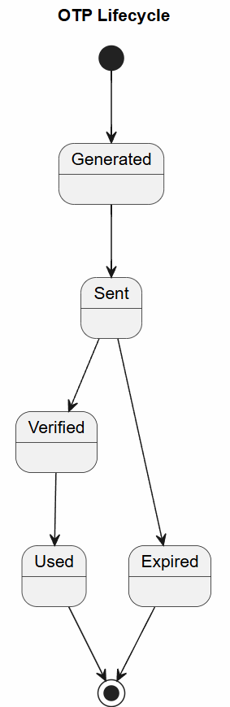

4.7. Media Upload
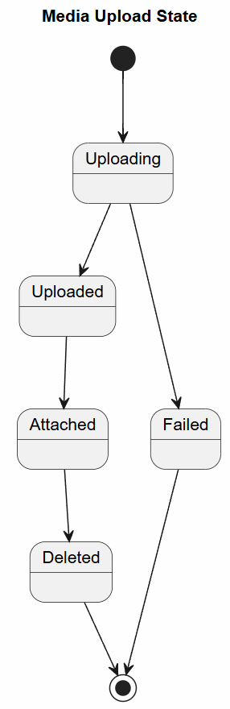

4.8. Websocket connection (Presence)
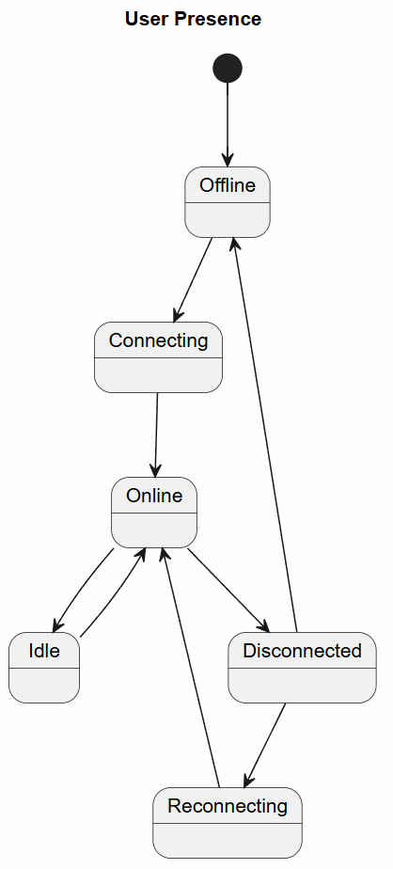

4.9. Device session state
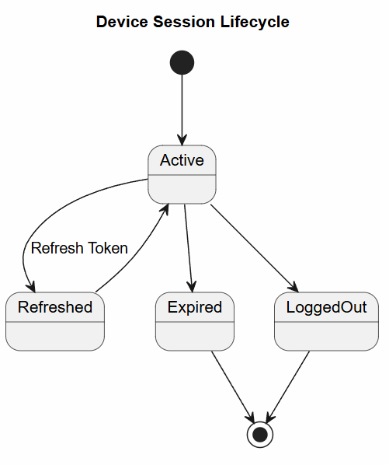

5. ENTITY RELATIONSHIP DIAGRAM (ERD)

5.1. Core Entity Relationship Diagram
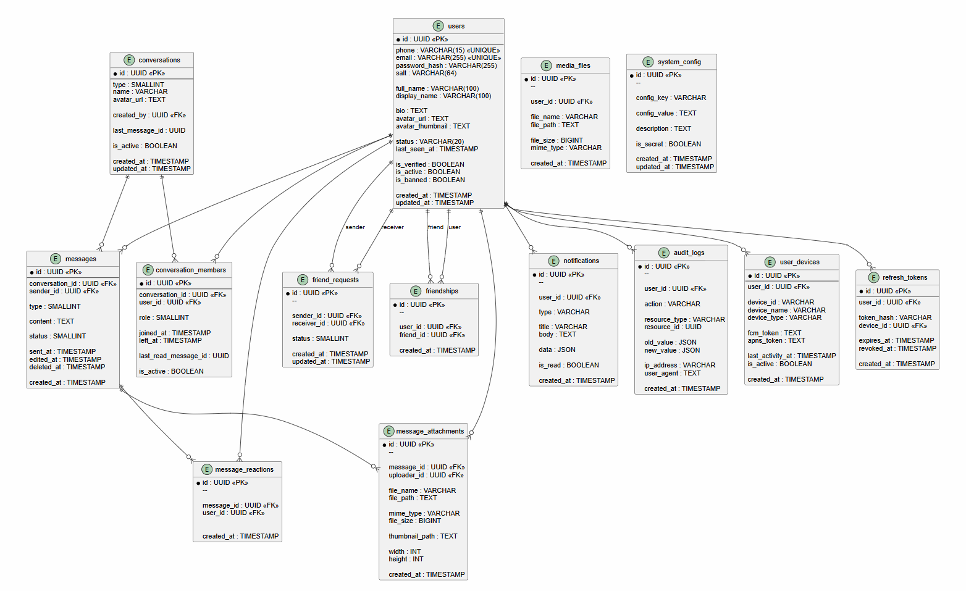

5.2. Relationship Types
Entity | Related Entity | Relation | Description
Users | UserDevices | One-to-Many | Một user có nhiều devices
Users | Friendships (user_id) | One-to-Many | Một user gửi nhiều friend requests
Users | Friendships (friend_id) | One-to-Many | Một user nhận nhiều friend requests
Users | Blocks (blocker_id) | One-to-Many | Một user block nhiều user khác
Users | Blocks (blocked_id) | One-to-Many | Một user bị nhiều user block
Users | Conversations (created_by) | One-to-Many | Một user tạo nhiều conversations
Users | ConversationMembers (user_id) | One-to-Many | Một user tham gia nhiều conversations
Users | Messages (sender_id) | One-to-Many | Một user gửi nhiều messages
Users | Notifications (user_id) | One-to-Many | Một user nhận nhiều notifications
Users | AuditLogs (user_id) | One-to-Many | Một user tạo nhiều audit logs
Users | MediaFiles (user_id) | One-to-Many | Một user upload nhiều media
Conversations | ConversationMembers | One-to-Many | Một conversation có nhiều members
Conversations | Messages | One-to-Many | Một conversation có nhiều messages
Messages | MessageReads (message_id) | One-to-Many | Một message có nhiều reads
Messages | MessageReads (user_id) | One-to-Many | Một user read nhiều messages

5.3. Cardinality Matrix
Entity | Users | Conv | Messages | Friends | Notifs | Media
Users | 1 | M | M | M | M | M
Conversations | M | 1 | M | - | - | -
Messages | M | M | 1 | - | - | M
Friendships | M | - | - | 1 | - | -
Notifications | M | - | - | - | 1 | -
MediaFiles | M | - | M | - | - | 1

6. API SPECIFICATION

6.1. API Overview

Base URLs
Environment | URL
Development | http://localhost:8080/api/v1
Staging | https://api-staging.connectpro.com/api/v1
Production | https://api.connectpro.com/api/v1
WebSocket | wss://ws.connectpro.com/v1/ws

Authentication
- Method: JWT (Bearer Token)
- Header: Authorization: Bearer {access_token}
- Refresh: Use refresh token to get new access token

Headers
Header | Value | Required
Content-Type | application/json | Yes
Authorization | Bearer {token} | Yes (except auth endpoints)
Accept-Language | vi, en | No
X-Request-ID | {uuid} | No

Response Format
{
"success": true,
"code": 200,
"message": "Success",
"data": { ... },
"pagination": {
"page": 1,
"limit": 20,
"total": 100,
"next_page": 2
},
"timestamp": "2026-07-28T10:30:00Z",
"request_id": "req_abc123"
}

6.2. Auth & User APIs

POST /auth/register
Request:
{
"phone": "+84901234567",
"email": "user@example.com",
"password": "SecurePassword123!",
"full_name": "Nguyễn Văn A",
"device_id": "web_chrome"
}
Response (200):
{
"success": true,
"data": {
"user_id": "550e8400-e29b-41d4-a716-446655440000",
"requires_verification": true
}
}
Error Responses:
- 400: Invalid phone/email/password
- 409: Phone already registered

POST /auth/login
Request:
{
"phone": "+84901234567",
"password": "SecurePassword123!",
"device_id": "web_chrome",
"device_name": "Chrome on MacBook"
}
Response (200):
{
"success": true,
"data": {
"access_token": "eyJhbGciOiJIUzI1NiIs...",
"refresh_token": "8e5f4d3c2b1a...",
"expires_in": 900,
"token_type": "Bearer",
"user": {
"id": "550e8400-e29b-41d4-a716-446655440000",
"full_name": "Nguyễn Văn A",
"phone": "+84901234567",
"email": "user@example.com",
"avatar_url": "https://cdn.connectpro.com/avatars/abc123.jpg",
"status": "online"
}
}
}

POST /auth/refresh
Request:
{
"refresh_token": "8e5f4d3c2b1a..."
}
Response (200):
{
"success": true,
"data": {
"access_token": "eyJhbGciOiJIUzI1NiIs...",
"refresh_token": "9f6e5d4c3b2a...",
"expires_in": 900
}
}

POST /auth/verify-otp
Request:
{
"phone": "+84901234567",
"otp_code": "123456"
}
Response (200):
{
"success": true,
"data": {
"is_verified": true
}
}

GET /users/me
Response (200):
{
"success": true,
"data": {
"id": "550e8400-e29b-41d4-a716-446655440000",
"full_name": "Nguyễn Văn A",
"display_name": "An Nguyen",
"phone": "+84901234567",
"email": "user@example.com",
"bio": "Software Engineer",
"avatar_url": "https://cdn.connectpro.com/avatars/abc123.jpg",
"avatar_thumbnail_url": "https://cdn.connectpro.com/avatars/abc123_thumb.jpg",
"status": "online",
"last_seen_at": "2026-07-28T10:30:00Z",
"is_verified": true,
"preferred_language": "vi",
"notification_enabled": true,
"created_at": "2026-01-15T08:00:00Z",
"last_login_at": "2026-07-28T10:30:00Z"
}
}

PATCH /users/me
Request:
{
"full_name": "Nguyễn Văn An",
"display_name": "An Nguyen Dev",
"bio": "Senior Software Engineer",
"preferred_language": "en"
}
Response (200):
{
"success": true,
"data": {
"full_name": "Nguyễn Văn An",
"display_name": "An Nguyen Dev",
"bio": "Senior Software Engineer",
"preferred_language": "en"
}
}

6.3. Friendship APIs

POST /friends/requests
Request:
{
"receiver_id": "660e8400-e29b-41d4-a716-446655440000",
"message": "Hi, let's connect!"
}
Response (201):
{
"success": true,
"data": {
"request_id": 123,
"status": "pending",
"sent_at": "2026-07-28T10:30:00Z"
}
}

GET /friends/requests
Query Params:
- status: pending|accepted|rejected (default: pending)
- page: 1
- limit: 20
Response (200):
{
"success": true,
"data": [
{
"id": 123,
"sender": {
"id": "660e8400-e29b-41d4-a716-446655440000",
"full_name": "Trần Thị B",
"avatar_url": "https://cdn.connectpro.com/avatars/def456.jpg",
"status": "online"
},
"message": "Hi, let's connect!",
"status": "pending",
"sent_at": "2026-07-28T10:30:00Z"
}
],
"pagination": {
"page": 1,
"limit": 20,
"total": 5
}
}

PUT /friends/requests/{id}
Request:
{
"action": "accept" // or "reject"
}
Response (200):
{
"success": true,
"data": {
"status": "accepted",
"accepted_at": "2026-07-28T10:35:00Z"
}
}

GET /friends
Query Params:
- page: 1
- limit: 50
- search: "Nguyen" (optional)
Response (200):
{
"success": true,
"data": [
{
"id": "660e8400-e29b-41d4-a716-446655440000",
"full_name": "Trần Thị B",
"display_name": "B Tran",
"avatar_url": "https://cdn.connectpro.com/avatars/def456.jpg",
"status": "online",
"last_seen_at": "2026-07-28T10:30:00Z",
"mutual_friends": 3,
"unread_count": 2
}
],
"pagination": {
"page": 1,
"limit": 50,
"total": 150
}
}

DELETE /friends/{friend_id}
Response (204):
{
"success": true,
"message": "Friend removed successfully"
}

POST /friends/block
Request:
{
"user_id": "660e8400-e29b-41d4-a716-446655440000",
"reason": "Spam"
}
Response (201):
{
"success": true,
"data": {
"blocked_at": "2026-07-28T10:40:00Z"
}
}

DELETE /friends/block/{user_id}
Response (204):
{
"success": true,
"message": "User unblocked successfully"
}

6.4. Conversation APIs

POST /conversations
Request (Direct):
{
"type": "direct",
"user_ids": ["660e8400-e29b-41d4-a716-446655440000"]
}
Request (Group):
{
"type": "group",
"name": "Development Team",
"description": "Team for project development",
"user_ids": ["660e8400-e29b-41d4-a716-446655440000", "770e8400-e29b-41d4-a716-446655440000"],
"is_public": false
}
Response (201):
{
"success": true,
"data": {
"conversation_id": "880e8400-e29b-41d4-a716-446655440000",
"type": "group",
"name": "Development Team",
"created_at": "2026-07-28T10:45:00Z",
"members": [
{
"user_id": "550e8400-e29b-41d4-a716-446655440000",
"role": "owner"
},
{
"user_id": "660e8400-e29b-41d4-a716-446655440000",
"role": "member"
}
]
}
}

GET /conversations
Query Params:
- page: 1
- limit: 20
- type: direct|group (optional)
- search: "Development" (optional)
Response (200):
{
"success": true,
"data": [
{
"id": "880e8400-e29b-41d4-a716-446655440000",
"type": "group",
"name": "Development Team",
"avatar_url": "https://cdn.connectpro.com/group-avatars/group_abc.jpg",
"last_message": {
"id": "990e8400-e29b-41d4-a716-446655440000",
"sender_id": "660e8400-e29b-41d4-a716-446655440000",
"sender_name": "Trần Thị B",
"content": "Let's discuss the architecture",
"type": "text",
"sent_at": "2026-07-28T10:40:00Z"
},
"last_message_at": "2026-07-28T10:40:00Z",
"unread_count": 3,
"member_count": 5,
"is_muted": false,
"is_pinned": true
}
],
"pagination": {
"page": 1,
"limit": 20,
"total": 45
}
}

GET /conversations/{id}
Response (200):
{
"success": true,
"data": {
"id": "880e8400-e29b-41d4-a716-446655440000",
"type": "group",
"name": "Development Team",
"description": "Team for project development",
"avatar_url": "https://cdn.connectpro.com/group-avatars/group_abc.jpg",
"created_by": "550e8400-e29b-41d4-a716-446655440000",
"created_at": "2026-07-20T08:00:00Z",
"members": [
{
"user_id": "550e8400-e29b-41d4-a716-446655440000",
"full_name": "Nguyễn Văn A",
"role": "owner",
"joined_at": "2026-07-20T08:00:00Z",
"is_active": true
},
{
"user_id": "660e8400-e29b-41d4-a716-446655440000",
"full_name": "Trần Thị B",
"role": "admin",
"joined_at": "2026-07-20T08:00:00Z",
"is_active": true
}
],
"settings": {
"is_public": false,
"join_approval_required": true,
"notification_enabled": true
}
}
}

PUT /conversations/{id}
Request:
{
"name": "Dev Team 2026",
"description": "Development team for 2026",
"is_public": true
}
Response (200):
{
"success": true,
"data": {
"id": "880e8400-e29b-41d4-a716-446655440000",
"name": "Dev Team 2026",
"description": "Development team for 2026",
"updated_at": "2026-07-28T10:50:00Z"
}
}

POST /conversations/{id}/members
Request:
{
"user_ids": ["770e8400-e29b-41d4-a716-446655440000"],
"role": "member"
}
Response (201):
{
"success": true,
"data": {
"added_members": [
{
"user_id": "770e8400-e29b-41d4-a716-446655440000",
"role": "member",
"joined_at": "2026-07-28T10:52:00Z"
}
]
}
}

DELETE /conversations/{id}/members/{user_id}
Response (204):
{
"success": true,
"message": "Member removed successfully"
}

POST /conversations/{id}/leave
Response (200):
{
"success": true,
"message": "Left group successfully"
}

6.5. Message APIs

GET /conversations/{id}/messages
Query Params:
- limit: 50
- before: "2026-07-28T10:00:00Z" (cursor)
- after: "2026-07-28T09:00:00Z" (optional)
Response (200):
{
"success": true,
"data": [
{
"id": "990e8400-e29b-41d4-a716-446655440000",
"conversation_id": "880e8400-e29b-41d4-a716-446655440000",
"sender": {
"id": "550e8400-e29b-41d4-a716-446655440000",
"full_name": "Nguyễn Văn A",
"avatar_url": "https://cdn.connectpro.com/avatars/abc123.jpg"
},
"type": "text",
"content": "Hello everyone!",
"status": "read",
"reactions": {
"❤️": ["660e8400-e29b-41d4-a716-446655440000"],
"👍": ["550e8400-e29b-41d4-a716-446655440000"]
},
"replied_to": {
"id": "991e8400-e29b-41d4-a716-446655440000",
"sender_name": "Trần Thị B",
"content": "Hi"
},
"sent_at": "2026-07-28T10:00:00Z",
"delivered_at": "2026-07-28T10:00:02Z",
"read_at": "2026-07-28T10:00:05Z",
"is_edited": false,
"is_deleted": false
}
],
"pagination": {
"has_more": true,
"cursor_prev": "2026-07-28T10:00:00Z",
"cursor_next": "2026-07-28T10:01:00Z"
}
}

POST /conversations/{id}/messages
Request (Text):
{
"type": "text",
"content": "Hello everyone!",
"replied_to_id": null,
"metadata": {}
}
Request (Media):
{
"type": "image",
"content": "Check this out!",
"media_file_id": "media_abc123",
"replied_to_id": null
}
Response (201):
{
"success": true,
"data": {
"id": "992e8400-e29b-41d4-a716-446655440000",
"conversation_id": "880e8400-e29b-41d4-a716-446655440000",
"sender": {
"id": "550e8400-e29b-41d4-a716-446655440000",
"full_name": "Nguyễn Văn A"
},
"type": "text",
"content": "Hello everyone!",
"status": "sent",
"sent_at": "2026-07-28T10:05:00Z"
}
}

PUT /messages/{id}
Request:
{
"content": "Hello everyone! Updated message"
}
Response (200):
{
"success": true,
"data": {
"id": "992e8400-e29b-41d4-a716-446655440000",
"content": "Hello everyone! Updated message",
"is_edited": true,
"edited_at": "2026-07-28T10:06:00Z",
"edit_history": [
{
"content": "Hello everyone!",
"edited_at": "2026-07-28T10:05:00Z"
},
{
"content": "Hello everyone! Updated message",
"edited_at": "2026-07-28T10:06:00Z"
}
]
}
}

DELETE /messages/{id}
Request:
{
"for_everyone": true // true: delete for all, false: delete for me only
}
Response (204):
{
"success": true,
"message": "Message deleted successfully"
}

POST /messages/{id}/reactions
Request:
{
"emoji": "❤️"
}
Response (201):
{
"success": true,
"data": {
"message_id": "992e8400-e29b-41d4-a716-446655440000",
"reactions": {
"❤️": ["550e8400-e29b-41d4-a716-446655440000"],
"👍": ["770e8400-e29b-41d4-a716-446655440000"]
}
}
}

DELETE /messages/{id}/reactions/{emoji}
Response (204):
{
"success": true,
"message": "Reaction removed"
}

POST /messages/{id}/read
Request:
{
"conversation_id": "880e8400-e29b-41d4-a716-446655440000"
}
Response (200):
{
"success": true,
"data": {
"message_id": "992e8400-e29b-41d4-a716-446655440000",
"read_at": "2026-07-28T10:07:00Z"
}
}

6.6. Notification APIs

GET /notifications
Query Params:
- page: 1
- limit: 20
- type: new_message|friend_request|system (optional)
- is_read: true|false (optional)
Response (200):
{
"success": true,
"data": [
{
"id": 12345,
"type": "new_message",
"title": "New message from Trần Thị B",
"body": "Let's discuss the architecture",
"data": {
"conversation_id": "880e8400-e29b-41d4-a716-446655440000",
"sender_id": "660e8400-e29b-41d4-a716-446655440000",
"message_id": "990e8400-e29b-41d4-a716-446655440000"
},
"is_read": false,
"created_at": "2026-07-28T10:40:00Z"
}
],
"pagination": {
"page": 1,
"limit": 20,
"total": 150
}
}

PUT /notifications/{id}/read
Response (200):
{
"success": true,
"message": "Notification marked as read"
}

PUT /notifications/read-all
Response (200):
{
"success": true,
"message": "All notifications marked as read"
}

6.7. Media APIs

POST /media/upload
Request: multipart/form-data
- file: Binary file data
- type: image|video|document|audio
Response (201):
{
"success": true,
"data": {
"file_id": "media_abc123",
"file_name": "photo_2026.jpg",
"file_size": 2048576,
"mime_type": "image/jpeg",
"url": "https://cdn.connectpro.com/uploads/photo_2026.jpg",
"thumbnail_url": "https://cdn.connectpro.com/uploads/photo_2026_thumb.jpg",
"width": 1920,
"height": 1080
}
}

GET /media/{file_id}
Response (200):
{
"success": true,
"data": {
"id": "media_abc123",
"file_name": "photo_2026.jpg",
"file_size": 2048576,
"mime_type": "image/jpeg",
"url": "https://cdn.connectpro.com/uploads/photo_2026.jpg",
"thumbnail_url": "https://cdn.connectpro.com/uploads/photo_2026_thumb.jpg",
"metadata": {
"width": 1920,
"height": 1080,
"orientation": "landscape"
}
}
}

DELETE /media/{file_id}
Response (204):
{
"success": true,
"message": "File deleted successfully"
}

6.8. Admin APIs

GET /admin/users
Query Params:
- page: 1
- limit: 20
- search: "Nguyen" (optional)
- status: active|banned|inactive (optional)
Response (200):
{
"success": true,
"data": [
{
"id": "550e8400-e29b-41d4-a716-446655440000",
"full_name": "Nguyễn Văn A",
"phone": "+84901234567",
"email": "user@example.com",
"status": "online",
"is_verified": true,
"is_active": true,
"is_banned": false,
"created_at": "2026-01-15T08:00:00Z",
"last_login_at": "2026-07-28T10:30:00Z",
"total_messages": 1250,
"total_friends": 45
}
],
"pagination": {
"page": 1,
"limit": 20,
"total": 150
}
}

PUT /admin/users/{id}/ban
Request:
{
"reason": "Violating community guidelines",
"duration": "permanent" // or "30days", "7days"
}
Response (200):
{
"success": true,
"data": {
"user_id": "660e8400-e29b-41d4-a716-446655440000",
"is_banned": true,
"banned_at": "2026-07-28T10:45:00Z",
"banned_until": null,
"reason": "Violating community guidelines"
}
}

PUT /admin/users/{id}/unban
Response (200):
{
"success": true,
"data": {
"user_id": "660e8400-e29b-41d4-a716-446655440000",
"is_banned": false,
"unbanned_at": "2026-07-28T10:50:00Z"
}
}

GET /admin/stats
Response (200):
{
"success": true,
"data": {
"total_users": 15000,
"active_users_today": 3500,
"active_users_online": 1200,
"total_messages": 1500000,
"messages_today": 25000,
"total_conversations": 5000,
"total_friendships": 45000,
"storage_used": {
"total": 150000000000,
"messages": 5000000000,
"media": 145000000000
},
"system_metrics": {
"cpu_usage": 45.5,
"memory_usage": 65.2,
"db_connections": 45,
"websocket_connections": 1200
}
}
}

7. SYSTEM FLOW DIAGRAMS

7.1. System Architecture Diagram
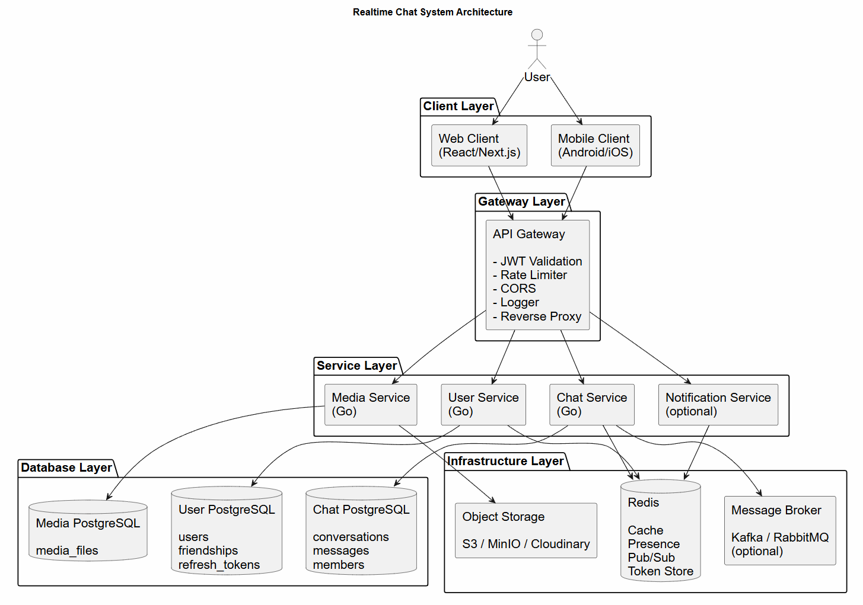

7.2. Overall System Flow Diagram
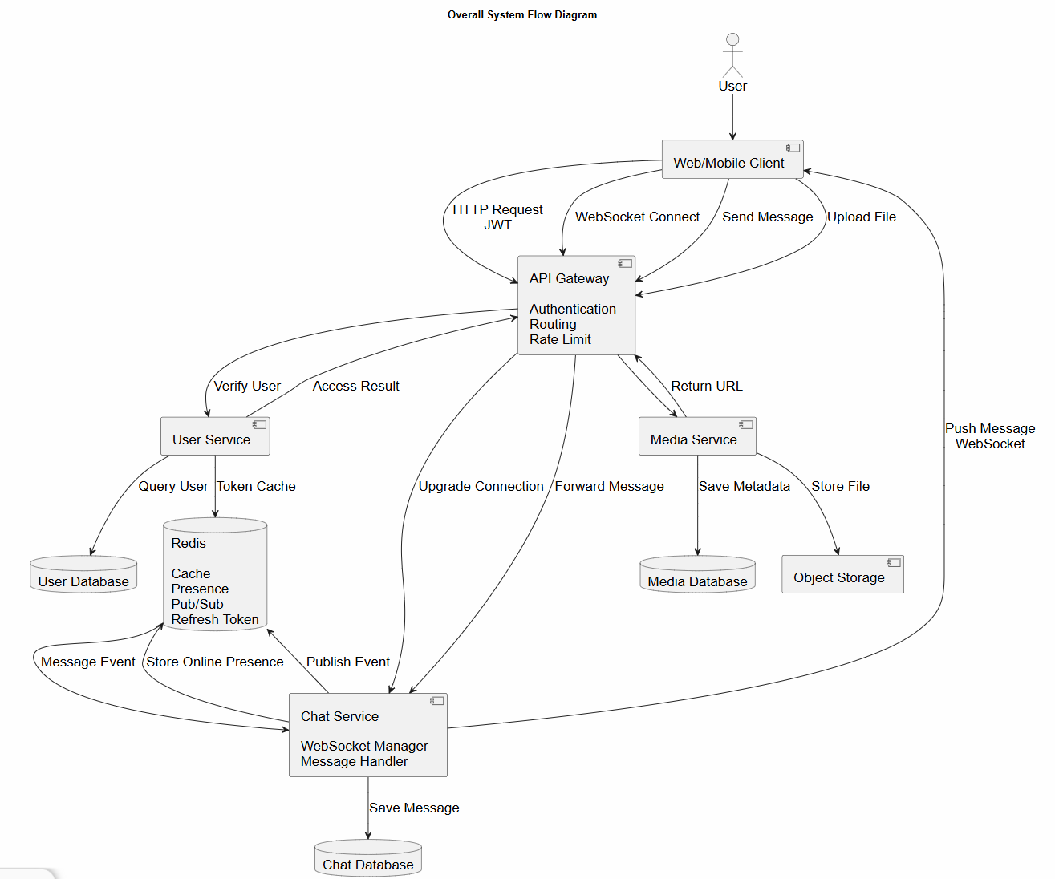

7.3. Authentication Flow
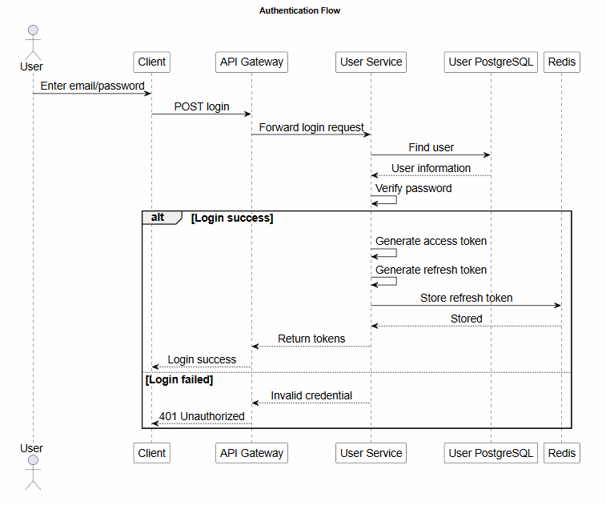

7.4. Send Message Flow
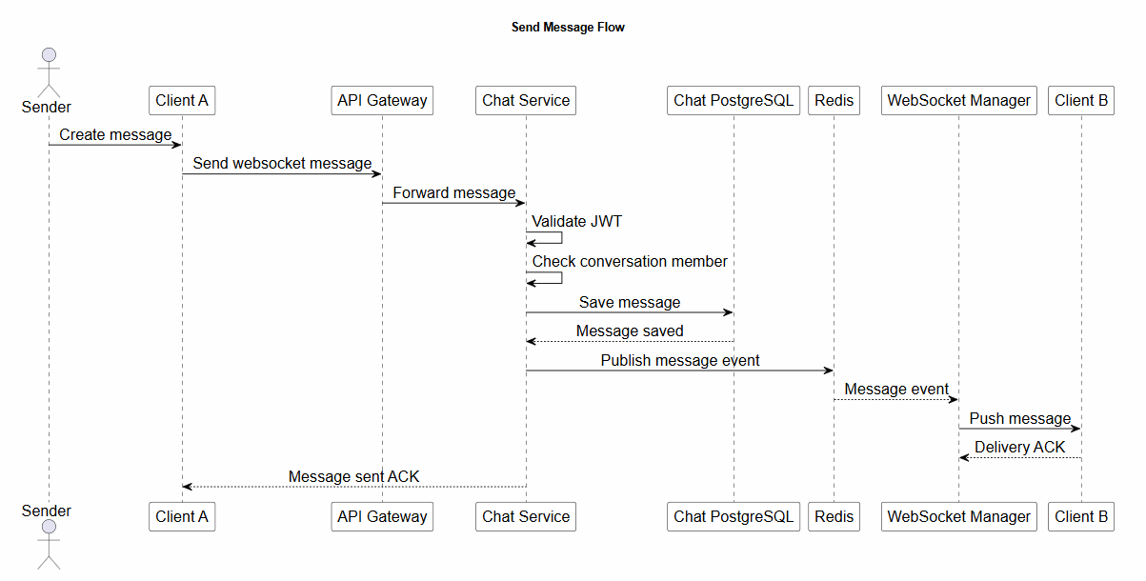

7.5. Receive Message Flow
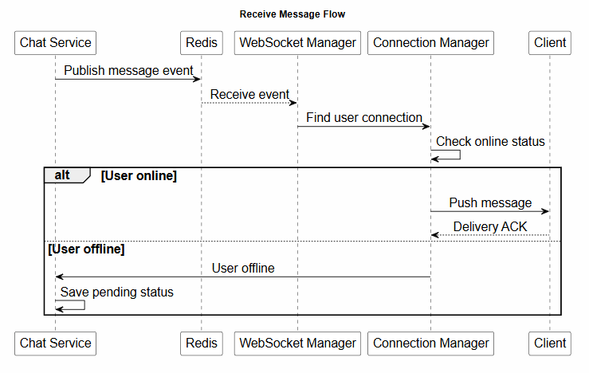

7.6. Media Upload Flow
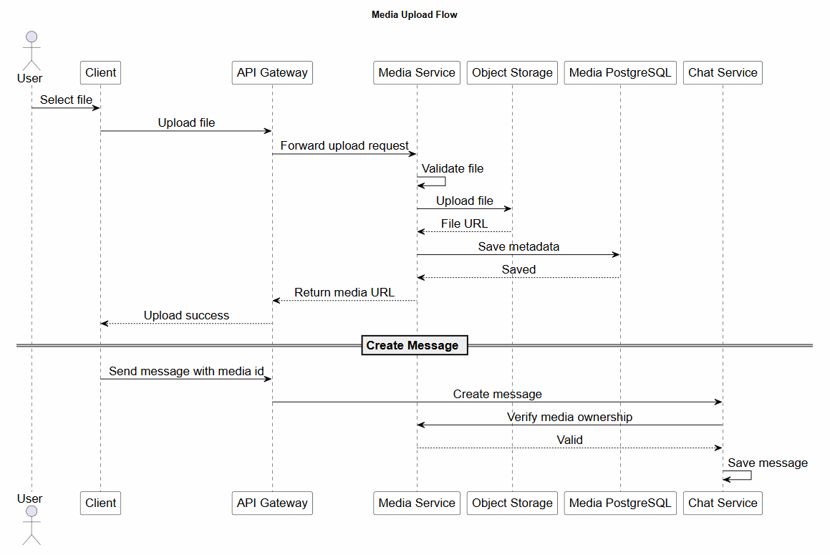

7.7. Friend Request Flow
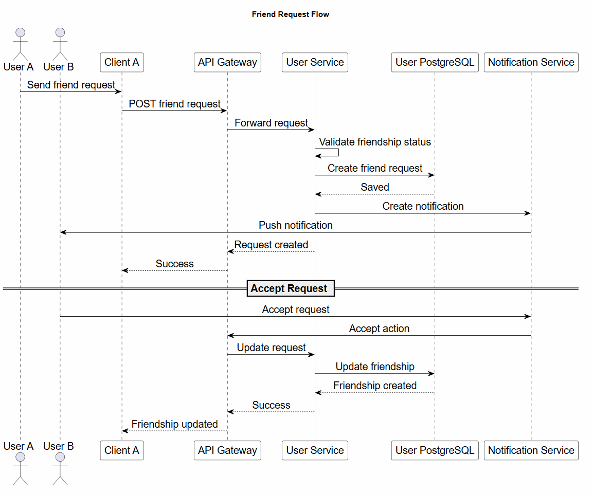

7.8. Refresh Token Rotation Flow
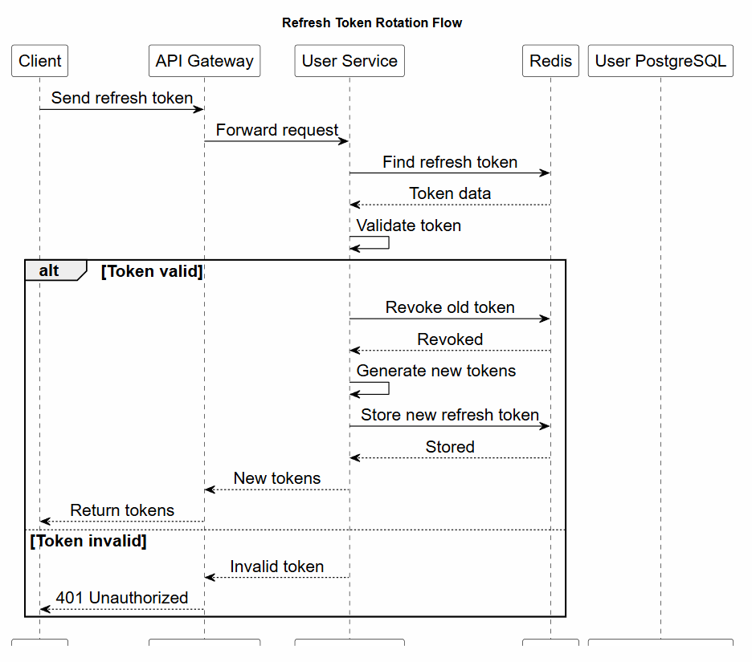

7.9. Presence Flow
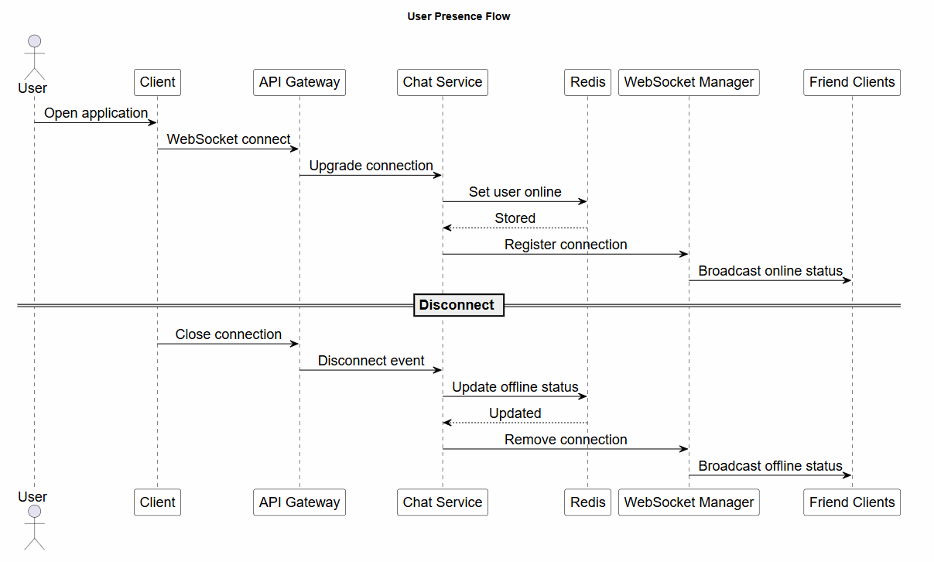

7.10. Notification Flow
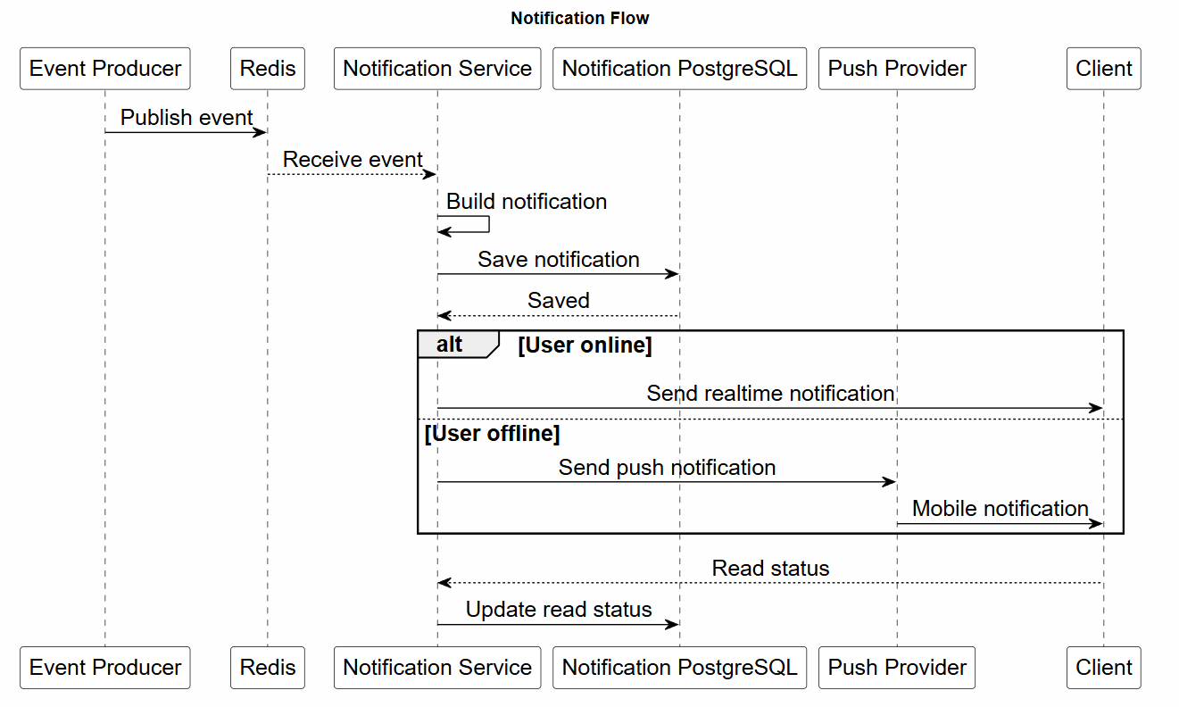

7.11. Group Creation Flow

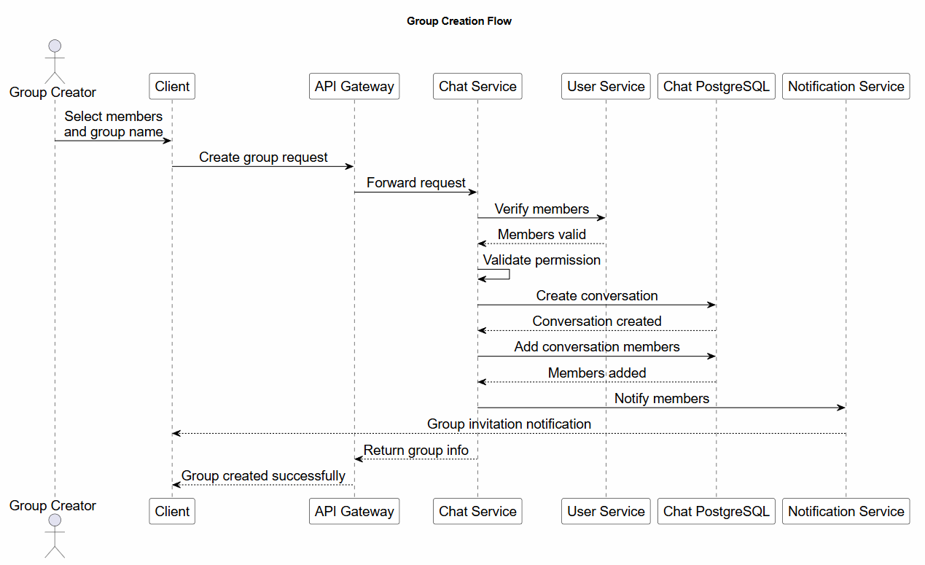

8. COMPONENT ARCHITECTURE

8.1. API Gateway Component Architecture

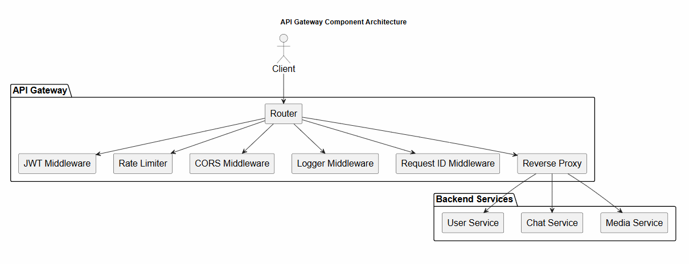

8.2. User Service Component Architecture

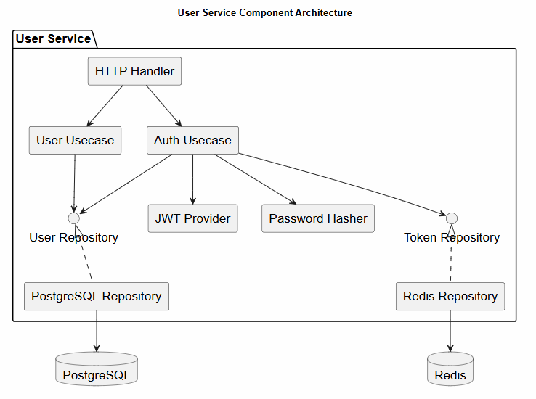

8.3. Chat Service Component Architecture

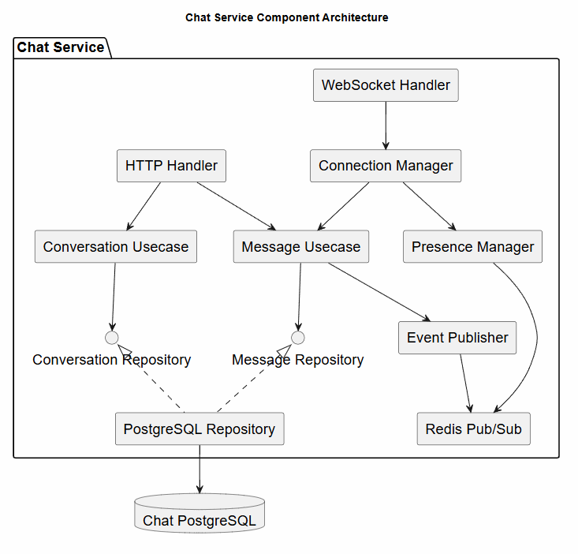

8.4. Media Service Component Architecture

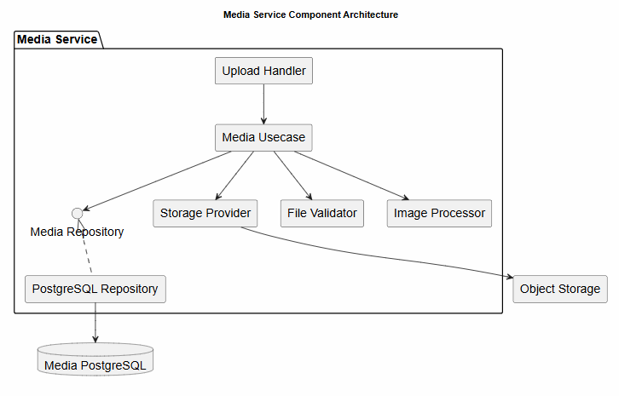

8.5. Notification Service Component Architecture

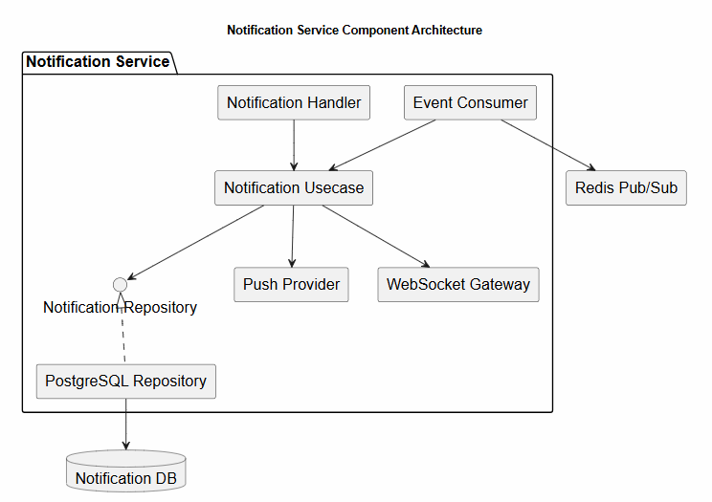

8.6. Service Dependencies Diagram

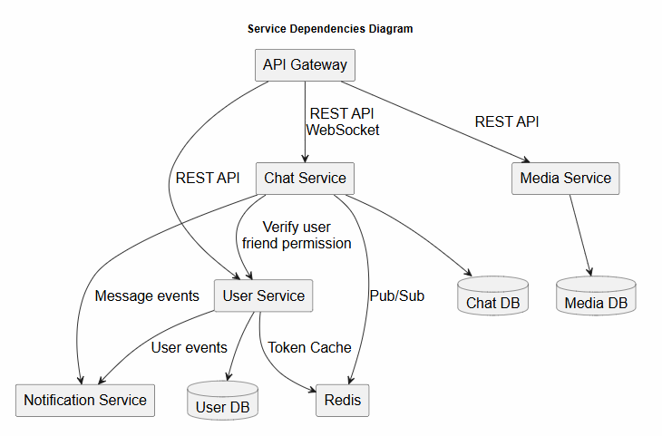

8.7. Infrastructure Components Diagram

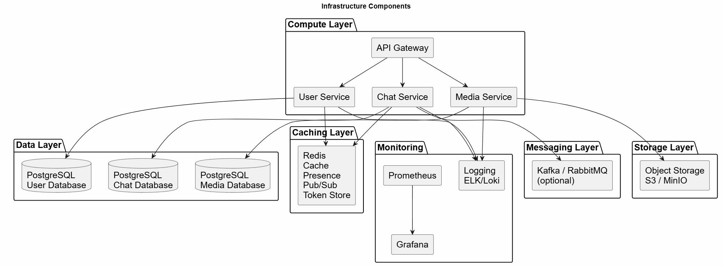

8.8. Communication Protocols Diagram
