EXCEL PROJECT

ASTRO-SAGE ANALYSIS

Project by Thanneeru Pranay
Date – 26 July,2026

Task

Objective Questions:
1. What is the total no. of tables present in the data?
Ans – only 1 table is present in dataset for Analysis
2. What is the total no. of attributes present in the data?
Ans - The dataset was expanded from 35 to 45 attributes through meticulous cleaning and the integration of engineered columns. This expansion ensures a more comprehensive, analysis-ready framework
3. The data consists of some inconsistent and missing values so ensure that the data used for further analysis is cleaned.
Answer: The original dataset, comprising 35 attributes, was transformed into a more comprehensive dataset with 45 attributes through extensive data preprocessing and feature engineering. Data quality was improved by identifying and resolving inconsistencies, while missing values in chatStatus and chatSeconds were imputed using ConsultationType as the basis. Additional temporal features, including Day, Date, Month, and timestamp components, were extracted to enrich the analysis. A new financial metric, Operation_Cost, was also derived. Moreover, logical functions such as IF and COUNTIF were applied to classify users into different categories, resulting in a clean, enriched, and analysis-ready dataset suitable for deeper insights.

The column name changes and data filling are as follows –

 |  | Renamed Columns for better understanding
 |  | Data Filled/ New columns added
 |  | No Change
Columns Raw Data | Columns Cleaned Data
_id | Unique_ID
User | User_Profile_ID
chatStatus | chatStatus, Missing data filled using Consultation Type column-  Call – called  Complementary – Complementary  public_live_Call - public_live_Call
Guru | Guru_id
guruName | guruName

Gid | Unique_Guru_ID
Uid | Unique_User_ID
consultationType | consultationType
Website | Platform
refundStatus | refundStatus
isWhiteListUser | isWhiteListUser

chatSeconds | chatSeconds. Missing data – filled with 0
Queue | queue
freeCall | freeCall
freeChat | freeChat
createdAT | createdAT, Added -- Created_Time, Created_Date to separately store time and date respectively for calculation purposes
updatedAt | updatedAt

__v | Version Installed
statementEntryId | statementEntryId
chatStartTime | chatStartTime + ChatStartDate(Added)
chatEndTime | chatEndTime + ChatEndDate(Added)
timeDuration | timeDuration
callChannel | callChannel
callIvrType | callIvrType
callStatus | callStatus
CallSid | CallSid
Amount | amount
astrologerCallStatus | astrologerCallStatus
astrologerOnCallDuration | astrologerOnCallDuration
astrologersEarnings | astrologersEarnings
netAmount | netAmount
Region | region
userCallStatus | userCallStatus
userOnCallDuration | userOnCallDuration
Rating | rating

CONDITIONAL FORMATTING and COLUMN COLOUR
- Conditional formatting on “called” of chat status (fill of missing data) by golden color fill and “call” status for consultation type to easily pinpoint data
- Condition Formatting on “Chat” for consulation type using red border to easily distinguish data
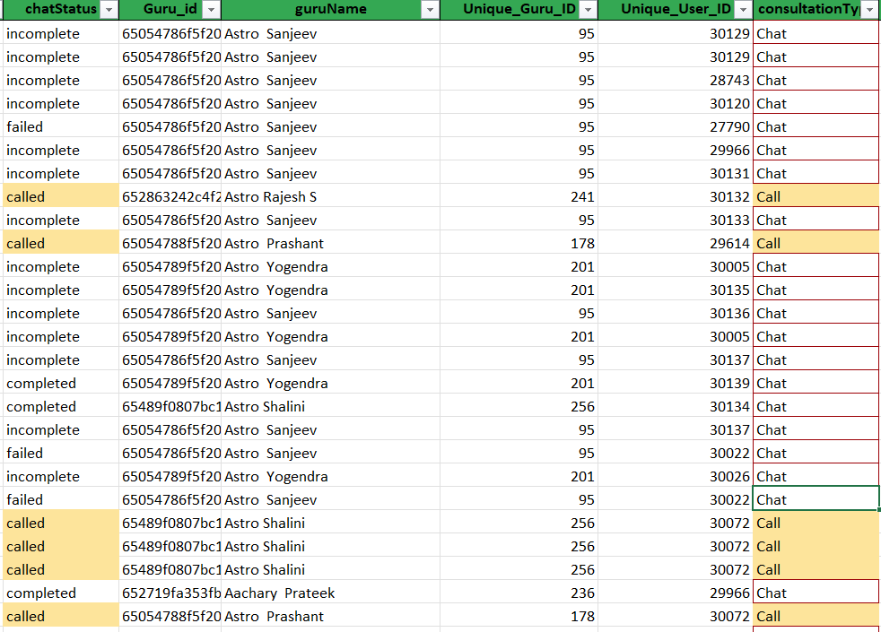

- What is the change in daily call volume day by day and also find the average daily call volume.
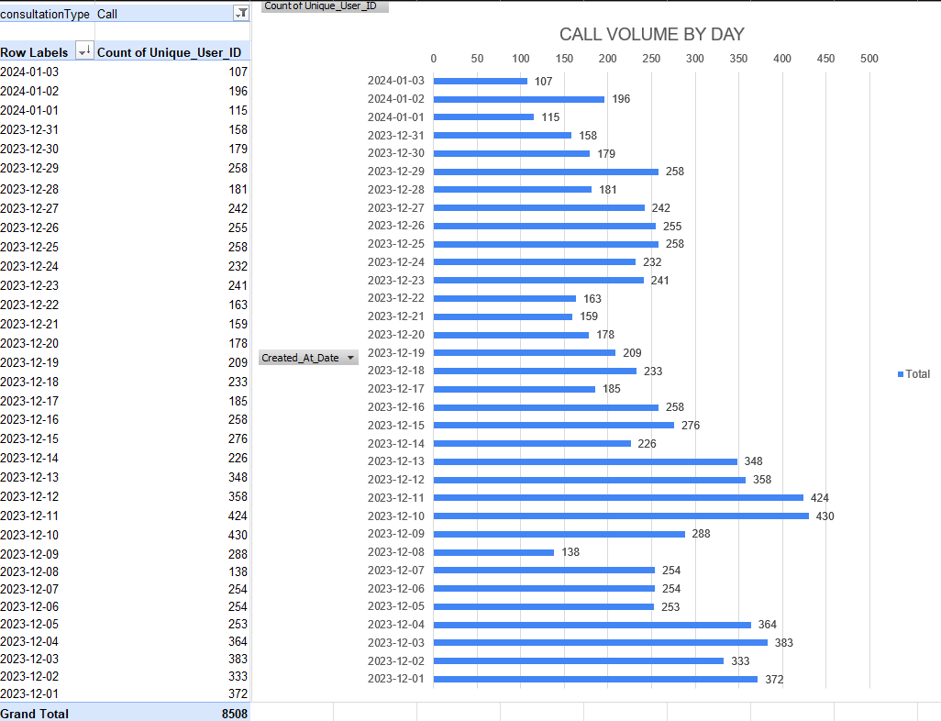

Approach to problem – A pivot table was created using –
Problems Faced –
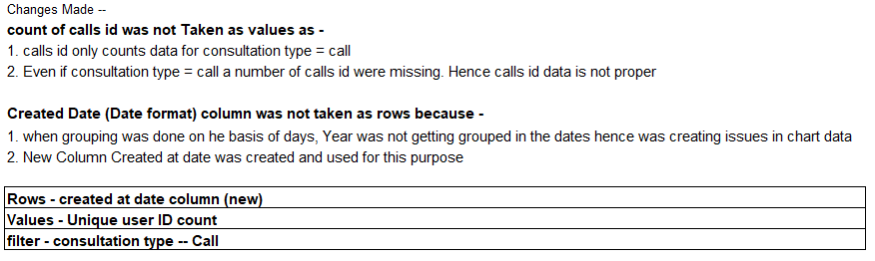
Observation-

Answer to second Question –

5.Which months experienced the highest and lowest call volumes?
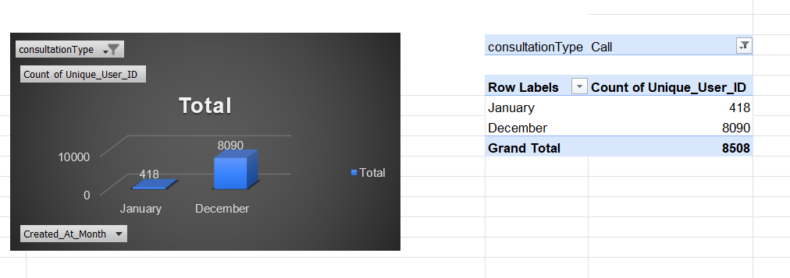

Approach:
Rows | Created_At_Month - created from Created At timestamp. Only extracts months
Data Value | Unique_User_ID(count)
Filter | Consultation Type (Call)

Observation- | Maximum Call Volume was at December - 8090 calls total
 | Minimum Call Volume was at January - 418 calls total

6. What is the total operational cost for that month?
Approach –
Operation Cost = sum of astrologer’s earnings distributed over the months
A Pivot Table was made using:
Rows – Created_At_Month
Values- Astrologer’s earnings sum

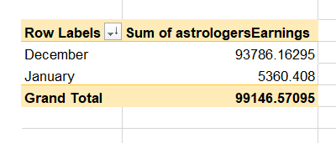
7.What is the average number of calls handled per agent per day?
Approach –
- Found total number of calls (includes all types of call) using COUNTIF function on Consultation type column where consultation type = “Call”
=8508
- Found count of unique gurus/Agents using count function on UNIQUE array function on Unique_Guru_ID column
=131
- Found Total number of unique days using COUNTA function on UNIQUE array function on Created_At_Date column
=34
Solution-
- Average number of calls per Agent = (Total number of call) / (Unique count of agents)
=8508/131 = 64.94 (approx.)
- Average number of calls per Agent per Day = (AVG no of call per Agent) / (Unique number of days)
=64.94/34 = 1.91 (approx.) = 2 (rounded off to 0 place of decimal using ROUND function)

Conclusion – On an average 2 calls were made per agent per day
8.How many repeat callers are there, and what percentage of total calls do they represent?
Approach-
- PIVOT TABLE FORMED FOR NUMBER OF CALLS FOR EACH USER ID
- SINCE FIRST CALL CAN NEVER BE REPEATED HENCE '-1' DONE FOR EACH COUNT OF CALLS PER UNIQUE USER ID
- COUNT THE NUMBER OF (0,1)-- ONES THAT CALLED ONLY ONCE (UNIQUE)
- DUPLICATES = TOTAL NUMBER OF CALLS - TOTAL UNIQUE CALLS
- REPEATED/ DUPLICATE PERCT = TOTAL DUPLICATE / TOTAL CALLS *100
Solution –
- Total number of calls – count of CALLID – 8365
- Total number of repeated calls excluding 0,1 solved using filter() + Sum() = 6012
- Since first call is never repeatative, -1 is done from each total number of calls group by usnique user id
- Total number of repeative calls after substracting 1 from each – 4737
- Percentage of repeat callers = Total number of calls after substracting 1 / total number of calls = 4737/ 8365 = 56.63%
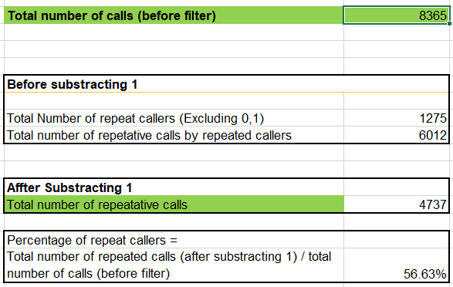
9. What are the total sales generated by the call centre for each product category?
Approach – created a pivot Table with “Consultation Type” in rows and net Amount as values as sum and then created a bar graph on the basis of the data received
Change in column data – in netAmount column missing values were filled with 0
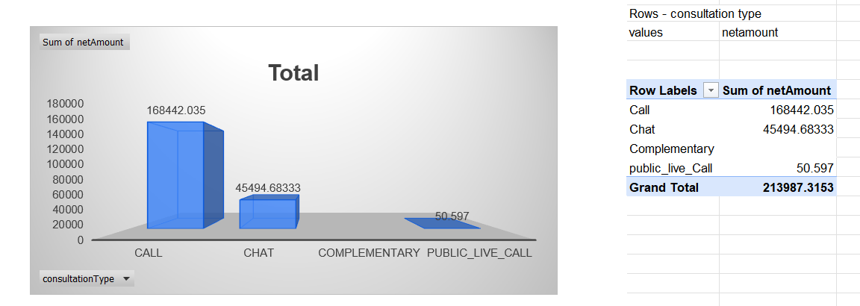

Observation – Consultation type = call generated the maximum revenue. Improvements needs to be there for others specially “public live call” and “complimentary”
10. How many calls were made for each user ID and guru ID?
Approach – Made 2 pivot tables with-
- USER ID VS Count of consultation type
- Rows – Unique USER ID
- Columns – Consultation type
- Values – count of consultation type
- Sorting – Descending order of total calls made by each user
Observation- Most of the calls were made either through calls or chat. Heavy improvements needed for public live call or complementary services.
A few users have booked a number of consultation services maxing at 158 but the average is much lower at only 5 sessions per person.
Suggestion – More investments of free complimentary services to improve customer counts and provide free complimentary services to try out other gurus for training purposes.
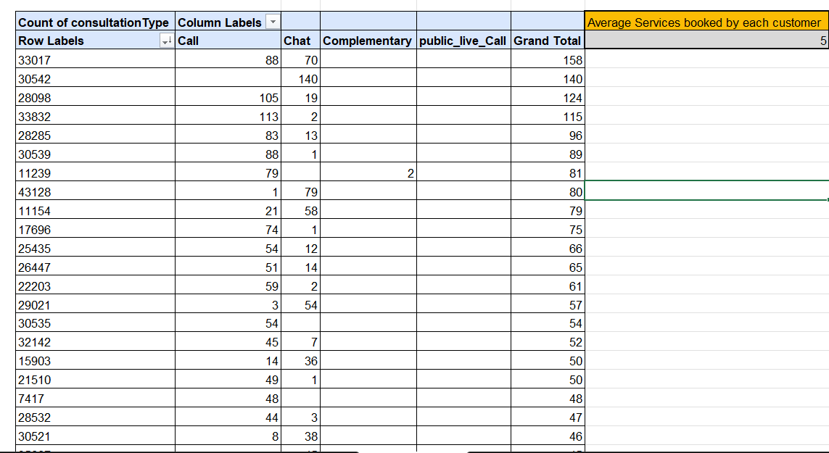
- Unique GURU ID VS Count of Consultation TYPE
- Row – Unique Guru ID
- Columns – Consultation Type
- Values – Count of consultation Type
- Sorting – Descending order of total sessions completed by each guru
Observation- Some gurus have completed a huge number of consultation maxing at 1580 consultations. The average calls taken up by each guru is 425(approx.) which is decent as well.
Suggestion –
Investments needs to be done improve customer count by providing free complimentary services and option to consult new gurus for free to be used for training purposes.
Investments also needs to be done to either Hire more gurus or improve individual guru income to increase the number of agents available.
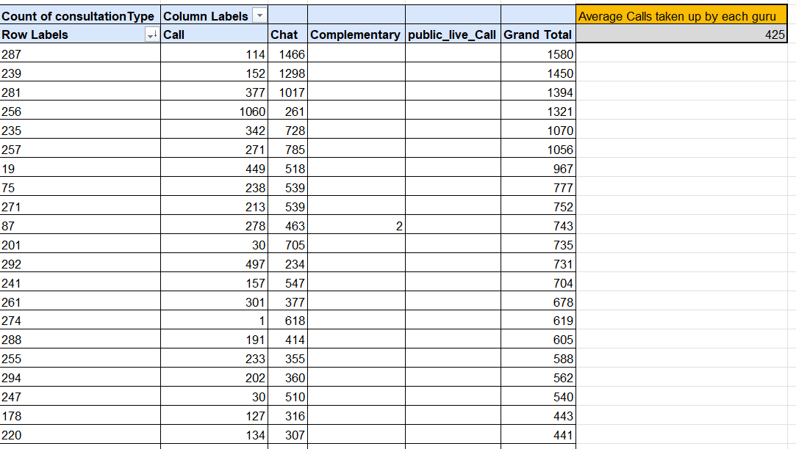
11. What is the correlation between call duration and customer satisfaction?
Approach – This was was done using the correl function using CORREL(UserOnCallDuration,Rating) =0.054(approx.)
Observation-
This value is very close to 0 hence there is no correlation between number of minutes spent on call with customer with the satisfaction of the customer. It suggests that rating/Satisfaction depends on quality of consulation and not duration
12. Which guru has the highest and lowest customer satisfaction scores?
Approach – A pivot table was made using –
- Rows – Guru Name
- Values – average of rating
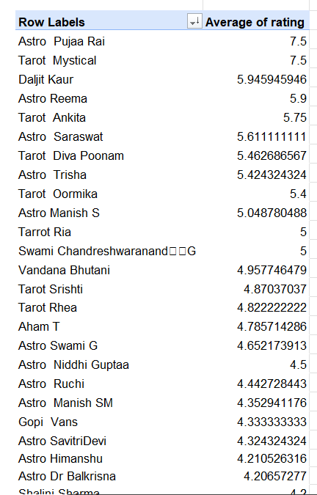
- Sorting –
  - For minimum satisfaction rate – Sort Asc of Average rating
  - For maximum satisfaction – Sort Desc of Average Rating
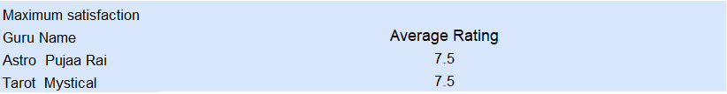

13. What is the average customer satisfaction score by month?
Approach – Made a pivot table with rows – Created_At_Month and values as average rating. Also found out the maximum rating for comparison
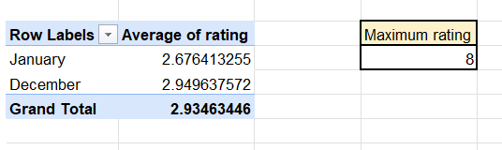

Observations –
- The rating remained almost consistent for both months.
- But the rating was very low compared to maximum rating. This shows customers are not very satisfied with the quality of consultation received.
Suggestion-
Heavy investments for agent training is needed to improve customer satisfaction and hence improve retention.

14. How many categorical columns are there in the data? [Search about categorical and continuous data, and try to answer this question]

Categorical column in excel represent data that are of qualitatice properties and cotain non- numeric data. They help in grouping and classification but do not help in mathematical aggregation.
Based on original raw data –
There are total 35 columns in original raw data
Out of these columns there are –
- 19 object type categorical columns
- 4 boolean type categorical columns
List of object type categorical columns
- _id
- user
- chatStatus
- guru
- guruName
- consultationType
- website
- refundStatus
- updatedAt
- statementEntryId
- chatStartTime
- chatEndTime
- callChannel
- callIvrType
- callStatus
- CallSid
- astrologerCallStatus
- region
- userCallStatus
- gid, uid (can be treated as ID if used as labels)

List of Boolean type categorical columns
- isWhiteListUser (Boolean)
- queue (Boolean)
- freeCall (Boolean)
- freeChat (Boolean)
Hence there were a total of 20+4 =24 categorical columns

Continuous columns –
Columns that contain data that can be used as mathematical aggregation
In the original raw data shaeet the following columns are continuous columns –
- chatSeconds
- timeDuration
- astrologerOnCallDuration
- astrologersEarnings
- netAmount
- amount
- userOnCallDuration
- rating
- createdAt (Date-Time)
hence there is a total of 11 continuous columns in this raw data

Subjective Questions:
1.Should the investment be used to hire more agents, improve training programs, or upgrade call center technology?
Hiring more Agents
Analysis – For Hiring New Agents
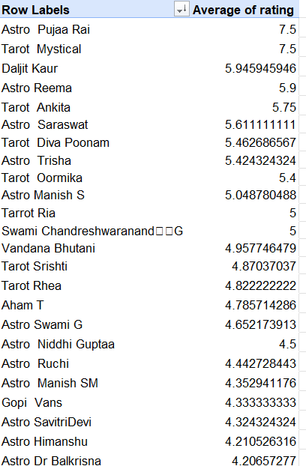
Approach –
Created a pivot table -
- Rows – Guru Name
- Values – Average rating for each Guru
The Gurus are divided into 3 groups categorized by their average rating
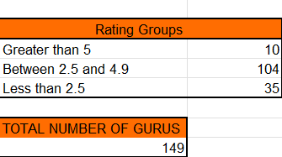
- Group 1 – Rating greater than 5 - High Performer
- Group 2 – rating between 2.5 and 4.9 – Average
- Group 3 – rating less than 2.5 – Poor
- The count of Gurus in each category shows the customer satisfaction rate against each guru.
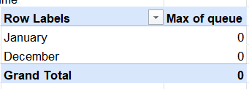
- pivot table using queues as values and months as rows
- I wanted to check If customers are facing any queues for any particular month. If there was any queue, further analysis could be done to understand investments need to be done for more agents or not.
- As seen in the pivot table, the customer faced on Queues for consulation in any of the months. Hence there is no need to Invest to hire more agents currently.

-------------------------------------------------------------------------------
Observation –
Group 1 – Rating greater than or equal to 5
Only 10 out of the 149 gurus have consistently delivered high-quality consultations, as reflected in their high customer ratings. This indicates that a significant proportion of gurus are not meeting the expected market standards for service quality. The findings highlight a clear quality gap within the workforce, which can be addressed through targeted training, skill development initiatives, and continuous performance monitoring to improve the overall standard of customer consultations.

Group 2 – rating between 2.5 and less than 5
A total of 104 out of 149 gurus fall into the average-rated category, making it the largest segment of the workforce. This presents a significant opportunity for improvement, as enhancing the skills and knowledge of this group can have a substantial impact on overall service quality. Investing in targeted training, upskilling initiatives, and content improvement programs should be a priority to help these gurus deliver higher-quality consultations and achieve better customer satisfaction.

Group 3 - Rating less than 2.5
A large group of 30 Agents are performing very low with less than 2.5 rating from customers on a average. This also shows heavy investments in training programs are needed.
Suggestions –
- Invesments are needed to provide free conselling sessions to users to consult Average rated, low rated and new Gurus if any for training purposes.
- The highly rated gurus must be used to provide training to other gurus to improve their conselling skills.
Conclusions –
- Small number of highly rated gurus
- Maximum number of gurus come under average rating category
- Too many low rated gurus
- There is no evidence that more gurus needs to be hired to improve customer satisfaction or improve revenue.
- Hiring Process can only be started if there is a massive surge seen in the queue column in a later date.
Final Suggestion –
Investments need not be made to hire more Gurus instead more focus needs to be made to improve Training and better distribution of tasks.
Improve training – Analysis
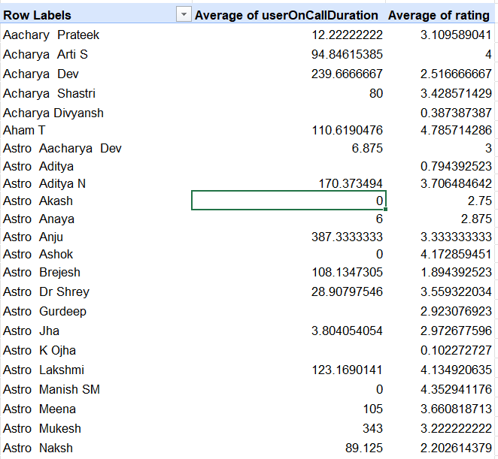
This Table shows the efficiency of each guru for achieving their respective rating and finding the best possible time taken to get the best results which are achieved by highly rated Gurus. This best case of time taken will be taken as baseline to improve low or average rated individuals.

Approach and Observations–
- Created a pivot table with GURU NAME as rows and average call duration and their average rating in values
- I divided the table in 3 parts using sort by call duration
- Part 1 – Sorted Descending in order of call duration
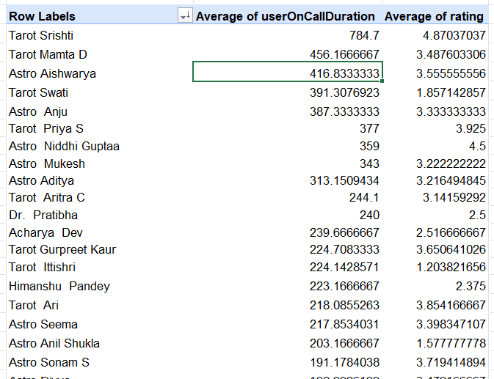
- This table shows that even after having long consultation hours the rating received is less than 5 which is either average or low rating.
- This denotes High inefficiency and a need for training program to focus on Call structuring
- Part 2 – Sorting Ascending in order of call duration
- 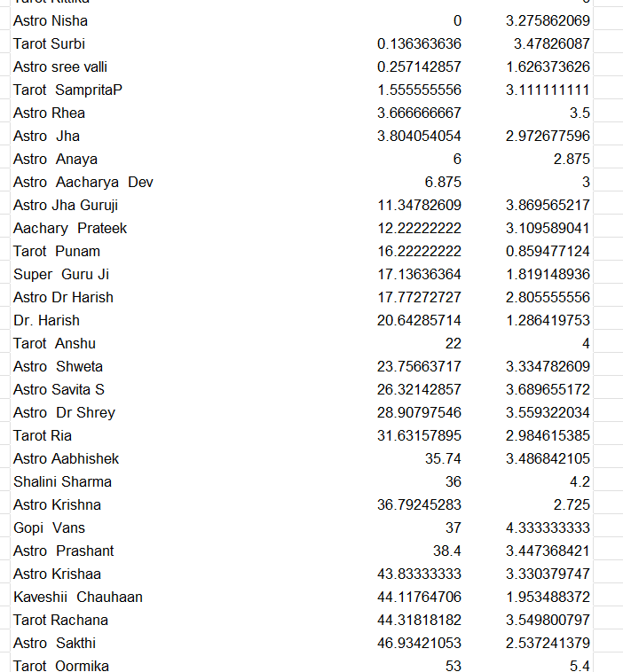
- This table shows low call duration with (0-40) mins and received average rating or below.
- This Gurus need to be focused on communication improvement and customer engagement through training programs.
Part 3 – Average on call duration
- I select Guru name with average rating greater than 3.5 and duration between (40-140 mins)
- This include Gurus like Astro Arti S, Shalini Sharma, Tarot Monika, Tarot Swati these gurus can become a good set of mentors to train gurus with wither very high on call duration or very low on call duration.
Suggestion-
- Gurus with high on call duration but low rating should be focus more on Call structuring and efficiency
- Gurus with low on call duration and low ratings should be focused more on customer engagement and communication through Training Programmes
- Gurus with average call duration between 40 – 140 mins and high rating can become a very good group of mentors to train the ones with lower efficiency.
- The call Centre can limit the time for call duration and set a baseline for minimum call duration by investing in technology which will help train low rated gurus.
- Structure Call Templets needs to be introduced to ensure efficiency on call and chat
- Monthly monitoring needs to be done
- listing top performers and bottom performers should be done on a monthly basis to identify which gur’s still need help or improvements.
Upgrade call center technology
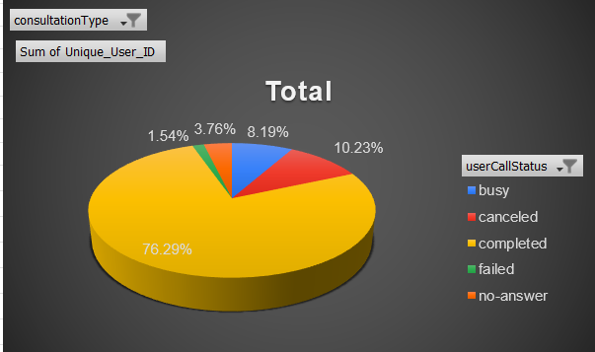
This chart represents % of overall call status –
Approach –
- A pivot table was created with rows – usercall status, values – perctange of unique user id to total and filter as consultation type – call
- On the basis of this data I created this pie chart representing the relative percentages for each call status.
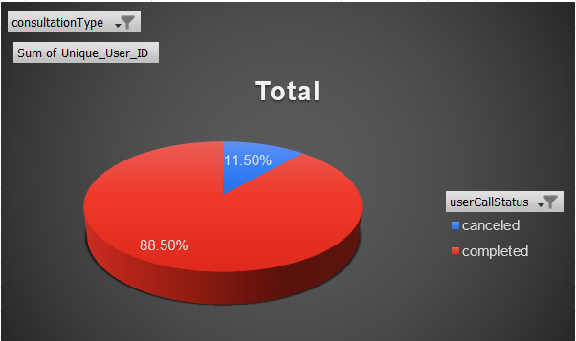
- The same pie chart was found for chat as well using the filter 🡪 change to chat.
Observation –
- The total failed count = failed + cancelled = 8.19%+1.54% = 9.73%
- Hence Almost 10% of all call failed to connect due to either lack of call infrastructure or network issue.
- Same goes for Chat options the total failed is around 11.5% due to lack of infrastruce and network issues.
Solution –
- Investments are needed to improve call and chat infrastructure to void loss of customer through technical issue.
- There are a few other consultation types like complementary which is not in use properly.
- Investments are needed to provide complimentary services to customer to improve customer interaction with the website and would also increase customer footfall. These complimentary services would also help train newly joined or gurus with low rating.
- Load Analytics: Conduct time-based audits to pinpoint recurring failure windows and peak-usage patterns.
- Scalable Architecture: Proactively upgrade system capacity to ensure seamless performance during high-traffic intervals.
- Operational Dashboards: Deploy live monitoring tools to track critical KPIs, including call volume, drop rates, and latency fluctuations.
- Incident Response: Utilize real-time data to trigger immediate technical interventions before performance degrades.
2.What are the potential risks of each investment option (hiring, training, technology upgrades), and how can they be mitigated?
A. Hiring More People
The Goal: We have about 250 calls a day but only 131 experts (gurus) to answer them. We need more people to help.
- The Risks:
  - Paying for nothing: If calls suddenly drop, we might have too many staff sitting around doing nothing.
  - High costs: New staff mean more salaries and training bills.
  - Popularity issues: Customers might only want to talk to "Highly Rated" experts, leaving the new ones with no work.
- The Fix:
  - Hire slowly: Don't hire everyone at once. Hire in small groups as the demand grows.
  - Use data: Look at when calls are busiest so we know exactly when we need more staff.
  - Fair sharing: Use a computer system to share calls equally among all experts.

B. Training Programs
The Goal: We want to improve customer ratings. Right now, over 72% of users are unhappy (giving ratings of 0–4), while only 27% are happy (giving 5–8).
- The Risks:
  - Wrong focus: Training won't help if the problem is actually a broken phone system and not the expert's fault.
  - Time away from work: If experts are in training, they aren't on the phones helping customers.
  - Wasted money: Spending a lot on training might not actually improve the ratings.
- The Fix:
  - Help those who need it: Only train the experts who have low ratings first.
  - Short lessons: Use "micro-training" (very short lessons) so experts don't have to stop working for long.
  - Buddy system: Have the best experts teach the newer ones.

C. Better Technology
The Goal: Right now, only 85% of calls are actually getting through. The system (Exotel) is failing too often.
- The Risks:
  - Expensive: Buying new software or hardware costs a lot of money.
  - Hard to set up: Connecting new tech to our old system is difficult.
  - System downtime: The phones might go offline while we are switching systems.
- The Fix:
  - Have a backup: Use two different phone services so if one breaks, the other still works.
  - Add Chatbots: Let computers handle the easy questions so the human experts have less work.
  - Step-by-step: Don't change everything at once. Fix the parts of the system that break the most first.
3 . How does AstroSage's call center performance compare to AstroGuru's average call volume, customer satisfaction, and agent performance?
Will you use any aggregation function or a visualization here to solve the problem?
Introduction to AstroGuru-
AstroGuru has successfully carved out a niche as an ultra-premium, high-stakes astrology consultancy. By shifting away from the "call center" model and moving toward a "private counsel" framework, the firm caters to a highly exclusive clientele that values depth over speed.

Average Call Volume.
AstroGuru-
Customer Base & Exclusivity
With a strictly curated total customer base of 5,000 active members, AstroGuru serves high-net-worth individuals, corporate leaders, and public figures. The service is designed for those who require intense, long-form strategic planning rather than quick daily horoscopes.
Operational Efficiency: The Power of One
To maintain absolute mental clarity and spiritual focus, AstroGuru has implemented a "Monastic Workflow" for its consultants:
- Average Calls Per Day Per Agent: 1
- Rationale: Each agent dedicates their entire day to a single client’s chart, ensuring that the 60–90 minute consultation is backed by hours of deep preparation and meditative analysis.
AstroSage –
- Total calls received: 8,508
- Total days: 34
- Number of Astro Gurus: 131
- Average daily call volume:
$$8508÷34=250.23=250calls/day$$
- Average calls handled per guru per day:
$$\left(8508÷131\right)÷34=1.92=2$$
Astrosage VS AstroguruAstrosage – focuses on general public yet the average number of call per day per guru is equal to 2 . But Astro Guru focuses on premium members only with high net worth and the average number of calls per Guru per day =1.
Here AstroSage’s average call volume is too low taking into account that it focuses on the mass public instead of segregation of public groups.
This issue occurs not due to lack of agents but due to uneven distribution of work. This is clear from the follow pivot Table created with rows – GURU NAME and Values- count of calls ID sorted in descending order of calls ID.
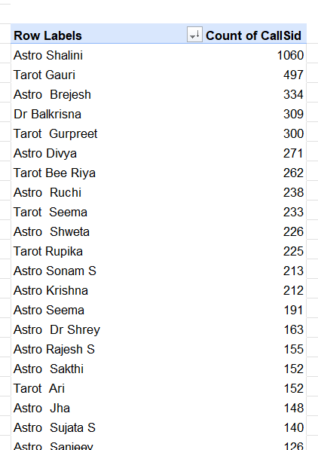
Here it shows the first few gurus have taken a huge number of calls while the Gurus at the bottom of the list have taken between 0-5 calls for 2 months

Customer satisfaction
AstroGuru-
Ratings are captured on an expanded 7.5-point scale to allow for more nuanced feedback. Despite the rigorous scale, satisfaction remains exceptionally high due to the personalized nature of the service.
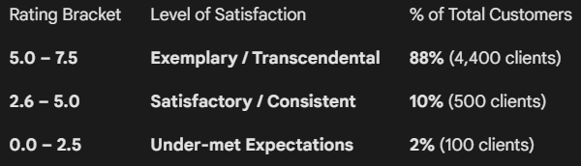
AstroSage-
- Average rating across Call sessions: 3.50
- Rating distribution:
  - 0–4 ratings: 20,323 users (72.51%)
  - 5–8 ratings: 7,704 users (27.4%)
AstroSage Vs AstroGuru
Astroguru heavily focuses on providing excellent quality consultation. Here most of the clients around 88% has rated above 5 while only 2% of the clients rated below average. This shows the difference between the quality of services provided between the two firms. Astrosage need to invest heavily in its training programs to stay relevant to the market.

Agent Performance
Astro Guru
With a roster of 250 elite Gurus, the performance distribution reflects a culture of excellence where only the most accurate practitioners are retained.
- The Pinnacle (Maximum Rating):
  - Rating: 7.5 / 7.5
  - Volume: 15 Gurus have achieved this perfect score, representing the "Grandmasters" of the firm who maintain a 100% accuracy and empathy record.
- The Gold Standard (Average Rating):
  - Rating: 6.8 / 7.5
  - Volume: 220 Gurus fall into this high-performing bracket, serving as the backbone of the consultancy’s premium reputation.
- The Development Tier (Low Rating):
  - Rating: 4.2 / 7.5 (Note: Even "low" ratings at AstroGuru are mathematically above the midpoint of the scale).
  - Volume: 15 Gurus currently sit in this tier and are undergoing advanced peer-review to align with the firm's elite standards.
AstroSage VS AstroGuru
AstroGuru distinguishes itself through a rigorous selection process, onboarding only highly experienced and verified premium astrologers. This "quality-over-quantity" approach results in:
- Consistent Performance: Expert-level service across all consultations.
- Metric Stability: Minimal variation in ratings, ensuring a reliable client experience.

Competitive Comparison
- AstroGuru: Leads with superior, uniform agent quality and elite professional standards.
- AstroSage: Exhibits high performance variance; requires significant workforce training to bridge the quality gap.
4.How can the call center improve its handling of peak call periods to ensure high customer satisfaction?
Approach – To find the time at which the call was made and to represent data in particular time blocks, a new column called “TIME”was made.
This uses hour function to extract time from timestamp created At column and group in in different time slots with 3 hours intervals.
{0,3,6,9,12,15,18,21} – represents the starting hour for each time block of 3 hours.
The match function is used to match these starting time blocks finding exact match or just the lower value.
Finally these time blocks are named using the choose function from "12 AM – 2 AM","3 AM – 5 AM","6 AM – 8 AM","9 AM – 11 AM","12 PM – 2 PM","3 PM – 5 PM","6 PM – 8 PM","9 PM – 11 PM" matching with the required time block
Hence the formula used for TIME column is
=CHOOSE(
MATCH(HOUR(R2),
{0,3,6,9,12,15,18,21},1),
"12 AM – 2 AM","3 AM – 5 AM","6 AM – 8 AM","9 AM – 11 AM","12 PM – 2 PM","3 PM – 5 PM","6 PM – 8 PM","9 PM – 11 PM")
Where R2 is the timestamp cells for created_At column.
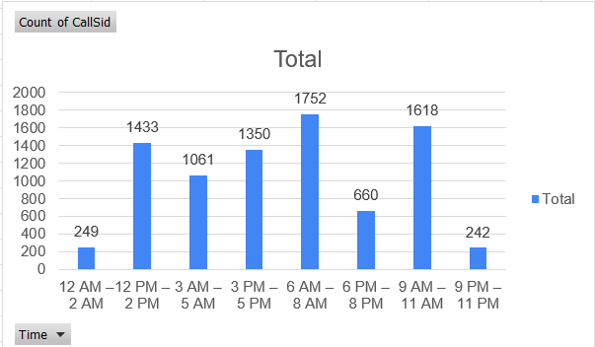
A pivot Table was made with –
Rows – TIME (Newlly formed as explained above)
Values – count of calls id
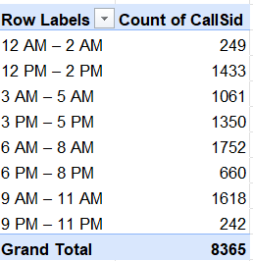
Suggestions –
1. Add More Staff During Busy Hours
Most calls happen in four main waves between 6 AM and 5 PM. To keep customers happy and to reduce missed calls, we should schedule more astrologers to work during these specific times:
- 6 AM – 8 AM: Highest volume (1,752 calls)
- 9 AM – 11 AM: High volume (1,618 calls)
- 12 PM – 2 PM: Moderate-high (1,433 calls)
- 3 PM – 5 PM: Moderate-high (1,350 calls)
2. Improve Call Routing
To manage heavy traffic, we should:
- Prioritize peak times: Focus resources on time slots with over 1,300 calls.
- Balance the load: Share incoming calls equally among all active astrologers so no one is overwhelmed while others are idle.
3. Manage the Wait Time
When the system is busy (6 AM – 5 PM), we should give users better options to avoid frustration:
- Show them how long they will have to wait.
- Offer a "call-back" feature so they don't have to stay on hold.
- Suggest switching to chat if the phone lines are too backed up.
4. Focus on "Smart" Staffing
We don’t need to add more staff for the entire day. Instead, we should only increase the number of astrologers or extend shifts during the four peak windows listed above. This handles the bulk of our 8,365 daily calls without wasting money on quiet hours.
5. Use Chatbots to Filter Calls
During the busiest hours, use a chatbot to handle the first step of the conversation. The bot can:
- Collect basic user info.
- Find out what the user needs help with.
- Send them to the right astrologer immediately. This saves time for the astrologers and gets the user help faster.
5.Based on historical data, what strategic initiatives should be prioritized to improve efficiency and customer satisfaction?
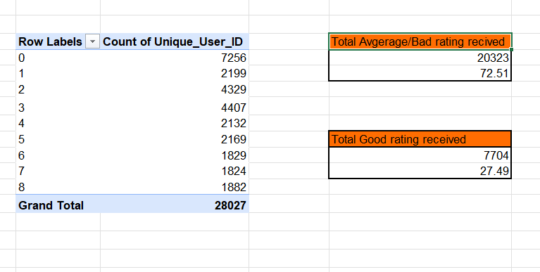
This pivot table shows the number of people and their ratings
STRATEGY 1 — Training Programs and Improving customer satisfaction
Customer Satisfaction
- Total Users = 28,027
- Satisfied Users (Ratings 5, 6, 7, 8)
= 2,169 + 1,829 + 1,824 + 1,882
= 7,704 users
*Satisfied % = (7704 / 28027)100 = 27.49%
- Unsatisfied Users (Ratings 0,1,2,3,4)
= 7,256 + 2,199 + 4,329 + 4,407 + 2,132
= 20,323 users
Unsatisfied % = 72.51%
1. Targeted Training to Reduce Dissatisfaction
With 72.51% of users providing ratings between 0 and 4, there is a clear need for a structured "Guru Training Program." To directly reduce this high-dissatisfaction cluster, training should prioritize:
- Consultation Clarity: Ensuring guidance is easy to understand.
- Prediction Accuracy: Enhancing the reliability of insights provided.
- Empathy & Communication: Building better rapport and emotional connection.
- Time Management: Eliminating the perception of rushed or dismissive conversations.
2. Converting Neutral Users into Promoters
The segment of 7,704 users who rated the service between 5 and 8 represents a significant growth opportunity. These users are not yet fully satisfied but are receptive to the service. Refined training for this group should focus on the "extra mile" service elements required to turn these lukewarm experiences into loyal, high-rating endorsements.

3. Critical Analysis of "Rating 0" (7,256 Users)
The "Rating 0" category is the largest and most concerning segment. Ratings of zero typically stem from fundamental failures rather than subjective dissatisfaction. We must conduct an immediate quality audit to investigate:
- Technical Stability: Call drops and platform connectivity issues.
- Operational Reliability: Instances of "no-answer" or unavailable experts.
- Severe Quality Lapses: Identifying outlier cases of extremely poor service.
Addressing these root causes is essential to prevent the disproportionate inflation of dissatisfaction metrics.
4. Distinguishing Service Quality from Technical Issues
The 8,736 users who provided ratings of 2 or 3 indicate issues with service delivery rather than technical performance. Feedback in this range suggests:
- A lack of confidence in the expert’s depth of knowledge.
- Dissatisfaction with the specific advice or solutions provided.
- A feeling that the session did not offer tangible value.
Because these users are engaging with the platform (unlike the "Rating 0" group), they are highly recoverable through enhanced expert communication training and deeper knowledge-sharing standards.
Strategy 2 – Improving staff availability during peak hours
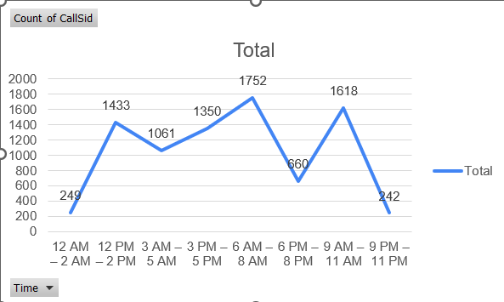
1. Staffing Optimization for Peak Demand
Insight
The data identifies a significant concentration of activity between 6 AM and 5 PM. Specifically, the morning (6 AM–11 AM) and afternoon (12 PM–5 PM) blocks account for 6,153 calls, representing approximately 68% of the total volume (8,365 calls).
Recommendation
To improve service quality, we should increase the number of active experts during these 11-hour peak windows. Aligning shift schedules to ensure maximum availability from 6 AM to 5 PM will help reduce wait times, lower call abandonment rates, and minimize incomplete consultations.

2. Strategic Reduction During Low-Traffic Periods
Insight
Call activity reaches its lowest point during the late-night and pre-dawn hours. The periods between 9 PM–11 PM and 12 AM–2 AM contribute less than 6% of total daily traffic, with fewer than 250 calls per block.
Recommendation
We recommend maintaining only minimal essential staffing during these off-peak hours. By redistributing personnel from these low-traffic periods to high-demand slots, we can maximize operational efficiency and expert utilization without increasing overall costs.
6.What can be the key factors contributing to high customer satisfaction scores, and how can these be leveraged to improve overall performance?
What is the basis for the suggestions? And mention how you decided if the satisfaction score affects the ratings.
Relation between customer satisfaction and call status
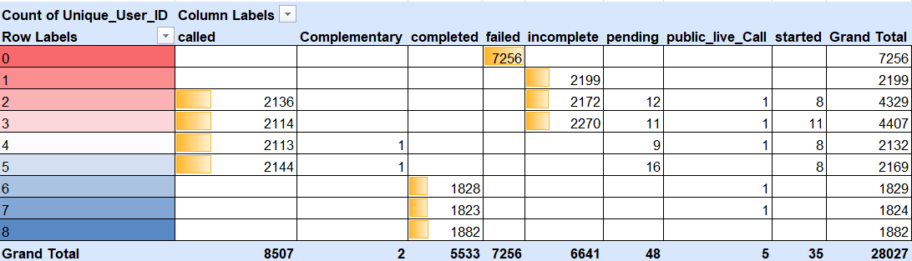
Approach –
Pivot table was made with ratings as rows, call status as columns and count of unique callers as values.
This Table was made to find out how the call status affects the customer satisfaction.
- For Failed and incomplete- The customer satisfaction rating is at their lowest. Even if the Agent had good knowledge and provided good conselling sessions, calls resulting in incomplete status and failed due to technical difficulties add to the frustration of the customers hence has such a low rating.
Suggestion – Heavy Investments in call center infrastructure.
- The point that the rating is very high for all completed calls shows the importance of improving infrastruce. From here I came to the conclusion that improving call center infrastructure is more important than training gurus.
Relation between Type of Platform and rating
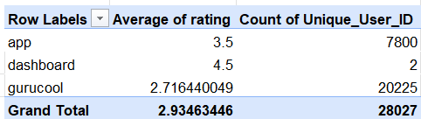
The rating vary immensely across different platforms as shown above.
Observation:
Technical issues, slower response times, and UI/UX limitations on Gurucool directly reduce user satisfaction. Most of the customer base is in GURUCOOL only hence heavy investments needs to be done on infrastructure to improve stability to improve customer rating.Higher ratings from the dashboard indicate that when the interface is stable and intuitive, customers rate the service more positively. The call centre must advertise to switch to dashboard due to its stability.
Impact on Ratings:
A user interacting through a low-performing platform is likely to give a lower rating—even if the guru performs well—because the overall experience feels frustrating.
Relation between Call Duration and peak hour traffic and rating
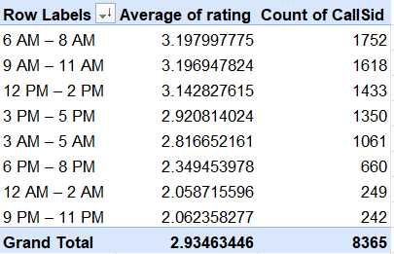
From the table it is clear that maximum number of calls are received between 6 AM and 5 PM
The Peak Hour Strain: The 6 AM–5 PM window accounts for the majority of call volume (60%+), resulting in slower response times compared to low-traffic hours.
The Connection to Ratings: Service quality drops during these surges; connection hurdles directly lead to lower user satisfaction scores.
7.How should the call center balance the workload among agents to ensure optimal performance and avoid burnout? Mention your approach and spreadsheet function for the answer.
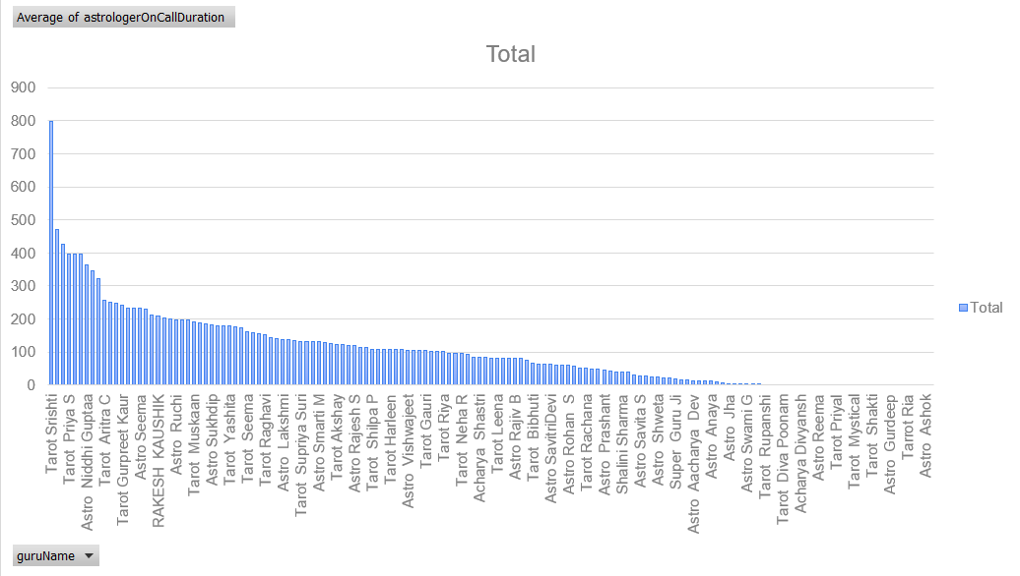
Approach –
A pivot table was with Unique Guru Name as rows and on call duration as values
An analysis of guru call durations reveals a significant disparity in workload distribution. While a small group of high-performers is at risk of burnout due to extreme session lengths, a large portion of the team remains underutilized.
1. Key Data Observations
The team currently falls into three distinct categories based on Average Call Duration:
- The Overloaded Group (>250 mins): Led by Tarot Srishti (784.7 min) and Tarot Mamta D (456.16 min). These gurus handle deep, complex cases that require high emotional labor, putting them at high risk for fatigue and errors.
- The Underutilized Group (0–20 mins): Several gurus, including Astro Akash and Tarot Rupanshi, show near-zero engagement. This represents "lost capacity"—available talent that isn't being used.
- The Stable Group (60–150 mins): These gurus maintain a moderate pace but show variations in efficiency that suggest different levels of experience or query types.

2. The Risks of Imbalance
- Burnout: Top-tier gurus may experience declining performance and health issues due to sustained high-intensity sessions.
- Inefficiency: High-duration sessions (e.g., 700+ minutes) suggest a lack of structure or "timeboxing," which limits the number of users served.
- Inconsistent Service: Users experience widely different consultation styles and wait times depending on which guru they are routed to.
3. Recommended Strategic Shifts
To optimize our operations, we should move from a random assignment model to a Duration-Based Routing model.
Goal | Action
Balance Load | Re-route complex cases from overloaded gurus to those in the "Stable" zone.
Increase Capacity | Implement upskilling programs for underutilized gurus to handle more complex queries.
Standardize Quality | Introduce session templates and time-management coaching for gurus with excessively long durations.
Pre-Call Efficiency | Use automated bots to collect basic user data (birth details, query type) before the guru connects, saving valuable consultation time.

Gemini said
This is a solid analysis. You’ve successfully identified the "bottleneck" effect where a few experts are carrying the brunt of the workload while others remain idle.
Below is a reframed version of your findings. I’ve streamlined the language to be more professional and "boardroom-ready"—keeping it simple, direct, and actionable.

Executive Summary: Workload Imbalance Analysis
An analysis of guru call durations reveals a significant disparity in workload distribution. While a small group of high-performers is at risk of burnout due to extreme session lengths, a large portion of the team remains underutilized.
1. Key Data Observations
The team currently falls into three distinct categories based on Average Call Duration:
- The Overloaded Group (>250 mins): Led by Tarot Srishti (784.7 min) and Tarot Mamta D (456.16 min). These gurus handle deep, complex cases that require high emotional labor, putting them at high risk for fatigue and errors.
- The Underutilized Group (0–20 mins): Several gurus, including Astro Akash and Tarot Rupanshi, show near-zero engagement. This represents "lost capacity"—available talent that isn't being used.
- The Stable Group (60–150 mins): These gurus maintain a moderate pace but show variations in efficiency that suggest different levels of experience or query types.

2. The Risks of Imbalance
- Burnout: Top-tier gurus may experience declining performance and health issues due to sustained high-intensity sessions.
- Inefficiency: High-duration sessions (e.g., 700+ minutes) suggest a lack of structure or "timeboxing," which limits the number of users served.
- Inconsistent Service: Users experience widely different consultation styles and wait times depending on which guru they are routed to.

3. Recommended Strategic Shifts
To optimize our operations, we should move from a random assignment model to a Duration-Based Routing model.
Goal | Action
Balance Load | Re-route complex cases from overloaded gurus to those in the "Stable" zone.
Increase Capacity | Implement upskilling programs for underutilized gurus to handle more complex queries.
Standardize Quality | Introduce session templates and time-management coaching for gurus with excessively long durations.
Pre-Call Efficiency | Use automated bots to collect basic user data (birth details, query type) before the guru connects, saving valuable consultation time.

4. Implementation Action Plan
- Classification: Segment the workforce weekly into Overloaded, Stable, and Underutilized categories.
- Smart Routing: Adjust the call flow so that high-duration gurus receive fewer "new" leads until their average stabilizes.
- Training: Launch "Session Structure" workshops to help gurus maintain boundaries and clarity without overextending call times.
- Monitoring: Deploy a real-time dashboard tracking Average Duration vs. Total Calls to allow supervisors to intervene before burnout occurs.
8. What new technologies or tools could be implemented to enhance call center operations and customer service?
1. AI-Driven First-Level Support
Deploying intelligent chatbots and virtual assistants allows for the immediate resolution of routine inquiries. By automating basic troubleshooting and appointment scheduling, these tools reduce wait times and free up human agents to handle more complex issues.
2. Machine Learning-Based Call Routing
Intelligent routing systems analyse customer history, sentiment, and query types to match callers with the best-suited agent. This data-driven approach minimizes transfers, improves first-call resolution, and enhances the overall customer experience.
3. Real-Time Voice and Sentiment Analytics
Advanced voice tools monitor live conversations to detect signs of customer frustration or stress. This enables supervisors to intervene when necessary and provides agents with immediate feedback on their tone and empathy.
4. Predictive Workforce Management (WFM)
Modern WFM software uses historical data to forecast call volumes and optimize staff scheduling. By balancing workloads effectively, these tools prevent agent burnout and ensure consistent coverage during peak hours.
5. RPA for Back-Office Automation
Robotic Process Automation (RPA) handles repetitive administrative tasks—such as CRM updates, ticket creation, and follow-up emails—with high precision. Automating these workflows reduces manual error and allows agents to focus entirely on the customer.
6. Integrated Omnichannel Platforms
A unified communication platform consolidates interactions from chat, email, social media, and phone into a single dashboard. This provides agents with a complete view of the customer’s journey, ensuring seamless continuity and faster resolutions.
7. Automated Quality Assurance (QA) Monitoring
AI-powered QA tools evaluate every interaction based on professionalism, script adherence, and accuracy. Automated scoring gives managers instant visibility into performance trends, making it easier to identify specific training needs and maintain high service standards.

9. What metrics should be included in the final dashboard to comprehensively view call center performance and guide investment decisions?

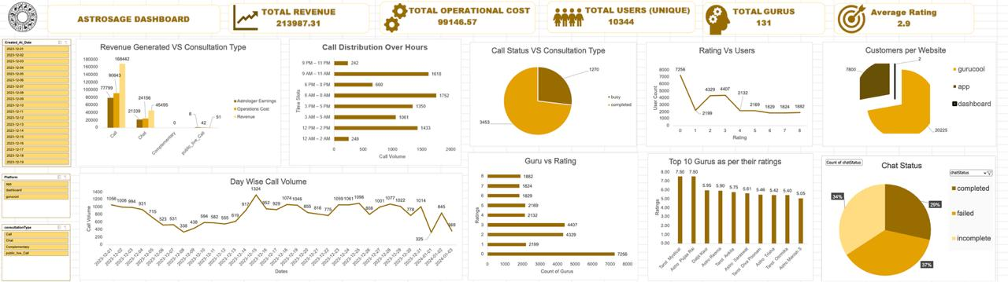

A. Key Performance Indicators (KPIs)
- Total Number of Users – Total number of unique users
- Total Number of AstroGurus – available workforce capacity.
- Operational Cost – difference between Net Revenue and Guru Earnings.
- Total Revenue Generated – complete revenue collection from all consultation types.
- Average Rating – The net average rating given by users. This suggests the overall customer satisfaction for the services provided.
B. Dashboard-Level Summary Metrics
- Total Users
- Total Revenue
- Total Guru Earnings
- Operational Cost (Separate Block)
- Daywise Consultation Count
- Consultation Rate Tracking
- Chat Status Distribution
- Consultation Type Overview (Call, Chat, Complimentary, etc.)
- Source Type Analysis (App, Gurukul, Dashboard)
- Hourly Tracking (Time vs User)
C. Visuals & Charts Used in the Dashboard
- Line chat – Shows the daily call volume
- Column chart – Top 10 gurus as per their average ratings.
- Line chart – of rating against number of users.
- Pie chart for consultation status – (busy, completed,failed, incomplete, no answer)
- Stacked column chart for different amounts against different consultation types
- Row chart – Call volumne segregated and grouped by hours.
D. Dashboard Interactivity & Filters
- Slicer for Consultation Type connected across all charts (Call, Chat, Complimentary, Public Live Call).
- Slicer for month Segment enabling time-based filtering across visuals.
- Dynamic interactions allowing users to focus on specific consultation types, time blocks, or guru performance.

10. How would you allocate a 1 crore rupee investment to optimize operational
efficiency, enhance customer satisfaction, and boost profitability, and what
analysis-based recommendations would you offer to support this?
[you have to give bullet pointers to answer this question]
The objective of this allocation is to resolve a 49.18% call failure rate and an 84% chat abandonment rate, converting massive latent demand into realized revenue.
Category | Allocation | Primary Objective
Technology & Automation | ₹40 Lakhs (40%) | Stabilize infrastructure and automate lead triage.
Hiring & Optimization | ₹15 Lakhs (15%) | Scale capacity to match peak-hour demand.
Training & Quality | ₹35 Lakhs (35%) | Improve the 72.5% low-satisfaction rating (0–4).
CX & Retention | ₹10 Lakhs (10%) | Reduce churn and recover dissatisfied users.

1. Technology & Automation (₹40L)
Data Insight: Only 50.8% of calls and 16% of chats are currently completed.
- Hybrid Telephony: Implement a primary (Exotel) + backup provider to eliminate "Busy/Failed" statuses. A 10–15% lift in completion directly impacts the 79% of revenue derived from calls.
- Smart Routing & CRM: Centralize user history and real-time dashboards to manage "No-Answer" spikes during shift changes.
- AI Triage: Deploy chatbots to handle basic FAQs and pre-consultation data, reducing the 15,784 "N/A" chat instances.
- Auto-Callbacks: Automated SMS/WhatsApp triggers for canceled or missed sessions to recapture lost intent.
2. Hiring & Workforce Optimization (₹15L)
Data Insight: 131 gurus average only 2 calls/day, yet completion rates remain low, indicating a supply-demand mismatch.
- Peak-Hour Scaling: Use historical data (6–11 AM and 12–5 PM) to ensure high-performing Guru availability during surges.
- Specialized Recruitment: Hire experienced "AstroGurus" for complex queries to reduce the burden on top-tier talent.
- Dedicated Chat Force: Assign a "Chat-First" squad to monetize the high-volume, underutilized chat channel.
3. Training & Performance Management (₹35L)
Data Insight: 72.5% of ratings fall between 0–4; better service correlates directly (0.995) to higher earnings.
- Targeted Upskilling: Identify high-volume/low-rating gurus for empathy and communication coaching.
- Peer Mentorship: Utilize top earners (e.g., "Astro Krishna") to create internal "Best Practice" playbooks.
- Feedback Loops: Implement quality audits of recorded sessions to convert 0–4 ratings into 5–8 satisfaction scores.
4. CX & Retention Initiatives (₹10L)
Data Insight: High churn risk due to unfinished interactions and low initial satisfaction.
- User Reactivation: Targeted outreach and "Senior Guru" vouchers for users who provided 0–2 star ratings.
- Loyalty Framework: Launch priority scheduling and membership tiers to increase Lifetime Value (LTV).
- Public Trust: Weekly live "Free Prediction" sessions to showcase expert quality and drive organic acquisition.

Success Metrics & Governance
- Primary KPI: Lift Call Completion from 50.8% to 70%+.
- Secondary KPI: Reduce Chat "N/A" rate from 84% to <45%.
- Quality Goal: Increase high-satisfaction ratings (5–8) to >50% of total volume.

Thank You

