Documentation Translate API

Step 1: Create Google Cloud Project

Step 2: Enabling API

Step 3: Create project asp.core MVC

Step 4: Installing client libraries

Google.Cloud.Translation.V2

Step 5: Set up authencation and create variable enviroment.

Set up project:

Reference: <https://cloud.google.com/translate/docs/setup>

Guid library:

Reference: <https://cloud.google.com/dotnet/docs/reference/Google.Cloud.Translation.V2/latest#installation>

**Configuration to rest API**

Language list.

 Afrikaans = "af";

 Amharic = "am";

 Arabic = "ar";

 Azerbaijani = "az";

 Belarusian = "be";

 Bulgarian = "bg";

 Bengali = "bn";

 Bosnian = "bs";

 Catalan = "ca";

 Cebuano = "ceb";

 Corsican = "co";

 Czech = "cs";

 Welsh = "cy";

 Danish = "da";

 German = "de";

 Greek = "el";

 English = "en";

 Esperanto = "eo";

 Spanish = "es";

 Estonian = "et";

 Basque = "eu";

 Persian = "fa";

 Finnish = "fi";

 French = "fr";

 Frisian = "fy";

 Irish = "ga";

 ScotsGaelic = "gd";

 Galician = "gl";

 Gujarati = "gu";

 Hausa = "ha";

 Hawaiian = "haw";

 Hindi = "hi";

 Hmong = "hmn";

 Croatian = "hr";

 HaitianCreole = "ht";

 Hungarian = "hu";

 Armenian = "hy";

 Indonesian = "id";

 Igbo = "ig";

 Icelandic = "is";

 Italian = "it";

 Hebrew = "iw";

 Japanese = "ja";

 Javanese = "jw";

 Georgian = "ka";

 Kazakh = "kk";

 Khmer = "km";

 Kannada = "kn";

 Korean = "ko";

 KurdishKurmanji = "ku";

 Kyrgyz = "ky";

 Latin = "la";

 Luxembourgish = "lb";

 Lao = "lo";

 Lithuanian = "lt";

 Latvian = "lv";

 Malagasy = "mg";

 Maori = "mi";

 Macedonian = "mk";

 Malayalam = "ml";

 Mongolian = "mn";

 Marathi = "mr";

 Malay = "ms";

 Maltese = "mt";

 MyanmarBurmese = "my";

 Nepali = "ne";

 Dutch = "nl";

 Norwegian = "no";

 Chichewa = "ny";

 Punjabi = "pa";

 Polish = "pl";

 Pashto = "ps";

 Portuguese = "pt";

 Romanian = "ro";

 Russian = "ru";

 Sindhi = "sd";

 Sinhala = "si";

 Slovak = "sk";

 Slovenian = "sl";

 Samoan = "sm";

 Shona = "sn";

 Somali = "so";

 Albanian = "sq";

 Serbian = "sr";

 Sesotho = "st";

 Sundanese = "su";

 Swedish = "sv";

 Swahili = "sw";

 Tamil = "ta";

 Telugu = "te";

 Tajik = "tg";

 Thai = "th";

 Filipino = "tl";

 Turkish = "tr";

 Ukrainian = "uk";

 Urdu = "ur";

 Uzbek = "uz";

 Vietnamese = "vi";

 Xhosa = "xh";

 Yiddish = "yi";

 Yoruba = "yo";

 ChineseSimplified = "zh";

ChineseTraditional = "zh-TW";

Zulu = "zu";

Step 1: https://translation.googleapis.com/language/translate/v2

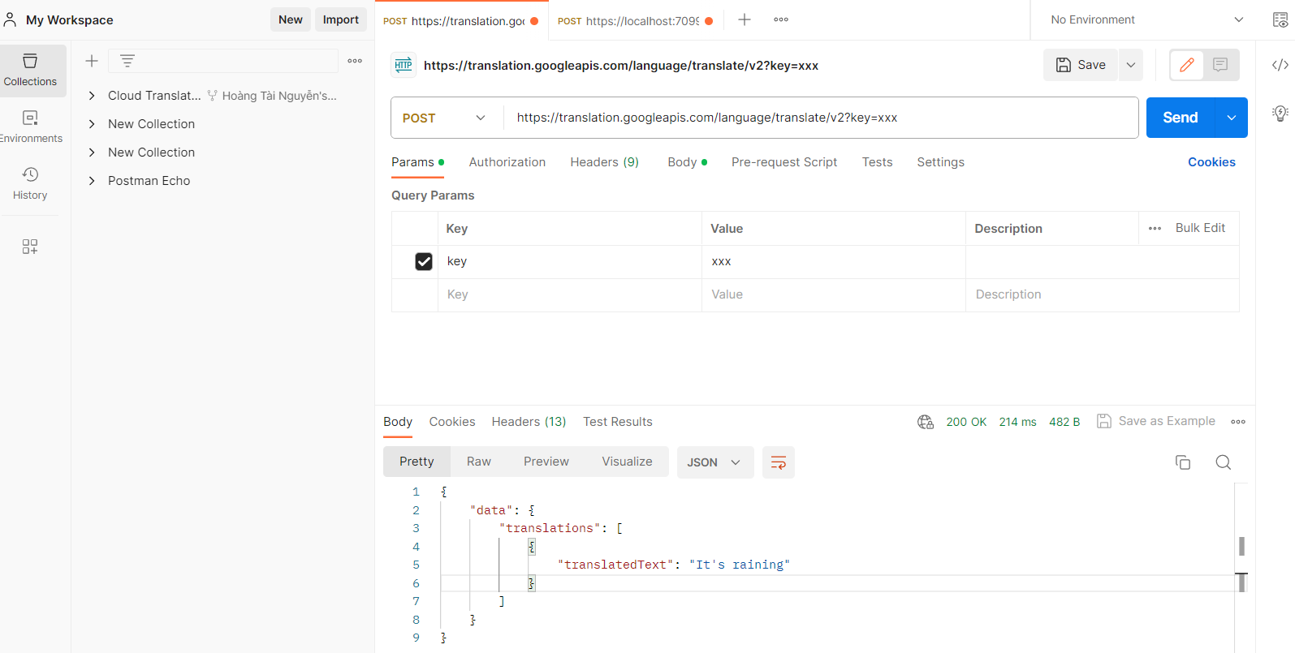

Step 2:

{

"key":"xxx",

"q": "Trời đang mưa",

  "source": "vi",

  "target": "en",

  "format": "text"

}

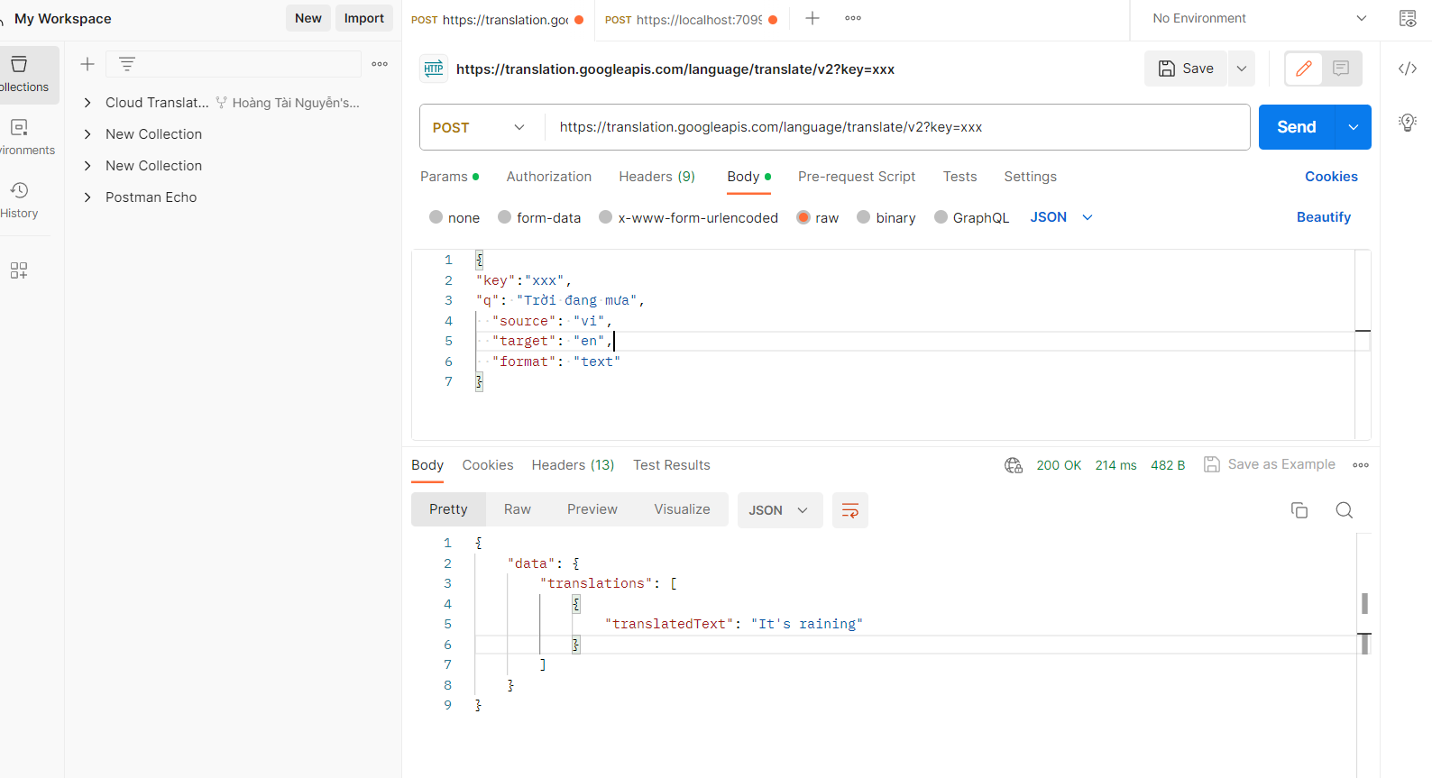

Reference: <https://cloud.google.com/translate/docs/reference/rest/v2/translate>

Reference: https://stackoverflow.com/questions/64478261/google-translate-api-authentication-postman