http://localhost:8080/hotels
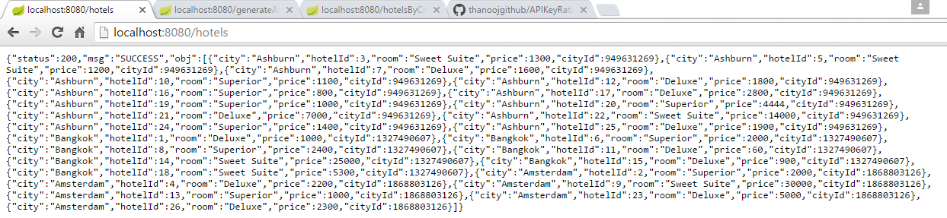
http://localhost:8080/generateAPIKey
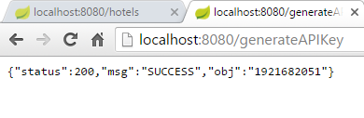
http://localhost:8080/hotelsByCityId/1921682051/949631269
