**SOAP and Restful**

**Agenda:**

* Basics Information of SOAP.
* SOAP message structure.
* Why SOAP?
* JAX-WS implementers?
* XSD in SOAP
* WSDL

GUI – SOAP with DB

GUI – REST with DB

Application to Application

**SOAP**, stands for **Simple Object Access Protocol**, is a [protocol](https://en.wikipedia.org/wiki/Protocol_(computing)) specification for exchanging **structured** information in the implementation of **JAX-WS API** [web services](https://en.wikipedia.org/wiki/Web_service).

* SOAP is platform independent
* SOAP is based on XML
* SOAP is a W3C recommendation

**SOAP** provides a way to communicate between applications running on different operating systems, with different technologies and programming languages.

The Java API for XML Web Services (JAX-WS), The JAX-WS 2.2 specification JSR 224.

**SOAP** recommend **Contract-first** Web Services Development Approach.

* XSD (types) and Operations creation in WSDL.

**SOAP** message structure contains:

|  |  |  |
| --- | --- | --- |
| **Element** | **Description** | **Required** |
| Envelope | Identifies the XML document as a SOAP message. Starting and ending | Yes |
| Header | Contains header information.  Inside the Header element you can put information that is not part of the body of a SOAP message. It could be information about the maximum time the SOAP request may take to process. | No |
| Body | Contains call, and response information. | Yes |
| Fault | Provides information about errors that occurred while processing the message.  The SOAP Fault element is returned inside the Body element from a web service (or intermediary node) in case an error occurs while processing the received SOAP message. | No |

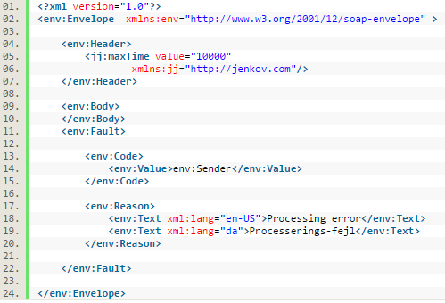

<https://www.w3.org/2003/05/soap-envelope/>

<https://www.w3.org/TR/soap/>

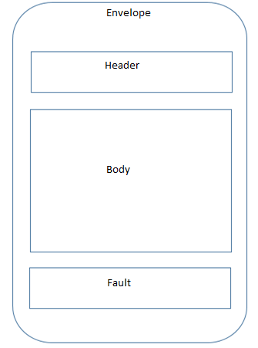

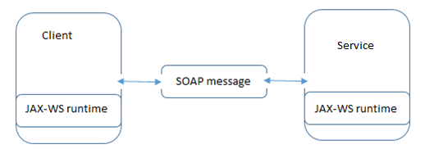

**SOAP** has three major characteristics:

* Extensibility (security)
* Neutrality (SOAP can operate over any transport protocol such as [HTTP](https://en.wikipedia.org/wiki/HTTP), [SMTP](https://en.wikipedia.org/wiki/SMTP), [TCP](https://en.wikipedia.org/wiki/Transmission_Control_Protocol), [UDP](https://en.wikipedia.org/wiki/SOAP-over-UDP), or [JMS](https://en.wikipedia.org/wiki/Java_Message_Service))
* Independence (SOAP allows for any [programming model](https://en.wikipedia.org/wiki/Programming_model)) – XML

E.g., Java Client can interact with .Net based Application.

* [JAX-WS in **RPC** Style](http://www.mkyong.com/webservices/jax-ws/jax-ws-hello-world-example/)(Not covering)
* [JAX-WS in **Document** Style](http://www.mkyong.com/webservices/jax-ws/jax-ws-hello-world-example-document-style/)

JAX-WS implementers:

* Apache Axis2(C++/Java)
* Apache CXF(SOAP/REST)
* Spring-WS

**XSD** (XML Schema Definition), check the validity of, structure and vocabulary of an XML document.

XSD is the Types element of a WSDL.

It is part of the WSDL specification <wsdl: types>

File extension is FileName.xsd

<http://schemas.xmlsoap.org/soap/envelope/>

<http://appfuse.org/rpc/soap-axis/confluenceservice-v1?wsdl>

