
BECAMEX BUSINESS SCHOOL

ASSIGNMENT 4
School Database SQL Practice Exercise

Course: MIS 443 - BUSINESS DATA MANAGEMENT
Lecturer: Mr. Dang Thai Doan

No. | Student’s Name | Student’s IRN
1 | Thân Quế Ngọc | 2232300060

Quarter 4, Academic Year 2025-2026

School Database
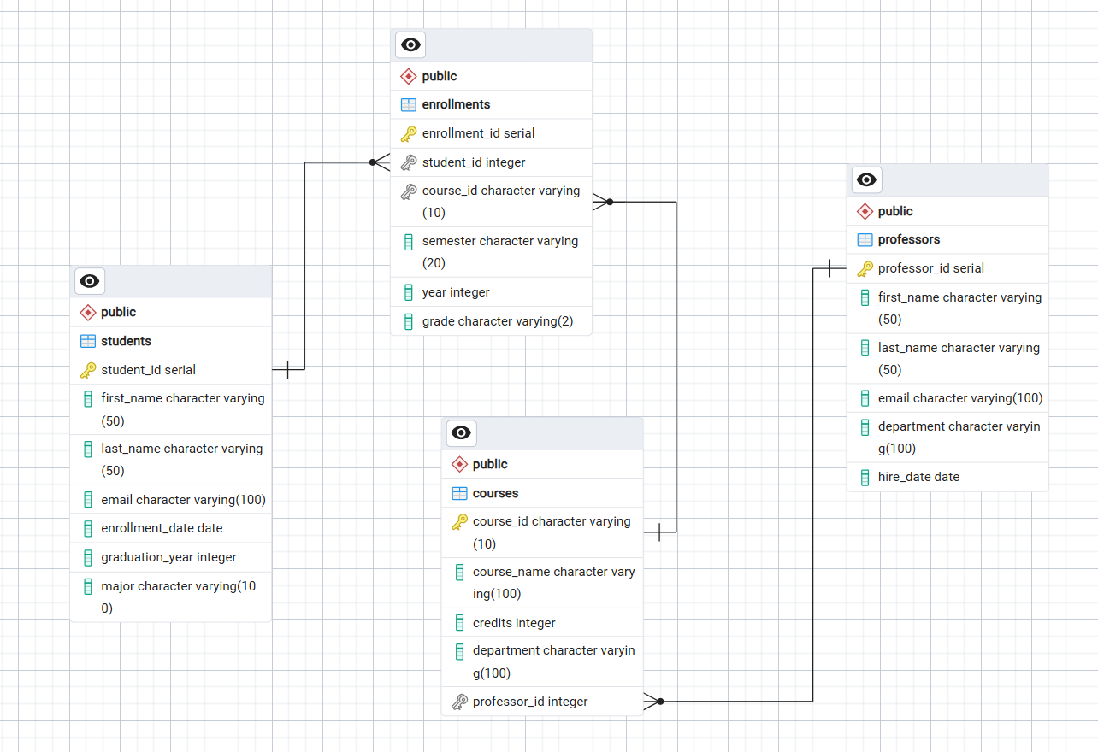
This dataset simulates a school management system consisting of four related tables. The "students" and "professors" tables store student and academic staff profiles. The "courses" table manages academic courses linked to professors using professor_id. The "enrollments" table records student registration and grades, linked via student_id and course_id. This structure allows the school to efficiently manage academic records, teaching assignments, and student grades.

GitHub Repposity Link:
thanquengoc/MIS443_2232300060_School

Conclusion
Hands-on experience was gained in relational schema design, database creation, table relationships, metadata constraints, and PostgreSQL query execution.

