
BECAMEX BUSINESS SCHOOL

Course Project
Practical Database Implementation for Data Analysis:
A Case Study of the Chinook Digital Music Store

Course: MIS 443 - BUSINESS DATA MANAGEMENT
Lecturer: Mr. Dang Thai Doan

Group Name: D2NB

No. | Student’s Name | Student’s IRN | GitHub Repository Link
1 | Vũ Đông Dương | 2032300044 | View on GitHub
2 | Thân Quế Ngọc | 2232300060 | View on GitHub
3 | Văn Vũ Quỳnh Như | 2232300079 | View on GitHub
4 | Đỗ Hoàng Bảo | 2232300071 | View on GitHub

Quarter 4, Academic Year 2025-2026
Table of Contents
1. Introduction to the selected database context 4
2. Description of the main tables and relationships 4
3. Entity-Relationship Diagram 5
4. Summary of the database implementation 6
4.1 Database Overview 6
4.2 Database Structure 7
4.3 Database Relationships 8
4.4 Database Development Workflow 9
4.5 Project Structure 10
4.6 SQL Implementation Summary 10
5. Summary of the 6 SQL questions completed 12
6. Differences between the original and the redesigned schema 13
7. Selected screenshots from pgAdmin 16
8. Database Connection and Visualization using Python 21
8.1 Database Connection 21
8.2 Is the store growing, flat, or shrinking over time? 22
8.3 Which countries generate the most revenue, and is a country valuable because it has many customers or because each one spends more? 22
8.4 Which genres earn the most, and does catalog size match demand? 23
8.5 How much of the catalog has never sold a single unit? 24
8.6 Do sales agents differ in ability, or only in how many customers they were assigned? 25
8.7 How did revenue accumulate over time, and how long did it take to reach the first $1,000? 25
9. Challenges encountered and solutions applied 26
10. Responsibilities and contributions of each member 27
11. Conclusion & Recommendations 28
11.1 Conclusion 28
11.2 Recommendations 28
12. References 29

Introduction to the selected database context
We chose the Chinook sample database, originally developed by Luis Rocha, and rebuilt it in PostgreSQL 17 using pgAdmin 4 for our independent analysis. It records comprehensive operational data across 11 interconnected tables, capturing both the store's media inventory (artist, album, track, genre, media_type, playlist, playlist_track) and its business transactions (customer, employee, invoice, invoice_line). The data scale provides a robust foundation for analysis: it includes 8 employees, 59 customers, 275 artists, 347 albums, and 3,503 media tracks, along with hundreds of corresponding invoice records mapping out customer purchases over time.
Project Objective & Scope:
While we sourced the foundational data from the original repository, we are not replicating the author's original scope. The objective of this project is to conduct a proprietary analysis of the Chinook dataset. Our scope involves formulating our own distinct business questions, applying custom analytical methodologies in PostgreSQL, and extracting unique insights regarding customer purchasing behavior and media performance.

Description of the main tables and relationships
Table | What it stores | Primary key | Foreign key
artist | Artist names | artist_id | none
album | Album titles and the associated artist | album_id | artist_id to artist
media_type | Names of media file formats | media_type_id | none
genre | Names of music and video genres | genre_id | none
track | Media track details including name, length, size, unit price, album, media type, and genre | track_id | album_id to album, media_type_id to media_type, genre_id to genre
playlist | Playlist names | playlist_id | none
playlist_track | Mapping of which tracks belong to which playlists | playlist_id, track_id | playlist_id to playlist, track_id to track
employee | Employee details including name, title, contact info, hire date, and manager hierarchy | employee_id | reports_to employee
customer | Customer details including name, address, contact info, and assigned support representative | customer_id | support_rep_id to employee
invoice | Invoice header information including billing date, billing address, and total amount | invoice_id | customer_id to customer
invoice_line | Invoice line items detailing the track purchased, quantity, and unit price | invoice_line_id | invoice_id to invoice, track_id to track

Entity-Relationship Diagram
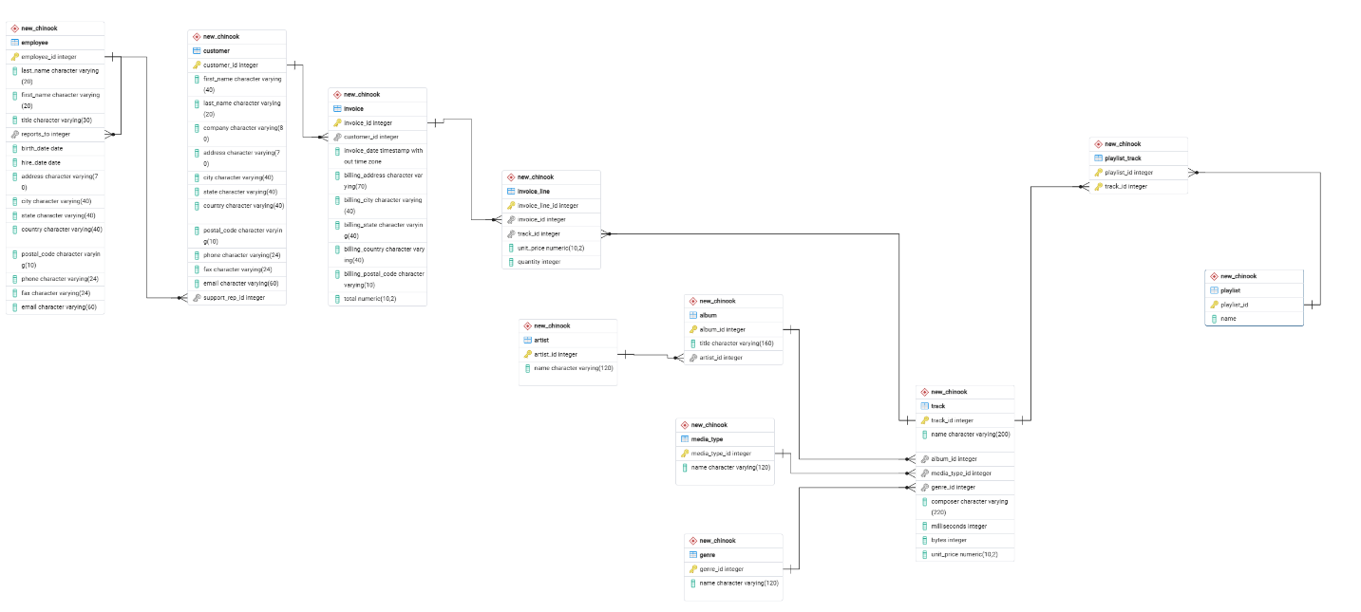

Summary of the database implementation
The objective of this project was to recreate the Chinook database in PostgreSQL based on the provided source database. The project covered the main database implementation process, including database creation, schema and relational table implementation, data loading, data verification, and SQL-based data analysis.
The implementation was completed using PostgreSQL 17 and pgAdmin 4, with the project files organized into separate SQL scripts according to each implementation stage.

4.1 Database Overview
Item | Description
Database Name | mis443_chinook
Schema | new_chinook
Database Platform | PostgreSQL 17
Development Tool | pgAdmin 4
Source Schema | public
Number of Tables | 11
Number of Analysis Questions | 6

4.2 Database Structure
The new_chinook database consists of eleven relational tables representing the main entities of a digital music store.
Table | Description
artist | Stores artist information
album | Stores album information and associated artists
genre | Stores music genre information
media_type | Stores media type information
playlist | Stores playlist information
playlist_track | Connects playlists with tracks
employee | Stores employee and sales representative information
track | Stores individual music tracks
customer | Stores customer information
invoice | Stores customer invoice information
invoice_line | Stores individual items included in invoices

Each table was created with an appropriate Primary Key to uniquely identify records.
Foreign Key constraints were implemented to maintain relationships and referential integrity between related tables. Additional constraints such as NOT NULL, CHECK, and ON DELETE rules were also applied.

4.3 Database Relationships
The database follows a relational model connecting the main entities through primary andforeign keys
.

Relationship Summary
Parent Table | Child Table | Relationship
artist | album | One Artist → Many Albums
album | track | One Album → Many Tracks
genre | track | One Genre → Many Tracks
media_type | track | One Media Type → Many Tracks
playlist | playlist_track | One Playlist → Many Playlist Tracks
track | playlist_track | One Track → Many Playlist Tracks
employee | customer | One Employee → Many Customers
customer | invoice | One Customer → Many Invoices
invoice | invoice_line | One Invoice → Many Invoice Lines
track | invoice_line | One Track → Many Invoice Lines

The playlist_track table is used to represent the relationship between playlists and tracks, while invoice_line connects purchased tracks with customer invoices.

Database Development Workflow
The database implementation followed the sequence below:
Create Database → Load Source Data → Create New Schema → Create Tables → Define Primary Keys and Foreign Keys → Load Data into New Schema → Cross-check Data → Develop Analysis Queries
This workflow allowed the new schema to be implemented and populated before conducting the SQL-based analysis. The cross-check step was also used to compare record counts between the original public schema and the newly implemented new_chinook schema.

Project Structure
The project repository was organized into separate SQL files according to the implementation and analysis stages.
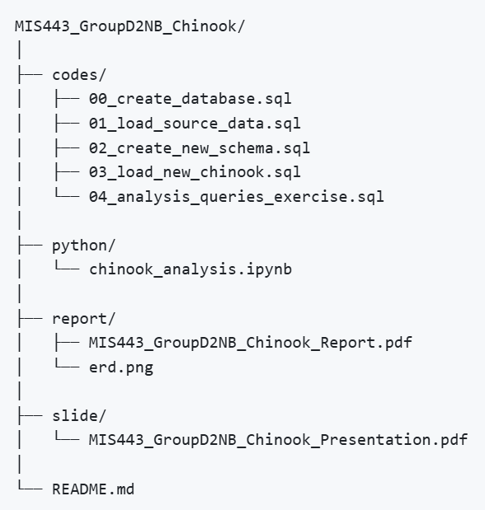

SQL Implementation Summary
The SQL implementation covered database creation, relational database development, data loading, validation, and analytical querying.
SQL Feature | Applied
CREATE DATABASE | ✅
CREATE SCHEMA | ✅
CREATE TABLE | ✅
PRIMARY KEY | ✅
FOREIGN KEY | ✅
NOT NULL | ✅
CHECK | ✅
INSERT INTO ... SELECT | ✅
SELECT | ✅
JOIN | ✅
LEFT JOIN | ✅
GROUP BY | ✅
Aggregate Functions | ✅
DATE_TRUNC() | ✅
CASE | ✅
LEFT JOIN ... IS NULL | ✅
Window Functions | ✅
SUM() OVER() | ✅
COUNT() | ✅
The implementation demonstrates the ability to create, populate, validate, and analyze a relational database using PostgreSQL, providing the foundation for the subsequent business-oriented analysis of the Chinook database.

Summary of the 6 SQL questions completed
Level/Category | Question Range | Key SQL Concepts & Clauses | Business Analytics Objective
Level 1: Easy | Q1 | SELECT, EXTRACT, GROUP BY, COUNT, COUNT(DISTINCT), SUM, ORDER BY | Measuring yearly revenue, invoice volume and active customer count to establish whether the store is growing, flat or shrinking.
Level 2: Medium | Q2, Q3, Q5 | INNER JOIN, LEFT JOIN, COALESCE, CASE, GROUP BY, derived metrics, LIMIT | Comparing markets, genres and sales agents across two and three tables, then dividing one aggregate by another to separate customer volume from customer value.
Level 3: Advanced | Q4, Q6 | Anti-join (LEFT JOIN … IS NULL), aggregate FILTER, scalar subquery, window function (SUM OVER), CTE (WITH) | Measuring how much of the catalog never sells and how fast revenue accumulates, including the date cumulative revenue first passed $1,000.

Technical Highlights Revealed in Questions
- Anti-join (Q4): used LEFT JOIN invoice_line followed by WHERE il.track_id IS NULL to isolate tracks that never appear on an invoice, returning 1,519 of 3,503 titles, or 43.4% of the catalog.
- Preserving unmatched rows (Q3): used LEFT JOIN with COALESCE so genres with no sales stay in the result instead of being dropped by an inner join. Rock is the largest genre at 1,297 tracks but returns $0.64 per track against $1.01 for TV Shows. Reggae and Classical yield less per track, yet Rock is 37% of the whole catalog, so that is where the most money sits at a below average return.
- Guarding a derived metric (Q2): divided one aggregate by another with SUM(i.total) / COUNT(DISTINCT c.customer_id), then wrapped it in a CASE so the average prints only where a country has at least three customers. Chile ($46.62 from one customer) and the Czech Republic (two customers) would otherwise outrank the USA on that column, which reports one person's spending as a market average. Every country still appears in the revenue ranking, and the 18 too small to average show a blank instead.
- Window function over grouped rows (Q6a): used SUM(SUM(total)) OVER (ORDER BY invoice_date::DATE), where the inner SUM totals each day and the outer one accumulates across days. Window functions run after GROUP BY, which is what makes the nesting legal. The 412 invoices fall on 354 distinct days and 58 of those days carry more than one invoice, so grouping before accumulating matters.
- CTE with window filtering (Q6b): wrapped the running total in a WITH clause because WHERE is evaluated before a window function produces its value, then applied ORDER BY with LIMIT 1 to return the first crossing instead of all 200 qualifying rows. Revenue passed $1,000 on 25 February 2023, 785 days after the first invoice.
- Counting against a denominator (Q4b): used COUNT(...) FILTER (WHERE il.track_id IS NULL) alongside the genre total, because the count and the rate disagree. Rock holds the most dead titles at 552 but its 42.6% dead rate is better than Jazz at 47.7% or TV Shows at 53.8%, so reporting the count alone would have named the wrong genre as the worst offender.
Scalar subqueries (Q4, Q6b): used (SELECT COUNT(*) FROM track) and (SELECT MIN(invoice_date)::DATE FROM invoice) so percentages and date baselines come from the data rather than hard-coded values.

Differences between the original and the redesigned schema
Both schemas hold the same eleven tables and the same 15,607 rows. The redesign changed what the database will accept, not what it stores.
Aspect | Original schema (public) | Our schema (new_chinook) | Reason
Nullability | artist.name, genre.name, media_type.name and playlist.name accept NULL | The same four columns declared NOT NULL | A lookup record with no name is not valid data. Verified against the source: no row was lost by tightening.
Date columns | employee.birth_date and employee.hire_date stored as TIMESTAMP | Both stored as DATE | Every value in the source has a zero time component, so the timestamp carried no information. The ETL casts explicitly with ::DATE.
Business rules | No CHECK constraints anywhere | 5 CHECK constraints: milliseconds > 0, quantity > 0, and a non-negative rule on three price and total columns | Negative durations, quantities and prices are rejected by the database itself rather than by application code that can be bypassed.
Delete behaviour | All 11 foreign keys left at the default NO ACTION | 2 CASCADE, 1 RESTRICT, 8 left at NO ACTION | invoice to invoice_line and playlist to playlist_track cascade, since a child row has no meaning without its parent. artist to album restricts, so an artist with albums cannot be deleted. track to album stays at NO ACTION on purpose, because deleting an album should not destroy the recordings.

The original is generated by a tool that targets five database engines at once, so it stays on the lowest common denominator. We target PostgreSQL only, which is what makes the stricter version possible.
Data validation performed after loading
Because the raw vendor data stays in the public schema, every figure in our own schema can be checked against its source. The following tests were run after the load and all of them pass.
Check | Method | Result
Row count reconciliation | A UNION ALL query comparing COUNT(*) for each table across both schemas. | All 11 tables match, 15,607 rows in total.
Arithmetic integrity | GROUP BY with HAVING comparing each stored invoice.total against the sum of its line items. | 0 of 412 invoices disagree, so the denormalised total has not drifted.
Pre-flight checks before tightening | Counted NULLs in the four columns before declaring them NOT NULL, and counted non-zero time components before casting to DATE. | 0 NULLs and 0 time components, so no data was lost by the stricter schema.

Selected screenshots from pgAdmin
Q1. Is the store growing, flat, or shrinking over time?
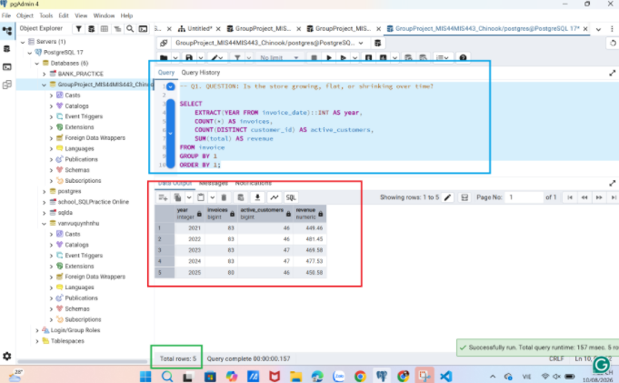
Q2. Which countries generate the most revenue, and is a country valuable because it has many customers or because each one spends more?
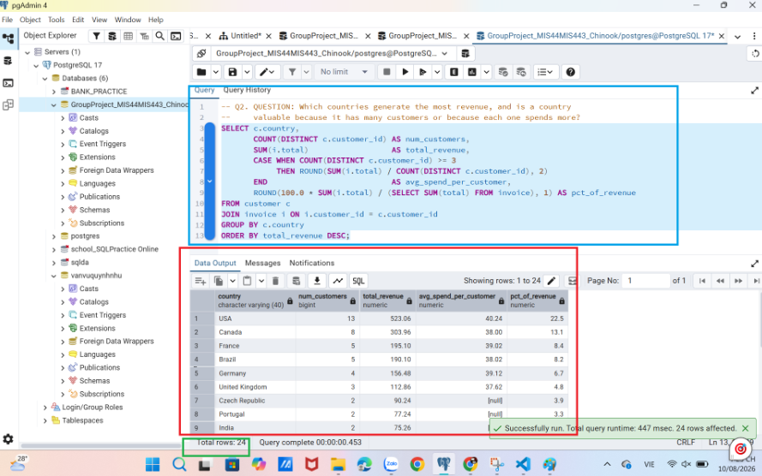
Q3. Which genres earn the most, and does catalog size match demand?
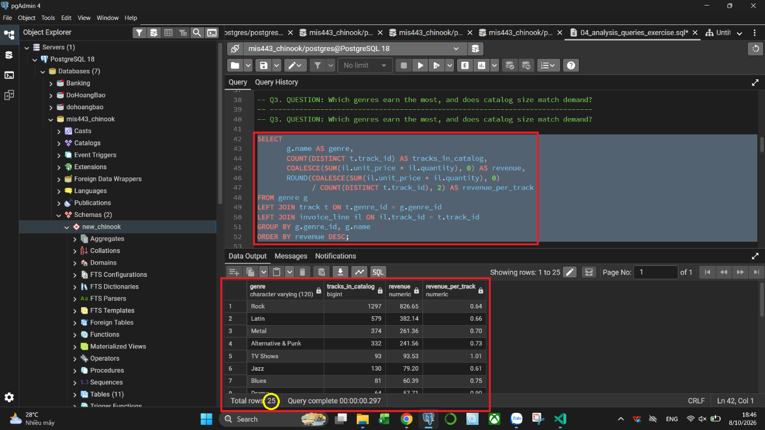
Q4. How much of the catalog has never sold a single unit?
Q4a. How much of the catalog has never sold a single unit?
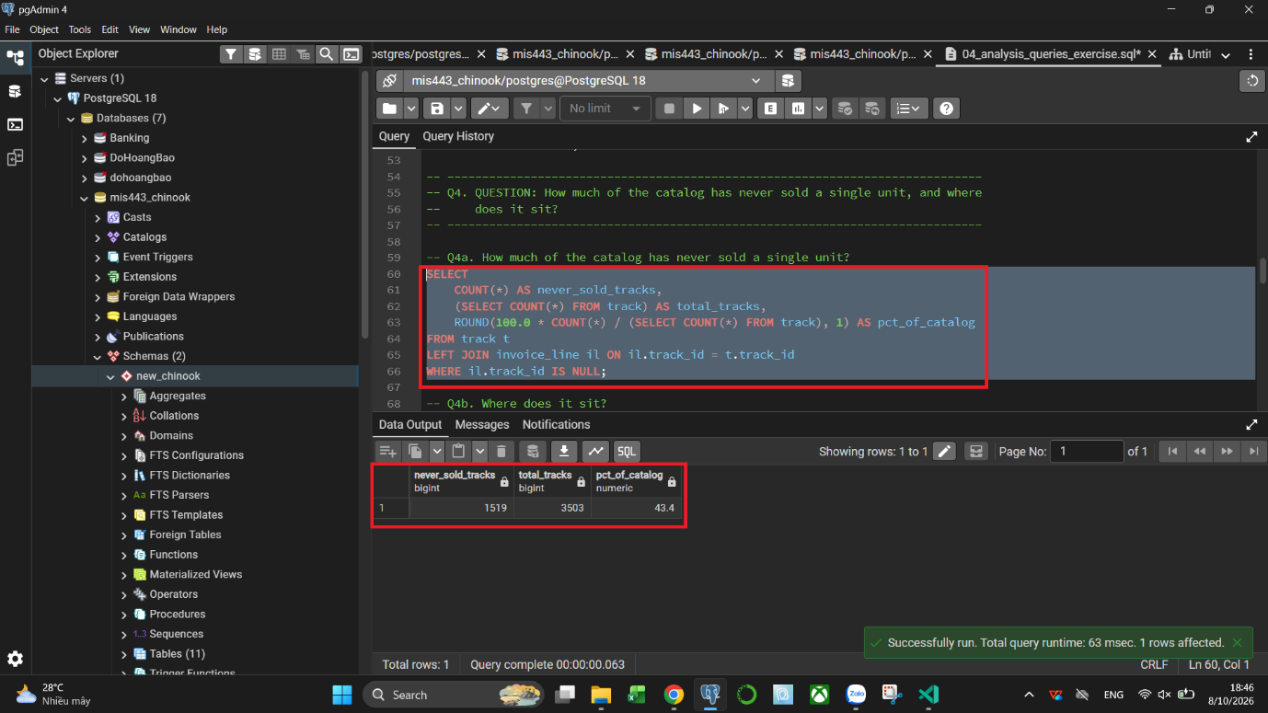

Q4b. Where does it sit?
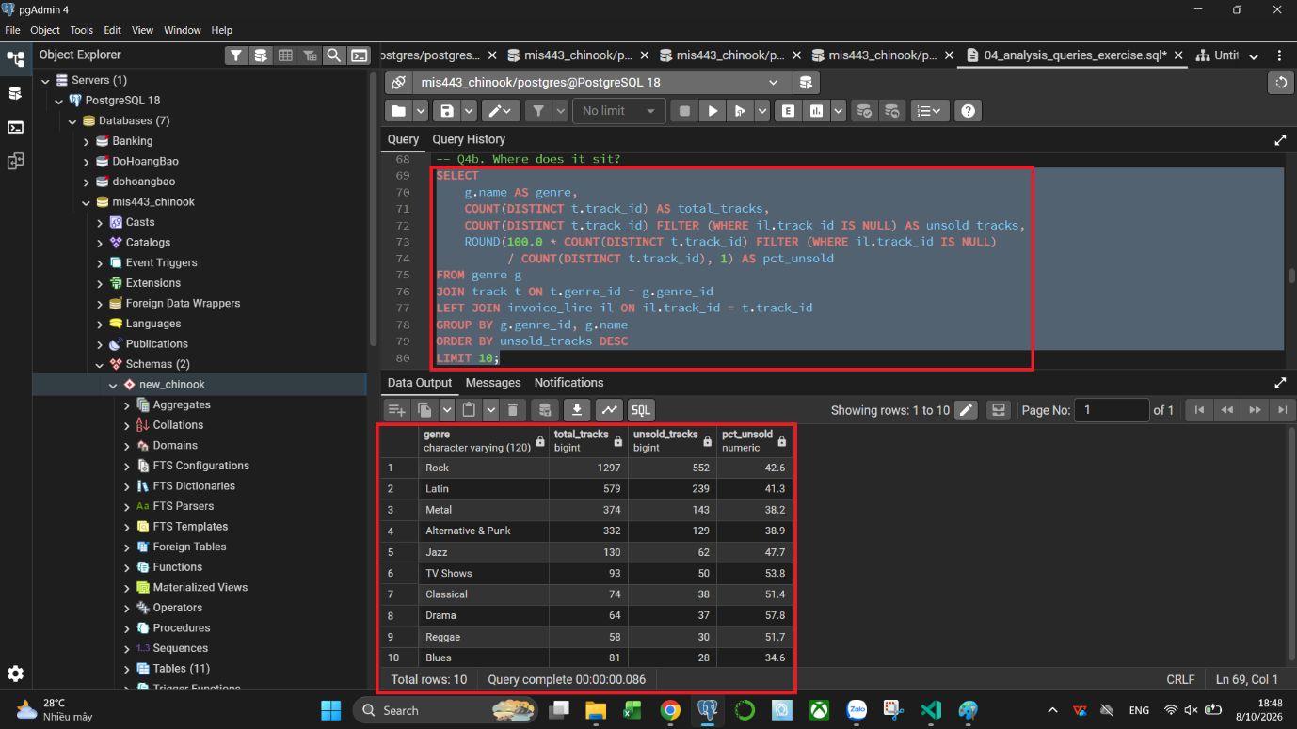
Q5. Do sales agents differ in ability, or only in how many customers they were assigned?
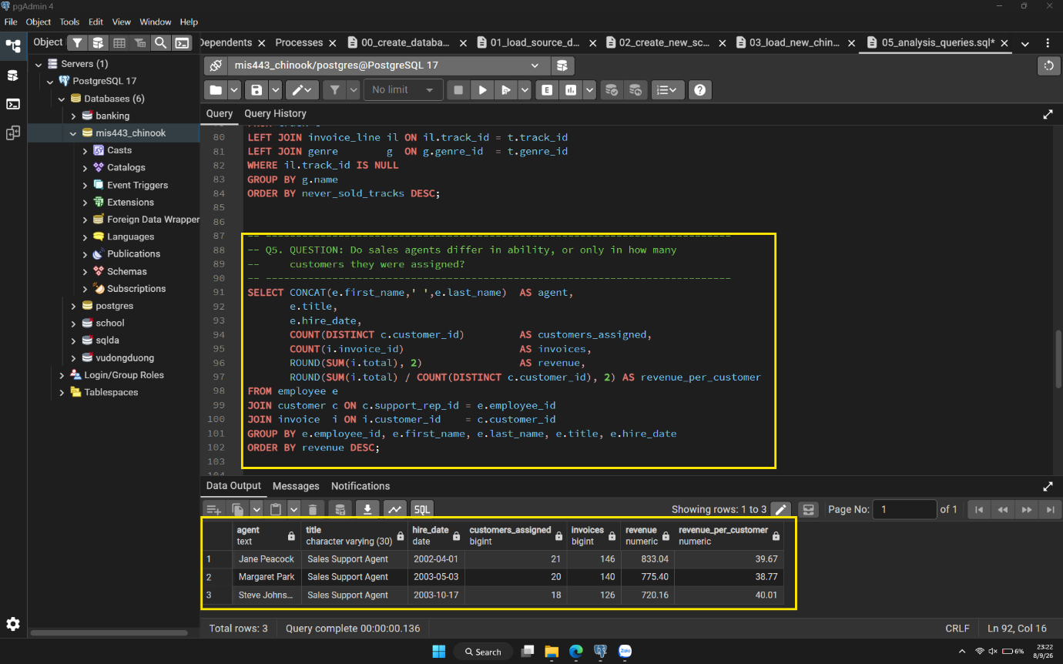

Q6. How did revenue accumulate over time, and how long did it take -- to reach the first $1,000?
Q6a. Total sales over time (running total by day)
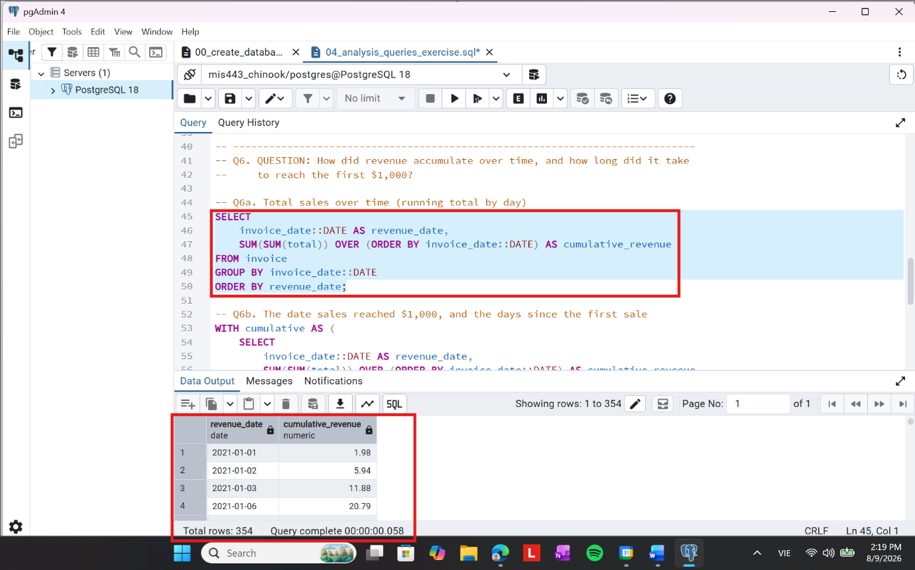
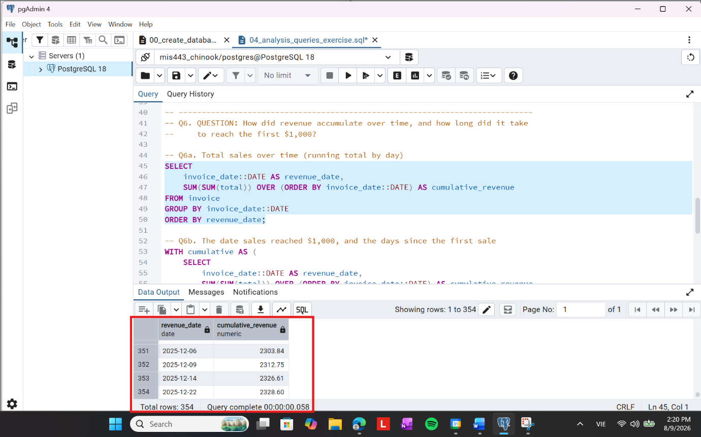

Q6b. The date sales reached $1,000, and the days since the first sale
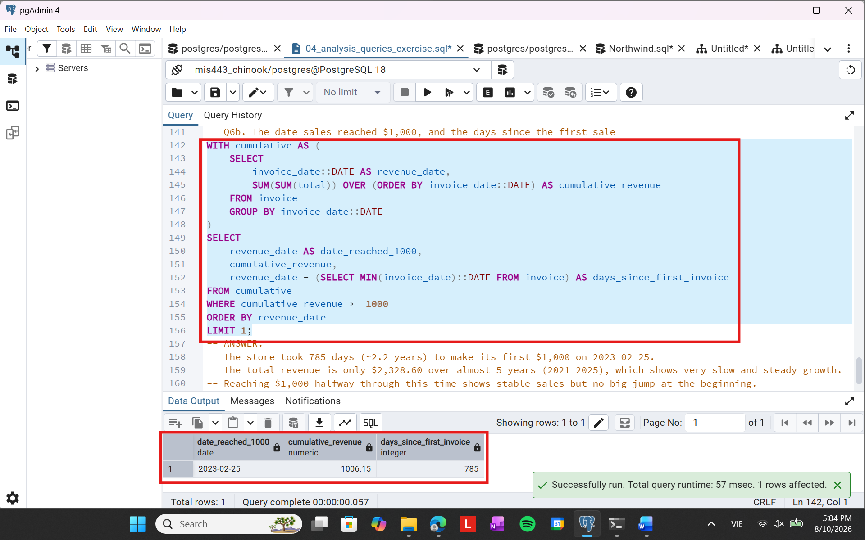

Database Connection and Visualization using Python

8.1 Database Connection
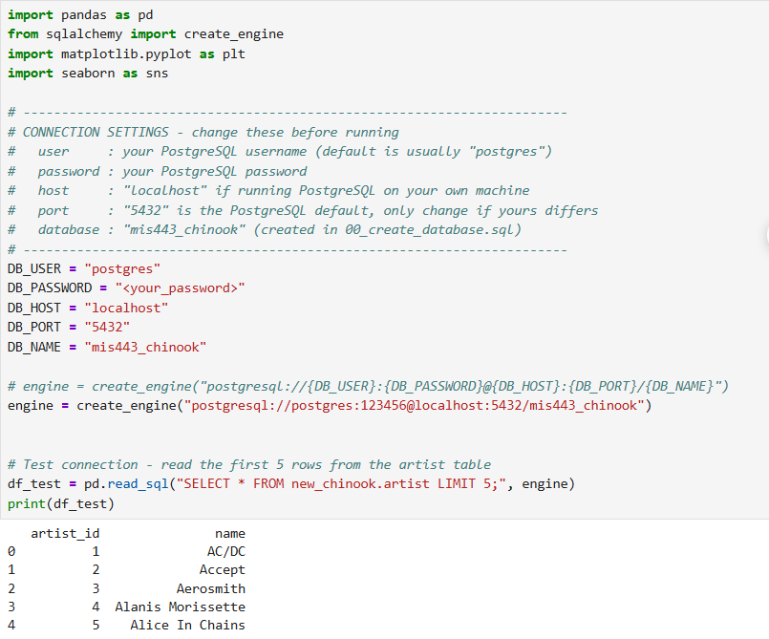

We use SQLAlchemy to connect Python to the PostgreSQL database mis443_chinook. Then, we use pandas.read_sql() to run SQL queries and load the results into DataFrames for analysis and visualization. The code also tests the connection by retrieving the first five rows from the artist table in the new_chinook schema. The results confirm that the connection works and the PostgreSQL to Python to Pandas pipeline is ready for the analysis in Sections 8.2 to 8.7.

8.2 Is the store growing, flat, or shrinking over time?
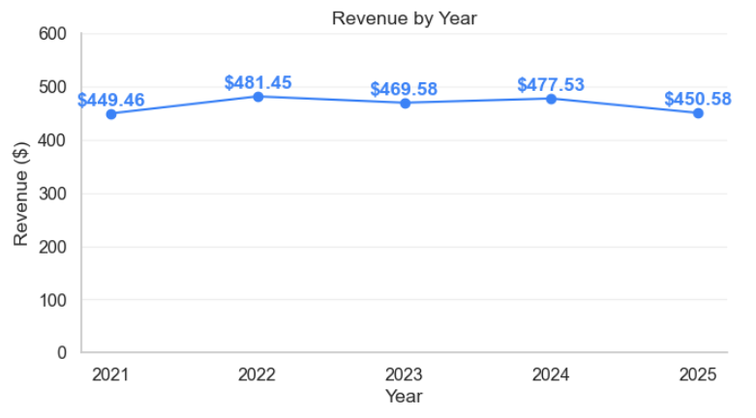
The store's revenue stayed around $450 to $480 per year from 2021 to 2025, with no clear growth or decline. This shows that the business has had stable revenue over the years. To increase sales, the store could use seasonal promotions, improve marketing campaigns, or expand its song catalog to attract new and existing customers.

8.3 Which countries generate the most revenue, and is a country valuable because it has many customers or because each one spends more?

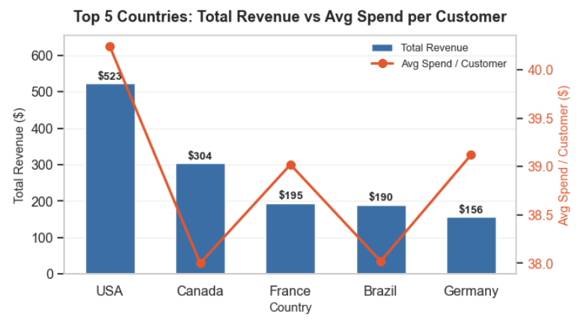
The USA is the strongest market, with the highest total revenue at $523 and average spending of about $40.2 per customer. Canada ranks second in revenue at $304 but has the lower average spending at about $38.0. This suggests that Canadian customers spend less per customer than those in the USA. The store could focus on attracting more customers in the USA and use bundle offers in Canada to increase spending per customer.

Which genres earn the most, and does catalog size match demand?
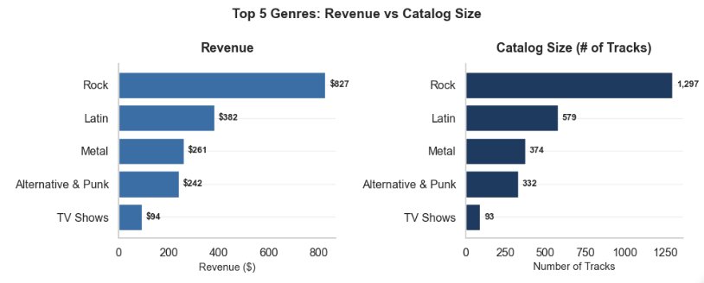

Rock generates the highest revenue ($827) and has the largest catalog (1,297 tracks). Latin, Metal, and Alternative & Punk show a similar pattern, with higher revenue linked to larger catalogs. TV Shows is different: despite the smallest catalog (93 tracks), it still generated $94 in revenue about $1.01 per track, compared to Rock's $0.64 per track suggesting stronger demand per title even with a much smaller catalog.

How much of the catalog has never sold a single unit?
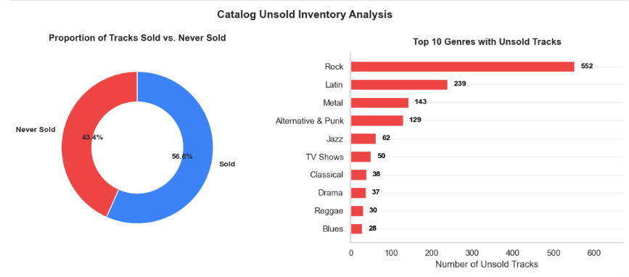
43.4% of tracks have never been sold, with most unsold tracks coming from the largest genres. Rock has the most unsold tracks in absolute terms (552), followed by Latin (239) and Metal (143), but Rock's unsold rate is actually lower (42.6%) than TV Shows (53.8%) and Jazz (47.7%), meaning its high count is simply a function of catalog size, not a sign it performs worse than other genres. The store could review low-selling tracks and improve marketing to increase sales.

Do sales agents differ in ability, or only in how many customers they were assigned?
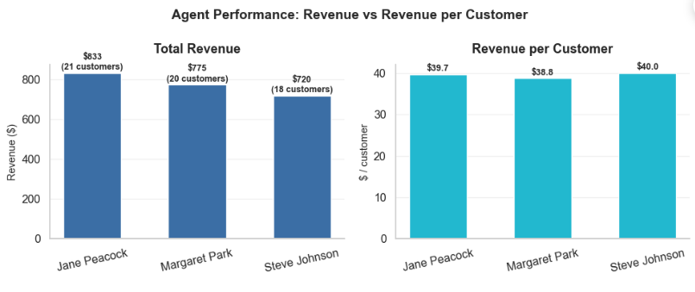
The 15.7% revenue gap comes from how many customers each agent was given, 21, 20 and 18, not from ability. Per customer all three land near $39, and with samples that small the difference sits inside ordinary sampling error. No difference was detected, which is not the same as proving they perform alike. This is also an online store: customers buy on their own, and the schema records only who is assigned to whom (customer.support_rep_id), nothing about what the agent did. Judging support work would need response times, satisfaction scores, first contact resolution, and refund rates, none of which the database holds.

8.7 How did revenue accumulate over time, and how long did it take to reach the first $1,000?
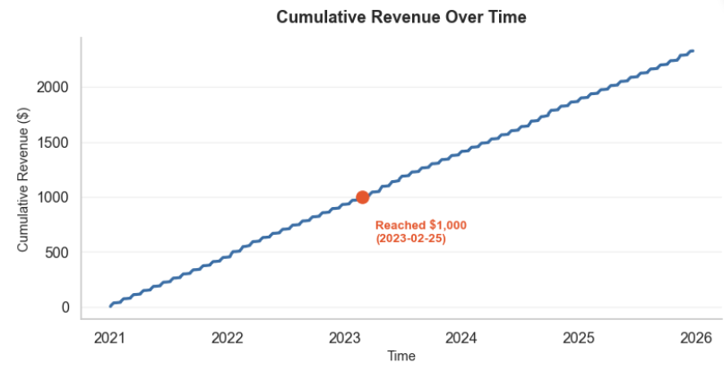
The store took 785 days, or about 2.2 years, to reach its first $1,000 in revenue on February 25, 2023. Total revenue reached about $2,329 over the five-year period from 2021 to 2025. The cumulative revenue increased steadily with no clear period of rapid growth, which is consistent with the year-over-year analysis. This suggests that the store has stable but slow sales growth. To improve future revenue, the store could consider new promotional strategies or catalog expansion.

Challenges encountered and solutions applied
Issue | Description | Solution
Issue 1: Table name collision between the raw and curated layers | Both layers use the same eleven table names (artist, album, track and the rest), so building our tables in the default schema would have clashed with the vendor data we needed to keep for comparison. | Created a separate schema, new_chinook, so both versions live in one database and the reconciliation query can check all eleven tables in a single statement.
Issue 2: Filtering on a window function | Q6 needed the rows where the running total reaches $1,000, but WHERE is evaluated before a window function produces its value. The first version instead ended at LIMIT 20, stopping the running total at $110.88 when reaching $1,000 takes 180 invoices. | Wrapped the window function in a CTE so the running total exists before filtering, then used ORDER BY with LIMIT 1 to return the first crossing instead of all 200 qualifying rows.
Issue 3: Small samples producing misleading averages | Chile showed the highest revenue per customer at $46.62, but from a single customer, so the figure was one person's spending rather than a market average. Q5 carried the same risk with only 18 to 21 customers per agent. | Wrapped the per-customer average in a CASE that prints it only where a country has at least three customers, so the figure never appears for one or two people, and reported that no difference between agents was detected rather than ranking them on a 3.2% gap.

Responsibilities and contributions of each member
Member | Tasks | Contributions
Vũ Đông Dương | Tested and captured screenshots for SQL Q5. Assigned project tasks to all members. Part 5 (Summary of the 6 SQL questions completed), Part 6 (Original & Redesigned Schema), and Part 9 (Challenges encountered and solutions applied) | 25%
Thân Quế Ngọc | Tested and captured screenshots for SQL Q6. Aggregated, checked and edited the report, SQL, Python scripts and README. Part 8 (Database Connection and Visualization using Python) and Part 10 (Responsibilities) | 25%
Văn Vũ Quỳnh Như | Tested and captured screenshots for SQL Qs 1, 2. Part 1 (Introduction to the selected database context), Part 2 (Description of the main tables and relationships), and Part 11 (Conclusion & Recommendations) | 25%
Đỗ Hoàng Bảo | Tested and captured screenshots for SQL Qs 3, 4. Part 3 (Entity-Relationship Diagram), Part 4 (Summary of the database implementation), and Part 11 (Conclusion & Recommendations) | 25%

Conclusion & Recommendations

11.1 Conclusion
The success of this project has been validated because it was able to demonstrate the execution and evaluation of a relational database. By converting the Chinook database to a strictly controlled schema, the implementation of strict rules for data validity has improved the integrity of data without losing the audit trail of events that happened in the past. After moving to the analytical phase with SQL and Python, the major findings of the study include the stable but slow-growing income, the presence of reliance on the US market for sales, and inefficient inventory, with up to 43.4% of the catalog remaining unsold. In addition, the analysis indicates that the differences in employee performance have to do with the number of customers assigned to employees rather than the selling capabilities of the employees themselves.

11.2 Recommendations
Derived from the data analysis, the following strategic initiatives are recommended to optimize the store's commercial and operational performance:
Inventory Optimization and Catalog: Since 43.4% of stock generates no revenue, management must analyze its decision to keep non-selling titles. The organization must resort to either conducting targeted promotions to sell non-productive titles or investing in profitable formats like TV Shows that gave the highest return of $1.01 per title.
Market Penetration Strategy: The US market is undoubtedly the most valuable market, so it has the highest value in total revenue at $523.06 and average expenditure per customer at $40.24. The company must focus on the acquisition strategy in the US and begin to implement regional product bundling in other markets like Canada, which have lower average expenditures.
Revenue Acceleration Tactics: In light of flat year-over-year revenue ($449 to $481) and the long 785-day duration required to generate the first $1,000, the store needs proactive sales methods. Such methods can include seasonal sale events, personalized recommendations, and loyalty programs.
Improving Operational KPIs: The present database schema limits the assessment of actual employees since it only maps the assignments of customers using the support_rep_id. To properly assess sales agents, it is essential to extend the database to include qualitative operational indicators such as customer satisfaction score, issue resolution time, and refund rates.

References
Rocha, L. (n.d.). Chinook database.GitHub.
https://github.com/lerocha/chinook-database

