
BECAMEX BUSINESS SCHOOL

ACTIVITY 1
Banking Database SQL Practice Exercise

Course: MIS 443 - BUSINESS DATA MANAGEMENT
Lecturer: Mr. Dang Thai Doan

Group Name: D2NB

No. | Student’s Name | Student’s IRN | GitHub Repository Link
1 | Vũ Đông Dương | 2032300044 | View on GitHub
2 | Thân Quế Ngọc | 2232300060 | View on GitHub
3 | Văn Vũ Quỳnh Như | 2232300079 | View on GitHub
4 | Đỗ Hoàng Bảo | 2232300071 | View on GitHub

Quarter 4, Academic Year 2025-2026
Table of Contents

1. Introduction to the selected database context 3
2. Description of the main tables and relationships 3
3. Entity-Relationship Diagram 4
4. Summary of the database implementation 4
4. Summary of the database implementation 4
4.1 Database Overview 4
4.2 Database Structure 5
4.3 Database Relationships 6
4.4 Database Development Workflow 7
4.5 Project Structure 7
4.6 SQL Implementation Summary 8
5. Summary of the 30 SQL questions completed 9
6. Selected screenshots from pgAdmin 11
7. Challenges encountered and solutions applied 29
8. Responsibilities and contributions of each member 30
9. Conclusion 30

Introduction to the selected database context
We chose the Banking schema from SQL Practice Online and rebuilt it in PostgreSQL 17 using pgAdmin 4.
The database models a small retail bank with five branches: New York, Los Angeles, Chicago, Houston and Phoenix. It records the customers at each branch, the accounts they hold, every deposit and withdrawal, and the loans issued to them.
One customer opens several accounts, each account collects transactions, and the same customer may also hold loans.
The data is small: 5 branches, 7 customers, 8 accounts, 8 transactions and 4 loans. Accounts were opened between September 2018 and June 2022, all transactions fall in January 2025, and loan rates run from 4.75% to 6.00%, three Active and one Paid.

Description of the main tables and relationships
Table | What it stores | Primary key | Foreign key
branches | The five bank locations, with city and state | branch_id | none
customers | Name, email and the branch the customer belongs to | customer_id | branch_id to branches
accounts | Deposit accounts, with type, balance and opening date | account_id | customer_id to customers
transactions | Deposits and withdrawals, with amount and date | transaction_id | account_id to accounts
loans | Amount lent, interest rate, status and start date | loan_id | customer_id to customers

Entity-Relationship Diagram
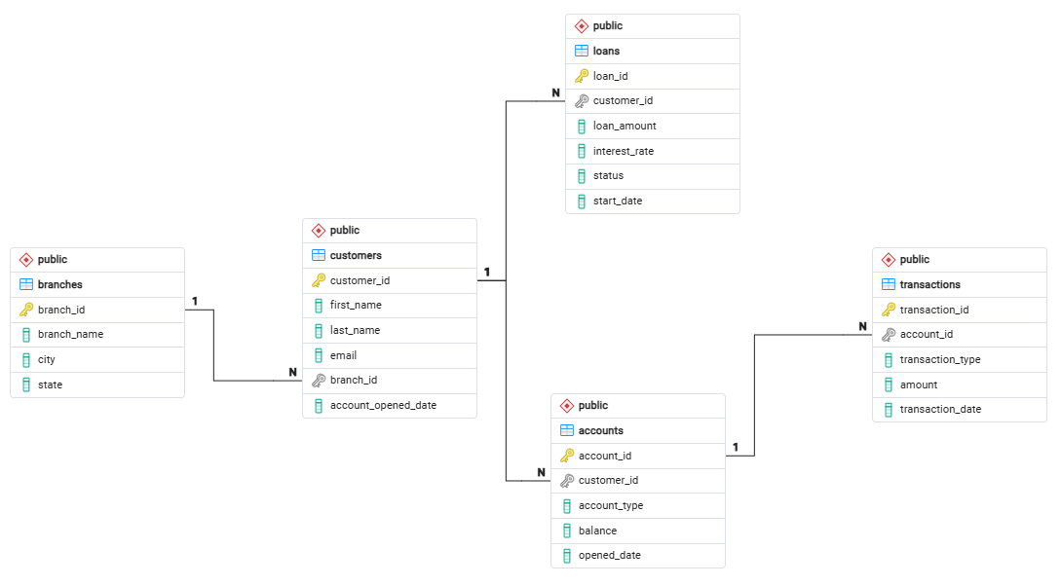

Summary of the database implementation

Summary of the database implementation
The objective of this assignment was to recreate the Banking database from SQL Practice Online using PostgreSQL. The project covered the complete database development lifecycle, including database creation, relational table implementation, data import, and SQL query development.
The implementation was completed using PostgreSQL and pgAdmin 4, with all project files organized and documented in a GitHub repository.

4.1 Database Overview
Item | Description
Database Name | Banking
Schema | Banking
Database Platform | PostgreSQL
Development Tool | pgAdmin 4
Source Dataset | SQL Practice Online
Number of Tables | 5
Number of CSV Files | 5
Number of SQL Questions | 30

4.2 Database Structure
The Banking database consists of five relational tables representing the core entities of a banking management system.
Table | Description
branches | Stores branch information
customers | Stores customer information and assigned branch
accounts | Stores customer bank accounts and balances
transactions | Records all account transactions
loans | Stores customer loan information

Each table was created with an appropriate Primary Key to uniquely identify each record.
Foreign Key constraints were implemented to preserve referential integrity between related tables.

4.3 Database Relationships
The database follows a one-to-many relational model.

Relationship Summary

Relationship Summary
Parent Table | Child Table | Relationship
branches | customers | One Branch → Many Customers
customers | accounts | One Customer → Many Accounts
customers | loans | One Customer → Many Loans
accounts | transactions | One Account → Many Transactions

Database Development Workflow
The database implementation followed the sequence below.
Create Database -> Create Tables -> Define Primary Keys -> Define Foreign Keys -> Import CSV Data -> Verify Imported Data -> Develop SQL Queries -> Upload Project to GitHub
This workflow ensured that all foreign key dependencies were satisfied before importing data into the database.

Project Structure
The project repository was organized into separate SQL files according to the implementation stages.
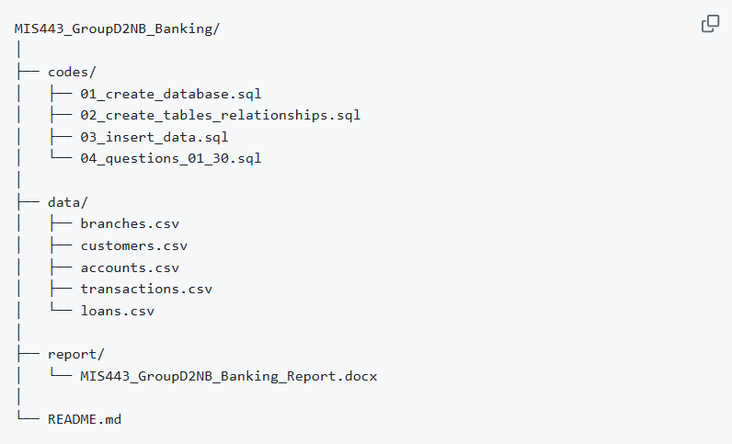

SQL Implementation Summary
The SQL implementation covered both fundamental and advanced SQL concepts throughout the assignment.
SQL Feature | Applied
SELECT | ✅
WHERE | ✅
ORDER BY | ✅
DISTINCT | ✅
JOIN | ✅
LEFT JOIN | ✅
GROUP BY | ✅
HAVING | ✅
Aggregate Functions | ✅
CASE | ✅
Subqueries | ✅
EXISTS / NOT EXISTS | ✅
UNION ALL | ✅
Window Functions | ✅
Common Table Expressions (CTEs) | ✅

The implementation demonstrates the ability to retrieve, filter, aggregate, and analyze relational data using PostgreSQL.

Summary of the 30 SQL questions completed
Level/Category | Question Range | Key SQL Concepts & Clauses | Business Analytics Objective
Level 1: Easy | Q1 - Q13 | SELECT, WHERE, ORDER BY, COUNT, SUM, DISTINCT, BETWEEN | Filtering account types (Savings), sorting accounts ($> \$10,000$), listing active loans, and isolating mid-month (Jan 10–20, 2025) transactions.
Level 2: Medium | Q14 - Q24 | LEFT JOIN, INNER JOIN, GROUP BY, NOT IN, COUNT() | Identifying customers without loans/accounts, multi-table joining (customers, branches, accounts), and calculating balance totals per branch.
Level 3: Hard | Q25 -Q30 | CASE WHEN, TO_CHAR(), NOT EXISTS, Correlated Subqueries, Window Functions (RANK()), CTEs (WITH) | Side-by-side cash flow aggregation, date grouping, top active loan identification, account ranking within types, and multi-stage branch portfolio analysis.

Technical Highlights Revealed in Questions
- Filtering Non-active Clients (Q11, Q12, Q24): Used NOT IN and NOT EXISTS subqueries to filter out non-borrower clients and those with no transaction record to facilitate marketing campaigns.
- Conditioned Aggregation (Q22, Q25): Utilized CASE WHEN statements in conjunction with SUM function in order to create comparative reports about deposit and withdrawal activities.
- Correlated Subqueries & Window Functions (Q27, Q28): Assessed client accounts showing account balances higher than the average amount in the group (WHERE balance > (SELECT AVG(...))) and ranked levels of account balances using RANK() function (RANK() OVER (PARTITION BY account_type ORDER BY balance DESC)).
- Multi-Tiered CTE (Q29, Q30): Used CTE clauses to make multi-level transformations—established the top client per branch with the highest deposits, and ranked accounts according to the level of funds held on them (high, medium, low).

Selected screenshots from pgAdmin
Q1. Return the complete customer roster from the customers table.
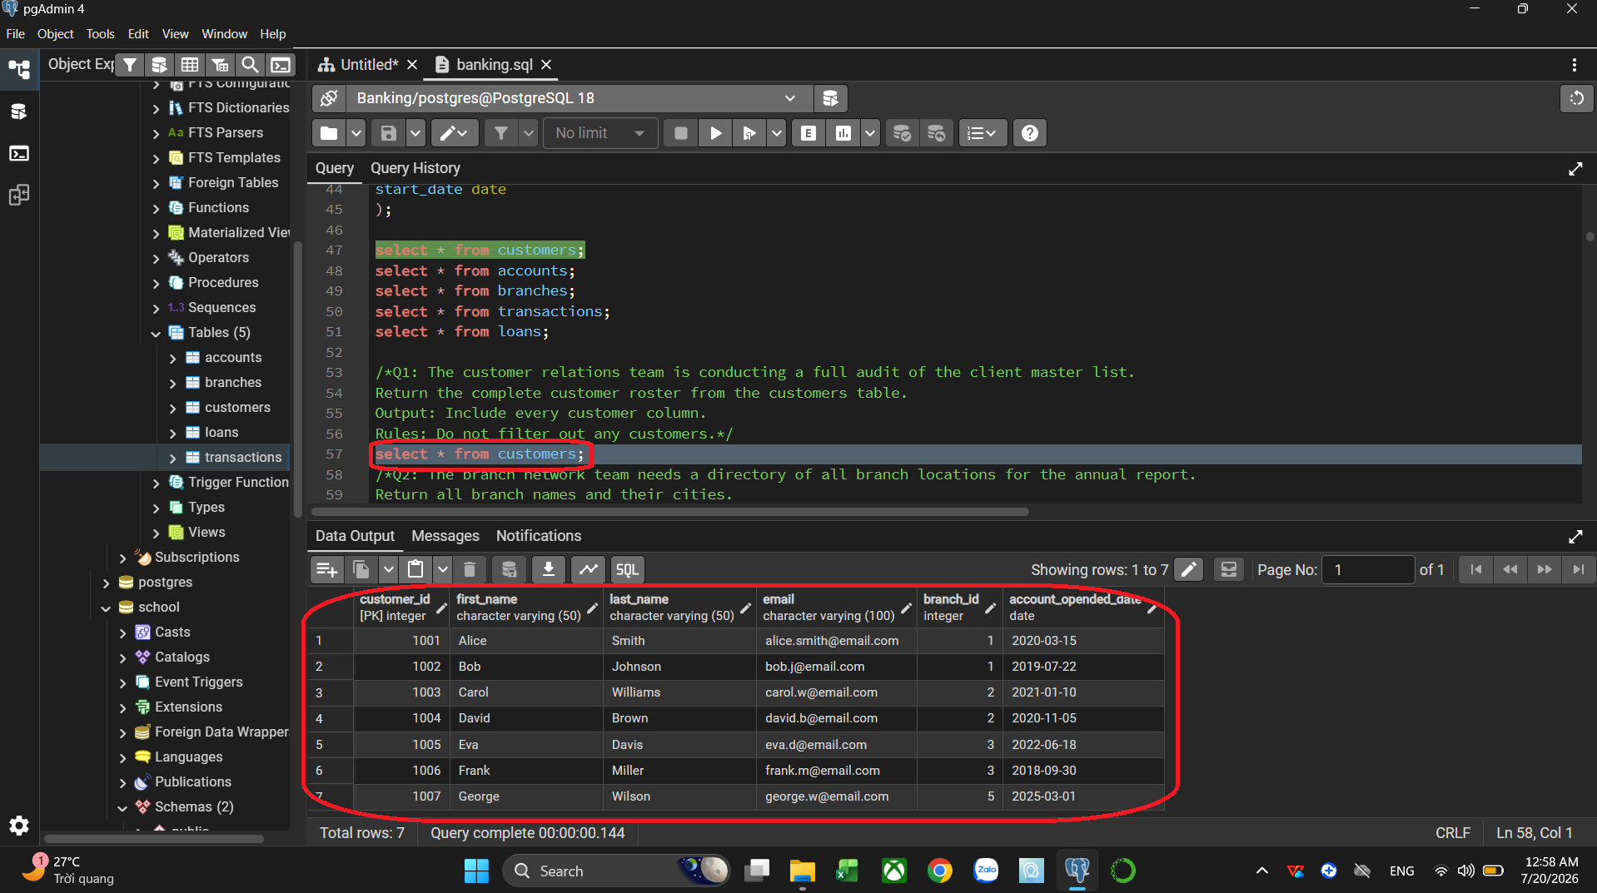

Q2. Return all branch names and their cities.
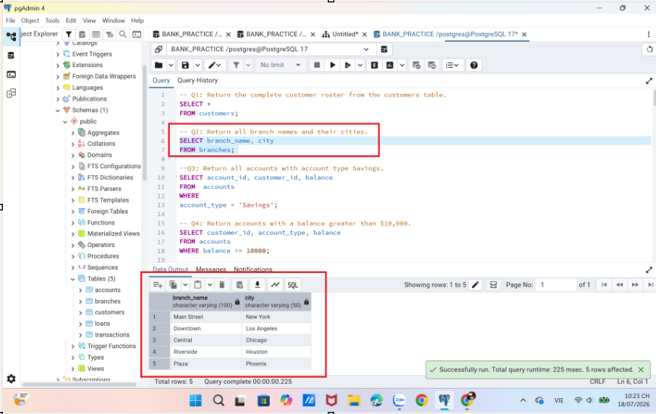
Q3. Return all accounts with account type Savings.
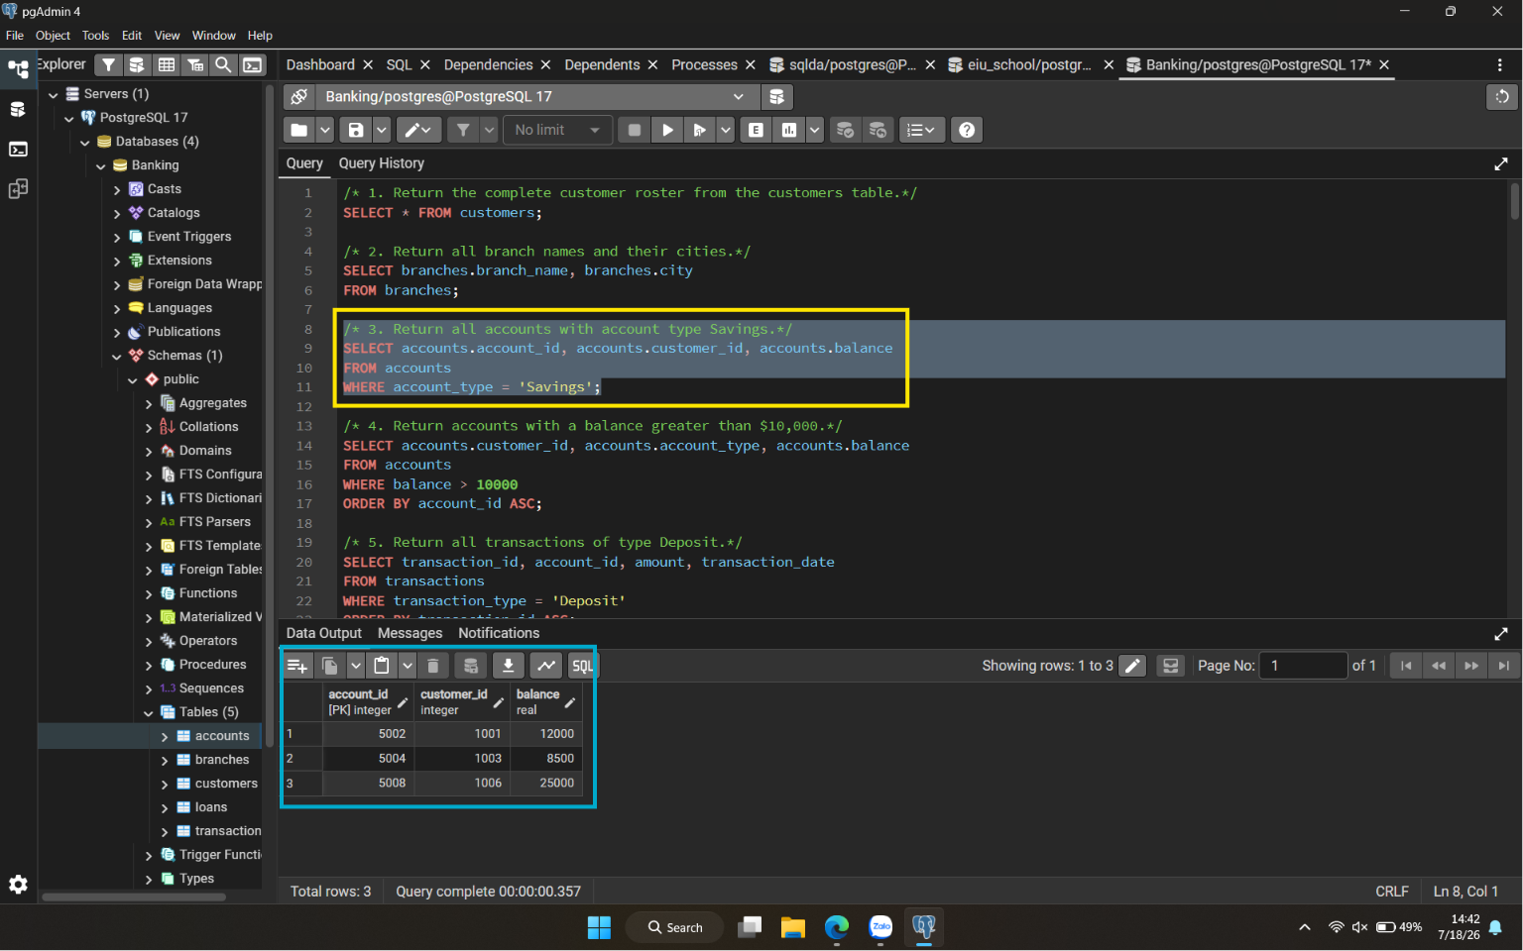

Q4. Return accounts with a balance greater than $10,000.
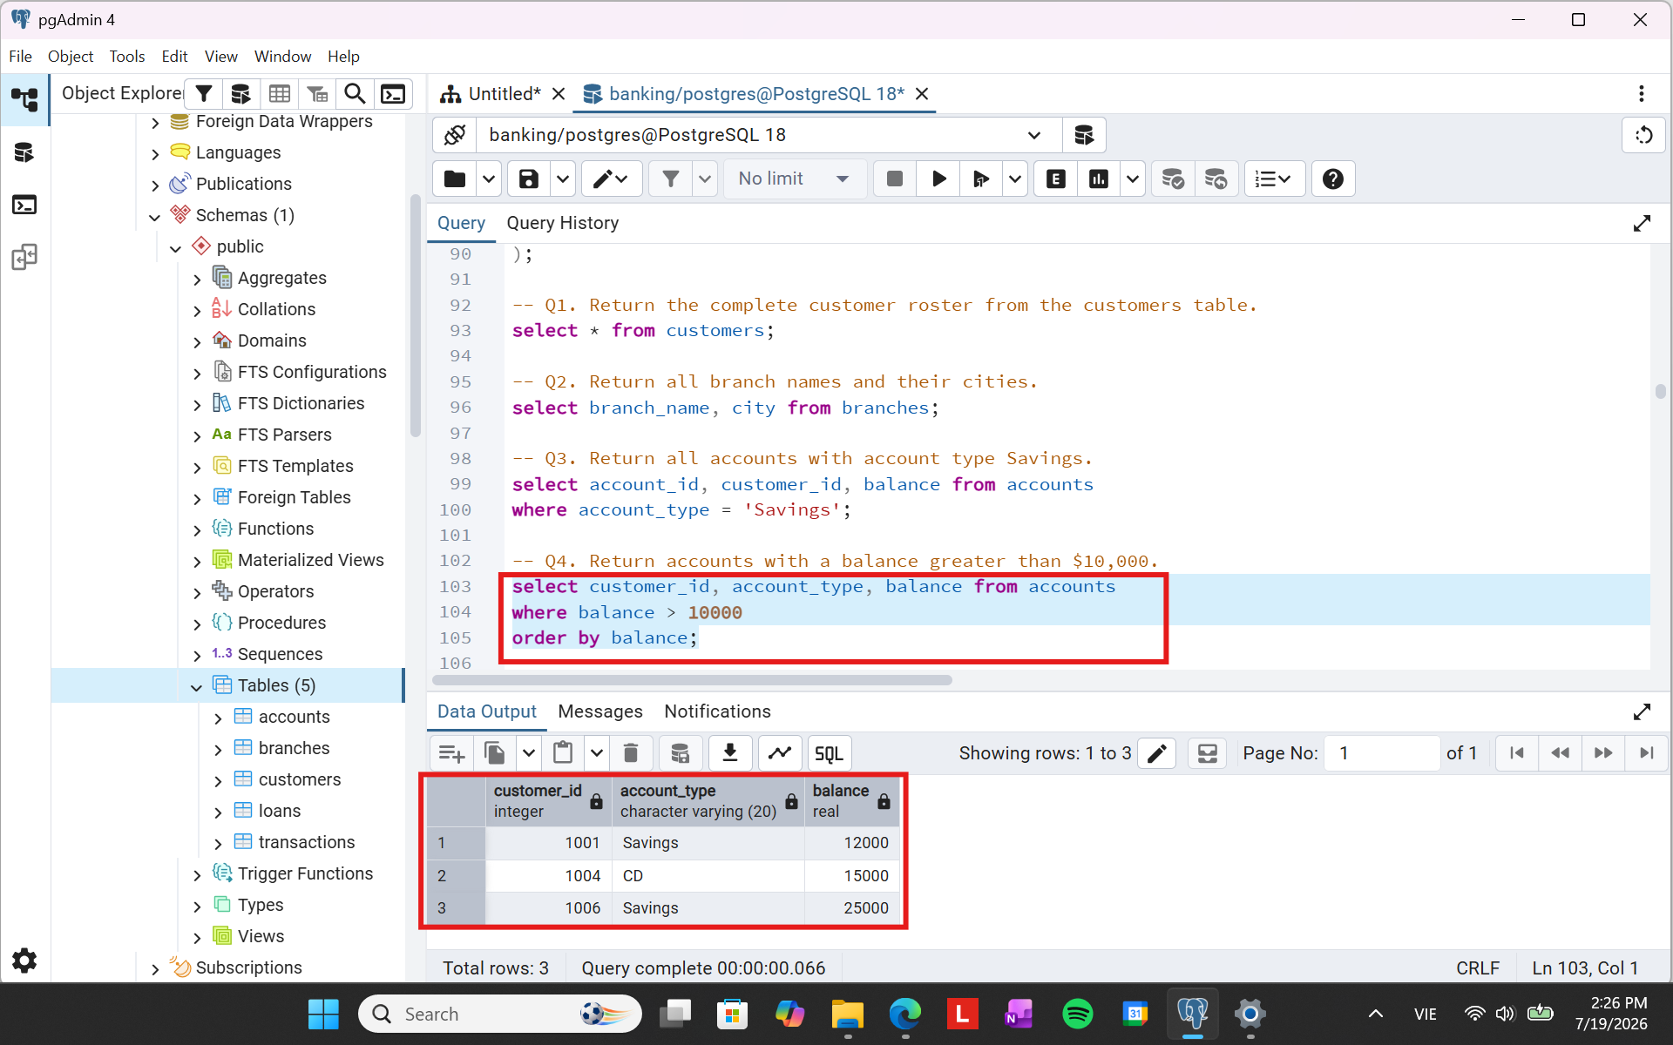

Q5. Return all transactions of type Deposit.
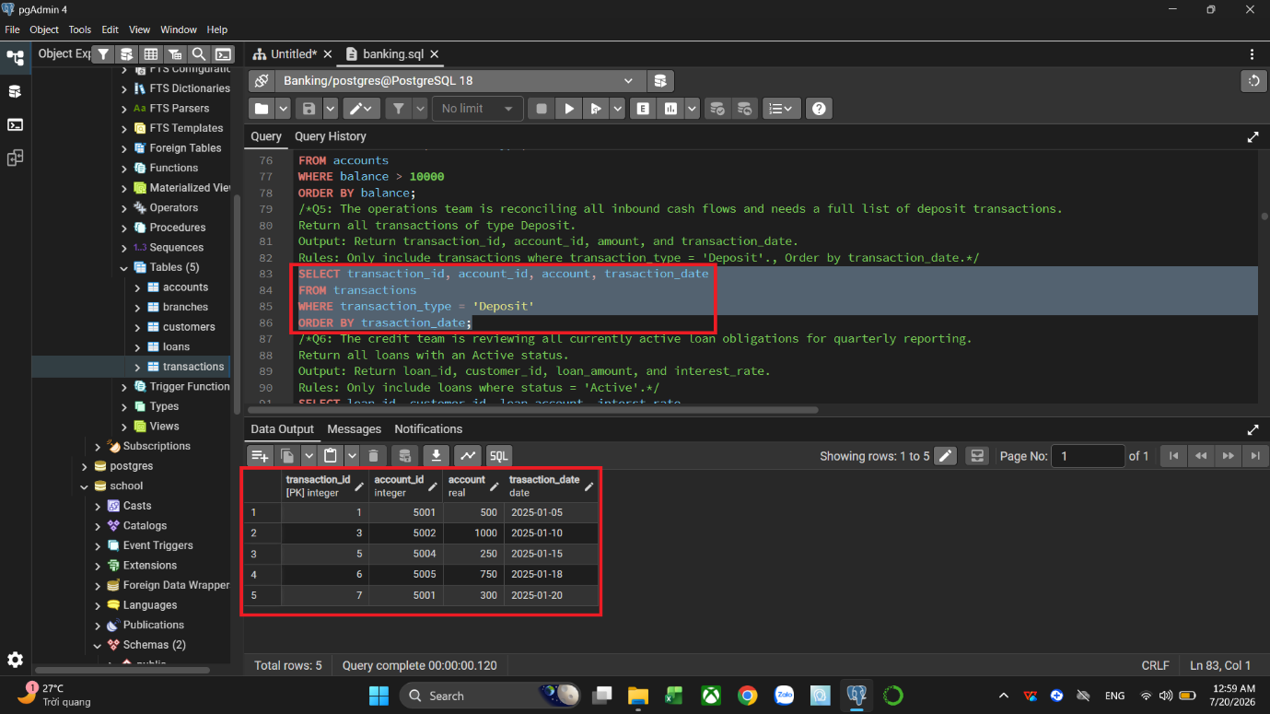

Q6. Return all loans with an Active status.
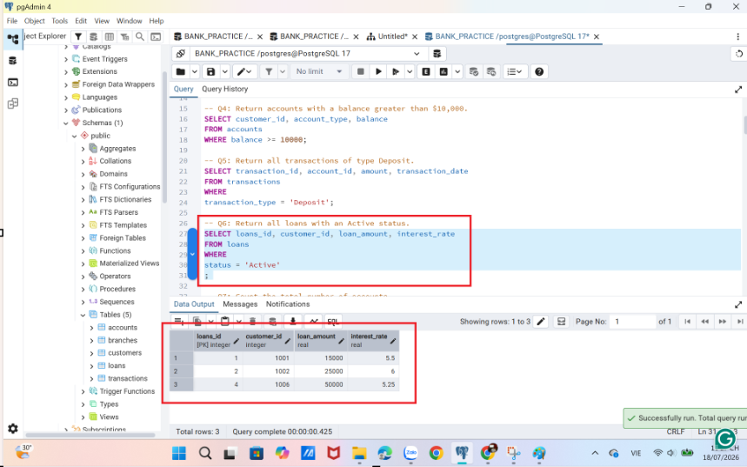

Q7. Count the total number of accounts.
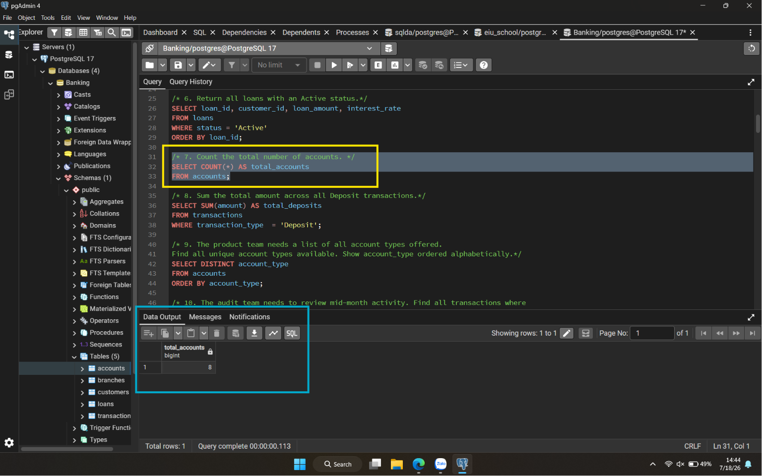

Q8. Sum the total amount across all Deposit transactions.
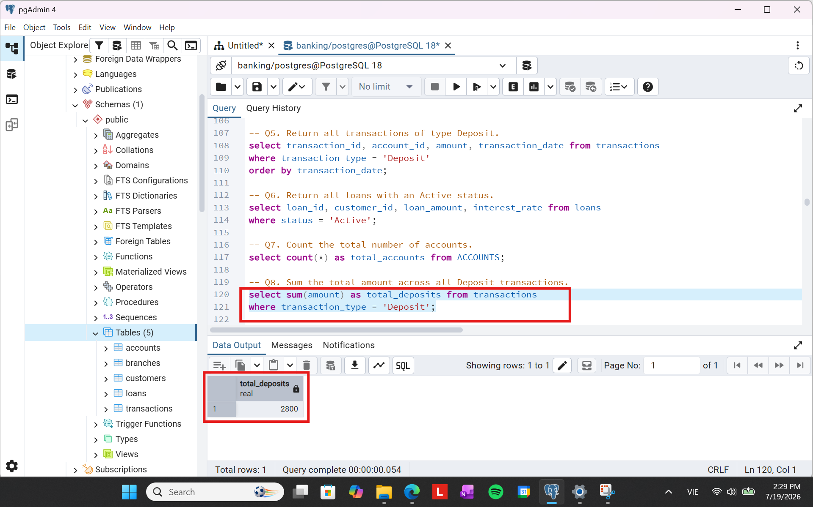

Q9. The product team needs a list of all account types offered. Find all unique account types available. Show account_type ordered alphabetically.
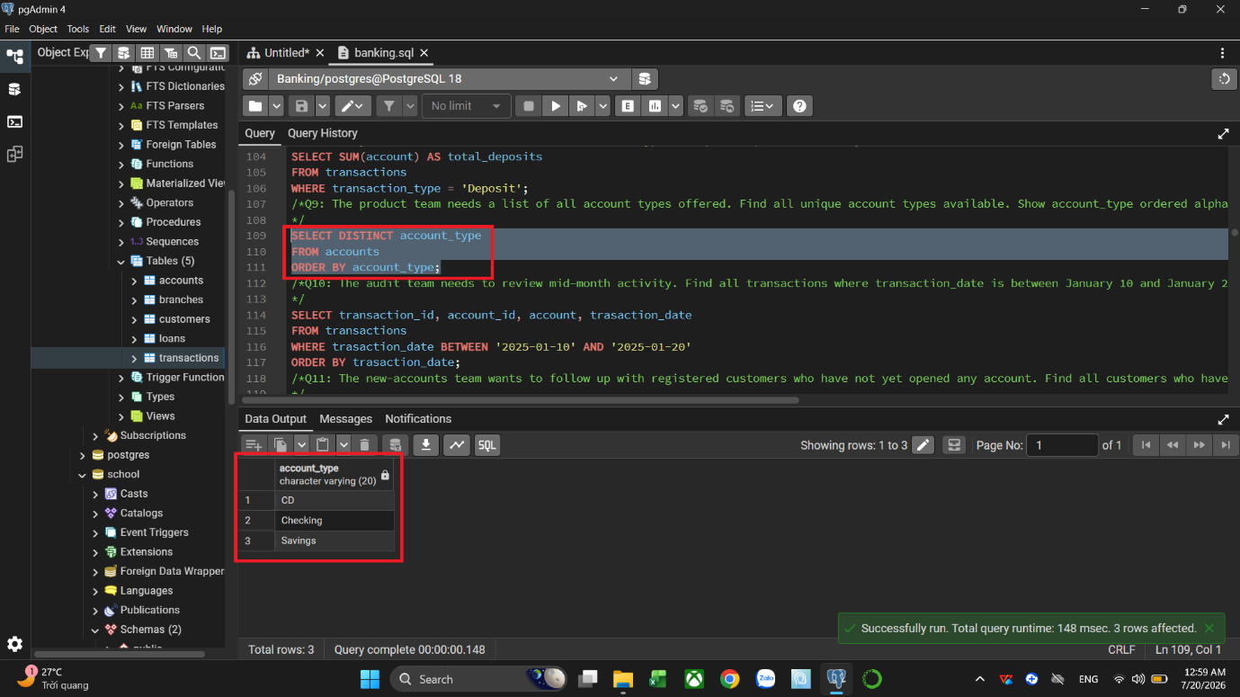

Q10. The audit team needs to review mid-month activity. Find all transactions where transaction_date is between January 10 and January 20, 2025 (inclusive). Show transaction_id, account_id, amount, and transaction_date. Order by transaction_date.
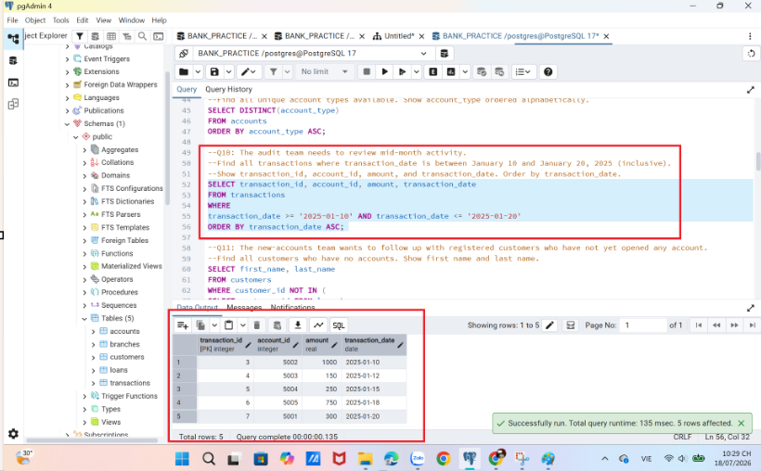
Q11. The new-accounts team wants to follow up with registered customers who have not yet opened any account. Find all customers who have no accounts. Show first name and last name.
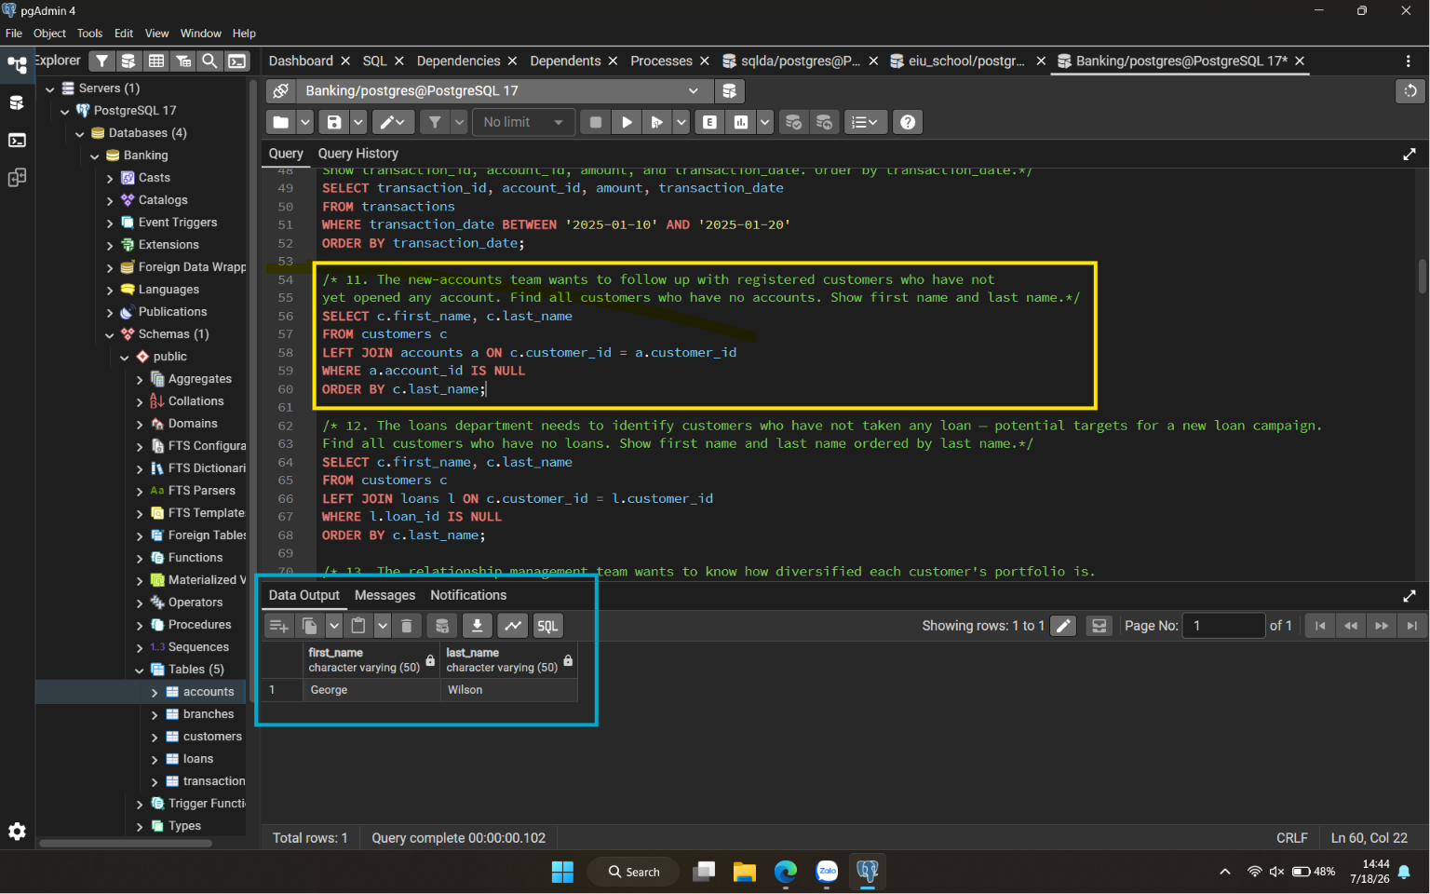

Q12. The loans department needs to identify customers who have not taken any loan -potential targets for a new loan campaign. Find all customers who have no loans. Show first name and last name ordered by last name.
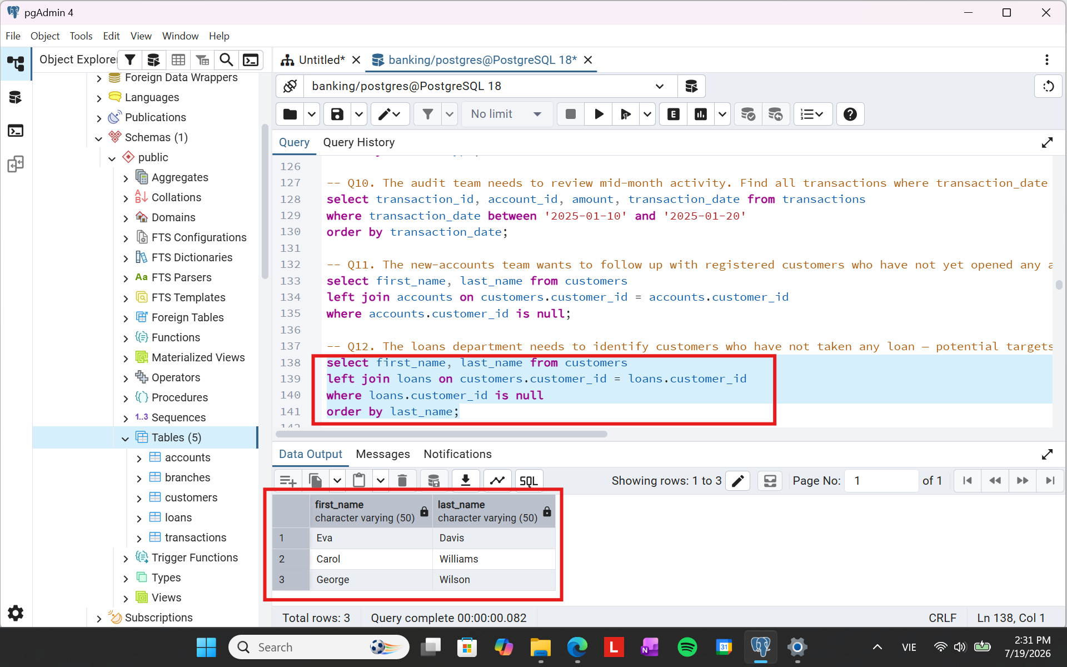

Q13. The relationship management team wants to know how diversified each customer's portfolio is. Show every customer's full name and the number of accounts they hold (including zero). Order by account_count descending, then last name.
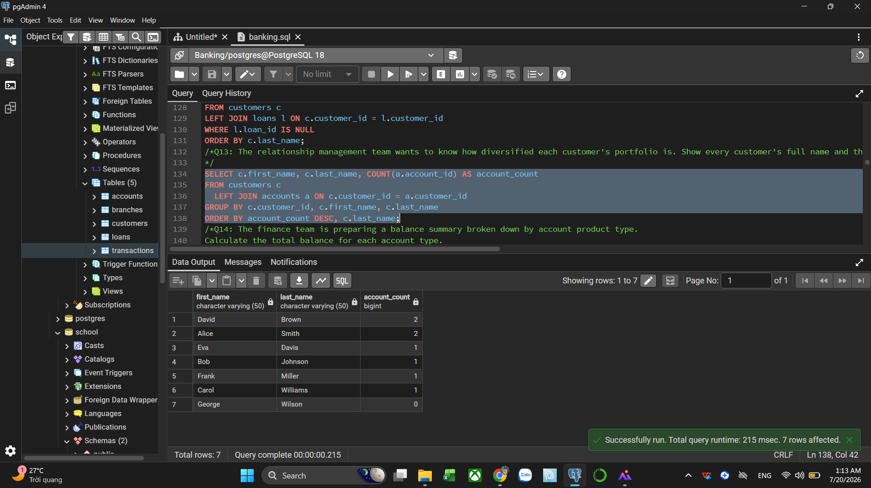

Q14. Calculate the total balance for each account type.
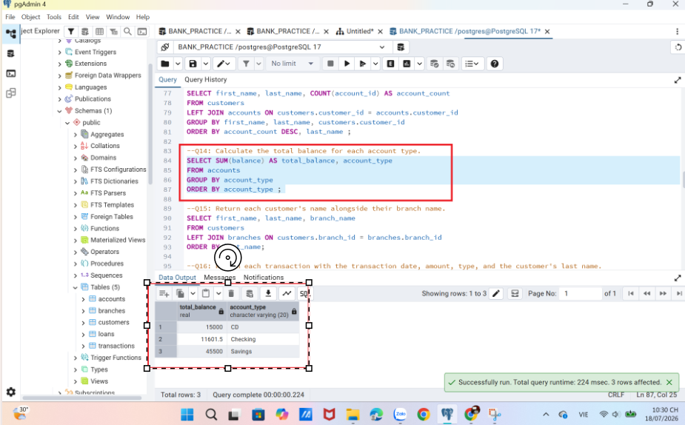

Q15. Return each customer's name alongside their branch name.
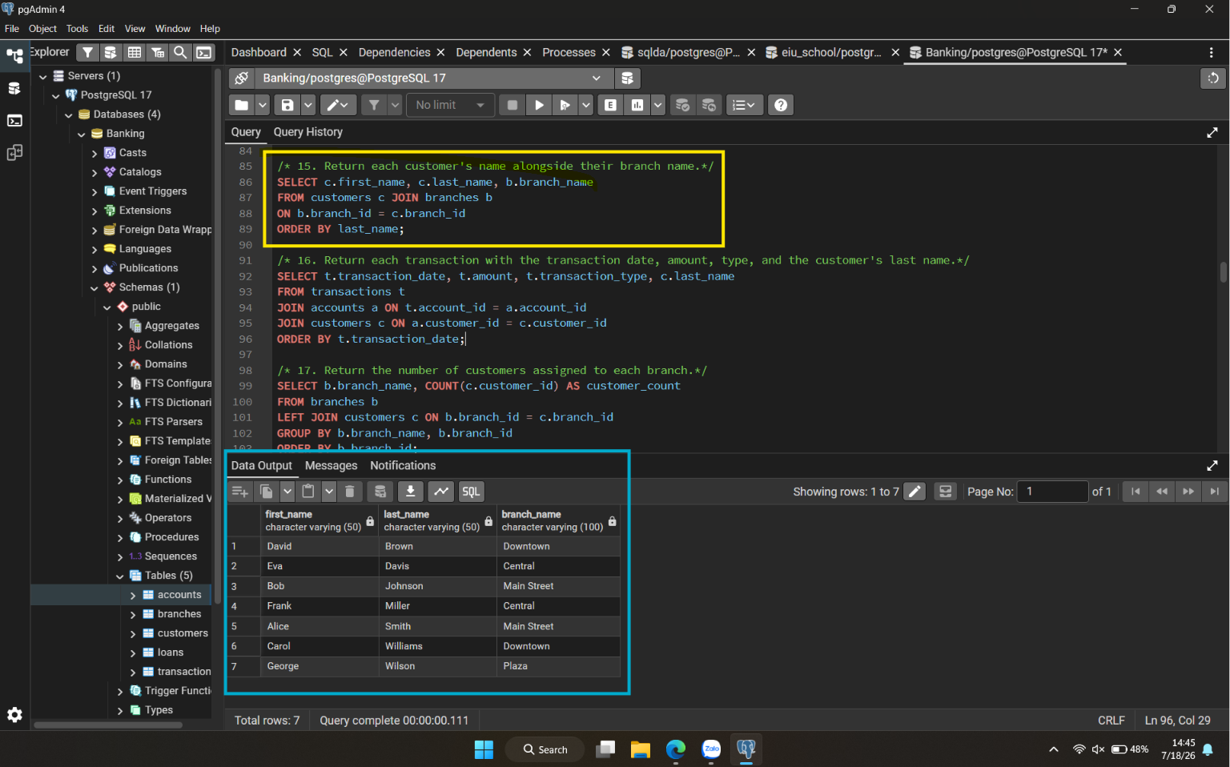
Q16. Return each transaction with the transaction date, amount, type, and the customer's last name.
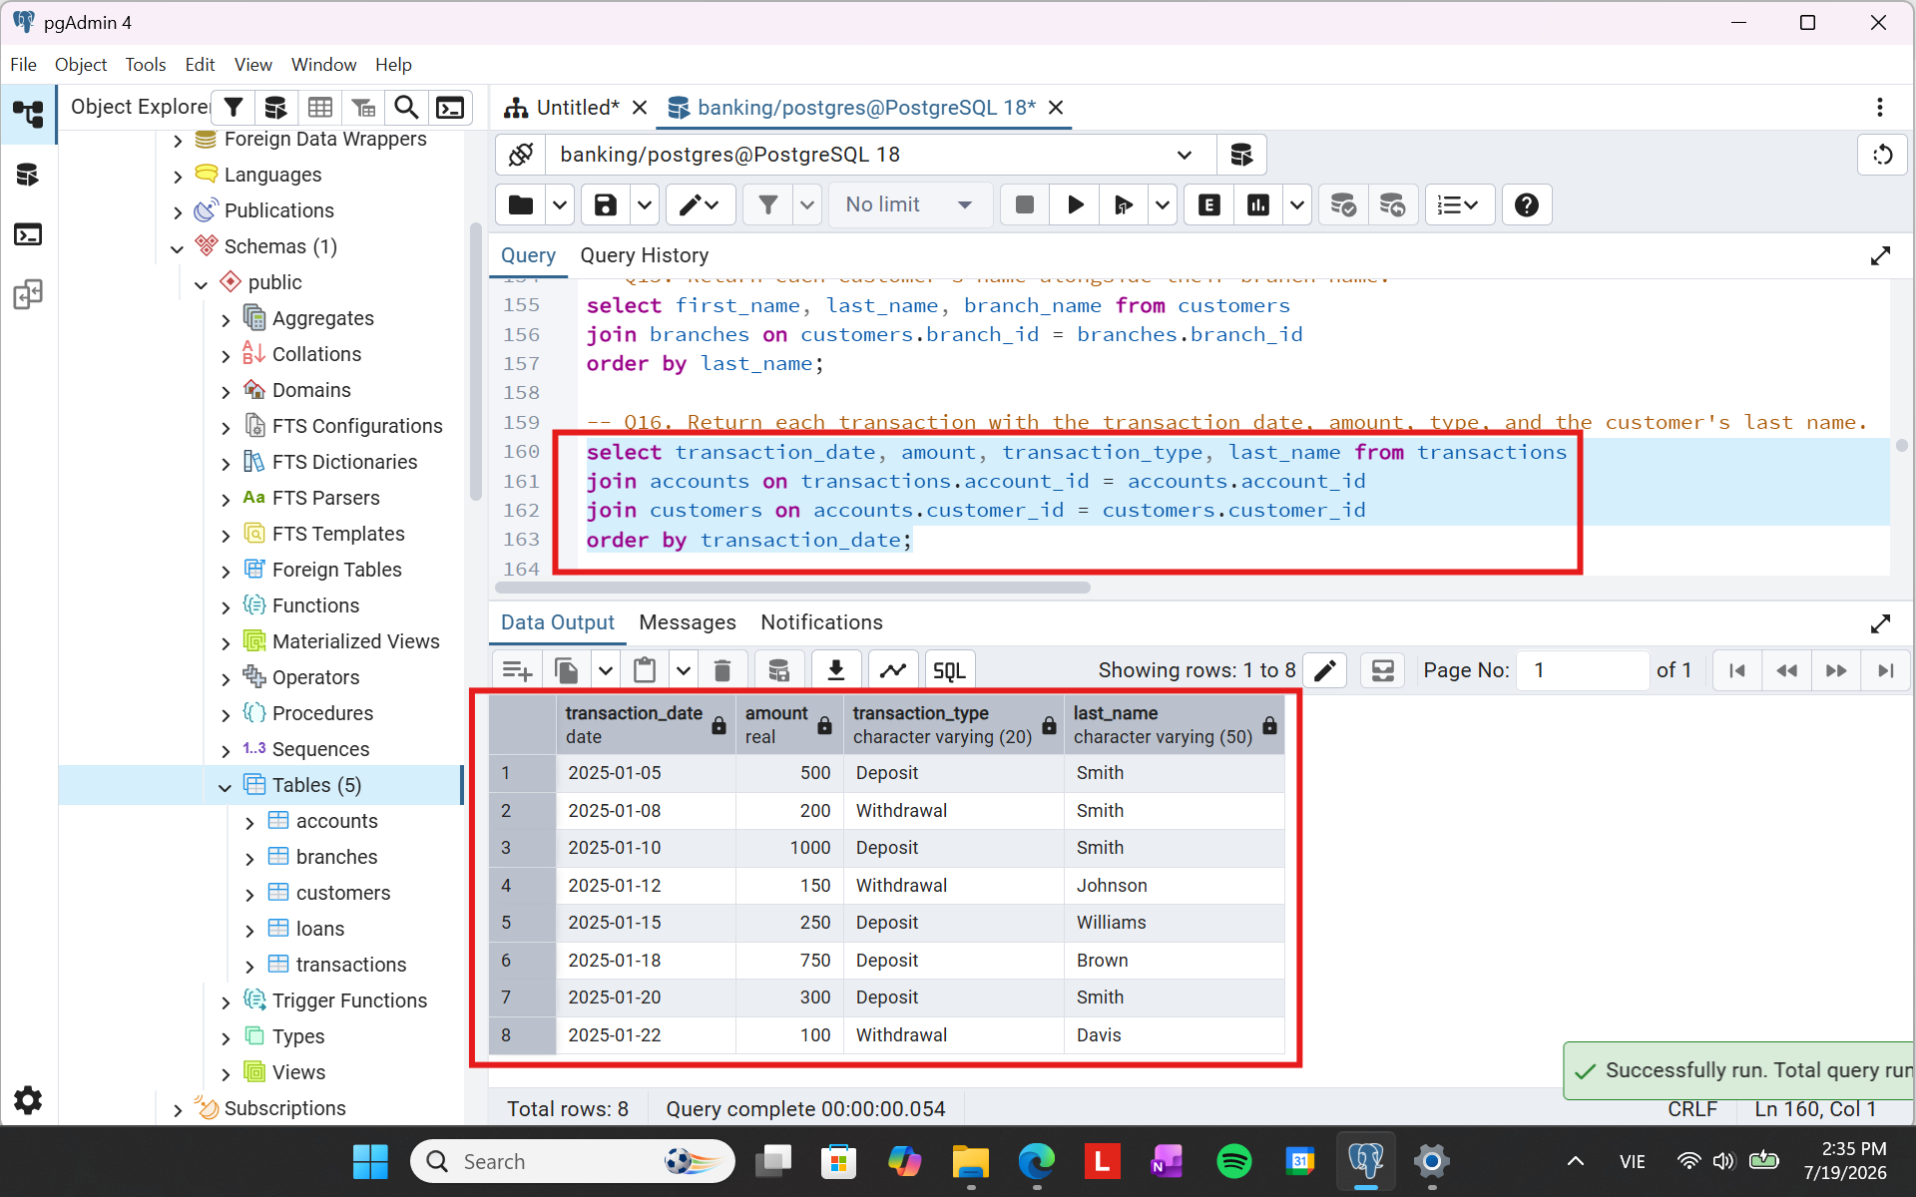

Q17. Return the number of customers assigned to each branch.
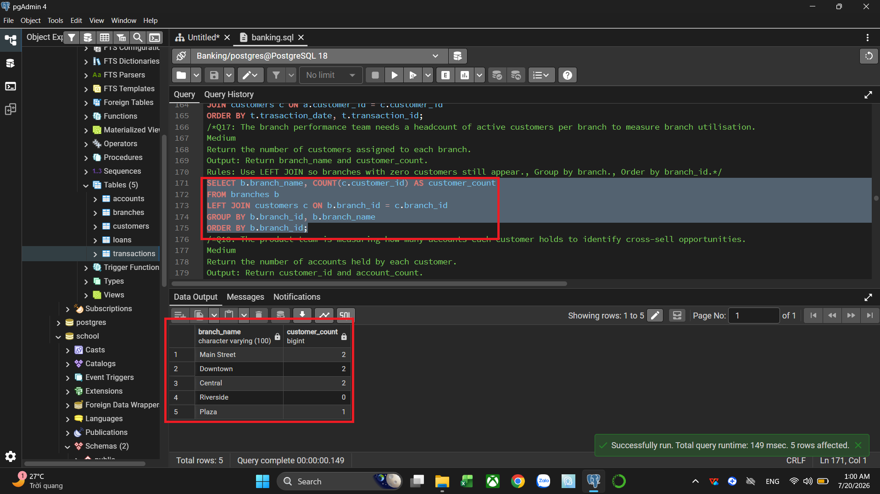

Q18. Return the number of accounts held by each customer.
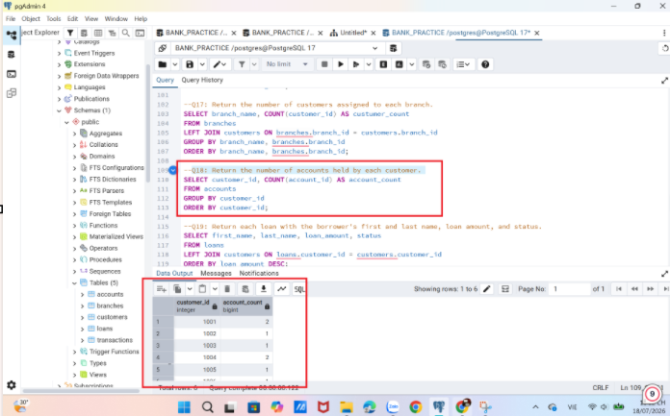

Q19. Return each loan with the borrower's first and last name, loan amount, and status.
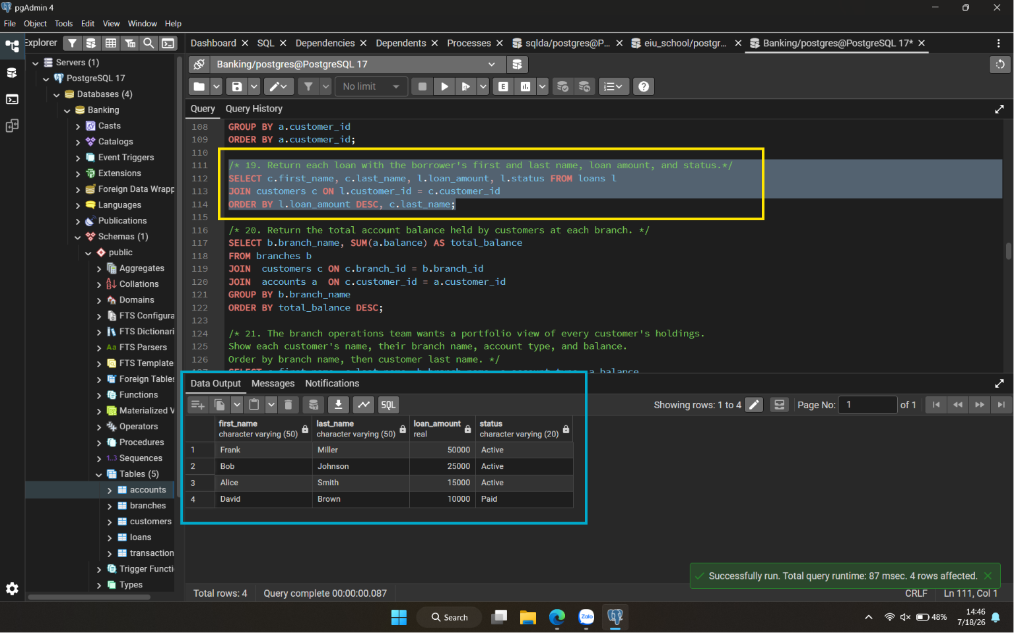

Q20. Return the total account balance held by customers at each branch.
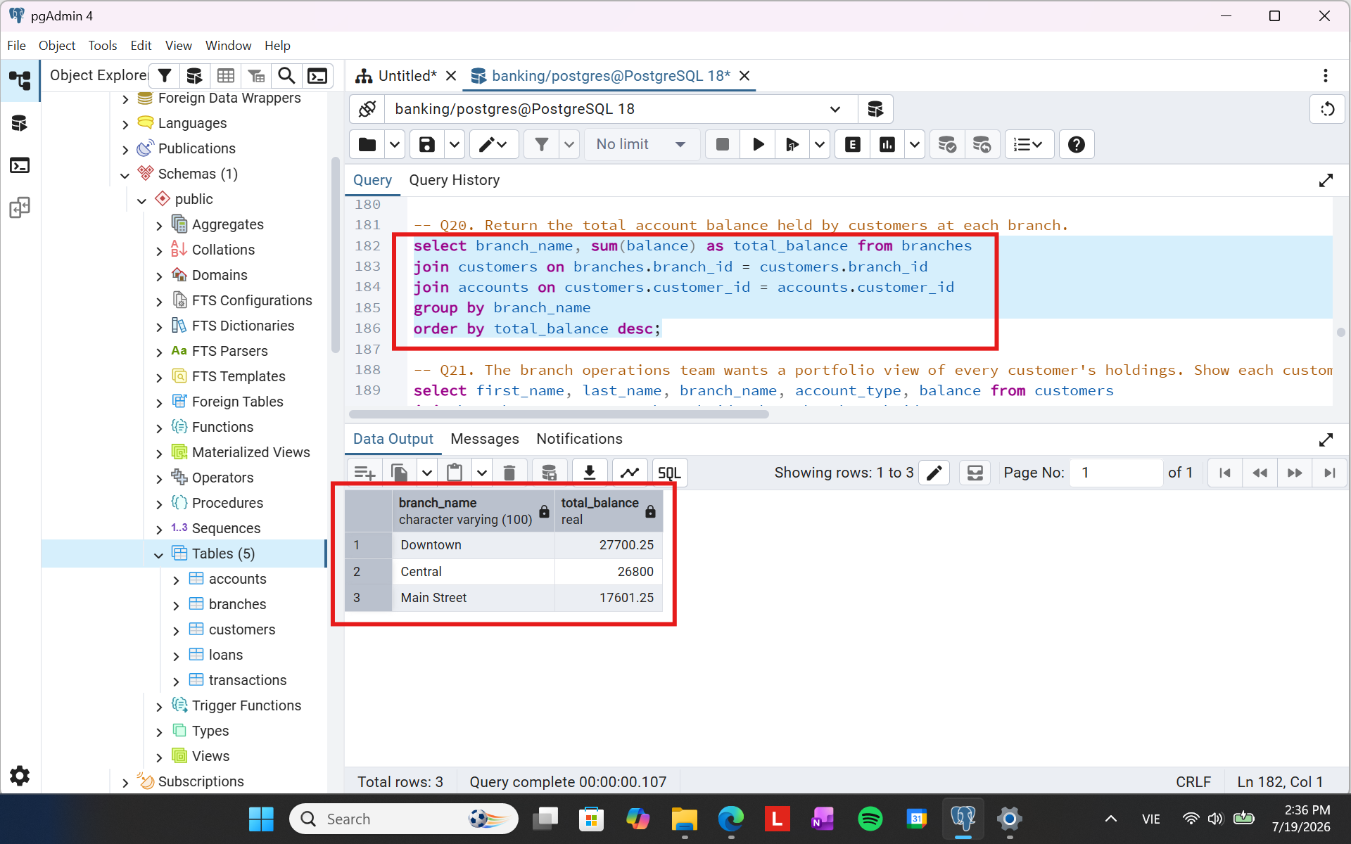

Q21. The branch operations team wants a portfolio view of every customer's holdings. Show each customer's name, their branch name, account type, and balance. Order by branch name, then customer last name.
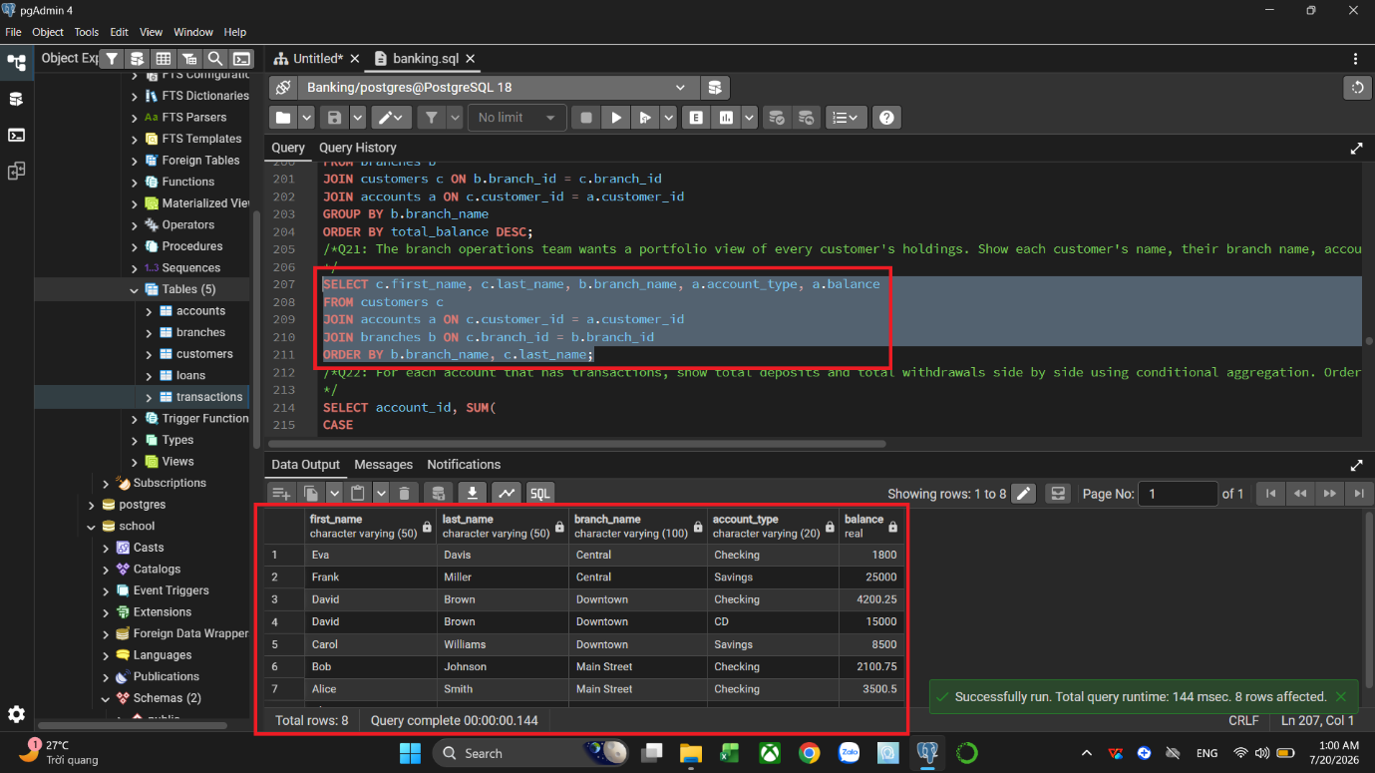
Q22. For each account that has transactions, show total deposits and total withdrawals side by side using conditional aggregation. Order by account_id.
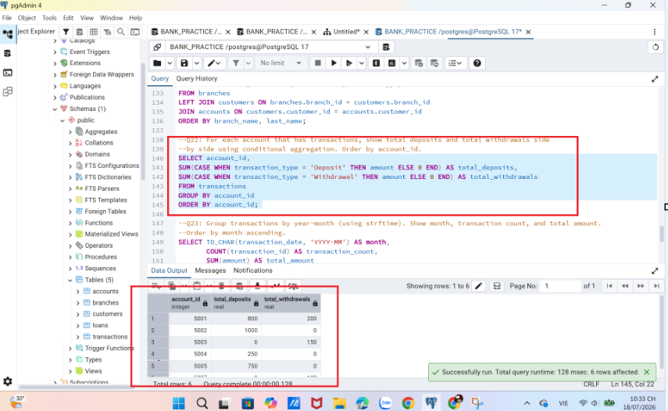

Q23. Group transactions by year-month (using strftime). Show month, transaction count, and total amount. Order by month ascending.
Using the `to_char` function because it is the standard function for formatting dates in PostgreSQL. `strftime` is a function that is only supported by the SQLite database management system. 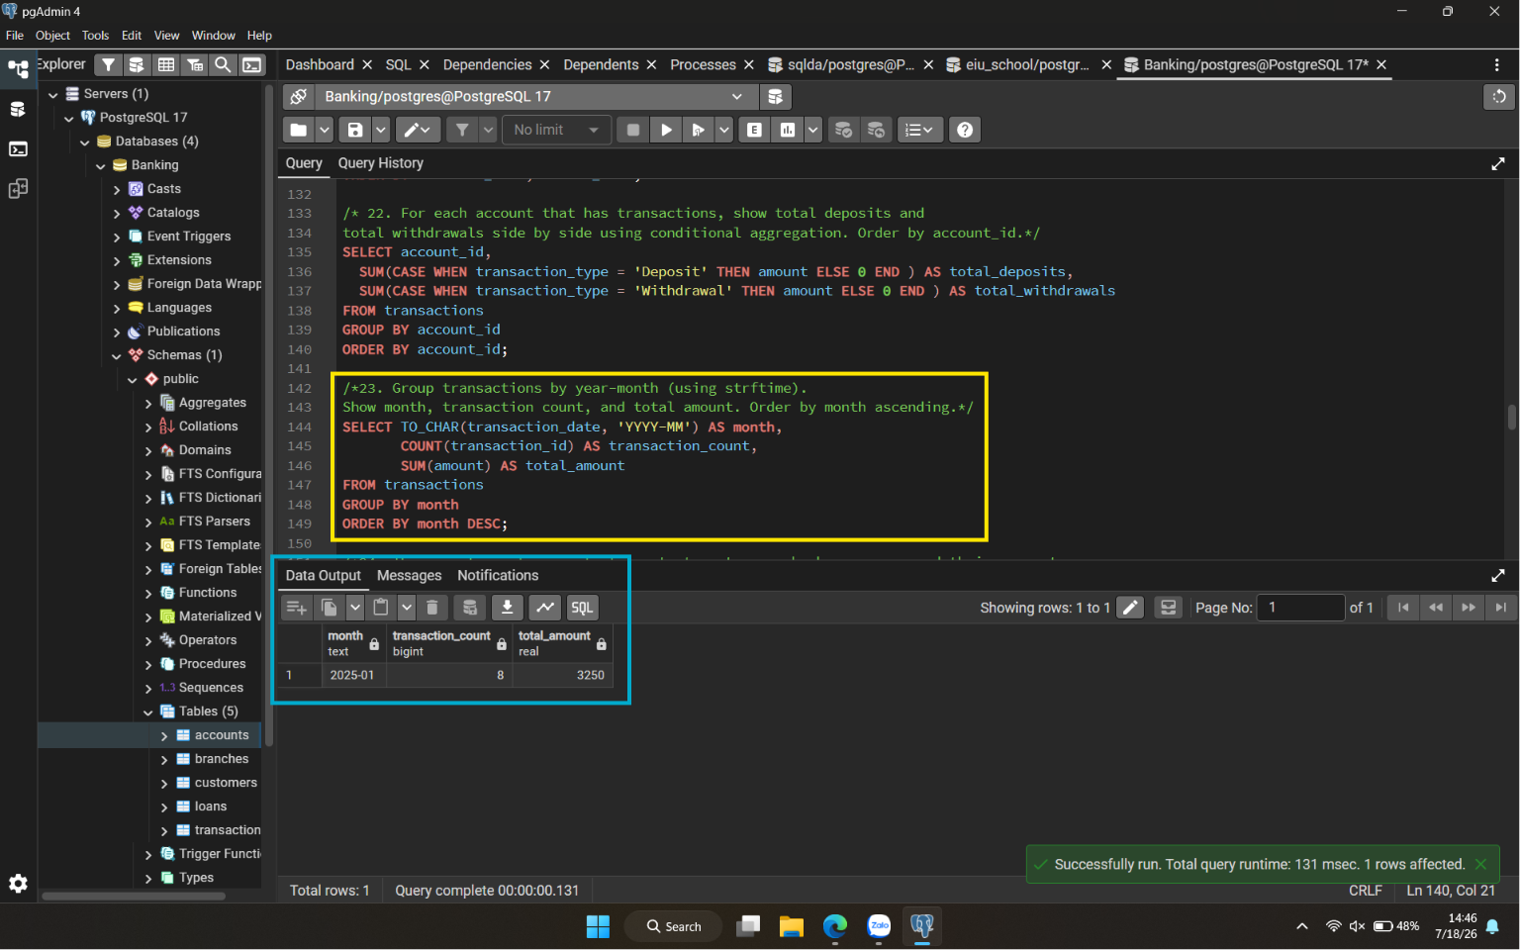

Q24. The operations team wants to contact customers who have never used their accounts. Find customers who have no transactions in any of their accounts. Show first name and last name.
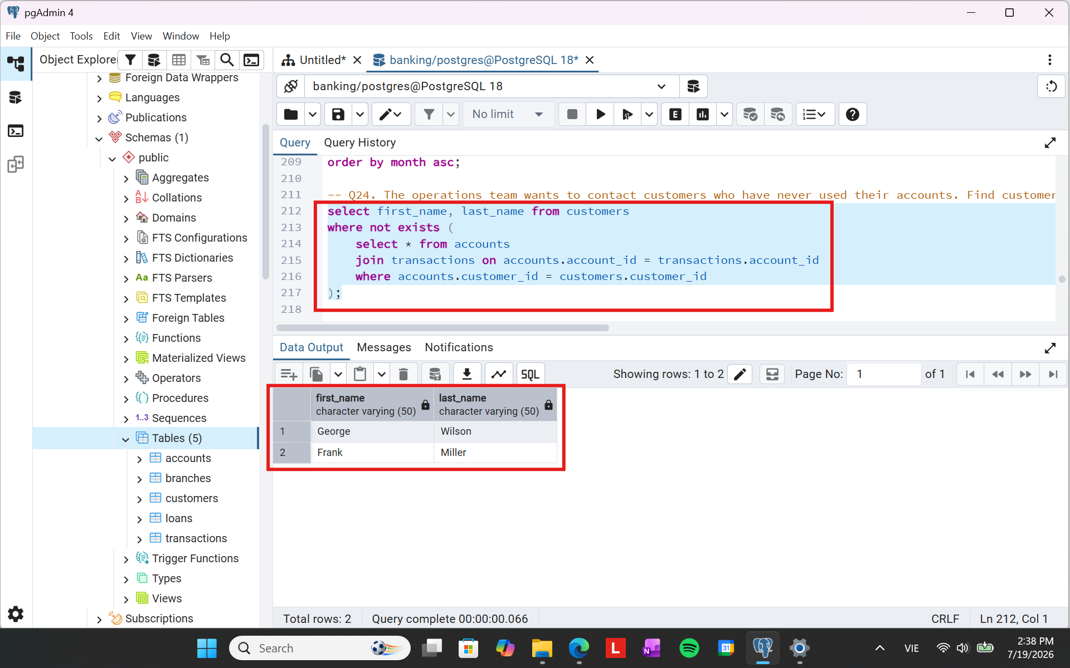
Q25. Create a cash flow list combining all deposits (labelled 'Income') and all withdrawals (labelled 'Expense') into one unified report. Show account_id, amount, flow_type, and transaction_date. Order by transaction_date.
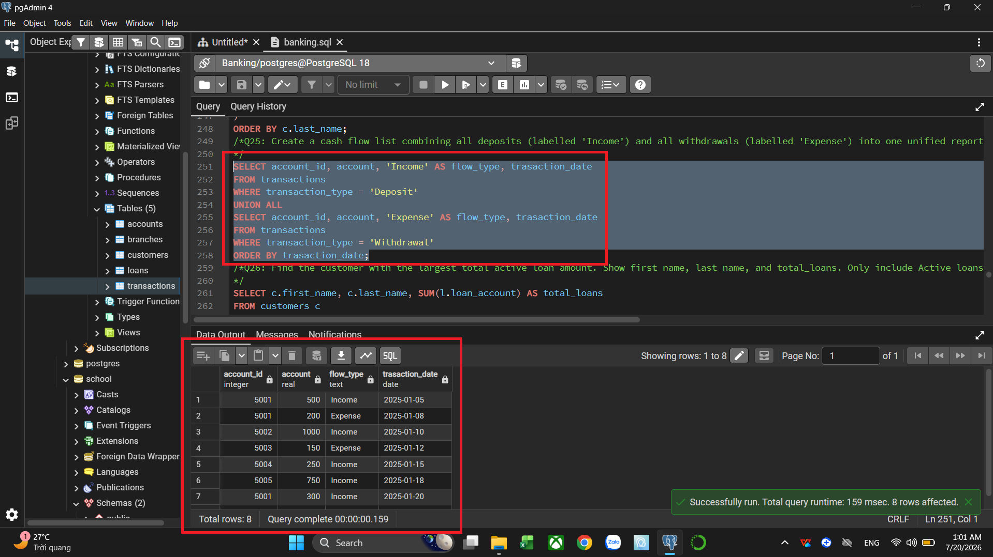
Q26. Find the customer with the largest total active loan amount. Show first name, last name, and total_loans. Only include Active loans.
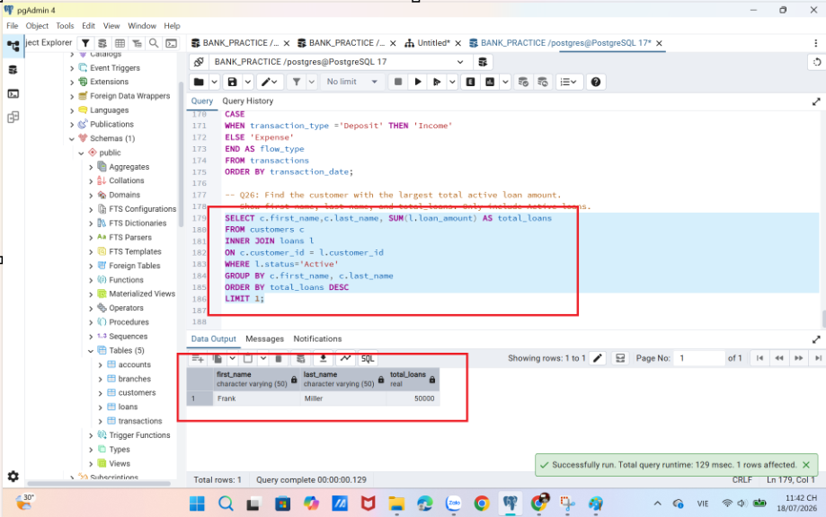
Q27. The wealth management team wants to identify accounts performing above their peer group. Find accounts with a balance above the average balance for their account_type. Show account_id, account_type, balance, and customer name.
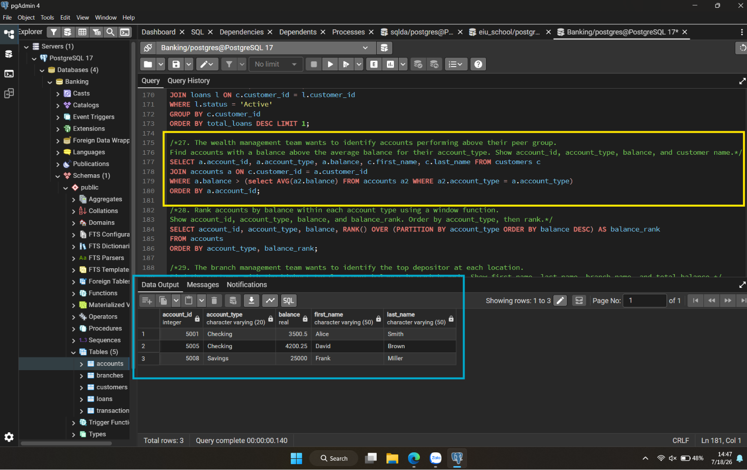
Q28. Rank accounts by balance within each account type using a window function. Show account_id, account_type, balance, and balance_rank. Order by account_type, then rank.
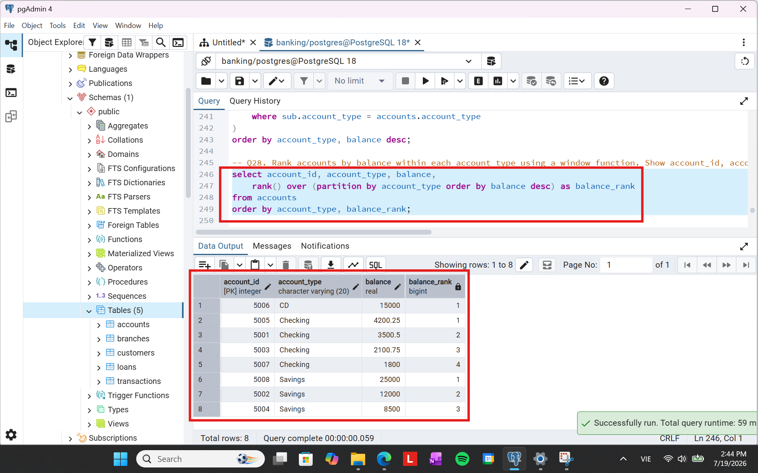

Q29. The branch management team wants to identify the top depositor at each location. Find the customer with the highest total account balance in each branch. Show first name, last name, branch name, and total_balance.
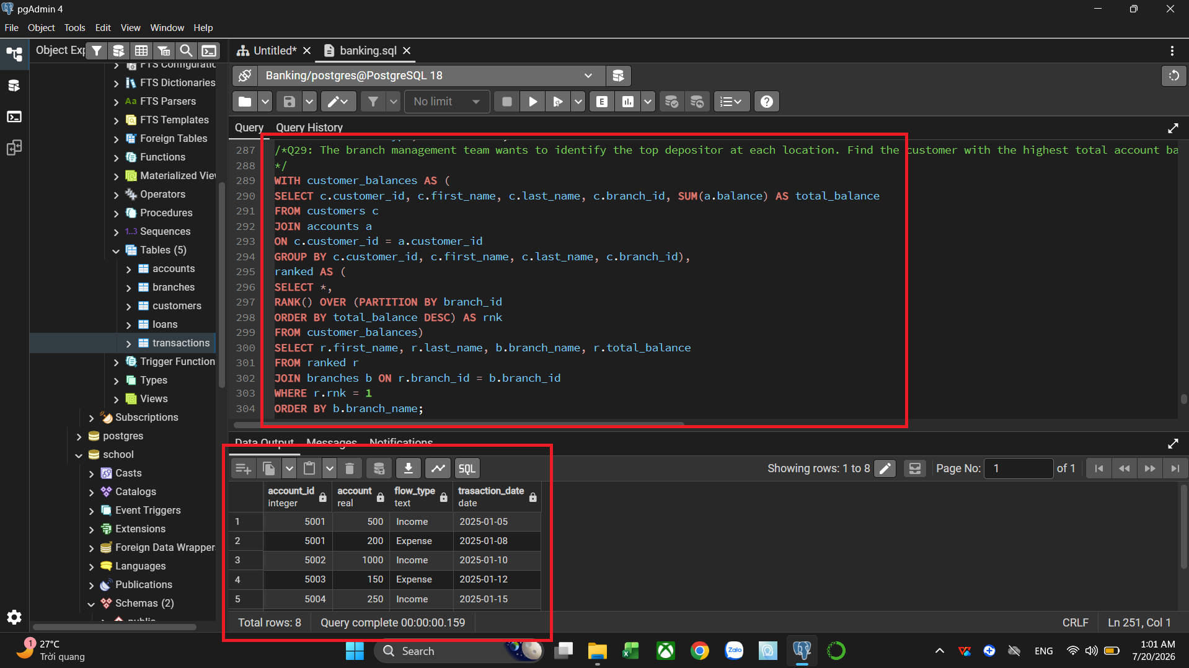
Q30. The product team wants a breakdown of account distribution by balance tier. Using a CTE, classify accounts into tiers: High (balance >= 10000), Medium (balance >= 3000), Low (below 3000). Show each tier's account count, average balance, and total balance. Order by avg_balance descending.
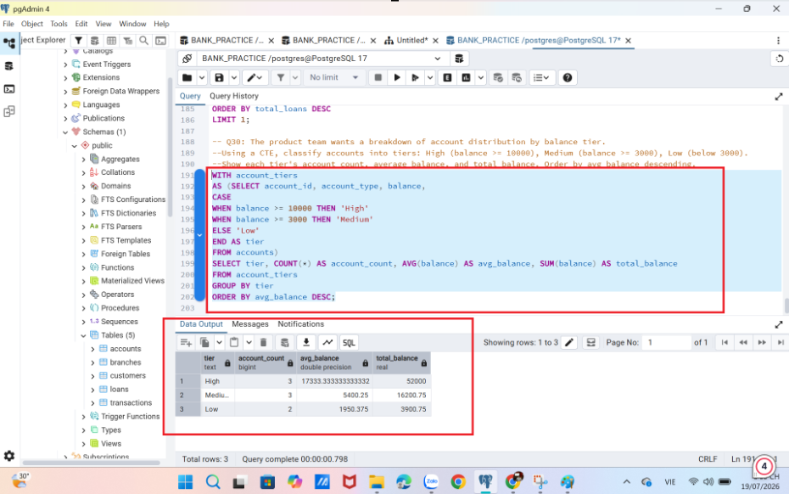

Challenges encountered and solutions applied
Issue | Description | Solution
Issue 1: Maintaining Unrelated Customer Records in Multi-Table Reports | This problem occurred because the standard INNER JOIN queries missed some locations or those clients who do not have active loans and operations with the money. | substituting inner joins with LEFT JOIN clauses, making sure that the reporting output is complete.
Issue 2: Transforming Row Transactions into Column Summaries | The problem that emerged was that the necessity to indicate total deposits and withdrawals at once for one account required separation of the transactions stored in the same column. | conditional aggregation via SUM(CASE WHEN transaction_type = 'Deposit' THEN amount ELSE 0 END).
Issue 3: Excluding Non-Active Entities | The issue was identifying the clients with zero transactions in different accounts, which required checking the nested dependencies of relations. | using the NOT EXISTS clause and correlated subqueries to make it possible to verify the existence of customers, accounts, and transactions.
Issue 4: Multi-Step Ranking and Data Grouping Restrictions | The problem referred to aggregating the top depositors of the branches in the normal GROUP BY statement. | implemented complex operations

Responsibilities and contributions of each member
Member | Tasks | Contributions
Vũ Đông Dương | Tested and captured screenshots for SQL Qs 3, 7, 11, 15, 19, 23, 27. Part 1 (Introduction to the selected database) and Part 2 (Table description) | 25%
Thân Quế Ngọc | Tested and captured screenshots for SQL Qs 4, 8, 12, 16, 20, 24, 28. Assigned project tasks to all members. Aggregated, checked and edited the report. Part 3 (ERD Diagram) and Part 8 (Responsibility) | 25%
Văn Vũ Quỳnh Như | Tested and captured screenshots for SQL Qs 2, 6, 10, 14, 18, 22, 26, 30. Part 5 (Summary table of SQL questions) and Part 7 (Challenges) | 25%
Đỗ Hoàng Bảo | Tested and captured screenshots for SQL Qs 1, 5, 9, 13, 17, 21, 25, 29. Part 4 (Summary of database implementation) and Part 9 (Conclusion) | 25%

Conclusion
This project successfully implemented the Banking database using PostgreSQL based on the SQL Practice Online schema. Throughout the assignment, the complete database development process was performed, including database creation, relational table design, constraint implementation, CSV data import, SQL query development, and project documentation.
A total of five relational tables were created and connected through primary and foreign key constraints to maintain data integrity. The database was populated using CSV datasets and validated before executing the required SQL tasks. All 30 SQL practice questions were completed successfully using a wide range of SQL techniques, from basic queries to advanced features such as conditional aggregation, subqueries, Common Table Expressions (CTEs), and window functions.
In addition to database implementation, the project emphasized good software engineering practices by organizing SQL scripts into separate modules and documenting the entire workflow through GitHub. This structure improves project readability, maintainability, and reproducibility.
Overall, this assignment significantly strengthened practical skills in:
- PostgreSQL database development
- Relational database design
- Primary and Foreign Key implementation
- SQL query development and optimization
- Data import and validation using CSV files
- GitHub project organization and technical documentation
The knowledge and experience gained from this assignment provide a strong foundation for more advanced topics in Business Data Management, Business Analytics, and future data-driven projects. Furthermore, the project demonstrates the ability to apply theoretical database concepts to a realistic banking environment, preparing students for practical database development tasks in academic and professional settings.

