Beyond 99% Accuracy: A Cross-Dataset Audit of NLP and SVM Phishing-URL Detection on the PhiUSIIL Benchmark
[Nama Penulis], [NIM]
Program Studi Teknik Informatika, [Universitas], Indonesia — [email]
Abstract—Phishing-URL detection is frequently benchmarked on the PhiUSIIL dataset, where many studies—including the NLP+SVM pipeline we take as our reference—report near-perfect accuracy (~99.99%). We argue that such figures measure dataset separability rather than deployable detection skill, and we test this claim empirically. First, we replicate the reference pipeline and reproduce 99.99% accuracy. A feature-availability ablation then shows that virtually any subset—structural URL features, page-content features, a single near-deterministic feature, or even raw URL character n-grams—reaches at least 99.7% on PhiUSIIL, so reported method-level gains are statistically indistinguishable from noise. Crucially, we evaluate cross-dataset generalization: a model trained on PhiUSIIL and tested on an independent PhishTank-based dataset collapses to ~49.7% accuracy (chance), while the reverse direction reaches 90%. This asymmetry indicates that PhiUSIIL induces non-transferable shortcuts. Finally, character-level URL n-grams are the only representation that retains cross-dataset ranking ability (AUC 0.94), pointing to character/subword models as the more generalizable direction. Our results caution against single-dataset evaluation in phishing-URL research and provide a reproducible cross-dataset protocol.
Keywords—phishing detection, URL classification, dataset bias, cross-dataset generalization, support vector machine, natural language processing.
I. INTRODUCTION
Phishing remains among the most prevalent cyber-threats: the Anti-Phishing Working Group reported close to one million phishing incidents in a single recent quarter [1]. Because attackers continuously register new deceptive domains, automated URL screening based on machine learning (ML) has become a standard line of defense [2], [12].
The PhiUSIIL Phishing URL Dataset [2] has become a popular benchmark, comprising 235,795 URLs (134,850 legitimate, 100,945 phishing) with 56 attributes extracted from the URL string and the rendered webpage. Numerous studies report accuracies above 99% on this dataset [2], [16], [17]. Our reference study [3] combines natural language processing (NLP) with a support vector machine (SVM) optimized by grid search and reports 99.99% accuracy and an ROC-AUC of 1.0, proposing the model for real-time, in-browser URL screening.
Such near-perfect figures should invite scrutiny rather than celebration. Two questions are rarely asked in this literature: (i) is the reported accuracy attributable to the proposed method, or merely to the separability of the benchmark? and (ii) does a model trained on PhiUSIIL retain any skill on phishing URLs drawn from a different distribution—the actual deployment scenario? To our knowledge, no study in the PhiUSIIL lineage performs an external, cross-dataset validation, a practice that is standard in mature ML evaluation [21].
This paper makes the following contributions:
1) We replicate the reference NLP+SVM pipeline and reproduce its ~99.99% accuracy.
2) Through a feature-availability ablation we show that PhiUSIIL is a saturated benchmark: nearly any feature subset—including raw URL character n-grams—exceeds 99.7%, so method-level gains are not identifiable.
3) We introduce a cross-dataset protocol and show that a PhiUSIIL-trained model collapses to chance (~49.7%) on an independent dataset, while the reverse direction generalizes (90%), evidencing sampling bias.
4) We show that character-level URL representations are the only ones that transfer across datasets (AUC 0.94), indicating a constructive direction for future work.
II. RELATED WORKS
Classical ML approaches dominate early phishing-URL detection. Zamir et al. [12] compared SVM, Random Forest, and Decision Tree on lexical URL features; Shombot et al. [9] implemented an SVM-based predictor; and Kumar et al. [13] combined SVM with NLP and a probabilistic neural network for email phishing. These models rely on static, hand-crafted features that degrade as attack patterns evolve [11].
NLP-oriented work treats the URL as text. Kalla and Kuraku [6] applied tokenization and word embeddings, and Aung and Yamana [4], [5] proposed segmentation-based NLP features. Character-level convolutional models [14] and transformer architectures [8], [15] further improve in-distribution accuracy at higher computational cost [7], [10]. Reviews [10], [11] confirm strong reported performance but note inconsistent evaluation protocols.
On PhiUSIIL specifically, the dataset framework [2] introduces a URL similarity index and incremental learning, and subsequent studies [3], [16], [17] report 99–100% accuracy. None of these works evaluate transfer to an independent dataset. Methodologically, data leakage and optimistic in-distribution estimates are well documented [21]: high accuracy can reflect dataset construction artifacts rather than genuine predictive skill. Our study operationalizes this concern for phishing-URL detection through an explicit cross-dataset audit.
III. PROPOSED METHOD
A. Datasets
D1 (PhiUSIIL) [2] is the reference benchmark (235,795 URLs; label 1 = legitimate, 0 = phishing). D2 is the independent PhishDataset of Aung and Yamana [5], a balanced set of 20,000 URLs (10,000 phishing from PhishTank, 10,000 legitimate from IP2Location; label 1 = phishing). We unify the convention so that phishing = 1 in both datasets.
B. Unified Feature Extraction
To ensure that only the data distribution—not the feature definition—differs across datasets, we implement a single lexical extractor applied identically to both. It computes 22 features from the raw URL string alone (length of URL/host/path; counts of dots, hyphens, underscores, slashes, query symbols, equals, '@', ampersands, percent signs; digit count and ratio; special-character count and ratio; presence of an IP host; HTTPS scheme; subdomain count; presence of '@'; TLD length; longest alphanumeric token). In parallel we extract character n-gram (3–5) TF-IDF features (max 20,000) directly from the URL string to represent the NLP view.
C. Models and Evaluation Protocol
We train a linear SVM (faithful to the reference code), Random Forest, and Logistic Regression. Three protocols are used: (i) in-distribution—train and test on PhiUSIIL via an 80/20 stratified split and 5-fold cross-validation; (ii) cross-dataset—train on PhiUSIIL, test on the full PhishDataset; and (iii) reverse—train on PhishDataset, test on PhiUSIIL. Metrics are accuracy, precision, recall, F1-score, ROC-AUC, and confusion matrices. Standardization is fit on the training partition only to avoid preprocessing leakage.
IV. EXPERIMENTAL SETUP
Experiments use Python with scikit-learn. The linear SVM uses C = 1.0; Random Forest uses 200 trees; character TF-IDF uses analyzer = char_wb, n-gram range (3,5), and 20,000 maximum features. All splits use a fixed random seed (42) and stratification. The canonical PhiUSIIL CSV (235,795 × 56) was verified against the official class counts (134,850 / 100,945) with no duplicate rows.
V. RESULTS AND DISCUSSION
A. Replication and Benchmark Saturation
Using all 50 numeric features, the linear SVM reproduces the reference result: 99.99% accuracy, F1 0.9999, AUC 1.0. Table I shows that performance barely changes across radically different feature subsets. Removing URLSimilarityIndex—a near-deterministic feature (value 100.0 for every legitimate URL, correlation 0.86 with the label)—leaves accuracy at 99.98%, because the signal is redundant. Even URL-string-only features (available before visiting the page) reach 99.66%, and raw URL character n-grams reach 99.78%. Five-fold cross-validation is consistent (F1 0.9999 and 0.9972). Because every reasonable representation saturates, the specific NLP+SVM+grid-search combination cannot be credited with the reported performance.
Feature set (SVM linear) | Acc | F1 | AUC
FULL (50 features, = paper) | 0.9999 | 0.9999 | 1.0000
minus URLSimilarityIndex | 0.9998 | 0.9999 | 1.0000
URL-only (21, pre-visit) | 0.9966 | 0.9971 | 0.9982
Content-only (needs page fetch) | 0.9957 | 0.9962 | 0.9998
NLP-only (URL char 3–5 gram) | 0.9978 | 0.9981 | 0.9989
URL-struct + NLP (combined) | 0.9981 | 0.9983 | 0.9990
TABLE I. Feature-availability ablation on PhiUSIIL (in-distribution).
B. Cross-Dataset Generalization
The picture inverts under cross-dataset evaluation (Table II, Fig. 1). A model that scores 99.3–99.8% on a PhiUSIIL hold-out drops to 49.6–49.8% accuracy—statistical chance—on the independent PhishDataset; the Random Forest reaches AUC 0.496, indicating no transferable signal at all. The confusion matrices in Fig. 2 show that the cross-dataset model degenerates into predicting almost everything as phishing. The near-perfect in-distribution scores therefore do not reflect deployable phishing-detection skill.
Model / features | In-dist (PhiUSIIL) | Cross (PhishDataset) | —
SVM lexical | acc 0.993 / AUC 0.997 | acc 0.496 / AUC 0.790
RF lexical | acc 0.996 / AUC 0.998 | acc 0.498 / AUC 0.496
SVM NLP char | acc 0.998 / AUC 0.999 | acc 0.613 / AUC 0.940
TABLE II. In-distribution vs. cross-dataset performance.
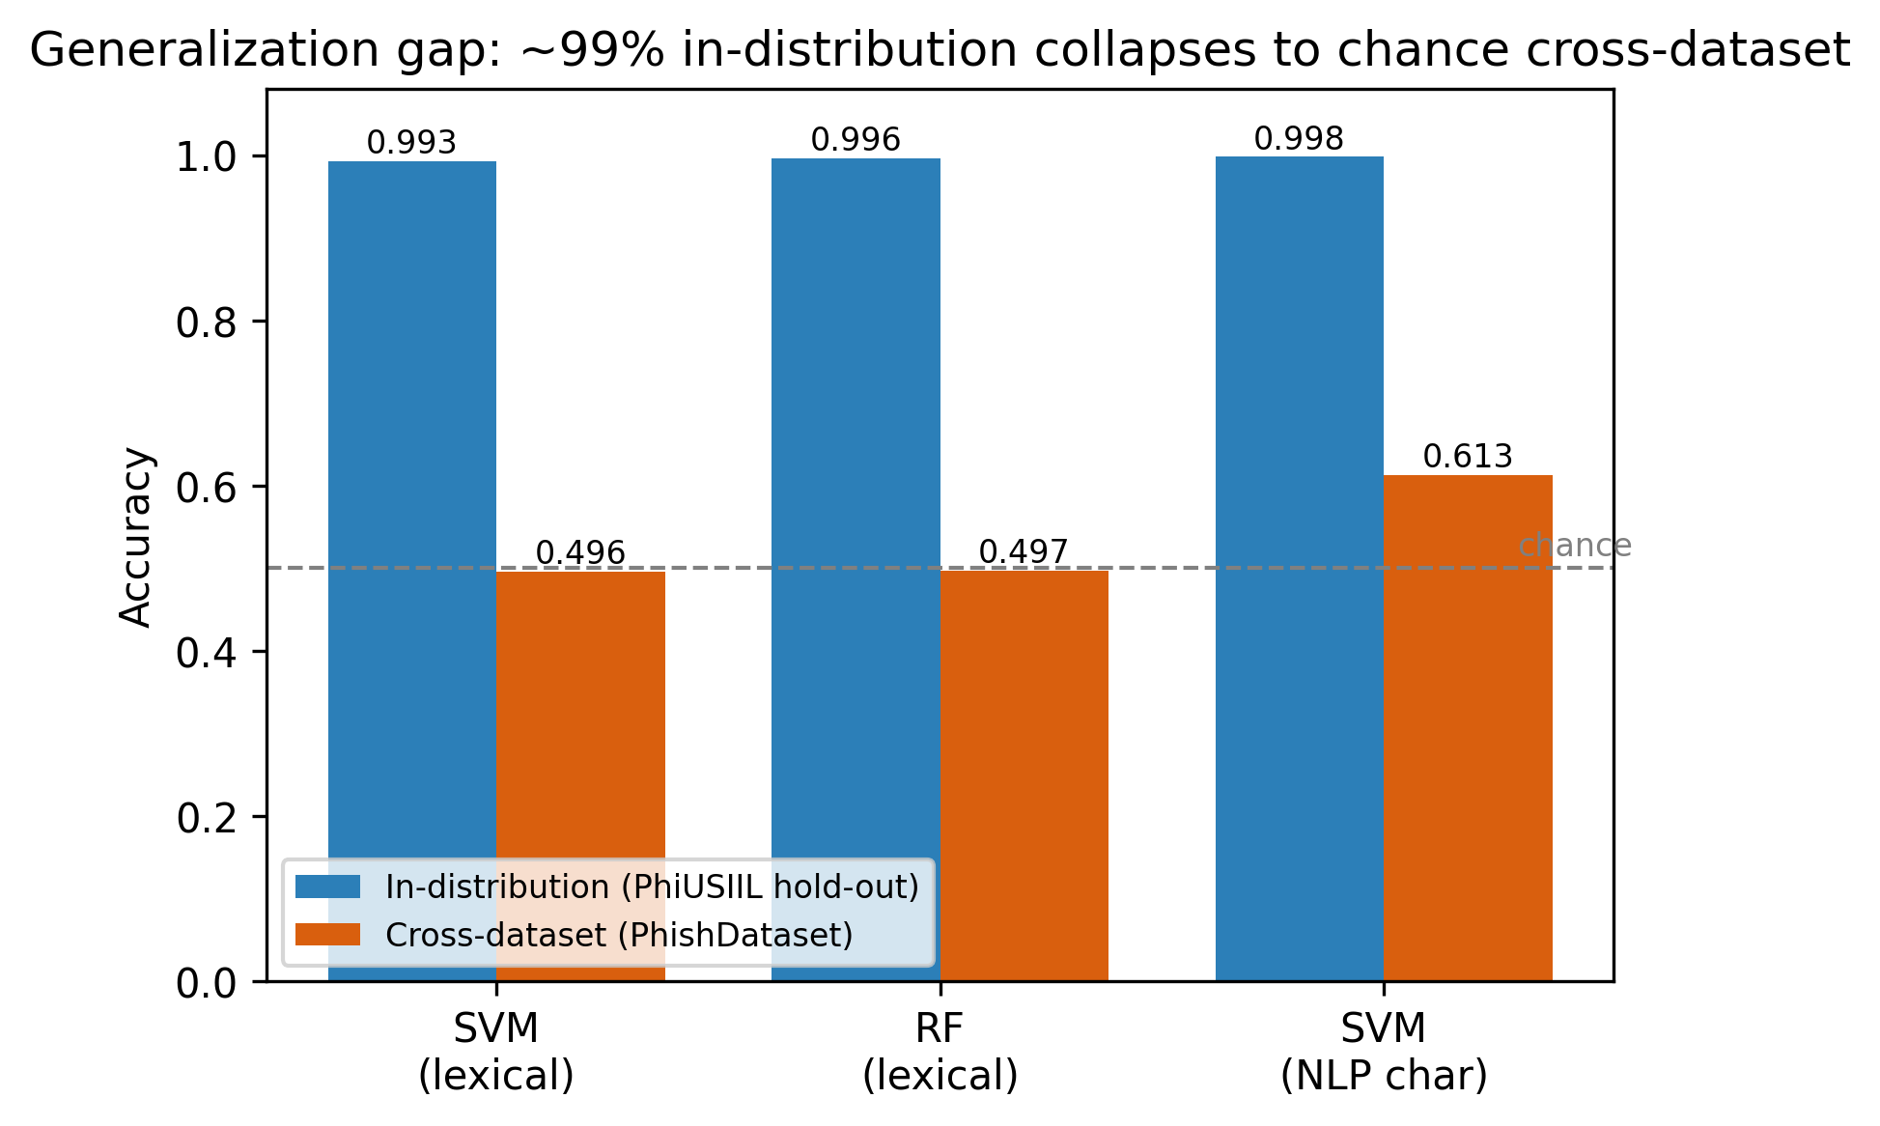
Fig. 1. In-distribution accuracy (~99%) collapses to chance on an independent dataset.
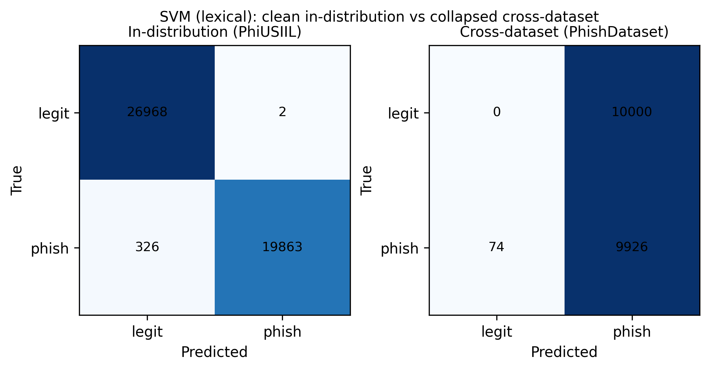
Fig. 2. SVM (lexical): clean in-distribution vs. collapsed cross-dataset behavior.
C. Asymmetry and Sampling Bias
Reversing the direction is revealing (Fig. 4). A model trained on the smaller but more realistic PhishDataset reaches 90.1% accuracy (AUC 0.974) on PhiUSIIL, whereas the PhiUSIIL-trained model achieves only ~50% on PhishDataset. This asymmetry indicates that PhiUSIIL's legitimate and phishing URLs are separable by incidental characteristics of how each class was collected—shortcuts that do not exist in independently sourced phishing data. In other words, PhiUSIIL teaches non-transferable patterns.
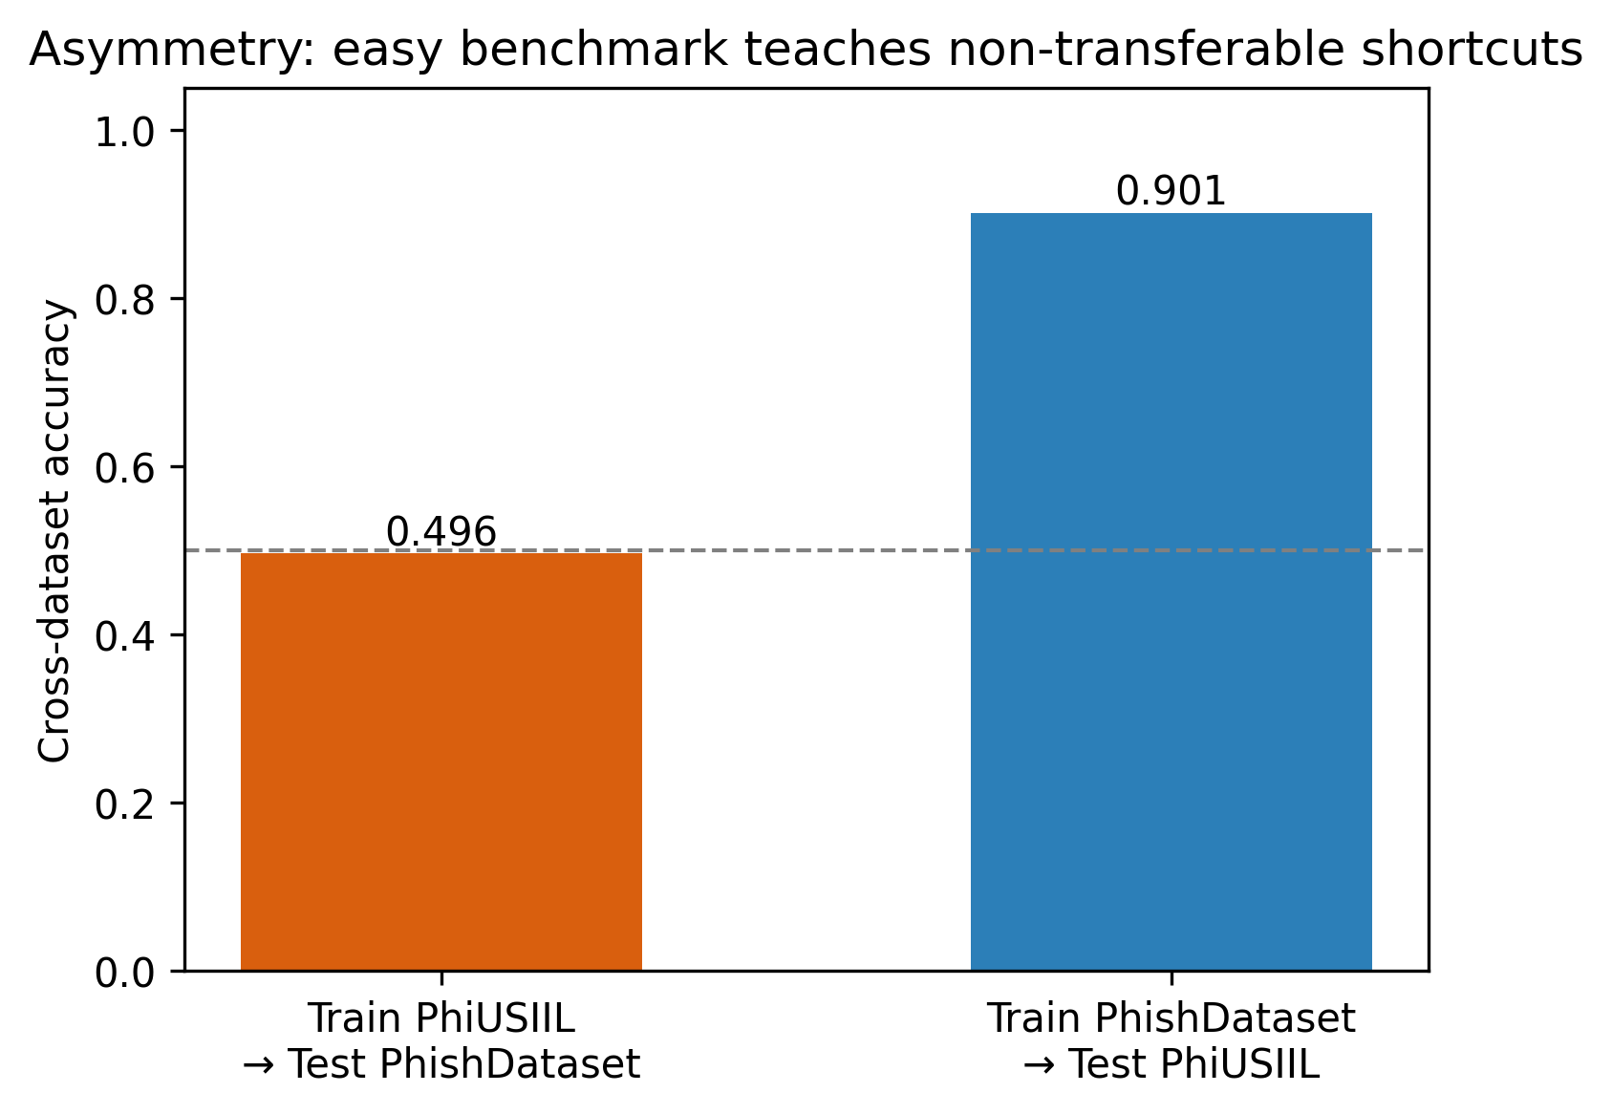
Fig. 4. Asymmetric transfer: the easy benchmark teaches non-transferable shortcuts.
D. NLP Isolation: The Only Transferable Signal
Although NLP adds little in-distribution (combined features improve on URL-structural features by only ~0.1%), character-level n-grams behave differently across datasets. While their cross-dataset accuracy also falls (to 61.3%) due to an uncalibrated decision threshold, they retain a cross-dataset ROC-AUC of 0.940 (Fig. 3)—substantially better than lexical features (0.790 for SVM, 0.496 for RF). Character-level URL representations thus capture distribution-robust regularities that hand-crafted lexical features do not, suggesting subword/transformer URL encoders and threshold calibration as promising directions.
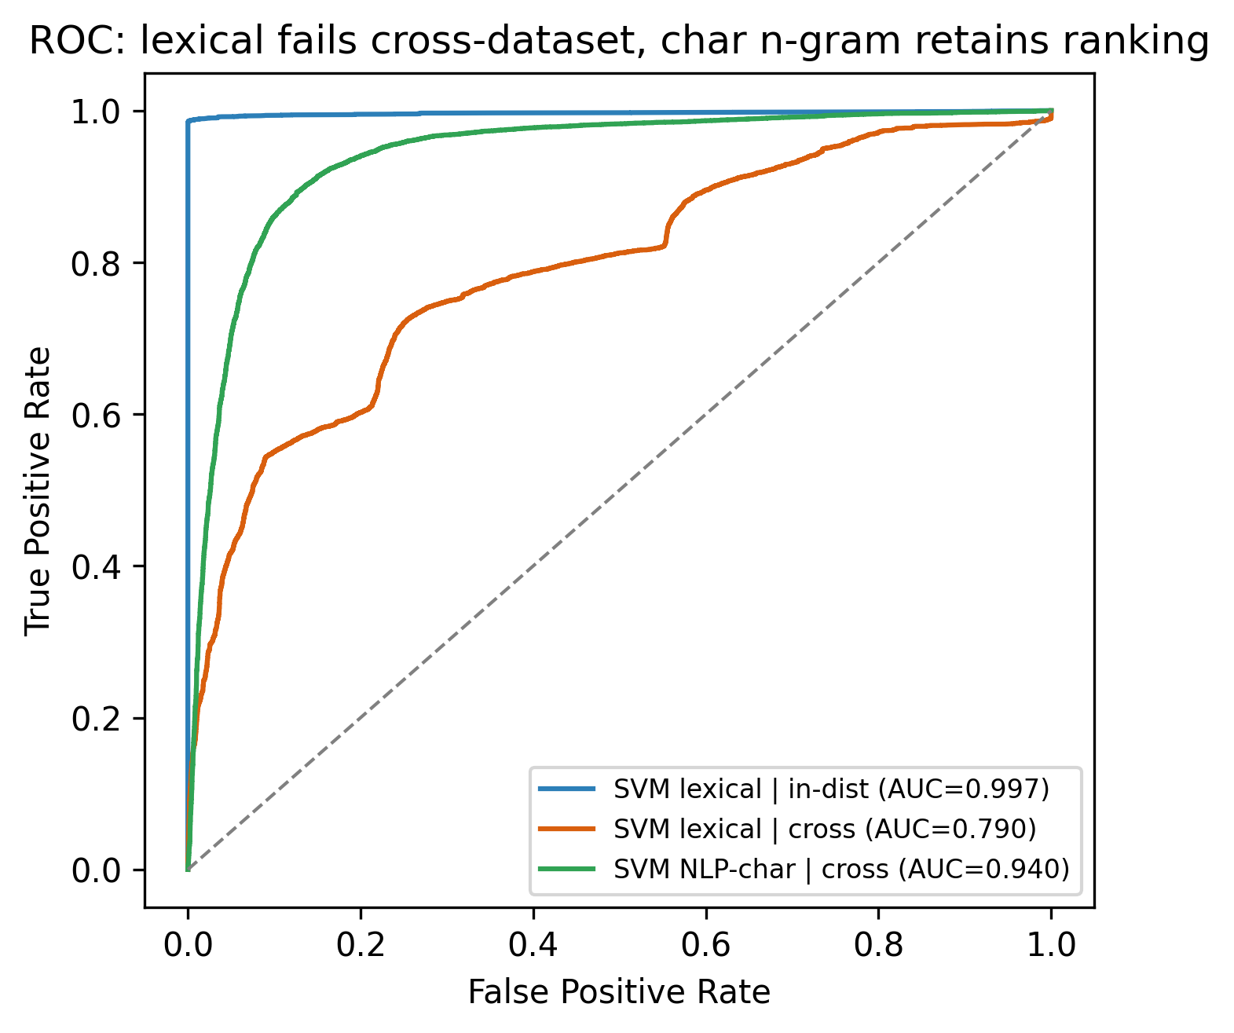
Fig. 3. ROC: lexical features fail to transfer; character n-grams retain ranking ability.
E. Discussion and Limitations
Our findings recontextualize the reference study's 99.99%: the figure is reproducible but benchmark-specific and does not indicate real-world utility. We do not claim the reference method is incorrect on PhiUSIIL; rather, the benchmark cannot discriminate method quality, and single-dataset evaluation overstates capability. Limitations include the use of one external dataset (D2) and a fixed threshold in cross-dataset testing; calibrated thresholds and additional datasets (e.g., Mendeley [23]) would refine the magnitude—though not the direction—of the observed gap.
VI. CONCLUSION
Near-perfect accuracy on PhiUSIIL reflects dataset separability rather than transferable phishing-detection skill: any feature subset exceeds 99.7% in-distribution, yet a PhiUSIIL-trained model performs at chance on an independent dataset, and the transfer is strongly asymmetric. Character-level URL representations are the only ones that generalize in ranking. We recommend that phishing-URL studies adopt cross-dataset evaluation as standard and explore character/subword encoders with threshold calibration and domain adaptation. Future work will extend the protocol to additional datasets and calibrated operating points.
REFERENCES
[1] Anti-Phishing Working Group, “Phishing Activity Trends Report,” 2024–2025. [Online]. Available: https://www.apwg.org
[2] A. Prasad and S. Chandra, “PhiUSIIL: A diverse security profile empowered phishing URL detection framework based on similarity index and incremental learning,” Computers & Security, vol. 136, 103545, 2024, doi: 10.1016/j.cose.2023.103545.
[3] M. A. S. Aritonang, M. J. Simanulang, T. P. Batubara, I. Zega, and M. H. Afrizal, “Natural Language Processing (NLP) and Support Vector Machine (SVM) Optimization in Detecting Phishing Website URLs,” Jurnal Teknik Informatika (JUTIF), vol. 7, no. 1, pp. 552–570, 2026, doi: 10.52436/1.jutif.2026.7.1.5334.
[4] E. S. Aung and H. Yamana, “PhiSN: Phishing URL Detection Using Segmentation and NLP Features,” Journal of Information Processing, vol. 32, pp. 973–989, 2024, doi: 10.2197/ipsjjip.32.973.
[5] E. S. Aung and H. Yamana, “Segmentation-based Phishing URL Detection,” in Proc. IEEE/WIC/ACM Int. Conf. Web Intelligence (WI-IAT ’21), 2021, doi: 10.1145/3486622.3493983.
[6] D. Kalla and S. Kuraku, “Phishing Website URL’s Detection Using NLP and Machine Learning Techniques,” Journal on Artificial Intelligence, vol. 5, pp. 145–162, 2023, doi: 10.32604/jai.2023.043366.
[7] Q. E. ul Haq, M. H. Faheem, and I. Ahmad, “Detecting Phishing URLs Based on a Deep Learning Approach to Prevent Cyber-Attacks,” Applied Sciences, vol. 14, no. 22, 10086, 2024, doi: 10.3390/app142210086.
[8] S. Asiri, Y. Xiao, and T. Li, “PhishTransformer: A Novel Approach to Detect Phishing Attacks Using URL Collection and Transformer,” Electronics, vol. 13, no. 1, 30, 2024, doi: 10.3390/electronics13010030.
[9] E. S. Shombot, G. Dusserre, R. Bestak, and N. B. Ahmed, “An application for predicting phishing attacks: A case of implementing a support vector machine learning model,” Cyber Security and Applications, vol. 2, 100036, 2024, doi: 10.1016/j.csa.2024.100036.
[10] C. Catal, G. Giray, B. Tekinerdogan, S. Kumar, and S. Shukla, “Applications of deep learning for phishing detection: a systematic literature review,” Knowledge and Information Systems, vol. 64, no. 6, pp. 1457–1500, 2022, doi: 10.1007/s10115-022-01672-x.
[11] A. Safi and S. Singh, “A systematic literature review on phishing website detection techniques,” Journal of King Saud University – Computer and Information Sciences, vol. 35, no. 2, pp. 590–611, 2023, doi: 10.1016/j.jksuci.2023.01.004.
[12] A. Zamir et al., “Phishing web site detection using diverse machine learning algorithms,” The Electronic Library, vol. 38, no. 1, pp. 65–80, 2020, doi: 10.1108/EL-05-2019-0118.
[13] A. Kumar, J. M. Chatterjee, and V. G. Díaz, “A novel hybrid approach of SVM combined with NLP and probabilistic neural network for email phishing,” Int. J. Electrical and Computer Engineering, vol. 10, no. 1, pp. 486–493, 2020, doi: 10.11591/ijece.v10i1.pp486-493.
[14] A. Aljofey, Q. Jiang, Q. Qu, M. Huang, and J. P. Niyigena, “An effective phishing detection model based on character level convolutional neural network from URL,” Electronics, vol. 9, no. 9, 1514, 2020, doi: 10.3390/electronics9091514.
[15] M. A. Uddin, M. Mahiuddin, and I. H. Sarker, “An Explainable Transformer-based Model for Phishing Email Detection: A Large Language Model Approach,” arXiv:2402.13871, 2024.
[16] A. J. John-Otumu, V. O. Aniugo, and V. C. Nwachukwu, “HyRANN-UPD: Enhancing Phishing URL Detection using Ridge Regression-based Feature Selection and Artificial Neural Networks,” Int. J. Computer Applications, vol. 186, no. 78, 2025.
[17] S. Javaid and M. Muslih, “Real-Time Phishing URL Detection Using Machine Learning,” Engineering Proceedings (MDPI), vol. 107, 108, 2025.
[18] K. Barik, S. Misra, and R. Mohan, “Web-based phishing URL detection model using deep learning optimization techniques,” Int. J. Data Science and Analytics, 2025.
[19] R. Liu et al., “PMANet: Malicious URL detection via post-trained language model guided multi-level feature attention network,” Information Fusion, vol. 113, 102638, 2025.
[20] O. K. Sahingoz, E. Buber, and E. Kugu, “DEPHIDES: Deep Learning Based Phishing Detection System,” IEEE Access, 2024.
[21] C. K. Yeh et al., “Data Leakage in Notebooks: Static Detection and Better Processes,” arXiv:2209.03345, 2022.
[22] C. Cortes and V. Vapnik, “Support-vector networks,” Machine Learning, vol. 20, pp. 273–297, 1995.
[23] S. Saeed, L. Fotia, M. J. M. Chowdhury, and M. A. Tamal, “Dataset of suspicious phishing URL detection,” Mendeley Data, 2024, doi: 10.17632/6tm2d6sz7p.1.

