100 Examples Of Teaching PowerBuilder Basic

1-Create Applications Windows And Controls  
2-Directory Browser  
3-File Browser  
4-Picture Browser  
5-Drag Icon  
6-User Password Authentication  
7-Flash Text  
8-Screen Saver  
9-Waiting Window  
10-Control Drag  
11-ScrollBar  
12-Progress Bar  
13-Animation Window  
14-Polygon Window  
15-StopWatch  
16-Guess Number  
17-Electronic Clock  
18-Number Use And Time Limit  
19-Limit Number Runs  
20-Modify System Time  
21-Color Dialog  
22-IP Address Edit Box  
23-Picture Button  
24-Help Button  
25-Hyperlink Button  
27-Create Windows And Menus  
28-Graphic Menu  
29-MDI Window With Base Map  
30-Floating Toolbar  
31-Hide And Show The Taskbar  
32-Right Click Menu  
33-Call HtmlHelp File  
34-Dynamic Open Window  
35-Dynamic Setting Menu  
36-Notepad  
37-Connect Database  
38-Set DataWindow Background Color  
39-Set DataWindow Bitmap  
40-Report Drawing Display  
41-DataWindow Zoom Display  
42-Dynamic Change DataWindow Style  
43-Tab  
44-ListView  
45-DropDown DataWindow  
46-Create DataWindow Dynamic  
47-Modify Data In DataWindow  
48-Recover Deleted Data  
49-Student Number Sorting  
50-DataWindow Sorting  
51-DataStore And Share Data  
52-Query Conditional  
53-Data Query  
54-Fuzzy Query  
56-Keyboard Simulator  
57-Save Data To Word  
58-Save Data To Excel  
59-Print Preview Report  
60-Report Printing  
61-DDE Remote Connecting Excel  
62-DDE Warm Connection And Hot Connection  
63-DDE Communication Between Two PB Applications Server  
64-DDE Communication Between Two PB Applications Client  
65-Play Sound File  
66-Using User Objects Make Group Buttons  
67-Standard Class User Objects  
68-Calculation Data Table Specific Data  
69-Multi Threading Count Process  
70-Graphics Button  
71-Control Panel  
72-Play AVI  
73-Custom Hotkeys  
74-Get Computer Systems Information  
75-DataWindow Button Image  
76-User Events Without Event ID  
78-Calculate Relative Time  
79-Custom Events And Functions User Objects  
80-Use OLE Control to Play Multimedia Files  
81-OLE Objects Send Data To Excel  
82-Graphic Control With Scroll Bar  
83-TreeView Control  
84-TreeView And Datawindow Data  
85-ListView Control  
86-Directory Resource Manager  
87-Graph Control  
88-Graph Control With DataWindow  
89-Splash Window  
90-Taskbar Icon  
91-Create Data Pipeline  
92-Data Pipeline Programming  
93-Get Host IP Address  
94-Create Executable File  
95-Generate To HTM  
96-Generate Datawindow to HTML  
99-Department and Personnel Management System  
100-Inventory Management System

1-Create Applications Windows And Controls

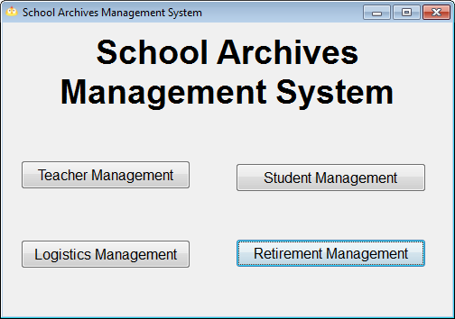  
2-Directory Browser

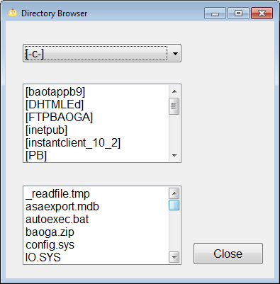

3-File Browser

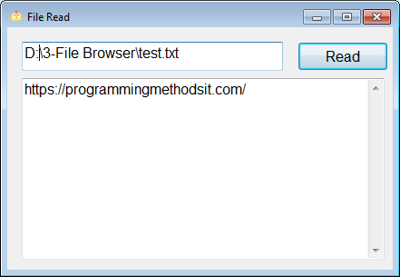  
4-Picture Browser

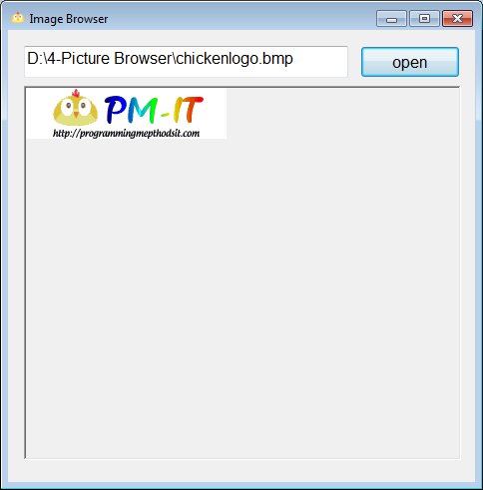

5-Drag Icon

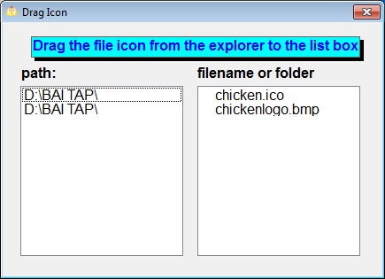  
6-User Password Authentication

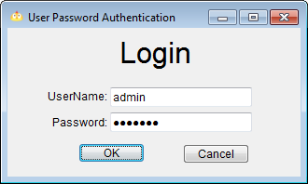  
7-Flash Text

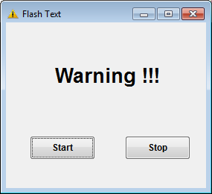

8-Screen Saver

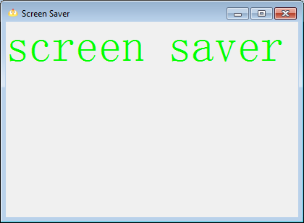  
9-Waiting Window

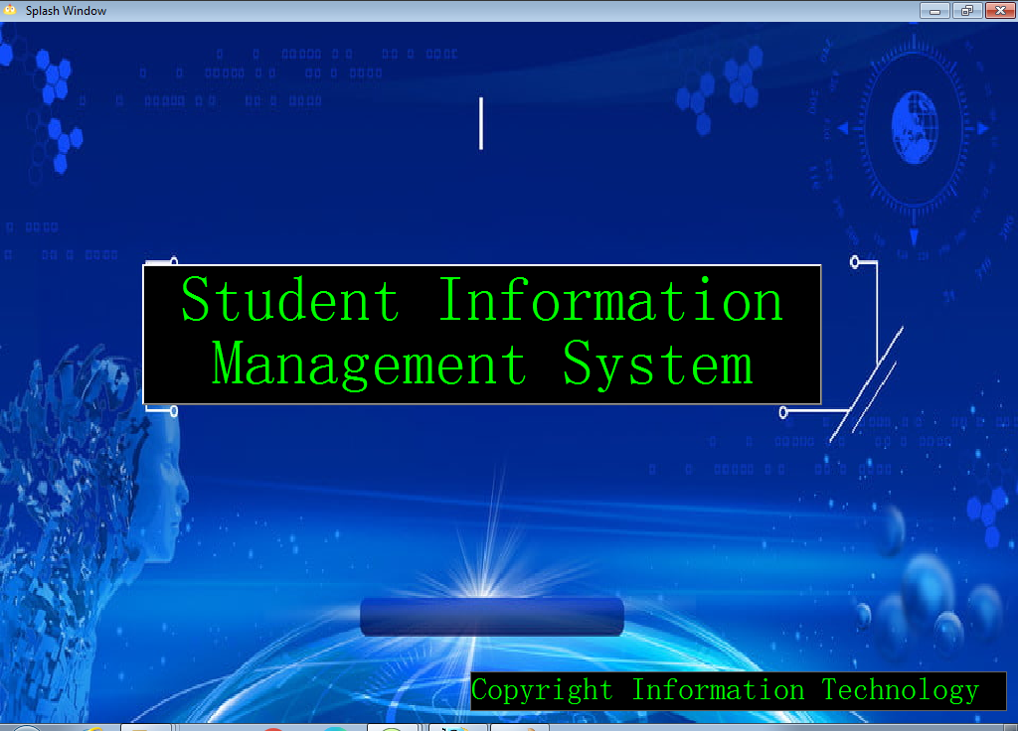

10-Control Drag

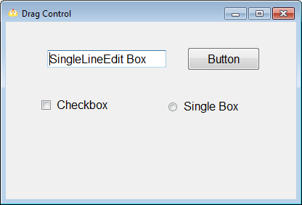  
11-ScrollBar

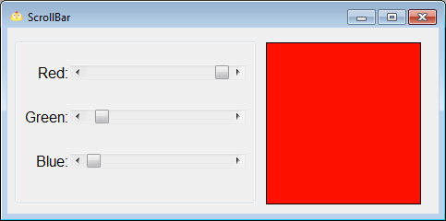  
12-Progress Bar

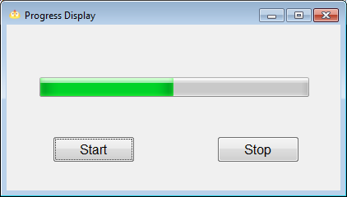

13-Animation Window

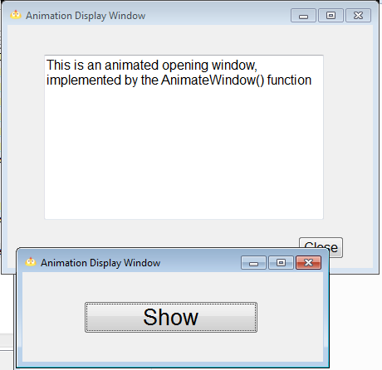  
14-Polygon Window

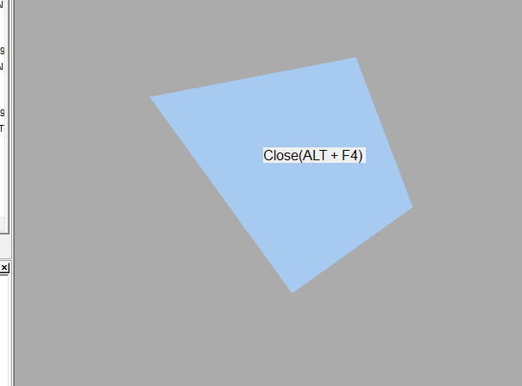

15-StopWatch

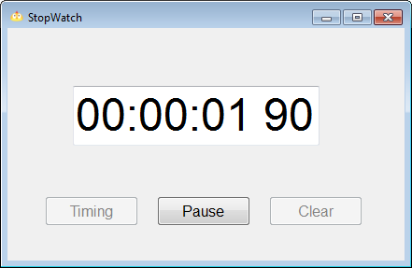  
16-Guess Number

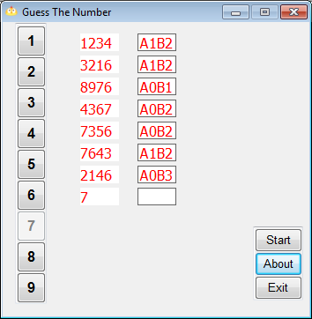  
17-Electronic Clock

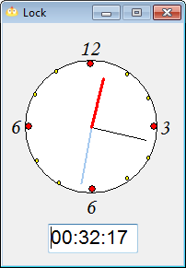

18-Number Use And Time Limit

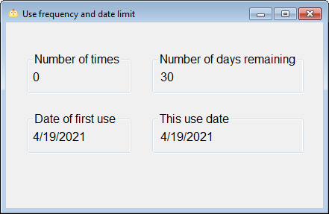  
19-Limit Number Runs

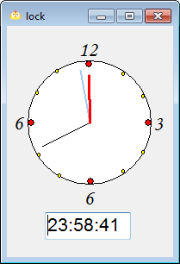  
20-Modify System Time

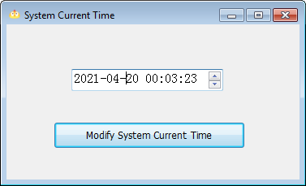

21-Color Dialog

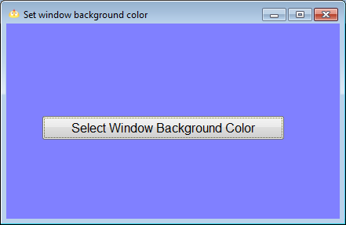  
22-IP Address Edit Box

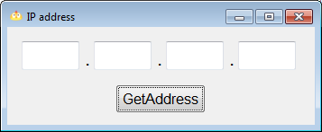  
23-Picture Button

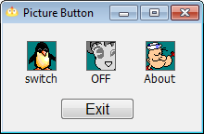

24-Help Button

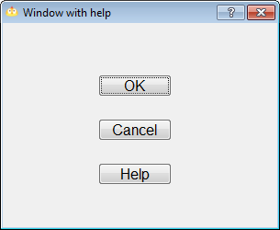  
25-Hyperlink Button

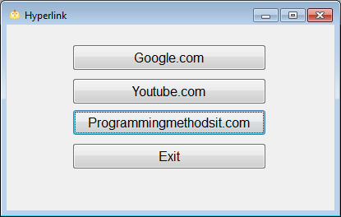  
27-Create Windows And Menus

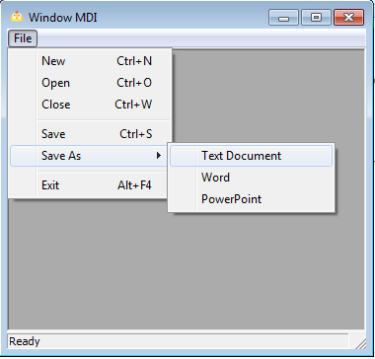

28-Graphic Menu

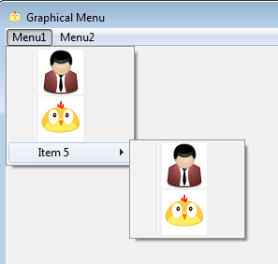  
29-MDI Window With Base Map

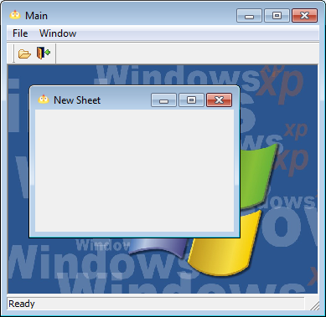  
30-Floating Toolbar

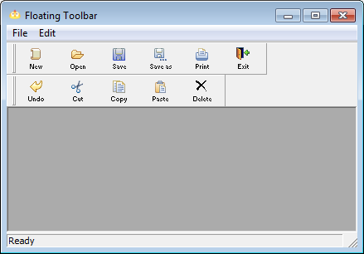

31-Hide And Show The Taskbar

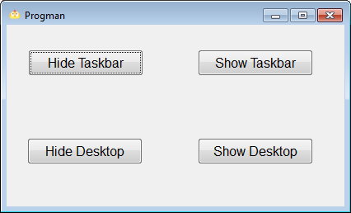  
32-Right Click Menu

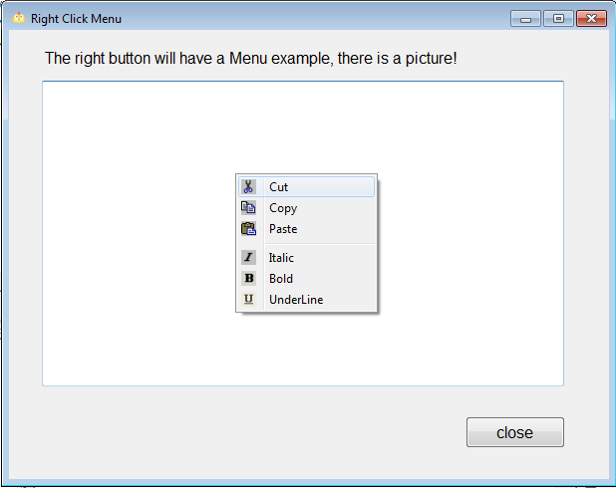

33-Call HtmlHelp File

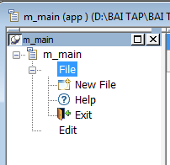  
34-Dynamic Open Window

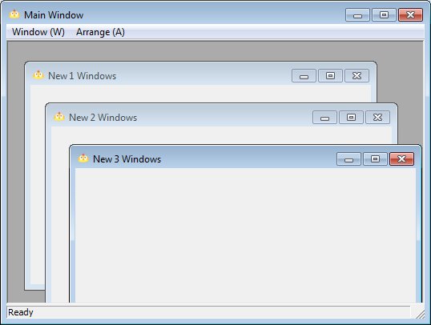  
35-Dynamic Setting Menu

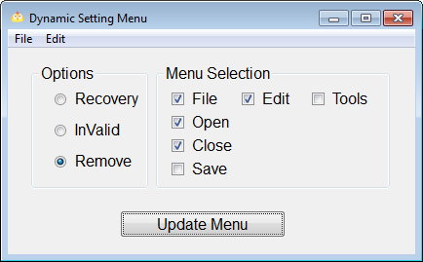

36-Notepad

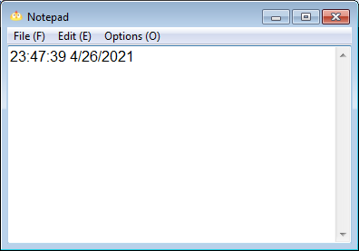  
37-Connect Database

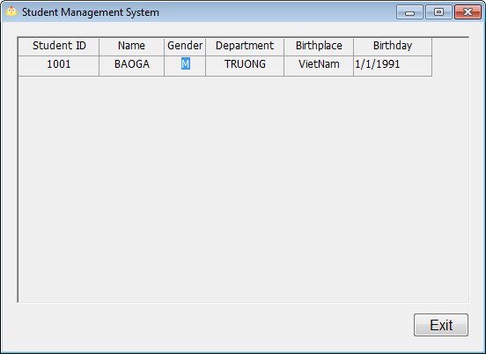

38-Set DataWindow Background Color

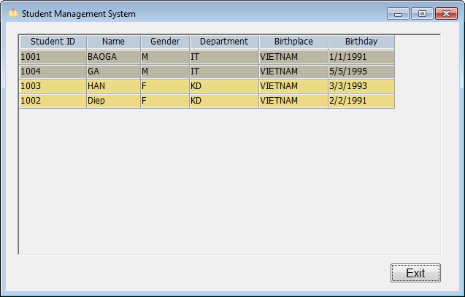  
39-Set DataWindow Bitmap

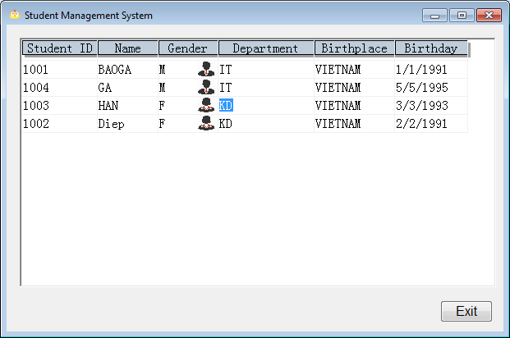

40-Report Drawing Display

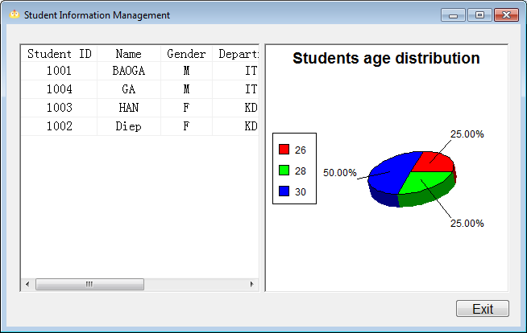  
41-DataWindow Zoom Display

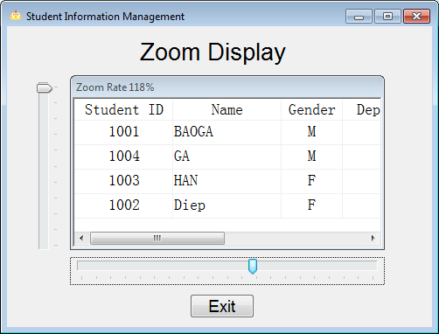

42-Dynamic Change DataWindow Style

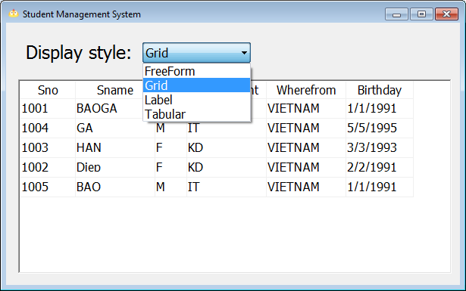  
43-Tab

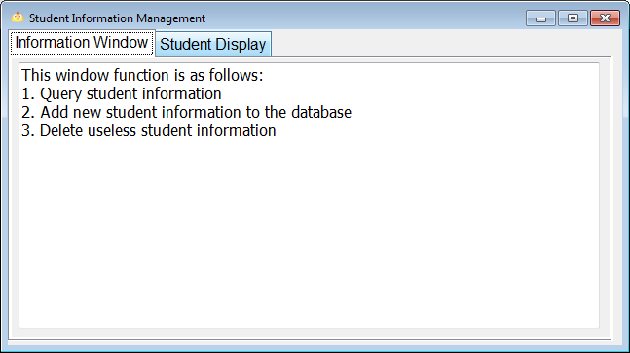

44-ListView

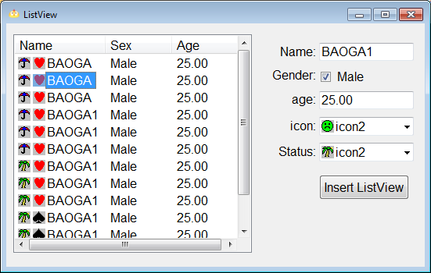  
45-DropDown DataWindow

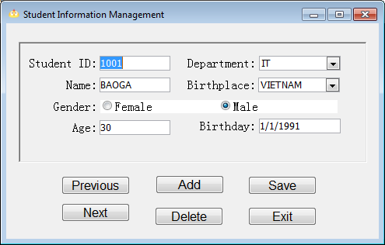

46-Create DataWindow Dynamic

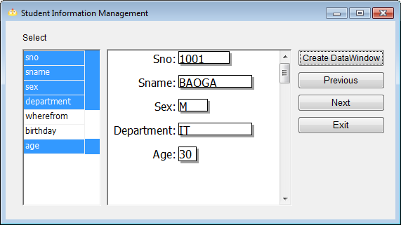  
47-Modify Data In DataWindow

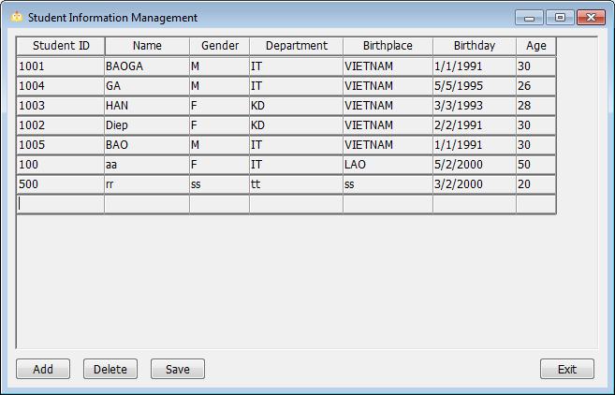

48-Recover Deleted Data

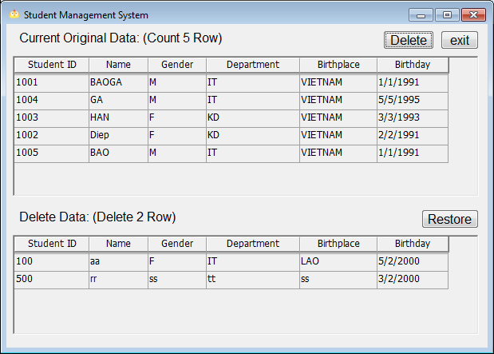  
49-Student Number Sorting

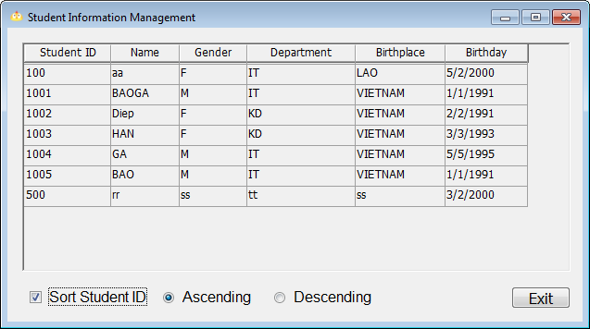

50-DataWindow Sorting

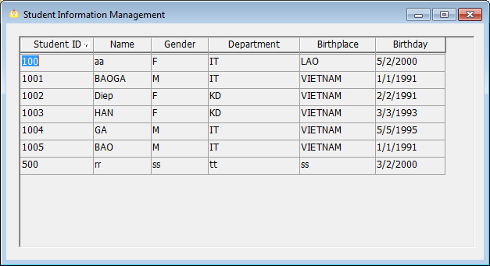  
51-DataStore And Share Data

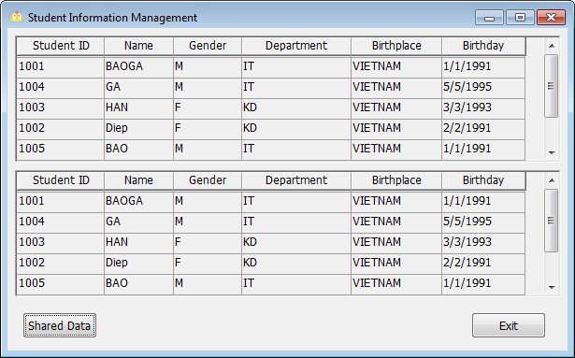

52-Query Conditional

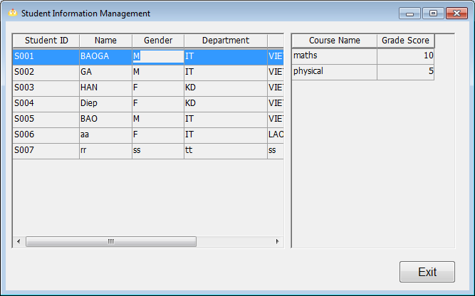  
53-Data Query

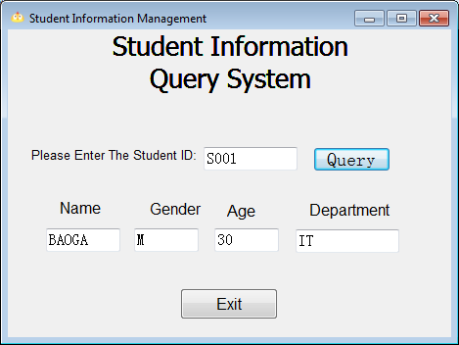

54-Fuzzy Query

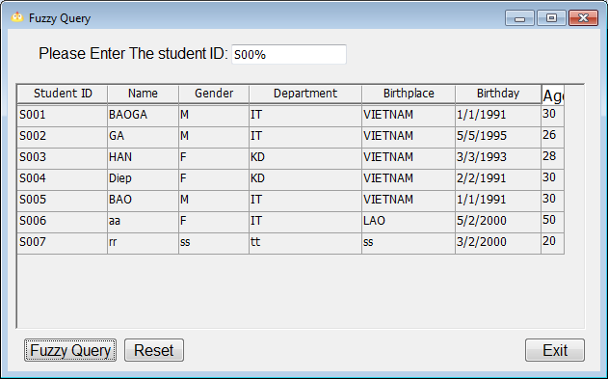  
56-Keyboard Simulator

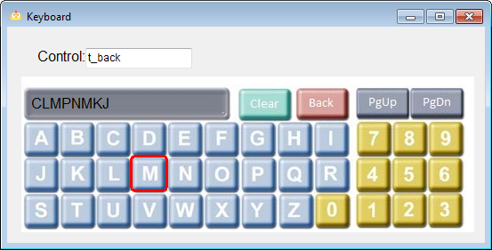

57-Save Data To Word

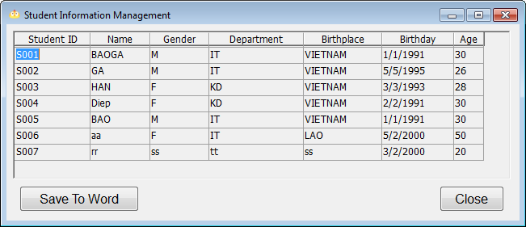  
58-Save Data To Excel

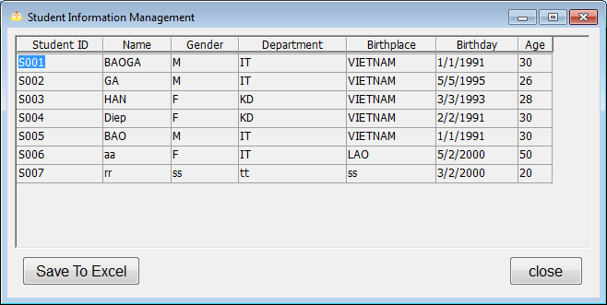

59-Print Preview Report

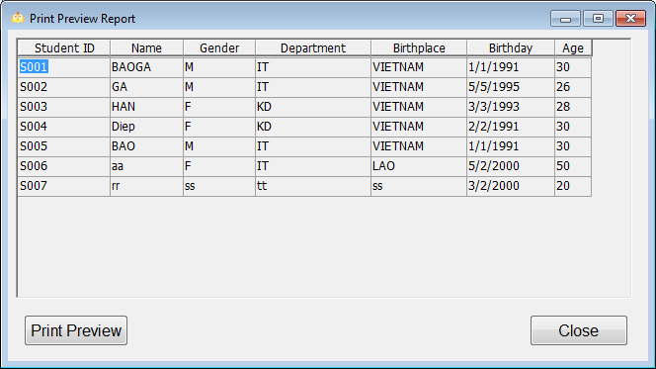  
60-Report Printing

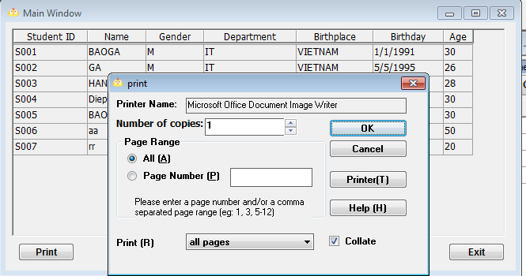

61-DDE Remote Connecting Excel

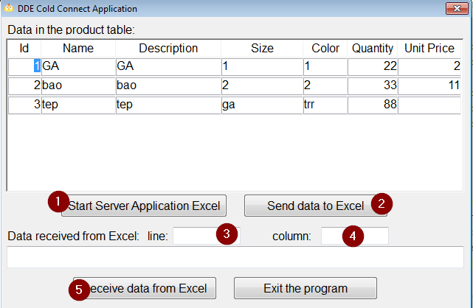  
62-DDE Warm Connection And Hot Connection

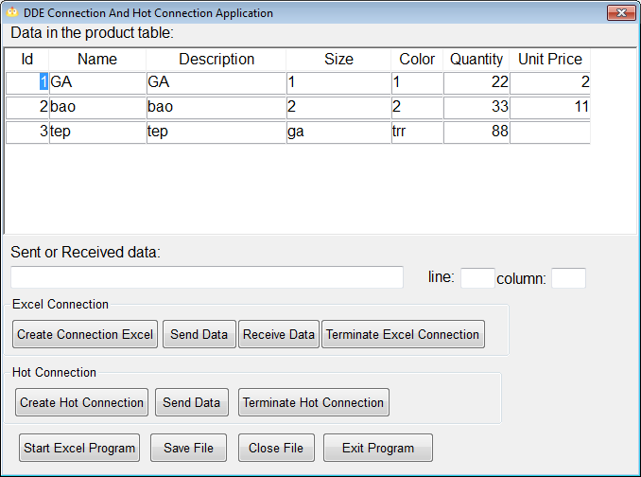

63-DDE Communication Between Two PB Applications Server

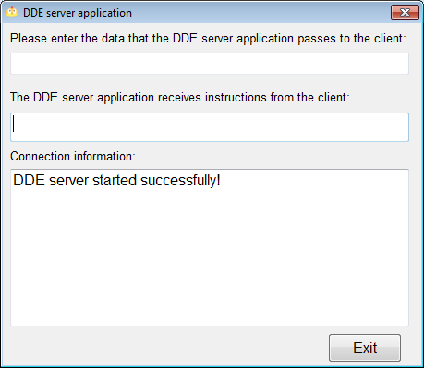  
64-DDE Communication Between Two PB Applications Client

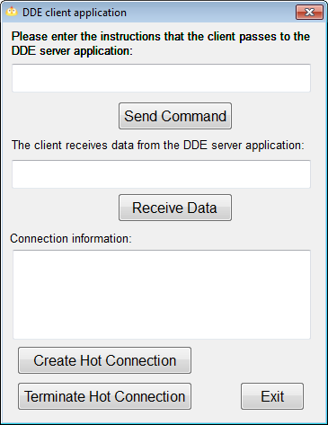

65-Play Sound File

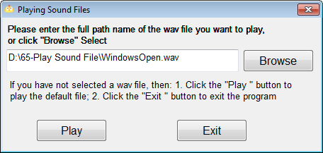  
66-Using User Objects Make Group Buttons

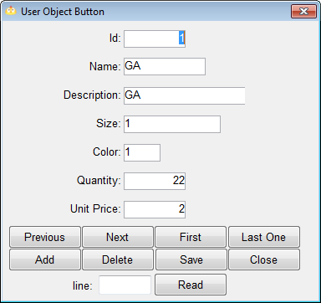  
67-Standard Class User Objects

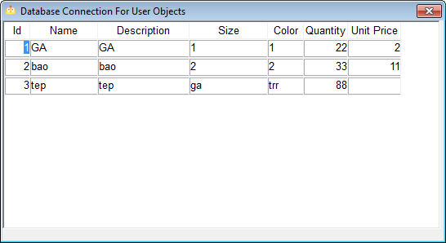

68-Calculation Data Table Specific Data

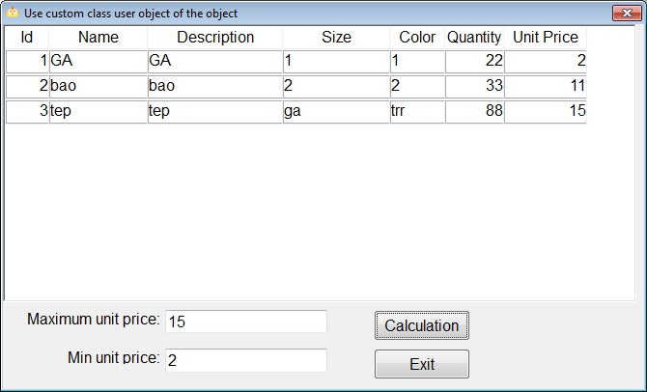  
69-Multi Threading Count Process

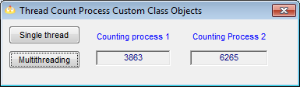  
70-Graphics Button  
71-Control Panel

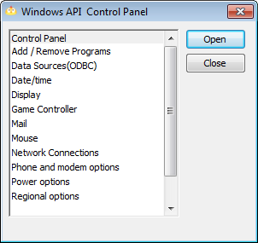

72-Play AVI

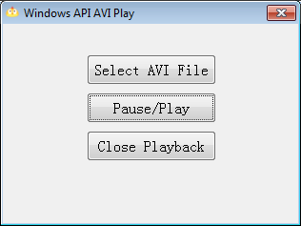  
73-Custom Hotkeys

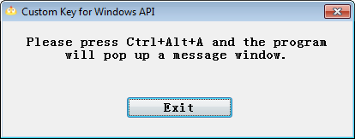  
74-Get Computer Systems Information

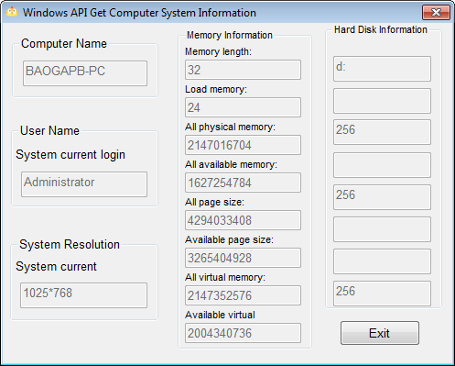

75-DataWindow Button Image

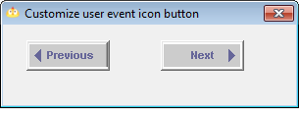  
76-User Events Without Event ID

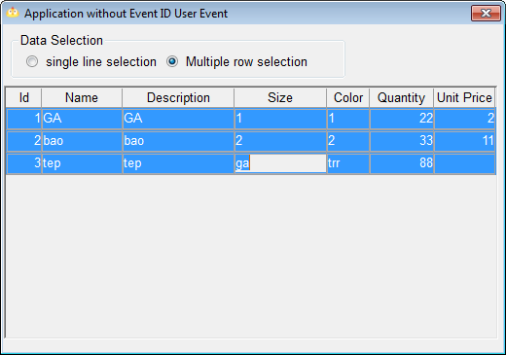  
78-Calculate Relative Time

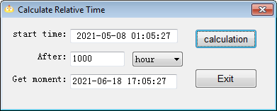

79-Custom Events And Functions User Objects

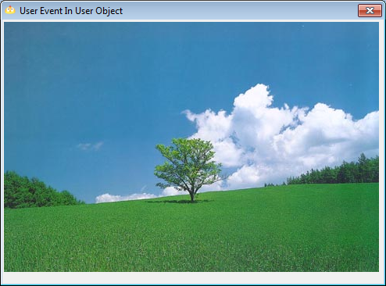  
80-Use OLE Control to Play Multimedia Files

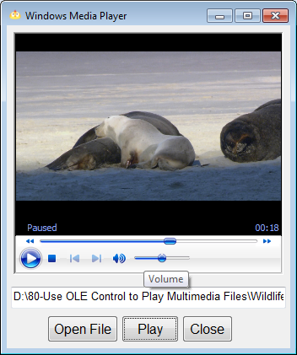

81-OLE Objects Send Data To Excel

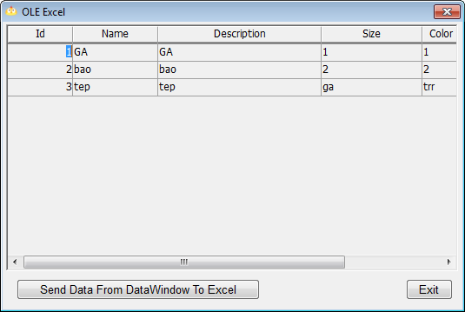  
82-Graphic Control With Scroll Bar

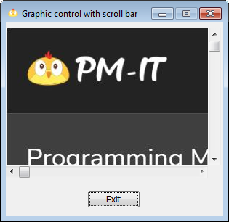

83-TreeView Control

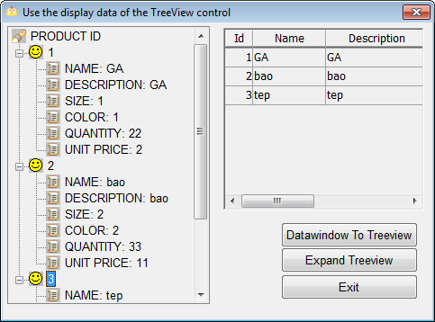  
84-TreeView And Datawindow Data

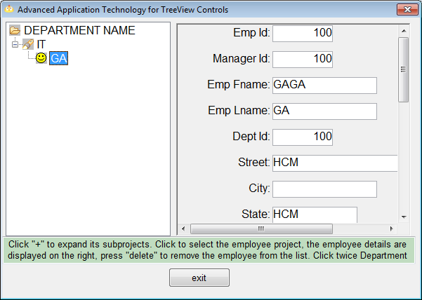

85-ListView Control

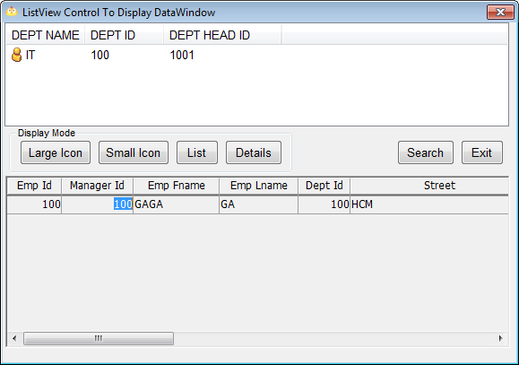  
86-Directory Resource Manager

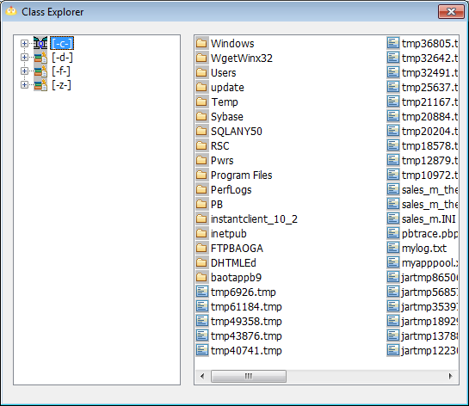

87-Graph Control

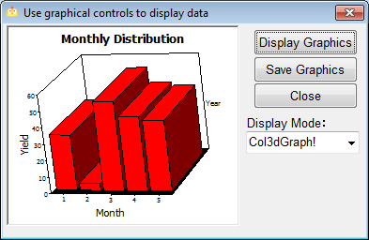  
88-Graph Control With DataWindow

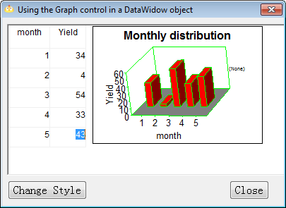  
89-Splash Window

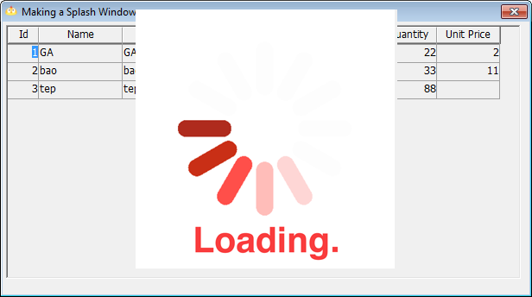

90-Taskbar Icon

  
91-Create Data Pipeline

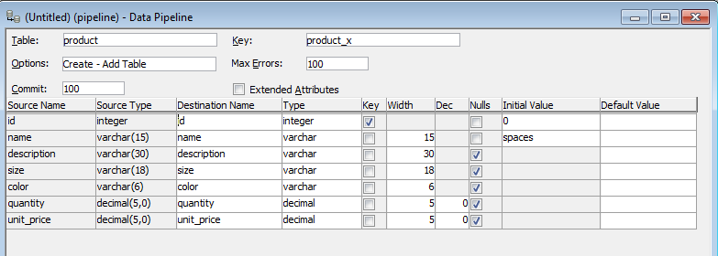  
92-Data Pipeline Programming

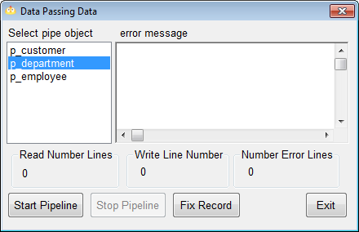  
93-Get Host IP Address

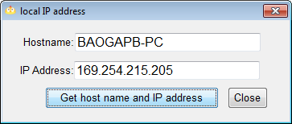

94-Create Executable File

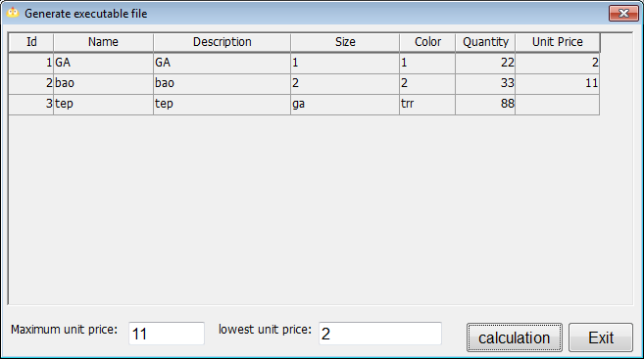  
95-Generate To HTM

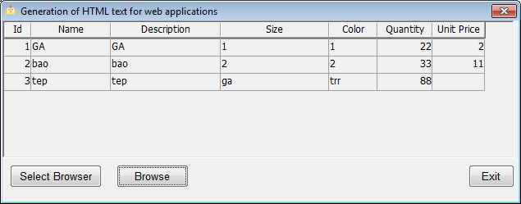

96-Generate Datawindow to HTML

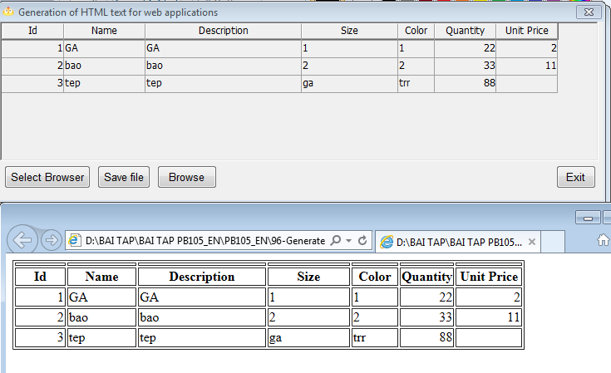  
99-Department and Personnel Management System

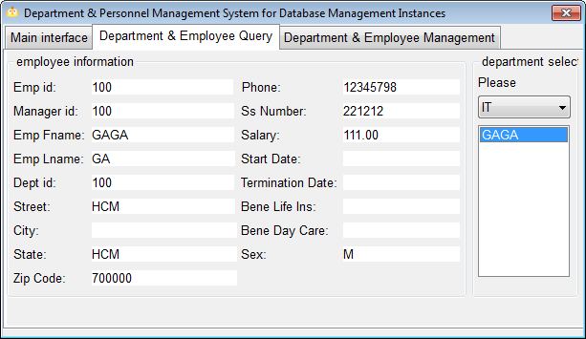

100-Inventory Management System

