PowerBuilder Examples And Skills Part 2

1.soundcmd

2.SysTray

3.getdrive

4.transparent

5.ras

6.easymove

7.controlpanel

8.StandardDialog

9.menubmp

10.datetimepicker

13.supersplash

14.mybutton

15.COLOR

16.xp_progress

17.picturebutton

18.shu_api_file

21.gradient

22.pbcamera

24.media

25.cdplay

26.transparent_win

27.statusbar

28.dateitemfunc

32.htmlhelp

33.crc

34.colorpicker

36.compression

42.Ping

44.fax

48.webbrowser

50.DWSORT

51.picture

52.dropdown

53.excel

56.dw2Word

57.PSRBrowser

59.barcode

61.Chart

62.DW2HTML

63.cursor

64.Dynamic

65.OpenParam

66.shareData

67.dropdownDataWIndow

68.dbViewTree

69.dragdrop

70.XML

71.printer

72.PrintCtrl

73.PowerPrinter

74.DW2Print

78.ado4excel

79.adortf

83.xceedzip

87.wsh

90.CPU

92.getfont

1.soundcmd

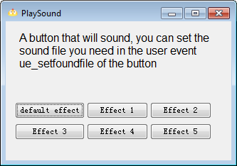

2.SysTray

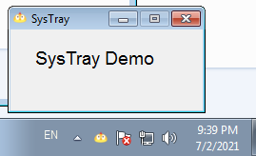

3.getdrive

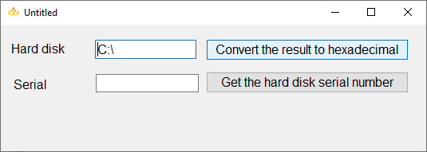

4.transparent

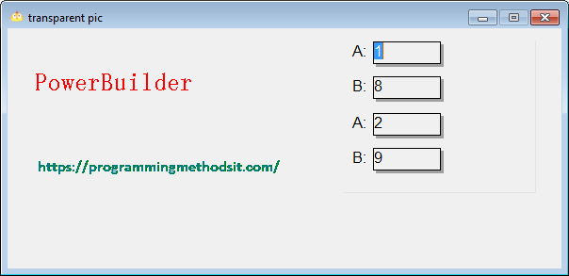

5.ras

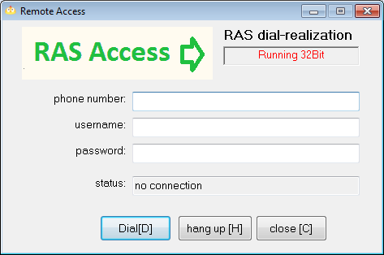

6.easymove

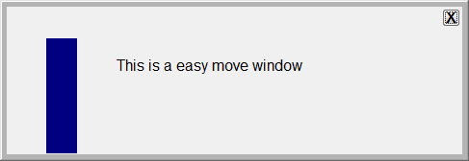

7.controlpanel

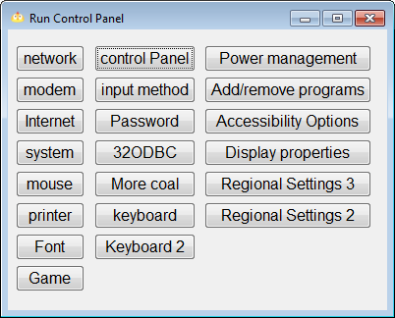

8.StandardDialog

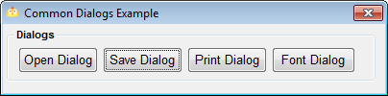

9.menubmp

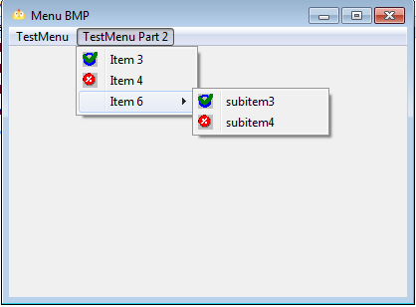

10.datetimepicker

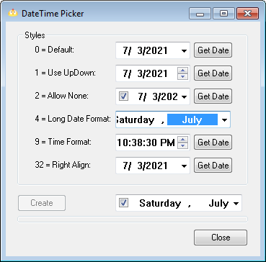

13.supersplash



14.mybutton

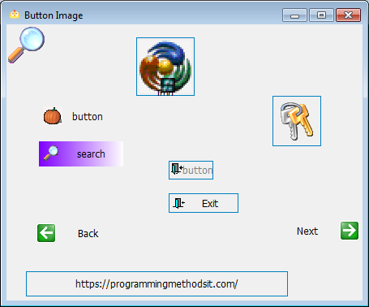

15.COLOR

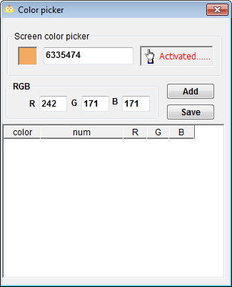

16.xp_progress

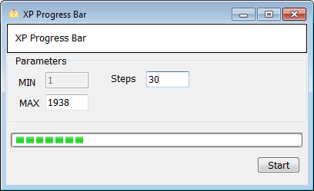

17.picturebutton

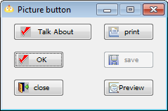

18.shu_api_file

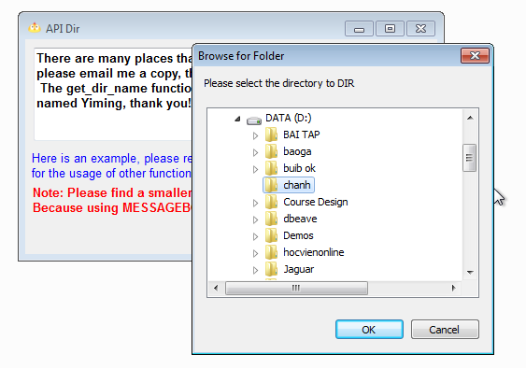

21.gradient

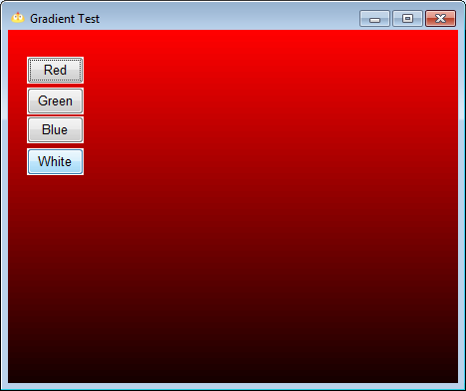

22.pbcamera

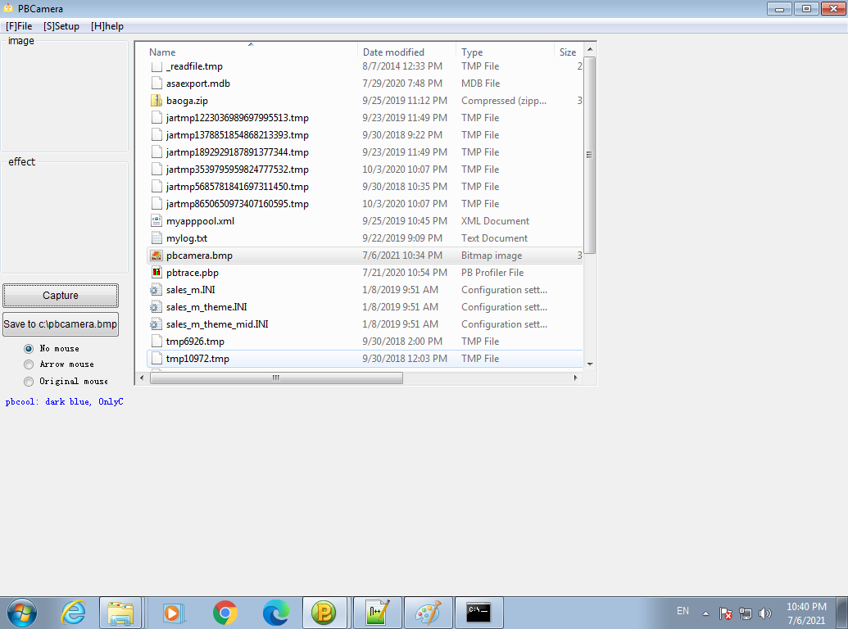

24.media

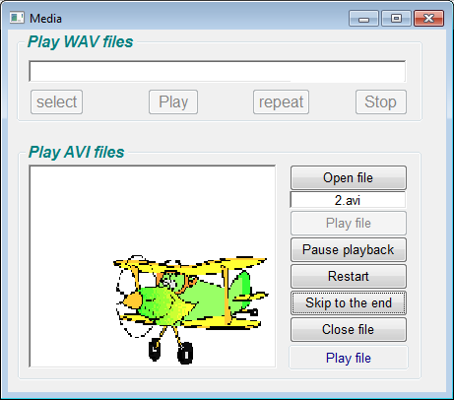

25.cdplay

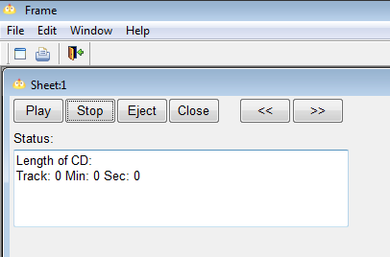

26.transparent_win

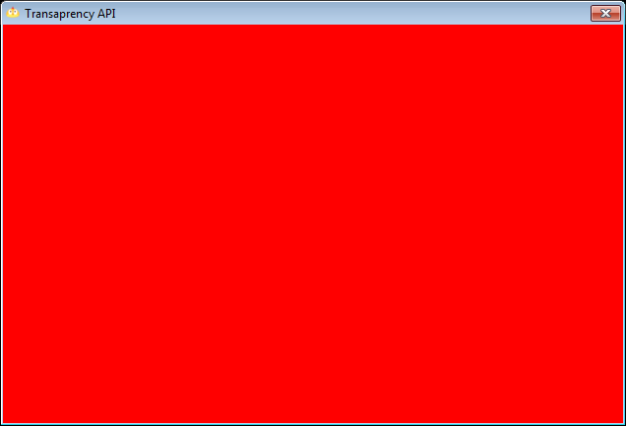

27.statusbar

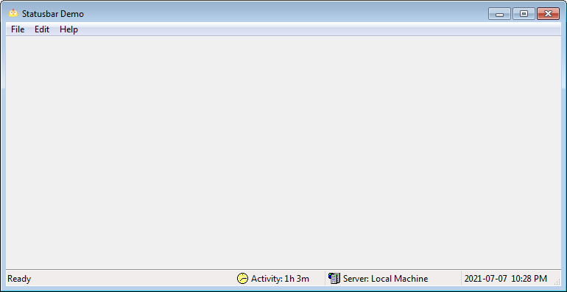

28.dateitemfunc

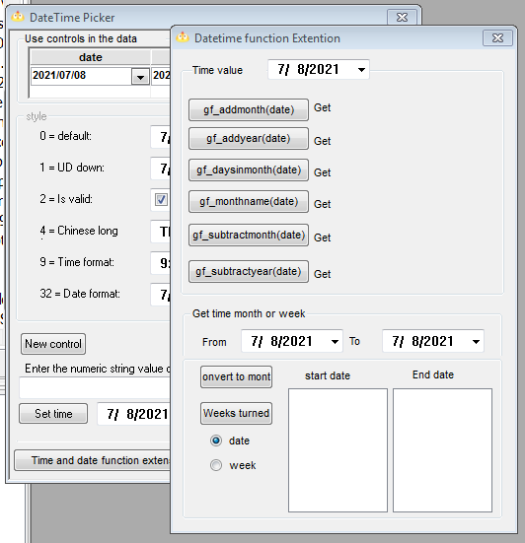

32.htmlhelp

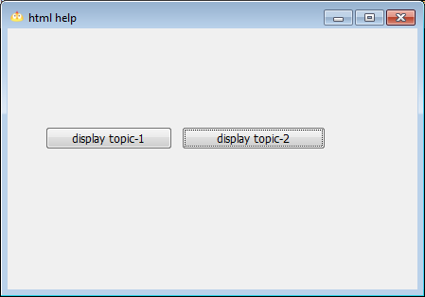

33.crc

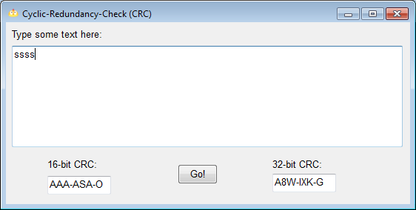

34.colorpicker

36.compression

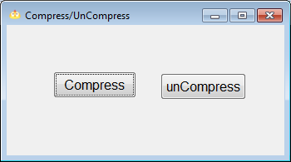

42.Ping

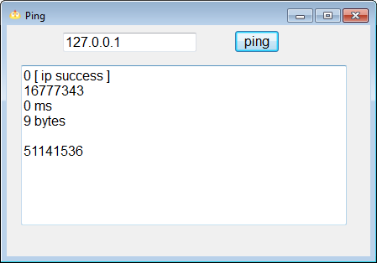

44.fax

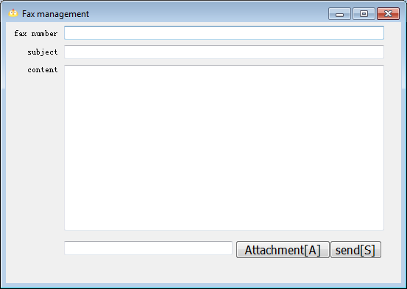

48.webbrowser

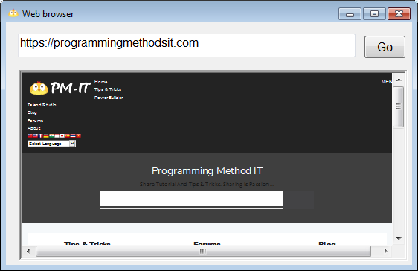

50.DWSORT

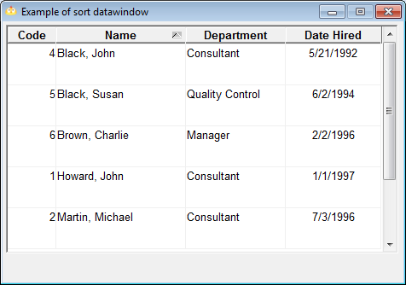

51.picture

52.dropdown

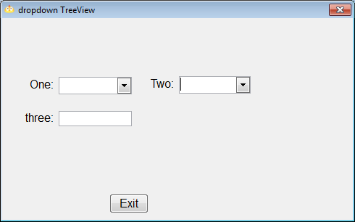

53.excel

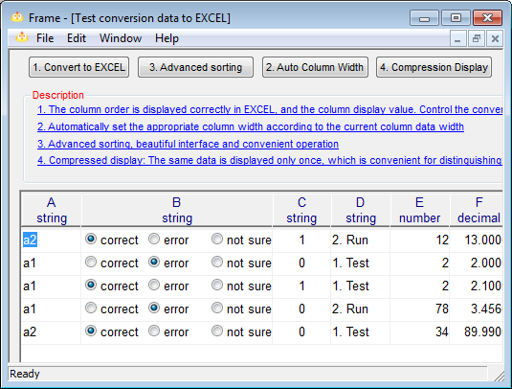

56.dw2Word

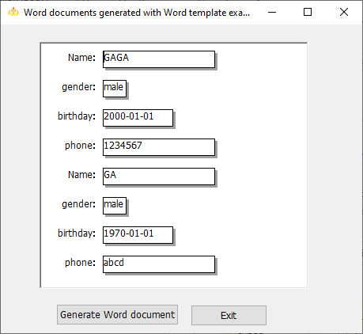

57.PSRBrowser

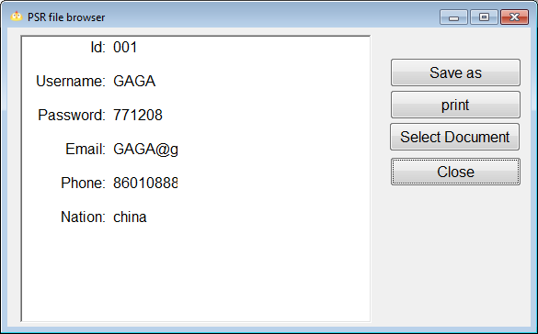

59.barcode

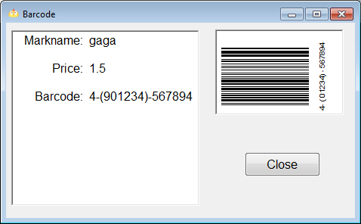

61.Chart

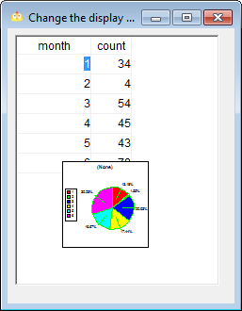

62.DW2HTML

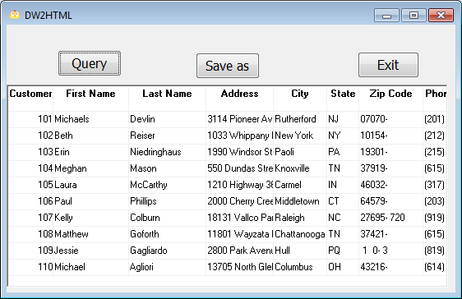

63.cursor

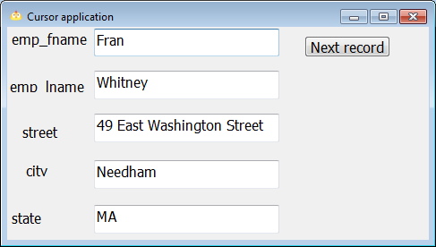

64.Dynamic

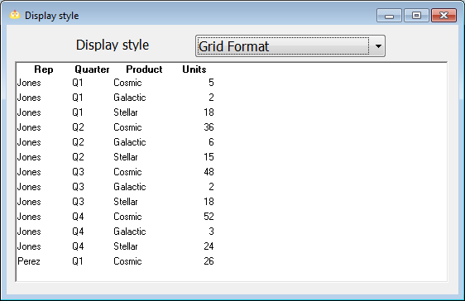

65.OpenParam

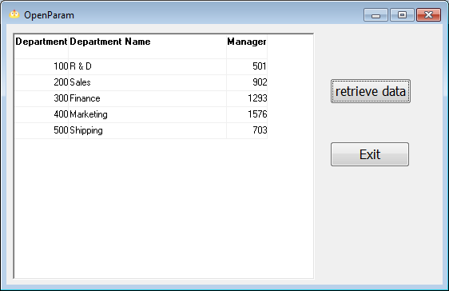

66.shareData

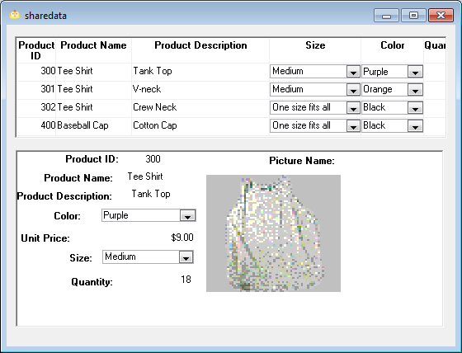

67.dropdownDataWIndow

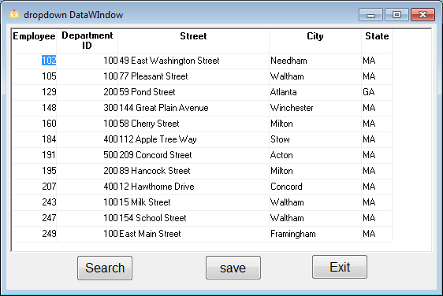

68.dbViewTree

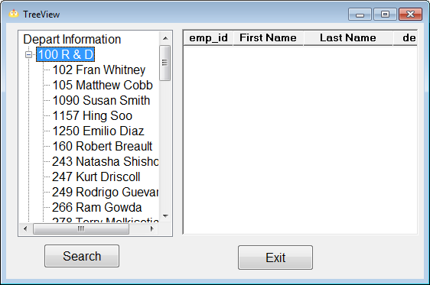

69.dragdrop

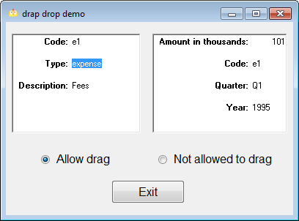

70.XML

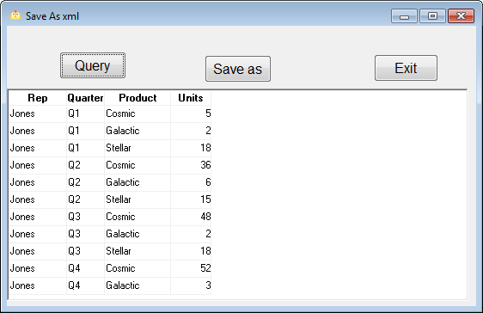

71.printer

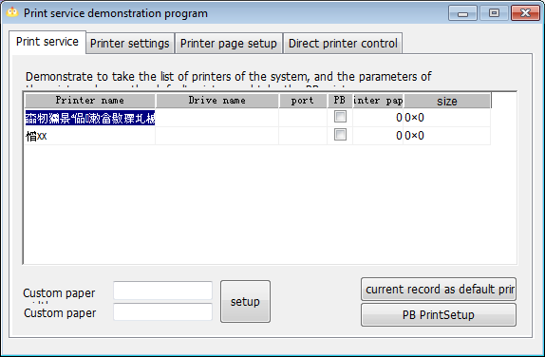

72.PrintCtrl

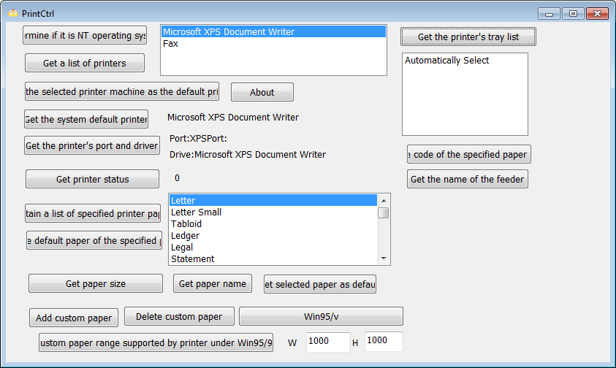

73.PowerPrinter

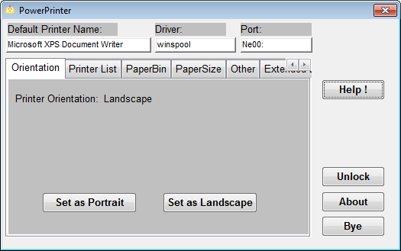

74.DW2Print

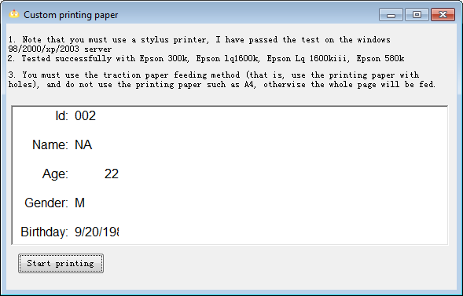

78.ado4excel

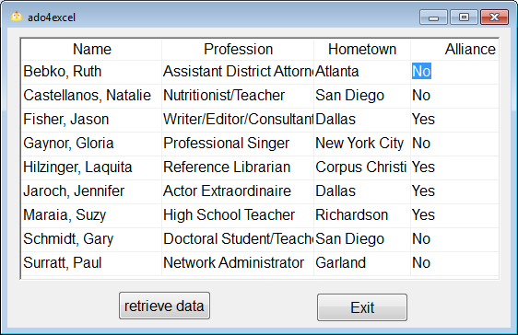

79.adortf

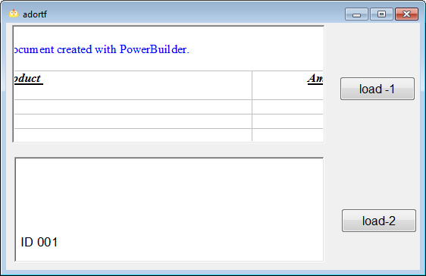

83.xceedzip

87.wsh

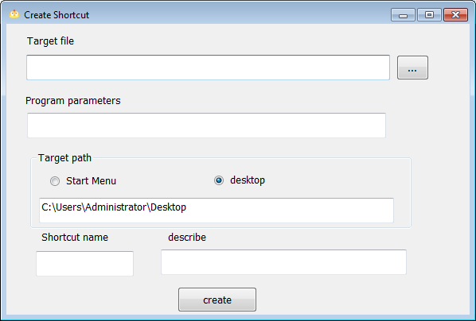

90.CPU

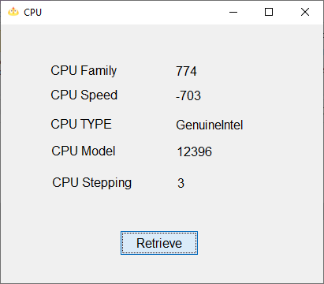

92.getfont

