All examples of this book. as follows:

Chapter 1 Window, Control and Interface

1.1 Implementation of Outlook Toolbar Interface - Outlook

1.2 Make Splash window - Splash

1.3 Make a beautiful status bar - StatusBar

1.4 Create icon bar application - Systray

1.5 MDI window display background image - MDIBmp

1.6 ToolTips - ToolTips in the window control display

1.7 Create a different command button - PictureButton/IconButton

1.8 Implementation of Transparent Text - TransparentST/TransParentButton

1.9 Making the navigation map interface - FlowChat

1.10 Make a menu with pictures and texts - BmpMenu

1.11 The size of the controls in the window is synchronized with the size of the window - Autosize

1.12 Dynamically create controls - DynamicControl

1.14 Control Fusion Technology - SplitBar/SplitResize

1.15 Wallpaper

Chapter 2 Data Window

2.1 Data window PDF format document output - PDF

2.2 Data window combination condition query - Query

2.3 Universal Sorting of Data Window - UniversalSort

2.4 Implementation of custom window for general display of data window - ColumnVisible

2.5 Incremental query in the data window - zlcx

2.6 Multi-table update of data window - UpdateMultable

2.7 Click the title bar to sort the data window - TitleSort

2.8 Dynamic Data Window - DynamicDataWindow

2.9 Composite Data Window - AddTitle

2.10 Data window print processing - PrintPreview/PrintPreview3 (The contents of PrintPreview and PrintPreview3 are the same, but there are some differences in implementation)

2.11 The dynamic change of the data window statistical graph type - GraphType

2.12 Realization of dynamic display of statistical graph values ??in data window - GraphValue

2.13 The encapsulation of the button in the data window - DwButton

Chapter 3 PowerScript

3.2 Realize the automatic upgrade of the client program - CSUPgrade

3.3 Base Conversion - NumberConvert

3.4 Registry function application - Regedit

3.5 RMB uppercase conversion function - AmountUppder

3.6 Close the external program in the application - CloseApp

3.7 Start the control panel project in the application - RunControl

3.8 Import Data Window for Non-Tab Delimited Text File - ImportFile

3.9 Run the compiled program with parameters - CommandParm

3.10 Get the last day of the month function - GetLastDay

3.11 Restrict the same program to run multiple times - OnlyOnce Resource file used in this chapter - pic

Chapter 4 Database and SQL

4.2 PowerBuilder + ASA8 C/S programming - Client-Server

4.4 Dynamic SQL and its application - DynamicSQL

4.5 Accessing Binary Large Objects - Blob

4.6 PowerBuilder application gets server time - GetServerTime

4.7 PowerBuilder extended attribute system table and its application - SystemTable

4.8 Connect to any ODBC data source - ODBCList

4.9 Database connection with customizable parameters - ServerSet

Chapter 5 Printing Topics

General printing example - Print

Chapter 6 User Objects

6.1.1 Create a customized user object (create a pop-up button) - ToggleButton

6.1.2 Create a standard visual user object (extended data window) - Datawindow

6.1.3 Create a visual external user object (status bar) - StatusBar

6.2.2 Create a general invisible user object (FTP application) - Ftp

Chapter 7 API

7.2.1 Change the display style of the window - ChangeWindow

7.2.2 Make the picture of the window transparent - TransWindow

7.2.3 Change the closing style of the window - CloseStyle

7.2.4 Realize the copy and paste of graphics and simple processing of images in PB - PictureBox

7.3.1 Get the internal process of the system - System Thread

7.3.2 Obtain basic system information - SystemInformation

7.4.1 Checking the connectivity of the physical network - Mping

7.4.2 Shut down, restart, log off the computer - ExitWindow

7.5.1 Use Visual C++ to develop dynamic link library - DllForPb9

7.5.2 Use Delphi to develop dynamic link library - SetScreen

7.5.3 Use Visual Basic to develop ActiveX dynamic link library - CPUInfo

Chapter 8 pipeline

Data pipeline - pipeline

Chapter 9 DDE, OLE, COM Use Technology

9.1.3 DDE client implementation steps - DDE

9.2.5 Invisible OLE objects - pbtowordandexcel

9.2.6 ActiveX Control - Media

9.2.7 Use external OLE controls to process binary data in the database - DBOLE

9.2.8 OLE wonderful application-develop XP style menu-XPMenu

9.3.3 COM component implementation in PowerBuilder - pb9com

Chapter 10 Compilation and Distribution

Compile - TestInstall

Chapter 11 Jaguar

Contains the source program of two examples of developing Jaguar components and calling Jaguar components

Chapter 12 PBNI

PBNI application technology – PBNI

Chapter 1 Window, Control and Interface

* 1. Implementation of Outlook Toolbar Interface – Outlook

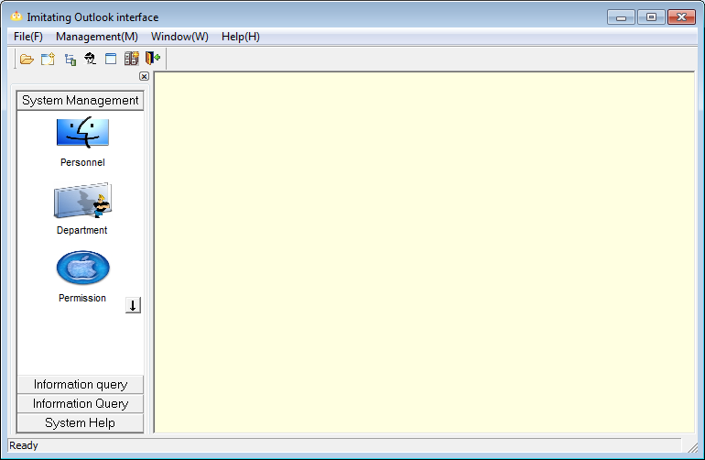

1.2 Make Splash window - Splash

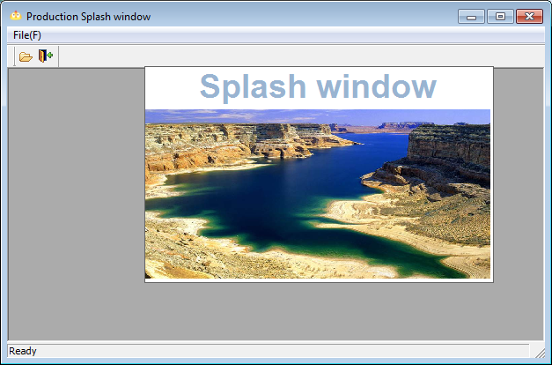

* 1. Make a beautiful status bar – StatusBar

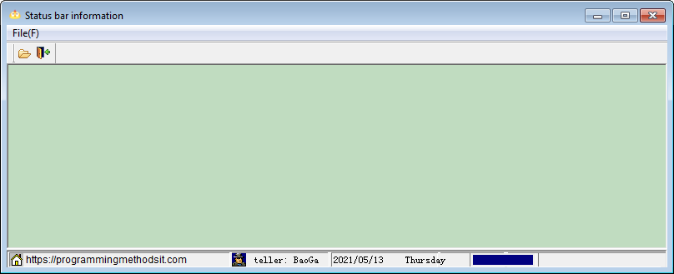

* 1. Create icon bar application – Systray

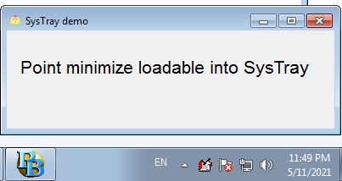

1.5 MDI window display background image – MDIBmp

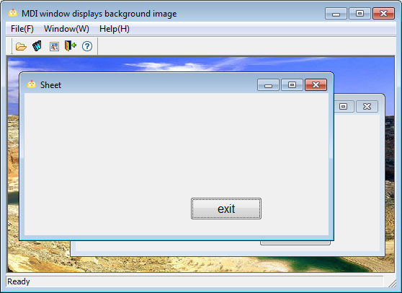

1.6 ToolTips - ToolTips in the window control display

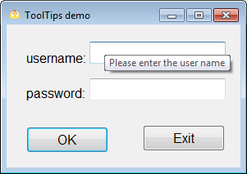

1.7 Create a different command button - PictureButton/IconButton

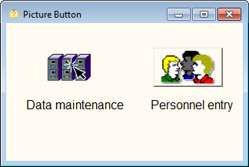

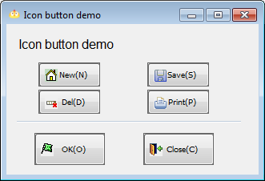

1.8 Implementation of Transparent Text - TransparentST/TransParentButton

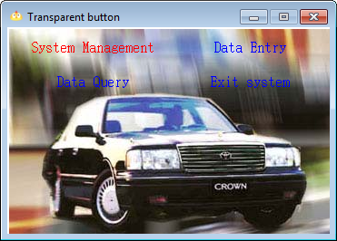

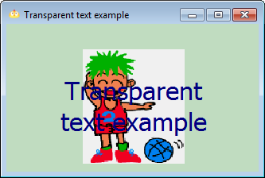

1.9 Making the navigation map interface – FlowChat

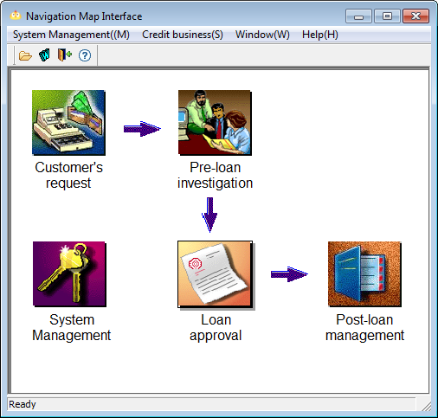

1.10 Make a menu with pictures and texts – BmpMenu

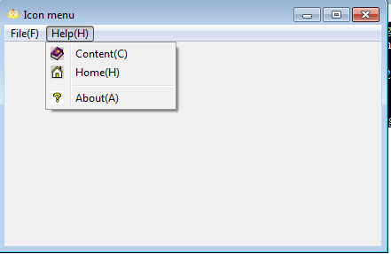

1.11 The size of the controls in the window is synchronized with the size of the window – Autosize

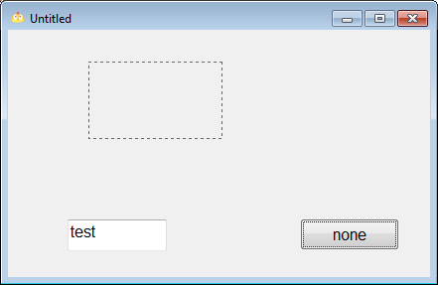

1.12 Dynamically create controls – DynamicControl

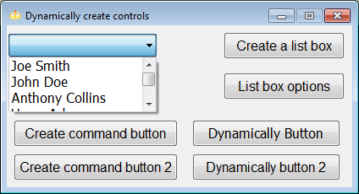

1.14 Control Fusion Technology - SplitBar/SplitResize

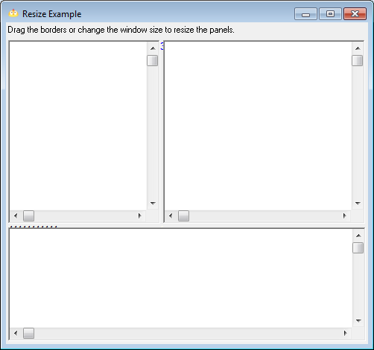

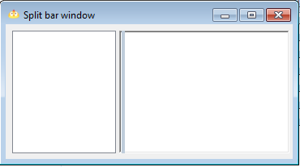

1.15 Wallpaper

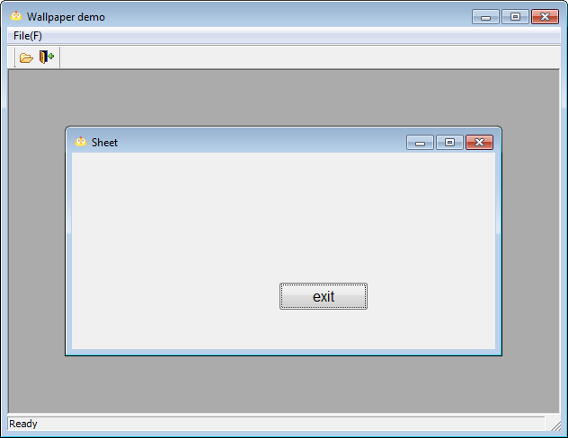

Chapter 2 Data Window

2.1 Data window PDF format document output – PDF

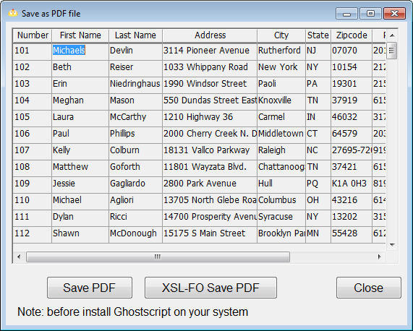

2.2 Data window combination condition query – Query

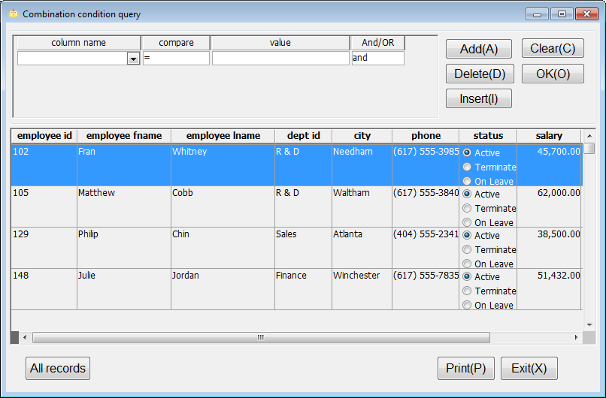

2.3 Universal Sorting of Data Window – UniversalSort

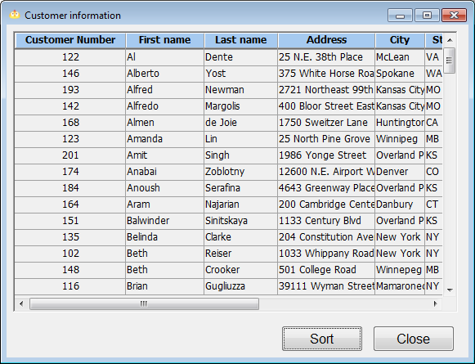

2.4 Implementation of custom window for general display of data window – ColumnVisible

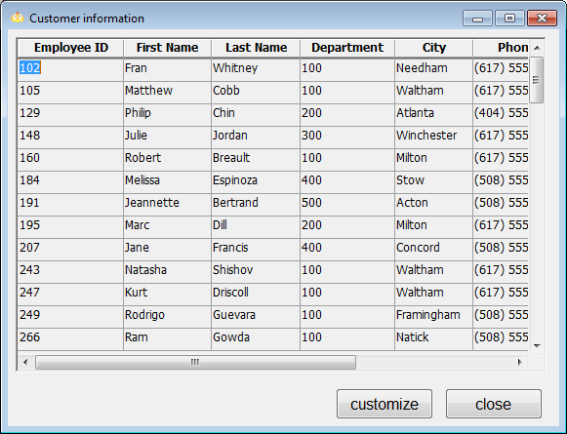

2.5 Incremental query in the data window – zlcx

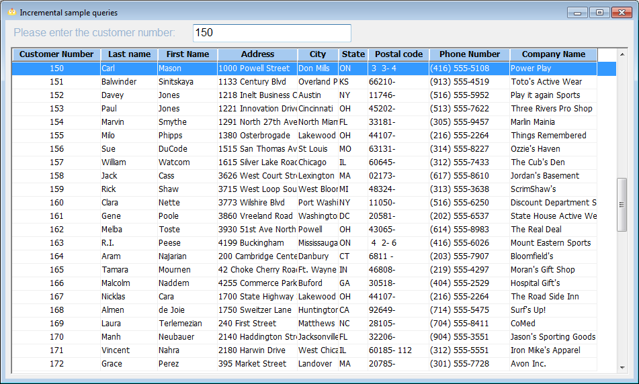

2.6 Multi-table update of data window – UpdateMultable

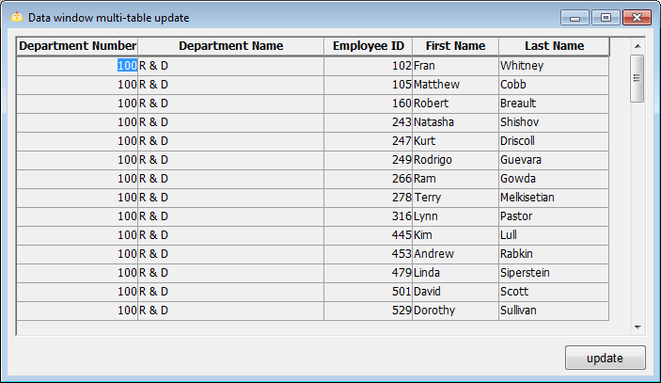

2.7 Click the title bar to sort the data window – TitleSort

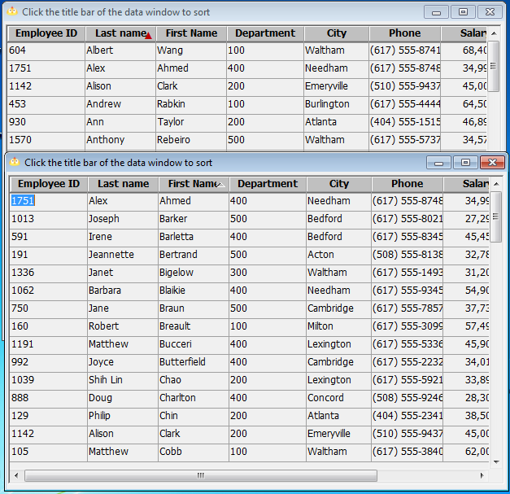

2.8 Dynamic Data Window – DynamicDataWindow

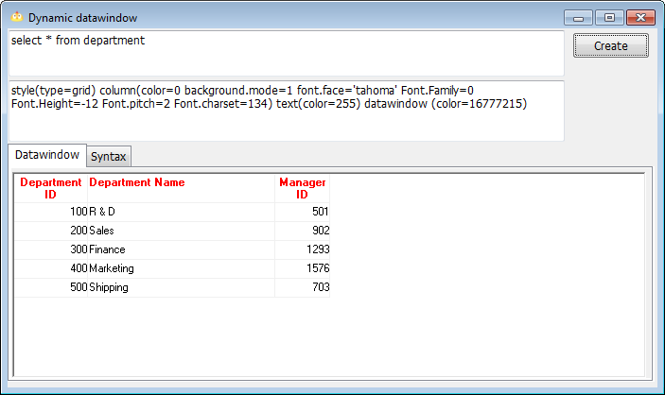

2.9 Composite Data Window – AddTitle

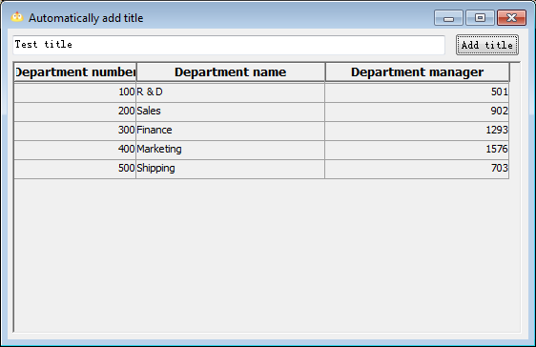

2.10 Data window print processing - PrintPreview/PrintPreview3 (The contents of PrintPreview and PrintPreview3 are the same, but there are some differences in implementation)

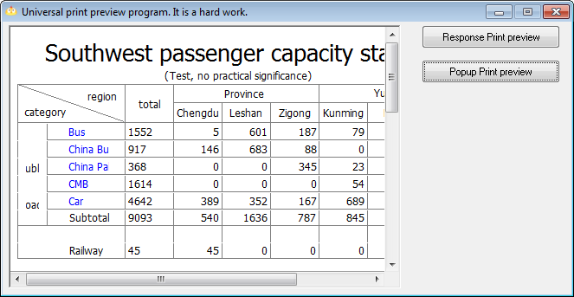

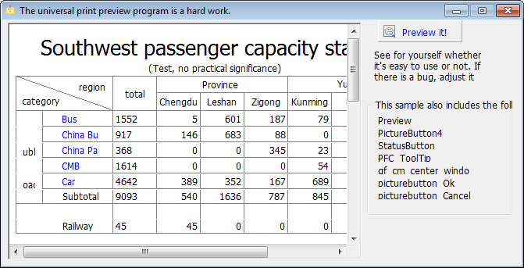

2.11 The dynamic change of the data window statistical graph type – GraphType

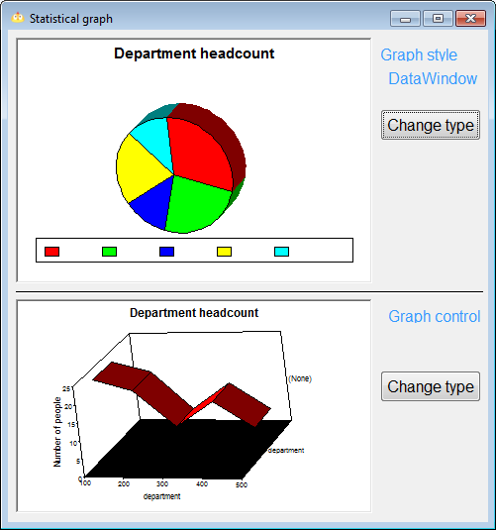

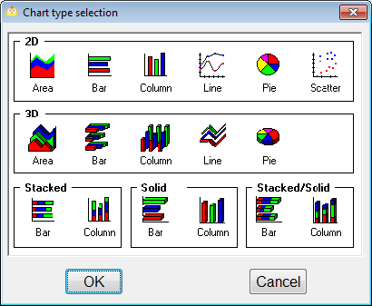

2.12 Realization of dynamic display of statistical graph values ??in data window – GraphValue

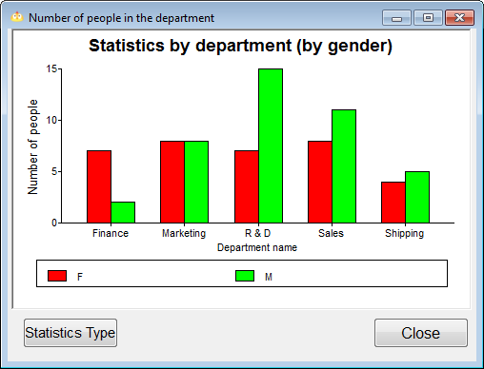

2.13 The encapsulation of the button in the data window – DwButton

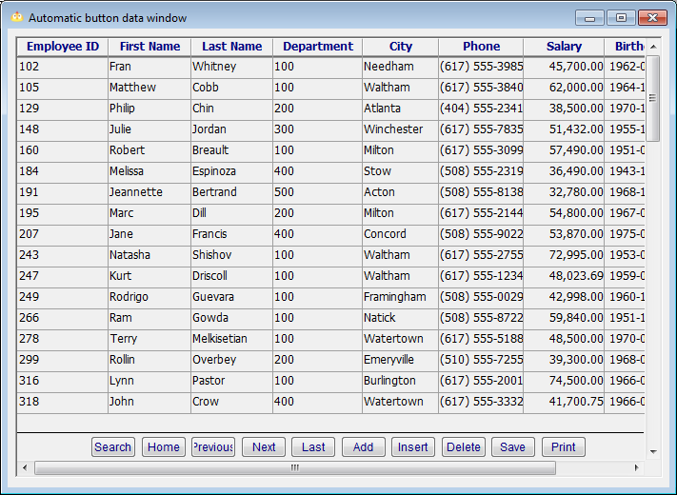

Chapter 3 PowerScript

3.2 Realize the automatic upgrade of the client program – CSUPgrade

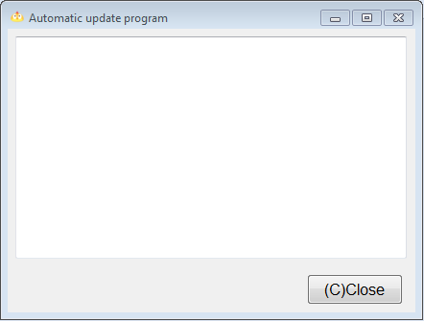

3.3 Base Conversion – NumberConvert

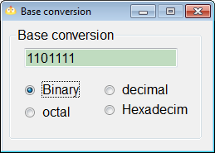

3.4 Registry function application – Regedit

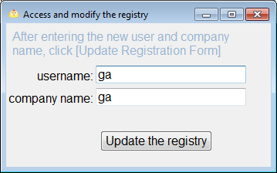

3.5 RMB uppercase conversion function – AmountUppder

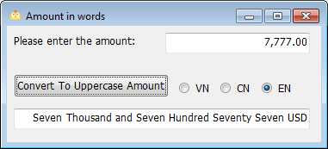

3.6 Close the external program in the application – CloseApp

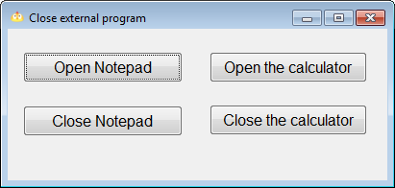

3.7 Start the control panel project in the application – RunControl

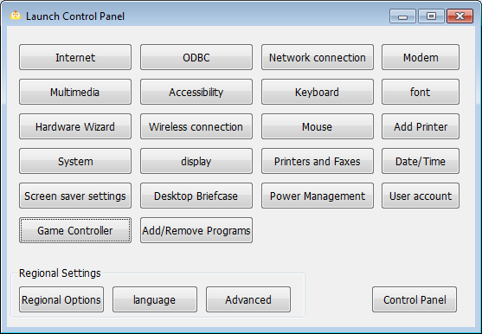

3.8 Import Data Window for Non-Tab Delimited Text File – ImportFile

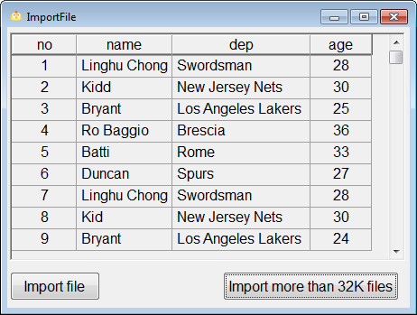

3.9 Run the compiled program with parameters – CommandParm

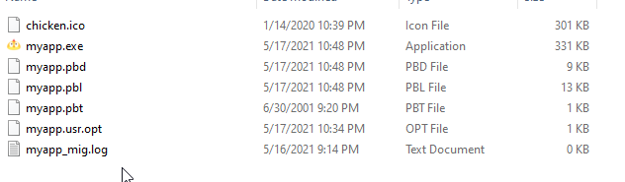

3.10 Get the last day of the month function – GetLastDay

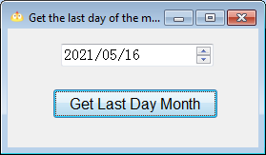

3.11 Restrict the same program to run multiple times - OnlyOnce Resource file used in this chapter – pic

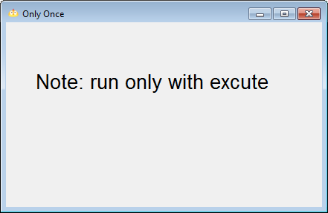

Chapter 4 Database and SQL

4.2 PowerBuilder + ASA8 C/S programming - Client-Server

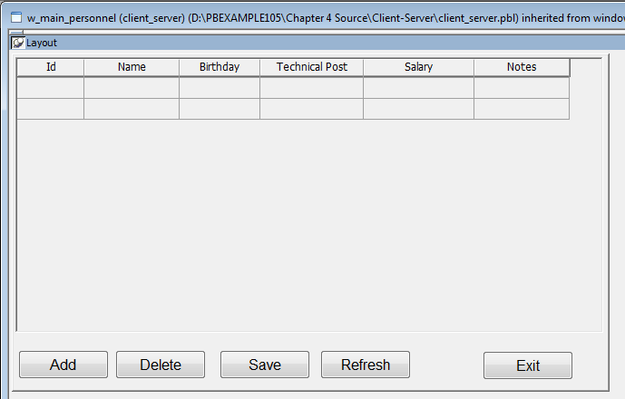

4.4 Dynamic SQL and its application – DynamicSQL

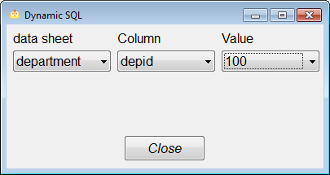

4.5 Accessing Binary Large Objects – Blob

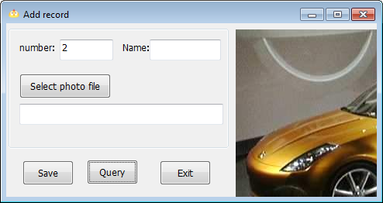

4.6 PowerBuilder application gets server time – GetServerTime

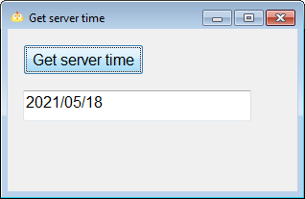

4.7 PowerBuilder extended attribute system table and its application – SystemTable

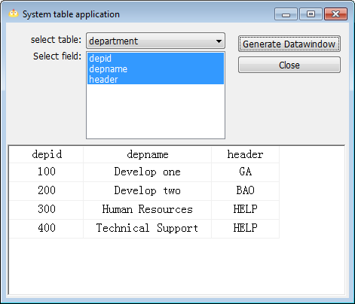

4.8 Connect to any ODBC data source – ODBCList

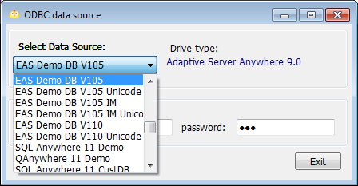

4.9 Database connection with customizable parameters – ServerSet

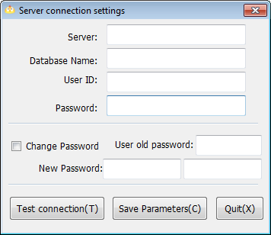

Chapter 5 Printing Topics

General printing example – Print

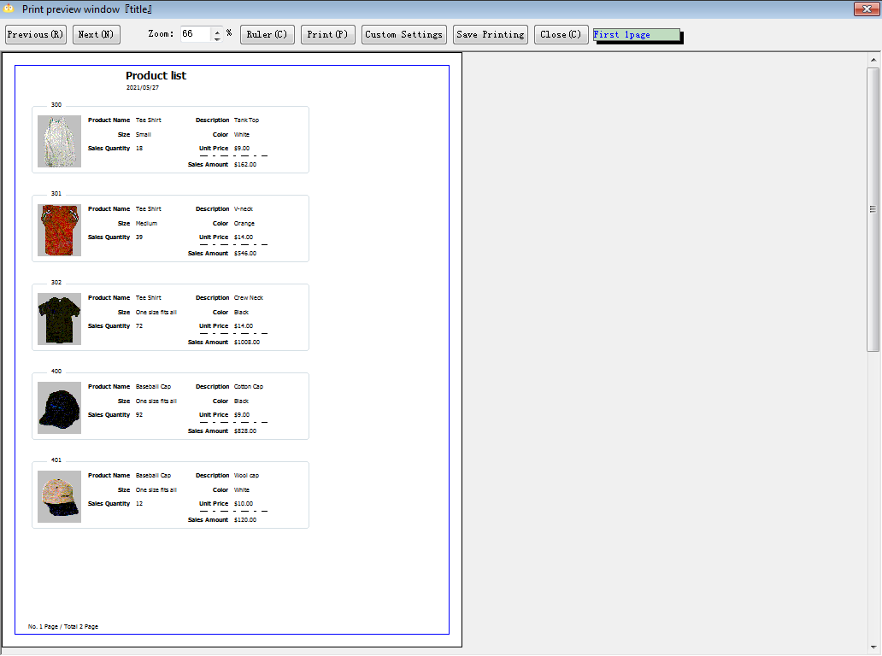

Chapter 6 User Objects

6.1.1 Create a customized user object (create a pop-up button) – ToggleButton

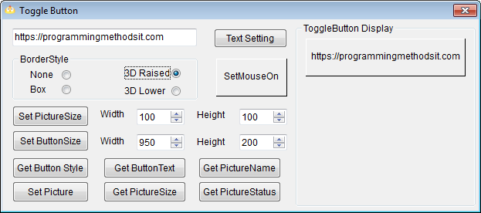

6.1.2 Create a standard visual user object (extended data window) – Datawindow

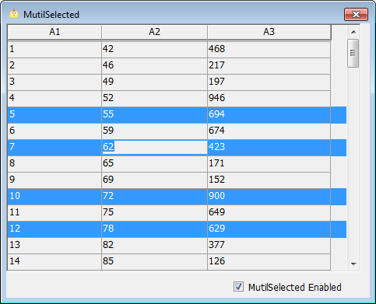

6.1.3 Create a visual external user object (status bar) – StatusBar

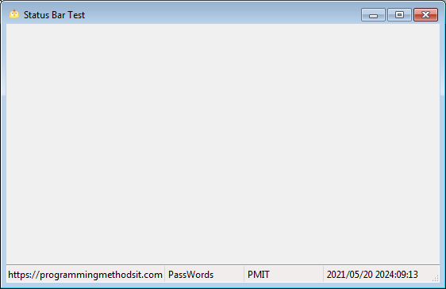

6.2.2 Create a general invisible user object (FTP application) – Ftp

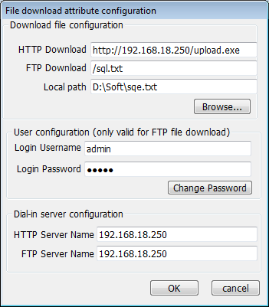

Chapter 7 API

7.2.1 Change the display style of the window – ChangeWindow

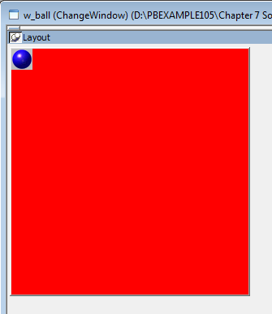

7.2.2 Make the picture of the window transparent – TransWindow

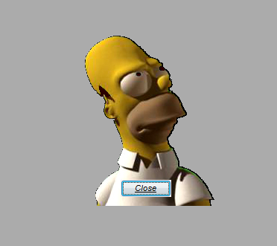

7.2.3 Change the closing style of the window – CloseStyle

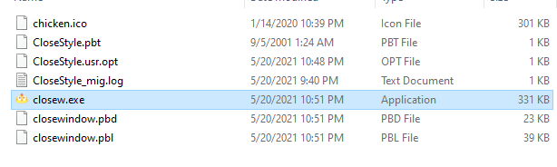

7.2.4 Realize the copy and paste of graphics and simple processing of images in PB – PictureBox

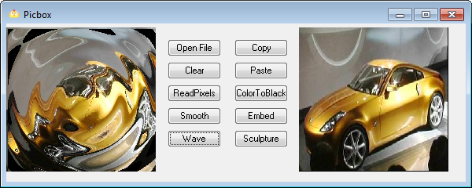

7.3.1 Get the internal process of the system - System Thread

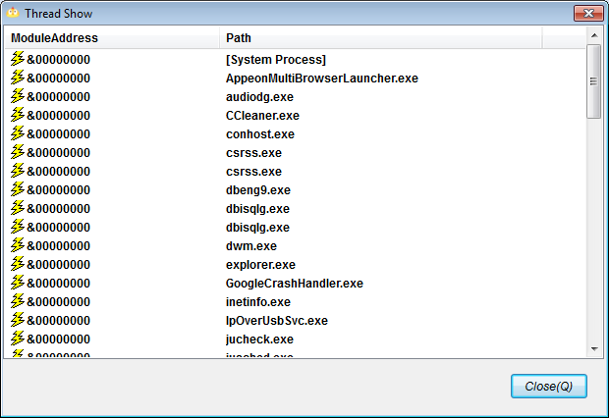

7.3.2 Obtain basic system information – SystemInformation

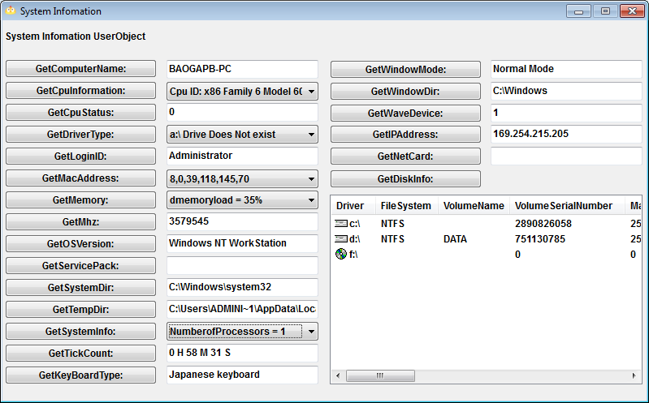

7.4.1 Checking the connectivity of the physical network – Mping

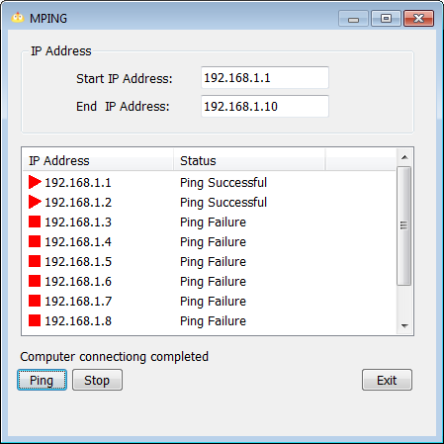

7.4.2 Shut down, restart, log off the computer – ExitWindow

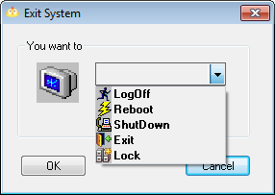

7.5.1 Use Visual C++ to develop dynamic link library - DllForPb9

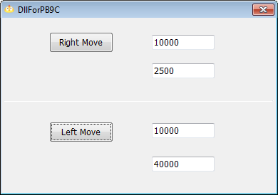

7.5.2 Use Delphi to develop dynamic link library – SetScreen

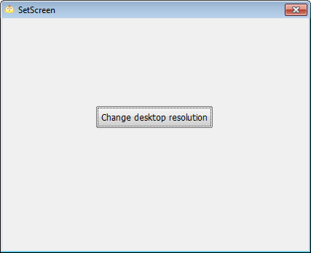

7.5.3 Use Visual Basic to develop ActiveX dynamic link library - CPUInfo

Chapter 8 pipeline

Data pipeline - pipeline

Chapter 9 DDE, OLE, COM Use Technology

9.1.3 DDE client implementation steps – DDE

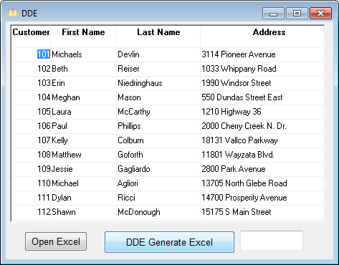

9.2.5 Invisible OLE objects – pbtowordandexcel

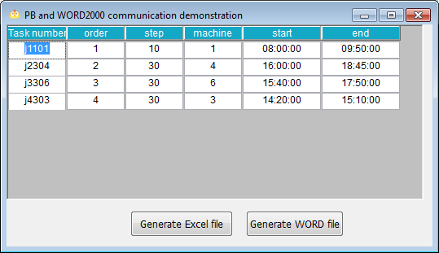

9.2.6 ActiveX Control – Media

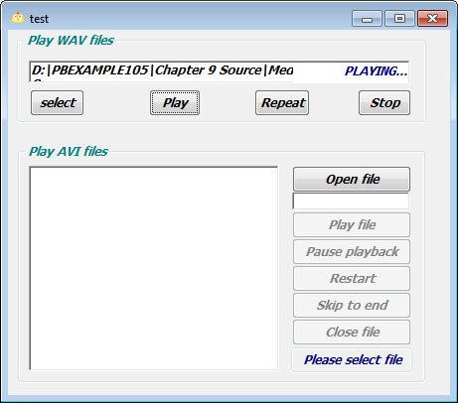

9.2.7 Use external OLE controls to process binary data in the database – DBOLE

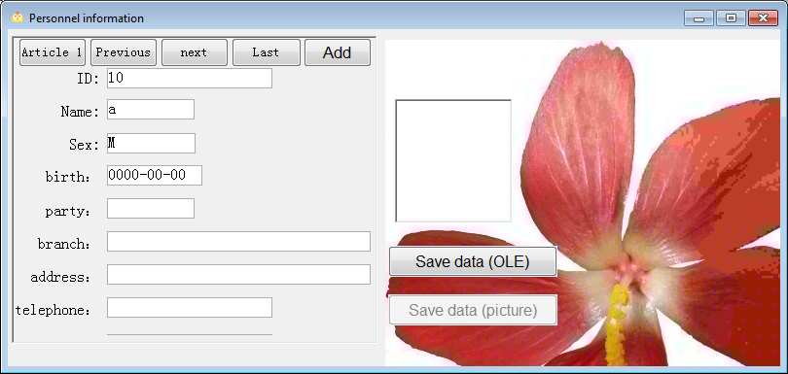

9.3.3 COM component implementation in PowerBuilder - pb9com

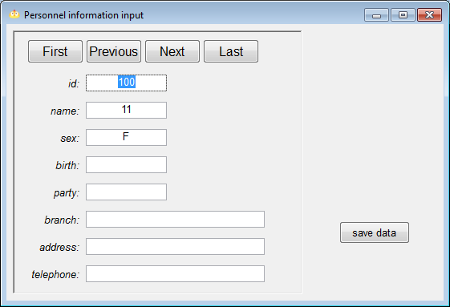

Chapter 10 Compilation and Distribution

Compile - TestInstall

Chapter 11 Jaguar

Contains the source program of two examples of developing Jaguar components and calling Jaguar components

Chapter 12 PBNI

PBNI application technology - PBNI