**Darknet YOLOv4 using Custom Dataset**

My recent project (Darknet Yolov4) is working with over 110,000 images (458 GB) related to the construction domain.

Please kindly go to my darknet Yolov4 Github: [https://github.com/thanthanswe-github/docker-darknet-yolov3-yolov4-training-test](https://github.com/thanthanswe0310/Computer-Vision-Project/tree/main/Docker-Darknet-Yolov3-4-Train-Test-Model)

Additionally, I created a darknet Yolov4 docker file as well.

Here, I would like to display my example images as well as real-time image.

Result Image:

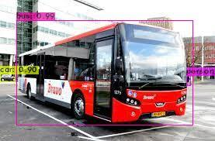

Fig 1: a bus (testing) image.

Fig2: A motorcycle image.

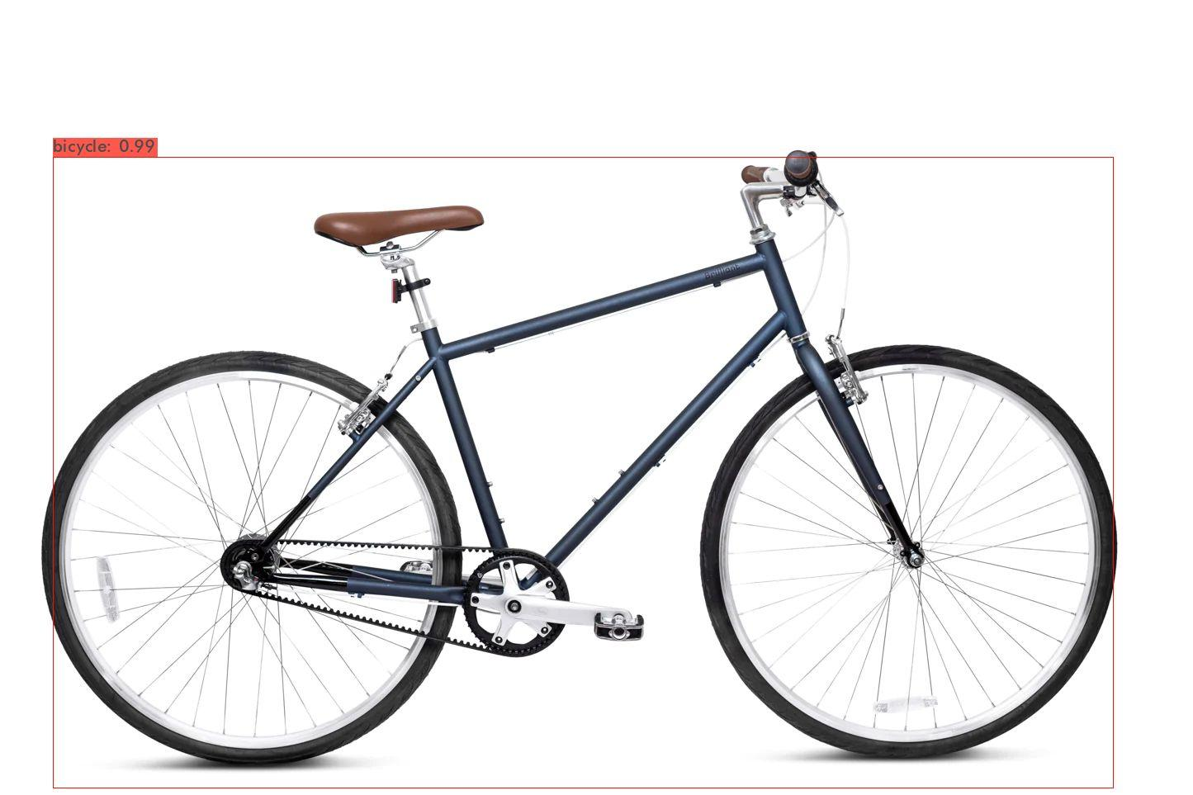

Fig 3: A bicycle (testing) image.

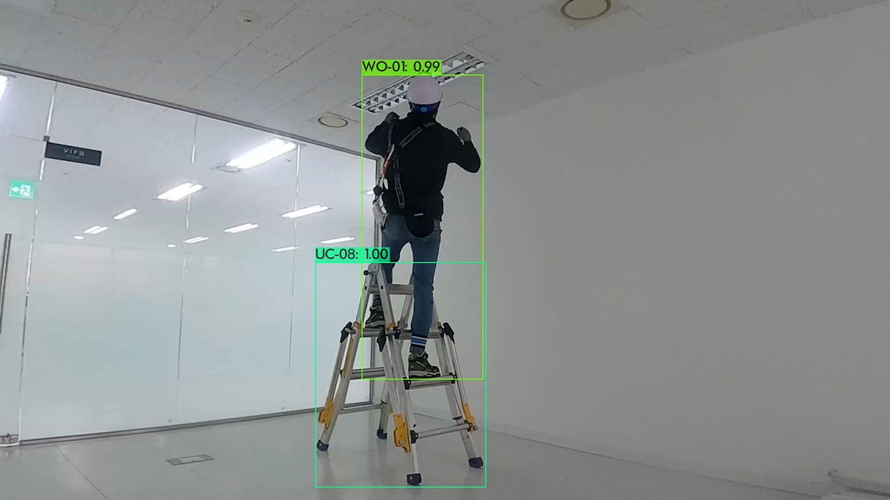

Fig 4: A worker on a ladder (real-time) image.