**Simple-HRNet for Key point detection using Custom Dataset**

Simple-HRNet (key point detection) is an unofficial implementation of the paper Deep High-Resolution Representation Learning for Human Pose Estimation. The code is a simplified version of the official code with the ease-of-use in mind.

However, the default prediction result is generated only in CSV or JSON file format. In this scenario, I implemented the prediction result in image (PNG) format. In the Simple-HRNet source code, I modified some code to get the prediction result in PNG file format.

* Here is some part of modification in train.py. Please check a [train.py python code](https://github.com/thanthanswe0310/Computer-Vision-Project/blob/main/source_code/simple-HRNet/training/Train.py) in my GitHub.
* Here is also modified in visualization.py. Please check a [visualization.py python code](https://github.com/thanthanswe0310/Computer-Vision-Project/blob/main/source_code/simple-HRNet/misc/visualization.py) in my GitHub.
* Additionally, I created a [Simple-HRNet Docker file](https://github.com/thanthanswe-github/Simple_HRNet/blob/main/Dockerfile)for Simple-HRNet for key point detection.

This is my simple-HRNet code in github: [https://github.com/thanthanswe-github/Simple_HRNet/blob/main/Dockerfile](https://github.com/thanthanswe0310/Computer-Vision-Project/blob/main/source_code/simple-HRNet/Dockerfile)

**Result Image:**

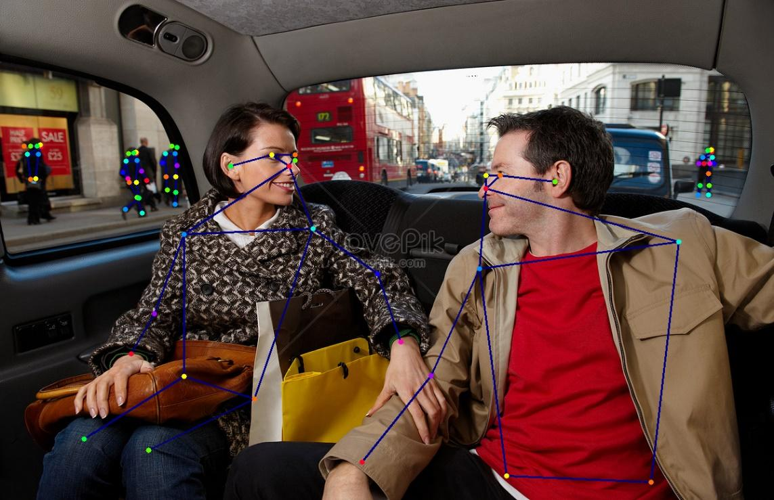

Fig 1: Two persons with car (testing) image.

Fig2: A person with handbag (testing) image.

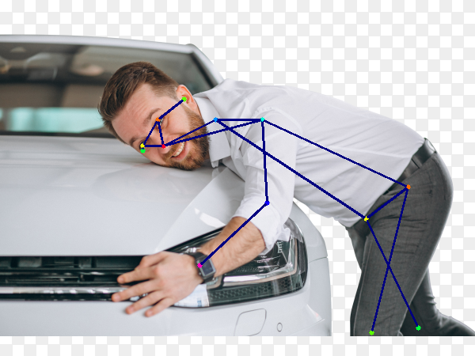

Fig 3: A person with car (testing) image.

Fig4: A worker on the ladder (real-time) tested image.

Fig5: A worker working on the box (real-time) tested image.