LABORATORY EXPERIMENT TESTS
AGTI (SEMESTER 5)
INFORMATION SECURITY
(IT-DP 3203)
SR. | JOBS | DATE | MARK GIVEN | MARK GOT
1. | Password Strength Checker (Test 1) |  | 5
2. | User Authentication Simulation  (Test 2) |  | 5
Total |  |  | 10

Student Name: | Teacher Name:
Roll Number: | Designation:
Sign: | Sign:

- PASSWORD STRENGTH CHECKER (TEST 1)

AIM: To develop a C++ program that evaluates the strength of a user-entered password based on predefined security criteria.
DESCRIPTION: Weak passwords are a major cause of security breaches in computer systems. This experiment evaluates the strength of a user-entered password by analyzing its characteristics and providing appropriate feedback. The program is written in C++ and executed in Code::Blocks, with input and output handled via the console.
ALGORITHM (Step-by-Step Logic)
- Start the program.
- Prompt the user to enter a password.
- Check whether the password:
- Contains uppercase letters
- Contains lowercase letters
- Contains digits
- Contains special characters
- Meets the minimum length requirement
- Count the number of conditions satisfied.
- Classify the password strength as:
- Weak → If 1–2 conditions are satisfied
- Moderate → If 3 conditions are satisfied
- Strong → If 4 or more conditions are satisfied and the password length is at least 8 characters
- Display the password strength to the user.
- End the program.

PROGRAM:
#include <iostream>
#include <string>
#include <cctype>

using namespace std;

int main() {
string password;

// Flags to track password conditions
bool hasUppercase = false;
bool hasLowercase = false;
bool hasDigit = false;
bool hasSpecialChar = false;

// Prompt user for password
cout << "Enter your password: ";
getline(cin, password);

// Analyze each character in the password
for (char ch : password) {
if (isupper(ch)) {
hasUppercase = true;
} else if (islower(ch)) {
hasLowercase = true;
} else if (isdigit(ch)) {
hasDigit = true;
} else {
hasSpecialChar = true;
}
}

// Count satisfied conditions
int conditionCount = 0;
if (hasUppercase) conditionCount++;
if (hasLowercase) conditionCount++;
if (hasDigit) conditionCount++;
if (hasSpecialChar) conditionCount++;

// Display analysis header
cout << "---------------------------------------------\n";
cout << "Password Analysis Result:\n";

// Determine password strength
string strength;
if (conditionCount <= 2) {
strength = "WEAK";
} else if (conditionCount == 3) {
strength = "MODERATE";
} else if (conditionCount >= 4 && password.length() >= 8) {
strength = "STRONG";
} else {
strength = "MODERATE";
}

cout << "Password Strength: " << strength << endl;
cout << "---------------------------------------------\n";

// Display suggestions if password is not strong
cout << "Suggestions:\n";

if (strength == "STRONG") {
cout << "(No suggestions - password is strong)\n";
} else {
if (!hasUppercase)
cout << "- Add at least one uppercase letter.\n";
if (!hasLowercase)
cout << "- Add at least one lowercase letter.\n";
if (!hasDigit)
cout << "- Add at least one digit.\n";
if (!hasSpecialChar)
cout << "- Add a special character (e.g., @, #, $, %).\n";
if (password.length() < 8)
cout << "- Make your password at least 8 characters long.\n";
}
return 0;
}

OUTPUT:
- Password Strength: WEAK
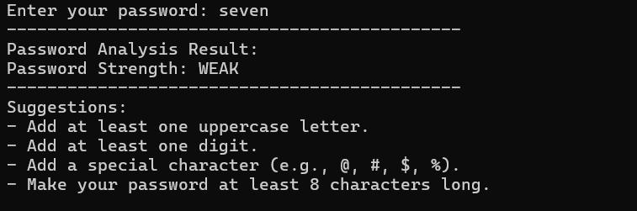

- Password Strength: STRONG
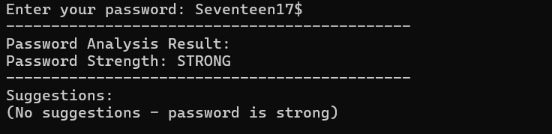

RESULT:
The C++ program was successfully executed and accurately evaluated the strength of the user-entered password.
Marking Scheme:
 | Sr. | Description | Mark Given | Mark Got
 | 1. | Follow instructions correctly | 1
 | 2. | List the algorithm | 1
 | 3. | Produce expected output | 2
 | 4. | Complete within time | 1

- USER AUTHENTICATION SIMULATION (TEST 2)

AIM: To demonstrate how users are verified before gaining access to a system using a C++ program.

DESCRIPTION: Develop a C++ console program to simulate a user authentication system that validates login credentials using hashed passwords and a 6-digit OTP. The program grants access if both the password and OTP are correct, or displays appropriate error messages for invalid credentials. This exercise demonstrates username/password authentication, OTP verification, secure password handling, and console-based input/output. The program is implemented in C++ and executed in Code::Blocks, with all interactions performed via the console.

ALGORITHM (Step-by-Step Logic)
- Start the program.
- Seed the random number generator using the current time.
- Create a user database (unordered map) to store usernames and hashed passwords.
- Create a hash function for password hashing.
User Registration
- Display "User Registration" prompt.
- Ask the user to enter a username.
- Check if the username already exists in the database:
- If yes, display "Username already exists" and terminate the program.
- Ask the user to enter a password.
- Hash the password and store it in the database with the username.
- Display "Registration successful".
User Login
- Display "User Login" prompt.
- Ask the user to enter username and password.
- Check if the username exists in the database:
- If not, display "Username not found" and terminate the program.
- Hash the entered password and compare it with the stored hash:
- If it does not match, display "Invalid password" and terminate the program.
OTP Verification
- Generate a random 6-digit OTP.
- Display the OTP (simulated) to the user.
- Prompt the user to enter the OTP.
- Compare the entered OTP with the generated OTP:
- If it matches, display "Access Granted".
- If it does not match, display "OTP verification failed" and "Access Denied".
- End the program.

PROGRAM:
#include <iostream>
#include <string>
#include <unordered_map>
#include <cstdlib>
#include <ctime>
#include <functional>

using namespace std;

/* Function: generateOTP
Purpose : Generates a random 6-digit OTP */
int generateOTP() {
return 100000 + rand() % 900000;
}

int main() {
// Seed random number generator
srand(static_cast<unsigned int>(time(0)));

// User database: username -> hashed password
unordered_map<string, size_t> userDatabase;

// Hash function for passwords
hash<string> hashPassword;

string username, password;

// =========================
// USER REGISTRATION
// =========================
cout << "=== User Registration ===\n";
cout << "Enter a username: ";
cin >> username;

// Check if username already exists
if (userDatabase.find(username) != userDatabase.end()) {
cout << "Username already exists. Registration failed.\n";
return 0;
}

cout << "Enter a password: ";
cin >> password;

// Store hashed password
userDatabase[username] = hashPassword(password);

cout << "Registration successful!\n\n";

// =========================
// USER LOGIN
// =========================
cout << "=== User Login ===\n";
string loginUsername, loginPassword;

cout << "Enter username: ";
cin >> loginUsername;

cout << "Enter password: ";
cin >> loginPassword;

// Check if username exists
if (userDatabase.find(loginUsername) == userDatabase.end()) {
cout << "\nUsername not found.\n";
cout << "Access Denied.\n";
return 0;
}

// Verify password
size_t enteredPasswordHash = hashPassword(loginPassword);

if (enteredPasswordHash != userDatabase[loginUsername]) {
cout << "\nInvalid password.\n";
cout << "Access Denied.\n";
return 0;
}

// =========================
// OTP VERIFICATION
// =========================
int otp = generateOTP();

cout << "\nOTP generated (Simulation).\n";
cout << "Your OTP is: " << otp << endl;

int userOTP;
cout << "Enter OTP: ";
cin >> userOTP;

if (userOTP == otp) {
cout << "\nAccess Granted.\n";
} else {
cout << "\nOTP verification failed.\n";
cout << "Access Denied.\n";
}
return 0;
}

OUTPUT:
- Access Granted.
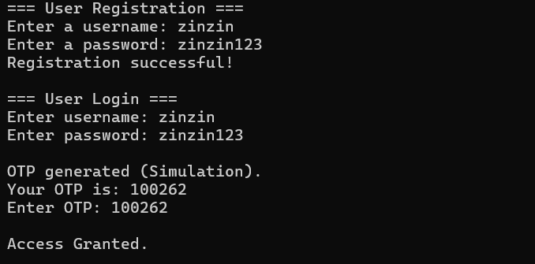

- Access Denied.
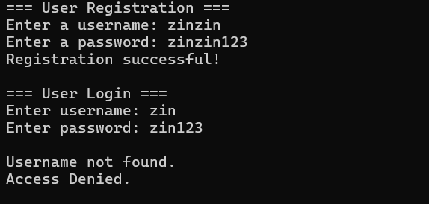

RESULT:
The program was successfully executed and correctly verified user credentials. It generated and validated OTPs as expected, granting access only when both the password and OTP were correct.

Marking Scheme:
 | Sr. | Description | Mark Given | Mark Got
 | 1. | Follow instructions correctly | 1
 | 2. | List the algorithm | 1
 | 3. | Produce expected output | 2
 | 4. | Complete within time | 1

