Answer all questions.

**(PART-A)**

1. What is involved in the process of interaction design?
2. Do you think it is better to develop technologies that will allow people to talk at a distance as if they were face to face, or to develop technologies that will support new ways of conversing?
3. Write down the list of **Usability goals and explain details.**

**(PART-B) (Submitted to Lecturer) ---------20 marks**

1. During this[design critique assignment](http://ifi7159.wordpress.com/module-1/assignment-3/), the following objects are shown:

Physical objects: Nokia 5220

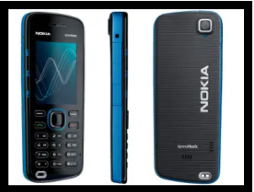

Just by looking at this object, we can comprehend several basic things:

- Nokia 5220

Nokia 5220 (released in 2008) is a bar phone with physical keyboard and a 2-inch TFT display. It’s a low-end phone from Nokia’s XpressMusic series which feature stereo speakers and dedicated external music controls. The phone runs Nokia S40 proprietary OS. it’s a handheld device, judging by the size, and it allows of input via keyboard. As to design principles, Nokia 5220 leaves an impression that all of the Norman’s design principles were used appropriately. If the phone is turned on, we see additional information that helps us build affordances about this object. The phone display shows date, time, network name, hotkey functions and, optionally, notifications.

Question:

Briefly go over them and see how they’re implemented, how do they affect interaction with the object and what were the tradeoffs the designer did make: Affordances, Consistency, Mapping, Visibility, Feedback and Constraints.

LG L9

LG L9 (released in 2012) is a mid-range smartphone from LG’s L series. It’s a bar phone with 4.7-inch IPS LCD capacitive touchscreen. The phone runs Android 4.0.4 with LG’s custom interface. It could be a smartphone, a multimedia player or whatever a device that requires a screen.

Answer the design principles factors using the following physical object:

Affordances, Consistency and etc…

