HERDWATCH
AI-Based Cattle Monitoring System



UNIVERSITY OF INFORMATION TECHNOLOGY

Group - 4
SEPTEMBER 2026

Course Name: CS-8117 Computer Vision
Project Title: HerdWatch AI-Based Cattle Monitoring System
Group Members
1. Yan Lin Naing
o Student ID: TNT-1934
o Email: yanlinnaing@uit.edu.mm
2. Khant Khant Wadi Hlaing
o Student ID: TNT-1977
o Email: khantkhantwadihlaing@uit.edu.mm
3. Thein Min Htet
o Student ID: TNT-1989
o Email: theinminhtet@uit.edu.mm
4. Mi Saung Wadi Zan
o Student ID: TNT-2005
o Email: mihsaungwadizan@uit.edu.mm
5. Thant Zin Moe
o Student ID: TNT-2081
o Email: thantzinmoe@uit.edu.mm

Supervisor: Dr. Thiri Mar Lar Swe
Department: Faculty of Computer Science
Submission Date:

Contents

1.Introduction 1
1.1 Overview 1
1.2 Project Scope 1
1.3 Objectives 2
2.Project Planning and Requirement Analysis 3
2.1 Functional vs. Non-Functional Requirements 3
2.2 Use Cases and User Stories 4
2.2.1 Use Case 4
2.2.2 User Stories 5
3.System Design and Architecture 6
3.1 System Architecture Design 6
3.2 System Process Flow 6
3.3 Main System Components 7
3.4 Database Design: ER diagrams 8
4.1 Tools and Technologies 9
4.2 Development Environment 9
4.3 Coding Standards 10
5. Screen Layout and Design 11
5.1 Dashboard 11
5.2 Cattle Monitor Screen 11
5.3 Main Interface Functions 12
6. Conclusion and Reflection 13
6.1 Project Summary 13
6.3 Lessons Learned 14
6.4 Future Enhancements 14
7. Appendices 15
Appendices A - Screen and Detection output 15
Appendices B - Key Project Source Structure 16
Appendices C - References 16

1.Introduction

1.1 Overview

HerdWatch Vision: Cattle Monitor is a computer-vision-based application designed to monitor cattle from images, recorded videos, and a live camera. The project combines a React web interface, a FastAPI backend, and a YOLO11s-based cattle detector. The system can detect cattle, maintain stable tracking identities in video, count visible animals within a configurable region of interest (ROI), and provide simple movement observations.
The project is intentionally positioned as an observation and monitoring tool rather than a veterinary diagnostic system. The user interface explicitly describes the conditions as visual observations and warns that persistent abnormal behaviour should be reviewed by a qualified veterinarian.
The supplied project contains separate frontend, backend, and computer-vision components. The frontend provides Dashboard and Cattle Monitor pages; the backend exposes health and prediction functionality; and the core vision module performs detection, tracking, counting, and movement-condition assessment.

1.2 Project Scope
- Accept cattle images and common video formats including JPG, PNG, BMP, MP4, AVI, MOV and MKV through the web interface.
- Support a live camera mode for continuous observation.
- Detect cattle using a trained YOLO11s detection model stored as cattle_count_best.pt.
- Restrict counting and movement observations to a configurable ROI.
- Use configurable detection confidence, line orientation, line position and ROI boundaries.
- Track cattle across video frames using ByteTrack and stable track IDs.
- Count animals using line-crossing logic for video and visible-in-ROI counting for static images.
- Classify observable movement into OBSERVING, LOW MOVEMENT, NORMAL MOVEMENT and HIGH ACTIVITY states.
- Produce annotated prediction images/videos and JSON metric artifacts.
- Provide system-health information indicating whether the API and trained detection model are available.
Out of scope: the supplied implementation does not establish veterinary diagnoses, and the pure cattle-detection model does not provide a clinical lameness diagnosis. The source code explicitly notes that keypoint-based lameness detection is not available for the pure detection model.

1.3 Objectives

1. Develop a practical computer-vision application for cattle detection and
monitoring.
2. Improve herd counting by combining object detection, ROI filtering, tracking IDs
and line-crossing logic.
3. Provide a usable browser-based interface for uploading footage or using a live
camera.
4. Give users interpretable movement signals without presenting them as medical
diagnoses.
5. Separate frontend, backend and model-processing responsibilities so the
application can be maintained and extended.
6. Store model outputs and job-level metrics so prediction results can be inspected
after processing.

2.Project Planning and Requirement Analysis

2.1 Functional vs. Non-Functional Requirements
The following requirements are derived from the supplied source code and interface text. They describe what the current project is designed to do rather than unverified performance targets.

ID | Type | Requirement | Implementation Evidence
FR1 | Functional | Upload cattle images/videos. | React Cattle Monitor upload control and accepted image/video types.
FR2 | Functional | Run cattle detection. | YOLO model loaded from outputs/models/cattle_count_best.pt.
FR3 | Functional | Track cattle in video. | Ultralytics tracking with ByteTrack and persistent track IDs.
FR4 | Functional | Count cattle. | ROI visible counting for images and directional line crossing for videos.
FR5 | Functional | Configure ROI and counting lines. | Frontend controls for orientation, position, confidence and x1/y1/x2/y2.
FR6 | Functional | Assess movement observations. | Movement score based on recent tracked points.
FR7 | Functional | Expose API health status. | FastAPI /health endpoint reports API status and model availability.
FR8 | Functional | Save prediction artifacts. | Outputs directories contain prediction images and job metric JSON.
NFR1 | Non-functional | Maintainable separation of concerns. | Frontend, backend, core vision and scripts are separate directories.
NFR2 | Non-functional | Deterministic training configuration. | Training code sets seed=42 and deterministic=True.
NFR3 | Non-functional | Input validation. | Counting configuration validates ROI, line position, hysteresis, minimum frames and confidence.
NFR4 | Non-functional | Browser-compatible video output. | Video processing writes H.264 MP4 using imageio/FFMPEG.
NFR5 | Non-functional | Safe interpretation. | UI warns that movement observations are not veterinary diagnoses.

2.2 Use Cases and User Stories

2.2.1 Use Case

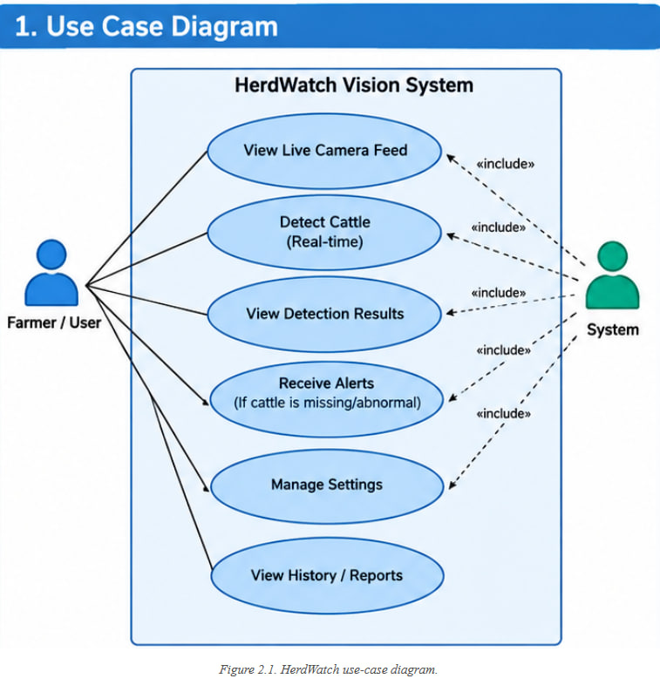
Figure 2.2.1 HerdWatch use-case diagram

2.2.2 User Stories
- As a farmer, I want to upload cattle footage so that I can automatically detect and count cattle.
- As a farmer, I want to use a live camera so that I can monitor cattle while the camera is running.
- As a farmer, I want to configure an ROI so that I can focus counting on a selected area.
- As a farmer, I want line-crossing counts so that I can monitor cattle moving through a boundary.
- As a farmer, I want movement status so that I can identify animals that may need closer observation.

3.System Design and Architecture

3.1 System Architecture Design

The system follows a layered architecture. The browser is responsible for user interaction and camera capture. The React frontend communicates with the FastAPI backend. The backend manages uploaded files, invokes the prediction core, performs live WebSocket inference, and exposes generated outputs. The trained YOLO model performs cattle detection, while OpenCV and NumPy support frame and trajectory processing.
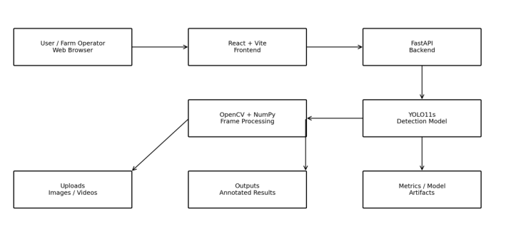 Figure 3.1: System Architecture Design

3.2 System Process Flow
The process begins with an image, uploaded video, or live camera frame. The frame is prepared for AI processing, YOLO11s detects cattle, ByteTrack associates detections between frames, and the system performs counting and movement analysis before displaying the result.
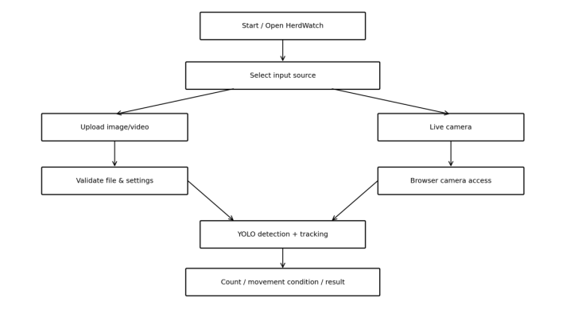

Figure 3.2: HerdWatch Process Flow

3.3 Main System Components

Component | Purpose
React Frontend | Dashboard, prediction screen, upload/live camera controls, ROI and line settings.
FastAPI Backend | API endpoints, prediction requests, WebSocket live processing, health checking.
YOLO11s | Detect cattle in each input frame.
ByteTrack | Track cattle between consecutive frames.
Counting Module | Calculate visible-in-ROI and directional line-crossing counts.
Movement Module | Estimate observable movement condition from tracking history.

3.4 Database Design: ER diagrams
The inspected application does not currently contain a relational database layer. However, a logical ER model is useful for documenting the information handled by the application and for guiding a future database implementation. The entities below correspond to the job/result structures already represented by the project.
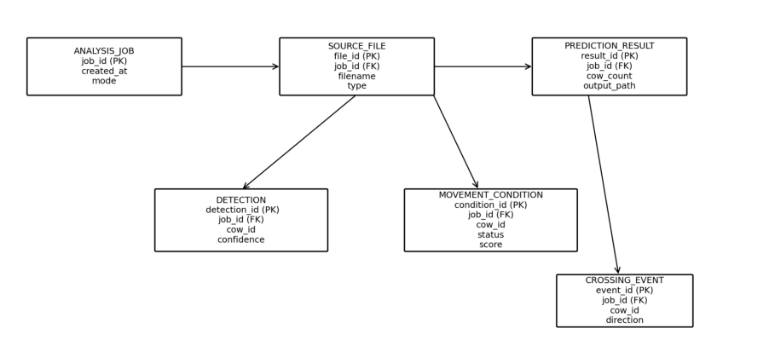
Figure 3.4: ER diagram
Entity | Important Attributes | Purpose
ANALYSIS_JOB | job_id, created_at, mode | Represents one monitoring/analysis session.
SOURCE_FILE | file_id, jo  b_id, filename, type | Stores information about an uploaded source.
PREDICTION_RESULT | result_id, job_id, cow_count, output_path | Stores final analysis results.
DETECTION | detection_id, job_id, cow_id, confidence | Stores individual tracked detections.
MOVEMENT_CONDITION | condition_id, job_id, cow_id, status, score | Stores movement observations.
CROSSING_EVENT | event_id, job_id, cow_id, direction | Stores directional line-crossing events.

Relationship summary: one analysis job can have one source file and one or more result-related records. A job may produce multiple detections, movement observations, and crossing events. This model can later be implemented in MySQL, PostgreSQL, SQLite, or another persistent database if historical analytics are required.

4. Development Environment Setup

4.1 Tools and Technologies
Technology | Use in HerdWatch
Python | Backend and computer-vision processing
FastAPI | Backend API and WebSocket services
Uvicorn | Runs the FastAPI application
React | Frontend interface
React Router | Frontend navigation
Vite | Frontend build/development tooling
Tailwind CSS | Frontend layout and styling utilities.
Ultralytics YOLO | YOLO11s training, prediction and evaluation
OpenCV | Frame and image processing
NumPy | Numerical processing
WebSocket | Live camera frame communication
Pandas | Evaluation metric table/CSV generation.
Pillow | Dataset image validation and pixel hashing.
imageio / FFMPEG | Browser-compatible annotated video writing.

4.2 Development Environment
The repository is organized into a frontend application under cv/frontend, a FastAPI backend under cv/backend, and computer-vision/training code under cv1/core and cv1/scripts. The frontend package configuration specifies React 19.2.8, React Router 7.18.2, Vite 8.2.0 and Tailwind CSS 4.3.3. The backend requirements are maintained in backend/requirements.txt, while the vision code imports libraries such as Ultralytics, OpenCV, NumPy, Pandas and Pillow.
For local development, the frontend is configured to communicate with a backend through the local development environment. The FastAPI application enables CORS for http://localhost:5173 and http://127.0.0.1:5173. The backend also mounts the project outputs directory at /outputs so generated images and videos can be accessed by the application.

4.3 Coding Standards
- Use descriptive module and function names such as process_source, assess_track_condition and train_model.
- Keep configuration validation close to the configuration object so invalid ROI or confidence settings fail early.
- Use type hints for core functions and data structures where practical.
- Separate training scripts from production prediction code.
- Write output artifacts to structured directories and use job IDs to avoid collisions between requests.
- Use comments/docstrings to explain non-obvious computer-vision decisions such as dense-tile detection and top-K frame counting.
- Treat visual movement results as observations and avoid diagnostic language in the user interface.
4.4 Model and Dataset Preparation
The training pipeline uses a cleaned cattle-counting dataset with one object class. The cleaning script removes empty annotations, converts polygon annotations to detection boxes, removes duplicate images/sources, and rebuilds 80/10/10 train/val/test splits. The script trains YOLO11s for 50 epochs (imgsz 640, batch size 4, seed 42, moderate augmentation).
​The project includes pseudo-labelling and dataset validation utilities, though the archive omits original dataset contents and full exported test metrics. Consequently, this section excludes synthetic precision, recall, or mAP values.

5. Screen Layout and Design

5.1 Dashboard
The Dashboard is the landing screen for system status and feature orientation. It presents a 'Live-ready cattle intelligence' message, a link to the Cattle Monitor, and status cards for the API and detection model. The dashboard also explains the three main capabilities: video tracking, live camera monitoring and condition signals.
The dashboard includes a condition guide with four states: Normal movement, Low movement, High activity and Observing. It also contains a prominent warning that the system reports visible movement patterns and detection confidence and cannot diagnose lameness, illness, pain, pregnancy or other medical conditions.
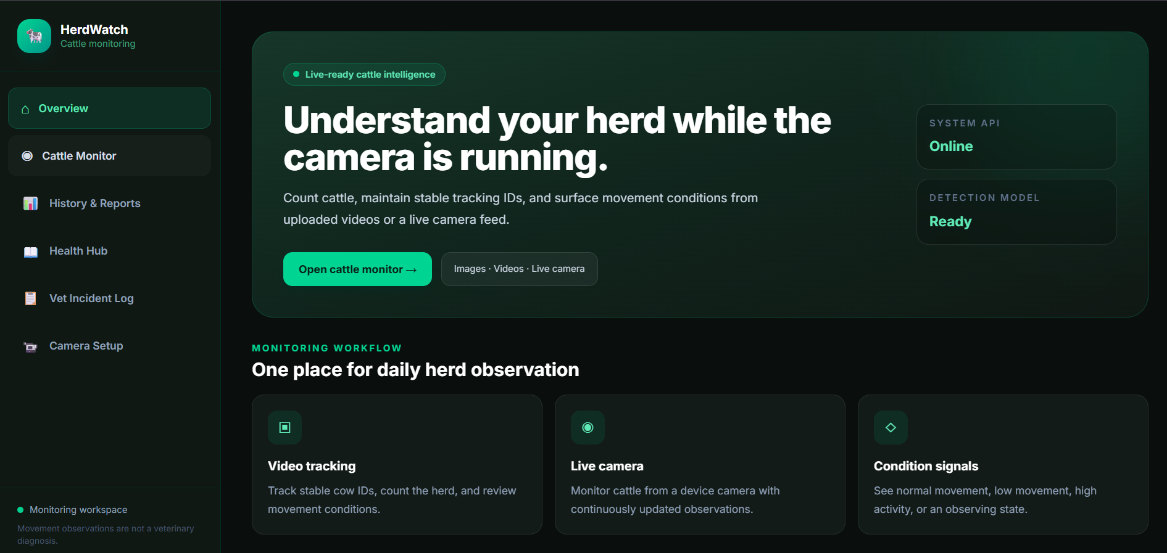

Figure 5.1. Dashboard Layout

5.2 Cattle Monitor Screen
The monitoring screen provides two operating modes: Upload Footage and Live Camera. It includes a Camera Counting Zone where the user can configure line orientation, line position, detection confidence, and ROI. The live view displays both the source camera stream and the AI tracking output.
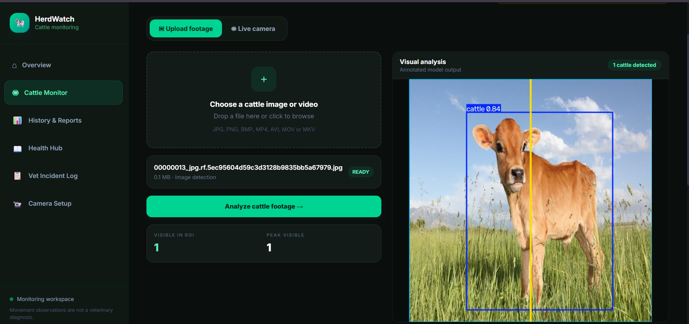

Figure 5.2. Monitor Screen Layout

5.3 Main Interface Functions
Screen/Control | Function
Dashboard | System overview, API status, model readiness, capability summary.
Upload Footage | Select an image/video for analysis.
Live Camera | Start/stop browser camera capture and live AI analysis.
Line Orientation | Choose vertical or horizontal counting movement.
Line Position | Move the counting line within the normalized scene.
Detection Confidence | Adjust the confidence threshold used by the monitoring session.
ROI | Restrict monitoring and counting to a selected region.
AI Tracking Output | Display annotated frames with detections/tracking.
Session Crossings | Show tracked crossing count.
Visible in ROI | Show cattle currently visible in the configured ROI.
Forward / Reverse | Show directional line-crossing counts.
Tracked Conditions | Show the number of condition observations.

5.4 Design Principles
- Keep the most important monitoring values visible without requiring navigation.
- Use clear controls for camera, ROI, line, and confidence configuration.
- Separate source imagery from AI-annotated output for easy visual comparison.
- Provide explicit status and error messages for unavailable camera/API/model resources.
- Keep animal-condition language observational and non-diagnostic.

6. Conclusion and Reflection

6.1 Project Summary
HerdWatch Vision demonstrates how a computer-vision model can be turned into an end-to-end monitoring application. The project does more than perform a single object-detection call: it adds configurable ROI filtering, stable video tracking, directional line crossing, movement-history analysis, a web API and a React user interface. This provides a foundation for practical cattle observation from common camera sources.
The supplied demonstration artifact successfully records two cattle detections from an image, and the annotated output shows the detector drawing bounding boxes and confidence labels. The runtime architecture is also structured so that a trained model can be reloaded when the model file changes.

6.2 Challenges and Solutions
Challenge | Solution Implemented
Cattle can appear close together and be difficult to separate. | The prediction module includes a dense-tile detection pass for likely tightly packed groups and applies non-maximum suppression.
Repeated video detections can cause over-counting. | ByteTrack maintains track IDs and the LineCrossingCounter records each counted track ID only once.
Small detection noise can create unstable line-crossing events. | The counter uses hysteresis, minimum track frames and an ROI boundary check.
A single noisy frame may inflate a video count. | The peak-frame count helper uses the median of the top-K per-frame counts rather than an absolute single-frame maximum.
Movement observations could be misunderstood as medical diagnoses. | The UI explicitly labels results as movement observations and includes a veterinary warning.
Different API jobs could overwrite the same output. | Prediction artifacts and metric files are stored using a job ID.
Browser playback can be sensitive to video encoding. | The video writer uses H.264 MP4 through imageio/FFMPEG for browser-compatible output.

6.3 Lessons Learned
- Object detection alone is not enough for reliable video counting; temporal tracking and event logic are important.
- Configuration such as ROI, confidence and line position should be exposed to users because camera views vary.
- Dataset cleaning and leakage-resistant splitting are essential before training an object detector.
- Safety-oriented wording matters when computer vision is applied to animal behaviour or welfare.
- Separating frontend, backend and core vision logic makes it easier to test and extend the application.
- Evaluation should distinguish a single demonstration result from measured dataset-level performance.

6.4 Future Enhancements
- Add a dedicated, validated pose/keypoint model if lameness or posture analysis is required.
- Add persistent database storage for sessions, historical counts and condition trends.
- Add authenticated multi-user access and role-based permissions for farm staff and administrators.
- Provide downloadable reports with daily/weekly herd counts and movement summaries.
- Add camera calibration and automatic ROI suggestions.
- Improve occlusion handling and evaluate tracker performance on crowded cattle scenes.
- Create a formal human-reviewed test set and report precision, recall, mAP@50 and mAP@50:95 alongside counting accuracy.
- Add automated alerts for persistent low movement, while retaining veterinary review as the final decision point.
- Add deployment documentation for edge devices or farm-local servers.

7. Appendices

Appendices A - Screen and Detection output

The following figure is a stored prediction artifact included in the project archive. It demonstrates the visual output format: cattle are enclosed by bounding boxes and the detector confidence is displayed. The associated job JSON reports two cattle detected with visible_in_roi counting.

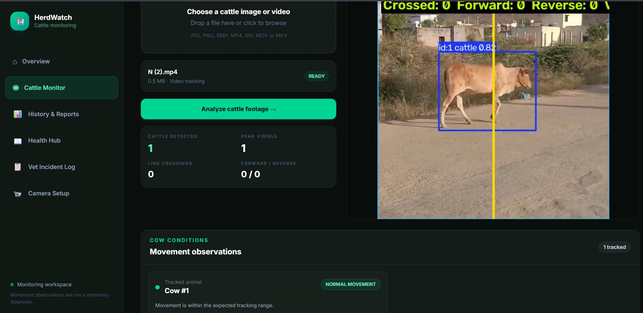

Figure 7.1. Detection Output Layout

Appendices B - Key Project Source Structure

Source file | Role
cv/backend/main.py | FastAPI application, CORS, static outputs, health endpoint, prediction router.
cv/backend/routers/predict.py | Image prediction and live webcam/WebSocket processing.
cv/frontend/src/App.jsx | React routing for Dashboard and Predict screens.
cv/frontend/src/pages/Dashboard.jsx | System overview and condition guidance.
cv/frontend/src/pages/Predict.jsx | Upload/live monitoring, camera capture, WebSocket, ROI and counting controls.
cv1/core/train.py | YOLO11s training configuration and model artifact export.
cv1/core/predict.py | Detection, tracking, counting, ROI and movement-condition logic.
cv1/core/evaluate.py | Test-set model evaluation and metric export.

Appendices C - References
- Project source code: cv1/core/train.py – YOLO11s training pipeline.
- Project source code: cv1/core/predict.py – detection, tracking, counting and movement observation pipeline.
- Project source code: cv1/core/lameness_classifier.py – counting configuration and line-crossing logic.
- Project source code: cv1/core/evaluate.py – test-set evaluation and metric export.
- Project source code: cv/backend/main.py and cv/backend/routers/ – FastAPI backend.
- Project source code: cv/frontend/src/pages/ and cv/frontend/src/components/ – React interface.
- Project artifact: outputs/metrics/jobs/f3a6aa66db4c49d89fef749bd8031c74.json – demonstration job metrics.
- Project artifact: outputs/predictions/f3a6aa66db4c49d89fef749bd8031c74.jpg – demonstration annotated detection.

