CHAPTER 3
IMPLEMENTATION AND DESIGN OF SCHOOL LIBRARY
MANAGEMENT SYSTEM
This paper presents school library management system by using C# programming language in ASP.NET Core framework to manage school library circulation and book catalogues. This system allows admins and users to view the book information and circulation records. In this system, admins only can manage book details, categories, members, borrow and return transactions, and system settings. Admins only can manage users.

3.1 User Interface Design
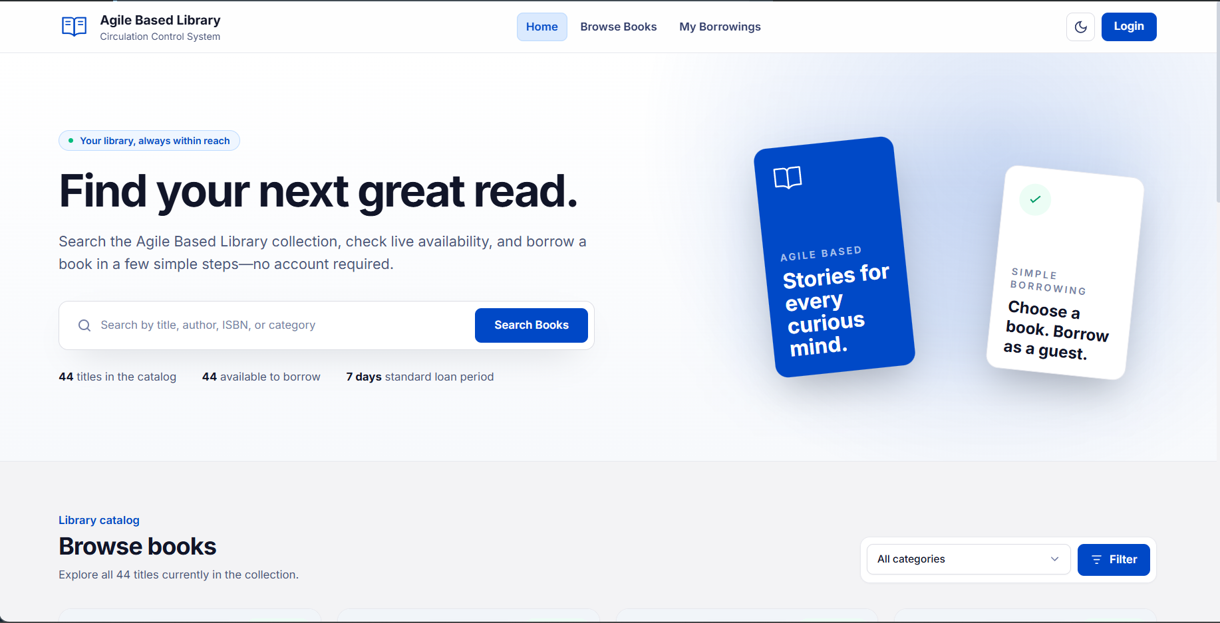
Figure 3.1 User Interface for Home Page Window
When the system starts, the user will see the home page as shown in Figure 3.1. Any user can browse available books, search the catalogue, or click the "Login" button to login.

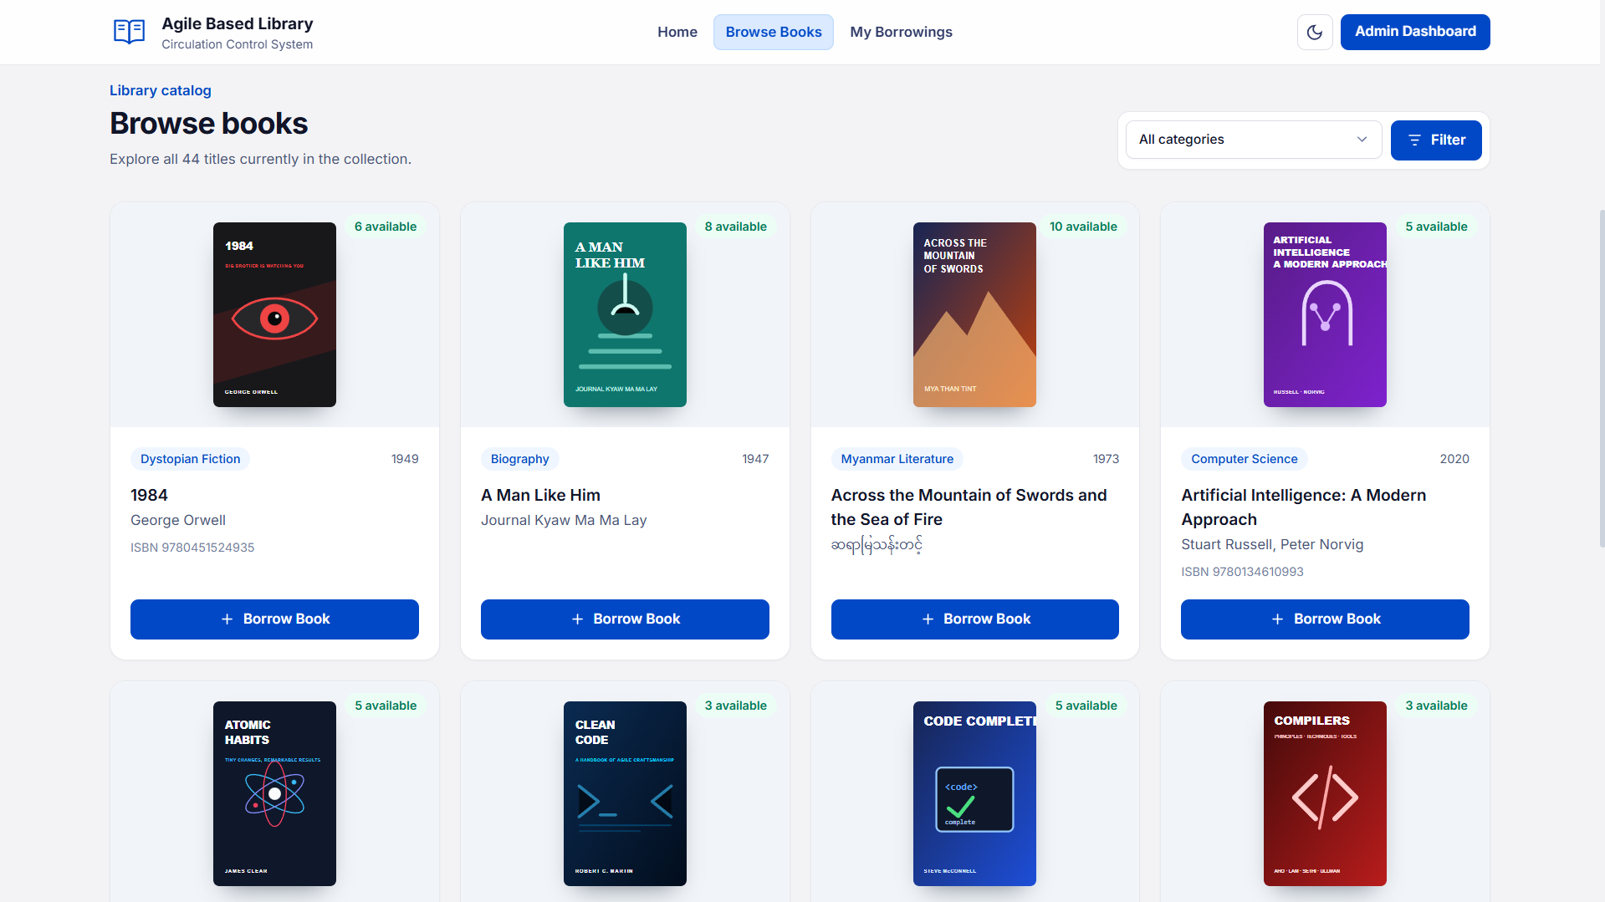
Figure 3.2 Displaying the Browse Books Window
Figure 3.2 shows the browse books catalogue window. In this window, users can explore available book titles, view real-time availability badges, and filter books by category.

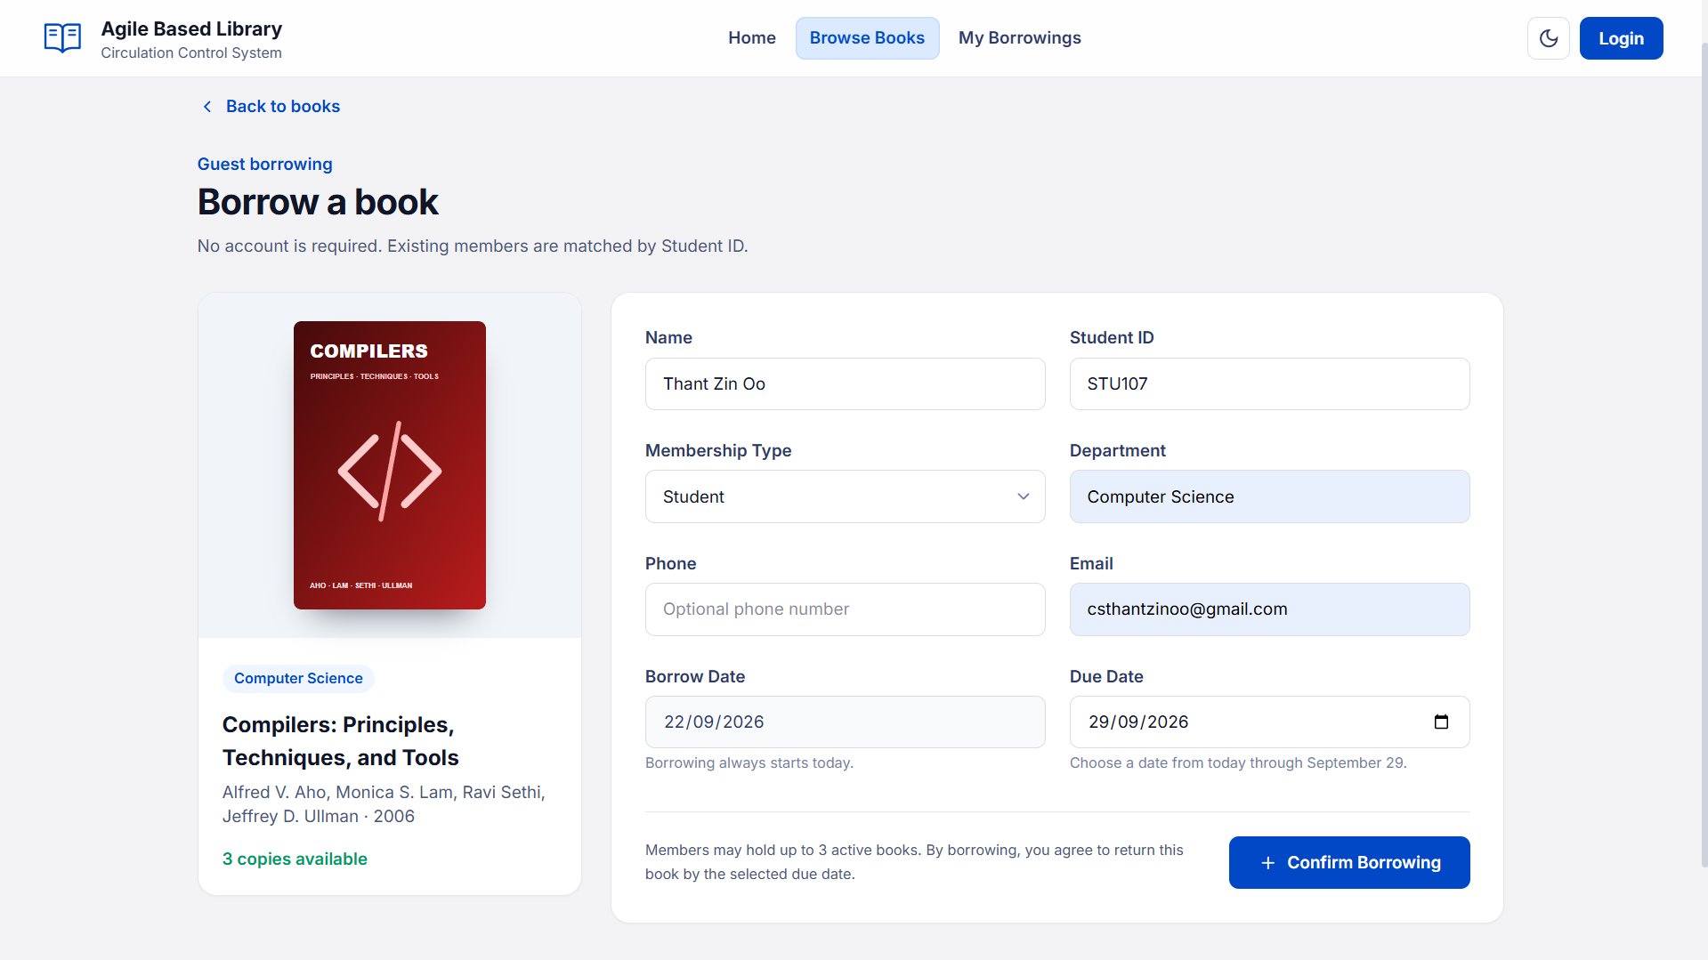
Figure 3.3 Displaying the Member Self-Service Book Borrowing Window
After clicking on the "Borrow Book" button, the user will be taken to the "Borrow a book" window as shown in Figure 3.3. Students and teachers can borrow the selected book without logging in by filling in their Name, Student ID, Membership Type, Department, and Email address. The user selects a valid return due date within the allowable loan period and confirms the transaction by clicking the "+ Confirm Borrowing" button.

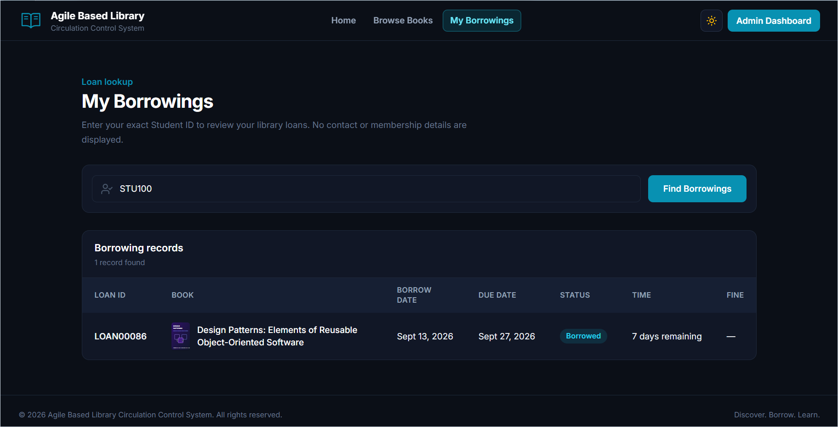
Figure 3.4 Displaying the Member Borrowing Lookup Window
Figure 3.3 shows the member self-service borrowing history window. The window provides users with the search tool to lookup their personal borrowing records, due dates, and fine balances.

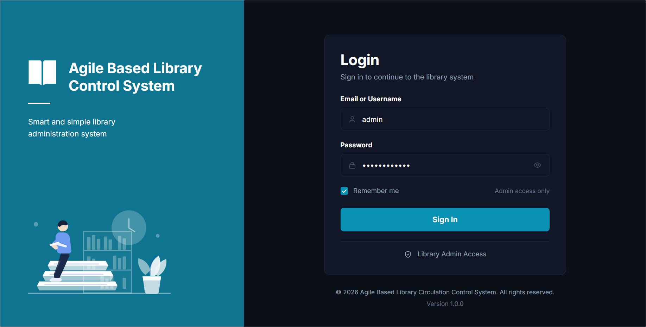
Figure 3.5 Displaying the User/Admin Login Window
Figure 3.5 shows the User/Admin login window. Admin can login by filling username or email and password in the form to authenticate into the system.

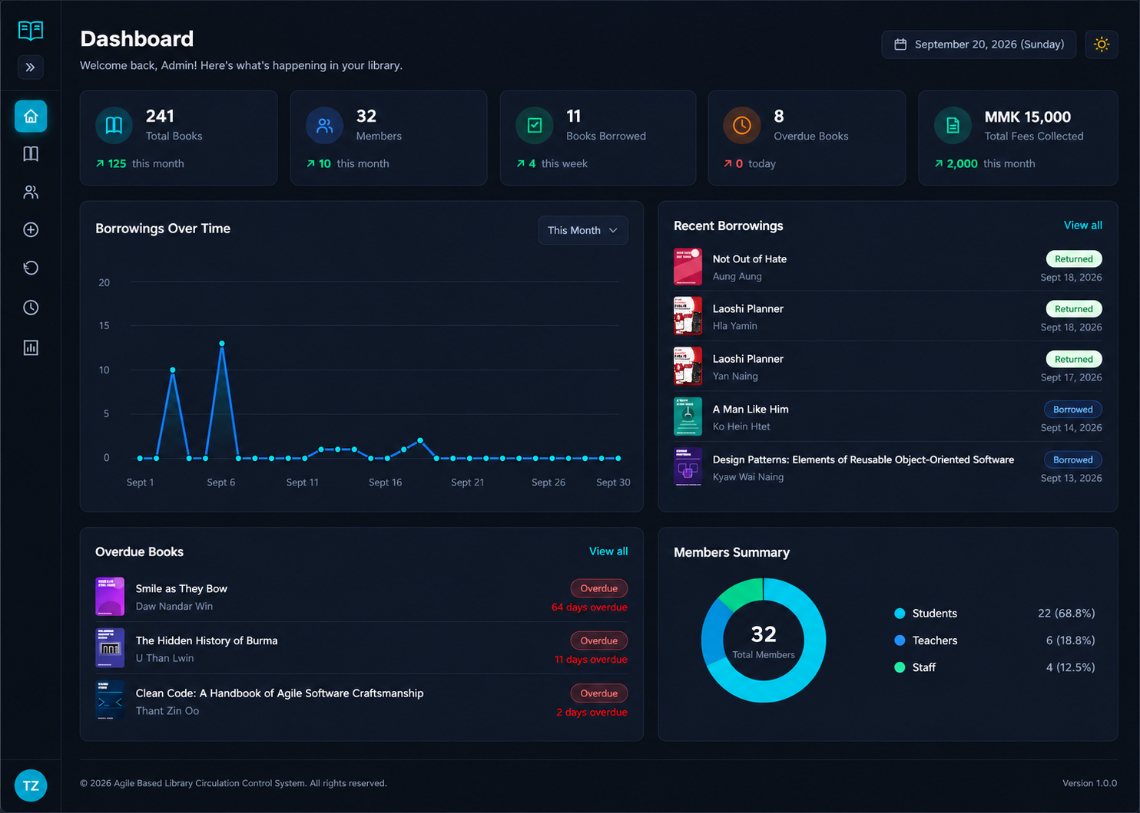
Figure 3.6 Displaying the Admin's Home Page Window
Figure 3.6 shows the logged in admin home page window. The window provides admin with the navigation bar with Home, Books, Members, Borrow, Return, Reports, Settings and Logout buttons.
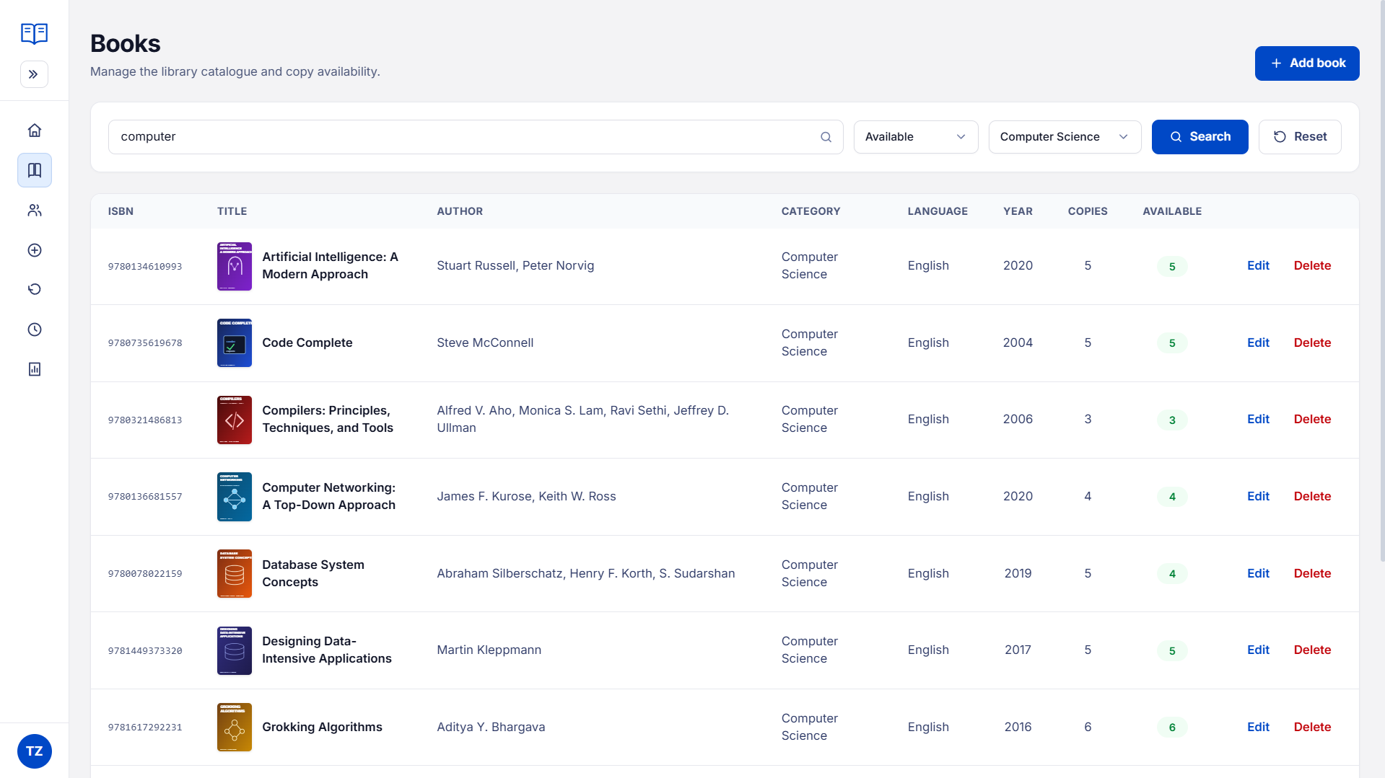
Figure 3.7 Displaying the Book Catalogue Window
After clicking on the "Books" button or book icon in the sidebar, the user will be taken to the "Book Catalogue" window as shown in Figure 3.7. Users can see the list of books and search by title, author, category or ISBN from the search bar.

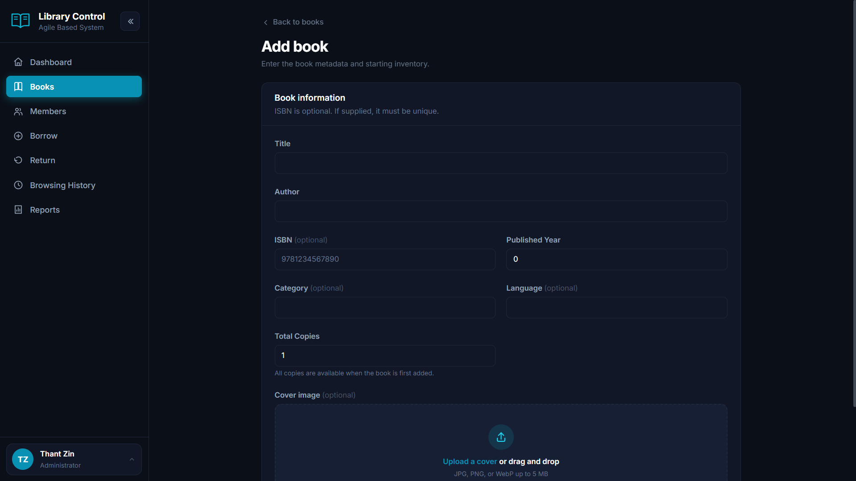
Figure 3.8 Displaying the Add New Book Window
Figure 3.7 shows the add new book modal window. Admin can register new books by filling title, author, ISBN, category, publisher, publish year, total copies, and uploading a cover image.

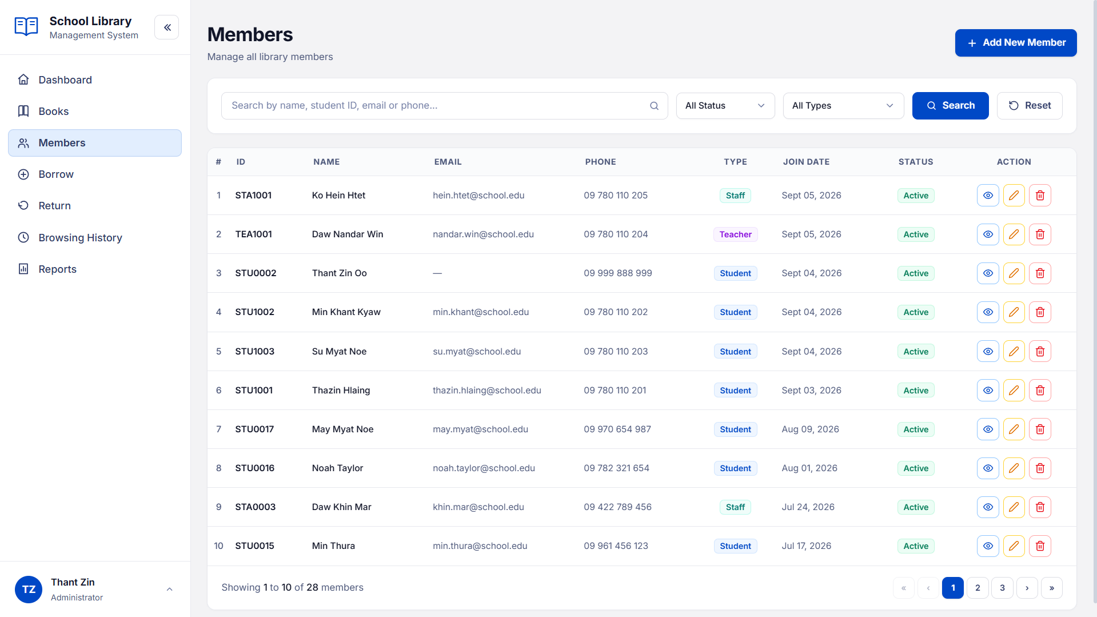
Figure 3.9 Displaying the Members Administration Directory Window
Figure 3.9 shows the library members administration window. The admin can view all registered members across Student, Teacher, and Staff tiers, search member records, and check active loan counts.

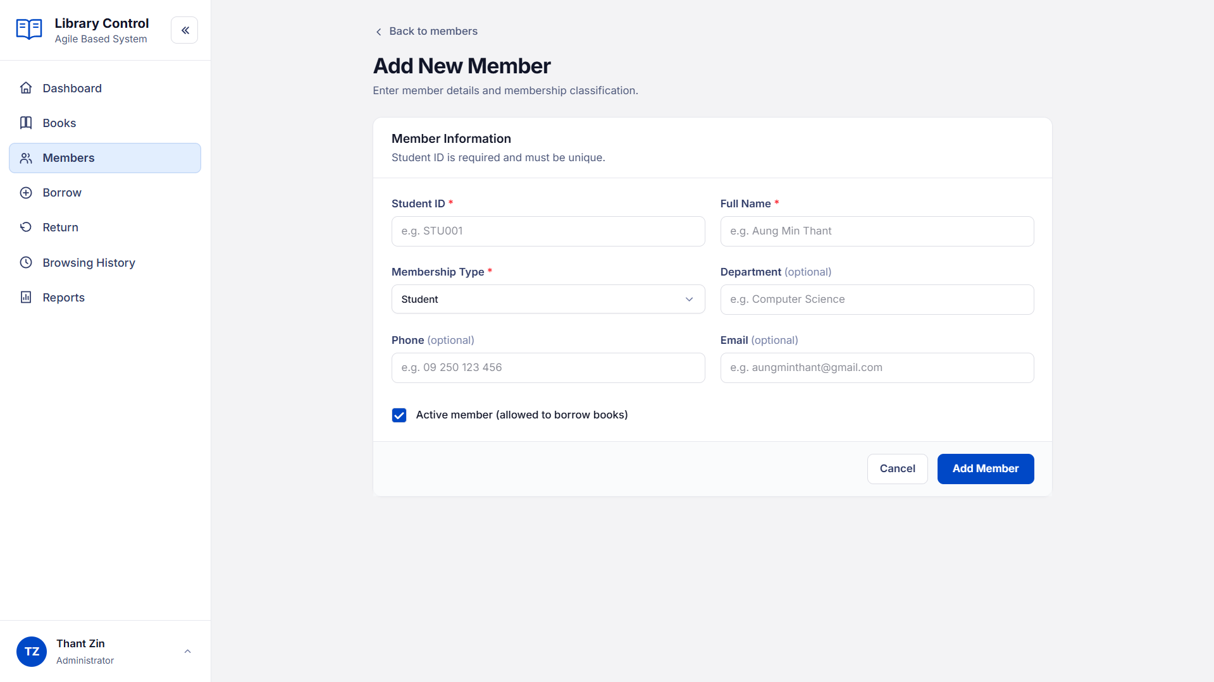
Figure 3.10 Displaying the Add New Member Registration Window
Figure 3.10 shows the new member registration modal window. The admin can register new patrons by providing their full name, member code, membership tier, department, contact number, and email address.

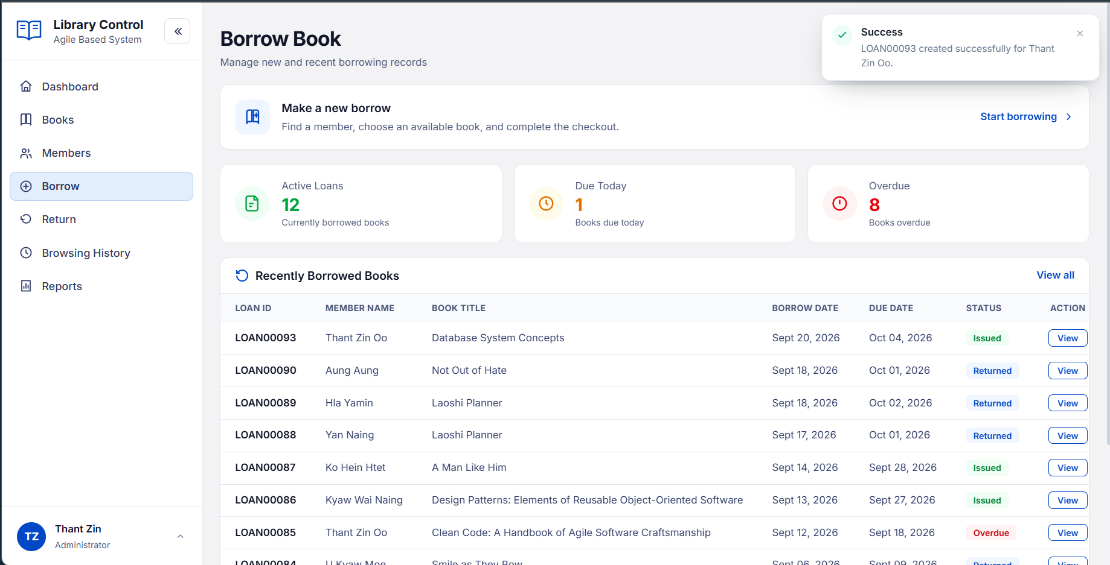
Figure 3.11 Displaying the Book Borrowing Circulation Window
Figure 3.11 shows the book borrowing circulation management window. Librarians can view active checkouts, search by member code or transaction ID, monitor return due dates, and track overdue items.

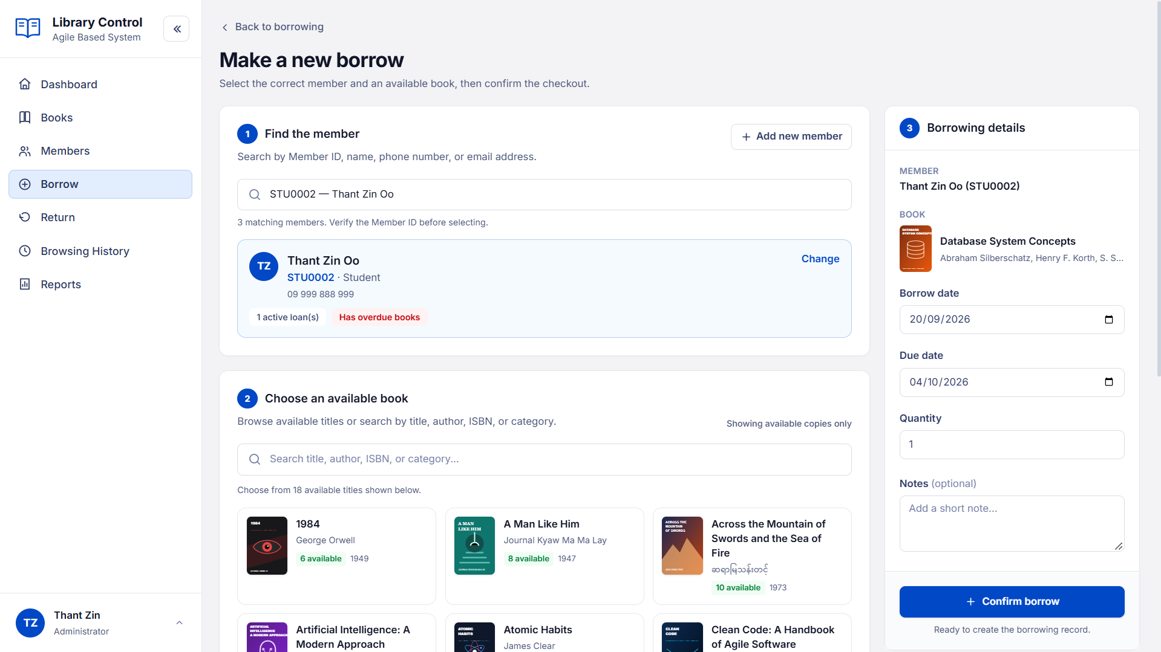
Figure 3.12 Displaying the New Book Checkout and Issue Window
Figure 3.12 shows the checkout window for issuing books to members. The librarian selects an active member, selects one or more books, specifies the due date, and confirms the checkout transaction.

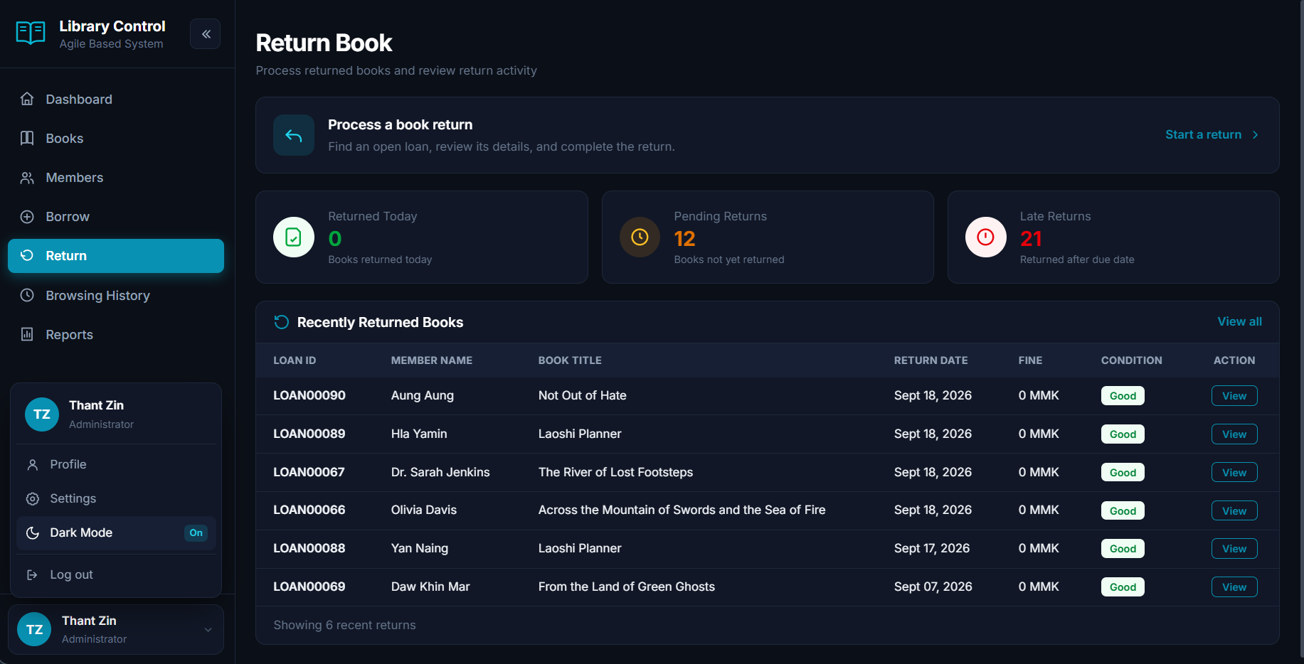
Figure 3.13 Displaying the Book Return Directory Window
Figure 3.13 shows the book returns directory window. The admin can review all completed book returns, return timestamps, condition gradings, and recorded fine payments.

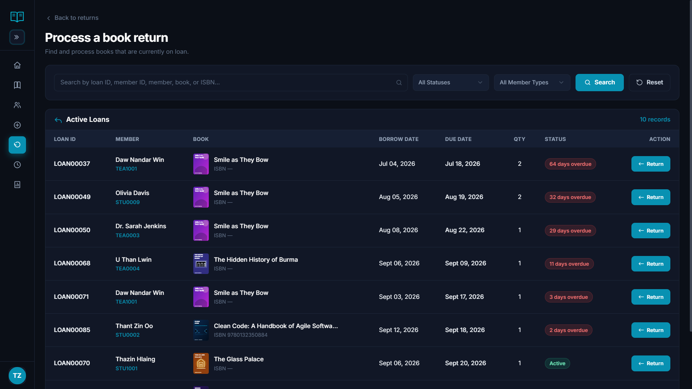
Figure 3.14 Displaying the Process Return and Fine Assessment Window
Figure 3.14 shows the process return modal dialog. The librarian inspects the returned book, records condition notes (Good, Damaged, or Lost), checks overdue days, and collects any assessed overdue fines.

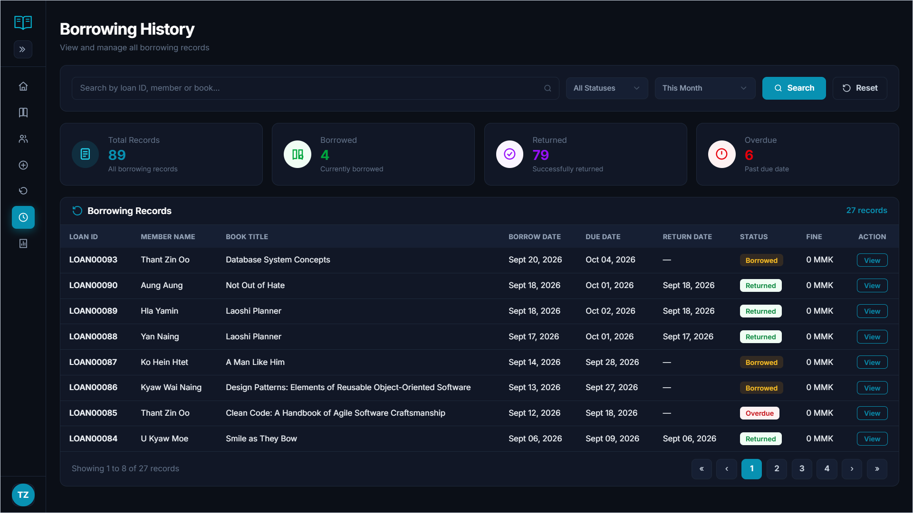
Figure 3.15 Displaying the Circulation History Audit Window
Figure 3.15 shows the circulation borrowing history window. This window provides a comprehensive audit trail of all historical circulation transactions with date range filters.

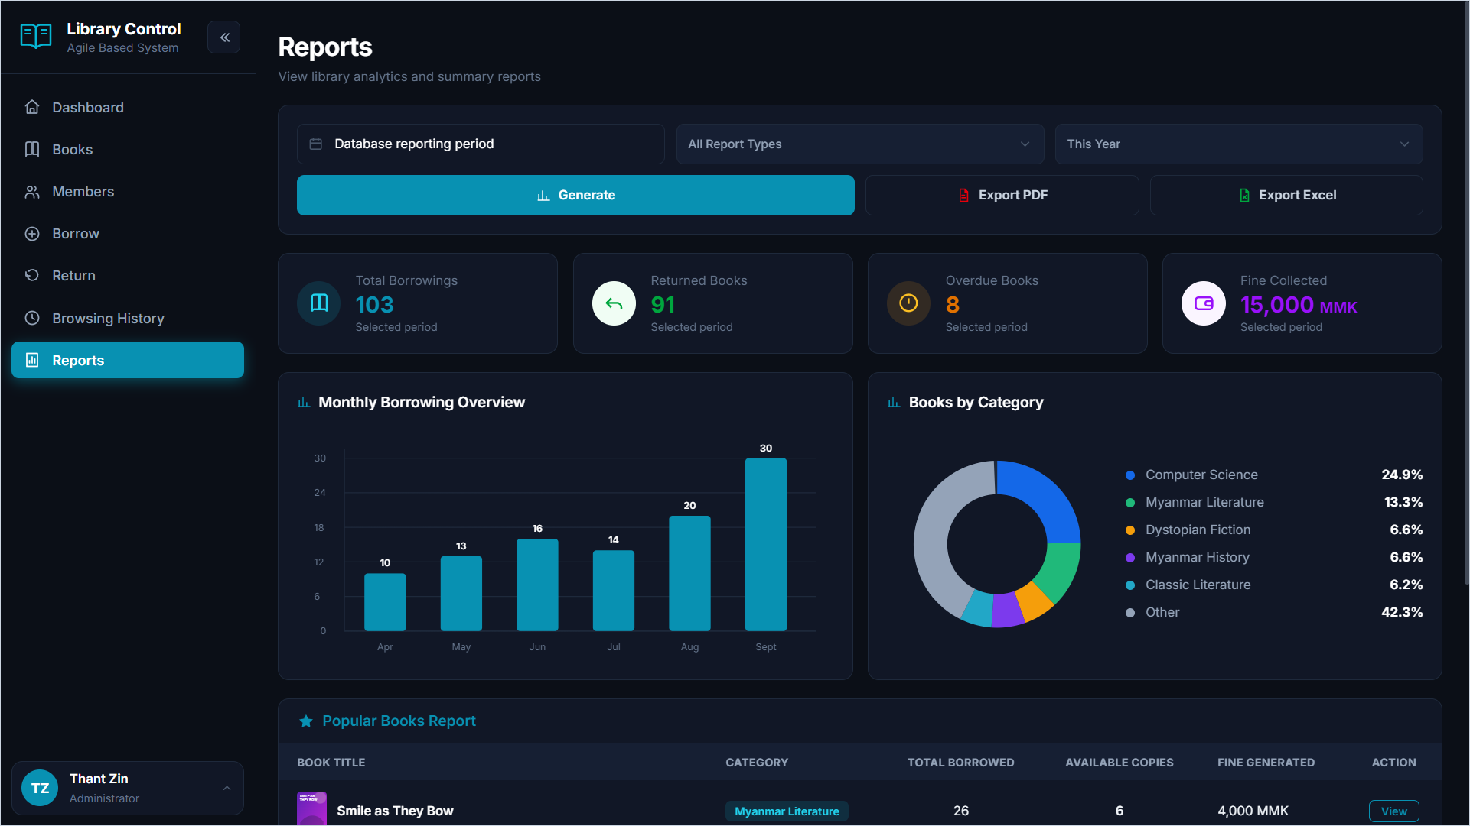
Figure 3.16 Displaying the Analytical Reports and Periodic Statistics Window
Figure 3.16 shows the analytical reports window. Admins can generate circulation performance statistics, overdue summaries, and top-borrowed book rankings filtered by month, year, or custom date ranges.

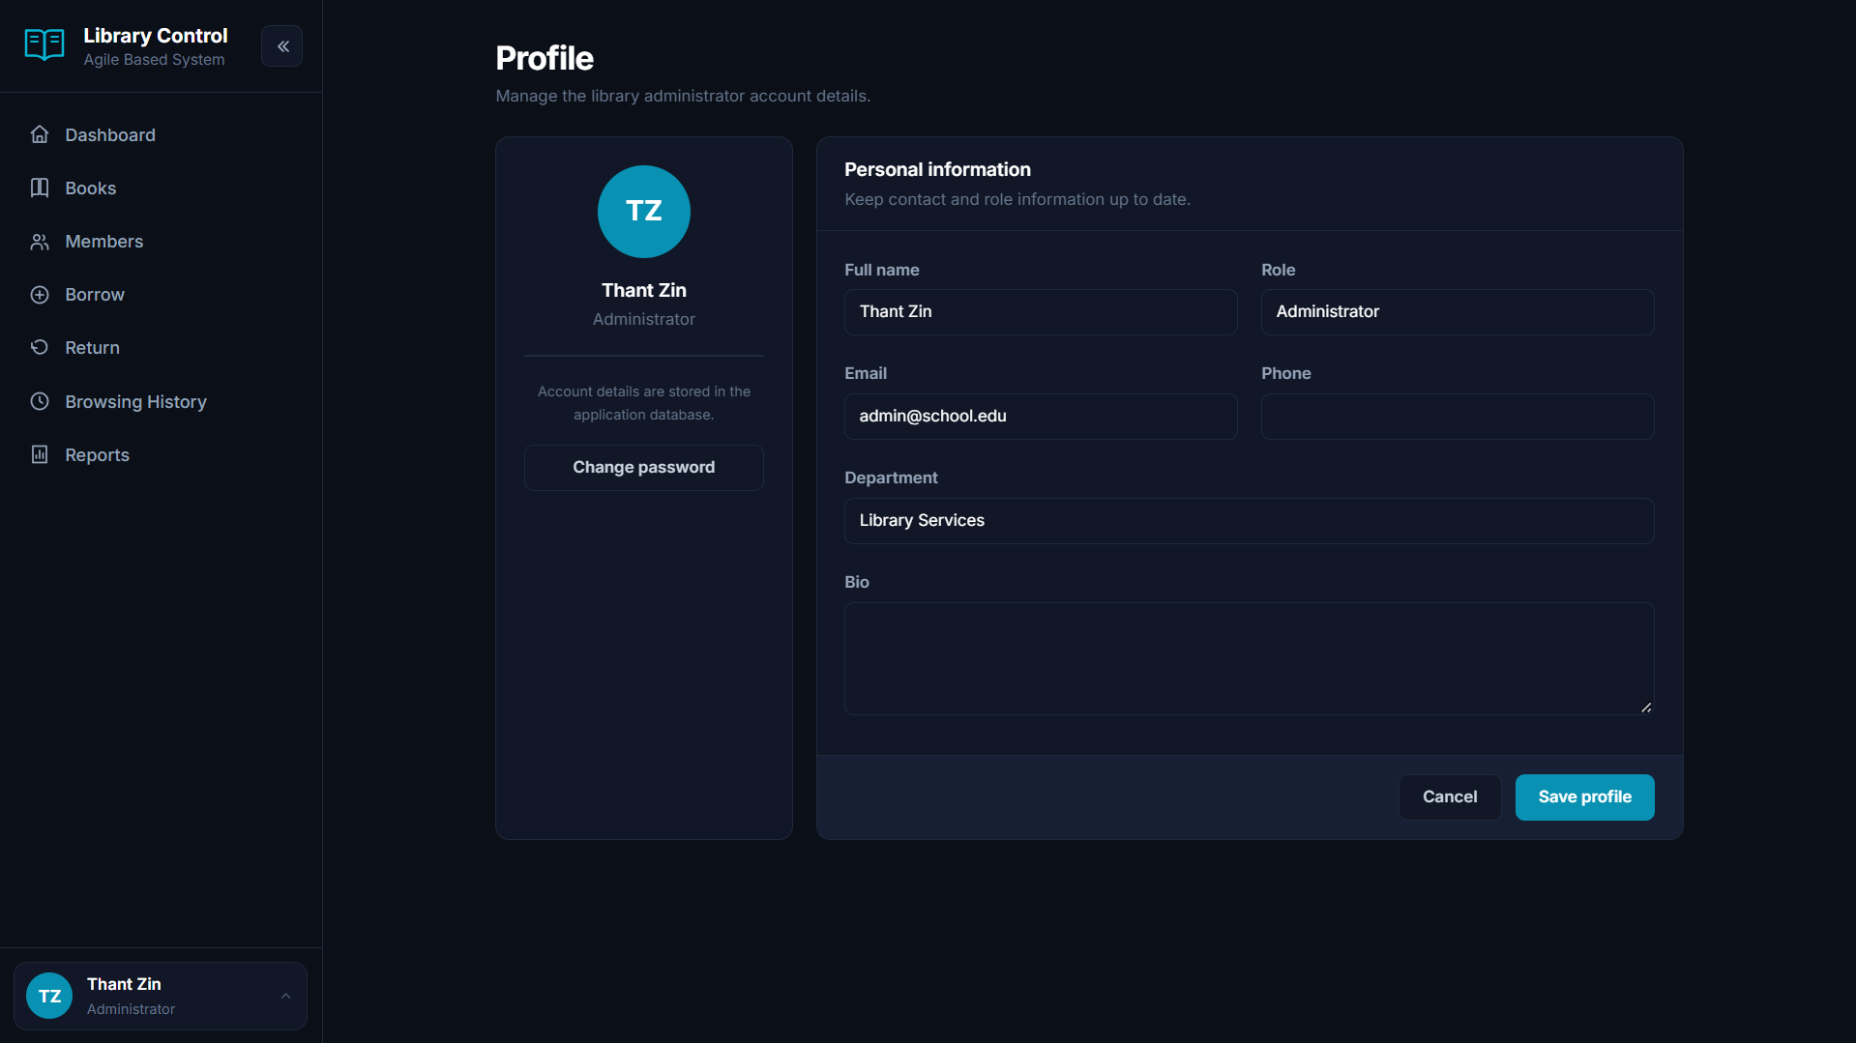
Figure 3.17 Displaying the Administrator Account Profile Window
Figure 3.17 shows the administrator profile window. The logged-in admin can view their profile details, assigned system role, registered email address, and last login activity.

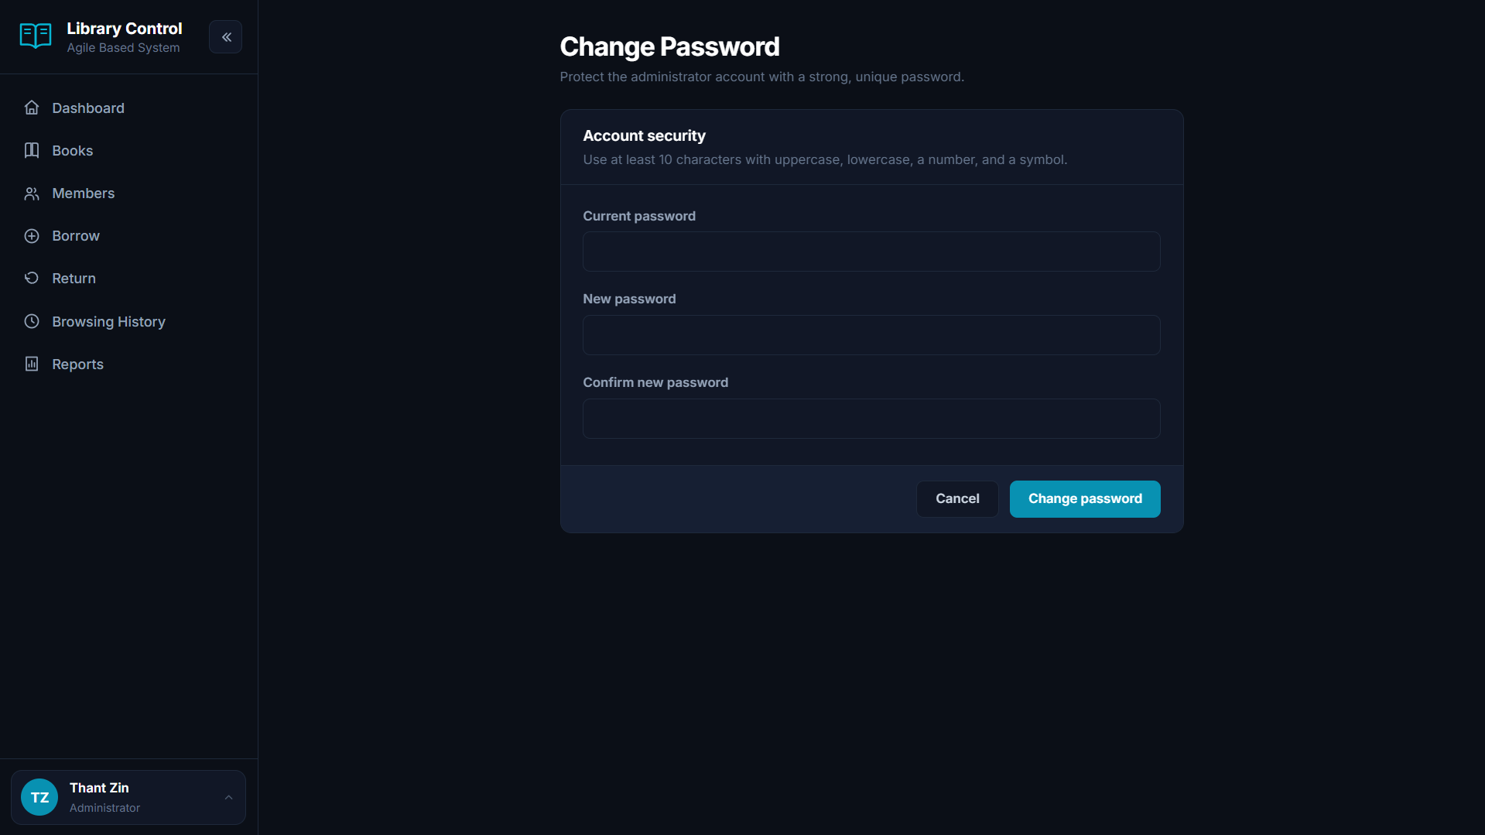
Figure 3.18 Displaying the Password Rotation and Security Window
Figure 3.18 shows the password rotation window. Admins and staff can update their login password with mandatory complexity requirements to ensure system account security.

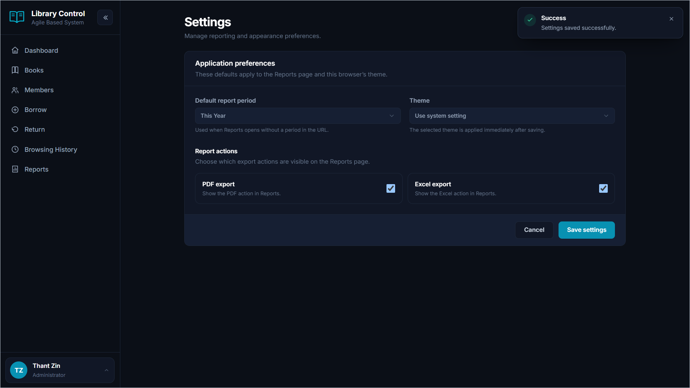
Figure 3.19 Displaying the Global System Settings Window
Figure 3.19 shows the global library settings window. The admin can configure system-wide rules including loan period durations, maximum borrow allowances, daily fine rates, and notification preferences.
3.2 Summary
In this chapter, the user interface design and operational workflows of the School Library Management System were presented. The interface provides accessible and responsive interactions for both public patrons and administrative personnel, ensuring efficient circulation management, inventory tracking, and institutional reporting.

