MEDICINE REMINDER USING ARDUINO

Abstract:
In modern culture, many people battle chronic illnesses. Currently, we see an increase in ailments, which is why more individuals than in past years need to take medications. Additionally, some people may stop taking their prescriptions on schedule as they age. If we want to solve difficulties or live better, we have to take medication frequently. The major goal of our work is to remind the patient to take their prescription on schedule. Also, the ease of use has to be compatible with elderly people and their limited education and expertise. Real-time clock (RTC)-based smart medicine boxes are the ultimate objective of our project. The proposed smart medication box with alerting system consists of time-reminder and doctor advice management capabilities. The system provides timely medication delivery to patients without additional help and also provides alert facilities. Many patients forget to take their medication on time, while others do so on an irregular schedule, which reduces the medication's efficiency.

Keywords:
DS3231 RTC Module -1, liquid crystal display, Real-time clock.

1.Introduction:
In the modern era, the majority of people keep busy with their everyday schedules. It is true that they prioritise their jobs above looking after their health.
[3] Diabetes and high blood pressure are two illnesses that are currently quite prevalent. [4] The rate of medication use has risen significantly recently. While certain illnesses are temporary, many have a long-term negative impact on a person's health. This Could be dangerous if not addressed correctly. For elderly people, taking regular medications becomes exceedingly challenging. Younger people might face the same issue. Maybe they are elderly, young, or someone else; a lot of our family members need continual assistance. But it is not always easy for us to keep reminding them of their medication.
This medical reminder system's primary aim is to persuade elderly patients to take their prescribed medication on time. The system is designed to be simply programmable and adaptable, allowing the elderly to create schedules of medication and reminders depending on each person's specific needs. This project's use of Arduino has a number of benefits. First off, Arduino offers a cheap and convenient platform for creating working prototypes and systems. The programming environment is user-friendly, making the integration and implementation of numerous elements simple.
The medical reminder system's user interface is designed to be simple to use and easy to understand, taking into account the distinct physical capabilities of its elderly users. Reminding messages can be sent to the elderly in a way that is most effective for them, whether that be through visual messages or audio alerts. [5] And indicates the time for the subsequent dose of medication on an LCD screen, and when the moment comes, messages are generated frequently and an LED begins to blink to show which container should be unlocked. A sensor detects whenever a patient opens a container, resets the light, and snoozes the alarm.
This Arduino-based medical reminder system offers a useful and adaptable answer to the problems with senior citizens taking their medications.[9] The suggested method may be utilised to provide healthcare for elderly persons living alone,
patients in remote locations, and chronically ill patients with significant medical needs.
2.Literature Review:
Integration of Arduino-based projects has created fresh prospects for the creation of medication reminder systems. The purpose of this review of current material is to investigate the design, functionality, and efficiency of Arduino-based medication reminders. We may determine possibilities, obstacles, and possible future paths for Arduino-based medication reminder systems by assessing the existing level of our knowledge.
Arduino-based medicine reminder projects involve the integration of various hardware components and modules. These components typically include sensors for medication detection, actuators for reminder alerts, display modules for user interaction, and connectivity modules for communication with external devices. Caretakers and medical professionals can benefit from Arduino-based medication adherence monitoring systems. By sensing changes in the weight of pharmaceutical containers, load cells or weight sensors, for instance, can be used to detect drug usage. For Arduino-based medicine reminder systems to be widely used, affordability and accessibility are crucial considerations. Although Arduino itself is reasonably priced, the total cost may change depending on the components selected and the level of customization needed (Smith et al., 2017). Making these technologies accessible to a wider group of users requires both cost and accessibility.
Caretakers and medical professionals can benefit from Arduino-based medication adherence monitoring systems. By sensing changes in the weight of pharmaceutical containers, load cells or weight sensors, for instance, can be used to detect drug usage. For Arduino-based medicine reminder systems to be widely used, affordability and accessibility are crucial considerations. Although Arduino itself is reasonably priced, the total cost may change depending on the components selected and the level of customization needed. Making these technologies accessible to a wider group of users requires both cost and accessibility.
To remind people to take their prescriptions, these actuators may be set to activate at certain intervals. Through interfaces like LCD displays or touchscreens, user engagement is made possible, enabling users to schedule medicine, get reminders, and give feedback [3]. Studies have looked at the efficiency of Arduino-based medication reminder projects in enhancing patient outcomes and medication adherence. These initiatives have shown outcomes that are encouraging for improving drug adherence. Patients' adherence behaviour have been favourable affected by these systems' real-time reminders and feedback.
Innovative approaches to encouraging medication adherence are provided by projects built on the Arduino platform. Arduino is a good platform for creating such systems because of its design flexibility, real-time monitoring capabilities, and user-friendly interfaces. Enhancing the user experience, resolving financial issues, and performing longitudinal studies to evaluate long-term efficacy should be the main goals of future research. The usefulness of Arduino-based medicine reminder projects might be further improved by the incorporation of machine learning techniques and data analytics. These technologies have the potential to greatly enhance drug adherence and patient outcomes with continuous research and improvement. A tiny box with several compartments and an IR sensor attached to each one makes up the arrangement. The box is linked to an Arduino Uno real-time clock and microcontroller, which processes the actions and displays the pill information and time of consumption on the LCD that is attached to the box in accordance. The DS3231 is used by the real-time clock (RTC) module in the medicine reminder to keep track of the current year, month, and day in addition to the current time. It comes with a tiny lithium coin-cell battery that powers the RTC.
Many patients would prefer to live on their own. They may have greater independence as a result, which would also lessen the burden on the healthcare system. The need to expand the healthcare system by creating technologies that would support "ageing in place," the idea of letting older individuals get healthcare while still living at home.

3.Proposed method:
The based smart medication reminder system. The suggested plan was specifically designed for the Android operating system. We use a reminder system for our system, which sounds an alert when it's time to take your medication. assist the user in learning additional information about their medication. It keeps track of the medication, so the amount of medication the user needs to take may be set in the program,enabled pill box with many compartments, each with a lid that can be opened and an IR sensor attached to it, makes up the device configuration. The pill box system contains IR sensors for medication monitoring and reporting, which frequently check whether the drug has been taken or not. The database will be updated and stored each time a drug is inserted into the pillbox. Real-time data is collected by the Arduino gadget and sent to the application.

3.1 Block diagram:

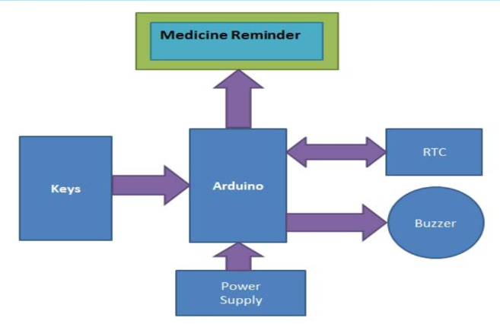
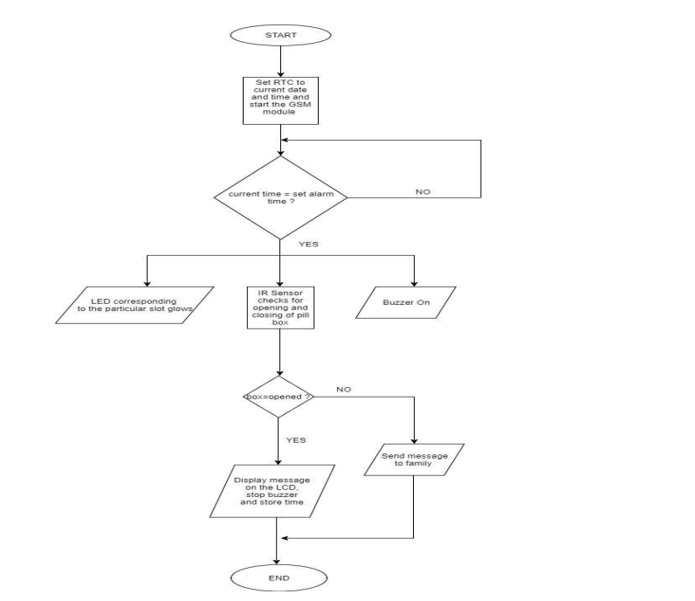

3.2 Description of the components:
3.2.1Arduino:
Based on the Microchip ATmega328P, the Arduino UNO is a free and open-source microcontroller board. that can connect to other expansion boards (shields) and other circuits, as shown in Figure A. Various expansion boards (shields) and other circuits can be interfaced with the board's sets of digital and analogue input/output (I/O) pins. The board has 6 analogue pins and 14 digital pins. It is the first easily handled Arduino of the USB kind. A bootloader has previously been used to reprogram the board. Without the aid of another piece of software, the user can upload new code thanks to the boot loader. The Arduino IDE (Integrated Development Environment), which is connected to the board using a sort of USB cable, may be used to program it.
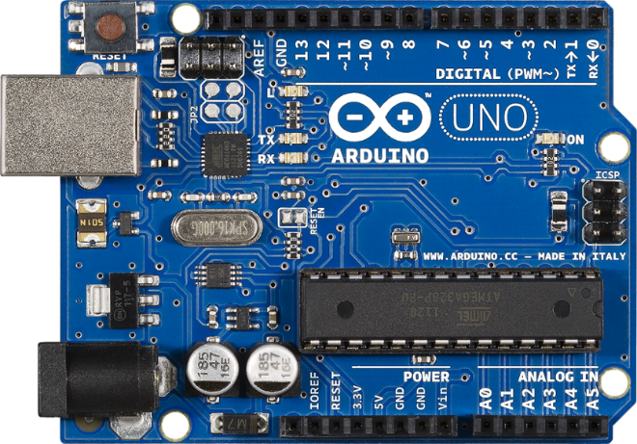
Fig
It has several headers that represent different pin functionalities. AREF (analogue reference), external interrupts, pulse width modulations, a serial peripheral interface, and serial/UART are just a few of the special pin functionalities it possesses. It has the ability to interface with other electronics, including computers and other microcontrollers. It accepts voltages between 7 and 20 volts and may be powered by a USB connection, an external 9-volt battery, or an adapter. It uses a crystal oscillator with a clock frequency of about 16 MHz to run. It has 32 kilobytes of flash memory.
3.2.3 LCD (display):
The term "liquid crystal display," or LCD, has a clear definition. It combines matter's liquid and solid states. The viewable image on an LCD is created by a liquid crystal. Incredibly thin display panels known as liquid crystal displays are widely used in laptop computers, mobile phones, portable video games, and TVs. Compared to cathode ray tube (CRT) technology, LCD technology may allow for significantly
smaller screen sizes.

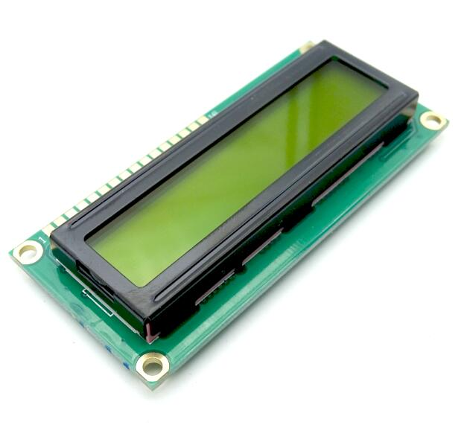
Figure 4. LCD screen
A liquid crystal display is made up of many layers, including two polarised panel filters and electrodes. LCD technology is used to show images on laptop computers and other electronic devices such as tiny computers. A lens projects light onto a liquid crystal layer. The colored image is generated by combining colored light with the grayscale image of the crystal (which is formed as an electric current travel through the crystal). The picture is then shown on the screen.
Push-button:
The "push button" has been used in a variety of mechanical and electrical equipment, both domestically and commercially, including calculators, push-button phones, kitchen appliances, and others.
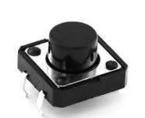
Push buttons can be linked together by a mechanical connection in industrial and commercial applications so that pressing one button releases the other. A stop button can "force" a start button to release in this manner. When a machine or process does not have any electrical control circuitry, this form of linking is employed for straightforward manual actions.

DS3231 RTC Module -1:
- RTC means Real Time Clock. Two calendar clock. Reset output and input. Low power consumption. Provide continuous timing battery backup. The device is compatible with DS3231 encapsulation and function. Complete the clock calendar function including the second, minute, time, week, date, month, and year, and provide the valid until 2100 leap year.
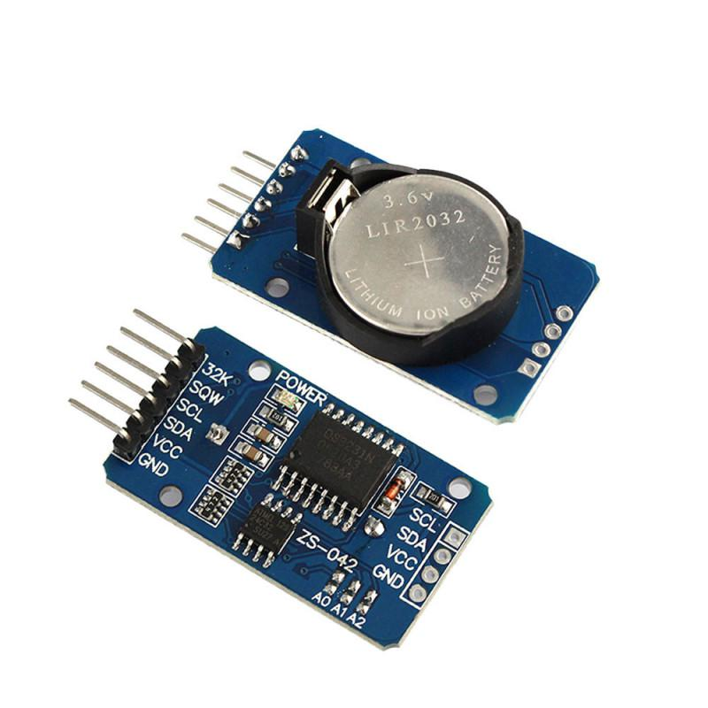
RTC modules are simply TIME and DATE remembering systems which have battery setup which in the absence of external power keeps the module running. This keeps the TIME and DATE up to date. So we can have accurate TIME and DATE from RTC module whenever we want.
5 Potentiometer
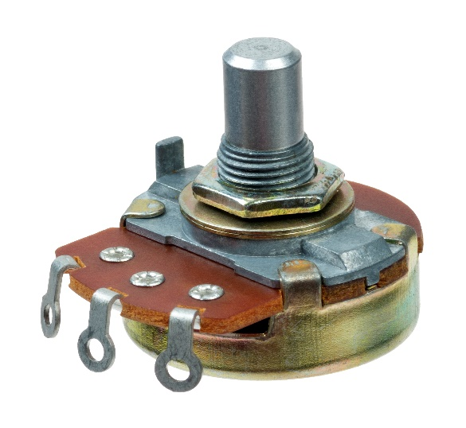
Potentiometers also known as POT, are nothing but variable resistors. They can provide a variable resistance by simply varying the knob on top of its head. It can be classified based on two main parameters. One is their Resistance (R-ohms) itself and the other is its Power (P-Watts) rating.

Resistor:
A resistor is a passive two-terminal electrical component that implements electrical resistance as a circuit element. In electronic circuits, resistors are used to reduce current flow, adjust signal levels, to divide voltages, bias active elements, and terminate transmission lines, among other uses. High-power resistors that can dissipate many watts of electrical power as heat may be used as part of motor controls, in power distribution systems, or as test loads for generators. Fixed resistors have resistances that only change slightly with temperature, time or operating voltage. Variable resistors can be used to adjust circuit elements (such as a volume control or a lamp dimmer), or as sensing devices for heat, light, humidity, force, or chemical activity
Buzzer:
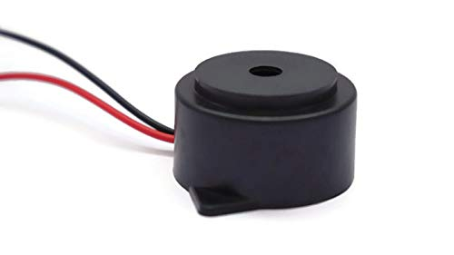
A buzzer is an electronic component that produces audible sound when an electric current is passed through it. It typically consists of a housing, a piezo element, and a driver circuit. When the driver circuit applies an alternating current to the piezo element, it vibrates and generates sound waves. Buzzer sound output can vary in terms of frequency, volume, and tone based on the driving signal. Buzzer components are commonly used in alarm systems, electronic devices, and Arduino projects to provide audible alerts or notifications.

Result:
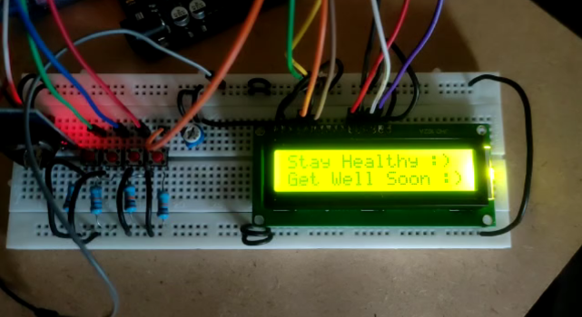

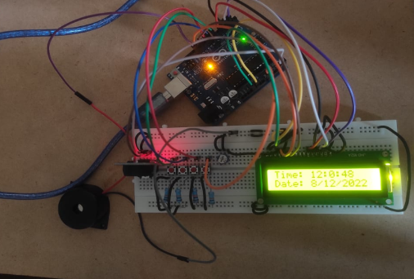
A working system that successfully reminds people to take their prescriptions on time and increases medication adherence is the outcome of the medicine reminder project using Arduino. The Arduino-based project effectively uses actuators like buzzers, speakers, or vibrating motors to produce reminder warnings at predetermined intervals. A user-friendly interface makes it simple for users to create custom medication regimens, and built-in sensors reliably track drug use activities. Users can record doses as taken or missed and offer input on medicine ingestion using the system. The medication reminder system changes user behaviour and raises medication adherence rates via timely reminders and user involvement. Through data logging, carers or healthcare professionals may remotely monitor adherence trends and ensure prompt interventions. In order to encourage prompt refills, the system also has a low medication alert feature that notifies users when their medicine levels are low. The use of Arduino components makes the implementation affordable, while a reliable power source and strong hardware integration guarantee long-term dependability. Overall, the Arduino-based medication reminder system offers a useful and user-friendly way to assist medication adherence and improve patient well-being.
Conclusion:
In conclusion, the Arduino-based medication reminder system has proven to be a useful tool for encouraging medication adherence. The system efficiently aids people in managing their drugs through the integration of reminder alarms, customizable medication regimens, and user-friendly interfaces. Drug adherence rates have been shown to benefit from the precise monitoring of drug ingestion events and the capacity to provide prompt reminders. A carer or healthcare provider may track adherence trends and take action as needed thanks to the remote monitoring features.
Its viability and feasibility are further enhanced by the Arduino-based system's low cost of deployment and long-term dependability. Overall, this study highlights the potential of Arduino-based healthcare solutions and offers a viable strategy for improving patient outcomes and increasing drug adherence. Future research should concentrate on user acceptability, scalability, and long-term efficacy for wider use and impact.

[1] Patel, M., & Patel, A. (2017). Arduino and GSM Based Medicine Reminder and Security System. International Journal of Engineering Research & Technology (IJERT), 6(6), 146-149.
[2 Mohamad, M. S., & Kamel, N. (2018). Arduino-Based Smart Pill Bottle for Medicine Adherence. International Journal of Engineering & Technology, 7(2.9), 88-91.
[3] Ng, D., & Terzis, A. (2015). Building an Arduino-based medication reminder device. In 2015 IEEE 11th International Conference on Wireless and Mobile Computing, Networking and Communications (WiMob) (pp. 128-135). IEEE.
[4] Ahmed, M., & Hamood, O. (2016). Design and implementation of a smart medicine box using Arduino. International Journal of Applied Engineering Research, 11(2), 983-990.
[5] Saputra, F. R., Hidayat, R., & Widyawan, W. (2020). Arduino-Based Medicine Reminder System Using GSM Module. Journal of Physics: Conference Series, 1481(1), 012031.

