1. INTRODUCTION
The Student Enrollment & Course Management System (SECMS) is a cloud-based application developed on the Salesforce platform to efficiently manage academic operations within educational institutions. The primary objective of this system is to simplify and automate the processes related to student registration, course management, instructor assignments, and enrollment approvals.
In traditional educational management systems, handling student records, course enrollments, and instructor allocations often involves manual processes that can lead to data redundancy, delays, and errors. The SECMS application addresses these challenges by providing a centralized and automated platform where administrators, instructors, and students can interact and manage information seamlessly.
The system allows administrators to maintain detailed student records, create and manage course information, and assign instructors to specific courses. Students can request enrollment in available courses, while instructors can manage course-related activities and monitor student participation. The application also includes automated workflows that handle enrollment approval processes, ensuring that requests are reviewed and processed efficiently.
By leveraging the powerful features of Salesforce, such as custom objects, automation through flows, and centralized data management, SECMS improves operational efficiency and data accuracy. The system enhances transparency in the enrollment process and reduces administrative workload by automating repetitive tasks.
Overall, the Student Enrollment & Course Management System serves as a scalable and reliable solution for educational institutions aiming to modernize their academic management processes. It ensures better coordination between students, instructors, and administrators while maintaining organized and secure academic records.
The Student Enrollment & Course Management System (SECMS) is a Salesforce-based application designed to manage students, courses, instructors, and enrollments efficiently. The system automates the process of course enrollment, instructor assignment, and approval workflows.
This application helps educational institutions streamline their operations by maintaining centralized student records and managing course enrollments effectively.

2. OBJECTIVES OF THE PROJECT
The main objective of the Student Enrollment & Course Management System (SECMS) is to simplify and automate the management of students, courses, instructors, and enrollment processes using the Salesforce platform. The system is designed to improve efficiency, accuracy, and accessibility of academic information within an educational institution. The specific objectives of this project are as follows:
- To manage course details and categories
The system is designed to organize and maintain information about various courses offered by the institution. Each course can include details such as course name, category, duration, description, and availability. By categorizing courses, administrators and students can easily identify and select courses based on their interests or academic requirements. This helps improve the overall course management process and ensures that course information is clearly structured and easily accessible.
- To store instructor information and their expertise
Another important objective of the system is to maintain detailed information about instructors. This includes instructor names, contact details, areas of expertise, and the courses they are responsible for teaching. Storing instructor data in the system helps administrators assign instructors to appropriate courses based on their expertise and qualifications. It also allows better coordination between instructors and students.
- To allow students to enroll in courses
The system provides a mechanism for students to enroll in available courses. Students can select courses based on their interests, eligibility, and availability. The enrollment process is recorded in the system, ensuring that all enrollments are tracked and managed efficiently. This feature helps reduce manual work and simplifies the course registration process for both students and administrators.
- To automate instructor assignment using Salesforce automation
The project utilizes Salesforce automation tools such as Flow to automatically assign instructors to courses based on predefined conditions. Automation reduces manual intervention and ensures that instructor assignments are performed quickly and accurately. This improves operational efficiency and ensures that courses are properly managed by qualified instructors.
- To implement an approval process for enrollment requests
The system also includes an automated approval process for course enrollment requests. When a student requests enrollment in a course, the request can be reviewed and approved by the appropriate authority, such as an administrator or instructor. This approval workflow ensures that enrollment decisions are properly controlled and validated before the student is officially enrolled in the course.
Overall, the project aims to create a reliable and efficient system that simplifies academic management, improves transparency in the enrollment process, and enhances the overall productivity of educational institutions.

3. TECHNOLOGIES USED
The Student Enrollment & Course Management System (SECMS) is developed using the Salesforce platform and its built-in tools to manage data, automate processes, and generate analytical insights. The key technologies used in this project are described below:
- Salesforce Platform
The Salesforce platform is the primary technology used to develop this application. It is a cloud-based Customer Relationship Management (CRM) platform that provides powerful tools for building custom applications without extensive coding. Salesforce offers features such as data management, security, automation, and reporting. In this project, the Salesforce platform serves as the foundation for storing student, course, instructor, and enrollment information while ensuring data security and accessibility.
- Custom Objects
Custom Objects are used to create and store application-specific data within Salesforce. In this system, several custom objects are created to represent different entities such as Students, Courses, Instructors, and Enrollments. These objects allow the system to maintain structured records for each entity and define relationships between them. Custom objects make it possible to manage academic data efficiently and organize information in a meaningful way.
- Flow Builder
Flow Builder is a powerful automation tool in Salesforce that allows users to automate business processes without writing code. In this project, Flow Builder is used to automate tasks such as instructor assignment and follow-up actions related to course enrollment. Automation helps reduce manual work, minimize errors, and improve the overall efficiency of the system.
- Approval Process
The Approval Process feature in Salesforce is used to manage the approval workflow for enrollment requests. When a student requests to enroll in a course, the request is sent for approval to an administrator or authorized user. The approval process ensures that enrollment decisions are reviewed and approved before they are finalized, providing better control and transparency in the system.
- Reports and Dashboards
Reports and Dashboards are used to analyze and visualize enrollment data in the system. Reports allow administrators to generate detailed summaries of student enrollments, course participation, and instructor assignments. Dashboards present this information through charts and visual components, enabling users to quickly understand trends and make informed decisions based on the data.

4. SYSTEM ARCHITECTURE
The Student Enrollment & Course Management System (SECMS) is designed using the Salesforce platform with a structured data model based on custom objects. The architecture focuses on managing student information, course details, instructor records, and course enrollments in an organized and automated manner. The system ensures smooth interaction between different components through well-defined relationships between objects.
Main Custom Objects
- Student
The Student object is used to store all personal and academic details related to students. This object acts as the central record for each student in the system. It includes information such as the student’s name, email, phone number, date of birth, and address. Each student record is unique and allows administrators to track the courses that the student has enrolled in. The Student object helps maintain a centralized database of all student information within the institution.
- Course
The Course object stores detailed information about the courses offered by the institution. It includes fields such as course name, course category, duration, description, and other relevant details. This object allows administrators to manage and organize courses efficiently. Courses can be assigned to instructors and made available for student enrollment through the system.
- Instructor
The Instructor object stores information related to instructors who teach the courses. It includes details such as instructor name, contact information, and area of expertise. This object helps the institution maintain a record of instructors and their specialization so that appropriate instructors can be assigned to relevant courses.
- Enrollment
The Enrollment object manages the relationship between students and courses. It acts as a junction object that connects students with the courses they enroll in. Each enrollment record represents a student's request or registration for a particular course. The enrollment object may also include fields such as enrollment status, approval status, and enrollment date.
Relationships in the System
The SECMS system uses relationships between objects to maintain data connections and ensure proper data flow:
- Student → Enrollment
A student can enroll in multiple courses, so one student record can be linked to many enrollment records.
- Course → Enrollment
A course can have many students enrolled in it, meaning one course can be associated with multiple enrollment records.
- Instructor → Course
An instructor can teach one or more courses, and each course can be assigned to a specific instructor based on expertise.
Through these relationships, the system efficiently manages the interaction between students, courses, and instructors while maintaining data integrity and enabling automation features within Salesforce.

5. CUSTOM OBJECTS AND FIELDS
In the Student Enrollment & Course Management System (SECMS), custom objects are created in the Salesforce platform to store and manage application data. Each object represents a major entity in the system such as students, courses, instructors, and enrollments. These objects contain various fields that store specific information required for managing the system effectively.
1. Student Object
The Student Object is used to store personal and academic information about students. It helps administrators maintain a centralized record of all students who are registered in the system.
Field Name | Data Type
Student Name | Text
Email | Email
Phone | Phone
Student Status | Picklist

Student Status Values:
- New – Indicates that the student has been recently added to the system.
- Active – Indicates that the student is currently active and eligible to enroll in courses.
- Inactive – Indicates that the student is temporarily not participating in courses.
- Completed – Indicates that the student has completed the enrolled courses.
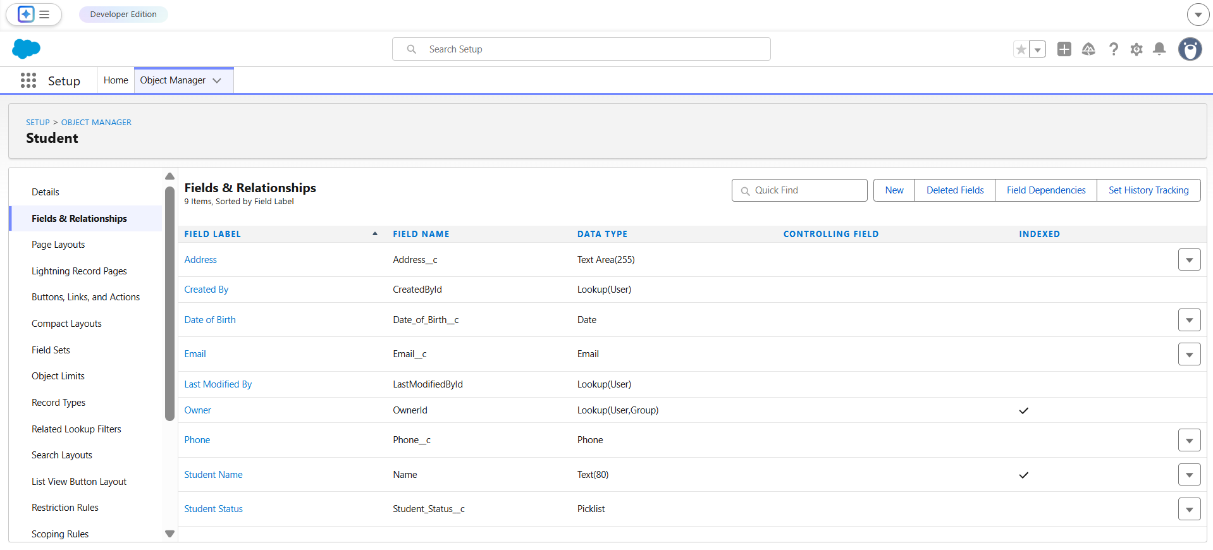
2. Course Object
The Course Object stores detailed information about the courses offered in the system. It allows administrators to categorize courses and assign instructors to them.
Field Name | Data Type
Course Name | Text
Category | Picklist
Duration | Number
Instructor | Lookup (Instructor)

Course Category Values:
- Technical – Courses related to programming, software development, and technology.
- Language – Courses focused on language learning and communication skills.
- Non-Technical – Courses related to general skills such as management, soft skills, and other non-technical subjects.
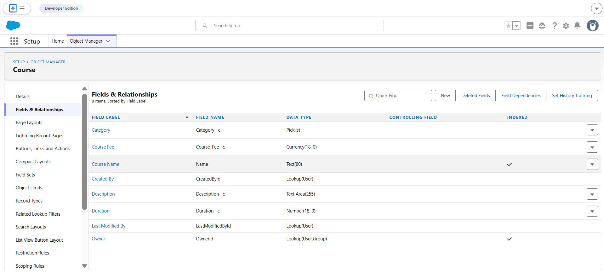
3. Instructor Object
The Instructor Object stores details about instructors who are responsible for teaching courses in the system. It helps in assigning the right instructor to the appropriate course based on their expertise.
Field Name | Data Type
Instructor Name | Text
Instructor Code | Text
Expertise | Picklist

Expertise Values:
- Technical – Instructors specialized in technical or programming-related subjects.
- Language – Instructors specialized in language training.
- Non-Technical – Instructors specialized in management, communication, or other non-technical subjects.
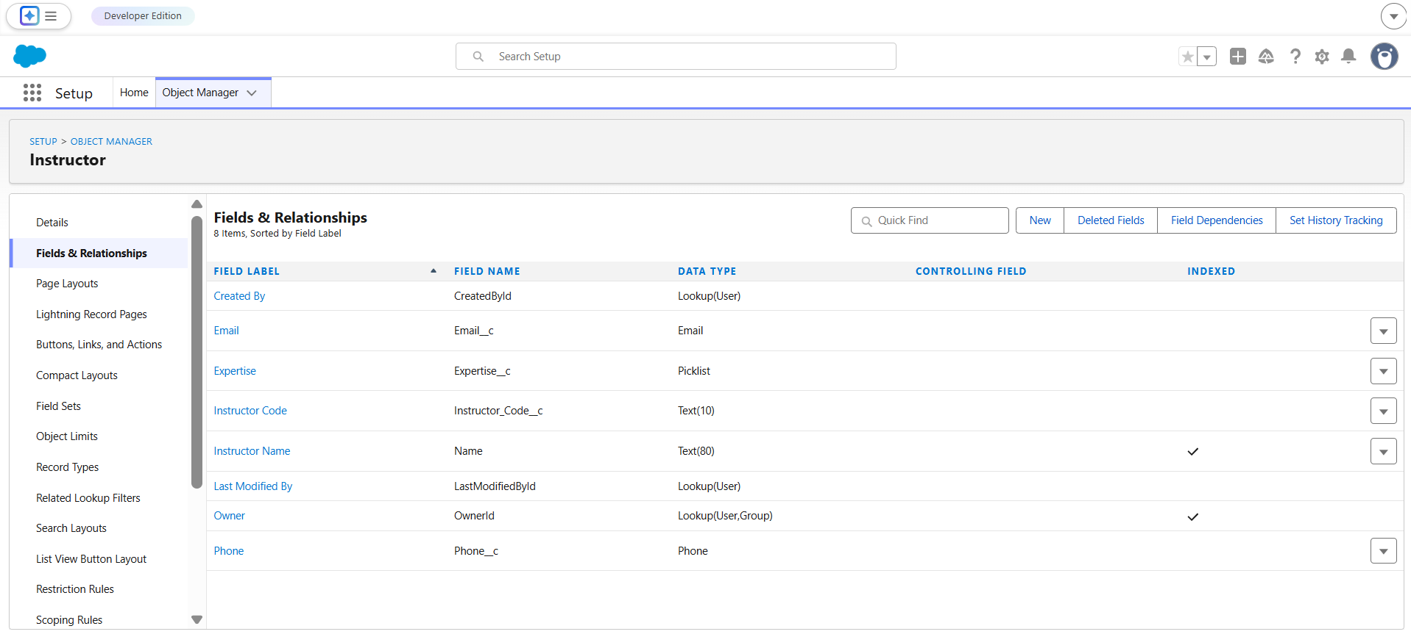
4. Enrollment Object
The Enrollment Object acts as a junction object that connects students with the courses they enroll in. It records enrollment requests and tracks the status of each enrollment.
Field Name | Data Type
Student | Lookup (Student)
Course | Lookup (Course)
Enrollment Status | Picklist

Enrollment Status Values:
- Requested – The student has requested enrollment in a course.
- Approved – The enrollment request has been approved by the administrator.
- Rejected – The enrollment request has been rejected.
- Completed – The student has successfully completed the course.
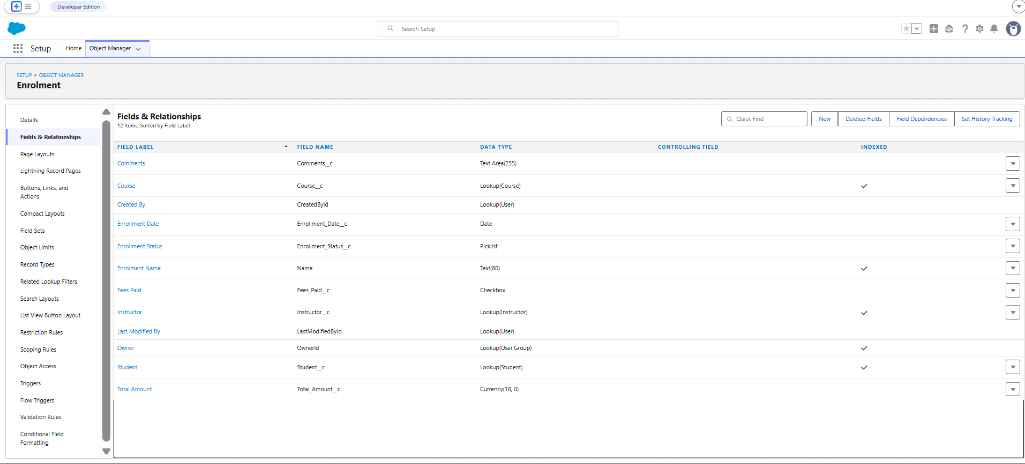
These custom objects and fields together form the core data structure of the SECMS application. They help in organizing information efficiently, maintaining relationships between different entities, and supporting automation and approval processes within the Salesforce platform.

6. AUTOMATION IMPLEMENTED
Automation is a key feature in the Student Enrollment & Course Management System (SECMS) that helps simplify administrative tasks and improve overall efficiency. In this project, automation is implemented using Salesforce Flow Builder, which allows processes to run automatically without requiring manual intervention. By automating certain operations, the system becomes faster, more accurate, and easier to manage.
Flow Automation
Automation is implemented in the Student Enrollment & Course Management System (SECMS) using Salesforce Flow Builder. The purpose of this automation is to automatically assign an instructor to a course based on the selected course category.
When a new course is created or when the course category is updated, the Salesforce Flow is triggered. The flow checks the category of the course and matches it with the expertise of available instructors in the system. Based on this condition, the system automatically assigns the most suitable instructor to that course.
This automation helps ensure that courses are always handled by instructors who have the correct subject expertise. It also eliminates the need for administrators to manually review and assign instructors for every course, which saves time and reduces the chances of human error.
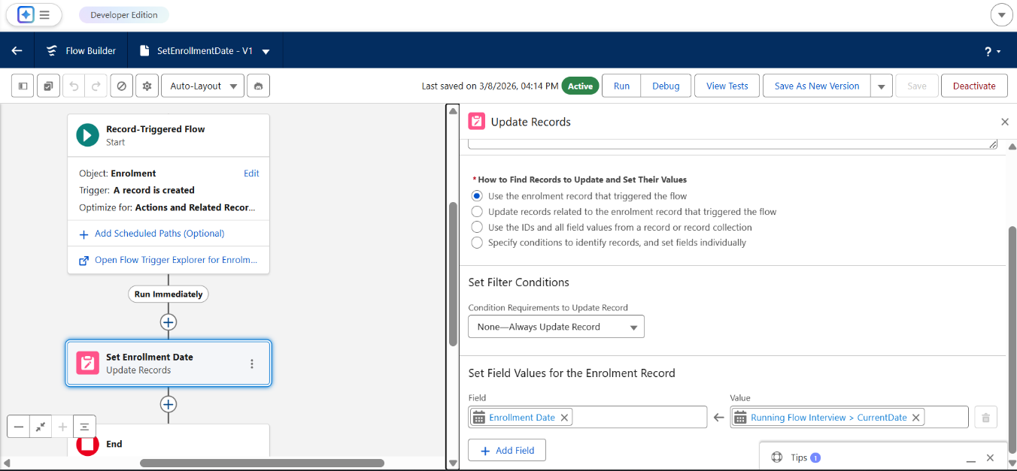
Based on this comparison, the system identifies an instructor whose expertise matches the course category and assigns that instructor to the course. This ensures that each course is handled by a qualified instructor who has the appropriate knowledge in that particular field. It also prevents incorrect assignments and ensures that the instructor allocation process is consistent and reliable.
Example of Automation Logic
Course Category | Assigned Instructor Expertise
Technical | Technical Instructor
Language | Language Instructor
Non-Technical | Non-Technical Instructor

For example, if a course is created under the Technical category, the flow automatically assigns an instructor whose expertise is marked as Technical. Similarly, language courses are assigned to instructors with language expertise, and non-technical courses are assigned to instructors specializing in non-technical subjects.
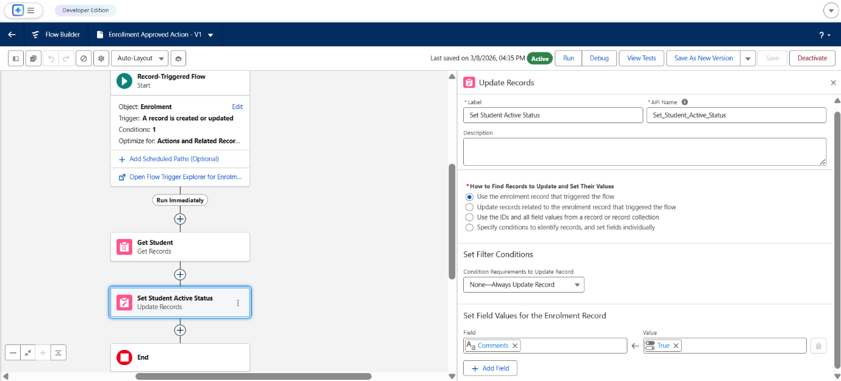

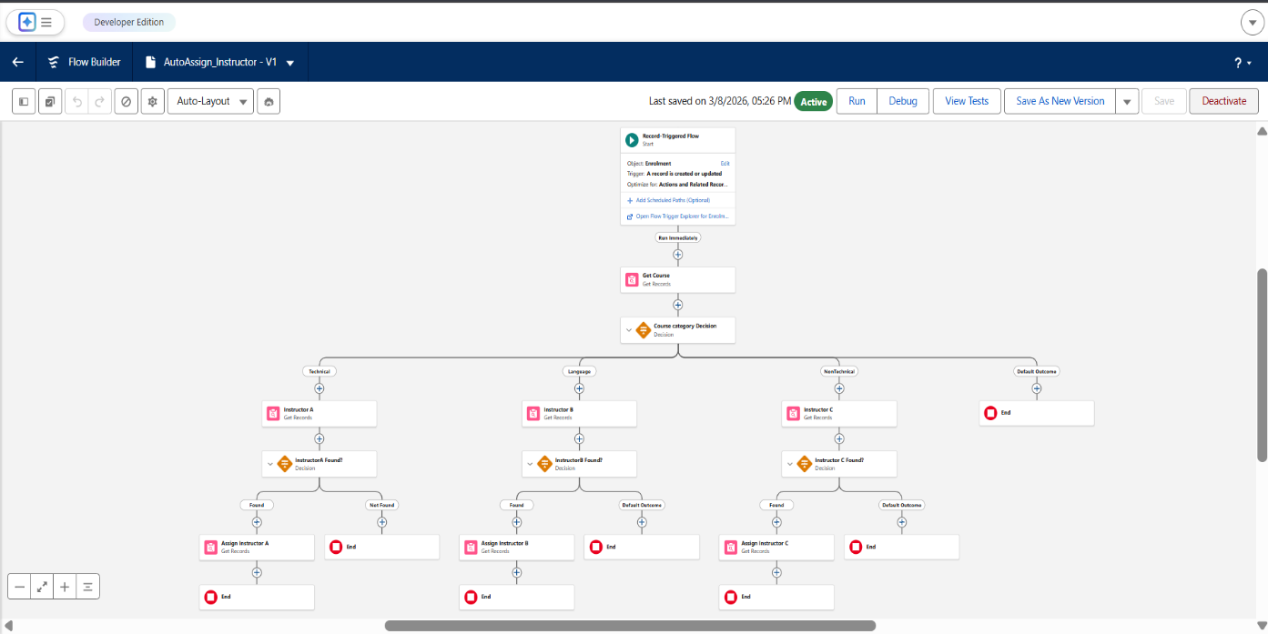
Overall, this automation improves system efficiency, ensures accurate instructor assignments, and significantly reduces manual work for administrators. This automation improves efficiency and reduces manual work. Through this automated process, the SECMS system improves operational efficiency, saves time for administrators, and ensures that courses are always managed by suitable instructors. This feature demonstrates how Salesforce automation tools can simplify complex administrative tasks and support better management of educational resources.

7. APPROVAL PROCESS
An approval process is implemented in the Student Enrollment & Course Management System (SECMS) to manage and control course enrollment requests submitted by students. This process ensures that every enrollment request is reviewed by an authorized person before the student is officially enrolled in the course.
The approval workflow helps maintain proper control over course registrations and ensures that only valid and approved requests are processed. It also improves transparency and accountability within the system.
Process Steps
- Student Submits Enrollment Request
The process begins when a student selects a course and submits an enrollment request through the system.
- Request Sent for Approval
Once the request is submitted, the system automatically sends it to the designated manager or administrator for approval.
- Manager Reviews the Request
The manager carefully reviews the enrollment request, verifying details such as student status, course availability, and other necessary conditions.
- Approval Decision
After reviewing the request, the manager can either approve or reject the enrollment.
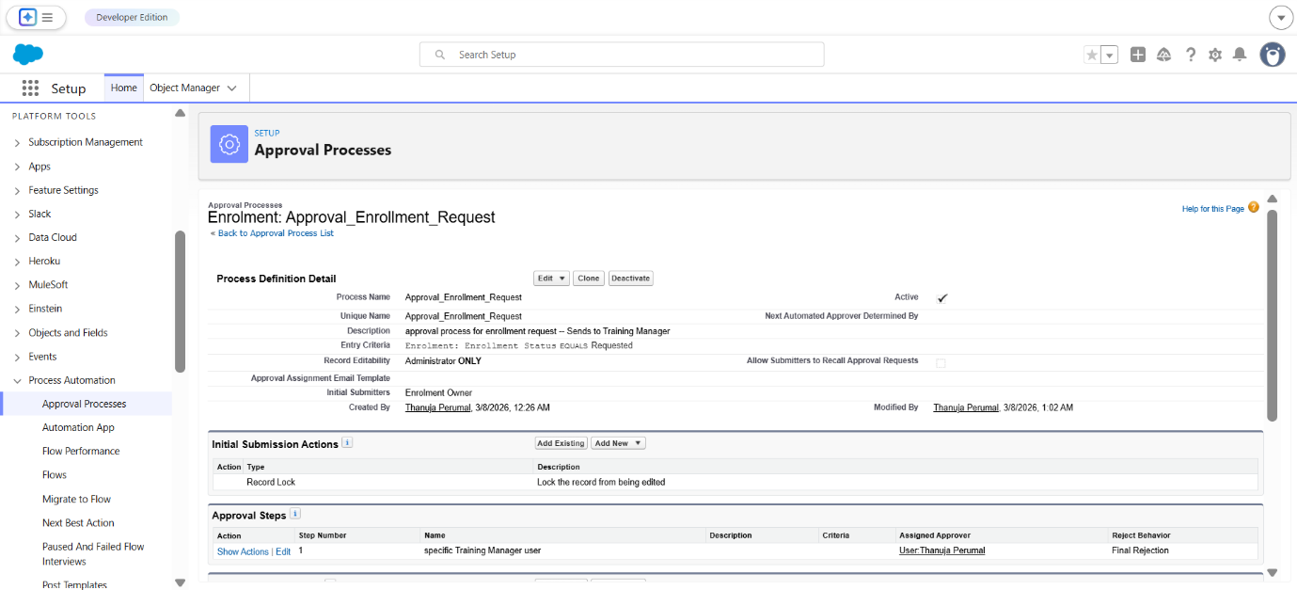
If the request is approved, the student is successfully enrolled in the course. If the request is rejected, the student will not be enrolled in the selected course. The Enrollment Status field in the system is automatically updated based on the manager’s decision. This automatic status update ensures that the enrollment records always reflect the latest approval outcome without requiring manual changes. Overall, the approval process helps maintain a structured workflow, improves system reliability, and ensures proper management of course enrollments.

8. REPORTS AND DASHBOARDS
Reports and dashboards are important features in the Student Enrollment & Course Management System (SECMS). They help administrators monitor system activities, track important data, and analyze the overall performance of the system. These tools provide organized information and visual summaries that support better decision-making.
Reports
Reports are used to generate detailed records of different activities within the system. They allow administrators to view and analyze data related to students, courses, instructors, and enrollments.
Example Reports
- Student Enrollment Report
This report displays detailed information about students and the courses they have enrolled in. It helps administrators track student participation and monitor enrollment activity.
- Course Enrollment Summary
This report provides a summary of how many students are enrolled in each course. It helps identify popular courses and understand course demand.
- Instructor Assignment Report
This report shows which instructors are assigned to different courses. It helps ensure that instructors are properly allocated based on their expertise.
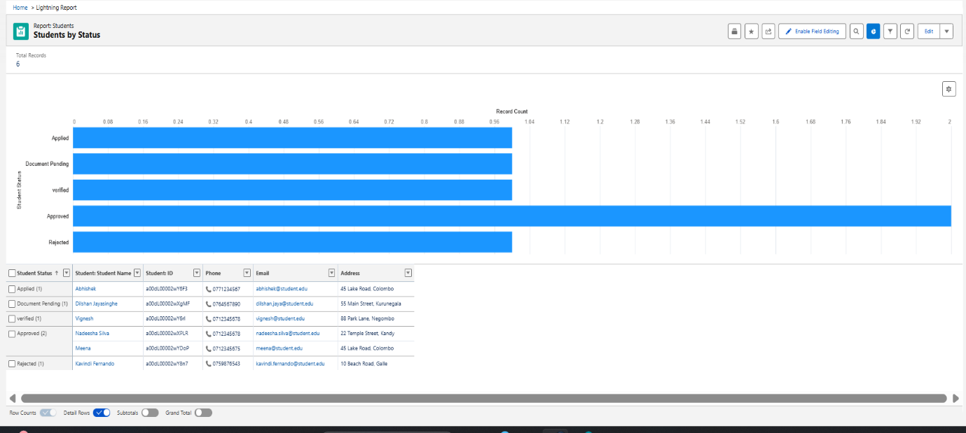
Dashboards
Dashboards present important data visually using charts, graphs, and summary components. They allow administrators to quickly understand system performance without reviewing detailed reports.
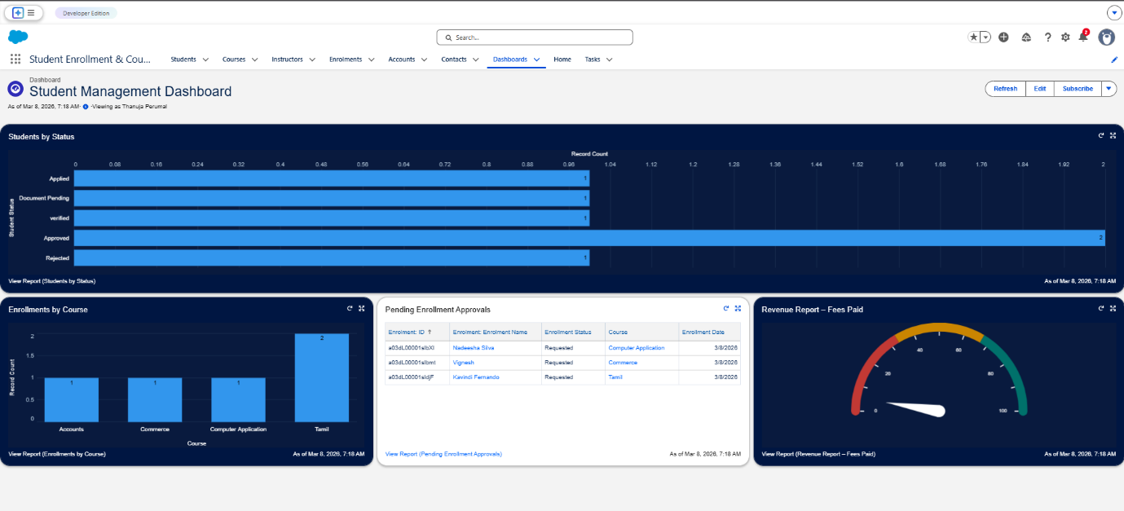
Dashboard Components
- Total Students – Displays the total number of students registered in the system.
- Total Courses – Shows the total number of courses available.
- Total Enrollments – Displays the total number of enrollment requests or completed enrollments.
- Enrollment Status Chart – Provides a visual representation of enrollment statuses such as requested, approved, rejected, and completed.
These dashboards provide clear visual insights into system usage and help administrators easily monitor activities, track trends, and manage the institution’s course enrollment process more effectively.

9. FUTURE ENHANCEMENTS
Although the Student Enrollment & Course Management System (SECMS) successfully manages students, courses, instructors, and enrollments, there are several possible improvements that can enhance the system’s functionality and user experience in the future. These enhancements can make the system more interactive, automated, and accessible.
- Student Self-Service Portal
A student self-service portal can be developed to allow students to manage their own academic activities. Through this portal, students will be able to register themselves, update their personal information, browse available courses, and enroll in courses without administrative assistance. They can also track their enrollment status, view assigned instructors, and check course completion details. This feature will reduce administrative workload and provide greater convenience to students.
- Mobile Application Integration
Integrating the system with a mobile application can make it more accessible and user-friendly. A mobile app would allow students and instructors to access the system anytime and anywhere using their smartphones. Students could receive notifications about course approvals, upcoming courses, or enrollment updates directly on their mobile devices. Similarly, instructors could view their assigned courses and manage their teaching schedules through the mobile application.
- Email Notification Automation
Email automation can be implemented to send automatic notifications for important system events. For example, students can receive confirmation emails when they successfully enroll in a course or when their enrollment request is approved or rejected. Instructors can also receive notifications when they are assigned to a new course. Automated email alerts will improve communication between students, instructors, and administrators while ensuring that all stakeholders stay informed.
- AI-Based Course Recommendation System
An Artificial Intelligence (AI) based recommendation system can be introduced to suggest suitable courses for students. The system can analyze student interests, previous enrollments, and academic history to recommend courses that match their skills and learning goals. This feature would help students discover relevant courses more easily and support personalized learning experiences within the system.
Implementing these enhancements in the future will improve the overall functionality, efficiency, and user engagement of the SECMS platform.

10. CONCLUSION
The Student Enrollment & Course Management System (SECMS) developed using the Salesforce platform successfully provides an efficient solution for managing students, courses, instructors, and enrollments within an educational institution. The system centralizes important academic data and ensures that all information related to student records, course details, and instructor assignments is stored in an organized and secure manner.
Through the use of Salesforce features such as custom objects, Flow Builder, approval processes, and reports and dashboards, the system automates many important administrative tasks. Automation, such as automatic instructor assignment based on course category, reduces manual work and minimizes the chances of human error. The approval process for course enrollment ensures that all student requests are reviewed and validated before final enrollment, improving system reliability and control.
The reporting and dashboard features provide valuable insights into the system’s performance by presenting data in both detailed and visual formats. Administrators can easily monitor the number of students, courses, and enrollments, as well as track the status of enrollment requests. These analytical tools help institutions make informed decisions and manage their academic processes more effectively.
Overall, the SECMS application demonstrates how the Salesforce platform can be used to build a scalable, efficient, and automated system for educational management. By streamlining the enrollment process and improving data organization, the system enhances operational efficiency and supports better management of institutional resources.

