## **Personalized Learning with Generative AI and LMS Integration**

## **1. INTRODUCTION**

### **1.1 Project Overview**

### This project focuses on developing a **personalized learning platform** by integrating **Generative AI (such as GPT-based models)** into a Learning Management System (LMS). The system dynamically generates **customized learning materials, quizzes, recommendations, and performance analytics** for each learner, based on their progress, preferences, and goals. The integration enables **self-paced, adaptive learning experiences**, improves student engagement, and supports instructors with **automated content creation and performance insights**.

### **1.2 Purpose**

* To **enhance learning outcomes** by tailoring study materials for each student.
* To help educators **save time** by automating quiz creation, grading, and report generation.
* To provide **24/7 AI-driven support** (tutors, chatbots) for learners inside the LMS.
* To create a scalable and cost-effective solution for **schools, universities, and corporate training**.

## **2. IDEATION PHASE**

## **2.1 Problem Statement** Traditional LMS platforms offer **static content** and **generic assessments**, which:

### Do not cater to **individual learning speeds or knowledge gaps**.

### Require **manual effort by teachers** to create quizzes, notes, and personalized guidance.

### Make it difficult to **identify at-risk students early**.

### **Solution:** Integrate **Generative AI** to **personalize learning** by dynamically generating resources, adapting difficulty levels, and automating teacher workflows

### **2.2 Empathy Map Canvas**

|  |  |
| --- | --- |
| **Think & Feel** | **“Am I progressing well?”, “I need tailored guidance.”** |

|  |  |
| --- | --- |
| **See** | **Static course content, limited interaction.** |

|  |  |
| --- | --- |
| **Hear** | **Teachers emphasizing performance but no personal attention.** |

|  |  |
| --- | --- |
| **Say & Do** | **Spend extra hours revising; seek external help.** |

|  |  |
| --- | --- |
| **Pain** | **Overwhelming workloads, lack of clarity, poor engagement.** |

|  |  |
| --- | --- |
| **Gain** | **Clear progress tracking, adaptive quizzes, AI-driven assistance.** |

### **2.3 Brainstorming**

## AI tutor chatbot integrated with LMS.

## Auto-generated quizzes based on weak topics.

## AI-powered **progress analytics dashboard**.

## Personalized **study notes and summaries**.

## Predictive insights to **alert instructors** about struggling students.

## **3. REQUIREMENT ANALYSIS**

### **3.1 Customer Journey Map**

### **Student logs into LMS.**

### **AI analyzes performance data (grades, activity logs).**

### **Personalized learning path is generated (quizzes, materials).**

### **Student interacts with AI tutor for doubts.**

### **Teacher receives automated insights and reports.**

### **Continuous feedback loop for both students and instructors.**

### **3.2 Solution Requirements**

### **Functional**:

### AI chatbot for tutoring.

### Auto-generation of quizzes, summaries, flashcards.

### Dashboard for teachers and students.

### **Non-functional**:

### Scalability (support thousands of users).

### Low latency for AI responses.

### Data security and privacy.

### **3.3 Data Flow Diagram**

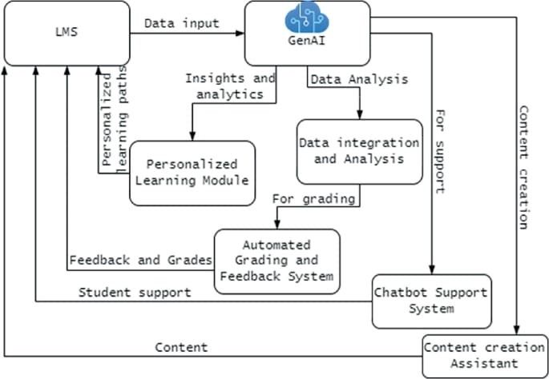**3.4 Technology Stack**

* **Frontend:** React.js (or Angular), Tailwind CSS
* **Backend:** Node.js / Python (FastAPI or Django)
* **AI Layer:** OpenAI GPT APIs or IBM Granite
* **Database:** PostgreSQL + Pinecone (for embeddings & similarity search)
* **Hosting:** AWS/GCP/Azure
* **LMS Integration:** Moodle/Canvas APIs or SCORM-compliant modules.

## **4. PROJECT DESIGN**

## **4.1 Problem-Solution Fit**

### Problem: LMS lacks personalization → Students lose motivation and teachers spend hours on repetitive tasks. Solution: Generative AI automates personalization, boosts engagement, and saves teacher effort.

### **4.2 Proposed Solution**

### • AI-driven content generation (quizzes, notes, flashcards).

### • Adaptive difficulty based on performance.

### • AI chatbot tutor for 24/7 learning support.

### • Real-time analytics for instructors

### **4.3 Solution Architecture**

## Users (Students/Teachers)

## |

## v

## LMS (Moodle/Canvas) -- API Integration --> AI Layer (GPT/Granite)

## |

## V

## Personalized Learning Engine

## |--- Content Generator

## |--- Progress Analyzer

## |--- Chatbot Tutor

## |

## v

## Frontend Dashboard (Student + Instructor)

## 

## 

## 

## 

## 

## **5. PROJECT PLANNING & SCHEDULING**

### **5.1 Project Planning**

## **• Phase 1 (Week 1-2): Requirement gathering & LMS API setup.**

## **• Phase 2 (Week 3-5): AI model integration & content generation.**

## **• Phase 3 (Week 6-7): Dashboard and analytics.**

## **• Phase 4 (Week 8): Testing and deployment**

## **6. FUNCTIONAL AND PERFORMANCE TESTING**

### **6.1 Performance Testing**

## Test AI response latency (<2 seconds).

## Test scalability (500 concurrent students).

## Accuracy testing for generated quizzes (manual validation by teachers).

## **7. RESULTS**

### **Output Screenshots**

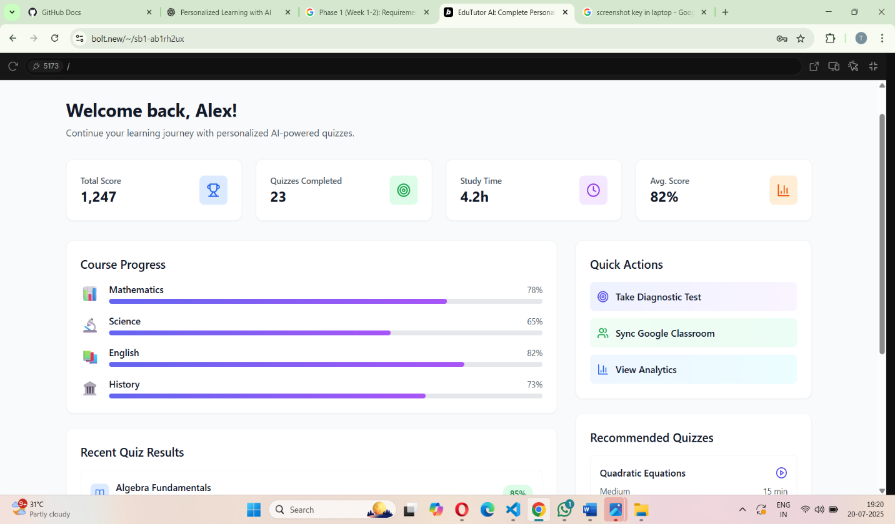

**8 .ADVANTAGES & DISADVANTAGES**

## **Advantages**

## **Personalized learning for each student.**

## **Saves teacher time via automation.**

## **Scalable and flexible for any institution.**

## **Disadvantages**

## **Reliance on AI models (cost, internet).**

## **Requires proper data security and privacy.**

**Accuracy depends on AI tuning**

## **9. CONCLUSION**

## This project demonstrates how **Generative AI integrated with LMS** can revolutionize education by making learning **personalized, efficient, and engaging**, while helping educators scale their efforts.

## **10. FUTURE SCOPE**

## • Voice-enabled AI tutors for real-time lectures.

## • Multilingual support.

## • AI-driven career guidance.

## • Integration with AR/VR for immersive learning

## **11. APPENDIX**

**GitHub_Repository_Link:**<https://github.com/thanuja276/Personalized-Learning-with-Generative-AI-and-LMS-Integration>

**GitHub/Project Demo**: https://fanciful-meringue-638b0a.netlify.app