

SIMATS ENGINEERING
Saveetha Institute of Medical and Technical Sciences
Chennai-602105

AI-BASED FACE RECOGNITION
ATTENDANCE SYSTEM

A CAPSTONE PROJECT REPORT
A Capstone Project Report submitted in partial fulfilment of the requirements for the course
CSA17 – ARTIFICIAL INTELLIGENCE
to the award of the degree of
BACHELOR OF ENGINEERING
IN
COMPUTER SCIENCE AND ENGINEERING

Course Faculty: Dr. Krishna Kumar Kathiresan, Professor
SIMATS Engineering, SIMATS

PRESENTED BY
Kamboji Thanuja – 192373012

SEPTEMBER 2026

BONAFIDE CERTIFICATE

This is to certify that the Capstone Project entitled “AI-Based Face Recognition Attendance System”
has been carried out by Kamboji Thanuja (192373012), and is submitted in partial fulfilment of the
requirements for the current semester of the B.E. Computer Science and Engineering programme at
SIMATS Engineering, Saveetha Institute of Medical and Technical Sciences, Chennai.

The project work is based on the design of an automated attendance system using Artificial Intelligence,
Computer Vision, and Face Recognition. The project records attendance information such as student
identity, date, time, and attendance status and provides attendance reporting for teachers and administrators.

COURSE FACULTY | COURSE COORDINATOR  Dr. John Justin
Dr. Krishna Kumar Kathiresan  Professor  Department of Computer Science & Engineering  SIMATS Engineering, Chennai-602105 | Program Director  Department of Computer Science & Engineering  SIMATS Engineering, Chennai-602105

DECLARATION
We, B. Bhargavi (1923211136) and Kamboji Thanuja (192373012), students of the Department of Computer Science and Engineering, SIMATS Engineering, Saveetha Institute of Medical and Technical Sciences, Chennai, hereby declare that the Capstone Project Work entitled “AI-Based Face Recognition Attendance System” is the result of our project work carried out for the course CSA17 – Artificial Intelligence.
The work presented in this report is based on the project presentation supplied for the capstone project. The system described in this report uses Artificial Intelligence, Computer Vision, face recognition, a camera/webcam, a database, and attendance reporting as described in the project presentation.
We further declare that the project description, objectives, modules, results, and conclusions presented here have been organized from the supplied capstone presentation and have not been intentionally represented as containing experimental measurements that were not provided in that source.

Student | Registration No. | Signature
B. Bhargavi | 1923211136 | ________________
Kamboji Thanuja | 192373012 | ________________

Place: Chennai
Date: ____________

INDIVIDUAL CONTRIBUTION STATEMENT

The supplied AI capstone presentation identifies two students as project presenters. The presentation describes the overall system and its two principal functional modules. The contribution statement below records the project roles at a report level without assigning unsupported percentages.

Student / Reg. No. | Project Responsibility | Contribution Area
B. Bhargavi  1923211136 | AI-Based Face Recognition Attendance System | Project presentation, system concept, attendance automation, face-recognition workflow and reporting content.
Komboji Thanuja  192373012 | AI-Based Face Recognition Attendance System | Project presentation, system concept, face registration/recognition workflow, attendance management and report documentation.

Project-level responsibilities represented in the presentation include student registration, face capture and recognition, automatic attendance marking, centralized attendance storage, duplicate-attendance prevention, attendance reporting, and results discussion.
• Student registration and face-recognition workflow.
• Attendance management and reporting workflow.
• Preparation and presentation of project objectives, architecture, results, conclusion, and references.
• Documentation of the proposed system as a capstone project.

ABSTRACT

The AI-Based Face Recognition Attendance System is an automated attendance-management solution designed to simplify and improve the process of recording student attendance. Traditional attendance methods such as manual registers and roll calls require considerable teacher effort, can lead to human errors, and may permit proxy attendance. The proposed system uses Artificial Intelligence, Computer Vision, and Face Recognition to identify registered students through a camera or webcam.
During student registration, administrative information such as Student ID, Name, Department, Year, and Section is entered into the system. Multiple images of the student are captured, processed, and used for face recognition. Facial features are extracted and represented as face embeddings for future matching. During attendance, the camera captures a student's face and compares it with the registered facial data. When a registered student is recognized, the system records the student ID, name, date, time, and attendance status.
Attendance records are maintained in a centralized database. The system is designed to prevent duplicate attendance for the same student on the same day and to avoid marking attendance for unregistered or unknown faces. Teachers and administrators can view student-wise, date-wise, and department-wise attendance details, calculate attendance percentages, and generate daily, weekly, and monthly reports.
The project presentation reports that the developed system successfully detects and recognizes registered students using a webcam, automatically marks attendance after successful recognition, records attendance details, identifies unknown faces, and provides attendance reports. The system therefore offers an automated, efficient, and user-friendly approach to attendance management.
Keywords: Artificial Intelligence, Computer Vision, Face Recognition, Face Embeddings, Attendance Management, Webcam, Database, Attendance Reporting

TABLE OF CONTENTS
Sl. No. | Title | Page
i | Certificate from the Supervisor | 2
ii | Declaration by the Candidates | 3
iii | Individual Contribution Statement | 4
iv | Abstract | 5
v | List of Figures | 7
vi | List of Tables | 7
vii | List of Abbreviations | 8
1 | CHAPTER 1: Introduction and Engineering Problem | 9–12
2 | CHAPTER 2: Literature Review and Existing Solutions | 13–15
3 | CHAPTER 3: Engineering Design, Requirements, Ethics, Safety, Risk & Security | 16–21
4 | CHAPTER 4: Implementation, Testing & Results, Project Management | 22–28
5 | CHAPTER 5: Conclusion, Future Work & Reflection | 29–32
 | References | 33
 | Appendices | 34–36

LIST OF FIGURES AND TABLES
LIST OF FIGURES
Figure No. | Figure Name | Page
1.1 | Overall attendance-system workflow | 10
3.1 | System architecture represented in the capstone presentation | 16
3.2 | Student registration and face-recognition workflow | 18
3.3 | Attendance management and reporting workflow | 20
4.1 | Project presentation – results and discussion | 24
4.2 | Project presentation – attendance system screens / output | 26

LIST OF TABLES
Table No. | Table Name | Page
1.1 | Problems in traditional attendance systems | 11
1.2 | Project objectives | 12
2.1 | Comparison of traditional and AI-based attendance approaches | 14
3.1 | Stakeholder requirements | 17
3.2 | Functional and non-functional requirements | 17
3.3 | Design specifications | 19
3.4 | Risk register | 21
4.1 | Tools and technologies identified from the project | 23
4.2 | Test plan and verification | 25
4.3 | Results reported in the presentation | 27
4.4 | Achievement of objectives | 28
5.1 | Strengths and limitations | 30
5.2 | Future work | 31
LIST OF ABBREVIATIONS / SYMBOLS
Symbol / Term | Description | Use in Project
AI | Artificial Intelligence | Core technology used for automated attendance.
CV | Computer Vision | Used for processing camera images and face detection.
ID | Identification / Student Identification | Used to identify registered students.
DB | Database | Centralized storage for attendance records.
UI | User Interface | System interface used by administrators/teachers.
OpenCV | Open Source Computer Vision Library | Referenced for computer vision and face detection.
API | Application Programming Interface | General software-interface term; no specific API is detailed in the supplied presentation.
ML | Machine Learning | Related AI term; no specific ML model is specified in the supplied presentation.
Note: The report intentionally does not assign a specific face-recognition model, threshold, database engine, or measured accuracy value because these details are not specified in the supplied capstone presentation.

CHAPTER 1
INTRODUCTION AND ENGINEERING PROBLEM
1.1 Background
Attendance is an important academic record because it allows institutions and teachers to monitor student participation. The supplied capstone presentation identifies manual registers and roll calls as traditional approaches that require time and may result in human errors. It also identifies proxy attendance as a problem that can occur when one student marks attendance for another.
The AI-Based Face Recognition Attendance System addresses these limitations through automated student identification. A camera or webcam captures a student's face, the system processes the image, extracts facial features, and compares the resulting representation with registered facial information. When a match is obtained for a registered student, attendance is recorded automatically.
The project combines Artificial Intelligence, Computer Vision, Face Recognition, a centralized database, and attendance reporting. This combination provides a workflow from student registration through recognition and attendance storage to teacher/administrator reporting.
1.2 Need for the Project
• Reduce the time required for manual attendance marking.
• Reduce human errors such as incorrect marking or missing records.
• Discourage proxy attendance through face verification.
• Support attendance management when the number of students is large.
• Make attendance records easier to search, update, view, and report.
• Provide attendance percentages and periodic attendance reports.

1.3 Proposed System Workflow
The proposed workflow begins with student registration. The administrator enters student information and captures multiple images using a webcam. Image processing is then applied, the student's face is detected, facial features are extracted, and the features are represented as face embeddings.
• Student information is registered in the system.
• Multiple student images are captured using a webcam.
• Captured images are processed to support recognition.
• The face is detected from the captured image.
• Facial features are extracted using AI-based face-recognition techniques.
• Features are represented as face embeddings and stored for future recognition.
• During attendance, a camera captures the current student's face.
• The captured face is compared with registered facial data.
• A recognized student is automatically marked Present.
• Attendance details are stored for reporting and later management.

1.4 Problem Statement
Traditional attendance systems require manual work and are time-consuming for teachers. Manual attendance may lead to human errors, including incorrect marking or missing records. Proxy attendance may occur when one student marks attendance for another. As class size increases, manually maintaining attendance records becomes difficult. Paper-based records also make it difficult to quickly search, update, and generate reports.
The engineering problem is therefore to develop an AI-based attendance-management system that can automatically recognize registered students, record attendance details, reduce manual effort, and provide accessible attendance reports.
Problem | Impact
Manual attendance marking | Consumes teacher time and effort.
Human errors | May produce incorrect or missing attendance records.
Proxy attendance | Attendance may be recorded for a different student.
Large student groups | Manual record maintenance becomes difficult.
Paper-based reporting | Searching, updating, and generating reports is inconvenient.
Repeated calculations | Attendance percentages require manual calculation.

1.5 Project Aim
The aim of the project is to develop an AI-based Face Recognition Attendance System that automatically identifies registered students through a camera and records their attendance in a centralized database.
1.6 Project Objectives
• Develop an AI-based system for automatic student attendance management.
• Identify and recognize students using facial recognition technology.
• Automatically mark attendance when a registered student is recognized.
• Reduce manual work, time, and human errors in attendance recording.
• Help prevent proxy attendance by verifying the student's face.
• Store attendance records with student details, date, time, and attendance status.
• Provide easy access to attendance reports for teachers and administrators.
• Improve the accuracy, efficiency, and reliability of the attendance process.
1.7 Scope
The project scope covers student registration, webcam-based image capture, face detection, facial feature extraction, face-embedding storage, face matching, automatic attendance marking, centralized attendance storage, duplicate-attendance prevention, unknown-face handling, attendance percentage calculation, and daily/weekly/monthly reporting.
The supplied presentation does not define real-time external integrations, a particular database platform, a particular face-recognition model, or numerical accuracy benchmarks; these are therefore outside the documented scope of this report.

CHAPTER 2
LITERATURE REVIEW AND EXISTING SOLUTIONS
2.1 Review Method
The supplied capstone presentation provides a practical project description rather than a detailed academic literature survey. Its references identify OpenCV Documentation for computer vision and face detection, Python Documentation for the programming language, and Flask Documentation for web application development.
For this report, the review therefore focuses on the approaches explicitly represented by the project: manual attendance, camera-based face recognition, automated attendance storage, and attendance reporting.
2.2 Existing Attendance Approaches
Approach | Advantages | Limitations
Manual register | Simple and familiar; no camera or recognition system required. | Time-consuming; human errors; difficult reporting; proxy attendance risk.
Roll call | Direct teacher control and simple to understand. | Consumes class time and may contain marking errors.
AI face recognition | Automated identification and attendance marking. | Requires camera, registered facial data, and functioning recognition workflow.
Database-backed attendance | Centralized records and easier reporting. | Depends on reliable storage and correct attendance inputs.

2.3 Comparative Analysis
The proposed system is motivated by the limitations of manual attendance. The project presentation specifically states that the AI system is intended to save time, improve attendance accuracy, reduce manual work, and help prevent proxy attendance.
Criterion | Traditional Manual Method | AI Face Recognition System
Attendance marking | Manual | Automatic after successful recognition
Student verification | Teacher/manual identification | Face recognition
Time requirement | Higher | Reduced through automation
Human error | Possible | Reduced by automated recording
Proxy attendance | Possible | Face verification helps prevent it
Record storage | Paper/manual records | Centralized database
Reporting | Manual search/calculation | System-generated reports and percentages
Unknown student handling | Depends on manual identification | Unknown faces can be excluded from attendance
2.4 Engineering Gap
The key gap addressed by the project is the lack of an automated workflow that combines student registration, facial recognition, attendance marking, centralized storage, duplicate checking, unknown-face handling, and reporting in one system. The project presentation describes these functions as connected parts of the proposed solution.

2.5 Proposed Contribution
The project contributes an integrated attendance workflow based on Artificial Intelligence and face recognition. The student-registration component creates the facial reference data required for recognition. The attendance component uses the camera input and recognition result to record attendance.
• Automated recognition of registered students through a webcam.
• Automatic attendance marking after successful recognition.
• Storage of student ID, name, date, time, and attendance status.
• Duplicate-attendance prevention for the same student on the same day.
• Identification of unknown faces so unregistered students are not marked present.
• Student-wise, date-wise, and department-wise attendance views.
• Attendance percentage calculation.
• Daily, weekly, and monthly attendance reports.
2.6 Summary
The literature/solution review supports the project decision to replace repetitive manual attendance tasks with a camera-based automated workflow. The supplied references further identify OpenCV, Python, and Flask as relevant technical resources for implementing the system.

CHAPTER 3
ENGINEERING DESIGN, REQUIREMENTS, ETHICS, SAFETY, RISK & SECURITY
3.1 System Architecture
The system architecture described in the capstone presentation can be represented as a sequence of registration, image capture, face processing, recognition, attendance recording, centralized storage, and reporting. The architecture is organized around two principal functional modules: Module 1 – Student Registration & Face Recognition and Module 2 – Attendance Management & Reporting.
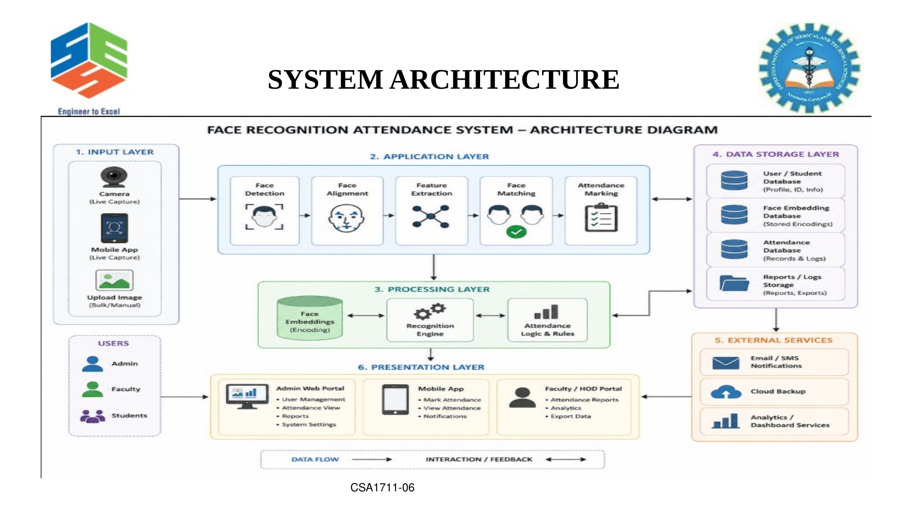
Figure 3.1: System architecture represented in the capstone presentation

3.2 Stakeholder Requirements
Stakeholder | Requirement
Administrator | Register student details and capture multiple face images.
Teacher | View attendance records, percentages, and reports.
Student | Be recognized correctly and have attendance recorded for the correct date/time.
System | Detect and recognize registered faces and avoid marking unknown faces.
Institution | Maintain centralized attendance records and reduce manual effort.
3.3 Functional and Non-Functional Requirements
Requirement | Type | Expected Behaviour
Student registration | Functional | Accept Student ID, Name, Department, Year, and Section.
Face capture | Functional | Capture multiple images using a webcam.
Face detection | Functional | Detect the student's face from captured images.
Feature extraction | Functional | Extract facial features and create face embeddings.
Recognition | Functional | Compare a captured face with registered facial data.
Attendance marking | Functional | Mark Present after successful recognition.
Duplicate prevention | Functional | Prevent repeated attendance for the same student on the same day.
Reporting | Functional | Provide student/date/department views and periodic reports.
Usability | Non-functional | Reduce manual effort and simplify attendance management.
Reliability | Non-functional | Store correct student and attendance details for later access.

3.4 Module 1 – Student Registration & Face Recognition
This module is responsible for registering student information and creating the facial reference information used for recognition. The administrator enters Student ID, Name, Department, Year, and Section.
• Capture multiple images of each student using a webcam.
• Process captured images using image-processing techniques.
• Detect the student's face in the captured image.
• Extract facial features using AI-based face-recognition techniques.
• Convert the extracted facial features into face embeddings.
• Store the face embeddings securely for future recognition.
The module forms the identity-registration foundation of the system. Recognition quality depends on the facial information available for matching, although the supplied presentation does not specify a numerical recognition threshold or accuracy measurement.

3.5 Module 2 – Attendance Management & Reporting
Module 2 is responsible for automatically recording and managing attendance once a student has been recognized.
• Automatically mark a recognized student as Present.
• Record Student ID, Name, Date, Time, and Attendance Status.
• Store attendance information in a centralized database.
• Prevent duplicate attendance for the same student on the same day.
• Allow teachers or administrators to view attendance records.
• Provide student-wise, date-wise, and department-wise attendance details.
• Calculate attendance percentage for each student.
• Generate daily, weekly, and monthly attendance reports.
• Support identification of students with low attendance.
• Reduce manual record keeping and calculation errors.
3.6 Design Specifications
Parameter | Target / Requirement | Priority
Student identification | Registered students should be identifiable through face recognition | High
Attendance marking | Automatic after successful recognition | High
Duplicate handling | Same-day duplicate attendance should be prevented | High
Unknown face handling | Unregistered faces should not be marked present | High
Attendance storage | Centralized database | High
Reporting | Daily, weekly, monthly and student/date/department views | Medium

3.7 Attendance Data Flow
The attendance process begins with camera input. The system identifies a face, compares it with registered facial information, and proceeds to attendance marking when the student is recognized.
• Camera/webcam captures the student's face.
• Face is detected from the captured image.
• Facial features are extracted.
• Features are compared with registered facial data.
• If recognized, the system records the student's identity.
• Attendance status is set to Present.
• Student ID, name, date, and time are stored.
• Existing records are checked to prevent duplicate attendance.
• Records become available for attendance analysis and reporting.

3.8 Ethics, Safety, Risk & Security
The project handles facial information and attendance records, so responsible handling of student information is important. The supplied presentation states that attendance data is stored in a centralized database and that face embeddings are stored securely. This report therefore treats controlled access and careful handling of student information as design considerations.
Risk | Likelihood | Impact | Mitigation
Unrecognized registered student | Medium | Medium | Use multiple registration images and the defined recognition workflow.
Unknown face marked present | Low/controlled by workflow | High | Do not mark attendance for unregistered/unknown faces.
Duplicate attendance | Medium | Medium | Check existing same-day attendance before recording.
Incorrect student details | Medium | Medium | Validate registration information before storing it.
Database record error | Medium | Medium | Verify recorded ID, name, date, time and status.
Unauthorized access to attendance/face data | Not specified | High | Use controlled access and secure handling as required by the deployment environment.
Safety principle: recognition and attendance outputs should be treated as system-generated records and checked appropriately, particularly where incorrect identification could affect academic records.

CHAPTER 4
IMPLEMENTATION, TESTING & RESULTS, PROJECT MANAGEMENT
4.1 Development Approach
The project was implemented as an integrated workflow consisting of student registration, face capture, face processing, recognition, attendance recording, database storage, and reporting. The supplied presentation describes the behaviour and results of the developed system but does not provide a detailed source-code listing, numerical accuracy benchmark, or step-by-step implementation log.
The report therefore documents implementation at the functional level supported by the presentation.
4.2 Implementation Flow
• Register student identity details.
• Capture multiple face images using a webcam.
• Process the captured images.
• Detect faces and extract facial features.
• Generate and store face embeddings.
• Capture faces during attendance.
• Match captured faces against registered facial data.
• Record attendance for recognized students.
• Prevent duplicate attendance for the same day.
• Store and report attendance information.
4.3 Development Resources
Resource | Purpose
Webcam / Camera | Capture student faces during registration and attendance.
Artificial Intelligence | Support facial feature extraction and recognition.
Computer Vision | Process images and detect faces.
Face embeddings | Represent extracted facial features for matching.
Database | Store student and attendance records.
Python | Referenced by the project documentation as a programming resource.
OpenCV | Referenced for computer vision and face detection.
Flask | Referenced for web application development.

4.4 Software Implementation & Tools Used
Tool / Technology | Purpose | Evidence in Supplied Material
Artificial Intelligence | Face recognition and automated identification | Project title, abstract and system description.
Computer Vision | Image processing and face detection | Introduction and references.
Webcam / Camera | Image acquisition | Registration and attendance workflow.
Face embeddings | Stored facial representation | Module 1 description.
Database | Centralized attendance storage | Abstract and Module 2 description.
OpenCV | Computer vision and face detection | References slide.
Python | Programming language resource | References slide.
Flask | Web application development resource | References slide.
4.5 Implementation Notes
The student registration module captures multiple images because the presentation specifies multiple images for each student. The attendance module relies on successful face recognition before marking a student Present. The workflow also contains a same-day duplicate check and an unknown-face condition, both of which are explicitly described in the presentation.
No unsupported implementation detail is introduced here regarding the exact neural-network architecture, face-encoding algorithm, database engine, web-server configuration, or recognition threshold.
4.6 Results and Discussion
The capstone presentation reports that the developed system successfully detects and recognizes registered students using a webcam. After successful face recognition, attendance is automatically marked. The system records student ID, name, date, and time in the database.
• The system reduces the time and effort required for manual attendance.
• Duplicate attendance can be prevented through an existing-record check.
• Unknown faces can be identified and prevented from being marked as attendance.
• Attendance records can be viewed and analyzed.
• The system provides attendance reports and attendance percentages.4.7 Test Plan & Verification
Testing is described at the functional level. Each major feature can be verified by providing the corresponding input and checking the expected system behaviour.
Test Case | Input / Action | Expected Result | Status from Presentation
Student registration | Enter student details | Student information is registered | Supported
Face capture | Capture multiple images | Images are captured for recognition | Supported
Face recognition | Present a registered face | Registered student is recognized | Successful
Attendance marking | Recognized student | Attendance marked Present | Successful
Record storage | Successful attendance | ID, name, date and time stored | Successful
Duplicate check | Repeat same-day attendance | Duplicate attendance prevented | Supported
Unknown face | Present unregistered face | Attendance not marked | Supported
Reporting | Open attendance records | Attendance details and percentages available | Supported
The word “Successful” in the table reflects the results explicitly stated in the supplied presentation rather than a numerical test score.

4.8 System Output / Demonstration Evidence
The supplied presentation contains dedicated architecture/module slides and result/output slides. These demonstrate the intended user-facing workflow and the reported outcome of the system.
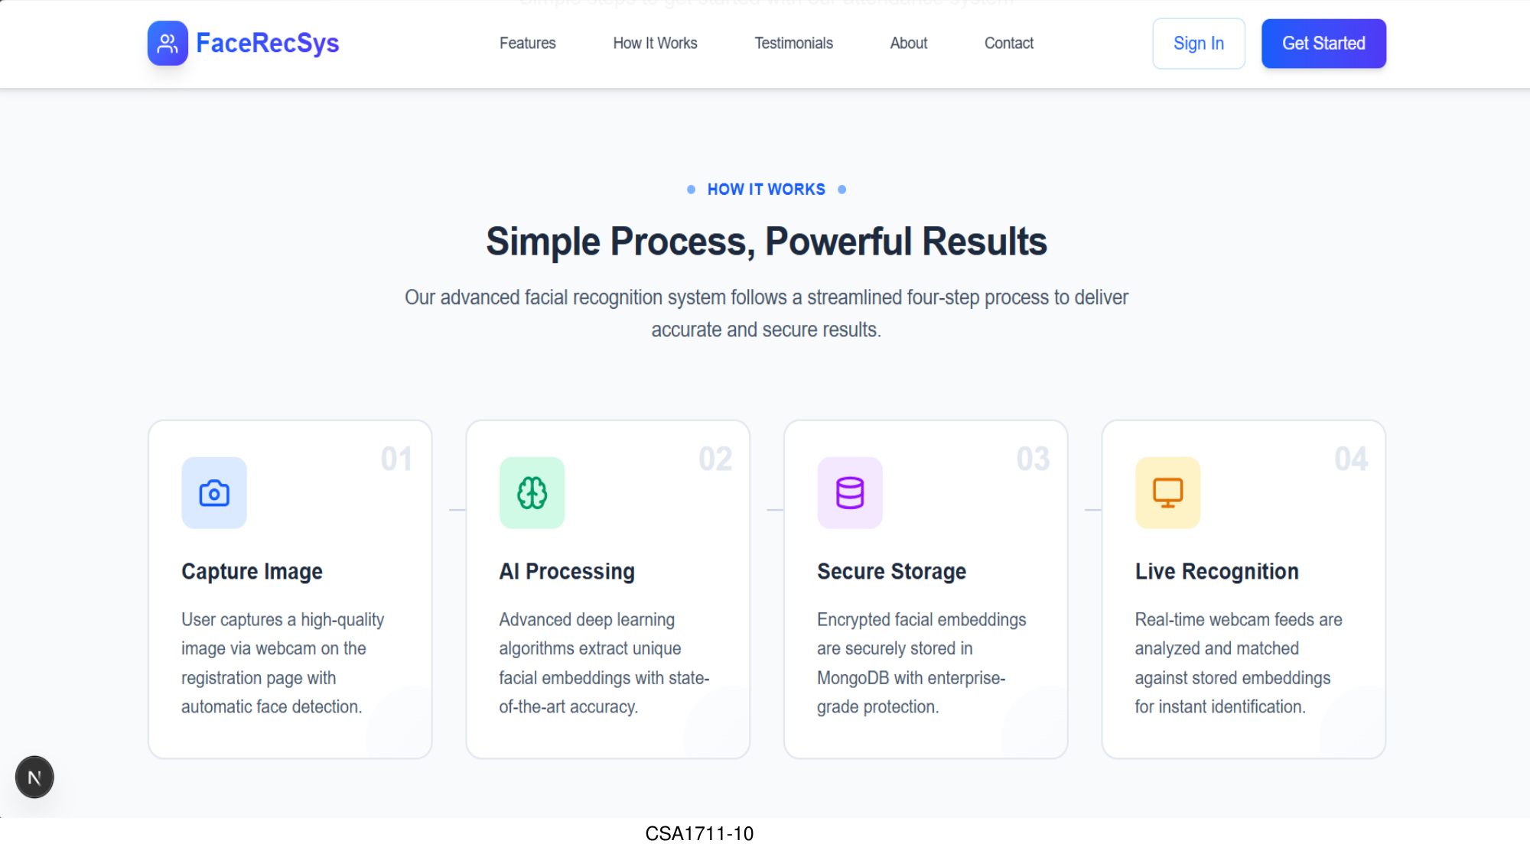
Figure: Project presentation – system output / demonstration slide
4.9 Results Summary
Result Area | Reported Outcome
Face detection and recognition | Registered students are detected and recognized using a webcam.
Attendance automation | Attendance is automatically marked after successful recognition.
Attendance information | Student ID, name, date and time are recorded.
Manual effort | Time and effort required for manual attendance are reduced.
Duplicate prevention | Same-day duplicate attendance can be prevented.
Unknown-face handling | Unknown/unregistered faces can be excluded from attendance.
Attendance analysis | Attendance records can be viewed and analyzed.
Reporting | Attendance reports and percentages are provided.
4.10 Engineering Judgment
The main engineering benefit is the conversion of a repetitive manual process into a recognition-driven workflow. The project connects identity registration, recognition, attendance storage, duplicate checking, and reporting. The system's practical value is therefore not limited to recognition alone; it is the integration of recognition with attendance management.
At the same time, the project presentation does not provide a numerical recognition accuracy, false-acceptance rate, false-rejection rate, or timing benchmark. These metrics should be measured in a future controlled evaluation rather than inferred.
4.11 Achievement of Objectives
Objective | Evidence | Achievement
Automatic attendance management | Attendance is marked automatically after recognition. | Achieved
Student recognition | Registered students are recognized using facial recognition. | Achieved
Reduce manual work | System reduces time and effort required for manual attendance. | Achieved
Reduce human error | Automated recording reduces manual record-keeping errors. | Achieved
Prevent proxy attendance | Face verification helps prevent proxy attendance. | Supported
Secure attendance storage | Attendance details are stored in a centralized database. | Achieved
Attendance reports | Daily, weekly and monthly reports are supported. | Achieved
Improve attendance management | System provides automated and user-friendly attendance management. | Achieved
4.12 Project Management
Activity | Indicative Project Stage
Problem identification and objectives | Initial project planning
System architecture | Design stage
Student registration and recognition | Module development
Attendance management and reporting | Module development
Testing and result verification | Validation stage
Presentation and report preparation | Final documentation

CHAPTER 5
CONCLUSION, FUTURE WORK AND REFLECTION
5.1 Conclusion
The AI-Based Face Recognition Attendance System provides an automated method for recording and managing student attendance. The project uses Artificial Intelligence, Computer Vision, and Face Recognition to identify students through a webcam or camera.
The system begins with student registration, where student information is entered and multiple facial images are captured. The images are processed, faces are detected, facial features are extracted, and face embeddings are stored. During attendance, the camera captures a student's face and the system compares it with registered facial data.
When a registered student is recognized, the system automatically records the student's identity, date, time, and attendance status. Centralized storage, duplicate-attendance prevention, unknown-face handling, attendance percentages, and periodic reports make the system more useful than a manual register.
The results stated in the project presentation show that the system successfully performs the principal attendance workflow and reduces manual work. Overall, the project demonstrates how AI and computer vision can be applied to automate a common academic administrative process.

5.2 Strengths and Limitations
Strengths | Limitations
Automates attendance marking. | No numerical recognition accuracy is provided in the presentation.
Uses face recognition for student verification. | Exact recognition model/algorithm is not specified.
Reduces manual work and time. | Performance under difficult lighting/pose conditions is not evaluated in the supplied material.
Stores attendance centrally. | Specific database technology is not identified.
Prevents duplicate same-day attendance. | Detailed security/access-control implementation is not specified.
Handles unknown faces. | No quantitative false-acceptance or false-rejection analysis is supplied.
Provides multiple attendance reports. | Large-scale deployment/scalability measurements are not supplied.
These limitations are documentation boundaries rather than claims that the system cannot support the corresponding features. They identify areas where additional engineering evaluation would be useful.
5.3 Future Work
• Evaluate recognition performance using a larger and more diverse student dataset.
• Measure recognition accuracy, false acceptance, false rejection, and processing time under controlled conditions.
• Evaluate recognition under different lighting, camera angles, distances, and facial conditions.
• Strengthen access control and privacy practices for facial information and attendance records.
• Improve the user interface for teachers and administrators.
• Provide richer attendance analytics and visual dashboards.
• Extend the system for larger student populations and multiple classrooms.
• Add stronger audit and exception-handling mechanisms for attendance corrections.
• Evaluate deployment using current computer-vision and face-recognition techniques.
The supplied presentation specifically supports continued improvement of the system; the detailed future-work items above are proposed engineering extensions rather than features already claimed as implemented.
5.4 Professional Learning & Individual Reflection
Through this project, the team gained practical understanding of how Artificial Intelligence and Computer Vision can be applied to automate attendance management. The work connects several stages—student registration, image capture, face detection, feature extraction, face recognition, attendance recording, centralized storage, and reporting—into a single workflow.
An important learning outcome is understanding that recognition is only one part of a complete attendance system. The project also requires correct student information, reliable attendance recording, duplicate handling, unknown-face handling, and reporting.
For the individual project work, the experience also provides learning in system analysis, module-based design, documentation, presentation, and testing. Future improvement would benefit from controlled quantitative evaluation and stronger attention to privacy, security, and deployment conditions.
5.5 Overall Reflection
The project demonstrates the practical value of applying AI to reduce repetitive administrative work. It also highlights the need to treat automated recognition as a decision-support mechanism that should be evaluated carefully before being used for consequential academic records.

REFERENCES
[1] OpenCV Documentation – Computer Vision and Face Detection.
[2] Python Documentation – Python Programming Language.
[3] Flask Documentation – Web Application Development.
Source basis: AI-CAPSTONE PROJECT presentation supplied for this report. The above references are reproduced from the References slide of the supplied presentation.
Note: No additional external references have been introduced so that the report remains grounded in the supplied capstone material.

APPENDIX A
PROJECT PRESENTATION CONTENT MAPPING
Report Section | Source Presentation Content
Abstract | Slides 2–3: system overview and abstract.
Introduction | Slide 3: introduction and motivation.
Problem Statement | Slide 4: limitations of manual attendance.
Objectives | Slide 5: project objectives.
System Architecture | Slide 6: architecture.
Module 1 | Slide 7: Student Registration & Face Recognition.
Module 2 | Slide 9: Attendance Management & Reporting.
Results | Slide 11: results and discussion.
Conclusion | Slide 12: conclusion.
References | Slide 13: OpenCV, Python, Flask documentation.
This mapping is included to make clear how the report content corresponds to the supplied presentation.

APPENDIX B
FUNCTIONAL REQUIREMENT CHECKLIST
No. | Requirement | Check
1 | Student details can be registered. | ✓
2 | Multiple face images can be captured. | ✓
3 | Face can be detected from captured image. | ✓
4 | Facial features can be extracted. | ✓
5 | Face embeddings can be stored. | ✓
6 | Registered students can be recognized. | ✓
7 | Attendance can be automatically marked. | ✓
8 | Student ID, name, date and time can be recorded. | ✓
9 | Same-day duplicate attendance can be prevented. | ✓
10 | Unknown faces can be excluded from attendance. | ✓
11 | Attendance records can be viewed. | ✓
12 | Attendance percentage can be calculated. | ✓
13 | Daily, weekly and monthly reports can be generated. | ✓
Checklist basis: functions explicitly described in the supplied AI capstone presentation.

APPENDIX C
FINAL PROJEC T SUMMARY
Core Technologies / Concepts: Artificial Intelligence, Computer Vision, Face Recognition, Webcam/Camera, Face Embeddings, Centralized Database, Attendance Reporting.
Principal Modules:
• Module 1 – Student Registration & Face Recognition
• Module 2 – Attendance Management & Reporting
Reported Outcome: The project presentation states that the developed system detects and recognizes registered students using a webcam, automatically marks attendance after successful recognition, records attendance details, prevents duplicate attendance, identifies unknown faces, and provides attendance reports and attendance percentages.

import cv2
import face_recognition
import os

name = input("Enter Student Name: ")
student_id = input("Enter Student ID: ")

folder = "dataset"
os.makedirs(folder, exist_ok=True)

cap = cv2.VideoCapture(0)

print("Look at the camera...")
print("Press SPACE to capture your face.")
print("Press ESC to cancel.")

while True:
ret, frame = cap.read()

if not ret:
break

cv2.imshow("Face Registration", frame)

key = cv2.waitKey(1)

if key == 32:
filename = f"{folder}/{student_id}_{name}.jpg"
cv2.imwrite(filename, frame)
print("Face registered successfully!")
break

elif key == 27:
break

cap.release()
cv2.destroyAllWindows()

