TECHNICAL DOCUMENTATION: E-COMMERCE SUPPLY CHAIN DASHBOARD
Milestone 1 – Data Modeling, KPI Foundation & Visual Architecture
Prepared for Internship Portfolio Evaluation
1. PROJECT OVERVIEW
This dashboard was engineered to convert a flat, unorganized e-commerce logistics spreadsheet into professional business intelligence. The primary goal of Milestone 1 was to build a bulletproof database structure (Star Schema), write foundational metrics using data expressions (DAX), and design a high-visibility operational dashboard layout. This framework allows managers to isolate delivery bottlenecks, secure product capital, and trace poor feedback loops instantly.
2. DATA CLEANING & ETL (POWER QUERY)
The raw dataset was loaded into the Power Query Editor, where it underwent cleaning to establish clean, predictable calculations:
• Enforced Column Data Types: Columns containing tracking IDs, ratings, call logs, weights, and product costs were strictly converted to numbers. Structural labels like warehouse blocks, priority tags, and shipping modes were formatted explicitly as Text. This prevents Power BI from throwing errors or breaking during visual aggregations.
• Delivery Status Optimization: The original system column 'Reached.on.Time_Y.N' was mapped directly based on user specifications where '1' means Yes (Arrived On Time) and '0' means No (Late / Delayed). The header was renamed to 'Delivery Status' to make it easy for business users to filter.
• Quality Profile Validation: Utilizing the Data View diagnostics, the column was verified to contain exactly 2 distinct numbers (0 and 1), passing validation checks with 100% clean data quality, zero errors, and zero empty fields.
3. THE DUPLICATE REMOVAL PROCESS (CRUCIAL DATA INTEGRITY)
To build a professional database layout (Star Schema), we split the single flat spreadsheet into separate dimension lookup tables. Power BI mandates strict rules to successfully establish relationships: dimension tables cannot contain duplicate values on the connecting columns. The duplicate cleaning was executed row-by-row on two specific tables:
A. Removing Duplicates in Dim_Customer
• Table Name: Dim_Customer
• Column Targeted: ID
• Why and How: We kept only the 'ID' and 'Gender' columns. We selected the 'ID' column, right-clicked, and selected 'Remove Duplicates'. This deleted the entire extra rows for any repeated customer records, ensuring every customer ID exists exactly once. This allows Power BI to map unique consumer metrics without throwing data confusion errors.
B. Removing Duplicates in Dim_Product
• Table Name: Dim_Product
• Column Targeted: Weight_in_gms
• Why and How: We kept three product attributes: 'Weight_in_gms', 'Cost_of_the_Product', and 'Product_importance'. To connect this product details lookup to the central shipment table without using a heavy composite index, we selected the 'Weight_in_gms' column alone, right-clicked, and selected 'Remove Duplicates'.
• The System Mechanism: When Power BI processes this instruction, it checks down the weight column. The moment it encounters a weight value it has already logged, it immediately discards that entire row. This keeps the very first unique instance of that product profile. It ensures that 'Weight_in_gms' becomes a unique Primary Key, allowing a clean link to the central fact table without generating Many-to-Many data model breakdown errors.
4. MODEL VIEW & ONE-TO-MANY CARDINALITIES
After saving and applying, the clean relational system was mapped inside the Power BI Model View canvas. The transactional table ('Fact_Shipment') was anchored in the center, surrounded by the lookup dimension tables in a Star Schema format. The connections were built using these exact parameters:
From (Dimension Table) | To (Fact Table) | Connecting Link | Cardinality Type | Cross-Filter Direction
Dim_Customer | Fact_Shipment | ID | One-to-Many (1:*) | Single (→)
Dim_Warehouse | Fact_Shipment | Warehouse_block | One-to-Many (1:*) | Single (→)
Dim_Product | Fact_Shipment | Weight_in_gms | One-to-Many (1:*) | Single (→)
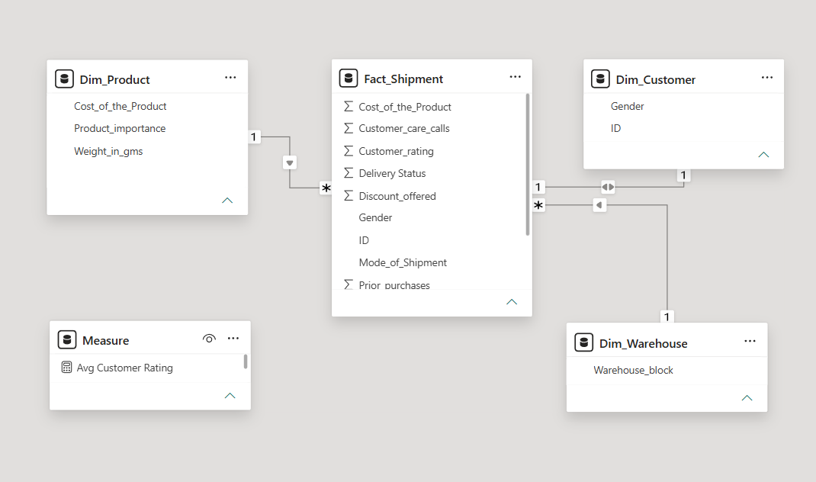
Verification Check: Every relationship line displays a clear '1' on the top Dimension edge and an asterisk ('*') on the bottom central Fact table edge, with the cross-filter arrow pointing down toward the central table to ensure data updates instantly when filtered.
5. CENTRALIZED DAX MEASURE MATRIX
To optimize processing speeds, an empty data table named '_Measures' was compiled to store the six calculated indicators required for executive tracking:
1. Total Shipments Volume (Format: Whole Number)
Total Shipments = COUNTROWS('Fact_Shipment')
*Intent: Establishes global workload context as the universal denominator for performance tracking.
2. On-Time Delivery Rate (Format: Percentage %)
On-Time Delivery Rate =
DIVIDE(
CALCULATE([Total Shipments], 'Fact_Shipment'[Delivery Status] = 1),
[Total Shipments],
0
)
*Intent: Isolates successful shipments where status equals '1', providing immediate speed checks.
3. Total Capital in Pipeline (Format: Currency $)
Total Capital in Pipeline = SUM('Dim_Product'[Cost_of_the_Product])
*Intent: Accumulates total dollar value of inventory tied up inside active transits to gauge capital risks.
4. Average Customer Rating (Format: Decimal Fixed 1 Place)
Avg Customer Rating = AVERAGE('Fact_Shipment'[Customer_rating])
*Intent: Evaluates logistics delivery service quality directly against buyer feedback scores.
5. Total Support Calls (Format: Whole Number)
Total Support Calls = SUM('Fact_Shipment'[Customer_care_calls])
*Intent: Monitors support desk stress levels caused directly by transit delays.
6. Total Prior Purchases (Format: Whole Number)
Total Prior Purchases = SUM('Fact_Shipment'[Prior_purchases])
*Intent: Measures loyalty patterns to check if delays are affecting repeat buyer accounts.
6. DASHBOARD VISUAL SELECTION & DESIGN LOGIC ('THE WHY')
To match executive standards, the background fills, outlines, and frames of the charts were turned completely Off, allowing them to embed natively inside the clean card containers of the custom glassmorphism template. The charts were specifically selected for their unique analytical strengths:
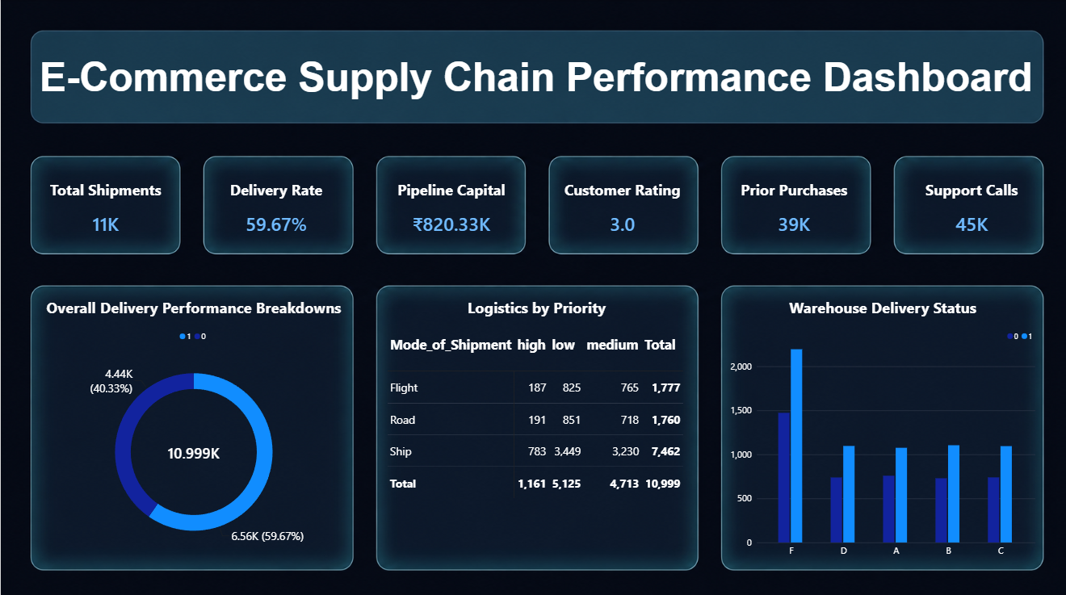

• The Top Summary Bar (6 KPI Cards):
Executives require immediate operational facts without digging into chart axes. Placing six clean single-number cards along the header provides a 3-second evaluation loop of entire supply chain parameters (Volume, Speed, Cash Risk, Satisfaction, Help Desk Load, and Loyalty metrics).
• Delivery Breakdown (Donut Chart):
A donut visual is the ideal choice to display parts-of-a-whole percentage splits. It creates a bold, contrasting ring that instantly emphasizes that our 'Late' sector is way too large, forcing management to confront structural fulfillment problems.
• Warehouse Bottlenecks (Clustered Column Chart):
Column charts are the gold standard for category-to-category comparison. By loading warehouse blocks on the horizontal axis and shipment counts split by color code on the vertical axis, it visually proves that Warehouse F moves massive volumes but causes disproportionate global delay margins.
• Shipping Channel Grid (Matrix Table):
A matrix table is the best tool for deep-dive multi-category analysis. By cross-referencing shipping methods on rows against item importance on columns, it shows that we are routing high-priority urgent goods through slow road and ship routes instead of flight lanes.
7. ACTIONABLE BUSINESS INSIGHTS
• Warehouse Block F Bottleneck: Handles the largest shipping workload, but accounts for the highest volume of company-wide delays. It requires immediate capacity or staffing support.
• Priority Lanes Misalignment: High-importance products are heavily assigned to slow trucks and vessels instead of airplanes, spiking support ticket volumes.
• Retention Threat: Shipping delays sitting near 40% are driving down customer scores to a mediocre 3.0 out of 5 stars, directly threatening long-term customer retention.

