E-COMMERCE SUPPLY CHAIN
PERFORMANCE DASHBOARD
Infosys Springboard Internship
Lakshmi Thanuja Dharmavarapu
Data Visualization Intern

1. INTRODUCTION
This dashboard was developed in Power BI to analyse an e-commerce supply chain dataset and present the information through a structured business intelligence report. The work progressed through four milestones, beginning with data modelling and core KPI development and continuing into inventory analysis, delivery analysis, supplier and transportation analysis, warehouse efficiency, executive reporting, and dashboard performance optimization.
The documentation records the data preparation, tables, calculated columns, DAX measures, visual selections, and dashboard structure used across the four milestones.

2. TOOLS USED
- Microsoft Power BI Desktop – used to build the data model, DAX measures, report pages, KPI cards, charts, slicers, and tables.
- Power Query – used for data cleaning, data type correction, column transformation, duplicate removal, and preparation of dimension tables.
- DAX (Data Analysis Expressions) – used to create reusable measures and calculated analytical fields.
- Microsoft Excel – used as the source format for the original e-commerce supply chain dataset.

3. DATASET
The original dataset contained the following fields:
'ID', 'Warehouse_block', 'Mode_of_Shipment', 'Customer_care_calls', 'Customer_rating', 'Cost_of_the_Product', 'Prior_purchases', 'Product_importance', 'Gender', 'Discount_offered', 'Weight_in_gms', 'Reached.on.Time_Y.N'
During Power Query preparation, 'Reached.on.Time_Y.N' was renamed to 'Delivery Status', where 1 represents an on-time shipment and 0 represents a delayed shipment.
The final Power BI model used the following tables:
Table Name | Role
Measure | Central location used to store DAX measures.
Dim_Customer | Customer lookup table containing ID and Gender.
Dim_Product | Product lookup table containing product-related attributes.
Dim_Warehouse | Warehouse lookup table containing Warehouse_block.
Fact_Shipment | Central transactional table containing shipment-level records and analytical fields.

4. MILESTONE 1 – DATA MODELLING & KPI FOUNDATION

4.1 Milestone 1 Overview
Milestone 1 focused on establishing the foundations of the E-Commerce Supply Chain Dashboard. The main work involved importing the raw logistics data, cleaning the dataset in Power Query, creating dimension tables, establishing the Star Schema, writing core DAX measures, and creating the first KPI layer.

4.2 Data Import and Cleaning
- Enforced Column Data Types: numerical fields including IDs, Customer Ratings, Support Calls, Item Weights, and Product Costs were converted to numeric data types. Warehouse Blocks, Priorities, and Shipping Modes were maintained as text.
- Delivery Status Optimization: 'Reached.on.Time_Y.N' was renamed to 'Delivery Status'. The value 1 represents On-Time Arrival and 0 represents Delayed Shipment.
- Quality Profile Validation: the delivery status field was checked for the two expected values, 0 and 1, before it was used in the dashboard.

4.3 Duplicate Removal and Data Modelling
- Dim_Customer: ID and Gender were retained and duplicate ID values were removed so that ID could be used as a unique lookup value.
- Dim_Product: Weight_in_gms, Cost_of_the_Product, and Product_importance were retained and duplicate Weight_in_gms values were removed for the product lookup.
The cleaned dimension tables were connected to the central Fact_Shipment table using one-to-many relationships with single-direction filtering, forming the Star Schema used throughout the report.

4.4 Model Relationships
From | To | Connecting Field | Cardinality | Filter Direction
Dim_Customer | Fact_Shipment | ID | One-to-Many (1:*) | Single
Dim_Warehouse | Fact_Shipment | Warehouse_block | One-to-Many (1:*) | Single
Dim_Product | Fact_Shipment | Weight_in_gms | One-to-Many (1:*) | Single

4.5 KPI and DAX Foundation
The core measures were stored in the Measure table so they could be reused across report pages.
Total Shipments = COUNTROWS('Fact_Shipment')
Purpose: establishes the total shipment volume and provides the base count used by percentage measures.
On-Time Delivery Rate =
DIVIDE(
CALCULATE([Total Shipments], 'Fact_Shipment'[Delivery Status] = 1),
[Total Shipments],
0
)
Purpose: calculates the proportion of shipments that reached the destination on time.
Total Inventory = SUM('Fact_Shipment'[Inventory])
Inventory Turnover = AVERAGE('Fact_Shipment'[Inventory_Turnover])
KPI Cards were used for these summary measures because single-value indicators make the main operational figures immediately readable.
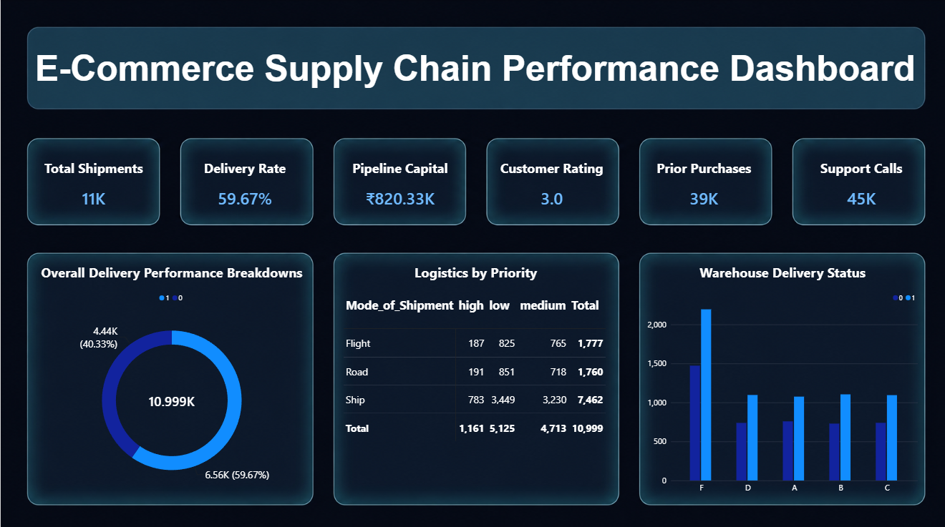

5. MILESTONE 2 – INVENTORY, DELIVERY, DRILL-DOWN & VARIANCE ANALYSIS

5.1 Milestone 2 Overview
Milestone 2 expanded the core framework into a multi-page operational analysis. The milestone introduced inventory analysis, product categorization, time-based delivery tracking, hierarchical drill-down, and warehouse-level variance analysis.

5.2 New Columns Created
Calculated Field / Column | Purpose
Inventory | Aggregates storage volumes and calculates absolute inventory levels across warehouse blocks.
Product_Category | Groups products into Basic, Standard, and Premium categories.
Region | Provides a geographic grouping for delivery and performance analysis.
Shipment_Date | Provides a time axis for shipment and inventory trends.
Shipment Year | Provides year-level grouping for time analysis.
Month Name | Provides month-level grouping for trend analysis.
Month Number | Supports chronological sorting of month names.
Month Year | Provides a combined year-month field for time-series reporting.
Year Month | Provides a sequential timeline field for longer trend views.

5.3 Inventory Analysis and KPI Layer
- Total Inventory KPI: summarizes total inventory volume.
- Inventory Turnover KPI: represents inventory movement efficiency.
- Total Products KPI: represents the number of product records being analysed.
- Slow-Moving Products KPI: identifies products with lower movement based on the dashboard measure.

5.4 Inventory by Product Category
Visual Component: Horizontal Bar Chart
Why this visual: a horizontal bar chart makes the Basic, Standard, and Premium category labels easy to read while allowing their inventory volumes to be compared directly.

5.5 Warehouse vs Inventory
Visual Component: Vertical Column Chart
Why this visual: a column chart provides a direct comparison between warehouse blocks and makes differences in inventory volume easy to identify.

5.6 Inventory Trend Over Time
Visual Component: Line Chart
Why this visual: a line chart is appropriate for chronological data because it shows changes, peaks, and drops in inventory across the shipment timeline.

5.7 Inventory Details Table
Visual Component: Table
Why this visual: the table provides detailed row-level information such as Weight_in_gms, Product_Category, Warehouse_block, Inventory, and Inventory Turnover, allowing individual records to be reviewed rather than only aggregated chart values.

5.8 Delivery Performance Analysis
- On-Time vs Delayed Deliveries – Donut Chart: used to show the proportion of on-time and delayed shipments as parts of the total shipment volume.
- Delivery Performance by Warehouse – Clustered Column Chart: used to compare shipment counts by warehouse while separating the delivery status categories.
- Delivery Trend Over Time – Line Chart: used to show how on-time and delayed shipment counts change over time.

5.9 Drill-Down Analysis
Visual Component: Interactive hierarchical chart.
Hierarchy used: Region → Warehouse_block → Mode_of_Shipment → Product_Category.
Why this visual: the hierarchy allows the user to start with a broad regional view and drill into a warehouse, shipment mode, and product category to locate the detailed source of a pattern.

5.10 Trend and Variance Analysis
- Inventory Trend Analysis – Line Chart: shows short-term inventory movement.
- Inventory Variance – KPI Card: displays the calculated overall variance as a single value.
Inventory Variance by Warehouse – Column Chart: compares positive and negative warehouse-level variance values.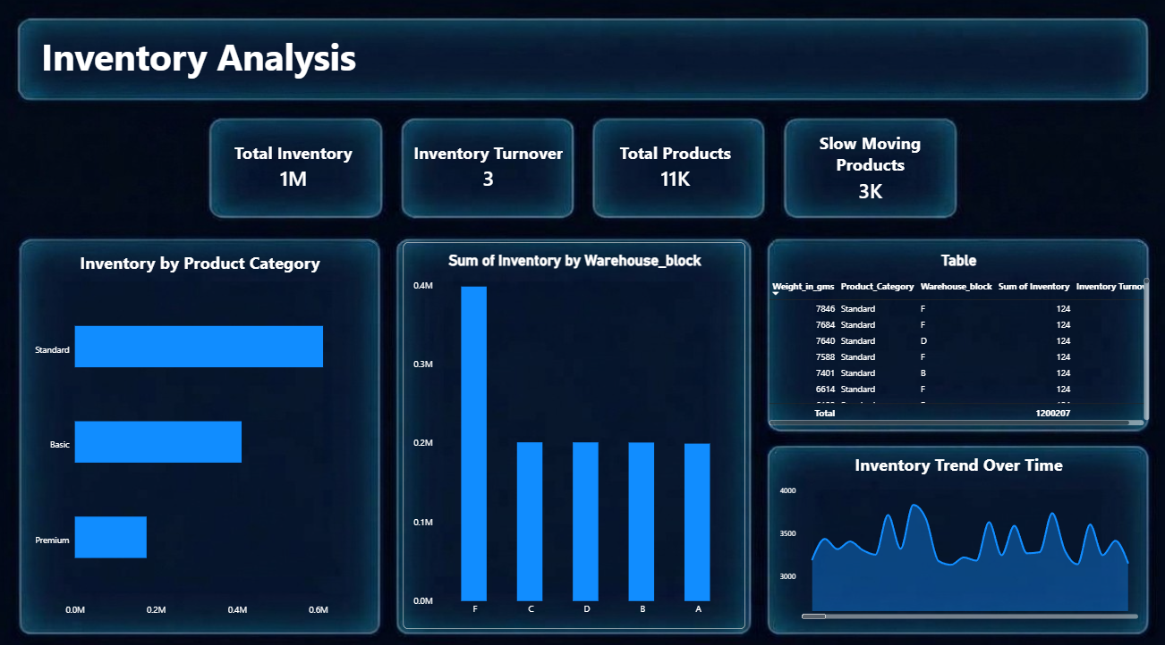

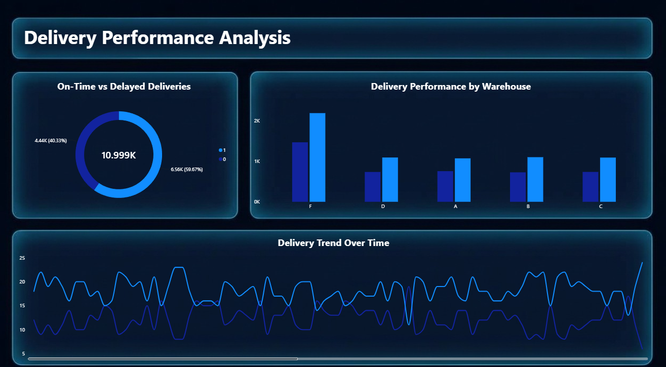
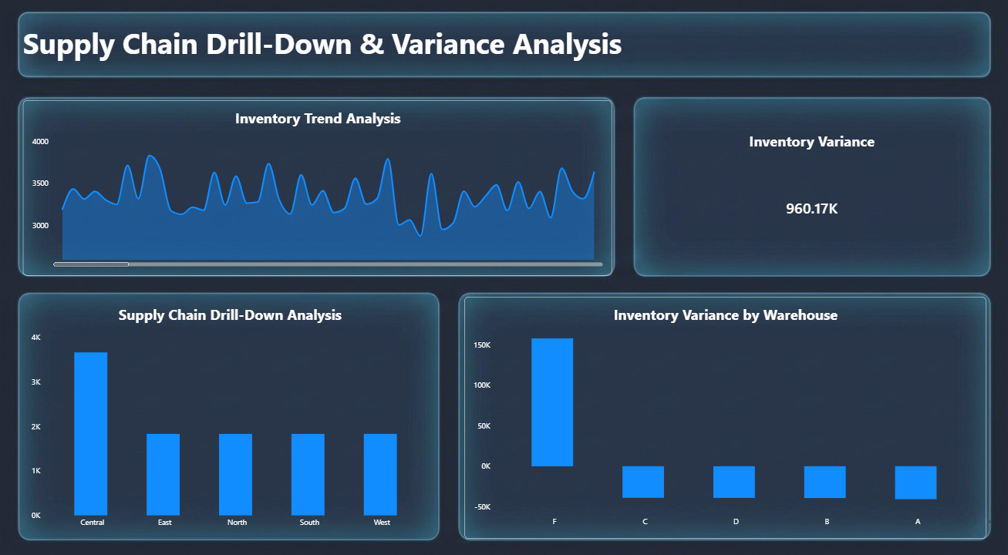

6. MILESTONE 3 – SUPPLIER, CARRIER, ROUTE & TRANSPORTATION PERFORMANCE ANALYSIS

6.1 Milestone 3 Overview
Milestone 3 extended the dashboard into supplier, carrier, route, transportation-cost, fulfillment, and quality analysis. Because the original dataset did not contain dedicated supplier, carrier, route, quality, and transportation-cost fields, additional analytical columns were created in Power BI for the required analysis.

6.2 New Analytical Columns
Column | Purpose
Supplier | Maps shipment records to supplier groups for supplier-wise shipment and quality analysis.
Carrier | Identifies the logistics carrier used for transportation-cost analysis.
Route | Represents the transit route used to compare route-level transportation cost.
Quality Score | Stores quality evaluation values for supplier performance comparison.
Transportation Cost | Stores shipment-level transportation cost for total and average cost calculations.
Fulfillment Status | Classifies records according to fulfillment state for fulfillment-rate analysis.

6.3 DAX Measures
Total Transportation Cost =
SUM('Fact_Shipment'[Transportation Cost])
Purpose: calculates total transportation expenditure.
Average Shipment Cost =
AVERAGE('Fact_Shipment'[Transportation Cost])
Purpose: calculates the average transportation cost per shipment.
Fulfillment Rate =
DIVIDE(
CALCULATE(
COUNTROWS('Fact_Shipment'),
'Fact_Shipment'[Fulfillment Status] = "Fulfilled"
),
COUNTROWS('Fact_Shipment'),
0
)
Purpose: calculates the percentage of records classified as fulfilled.
On-Time Rate =
DIVIDE(
CALCULATE(
COUNTROWS('Fact_Shipment'),
'Fact_Shipment'[Delivery Status] = 1
),
COUNTROWS('Fact_Shipment'),
0
)
Purpose: calculates the percentage of shipments delivered on time.

6.4 KPI Cards
- Total Transportation Cost – displays total transportation expenditure.
- Average Shipment Cost – displays average freight cost per shipment.
- Fulfillment Rate – displays the proportion of fulfilled shipments.
- On-Time Rate – displays overall on-time delivery performance.

6.5 Supplier-wise Shipment Count
Visual Component: Column Chart
Why this visual: a column chart allows shipment volume to be compared directly across suppliers.

6.6 Supplier-wise Quality Score
Visual Component: Column Chart
Why this visual: the chart makes differences in average quality score between suppliers easy to compare.

6.7 Carrier-wise Transportation Cost
Visual Component: Column Chart
Why this visual: the chart compares transportation expenditure across carriers and makes cost differences visible.

6.8 Route-wise Transportation Cost
Visual Component: Horizontal Bar Chart
Why this visual: horizontal bars make longer route names easier to read while comparing transportation costs.

6.9 Slicers and Interactive Filtering
- Supplier – filters the report to a selected supplier.
- Carrier – filters the report to a selected carrier.
- Region – filters the report to a selected region.
- Route – filters the report to a selected route.
The slicers were connected to the report visuals so that KPI cards and charts respond to the selected filters.
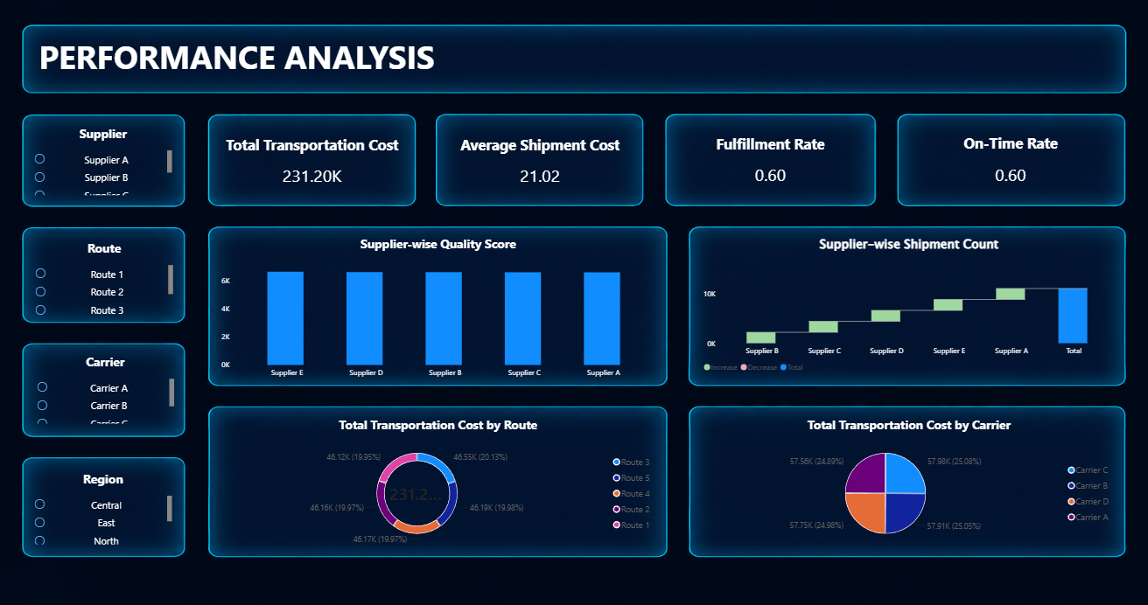

7. MILESTONE 4 – WAREHOUSE EFFICIENCY, EXECUTIVE OVERVIEW & DASHBOARD PERFORMANCE OPTIMIZATION

7.1 Milestone 4 Overview
Milestone 4 focused on extending the supply chain report from inventory, delivery, and transportation analysis into warehouse efficiency and executive-level monitoring. The milestone contains three report components: Warehouse Efficiency Report, Executive Overview Dashboard, and Dashboard Performance Optimization.
The existing Power BI model was retained. The exact tables used were Measure, Dim_Customer, Dim_Product, Dim_Warehouse, and Fact_Shipment. Since the original dataset did not contain all warehouse-efficiency fields required by the milestone, additional analytical columns were created in Fact_Shipment using sample values and calculated logic.

7.2 Existing Power BI Tables
Table | Use in Milestone 4
Measure | Stores the Milestone 4 DAX measures.
Dim_Customer | Provides customer-level information such as ID and Gender.
Dim_Product | Provides product-related fields such as Cost_of_the_Product, Product_importance, and Weight_in_gms.
Dim_Warehouse | Provides Warehouse_block for warehouse-level analysis.
Fact_Shipment | Central table used for orders, delivery, shipment quantity, capacity, picking accuracy, shipped quality, and operating-cost analysis.

7.3 Existing Fact_Shipment Columns Used
'Cost_of_the_Product', 'Customer_care_calls', 'Customer_rating', 'Delivery Status', 'Discount_offered', 'Gender', 'ID', 'Inventory', 'Mode_of_Shipment', 'Prior_purchases', 'Product_Category', 'Product_importance', 'Region', 'Shipment_Date', 'Warehouse_block', 'Weight_in_gms'

7.4 New Columns Created for Milestone 4
Column | Creation / Logic | Purpose
Shipped_Quantity | 1 + MOD('Fact_Shipment'[ID], 10) | Creates shipment quantities from 1 to 10 for quantity-based warehouse analysis.
Warehouse_Capacity | Assigned by Warehouse_block using SWITCH. | Provides sample warehouse capacity values for utilisation analysis.
Picking_Accuracy | Assigned by Warehouse_block using SWITCH. | Provides warehouse-level picking accuracy percentages.
Operating_Cost | Cost_of_the_Product + Customer_care_calls*10 + Discount_offered*5 | Creates an operational-cost value for the executive dashboard.
Shipped_Quality | Assigned as a quality score using sample quality categories/values. | Provides a quality measure for shipped-quantity analysis.
The sample warehouse-capacity and picking-accuracy values used in the Power BI calculation logic were:
Warehouse_block | Warehouse_Capacity | Picking_Accuracy
A | 5000 | 96%
B | 6000 | 94%
C | 5500 | 95%
D | 6500 | 97%
F | 7000 | 93%

7.5 Milestone 4 DAX Measures
Total Orders =
DISTINCTCOUNT('Fact_Shipment'[ID])
Purpose: counts distinct order IDs so that the KPI represents the number of orders rather than repeated row counts.
Total Shipped Quantity =
SUM('Fact_Shipment'[Shipped_Quantity])
Purpose: totals the quantity shipped across the available shipment records.
Capacity Utilisation =
DIVIDE(
[Total Shipped Quantity],
SUM('Fact_Shipment'[Warehouse_Capacity]),
0
)
Purpose: compares shipped quantity with available warehouse capacity.
On-Time Delivery =
DIVIDE(
CALCULATE(
DISTINCTCOUNT('Fact_Shipment'[ID]),
'Fact_Shipment'[Delivery Status] = 1
),
DISTINCTCOUNT('Fact_Shipment'[ID]),
0
)
Purpose: measures the proportion of distinct orders delivered on time.
Picking Accuracy =
AVERAGE('Fact_Shipment'[Picking_Accuracy])
Purpose: provides the average warehouse picking-accuracy percentage.
Supporting Shipped Quality =
AVERAGE('Fact_Shipment'[Shipped_Quality])
Purpose: provides a supporting shipped-quality score for analytical use; it is not a visible KPI on the current Warehouse Efficiency page.
Operating Cost =
SUM('Fact_Shipment'[Operating_Cost])
Purpose: provides the total calculated operating cost for the selected filter context.

7.6 Warehouse Efficiency Report
The first Milestone 4 dashboard is the Warehouse Efficiency Report. It combines five KPI cards with warehouse-level order volume, shipped quantity, delivery status, and capacity-utilisation visuals.
KPI Card | Purpose
Total Orders | Shows the total number of distinct orders.
Total Shipped Quantity | Shows the total quantity shipped.
Capacity Utilisation | Shows the relationship between shipped quantity and warehouse capacity.
On-Time Delivery | Shows the percentage of orders delivered on time.
Picking Accuracy | Shows the average picking-accuracy percentage.
KPI Cards are used for Total Orders, Total Shipped Quantity, Capacity Utilisation, On-Time Delivery, and Picking Accuracy because these are key operational indicators that should be readable immediately.

7.7 Executive Overview Dashboard
The second dashboard provides an executive-level view of the supply chain using Operating Cost as the headline KPI, together with regional order volume, warehouse cost distribution, delivery-status distribution, and monthly order monitoring.
Table columns | Purpose
Total Orders | Summarizes order volume.
Total Shipped Quantity | Summarizes shipped quantity.
Capacity Utilisation | Summarizes warehouse capacity usage.
On-Time Delivery | Summarizes delivery performance.
Picking Accuracy | Summarizes picking accuracy.
Operating Cost | Summarizes calculated operating expenditure.
Slicers were added to make the executive dashboard interactive:
- Warehouse_block – filters the dashboard by warehouse.
- Region – filters the dashboard by geographical region.
- Mode_of_Shipment – filters the dashboard by shipment mode.
- Product_Category – filters the dashboard by product category.
The slicers allow the user to move from the overall executive view to a selected warehouse, region, shipment mode, or product category without creating separate report pages.

7.8 Dashboard Performance Optimization
The third Milestone 4 component focuses on dashboard performance optimization through a compact, scrollable table. A table visual was used because detailed shipment records can be inspected without relying only on aggregated KPIs.
The table uses the shipment-level fields visible in the report, including ID, Warehouse_block, Region, Product_Category, Mode_of_Shipment, Inventory, Weight_in_gms, and Delivery Status, so individual records can be inspected in detail.
The table supports detailed inspection after the dashboard identifies a warehouse, region, product category, or shipment mode that requires closer review.

7.9 Visual Selection – Why Each Visual Was Used
Dashboard Performance Optimization – Detail Table: provides row-level shipment information for detailed inspection and validation.
Executive Overview – Total Orders by Month Year (Line Chart): shows the order trend over the available shipment timeline.
Executive Overview – Delivery Status Distribution (Donut Chart): presents the on-time versus delayed delivery split in a compact executive view.
Executive Overview – Operating Cost by Warehouse_block (Pie Chart): shows each warehouse's share of operating cost as a part of the total.
Executive Overview – Orders by Region (Column Chart): compares order volume across regions and highlights the region with the highest order concentration.
Warehouse Efficiency Report – Capacity Utilisation (Line Chart): shows the capacity-utilisation pattern across warehouse blocks and makes differences between warehouses easy to observe.
Warehouse Efficiency Report – On-Time vs Delayed Orders (Donut Chart): shows the proportion of on-time and delayed orders as a simple part-to-whole comparison.
Warehouse Efficiency Report – Shipped Quantity by Warehouse (Bar Chart): compares shipped quantity horizontally across warehouses and makes the largest shipping volume easy to identify.
Warehouse Efficiency Report – Orders by Warehouse (Column Chart): compares order volume across warehouse blocks and makes differences in warehouse workload easy to identify.
Visual | Reason for Use in Milestone 4
KPI Card | Presents important operational and financial measures as clear single values.
Slicer | Allows users to filter the report by warehouse, region, shipment mode, and product category.
Column Chart | Provides direct category-to-category comparisons where warehouse or operational groups need to be compared.
Line Chart | Shows changes over time where a chronological trend is required.
Bar Chart | Provides easy comparison when category names or labels are better suited to horizontal display.
Donut / Pie Chart | Shows a simple part-to-whole distribution when a percentage split is required.
Table | Provides detailed row-level values for audit and performance inspection.

7.10 Milestone 4 Implementation Flow
- Retained the existing Star Schema tables: Measure, Dim_Customer, Dim_Product, Dim_Warehouse, and Fact_Shipment.
- Used the existing Fact_Shipment columns already created in earlier milestones.
- Created the additional analytical columns Shipped_Quantity, Warehouse_Capacity, Picking_Accuracy, Operating_Cost, and Shipped_Quality because the source dataset did not contain the required warehouse-efficiency fields.
- Created the Milestone 4 measures used by the report: Total Orders, Total Shipped Quantity, Capacity Utilisation, On-Time Delivery, Picking Accuracy, and Operating Cost; the supporting Shipped_Quality field was retained for analytical use.
- Built the Warehouse Efficiency Report with five KPI Cards and four supporting visuals: Orders by Warehouse, Shipped Quantity by Warehouse, On-Time vs Delayed Orders, and Capacity Utilisation.
- Built the Executive Overview Dashboard with the visible Operating Cost KPI, four slicers, and four supporting visuals shown in the dashboard.
- Built the Dashboard Performance Optimization page with a detailed shipment table for record-level inspection.
- Applied consistent formatting, sizing, spacing, and the same dark blue/cyan visual theme across the Milestone 4 pages so that the report remains visually consistent with the earlier milestone pages.

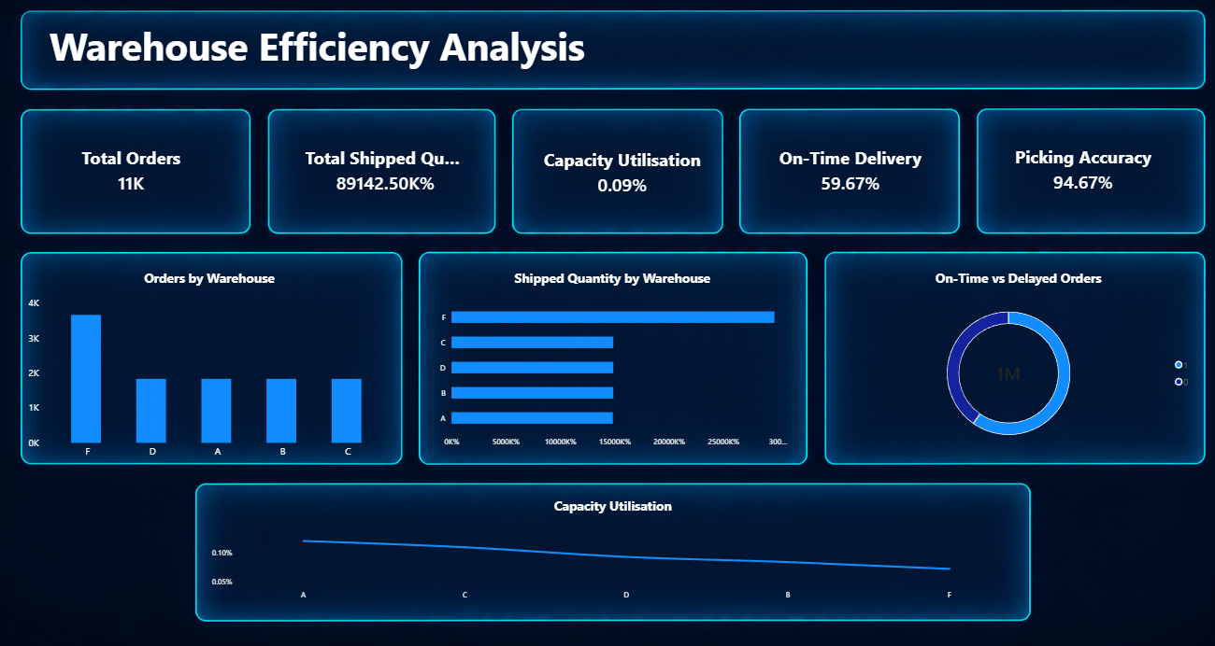
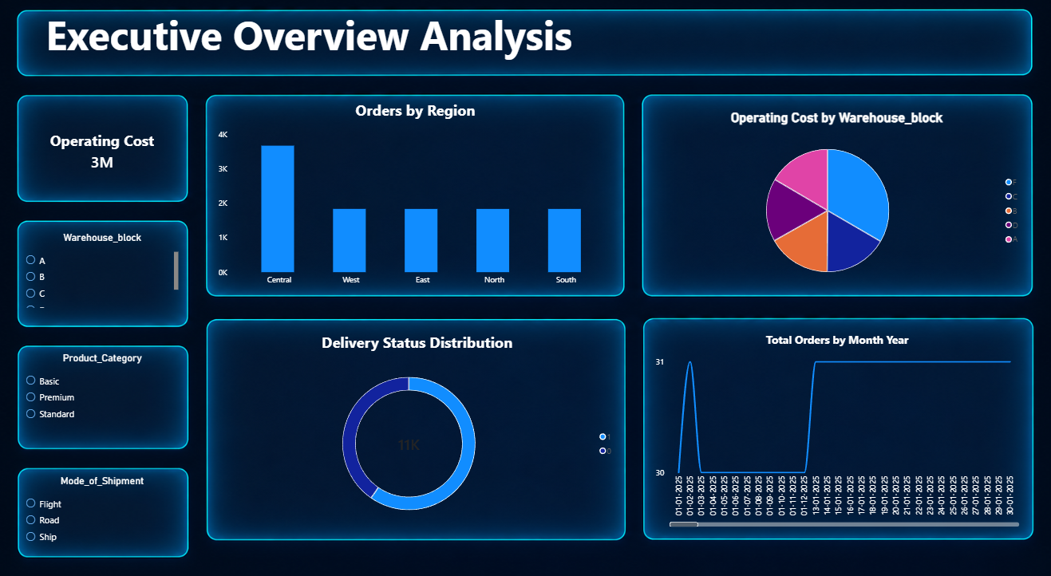
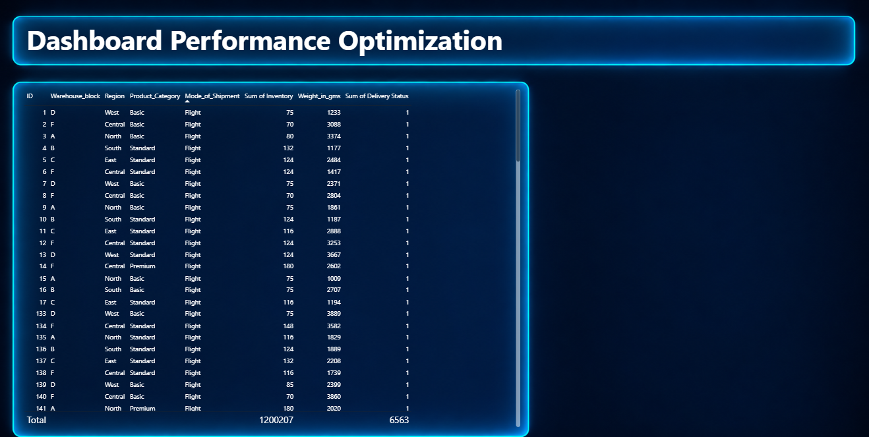

8. CONCLUSION
The four milestones together developed the E-Commerce Supply Chain Dashboard from a cleaned source dataset into a structured Power BI reporting system. Milestone 1 established the Star Schema and foundational KPIs. Milestone 2 introduced inventory, delivery, drill-down, trend, and variance analysis. Milestone 3 extended the report into supplier, carrier, route, transportation cost, fulfillment, and quality analysis. Milestone 4 added warehouse efficiency, executive monitoring, additional operational and financial KPIs, interactive slicers, and a detailed performance table.
The final report uses reusable DAX measures, structured dimension and fact tables, calculated analytical fields, and multiple visual types to support both high-level monitoring and detailed operational analysis.

9. REFERENCES
- Microsoft Power BI Documentation – Data modelling, report visuals, Power Query, and DAX.
- Microsoft Learn – DAX function reference and Power BI modelling guidance.
- Original E-Commerce Supply Chain dataset supplied for the internship dashboard project.

